INDOOR AIR QUALITY ASSESSMENT

Memorial Elementary School
6 Prospect Street
Hopedale, Massachusetts

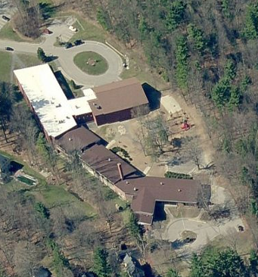

Prepared by:
Massachusetts Department of Public Health
Bureau of Environmental Health
Indoor Air Quality Program
October 2013

Background/Introduction
At the request of Mr. Leonard Izzo, Health Agent for the town of Hopedale, the Massachusetts Department of Public Health (MDPH), Bureau of Environmental Health (BEH) provided assistance and consultation regarding indoor air quality (IAQ) at the Memorial Elementary School (MES) located at 6 Prospect Street, Hopedale, Massachusetts. On September 5, 2013, Cory Holmes, Environmental Analyst/Regional Inspector in BEH’s IAQ Program visited the school to perform an assessment. The assessment was prompted by mold concerns, believed to have occurred over the summer.
The MES is a two-story red brick building that was reportedly built in the 1950s. An addition was built in the mid 1990s. Based upon observations it is likely that mechanical ventilation systems were also upgraded in the original portion of the building at that time. The building contains general classrooms, media center, kitchen/cafeteria, gymnasium, faculty workrooms/lounge and office space. The interior of classrooms consist mainly of cinderblock walls, vinyl floor tile with area rugs and drop ceiling tiles. A few areas have wall-to-wall carpeting. Windows are openable throughout the building.

Methods
BEH/IAQ staff performed visual inspection of building materials for water damage and/or microbial growth. Air tests for carbon monoxide, carbon dioxide, temperature and relative humidity were conducted with the TSI, Q-Trak, IAQ Monitor, Model 7565. Air tests for airborne particle matter with a diameter less than 2.5 micrometers were taken with the TSI, DUSTTRAK™ Aerosol Monitor Model 8520.

Results
The school houses approximately 630 students in grades K through 3 with a staff of approximately 95-100. Tests were taken during normal operations at the school. Results appear in Table 1.

Discussion

Ventilation
It can be seen from Table 1 that carbon dioxide levels were below 800 parts per million (ppm) in 35 of 40 areas, suggesting optimal air exchange in the large majority of areas surveyed. However, it is also important to note that several areas had open windows at the time carbon dioxide measurements were taken, which can greatly reduce carbon dioxide levels. Carbon dioxide levels would be expected to be higher with windows closed.
Fresh air in classrooms is supplied by unit ventilators (univents) (Picture 1). A univent is designed to draw air from outdoors through a fresh air intake located on the exterior wall of the building (Picture 2). Return air is drawn through an air intake located at the base of each unit where fresh and return air are mixed, filtered, heated and provided to classrooms through an air diffuser located in the top of the unit (Figure 1).
Univents were deactivated or obstructed with classroom items in several areas (Pictures 3 and 4; Table 1). In order for univents to provide fresh air as designed, intakes/returns must remain free of obstructions. Importantly, these units must remain on and be allowed to operate while rooms are occupied.
Mechanical ventilation for the gym is provided by an air handling unit (AHU) that is located in a mechanical room in the lower level. BEH/IAQ staff observed a number of items being stored on top of the AHU (Picture 5), which should be removed/relocated to prevent damage.
Exhaust ventilation in classrooms is provided by motorized vents located in the top of coat closets (Pictures 6 and 7). This is a suboptimal design that inhibits airflow. The exhaust system is designed to draw air into the coat closet via a passive grill in the front door of the cabinet. Air is pulled through the closet, drawn into the vent in top of the closet and ducted out of the building. In many cases the exhaust vents were off, louvers were shut and/or airflow was obstructed by items stored in or in front of the closets (Pictures 8 through 11).
It is important to note that some exhaust vents are located near hallway doors, which are generally left open (Picture 12). With the hallway doors open, the exhaust vent can be obstructed and will tend to draw air from the hallway into the classroom, instead of drawing stale air from the classroom. Therefore it is recommended that classroom doors remain shut during periods of occupancy to allow exhaust vents to operate as designed. As with univents, in order to function properly, exhaust vents must be activated and remain free of obstructions.
To maximize air exchange, the MDPH recommends that both supply and exhaust ventilation operate continuously during periods of occupancy. In order to have proper ventilation with a mechanical supply and exhaust system, the systems must be balanced to provide an adequate amount of fresh air to the interior of a room while removing stale air from the room. It is recommended that heating, ventilating and air conditioning (HVAC) systems be re-balanced every five years to ensure adequate air systems function (SMACNA, 1994). The date of the last balancing of these systems was not available at the time of assessment.
Minimum design ventilation rates are mandated by the Massachusetts State Building Code (MSBC). Until 2011, the minimum ventilation rate in Massachusetts was higher for both occupied office spaces and general classrooms, with similar requirements for other occupied spaces (BOCA, 1993). The current version of the MSBC, promulgated in 2011 by the State Board of Building Regulations and Standards (SBBRS), adopted the 2009 International Mechanical Code (IMC) to set minimum ventilation rates. Please note that the MSBC is a minimum standard that is not health-based. At lower rates of cubic feet per minute (cfm) per occupant of fresh air, carbon dioxide levels would be expected to rise significantly. A ventilation rate of 20 cfm per occupant of fresh air provides optimal air exchange resulting in carbon dioxide levels at or below 800 ppm in the indoor environment in each area measured. MDPH recommends that carbon dioxide levels be maintained at 800 ppm or below. This is because most environmental and occupational health scientists involved with research on IAQ and health effects have documented significant increases in indoor air quality complaints and/or health effects when carbon dioxide levels rise above the MDPH guidelines of 800 ppm for schools, office buildings and other occupied spaces (Sundell et al., 2011). The ventilation must be on at all times that the room is occupied. Providing adequate fresh air ventilation with open windows and maintaining the temperature in the comfort range during the cold weather season is impractical. Mechanical ventilation is usually required to provide adequate fresh air ventilation.
Carbon dioxide is not a problem in and of itself. It is used as an indicator of the adequacy of the fresh air ventilation. As carbon dioxide levels rise, it indicates that the ventilating system is malfunctioning or the design occupancy of the room is being exceeded. When this happens, a buildup of common indoor air pollutants can occur, leading to discomfort or health complaints. The Occupational Safety and Health Administration (OSHA) standard for carbon dioxide is 5,000 parts per million parts of air (ppm). Workers may be exposed to this level for 40 hours/week, based on a time-weighted average (OSHA, 1997).
The MDPH uses a guideline of 800 ppm for publicly occupied buildings. A guideline of 600 ppm or less is preferred in schools due to the fact that the majority of occupants are young and considered to be a more sensitive population in the evaluation of environmental health status. Inadequate ventilation and/or elevated temperatures are major causes of complaints such as respiratory, eye, nose and throat irritation, lethargy and headaches. For more information concerning carbon dioxide, consult Appendix A.
Indoor temperature measurements ranged from 73 F to 78 F (Table 1), which were within the MDPH recommended comfort range on the day of assessment. The MDPH recommends that indoor air temperatures be maintained in a range of 70 F to 78 F in order to provide for the comfort of building occupants. In many cases concerning indoor air quality, fluctuations of temperature in occupied spaces are typically experienced, even in a building with an adequate fresh air supply. In addition, it is difficult to control temperature and maintain comfort without operating the ventilation equipment as designed (e.g., univents/exhaust vents deactivated/obstructed). Heat complaints were reported in computer room 220, which is air conditioned. The thermostat for Room 220 was reportedly located in the library, which made temperature control in the computer room difficult. To help facilitate airflow throughout the room BEH/IAQ staff recommends placing a stand-up oscillating fan at the front of the room directing air toward the back.
Relative humidity measurements in the building ranged from 53 to 71 percent, most of which were above the MDPH recommended comfort range and reflective of outdoor conditions (Table 1). The MDPH recommends a comfort range of 40 to 60 percent for indoor air relative humidity. Note that the outdoor relative humidity was measured at 75 to 88 percent with intermittent morning showers and that the MES is not air conditioned, with the exception of the media center, computer room and main office. In order to remove moisture from the indoor environment a mechanical means is necessary. Such means are typically in the form of air conditioning or dehumidification. Relative humidity in excess of 70 percent for extended periods of time can provide an environment for mold and fungal growth in building materials (ASHRAE, 1989). It was reported by school officials that dehumidifiers are typically employed in lower level classrooms over the summer as needed to help prevent mold growth, which will be discussed further in the Microbial/Moisture Concerns section of this report.
Relative humidity levels in the building would be expected to drop during the winter months due to heating. The sensation of dryness and irritation is common in a low relative humidity environment. Low relative humidity is a very common problem during the heating season in the northeast part of the United States.

Microbial/Moisture Concerns
In order for building materials to support mold growth, a source of water exposure is necessary. Identification and elimination of the source of water moistening building materials is necessary to control mold growth. As mentioned previously, the assessment was prompted by concerns of mold growth that occurred over the summer on area carpets and flat surfaces (e.g., cabinets). At the time of assessment, area carpets had been cleaned or discarded and flat surfaces were reportedly cleaned and disinfected. School officials reported that historically dehumidifiers were operated as needed in lower level areas during summer months. Due to mold growth conditions experienced during this past summer, additional dehumidification units will be employed in ground floor areas in the future.
Water-damaged/missing ceiling tiles were noted in a number of areas throughout the building. Water-damaged ceiling tiles can indicate sources of water penetration and provide a source of mold. Ceiling tiles should be replaced after a water leak is discovered and repaired. Once mold has colonized porous materials, they are difficult to clean and should be removed/discarded. A moldy ceiling tile was observed in computer room 220 (Picture 13). This ceiling tile is installed around a fire alarm unit, making it difficult to replace. At the time of the assessment BEH/IAQ staff recommended cutting the moldy portion of the tile and discarding it, until the alarm company can be contacted for assistance in replacement of the entire tile.
The US Environmental Protection Agency (US EPA) and the American Conference of Governmental Industrial Hygienists (ACGIH) recommend that porous materials (e.g., carpeting, gypsum wallboard) be dried with fans and heating within 24 to 48 hours of becoming wet (US EPA, 2001; ACGIH, 1989). If not dried within this time frame, mold growth may occur. Once mold has colonized porous materials, they are difficult to clean and should be removed/discarded.
Visible mold growth was observed in the refrigerator in the lower level mechanical/storeroom. Upon opening the refrigerator BEH/IAQ staff found both the refrigerator and freezer door gaskets to be stained/colonized with mold (Picture 14). The refrigerator also had food spillage and appeared not to have been cleaned for some time (Picture 15).
Plants were noted in a few classrooms (Table 1). Plants can be a source of pollen and mold which can be respiratory irritants to some individuals. Plants should be properly maintained and equipped with drip pans and should be located away from univents to prevent the aerosolization of dirt, pollen and mold.
BEH/IAQ staff observed plants, shrubs and trees in close proximity to the building’s exterior (Pictures 16 through 18) and in some cases near univent air intakes (Picture 18). Plants, shrubs and trees in close proximity to the building hold moisture against the building exterior. The growth of roots against exterior walls can bring moisture in contact with the foundation. Plant roots can eventually penetrate the wall, leading to cracks and/or fissures in the foundation. Over time, these conditions can undermine the integrity of the building envelope and provide a means of water entry into the building via capillary action through exterior walls, foundation concrete, and masonry (Lstiburek & Brennan, 2001). The freezing and thawing action of water during the winter months can create cracks and fissures in the foundation that can result in additional penetration points for both water and pests. Trees, shrubs and plants can also be a source of pollen, debris and mold into univents and windows. Consideration should be given to removing landscaping in close proximity to exterior walls.
Also of note were accumulated grass clippings from lawn mowing on fresh air intakes (Picture 19). Grass clippings and associated debris from mowing can be a source of eye and respiratory irritation. These air intakes should be thoroughly cleaned and grass clippings should be directed away from air intakes during mowing.
Several aquariums and terrariums were observed in classrooms (Table 1). Aquariums should be properly maintained to prevent microbial/algal growth, which can emit unpleasant odors. Similarly, terrariums should be properly maintained to ensure soil does not become a source for mold growth/odors.
Open seams between sink countertops and backsplashes were observed in a number of rooms (Picture 20/Table 1). If not watertight, moisture can penetrate through seams, causing damage. Improper drainage or sink overflow can lead to water penetration into countertops, cabinet interiors and areas behind cabinets. Water penetration and chronic exposure of porous and wood-based materials can cause these materials to swell and show signs of water damage (Picture 20). Repeated moistening of porous materials can result in mold growth.

Other IAQ Evaluations
Indoor air quality can be negatively influenced by the presence of respiratory irritants, such as products of combustion. The process of combustion produces a number of pollutants. Common combustion emissions include carbon monoxide, carbon dioxide, water vapor and smoke (fine airborne particle material). Of these materials, exposure to carbon monoxide and particulate matter with a diameter of 2.5 micrometers (μm) or less (PM2.5) can produce immediate, acute health effects upon exposure. To determine whether combustion products were present in the indoor environment, BEH/IAQ staff obtained measurements for carbon monoxide and PM2.5.

Carbon Monoxide
Carbon monoxide is a by-product of incomplete combustion of organic matter (e.g., gasoline, wood and tobacco). Exposure to carbon monoxide can produce immediate and acute health effects. Several air quality standards have been established to address carbon monoxide and prevent symptoms from exposure to these substances. The MDPH established a corrective action level concerning carbon monoxide in ice skating rinks that use fossil-fueled ice resurfacing equipment. If an operator of an indoor ice rink measures a carbon monoxide level over 30 ppm, taken 20 minutes after resurfacing within a rink, that operator must take actions to reduce carbon monoxide levels (MDPH, 1997).
The American Society of Heating Refrigeration and Air-Conditioning Engineers (ASHRAE) has adopted the National Ambient Air Quality Standards (NAAQS) as one set of criteria for assessing indoor air quality and monitoring of fresh air introduced by HVAC systems (ASHRAE, 1989). The NAAQS are standards established by the US EPA to protect the public health from six criteria pollutants, including carbon monoxide and particulate matter (US EPA, 2006). As recommended by ASHRAE, pollutant levels of fresh air introduced to a building should not exceed the NAAQS levels (ASHRAE, 1989). The NAAQS were adopted by reference in the Building Officials & Code Administrators (BOCA) National Mechanical Code of 1993 (BOCA, 1993), which is now an HVAC standard included in the Massachusetts State Building Code (SBBRS, 2011). According to the NAAQS, carbon monoxide levels in outdoor air should not exceed 9 ppm in an eight-hour average (US EPA, 2006).
Carbon monoxide should not be present in a typical, indoor environment. If it is present, indoor carbon monoxide levels should be less than or equal to outdoor levels. On the day of assessment, outdoor carbon monoxide concentrations were non-detect (ND) (Table 1). No measurable levels of carbon monoxide were detected inside the building (Table 1).

Particulate Matter
The US EPA has established NAAQS limits for exposure to particulate matter. Particulate matter includes airborne solids that can be irritating to the eyes, nose and throat. The NAAQS originally established exposure limits to PM with a diameter of 10 μm or less (PM10). In 1997, US EPA established a more protective standard for fine airborne particulate matter with a diameter of 2.5 μm or less (PM2.5). This more stringent PM2.5 standard requires outdoor air particle levels be maintained below 35 μg/m³ over a 24-hour average (US EPA, 2006). Although both the ASHRAE standard and BOCA Code adopted the PM10 standard for evaluating air quality, MDPH uses the more protective PM2.5 standard for evaluating airborne PM concentrations in the indoor environment.
Outdoor PM2.5 concentrations were measured at 4 μg/m³ (Table 1). PM2.5 levels measured in the school were between 2 to 12 μg/m³ (Table 1), which were below the NAAQS PM2.5 level of 35 μg/m³. Frequently, indoor air levels of particulates (including PM2.5) can be at higher levels than those measured outdoors. A number of activities that occur indoors and/or mechanical devices can generate particulate during normal operations. Sources of indoor airborne particulates may include but are not limited to particles generated during the operation of fan belts in the HVAC system, use of stoves and/or microwave ovens in kitchen areas; use of photocopiers, fax machines and computer printing devices; operation of an ordinary vacuum cleaner and heavy foot traffic indoors.

Volatile Organic Compounds
Indoor air concentrations can be greatly impacted by the use of products containing volatile organic compounds (VOCs). VOCs are carbon-containing substances that have the ability to evaporate at room temperature. Frequently, exposure to low levels of total VOCs (TVOCs) may produce eye, nose, throat and/or respiratory irritation in some sensitive individuals. For example, chemicals evaporating from a paint can stored at room temperature would most likely contain VOCs. In an effort to identify materials that can potentially increase indoor VOC concentrations, BEH/IAQ staff examined rooms for products containing these respiratory irritants.
Classrooms contained dry erase boards and related materials. Materials such as dry erase markers and dry erase board cleaners may contain VOCs, such as methyl isobutyl ketone, n-butyl acetate and butyl-cellusolve (Sanford, 1999), which can be irritating to the eyes, nose and throat.
Classroom 210 had a strong odor of air freshener. Air fresheners contain chemicals that can be irritating to the eyes, nose and throat of sensitive individuals. Many air fresheners contain 1,4-dichlorobenzene, a VOC which may cause reductions in lung function (NIH, 2006). Furthermore, deodorizing agents do not remove materials causing odors, but rather mask odors that may be present in the area.

Other Conditions
Other conditions that can affect IAQ were observed during the assessment. In many classrooms, a large number of items were on floors, windowsills, tabletops, counters, bookcases and desks, which provide a source for dusts to accumulate. These items (e.g., papers, folders, boxes) make it difficult for custodial staff to clean. Items should be relocated and/or be cleaned periodically to avoid excessive dust build up. In addition, dust and debris can accumulate on flat surfaces (e.g., desktops, shelving and carpets) in occupied areas and subsequently be re-aerosolized causing further irritation.
A number of air diffusers, exhaust/return vents and personal fans were found to have accumulated dust/debris (Pictures 21 and 22; Table 1). Of particular note were the grills along the top of univents, which had accumulated dust/debris. It was not clear if these units were accessible to clean by opening or removal of the grill. Re-activated supply vents and fans can aerosolize dust accumulated on vents/fan blades. If exhaust vents are not functioning, backdrafting can occur, which can re-aerosolize accumulated dust particles.
Sections of the ceiling tile grid in classroom 122 were missing, exposing fiberglass insulation (Picture 23). Fiberglass can be a source of irritation to the eyes, skin and respiratory system. In addition, the ceiling tile grid is a weight-bearing system that should be intact.
Finally, reoccurring odor complaints were reported in classroom 200. BEH/IAQ staff detected a slight odor upon entry; however no obvious source could be identified. Occupants/school officials believed that the odor may be related to wooden shelving in the foyer and/or in the storeroom, therefore removal of these items is planned to investigate if odors dissipate.

Conclusions/Recommendations
As previously mentioned, at the time of assessment, area carpets had been cleaned or discarded and flat surfaces that were reported to be colonized with mold were cleaned and disinfected. To prevent/reduce this occurrence next summer, the expanded use of dehumidifiers and air conditioning (where available) should be employed during periods of excess relative humidity (i.e., >70%) for extended periods of time. Also please see attached as Appendix B MDPH guidance Preventing Mold Growth in Massachusetts Schools during Hot, Humid Weather.
In view of the findings at the time of the visit, the following recommendations are made:
- Operate all supply and exhaust ventilation systems throughout the building (e.g., gym, cafeteria, classrooms) continuously during periods of occupancy to maximize air exchange. If increased airflow is desired, operate univents in fan “high” mode. School staff should be encouraged not to deactivate classroom univents and to report any mechanical/control issues to the facilities department.
- Make repairs to exhaust motors as needed, if they cannot be repaired; replace.
- Ensure all coat closet exhaust vent louvers are open and that items stored within are not restricting airflow.
- Contact HVAC engineering firm and/or carpenter to examine methods to improve exhaust capabilities. One method may include relocating passive grill at top of coat closet closer to exhaust vents.
- Remove all blockages from the top and front of univents to ensure adequate airflow.
- Close classroom doors for proper operation of mechanical ventilation system/air exchange.
- Remove items from the top of the AHU shown in Picture 5 to prevent damage to the AHU.
- To facilitate airflow in computer room 220, utilize a stand-up oscillating fan at the front of the room.
- Consider adopting a balancing schedule of every 5 years for all mechanical ventilation systems, as recommended by ventilation industrial standards (SMACNA, 1994).
- For buildings in New England, periods of low relative humidity during the winter are often unavoidable. Therefore, scrupulous cleaning practices should be adopted to minimize common indoor air contaminants whose irritant effects can be enhanced when the relative humidity is low. To control dusts, a high efficiency particulate arrestance (HEPA) filter equipped vacuum cleaner in conjunction with wet wiping of all surfaces is recommended. Avoid the use of feather dusters. Drinking water during the day can help ease some symptoms associated with a dry environment (throat and sinus irritations).
- To prevent mold growth on area carpets over the summer, carpets should be rolled up. They should be professionally cleaned and stored in a conditioned space.
- Ensure roof/plumbing leaks are repaired and replace any remaining water-damaged ceiling tiles. Examine the area above these tiles for mold growth (e.g., computer room 220). Disinfect areas of water leaks with an appropriate antimicrobial, as needed.
- Ensure plants, trees and shrubs are located at least five feet away from exterior walls/foundation of the building, particularly those in close proximity to univent fresh air intakes.
- Ensure air intakes are thoroughly cleaned. Direct grass clippings away from air intakes during mowing.
- Clean and disinfect interior of refrigerators and freezers with mild detergent or antimicrobial agent. If they cannot be adequately cleaned, replace mold-contaminated gaskets. Clean spilled food promptly, and clean the refrigerator of expired items on a regular schedule.
- Seal areas between sink countertops and backsplashes to prevent water-damage to the interior of cabinets and adjacent materials. Consider replacing severely damaged units with a one-piece molded countertop (i.e., classroom 207).
- Ensure indoor plants are equipped with drip pans. Examine drip pans periodically for mold growth and disinfect with an appropriate antimicrobial, as needed. Move plants away from the air stream of mechanical ventilation equipment.
- Ensure that aquariums and terrariums are kept clean to prevent odors.
- Relocate or consider reducing the amount of materials stored in classrooms to allow for more thorough cleaning of classrooms. Clean items regularly with a wet cloth or sponge to prevent excessive dust build-up.
- Determine if univent diffuser grills can be removed to enable cleaning of accumulated dust/debris.
- Clean exhaust vents, passive (coat closet) grills and personal fans periodically of accumulated dust/debris.
- Replace missing ceiling tile grid in classroom 122 (and other areas) to maintain structural integrity and prevent exposure to fiberglass insulation where present.
- Continue with plans to remove wooden shelving in classroom 200 foyer/storeroom to determine if odors dissipate. Replace base coving that was removed in foyer, once investigation is complete.
- Consider adopting the US EPA (2000) document, “Tools for Schools”, as an instrument for maintaining a good indoor air quality environment in the building. This document is available at: http://www.epa.gov/iaq/schools/index.html.
- Refer to resource manual and other related indoor air quality documents located on the MDPH’s website for further building-wide evaluations and advice on maintaining public buildings. These documents are available at: http://mass.gov/dph/iaq.

References
ACGIH. 1989. Guidelines for the Assessment of Bioaerosols in the Indoor Environment. American Conference of Governmental Industrial Hygienists, Cincinnati, OH.
ASHRAE. 1989. Ventilation for Acceptable Indoor Air Quality. American Society of Heating, Refrigeration and Air Conditioning Engineers. ANSI/ASHRAE 62-1989.
BOCA. 1993. The BOCA National Mechanical Code/1993. 8th ed. Building Officials and Code Administrators International, Inc., Country Club Hill, IL.
Lstiburek, J. & Brennan, T. 2001. Read This Before You Design, Build or Renovate. Building Science Corporation, Westford, MA. U.S. Department of Housing and Urban Development, Region I, Boston, MA.
MDPH. 1997. Requirements to Maintain Air Quality in Indoor Skating Rinks (State Sanitary Code, Chapter XI). 105 CMR 675.000. Massachusetts Department of Public Health, Boston, MA.
NIH. 2006. Chemical in Many Air Fresheners May Reduce Lung Function. NIH News. National Institute of Health. July 27, 2006. http://www.nih.gov/news/pr/jul2006/niehs-27.htm.
OSHA. 1997. Limits for Air Contaminants. Occupational Safety and Health Administration. Code of Federal Regulations. 29 C.F.R 1910.1000 Table Z-1-A.
Sanford. 1999. Material Safety Data Sheet (MSDS No: 198-17). Expo Dry Erase Markers Bullet, Chisel, and Ultra Fine Tip. Sanford Corporation. Bellwood, IL.
SBBRS. 2011. Mechanical Ventilation. State Board of Building Regulations and Standards. Code of Massachusetts Regulations, 8th edition. 780 CMR 1209.0
SMACNA. 1994. HVAC Systems Commissioning Manual. 1st ed. Sheet Metal and Air Conditioning Contractors’ National Association, Inc., Chantilly, VA.
Sundell, J., H. Levin, W. W. Nazaroff, W. S. Cain, W. J. Fisk, D. T. Grimsrud, F. Gyntelberg, Y. Li, A. K. Persily, A. C. Pickering, J. M. Samet, J. D. Spengler, S. T. Taylor, and C. J. Weschler. 2011. Ventilation rates and health: multidisciplinary review of the scientific literature. Indoor Air, Volume 21: pp 191–204.
US EPA. 2000. Tools for Schools. Office of Air and Radiation, Office of Radiation and Indoor Air, Indoor Environments Division (6609J). EPA 402-K-95-001, Second Edition. http://www.epa.gov/iaq/schools/actionkit.html.
US EPA. 2001. Mold Remediation in Schools and Commercial Buildings. US Environmental Protection Agency, Office of Air and Radiation, Indoor Environments Division, Washington, D.C. EPA 402-K-01-001. March 2001.
US EPA. 2006. National Ambient Air Quality Standards (NAAQS). US Environmental Protection Agency, Office of Air Quality Planning and Standards, Washington, DC. http://www.epa.gov/air/criteria.html.
Picture 1

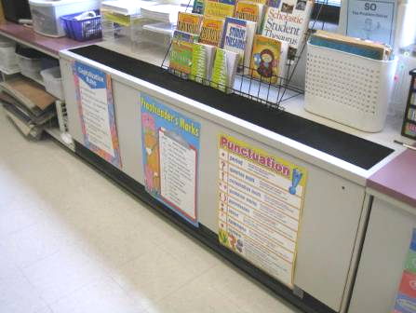

Classroom unit ventilator (univent)

Picture 2

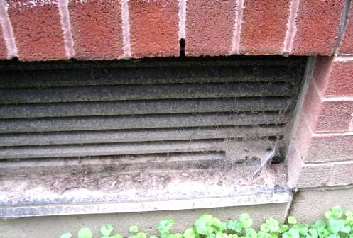

Univent fresh air intake, note grass clippings and accumulated debris

Picture 3

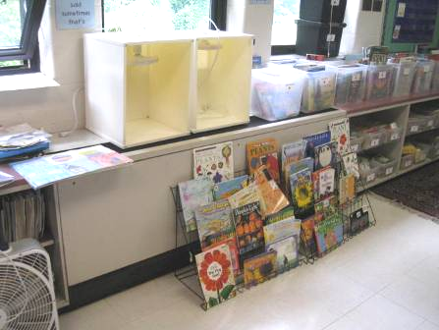

Items obstructing univent supply diffuser (top) and return vent (bottom/front)

Picture 4



Items obstructing univent supply diffuser (top) and return vent (bottom/front)

Picture 5

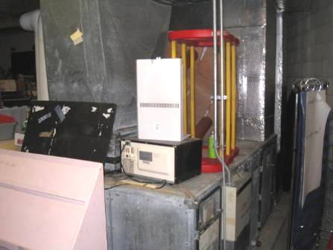

Various items stored on top of AHU in lower level mechanical room

Picture 6

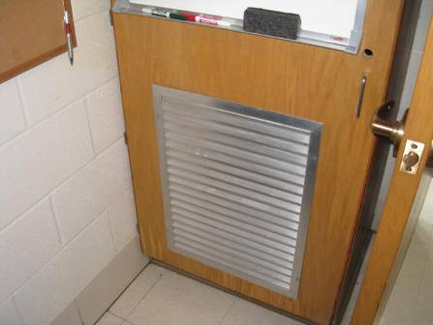

Passive grill on front of coat closet

Picture 7

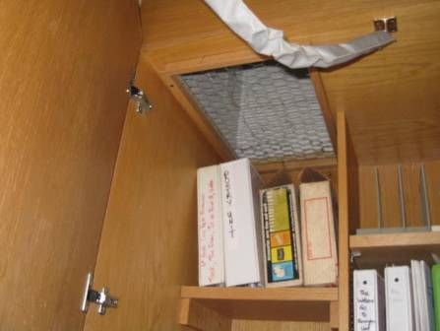

Exhaust vent in top of coat closet

Picture 8

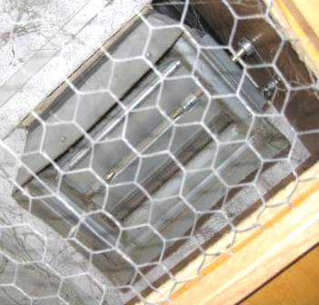

Exhaust vent in coat closet with louvers shut

Picture 9

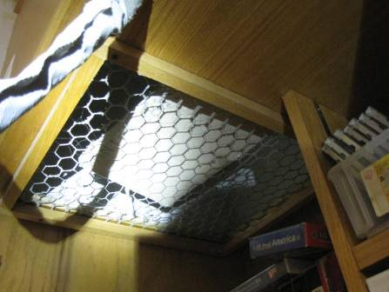

Exhaust vent obstructed by debris

Picture 10

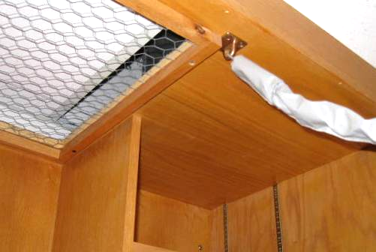

Obstructed exhaust vent, note only thin slot allowing airflow (arrow)

Picture 11

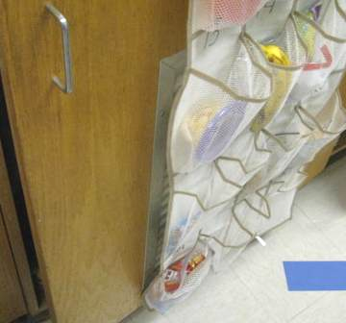

Coat closet exhaust vent obstructed by hanging item

Picture 12

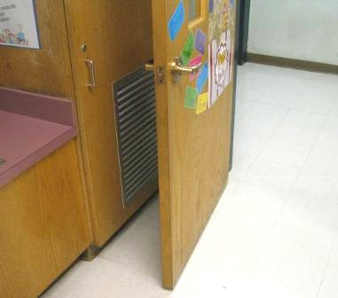

Coat closet exhaust vent obstructed by open hallway door

Picture 13

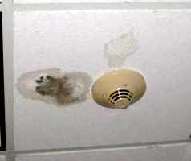

Water-damaged/moldy ceiling tile in computer room 220

Picture 14

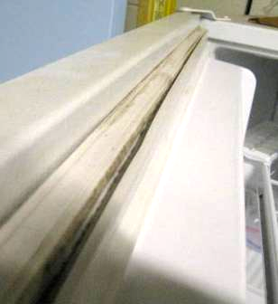

Staining/mold growth on freezer gasket

Picture 15

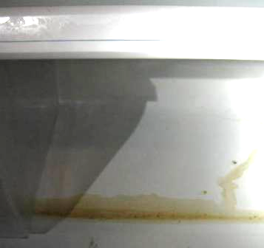

Food spillage/staining at bottom of refrigerator

Picture 16

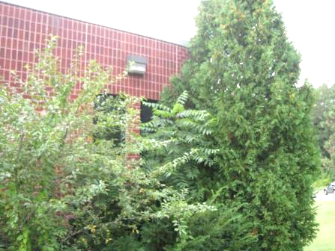

Trees/shrubs in close proximity to exterior walls

Picture 17

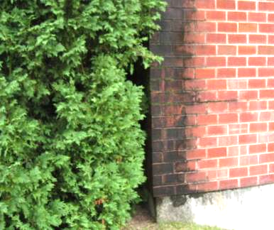

Trees/shrubs in close proximity to exterior walls, note moss/mold growth (dark staining) due to chronic moisture exposure

Picture 18

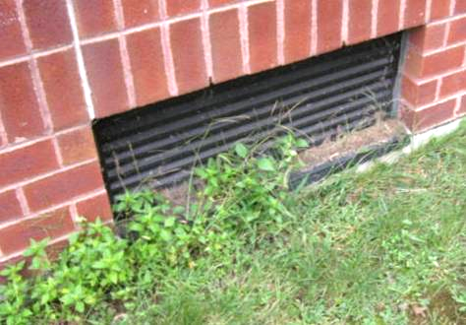

Plant growth in front of univent air intake

Picture 19

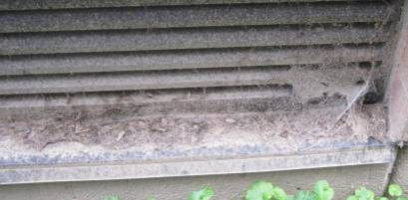

Accumulated grass clippings in/on univent fresh air intake

Picture 20

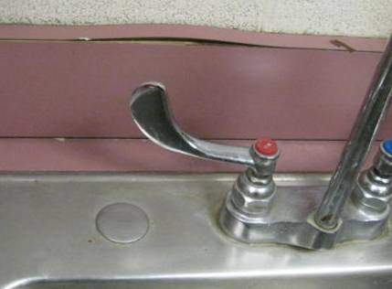

Space between sink countertop and backsplash, note water-damaged/delaminating backsplash

Picture 21

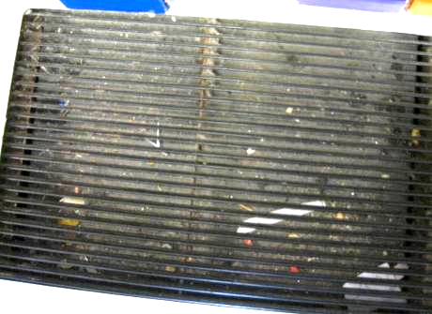

Dust/debris in univent air diffuser

Picture 22

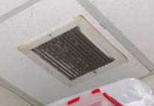

Dust/debris on ceiling-mounted exhaust vent

Picture 23

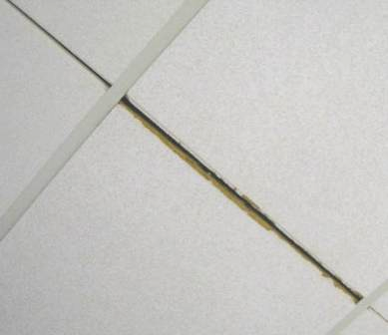

Missing ceiling tile grid exposing fiberglass insulation in classroom 122
Location | Carbon  Dioxide  (ppm) | Carbon Monoxide  (ppm) | Temp  (°F) | Relative  Humidity  (%) | PM2.5  (μg/m³) | Occupants  in Room | Windows  Openable | Ventilation |  |  | Remarks
 |  |  |  |  |  |  |  | Intake | Exhaust |  | Remarks
Background | 386 | ND | 69 | 75-88 | 4 |  |  |  |  |  | Mostly cloudy, humid, clearing rain (am)
100 | 675 | ND | 75 | 63 | 4 | 23 | Y  Open | Y |  | Y | Dust/debris in UV diffuser, AT (2), space btwn sink backsplash and countertop
102 | 761 | ND | 75 | 65 | 4 | 22 | Y  Open | Y |  | Y  Off | Exhaust vent off/obstructed, DO, bowing CT near windows
112 | 877 | ND | 75 | 67 | 8 | 23 | Y | Y |  | Y | Dust/debris in UV diffuser, water-damaged sink countertop
114 | 747 | ND | 74 | 65 | 6 | 25 | Y  Open | Y |  | Y | 3 WD CT near windows, dust/debris on vents, space btwn sink backsplash and countertop
116 | 792 | ND | 74 | 66 | 7 | 24 | Y  Open | Y  Off |  | Y | Aqua, plants, PF, dust/debris on/around metal outlet near Aqua
118 | 937 | ND | 75 | 71 | 11 | 23 | Y | Y |  | Y | Aqua, WD CT near window, plants, space btwn sink backsplash and countertop
120 | 490 | ND | 73 | 67 | 8 | 24 | Y  Open | Y |  | Y  Off | Exhaust vent off/louvers shut, AT, plants, space btwn sink backsplash and countertop
122 | 778 | ND | 73 | 63 | 9 | 23 | Y  Open | Y |  | Y | Exhaust vent louvers shut, items on/front of UV, exposed fiberglass (btwn CTs), aqua, plants, space btwn sink backsplash and countertop
123 | 543 | ND | 75 | 64 | 7 | 0 | Y  Open | N |  | Y | Open utility holes in walls
Lower Level Mechanical/Store Room |  |  |  |  |  |  |  |  |  |  | Items stored on top of AHU, mold on refrigerator gaskets
2nd Floor
200 | 780 | ND | 78 | 59 | 12 | 24 | Y | Y |  | Y  Off | DO, odor complaints (wooden shelving)
201 | 990 | ND | 77 | 64 | 7 | 21 | Y | Y  Off |  | Y  Off | Exhaust vent off/blocked, DO
203 | 745 | ND | 77 | 61 | 5 | 3 | Y | Y |  | Y
205 | 910 | ND | 76 | 61 | 9 | 20 | Y  Open | Y |  | Y | Exhaust vent blocked, items on/front of UV, PF
206 | 614 | ND | 77 | 56 | 5 | 23 | Y  Open | Y |  | Y | DO, PF-dusty
207 | 797 | ND | 77 | 57 | 6 | 23 | Y  Open | Y |  | Y | PF
208 A | 537 | ND | 76 | 56 | 3 | 0 | Y  Open | Y |  | Y | PF, DO
208 B | 628 | ND | 76 | 56 | 3 | 0 | Y  Open | Y |  | Y | DO, PF-dusty
209 | 927 | ND | 78 | 59 | 4 | 20 | Y  Open | Y |  | Y  Off | Exhaust vent off/louvers shut
210 | 696 | ND | 76 | 56 | 4 | 20 | Y  Open | Y |  | Y | Exhaust vent blocked, space btwn sink backsplash and countertop, items on/front of UV, PF, strong odor of air deodorizer
211 | 462 | ND | 78 | 65 | 12 | 21 | Y | Y |  | Y  Off | Exhaust vent off/louvers shut, UV return vent blocked, WD CT, AT, space btwn sink backsplash and countertop
212 | 591 | ND | 77 | 57 | 4 | 0 | Y  Open | Y |  | Y | 2 WD CT near windowsill, DO, cobwebs on windowsill
213 | 797 | ND | 76 | 59 | 8 | 19 | Y  Open | Y |  | Y | DO, space btwn sink backsplash and countertop
214 | 771 | ND | 77 | 59 | 4 | 23 | Y  Open | Y |  | Y | Items in front of UV, space btwn sink backsplash and countertop
215 | 750 | ND | 78 | 59 | 8 | 25 | Y  Open | Y |  | Y | DO, water-damaged sink countertop, PF, items on/front of UV
216 | 503 | ND | 77 | 56 | 6 | 0 | Y  Open | Y |  | Y  Off | Exhaust vent off/louvers shut, DO, occupants at lunch
217 | 770 | ND | 77 | 60 | 5 | 21 | Y  Open | Y |  | Y | PF, water-damaged sink countertop, dust/debris exhaust vents, DO
218 Media Center | 475 | ND | 74 | 60 | 4 | 22 | Y | Y |  | Y | Wall-to-wall carpeting, WD CT
219 | 771 | ND | 77 | 61 | 7 | 5 | Y  Open | Y |  | Y | WD CT, PF
220 Computer Room | 607 | ND | 77 | 57 | 2 | 27 | Y  Open | Y |  | Y | Recommend oscillating fan (front of room), moldy CT, 2 WD CT
221 Faculty Lounge | 592 | ND | 76 | 60 | 4 | 3 | Y  Open | Y |  | Y | Items on UV, 3 WD CT, wall-mounted AC
222 | 467 | ND | 75 | 59 | 3 | 2 | Y  Open | Y |  | Y | WD CT, dust/debris on exhaust vents, DO
224 | 579 | ND | 76 | 58 | 4 | 24 | Y  Open | Y |  | Y | Damaged sink countertop, PF-dusty, DO
226 | 477 | ND | 75 | 58 | 3 | 27 | Y  Open | Y |  | Y | DO, items on/front of UV, MT, AT
227 | 535 | ND | 75 | 61 | 6 | 1 | Y  Open | Y |  | Y | 25 occupants gone ~ 25 mins, DO, space btwn sink backsplash and countertop
228 | 563 | ND | 75 | 60 | 4 | 24 | Y  Open | Y |  | Y | DO, PF, items blocking UV return vent, dust/debris on exhaust vents, space btwn sink backsplash and countertop
229 | 611 | ND | 76 | 63 | 4 | 0 | Y  Open | Y |  | Y | Occupants at lunch, 6 WD CT, DO, sink countertop water-damaged
230 | 479 | ND | 75 | 61 | 4 | 0 | Y  Open | Y |  | Y | PF, space btwn sink backsplash and countertop, dust/debris on exhaust vents
231 | 498 | ND | 75 | 61 | 4 | 0 | Y  Open | Y |  | Y  Off | Plants, plant debris/dust/debris in UV diffuser
248/252 | 434 | ND | 76 | 53 | 3 | 0 | Y  Open | Y |  | Y | Dust/debris on supply vents
Cafeteria | 573 | ND | 77 | 60 | 4 | 0 | Y  Open | Y |  | Y | Readings taken shortly after lunch

