INDOOR AIR QUALITY ASSESSMENT

Memorial Middle School
81 Central Ave
Hull, MA 02045



Prepared by:
Massachusetts Department of Public Health
Center for Environmental Health
Emergency Response Indoor Air Quality Program
April 2007

Background/Introduction
At the request of the Town of Hull Board of Selectmen and School Department, the Massachusetts Department of Public Health (MDPH) Center for Environmental Health (CEH) provided assistance and consultation regarding indoor air quality at each of Hull’s public schools. These assessments were coordinated through David Twombly, Director of Operations, Hull Public Schools (HPS) and Kevin O’Brien, Director of the Hull Board of Health.
On February 12, 2007, Cory Holmes an Environmental Analyst in CEH’s Emergency Response/Indoor Air Quality (ER/IAQ) Program conducted an assessment at the Memorial Middle School (MMS), 81 Central Street, Hull, Massachusetts. Mr. Holmes was accompanied during the assessment by Andrew G Stephens, Principal and Mr. Twombly for portions of the assessment.
The MMS is a three-story red brick building constructed in 1949. The building was completely renovated in 2001-2002. The school consists of general classrooms, science classrooms, gymnasium, auditorium, kitchen/cafeteria, media center, art room, music room, teacher work rooms and office space. Windows are openable throughout the building.

Methods
Air tests for carbon dioxide, carbon monoxide, temperature and relative humidity were conducted with the TSI, Q-TRAK™ IAQ Monitor, Model 8551. Air tests for airborne particulate matter with a diameter less than 2.5 micrometers were taken with the TSI, DUSTTRAK™ Aerosol Monitor Model 8520. Screening for total volatile organic compounds (TVOCs) was conducted using an HNu, Model 102 Snap-on Photo Ionization Detector (PID). CEH staff also performed a visual inspection of building materials for water damage and/or microbial growth.

Results
The MMS currently houses grades 5 through 8, with a student population of 285 and a staff of approximately 40. Tests were taken under normal operating conditions. Test results appear in Table 1.

Discussion

Ventilation
It can be seen from Table 1 that carbon dioxide levels were elevated above 800 parts per million (ppm) in twenty of thirty-five areas surveyed, indicating less than optimal air exchange in over half of the areas surveyed on the day of the assessment. It is important to note that several areas with carbon dioxide levels below 800 ppm were sparsely populated, unoccupied and/or had windows open, which can greatly reduce carbon dioxide levels. Carbon dioxide levels would be expected to be higher with full occupancy and with windows shut. It is also important to note that the assessment was conducted on an extremely cold day (29 ºF), with a wind chill below 0 ºF. During these types of temperature extremes, fresh air drawn into the heating, ventilating and air-conditioning (HVAC) system is often reduced to prevent freezing/damage of HVAC system components. Limiting fresh air intake either by mechanical and/or natural means (e.g., closing of windows) can contribute to an increase in carbon dioxide levels.
Fresh air in exterior classrooms is supplied by unit ventilator (univent) systems (Pictures 1 and 2). A univent is designed to draw air from outdoors through a fresh air intake located on the exterior wall of the building (Picture 3). Return air is drawn through an air intake located at the base of the unit (Figure 1). Fresh and return air are mixed, filtered, heated and provided to classrooms through an air diffuser located in the top of the unit. Several univents were deactivated during the assessment (Table 1), therefore no mechanical means to introduce fresh air was being provided in these areas. The univent in room 327 was reportedly deactivated due to excessive noise and heat. Obstructions to airflow, such as papers and books stored on univents and bookcases, carts and desks in front of univent returns, were seen in several classrooms. In order for univents to provide fresh air as designed, units must be activated and remain free of obstructions.
Exhaust ventilation in classrooms is provided by ceiling-mounted vents (Picture 4) powered by rooftop motors (Picture 5). Exhaust vents were either not drawing or were drawing weakly in several areas (Table 1). CEH staff examined the vent in classroom 140; no draw was detected and it could not be determined if the vent was ducted to a rooftop motor (Picture 6). In order to function properly, exhaust vents must be activated during periods of occupancy. Without sufficient supply and exhaust ventilation, environmental pollutants can build up and lead to indoor air quality/comfort complaints. It is important to note that the location of some exhaust vents can limit exhaust efficiency. In some classrooms, exhaust vents are located above hallway doors (Picture 4). When classroom doors are open, exhaust vents tend to draw air from the hallway, thereby reducing the effectiveness of the vents to remove common environmental pollutants from classrooms.
To maximize air exchange, the MDPH recommends that both supply and exhaust ventilation operate continuously during periods of school occupancy. In order to have proper ventilation with a mechanical supply and exhaust system, the systems must be balanced to provide an adequate amount of fresh air to the interior of a room while removing stale air from the room. It is recommended that existing ventilation systems be re-balanced every five years to ensure adequate air systems function (SMACNA, 1994). The date of the last balancing of these systems was not available at the time of the assessment, but should have occurred at some point after construction/renovation in 2002.
The Massachusetts Building Code requires a minimum ventilation rate of 15 cubic feet per minute (cfm) per occupant of fresh outside air or have openable windows in each room (SBBRS, 1997; BOCA, 1993). The ventilation must be on at all times that the room is occupied. Providing adequate fresh air ventilation with open windows and maintaining the temperature in the comfort range during the cold weather season is impractical. Mechanical ventilation is usually required to provide adequate fresh air ventilation.
Carbon dioxide is not a problem in and of itself. It is used as an indicator of the adequacy of the fresh air ventilation. As carbon dioxide levels rise, it indicates that the ventilating system is malfunctioning or the design occupancy of the room is being exceeded. When this happens a buildup of common indoor air pollutants can occur, leading to discomfort or health complaints. The Occupational Safety and Health Administration (OSHA) standard for carbon dioxide is 5,000 parts per million parts of air (ppm). Workers may be exposed to this level for 40 hours/week based on a time weighted average (OSHA, 1997).
The MDPH uses a guideline of 800 ppm for publicly occupied buildings. A guideline of 600 ppm or less is preferred in schools due to the fact that the majority of occupants are young and considered to be a more sensitive population in the evaluation of environmental health status. Inadequate ventilation and/or elevated temperatures are major causes of complaints such as respiratory, eye, nose and throat irritation, lethargy and headaches. For more information concerning carbon dioxide, please see Appendix A.
Temperature readings indoors on the day of the assessment ranged from 68 º F to 76 º F, which were within the MDPH comfort guidelines in all but one area surveyed (the gym at 68 º F). The MDPH recommends that indoor air temperatures be maintained in a range of 70 º F to 78 º F in order to provide for the comfort of building occupants. In many cases concerning indoor air quality, fluctuations of temperature in occupied spaces are typically experienced, even in a building with an adequate fresh air supply. As mentioned the univent in classroom 327 was reportedly deactivated due to excessive noise and heat emission.
The relative humidity measurements ranged from 14 to 21 percent, which were below the MDPH recommended comfort range the day of the assessment. The MDPH recommends a comfort range of 40 to 60 percent for indoor air relative humidity. Relative humidity levels in the building would be expected to drop during the winter months due to heating. The sensation of dryness and irritation is common in a low relative humidity environment. Low relative humidity is a very common problem during the heating season in the northeast part of the United States.

Microbial/Moisture Concerns
Water stained ceiling tiles were observed in classroom 329, which can indicate leaks from the roof or plumbing system. Water-damaged ceiling tiles can provide a source for mold and should be replaced after a water leak is discovered and repaired. Breaches between the sink countertop and backsplash were seen in a few areas (Picture 7/Table 1). Improper drainage or sink overflow can lead to water penetration to countertop wood, the cabinet interior and areas behind cabinets. Like other porous materials, if these materials become wet repeatedly they can provide a medium for mold growth.
Plants were noted in several classrooms (Picture 8). Plants can be a source of pollen and mold, which can be respiratory irritants for some individuals. Plants should be properly maintained and equipped with drip pans to prevent water damage to porous building materials (Picture 9), which can lead to mold growth. Plants should also be located away from ventilation sources (e.g., air intakes, univent diffusers) to prevent the entrainment and/or aerosolization of dirt, pollen or mold.
During an exterior inspection of the building CEH staff observed cardboard material protruding from a ground level univent fresh air intake (Picture 10). If wetted repeatedly, porous materials can become colonized with mold and provide a source of spores and odors. Upon discovery, CEH staff reported this finding and recommended to Mr. Twombly and Principal Stephens that the material be removed.

Other IAQ Evaluations
Indoor air quality can be negatively influenced by the presence of respiratory irritants, such as products of combustion. The process of combustion produces a number of pollutants. Common combustion emissions include carbon monoxide, carbon dioxide, water vapor and smoke (fine airborne particle material). Of these materials, exposure to carbon monoxide and particulate matter with a diameter of 2.5 micrometers (μm) or less (PM2.5) can produce immediate, acute health effects upon exposure. To determine whether combustion products were present in the school environment, CEH staff obtained measurements for carbon monoxide and PM2.5.
Carbon monoxide is a by-product of incomplete combustion of organic matter (e.g., gasoline, wood and tobacco). Exposure to carbon monoxide can produce immediate and acute health affects. Several air quality standards have been established to address carbon monoxide and prevent symptoms from exposure to these substances. The MDPH established a corrective action level concerning carbon monoxide in ice skating rinks that use fossil-fueled ice resurfacing equipment. If an operator of an indoor ice rink measures a carbon monoxide level over 30 ppm, taken 20 minutes after resurfacing within a rink, that operator must take actions to reduce carbon monoxide levels (MDPH, 1997).
The American Society of Heating Refrigeration and Air-Conditioning Engineers (ASHRAE) has adopted the National Ambient Air Quality Standards (NAAQS) as one set of criteria for assessing indoor air quality and monitoring of fresh air introduced by HVAC systems (ASHRAE, 1989). The NAAQS are standards established by the US EPA to protect the public health from six criteria pollutants, including carbon monoxide and particulate matter (US EPA, 2006). As recommended by ASHRAE, pollutant levels of fresh air introduced to a building should not exceed the NAAQS levels (ASHRAE, 1989). The NAAQS were adopted by reference in the Building Officials & Code Administrators (BOCA) National Mechanical Code of 1993 (BOCA, 1993), which is now an HVAC standard included in the Massachusetts State Building Code (SBBRS, 1997). According to the NAAQS, carbon monoxide levels in outdoor air should not exceed 9 ppm in an eight-hour average (US EPA, 2006).
Carbon monoxide should not be present in a typical, indoor environment. If it is present, indoor carbon monoxide levels should be less than or equal to outdoor levels. On the day of assessment, outdoor carbon monoxide concentrations were non-detect (ND). Carbon monoxide levels measured in the school were also ND (Table 1).
The US EPA has established NAAQS limits for exposure to particulate matter. Particulate matter is airborne solids that can be irritating to the eyes, nose and throat. The NAAQS originally established exposure limits to particulate matter with a diameter of 10 μm or less (PM10). According to the NAAQS, PM10 levels should not exceed 150 microgram per cubic meter (μg/m³) in a 24-hour average (US EPA, 2006). These standards were adopted by both ASHRAE and BOCA. Since the issuance of the ASHRAE standard and BOCA Code, US EPA proposed a more protective standard for fine airborne particles. This more stringent PM2.5 standard requires outdoor air particle levels be maintained below 35 μg/m³ over a 24-hour average (US EPA, 2006). Although both the ASHRAE standard and BOCA Code adopted the PM10 standard for evaluating air quality, MDPH uses the more protective proposed PM2.5 standard for evaluating airborne particulate matter concentrations in the indoor environment.
Outdoor PM2.5 concentrations were measured at 22 μg/m³ (Table 1). PM2.5 levels measured indoors ranged from 4 to 27 μg/m³ (Table 1). PM2.5 measurements were above background in several areas but below the NAAQS of 35 μg/m³. Frequently, indoor air levels of particulates (including PM2.5) can be at higher levels than those measured outdoors. A number of mechanical devices and/or activities that occur in schools can generate particulate during normal operations. Sources of indoor airborne particulates may include but are not limited to particles generated during the operation of fan belts in the HVAC system, cooking in the cafeteria stoves and microwave ovens; use of photocopiers, fax machines and computer printing devices; operation of an ordinary vacuum cleaner and heavy foot traffic indoors.
Indoor air quality can also be impacted by the presence of materials containing volatile organic compounds (VOCs). VOCs are substances that have the ability to evaporate at room temperature. Frequently, exposure to low levels of total VOCs (TVOCs) may produce eye, nose, throat and/or respiratory irritation in some sensitive individuals. For example, chemicals evaporating from a paint can stored at room temperature would most likely contain VOCs. In an effort to determine whether VOCs were present in the building, air monitoring for TVOCs was conducted. Outdoor air samples were taken for comparison. Outdoor TVOC concentrations were ND (Table 1). Indoor TVOC measurements throughout the building were also ND (Table 1).
Please note, that the TVOC air measurements are only reflective of the indoor air concentrations present at the time of sampling. Indoor air concentrations can be greatly impacted by the use TVOC containing products (e.g., the concentration of TVOCs within a classroom increases when the product is in use). Dry erase markers were seen in several classrooms. Materials such as dry erase markers and dry erase board cleaners may contain VOCs, (e.g. methyl isobutyl ketone, n-butyl acetate and butyl-cellusolve) (Sanford, 1999). Cleaning products were found under sinks and on countertops in some classrooms. Like dry erase materials, cleaning products contain VOCs and other chemicals that can be irritating to the eyes, nose and throat of sensitive individuals.
The staff dining room contained two photocopiers and a lamination machine. When in use, laminating machines and photocopiers can give off waste heat and irritating odors. VOCs and ozone can be produced by photocopiers, particularly if the equipment is older and in frequent use. Ozone is a respiratory irritant (Schmidt Etkin, D., 1992). Local exhaust ventilation is recommended in areas where photocopiers and lamination machines are present to help remove excess heat and odors. A ceiling-mounted exhaust vent was noted in this area; however it was not operating at the time of the assessment.
Several other conditions that can affect indoor air quality were noted during the assessment. In some classrooms items were observed on windowsills, tabletops, counters, bookcases and desks. The large number of items stored in classrooms provides a source for dusts to accumulate. These items (e.g., papers, folders, boxes) also make it difficult for custodial staff to clean. Items should be relocated and/or be cleaned periodically to avoid excessive dust build up. The univent in classroom 224 had crayons and other debris inside the unit/diffuser (Picture 11). Crayons can melt and provide a source of irritating odors when the heat/fan is activated, other material can become airborne and provide a source of eye and respiratory irritation.
A number of exhaust/return vents and personal fans had accumulated dust (Picture 12). If exhaust vents are not functioning, backdrafting can occur, which can re-aerosolize dust particles. In addition, these materials can accumulate on flat surfaces (e.g., desktops, shelving and carpets) in occupied areas and subsequently be re-aerosolized causing further irritation. Dust can be irritating to eyes, nose and the respiratory tract.

Conclusions/Recommendations
In view of the findings at the time of the visit, the following recommendations are made to improve general indoor air quality:
- Operate all ventilation systems throughout the building (e.g., gym, auditorium, classrooms) continuously during periods of school occupancy independent of thermostat control to maximize air exchange.
- Examine univent in classroom 327 for noise/temperature control issues and make repairs as needed.
- Use openable windows in conjunction with mechanical ventilation to facilitate air exchange. Care should be taken to ensure windows are properly closed at night and weekends to avoid the freezing of pipes and potential flooding.
- Remove all blockages from univents to ensure adequate airflow.
- Inspect exhaust motors and belts for proper function, repair and replace as necessary.
- Examine ceiling-mounted exhaust vent in classroom 140 (and similar vents), to determine if they are ducted to rooftop motors. If not, consider attaching to provide mechanical exhaust ventilation.
- Reactivate local exhaust ventilation in staff dining room to help reduce excess heat/odors from photocopiers and lamination machine.
- For buildings in New England, periods of low relative humidity during the winter are often unavoidable. Therefore, scrupulous cleaning practices should be adopted to minimize common indoor air contaminants whose irritant effects can be enhanced when the relative humidity is low. To control for dusts, a high efficiency particulate arrestance (HEPA) filter equipped vacuum cleaner in conjunction with wet wiping of all surfaces is recommended. Avoid the use of feather dusters. Drinking water during the day can help ease some symptoms associated with a dry environment (throat and sinus irritations).
- Isolate and repair water leaks and replace water-damaged ceiling tiles. Examine above and around these areas for mold growth. Disinfect areas of water leaks with an appropriate antimicrobial. Building occupants should report any roof leaks or other signs of water penetration to school maintenance staff for remediation.
- Ensure plants have drip pans. Examine drip pans periodically for mold growth and disinfect with an appropriate antimicrobial where necessary. Keep plants away from the air stream of univents.
- Seal areas between sink countertops and backsplashes to prevent water-damage to the interior of cabinets and adjacent wallboard.
- Ensure cardboard material shown in Picture 10 is removed from univent fresh air intake.
- Relocate or consider reducing the amount of materials stored in classrooms to allow for more thorough cleaning. Clean items regularly with a wet cloth or sponge to prevent excessive dust build-up.
- Clean accumulated dust and debris from the interior of univent air diffusers, exhaust vents and blades of personal fans.
- Store cleaning products properly and out of reach of students.
- Consider adopting the US EPA (2000) document, “Tools for Schools”, to maintain a good indoor air quality environment on the building. This document can be downloaded from the Internet at: http://www.epa.gov/iaq/schools/index.html.
- Refer to resource manuals and other related indoor air quality documents for further building-wide evaluations and advice on maintaining public buildings. Copies of these materials are located on the MDPH’s website: http://mass.gov/dph/indoor_air

References
ASHRAE. 1989. Ventilation for Acceptable Indoor Air Quality. American Society of Heating, Refrigeration and Air Conditioning Engineers. ANSI/ASHRAE 62-1989
BOCA. 1993. The BOCA National Mechanical Code/1993. 8th ed. Building Officials & Code Administrators International, Inc., Country Club Hills, IL.
MDPH. 1997. Requirements to Maintain Air Quality in Indoor Skating Rinks (State Sanitary Code, Chapter XI). 105 CMR 675.000. Massachusetts Department of Public Health, Boston, MA.
OSHA. 1997. Limits for Air Contaminants. Occupational Safety and Health Administration. Code of Federal Regulations. 29 C.F.R 1910.1000 Table Z-1-A.
Sanford. 1999. Material Safety Data Sheet (MSDS No: 198-17). Expo® Dry Erase Markers Bullet, Chisel, and Ultra Fine Tip. Sanford Corporation, Bellwood, IL.
SBBRS. 1997. Mechanical Ventilation. State Board of Building Regulations and Standards. Code of Massachusetts Regulations. 780 CMR 1209.0.
SMACNA. 1994. HVAC Systems Commissioning Manual. 1st ed. Sheet Metal and Air Conditioning Contractors’ National Association, Inc., Chantilly, VA.
US EPA. 2006. National Ambient Air Quality Standards (NAAQS). . US Environmental Protection Agency, Office of Air Quality Planning and Standards, Washington, DC. http://www.epa.gov/air/criteria.html.
US EPA. 2001. “Mold Remediation in Schools and Commercial Buildings”. Office of Air and Radiation, Indoor Environments Division, Washington, DC. EPA 402-K-01-001. March 2001. Available at: http://www.epa.gov/iaq/molds/mold_remediation.html
US EPA. 2000. Tools for Schools. Office of Air and Radiation, Office of Radiation and Indoor Air, Indoor Environments Division (6609J). EPA 402-K-95-001, Second Edition. http://www.epa.gov/iaq/schools/tools4s2.html
Picture 1

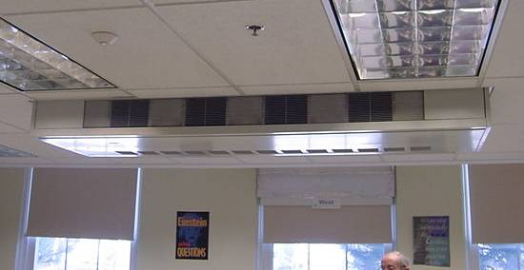

Ceiling-Mounted Univent First Floor

Picture 2

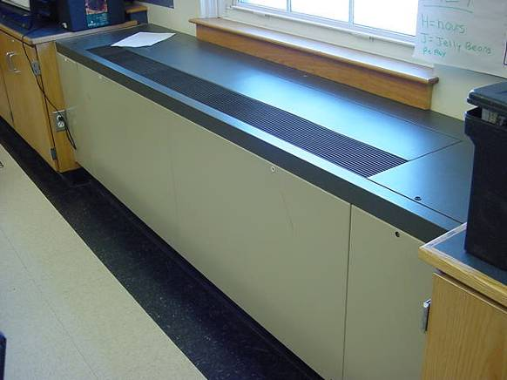

Typical Wall-Mounted Univent

Picture 3

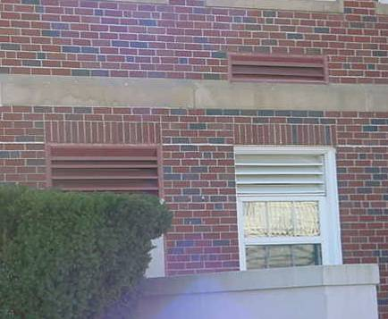

Univent Fresh Air Intakes

Picture 4

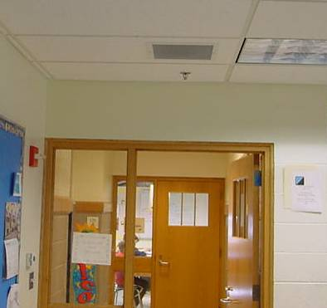

Classroom Exhaust Vent, Note Proximity to Hallway Door
Picture 5

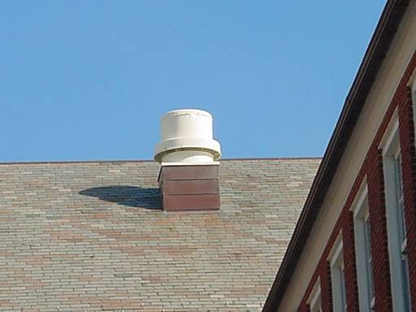

Rooftop Exhaust Motor

Picture 6

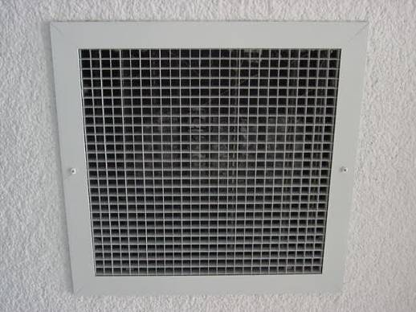

Ceiling-Mounted Exhaust Vent in Classroom 140
Picture 7

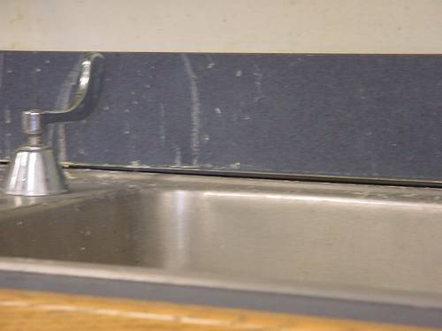

Breach between Sink Countertop and Backsplash

Picture 8

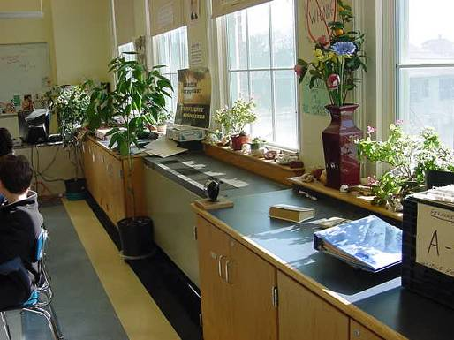

Plants in Classroom
Picture 9

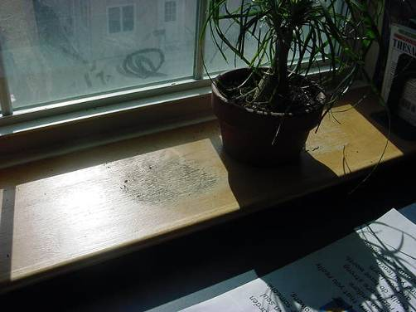

Plant Moved to Show Water Damaged Wooden Windowsill

Picture 10

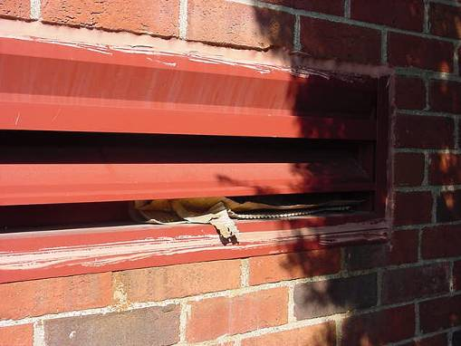

Cardboard Protruding from Univent Fresh Air Intake
Picture 11

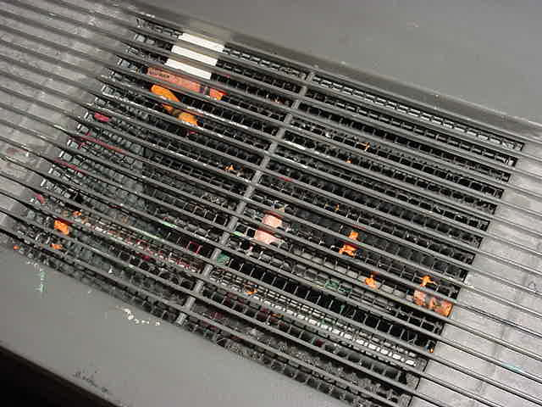

Crayons and Other Debris in Univent Air Diffuser Classroom 224

Picture 12

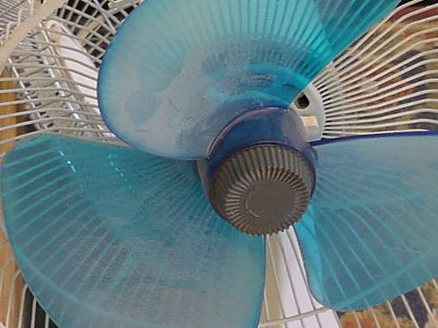

Dust Accumulation on Fan Blades
Location/ Room | Occupants  in Room | Temp  (°F) | Relative  Humidity  (%) | Carbon  Dioxide  (ppm) | Carbon Monoxide  (ppm) | TVOCs  (ppm) | PM2.5  (µg/m3) | Windows  Openable | Ventilation |  | Remarks
 |  |  |  |  |  |  |  |  | Supply | Exhaust | Remarks
background |  | 29 | 27 | 329 | ND | ND | 22 |  |  |  | Clear, sunny, cold, west winds 15-20 mph
129 | 16 | 70 | 21 | 701 | ND | ND | 14 | Y  # open: 0  # total: 3 | Y  univent | Y  ceiling | DEM
126 | 21 | 74 | 21 | 843 | ND | ND | 13 | Y  # open: 0  # total: 3 | Y  univent | Y  ceiling | DEM, plants
135 | 0 | 72 | 16 | 706 | ND | ND | 14 | Y  # open: 0  # total: 7 | Y  univent | Y  ceiling | DO, plants
134 | 22 | 73 | 19 | 922 | ND | ND | 15 | Y  # open: 0  # total: 5 | Y  univent | Y  ceiling | Cleaners, DEM
137 | 14 | 73 | 19 | 960 | ND | ND | 14 | Y  # open: 0  # total: 5 | Y  univent | Y  ceiling | DEM, breach sink/countertop
140 | 16 | 74 | 18 | 842 | ND | ND | 17 | Y  # open: 1  # total: 6 | Y  univent | Y  ceiling | No draw detected from exhaust vent-could not determine if ducted to rooftop motor
Staff Dining | 0 | 74 | 14 | 478 | ND | ND | 19 | Y  # open: 0  # total: 3 | Y  univent | Y  ceiling | Exhaust-no draw, 2 photocopiers, 1 lamination machine, DO
Cafeteria | 5 | 75 | 14 | 495 | ND | ND | 21 | Y  # open: 0  # total: 14 | Y  univent | Y  ceiling | DO
Nurse | 5 | 70 | 16 | 503 | ND | ND | 18 | Y  # open: 0  # total: 3 | Y  univent | Y  ceiling | UV-off
Gym | 20 | 68 | 16 | 542 | ND | ND | 19 | Y  # open: 0  # total: 16 | Y  wall | Y  wall
138 | 6 | 72 | 19 | 952 | ND | ND | 15 | Y  # open: 0  # total: 2 | Y  univent | Y  ceiling | DEM
246 | 16 | 75 | 18 | 660 | ND | ND | 19 | Y  # open: 0  # total: 4 | Y  univent | Y  ceiling
244 | 15 | 74 | 18 | 758 | ND | ND | 19 | Y  # open: 0  # total: 4 | Y  univent | Y  ceiling | DEM, plants, DO
238 | 19 | 73 | 18 | 856 | ND | ND | 19 | Y  # open: 0  # total: 5 | Y  univent | Y  ceiling | UV-obstructed by items
236 | 2 | 74 | 16 | 636 | ND | ND | 14 | Y  # open: 0  # total: 1 | Y  ceiling | Y  ceiling
233 | 18 | 74 | 20 | 986 | ND | ND | 14 | Y  # open: 1  # total: 5 | Y  univent | Y  ceiling | No draw detected from exhaust vent-could not determine if ducted to rooftop motor, plants on paper, DEM, PF, DO
232 | 24 | 75 | 21 | 1508 | ND | ND | 18 | Y  # open: 0  # total: 4 | Y  univent | Y  ceiling | UV-off, exhaust-no draw, DEM
239 | 0 | 75 | 17 | 825 | ND | ND | 16 | Y | Y  univent | Y  ceiling | UV-off, 20 occupants gone approx. 5 mins, DEM
230 | 0 | 73 | 15 | 550 | ND | ND | 21 | N | Y  ceiling | Y  ceiling | Exhaust-no draw, DO
227 | 19 | 74 | 20 | 1203 | ND | ND | 14 | Y  # open: 0  # total: 4 | Y  univent | Y  ceiling | UV-off, DO, DEM
322 | 21 | 73 | 18 | 813 | ND | ND | 16 | Y  # open: 0  # total: 5 | Y  univent | Y  ceiling | DO, DEM
329 | 20 | 75 | 20 | 1005 | ND | ND | 15 | Y | Y  univent | Y  ceiling | DO, DEM, aquarium, plants, 2 CT, plants
228 | 0 | 72 | 17 | 635 | ND | ND | 10 | Y  # open: 0  # total: 1 | Y  ceiling | Y  ceiling | DO, DEM
Main Office | 2 | 73 | 16 | 631 | ND | ND | 12 | Y  # open: 0  # total: 3 | Y  ceiling | Y  ceiling | DO, plants
224 | 1 | 70 | 19 | 1044 | ND | ND | 12 | Y  # open: 0  # total: 6 | Y  univent | Y  ceiling | Crayons/debris in UV, plants, breach sink/countertop
223 | 23 | 71 | 20 | 1070 | ND | ND | 16 | Y  # open: 0  # total: 4 | Y  univent | Y  ceiling | Dust accumulation on exhaust vent
Auditorium | 0 | 72 | 15 | 411 | ND | ND | 9 | Y  # open: 0  # total: 12 | Y  ceiling | Y  wall
306 | 1 | 74 | 18 | 779 | ND | ND | 16 | Y  # open: 0  # total: 3 | Y  univent | Y  ceiling | UV-off, occupants gone approx. 20 mins
307 | 1 | 74 | 16 | 501 | ND | ND | 10 | Y  # open: 0  # total: 1 | Y  univent | Y  ceiling | UV-off
Media Center | 0 | 75 | 17 | 837 | ND | ND | 4 | Y  # open: 0  # total: 16 | Y  ceiling | Y  ceiling
305 | 14 | 74 | 19 | 1229 | ND | ND | 13 | Y  # open: 0  # total: 4 | Y  univent | Y  ceiling | Exhaust-no draw, DEM, DO, cleaners
318 | 21 | 76 | 21 | 1229 | ND | ND | 20 | Y  # open: 0  # total: 5 | Y  univent | Y  ceiling | UV-off, exhaust-no draw, plants
320 | 10 | 76 | 20 | 1220 | ND | ND | 27 | Y  # open: 0  # total: 1 | Y  univent | Y  ceiling | UV-off, exhaust-no draw
323 | 16 | 74 | 18 | 869 | ND | ND | 19 | Y  # open: 0  # total: 7 | Y  univent | Y  ceiling | 1 of 2 UV-on, DO, DEM
327 | 20 | 76 | 20 | 1069 | ND | ND | 17 | Y  # open: 0  # total: 4 | Y  univent | Y  ceiling | UV-reportedly deactivated due to excessive noise/heat, DEM, plants

