INDOOR AIR QUALITY REASSESSMENT

Memorial Middle School
81 Central Ave
Hull, MA 02045



Prepared by:
Massachusetts Department of Public Health
Bureau of Environmental Health
Indoor Air Quality Program
February 2008

Background/Introduction
At the request of David Twombly, Director of Operations, Hull Public Schools (HPS), the Massachusetts Department of Public Health (MDPH) Bureau of Environmental Health (BEH) was asked to conduct a reassessment of the Memorial Middle School (MMS), 81 Central Street, Hull, Massachusetts. The building was previously visited by BEH staff in February 2007 and a report was issued detailing conditions observed at the time of the visit (MDPH, 2007).
On October 29, 2007, Cory Holmes and Sharon Lee, Environmental Analysts in BEH’s Indoor Air Quality (IAQ) Program, visited the MMS to conduct an IAQ assessment. BEH staff were accompanied by David Twombly, Director of Operations and James Griffin, Facilities Manager for portions of the assessment.
The MMS is a three-story red brick building constructed in 1949. The building was completely renovated in 2001-2002. The school consists of general classrooms, science classrooms, gymnasium, auditorium, kitchen/cafeteria, media center, art room, music room, teacher work rooms and office space. Windows are openable throughout the building.

Actions on Previous MDPH Recommendations
As mentioned, MDPH staff had previously visited the building and issued a report with recommendations to improve indoor air quality (MDPH, 2007). A summary of actions taken on previous recommendations is included as Appendix A.

Methods
Air tests for carbon dioxide, carbon monoxide, temperature and relative humidity were conducted with the TSI, Q-TRAK™ IAQ Monitor, Model 8551. Air tests for airborne particulate matter with a diameter less than 2.5 micrometers were taken with the TSI, DUSTTRAK™ Aerosol Monitor Model 8520. Screening for total volatile organic compounds (TVOCs) was conducted using an HNu, Model 102 Snap-on Photo Ionization Detector (PID). BEH staff also performed a visual inspection of building materials for water damage and/or microbial growth.

Results
The MMS houses grades 5 through 8, with a student population of 285 and a staff of approximately 40. Tests were taken under normal operating conditions. Test results appear in Table 1.

Discussion

Ventilation
It can be seen from Table 1 that carbon dioxide levels were elevated above 800 parts per million (ppm) in nine of thirty-five areas, indicating adequate air exchange in the majority of areas surveyed during the assessment. It is important to note however, that several areas with carbon dioxide levels below 800 ppm were sparsely populated, which can greatly reduce carbon dioxide levels. Carbon dioxide levels would be expected to be higher with full occupancy.
Fresh air in exterior classrooms is supplied by unit ventilator (univent) systems. A univent is designed to draw air from outdoors through a fresh air intake located on the exterior wall of the building. Return air is drawn through an air intake located at the base of the unit (Figure 1). Fresh and return air are mixed, filtered, heated and provided to classrooms through an air diffuser located in the top of the unit. Several univents were deactivated during the assessment (Table 1), therefore no mechanical means to introduce fresh air was being provided in these areas. During the last assessment, the univent in room 327 was found deactivated reportedly due to excessive noise and heat; at the time of the reassessment the univent remained on a repair list. The deactivated univent in classroom 140 was reactivated by Mr. Griffin during the current assessment. The univent in classroom 307 was reported by the occupant to be noisy, which may indicate a mechanical issue. As discussed in the previous assessment, in order for univents to provide fresh air as designed, units must be activated and remain free of obstructions.
Exhaust ventilation in classrooms is provided by ceiling-mounted vents powered by rooftop motors. Exhaust vents were operating at the time of assessment. Some exhaust vents are located above hallway doors. When classroom doors are open, exhaust vents tend to draw air from the hallway, thereby reducing the effectiveness of the vents to remove common environmental pollutants from classrooms.
To maximize air exchange, the MDPH recommends that both supply and exhaust ventilation operate continuously during periods of school occupancy. In order to have proper ventilation with a mechanical supply and exhaust system, the systems must be balanced to provide an adequate amount of fresh air to the interior of a room while removing stale air from the room. It is recommended that existing ventilation systems be re-balanced every five years to ensure adequate air systems function (SMACNA, 1994). The date of the last balancing of these systems should have occurred at some point after construction/renovation in 2002.
The Massachusetts Building Code requires a minimum ventilation rate of 15 cubic feet per minute (cfm) per occupant of fresh outside air or have openable windows in each room (SBBRS, 1997; BOCA, 1993). The ventilation must be on at all times that the room is occupied. Providing adequate fresh air ventilation with open windows and maintaining the temperature in the comfort range during the cold weather season is impractical. Mechanical ventilation is usually required to provide adequate fresh air ventilation.
Carbon dioxide is not a problem in and of itself. It is used as an indicator of the adequacy of the fresh air ventilation. As carbon dioxide levels rise, it indicates that the ventilating system is malfunctioning or the design occupancy of the room is being exceeded. When this happens a buildup of common indoor air pollutants can occur, leading to discomfort or health complaints. The Occupational Safety and Health Administration (OSHA) standard for carbon dioxide is 5,000 parts per million parts of air (ppm). Workers may be exposed to this level for 40 hours/week based on a time weighted average (OSHA, 1997).
The MDPH uses a guideline of 800 ppm for publicly occupied buildings. A guideline of 600 ppm or less is preferred in schools due to the fact that the majority of occupants are young and considered to be a more sensitive population in the evaluation of environmental health status. Inadequate ventilation and/or elevated temperatures are major causes of complaints such as respiratory, eye, nose and throat irritation, lethargy and headaches. For more information concerning carbon dioxide, please see Appendix B.
Temperature readings indoors on the day of the assessment ranged from 66 º F to 77 º F, which were below the MDPH comfort guidelines in some of the areas surveyed (Table 1). The MDPH recommends that indoor air temperatures be maintained in a range of 70 º F to 78 º F in order to provide for the comfort of building occupants. In many cases concerning indoor air quality, fluctuations of temperature in occupied spaces are typically experienced, even in a building with an adequate fresh air supply.
The relative humidity measurements ranged from 20 to 36 percent, which were below the MDPH recommended comfort range the day of the assessment. The MDPH recommends a comfort range of 40 to 60 percent for indoor air relative humidity. Relative humidity levels in the building would be expected to drop during the winter months due to heating. The sensation of dryness and irritation is common in a low relative humidity environment. Low relative humidity is a very common problem during the heating season in the northeast part of the United States.

Microbial/Moisture Concerns
Plants were noted in several classrooms; some plants were observed on univents (Pictures 1 and 2). Plants can be a source of pollen and mold, which can be respiratory irritants for some individuals. Plants should be properly maintained and equipped with drip pans to prevent water damage to porous building materials, which can lead to mold growth. Plants should also be located away from ventilation sources (e.g., air intakes, univent diffusers) to prevent the entrainment and/or aerosolization of dirt, pollen or mold.
A number of aquariums and terrariums were observed in classrooms (Picture 3). Aquariums should be properly maintained to prevent microbial/algae growth, which can emit unpleasant odors. Similarly, terrariums should be properly maintained to ensure soil does not become a source for mold growth.
A humidifier was observed in a classroom. As with univents, humidifiers can aerosolize particles and odors. In addition, the water reservoirs can provide a source for mold growth. Water reservoirs for humidifiers should be cleaned as per the manufacturer’s instructions to prevent microbial growth and odors. The air diffuser should also be cleaned periodically to prevent dust collection and aerosolization of materials.

Other IAQ Evaluations
Indoor air quality can be negatively influenced by the presence of respiratory irritants, such as products of combustion. The process of combustion produces a number of pollutants. Common combustion emissions include carbon monoxide, carbon dioxide, water vapor and smoke (fine airborne particle material). Of these materials, exposure to carbon monoxide and particulate matter with a diameter of 2.5 micrometers (μm) or less (PM2.5) can produce immediate, acute health effects upon exposure. To determine whether combustion products were present in the school environment, BEH staff obtained measurements for carbon monoxide and PM2.5.
Carbon monoxide is a by-product of incomplete combustion of organic matter (e.g., gasoline, wood and tobacco). Exposure to carbon monoxide can produce immediate and acute health affects. Several air quality standards have been established to address carbon monoxide and prevent symptoms from exposure to these substances. The MDPH established a corrective action level concerning carbon monoxide in ice skating rinks that use fossil-fueled ice resurfacing equipment. If an operator of an indoor ice rink measures a carbon monoxide level over 30 ppm, taken 20 minutes after resurfacing within a rink, that operator must take actions to reduce carbon monoxide levels (MDPH, 1997).
The American Society of Heating Refrigeration and Air-Conditioning Engineers (ASHRAE) has adopted the National Ambient Air Quality Standards (NAAQS) as one set of criteria for assessing indoor air quality and monitoring of fresh air introduced by HVAC systems (ASHRAE, 1989). The NAAQS are standards established by the US EPA to protect the public health from six criteria pollutants, including carbon monoxide and particulate matter (US EPA, 2006). As recommended by ASHRAE, pollutant levels of fresh air introduced to a building should not exceed the NAAQS levels (ASHRAE, 1989). The NAAQS were adopted by reference in the Building Officials & Code Administrators (BOCA) National Mechanical Code of 1993 (BOCA, 1993), which is now an HVAC standard included in the Massachusetts State Building Code (SBBRS, 1997). According to the NAAQS, carbon monoxide levels in outdoor air should not exceed 9 ppm in an eight-hour average (US EPA, 2006).
Carbon monoxide should not be present in a typical, indoor environment. If it is present, indoor carbon monoxide levels should be less than or equal to outdoor levels. On the day of assessment, outdoor carbon monoxide concentrations were non-detect (ND). Carbon monoxide levels measured in the school were also ND (Table 1).
The US EPA has established NAAQS limits for exposure to particulate matter. Particulate matter is airborne solids that can be irritating to the eyes, nose and throat. The NAAQS originally established exposure limits to particulate matter with a diameter of 10 μm or less (PM10). According to the NAAQS, PM10 levels should not exceed 150 microgram per cubic meter (μg/m³) in a 24-hour average (US EPA, 2006). These standards were adopted by both ASHRAE and BOCA. Since the issuance of the ASHRAE standard and BOCA Code, US EPA proposed a more protective standard for fine airborne particles. This more stringent PM2.5 standard requires outdoor air particle levels be maintained below 35 μg/m³ over a 24-hour average (US EPA, 2006). Although both the ASHRAE standard and BOCA Code adopted the PM10 standard for evaluating air quality, MDPH uses the more protective proposed PM2.5 standard for evaluating airborne particulate matter concentrations in the indoor environment.
Outdoor PM2.5 concentrations were measured at 5 μg/m³ (Table 1). PM2.5 levels measured indoors ranged from 1 to 11 μg/m³ (Table 1). PM2.5 measurements were above background in several areas but below the NAAQS of 35 μg/m³. Frequently, indoor air levels of particulates (including PM2.5) can be at higher levels than those measured outdoors. A number of mechanical devices and/or activities that occur in schools can generate particulate during normal operations. Sources of indoor airborne particulates may include but are not limited to particles generated during the operation of fan belts in the HVAC system, cooking in the cafeteria stoves and microwave ovens; use of photocopiers, fax machines and computer printing devices; operation of an ordinary vacuum cleaner and heavy foot traffic indoors.
Indoor air quality can also be impacted by the presence of materials containing volatile organic compounds (VOCs). VOCs are substances that have the ability to evaporate at room temperature. Frequently, exposure to low levels of total VOCs (TVOCs) may produce eye, nose, throat and/or respiratory irritation in some sensitive individuals. For example, chemicals evaporating from a paint can stored at room temperature would most likely contain VOCs. In an effort to determine whether VOCs were present in the building, air monitoring for TVOCs was conducted. Outdoor air samples were taken for comparison. Outdoor TVOC concentrations were ND (Table 1). Indoor TVOC measurements throughout the building were also ND (Table 1).
Please note, that the TVOC air measurements are only reflective of the indoor air concentrations present at the time of sampling. Indoor air concentrations can be greatly impacted by the use TVOC containing products (e.g., the concentration of TVOCs within a classroom increases when the product is in use). Dry erase markers were seen in several classrooms. Materials such as dry erase markers and dry erase board cleaners may contain VOCs, (e.g., methyl isobutyl ketone, n-butyl acetate and butyl-cellusolve) (Sanford, 1999). Cleaning products were found under sinks and on countertops in some classrooms (Picture 4). Like dry erase materials, cleaning products contain VOCs and other chemicals that can be irritating to the eyes, nose and throat of sensitive individuals. In addition, staff should use cleaners supplied by the HPS to prevent production of odors/materials from incompatible cleaners (i.e. bleach and ammonia).
Several other conditions that can affect indoor air quality were noted during the assessment. Of concern is the present use of the science prep room. At the time of assessment, BEH staff observed chemicals, dyes, cleaners, and paper and food products stored in the flammable and chemical cabinets (Pictures 5 to 11). These cabinets should be used for storage of science-related flammables/chemicals only; paper and food products should be not be stored in these cabinets. In addition, chemicals stored in these cabinets should be labeled. Similarly, the chemical hood should not be used to store paper products (Picture 12). In addition, the science prep room should be used for preparation of science-related projects, rather than for food preparation (Picture 13). Preparing food in the science prep room may result in cross-contamination and food is also a pest attractant.
Lastly, the sink in the science prep room is connected to a wastewater neutralization system. The system is designed for neutralizing acidic and caustic solutions and should not be used for other purposes (i.e., dish washing, food disposal) as this could result in the introduction of solid particles. Disposal of solid materials (i.e., food) can damage the neutralization system.
In some classrooms, excess items were observed on windowsills, tabletops, counters, bookcases and desks (Picture 14). The large number of items stored in classrooms provides a source for dusts to accumulate. These items (e.g., papers, folders, boxes) also make it difficult for custodial staff to clean. Items should be relocated and/or be cleaned periodically to avoid excessive dust build up.
A number of supply, exhaust/return vents and personal fans had accumulated dust (Picture 15). If exhaust vents are not functioning, backdrafting can occur, which can re-aerosolize dust particles. In addition, these materials can accumulate on flat surfaces (e.g., desktops, shelving and carpets) in occupied areas and subsequently be re-aerosolized causing further irritation. Dust can be irritating to eyes, nose and the respiratory tract.
Missing, damaged, broken and ajar ceiling tiles were observed in some areas (Table 1). Breaches in the ceiling tile system can provide pathways for dust, dirt, odors and other pollutants to move into occupied areas.
Upholstered cushions/pillows) was observed in a few areas (Picture 16). These upholstered items are covered with fabric that comes in contact with human skin, which can leave oils, perspiration, hair and skin cells. Dust mites feed upon human skin cells and excrete waste products that contain allergens. Furthermore, increased relative humidity levels above 60 percent can also perpetuate dust mite proliferation (US EPA, 1992). In order to remove dust mites and other pollutants, frequent vacuuming of upholstered furniture is recommended (Berry, 1994). Since these items are placed on the floor, they are likely to collect dust. It is also recommended that upholstered furniture present in schools be professionally cleaned on an annual basis or every six months if dusty conditions exist (IICRC, 2000).
Lastly, an air purifier was observed on the floor of a classroom (Picture 17). This equipment is normally equipped with filters that should be cleaned or changed as per manufacturer’s instructions to prevent build up and re-aerosolization of dirt, dust and particulate matter. In addition, air purifiers should be placed within the breathing zone rather than at floor level.

Conclusions/Recommendations
HPS officials, working in conjunction with faculty members and school maintenance staff, have improved indoor environmental conditions in the building by implementing the majority of BEH’s previous recommendations. In view of the findings at the time of the reassessment, the following additional recommendations are made to further improve indoor air quality:
- Continue with plans for repairing univent in classroom 327.
- Examine univent in classroom 307 for noise/temperature control issues and make repairs as needed.
- Use openable windows in conjunction with mechanical ventilation to facilitate air exchange. Care should be taken to ensure windows are properly closed at night and weekends to avoid the freezing of pipes and potential flooding.
- Remove all blockages from univents to ensure adequate airflow.
- For buildings in New England, periods of low relative humidity during the winter are often unavoidable. Therefore, scrupulous cleaning practices should be adopted to minimize common indoor air contaminants whose irritant effects can be enhanced when the relative humidity is low. To control for dusts, a high efficiency particulate arrestance (HEPA) filter equipped vacuum cleaner in conjunction with wet wiping of all surfaces is recommended. Avoid the use of feather dusters. Drinking water during the day can help ease some symptoms associated with a dry environment (throat and sinus irritations).
- Ensure plants have drip pans. Examine drip pans periodically for mold growth and disinfect with an appropriate antimicrobial where necessary. Keep plants away from the air stream of univents.
- Ensure the humidifiers and their water reservoirs are cleaned periodically to prevent mold growth and aerosolization of materials.
- Relocate or consider reducing the amount of materials stored in classrooms to allow for more thorough cleaning. Clean items regularly with a wet cloth or sponge to prevent excessive dust build-up.
- Clean accumulated dust and debris from the interior of univent air diffusers, exhaust vents and blades of personal fans.
- Store cleaning products properly and out of reach of students.
- Use the neutralization sink system appropriately (i.e., for disposal of acidic/basic solutions).
- Conduct a chemical inventory in all chemical storage areas and science classrooms. Discard hazardous materials or empty containers of hazardous materials in a manner consistent with environmental statutes and regulations. Follow proper procedures for storing and securing hazardous materials. Obtain Material Safety Data Sheets (MSDS’) for chemicals from manufacturers or suppliers.
- Refrain from using the science prep room for non-science related purposes.
- Clean upholstered cushions and pillows on the schedule recommended in this report. If not possible/practical consider removal.
- Clean chalk and dry erase board trays to prevent accumulation of materials.
- Consider adopting the US EPA (2000) document, “Tools for Schools”, to maintain a good indoor air quality environment on the building. This document can be downloaded from the Internet at: http://www.epa.gov/iaq/schools/index.html.
- Refer to resource manuals and other related indoor air quality documents for further building-wide evaluations and advice on maintaining public buildings. Copies of these materials are located on the MDPH’s website: http://mass.gov/dph/indoor_air

References
ASHRAE. 1989. Ventilation for Acceptable Indoor Air Quality. American Society of Heating, Refrigeration and Air Conditioning Engineers. ANSI/ASHRAE 62-1989
Berry, M.A. 1994. Protecting the Built Environment: Cleaning for Health, Michael A. Berry, Chapel Hill, NC.
BOCA. 1993. The BOCA National Mechanical Code/1993. 8th ed. Building Officials & Code Administrators International, Inc., Country Club Hills, IL.
IICRC. 2000. IICRC S001 Reference Guideline for Professional On-Location Cleaning of Textile Floor Covering Materials Institute of Inspection, Cleaning and Restoration Certification. Institute of Inspection Cleaning and Restoration, Vancouver, WA.

MDPH. 2007. Indoor Air Quality Assessment, Memorial Middle School, Hull, Massachusetts. Massachusetts Department of Public Health, Center for Environmental Health, Boston, MA.
MDPH. 1997. Requirements to Maintain Air Quality in Indoor Skating Rinks (State Sanitary Code, Chapter XI). 105 CMR 675.000. Massachusetts Department of Public Health, Boston, MA.
OSHA. 1997. Limits for Air Contaminants. Occupational Safety and Health Administration. Code of Federal Regulations. 29 C.F.R 1910.1000 Table Z-1-A.
Sanford. 1999. Material Safety Data Sheet (MSDS No: 198-17). Expo® Dry Erase Markers Bullet, Chisel, and Ultra Fine Tip. Sanford Corporation, Bellwood, IL.
SBBRS. 1997. Mechanical Ventilation. State Board of Building Regulations and Standards. Code of Massachusetts Regulations. 780 CMR 1209.0.
SMACNA. 1994. HVAC Systems Commissioning Manual. 1st ed. Sheet Metal and Air Conditioning Contractors’ National Association, Inc., Chantilly, VA.
US EPA. 2006. National Ambient Air Quality Standards (NAAQS). . US Environmental Protection Agency, Office of Air Quality Planning and Standards, Washington, DC. http://www.epa.gov/air/criteria.html.
US EPA. 2001. “Mold Remediation in Schools and Commercial Buildings”. Office of Air and Radiation, Indoor Environments Division, Washington, DC. EPA 402-K-01-001. March 2001. Available at: http://www.epa.gov/iaq/molds/mold_remediation.html
US EPA. 2000. Tools for Schools. Office of Air and Radiation, Office of Radiation and Indoor Air, Indoor Environments Division (6609J). EPA 402-K-95-001, Second Edition. http://www.epa.gov/iaq/schools/tools4s2.html
US EPA. 1992. Indoor Biological Pollutants. US Environmental Protection Agency, Environmental Criteria and Assessment Office, Office of Health and Environmental Assessment, research Triangle Park, NC. EPA 600/8-91/202 January 1992.
Picture 1

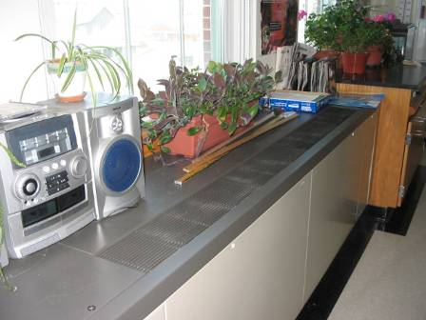

Plants and items on univent

Picture 2

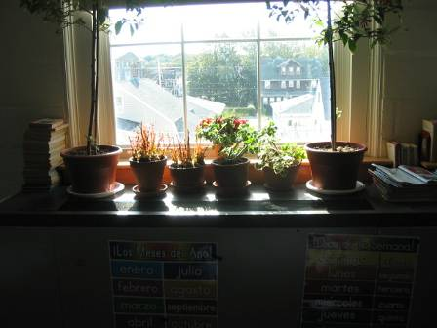

Plants and items on univent
Picture 3

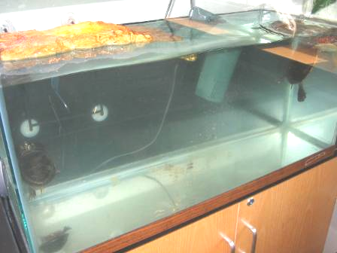

Aquarium

Picture 4

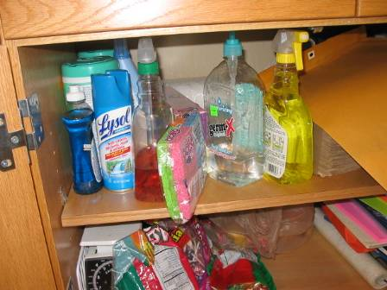

Cleaners

Picture 5

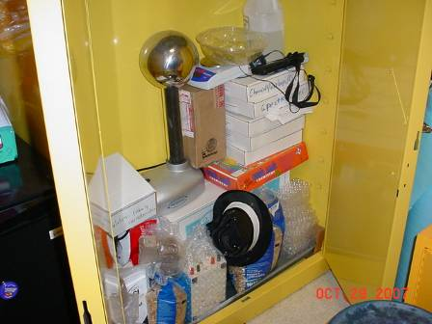

Flammable cabinet used for storage of items

Picture 6

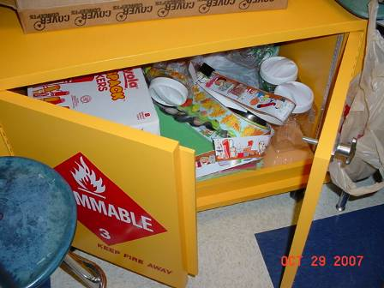

Flammable cabinet used for storage of items

Picture 7

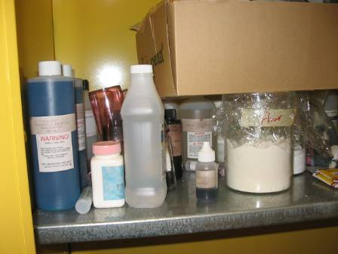

Chemical cabinet used for mixed storage

Picture 8

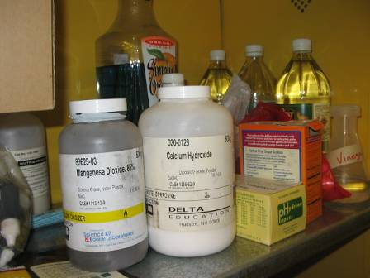

Chemical cabinet used for mixed storage

Picture 9

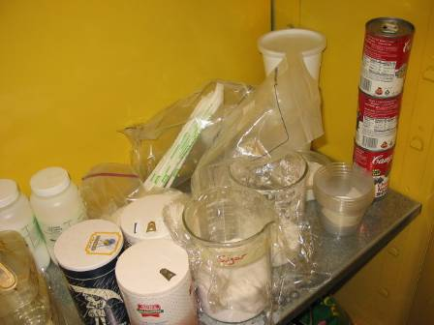

Chemical cabinet used for mixed storage

Picture 10

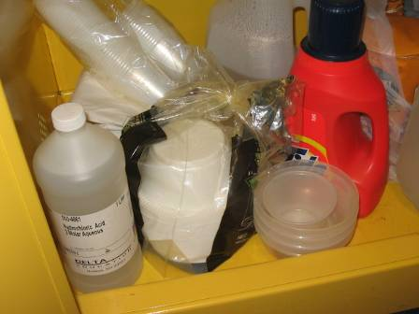

Chemical cabinet used for mixed storage

Picture 11

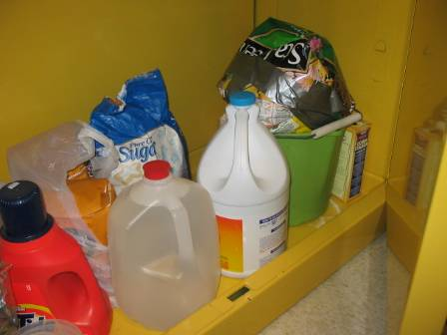

Chemical cabinet used for mixed storage

Picture 12

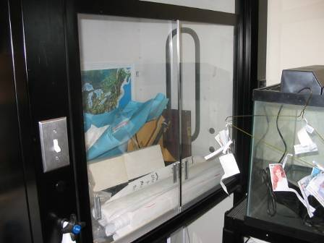

Paper products stored in chemical hood

Picture 13

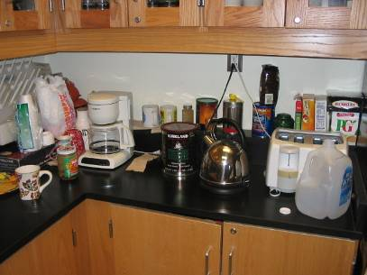

Food/kitchen appliances in chemical prep room

Picture 14

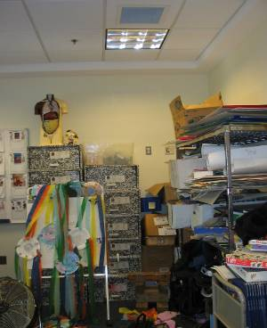

Materials in classroom

Picture 15

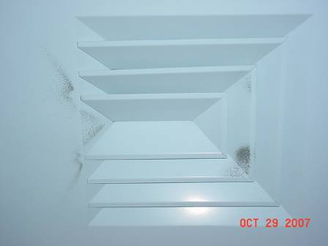

Dust on supply vent due to static charge

Picture 16

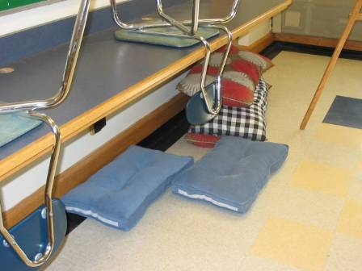

Pillows/cushions on a classroom floor
Picture 17

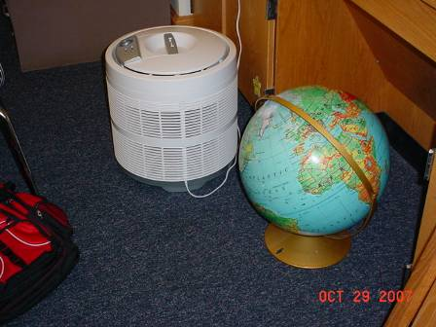

Air purifier on floor

Location/ Room | Occupants  in Room | Temp  (°F) | Relative  Humidity  (%) | Carbon  Dioxide  (ppm) | Carbon Monoxide  (ppm) | TVOCs  (ppm) | PM2.5  (µg/m3) | Windows  Openable | Ventilation |  | Remarks
 |  |  |  |  |  |  |  |  | Supply | Exhaust | Remarks
background |  | 50 | 35 |  | ND | ND | 5 |  |  |  | Cold, breezy
Auditorium | 0 | 71 | 22 | 447 | ND | ND | 1 | Y | Y | Y | ceiling supply - dusty
Boys lock room | 0 | 70 | 27 | 522 | ND | ND | 4 | Y | Y | Y
Cafeteria | 90 | 67 | 21 | 628 | ND | ND | 11 | N | Y | Y | DO
Girls locker room | 0 | 67 | 21 | 419
Gym | 0 | 66 | 21 | 452 | ND | ND | 4 | Y | Y | Y | Ceiling fan on
Media center | 2 | 74 | 28 | 549 | ND | ND | 2 | Y  Open | Y | Y | plants
Science storage room |  |  |  |  |  |  |  |  |  |  | Fume hood used for storage, chemical closet used for paper storage, kitchen appliances and food, reported odors from sink
114 | 0 | 68 | 21 | 399 | ND | ND | 6 | Y | 0/2 | Y | Y
115 | 0 | 69 | 36 | 628 | ND | ND | 5 | Y | Y | Y | DO
126 | 15 | 72 | 27 | 789 | ND | ND | 7 | Y | Y | Y
140 | 17 | 70 | 31 | 818 | ND | ND | 6 | Y | Y | Y | UV - off (reactivated by James Griffin); 14 occupants left for lunch,
213 | 0 | 71 | 24 | 484 | ND | ND | 3 | N | Y | N
223 | 19 | 74 | 28 | 842 | ND | ND | 4 | Y | Y | Y | DEM, humidifier
224 | 1 | 71 | 29 | 862 | ND | ND | 4 | Y | Y | Y | 16 occupants left 20 min prior to assessment
226 | 0 | 71 | 24 | 572 | ND | ND | 3 | N | Y | Y
227 | 19 | 71 | 30 | 789 | ND | ND | 5 | Y | Y | Y | DEM
228 | 0 | 72 | 23 | 484 | ND | ND | 6 | Y | Y | Y | DEM
230 | 0 | 72 | 21 | 486 | ND | ND | 6 | N | Y | Y
232 | 0 | 72 | 24 | 564 | ND | ND | 7 | Y | Y | Y | DEM, cleaners
233 | 21 | 71 | 22 | 883 | ND | ND | 6 | Y  2/5 open | Y | Y | VL, items, DO, DEM
236 | 0 | 73 | 21 | 588 | ND | ND | 5 | Y | Y | Y | DEM
238 | 21 | 73 | 20 | 640 | ND | ND | 7 | Y  2/5 open | Y | Y | DEM, clutter
239 | 21 | 75 | 27 | 878 | ND | ND | 8 | Y | Y | Y | DEM, PF, clutter, items on univent
244 | 18 | 74 | 23 | 725 | ND | ND | 10 | Y | Y | Y | DO, hanging plant
246 | 18 | 74 | 23 | 708 | ND | ND | 7 | Y  2/3 open | Y | Y | DEM,
305 | 9 | 72 | 31 | 669 | ND | ND | 4 | Y | Y | Y | DEM
306 | 16 | 77 | 34 | 760 | ND | ND | 4 | Y | Y | Y | DEM, 1 broken CT
307 | 10 | 74 | 27 | 655 | ND | ND | 3 | Y | Y | Y | UV - noise, DO, PF
312 | 20 | 75 | 26 | 980 | ND | ND | 4 | Y | Y | Y
313 | 0 | 71 | 24 | 501 | ND | ND | 2 | Y | Y | Y
318 | 21 | 71 | 25 | 781 | ND | ND | 9 | Y | Y | Y | DO, DEM, PF, VL
320 | 3 | 71 | 23 | 627 | ND | ND | 7 | Y | Y | Y | Items on univent
322 | 18 | 71 | 23 | 825 | ND | ND | 8 | Y | Y | Y | DO, aqua
323 | 7 | 71 | 24 | 641 | ND | ND | 7 | Y | Y | Y | DEM, plants on univent
327 | 8 | 73 | 26 | 826 | ND | ND | 7 | Y | Y  off | Y | UV - rattling/noise (on repair list), plants
329 | 19 | 71 | 24 | 874 | ND | ND | 8 | Y | Y | Y | DEM, aqua/terra, plants, plants on univent

Hull School Department Actions on MDPH Recommendations

The following is a status report of action(s) taken on MDPH recommendations (in bold) based on a report from Hull Public Schools (HPS) and BEH staff observations.
- Operate all ventilation systems throughout the building (e.g., gym, auditorium, classrooms) continuously during periods of school occupancy independent of thermostat control to maximize air exchange.
Action: A memo was sent to faculty and staff instructing them to operate univents at all times throughout the school year; however some univents were deactivated at the time of the October 2007 assessment.
- Examine univent in classroom 327 for noise/temperature control issues and make repairs as needed.
Action: HPS had contacted their HVAC vendor for repairs; however, the univent was still a repair list at the time of reassessment.
- Use openable windows in conjunction with mechanical ventilation to facilitate air exchange. Care should be taken to ensure windows are properly closed at night and weekends to avoid the freezing of pipes and potential flooding.
Action: HPS identified six windows that were not operational. Repairs were made during the summer months. Facilities will work with faculty and staff to ensure that windows are properly closed at night.
- Remove all blockages from univents to ensure adequate airflow.
Action: A memo was sent to faculty and staff instructing removal of all materials from the top of univents. At the time of the BEH reassessment, items were observed on top of some univents.

- Inspect exhaust motors and belts for proper function, repair and replace as necessary.
Action: The HPS HVAC vendor inspected exhaust motors and replaced a coupler, repaired the univent in classroom 306 and installed a new coil in classroom 323.
- Examine ceiling-mounted exhaust vent in classroom 140 (and similar vents), to determine if they are ducted to rooftop motors. If not, consider attaching to provide mechanical exhaust ventilation.
Action: According to reports by HPS, a new attic in-line exhaust system was installed, the motor starter contactor as well as the actuator for control valves were replaced and new ductwork and a second motor for the rooftop unit was installed.
- Reactivate local exhaust ventilation in staff dining room to help reduce excess heat/odors from photocopiers and lamination machine.
Action: New ductwork was installed and rooftop motors were replaced.
- For buildings in New England, periods of low relative humidity during the winter are often unavoidable. Therefore, scrupulous cleaning practices should be adopted to minimize common indoor air contaminants whose irritant effects can be enhanced when the relative humidity is low. To control for dusts, a high efficiency particulate arrestance (HEPA) filter equipped vacuum cleaner in conjunction with wet wiping of all surfaces is recommended. Avoid the use of feather dusters. Drinking water during the day can help ease some symptoms associated with a dry environment (throat and sinus irritations).
Action: The HPS will continue to use vacuums with HEPA air filters.
- Isolate and repair water leaks and replace water-damaged ceiling tiles. Examine above and around these areas for mold growth. Disinfect areas of water leaks with an appropriate antimicrobial. Building occupants should report any roof leaks or other signs of water penetration to school maintenance staff for remediation.
Action: HPS contacted a roofing contractor, who replaced approximately 50 roof slates at the rear of the building. HPS will replace ceiling tiles through the building as needed.
- Ensure plants have drip pans. Examine drip pans periodically for mold growth and disinfect with an appropriate antimicrobial where necessary. Keep plants away from the air stream of univents.
Action: HPS sent a memo to all faculty ad staff regarding the removal and upkeep of plants and drip pans in classrooms. More work is needed in this area.
- Seal areas between sink countertops and backsplashes to prevent water-damage to the interior of cabinets and adjacent wallboard.
Action: Custodial staff sealed breaches between the sink backsplash and countertop over the summer.
- Ensure cardboard material shown in Picture 10 is removed from univent fresh air intake.
Action: Cardboard had been removed from the univent’s fresh air intake.
- Relocate or consider reducing the amount of materials stored in classrooms to allow for more thorough cleaning. Clean items regularly with a wet cloth or sponge to prevent excessive dust build-up.
Action: HPS staff sent a memo notifying staff to reduce the amount of materials in classrooms. More work is needed in this area.
- Clean accumulated dust and debris from the interior of univent air diffusers, exhaust vents and blades of personal fans.
Action: HPS reported that custodians will periodically dust fan blades, exhaust vents and univents. At the time of assessment, dust was observed on some univents and supply and exhaust vents.
- Store cleaning products properly and out of reach of students.
Action: HPS will work with faculty and staff to ensure that cleaning products are stored properly and out of reach of students. Copies of material safety data sheets for cleaning products provided by the HPS would be maintained through the HPS. At the time of assessment, BEH observed a number of cleaners under sinks.

