INDOOR AIR QUALITY ASSESSMENT

Memorial Middle School
615 Rollstone Street
Fitchburg, MA

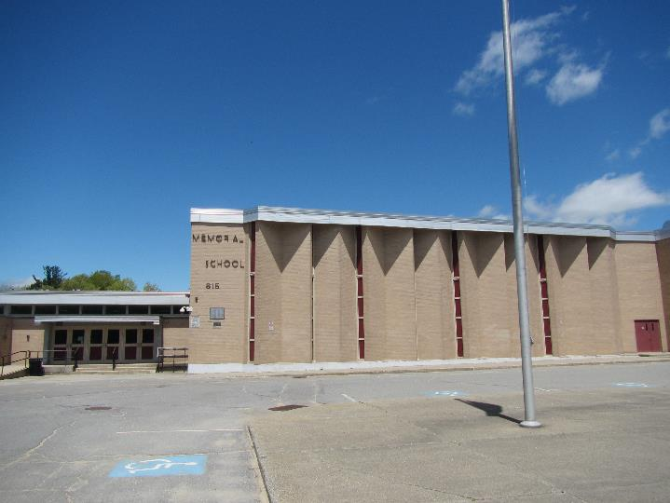

Prepared by:
Massachusetts Department of Public Health
Bureau of Environmental Health
Indoor Air Quality Program
June 2019

Background

Building: | Memorial Middle School (MMS)
Address: | 615 Rollstone St, Fitchburg, MA
Assessment Requested by: | Robert M. Jokela  Acting Superintendent  Fitchburg Public Schools
Reason for Request: | General indoor air quality (IAQ)
Date of Assessment: | May 21, 2019
Massachusetts Department of Public Health/Bureau of Environmental Health (MDPH/BEH) Staff Conducting Assessment: | Jason Dustin, Environmental Analyst/Inspector, IAQ Program
Building Description: | The MMS is a brick and concrete structure originally built in 1967 with renovations in 1993. The school contains general classrooms, science classrooms, art classrooms, a gym, a cafeteria, a library and offices. Two temporary modular classrooms were added approximately 15 years ago.
Building Population: | Approximately 700 total students and staff
Windows: | Most windows are openable

This building has been visited in the past by the IAQ program. Reports from previous visits are available on request.

IAQ Testing Results
Please refer to the IAQ Manual for methods, sampling procedures, and interpretation of results (MDPH, 2015). The following is a summary of indoor air testing results (Table 1).
- Carbon dioxide levels were above the MDPH guideline of 800 parts per million (ppm) in the majority of the rooms tested, indicating inadequate air exchange in the majority of the building.
- Temperature was within the MDPH recommended range of 70°F to 78°F the day of the assessment, however many occupants expressed temperature complaints.
- Relative humidity was within or close to the lower end of the MDPH recommended range of 40 to 60% in all areas the day of assessment.
- Carbon monoxide levels were non-detectable (ND) in all areas tested.
- Fine particulate matter (PM2.5) concentrations measured were below the National Ambient Air Quality (NAAQS) limit of 35 μg/m³ in all areas tested.

Ventilation
A heating, ventilating and air conditioning (HVAC) system has several functions. First it provides heating and, if equipped, cooling. Second, it is a source of fresh air. Finally, an HVAC system will dilute and remove normally occurring indoor environmental pollutants by not only introducing fresh air, but by filtering the airstream and ejecting stale air to the outdoors via exhaust ventilation. Even if an HVAC system is operating as designed, point sources of respiratory irritation may exist and cause symptoms in sensitive individuals.
Fresh air to classrooms along exterior walls is supplied by unit ventilator (univent) systems (Picture 1). A univent draws air from the outdoors through a fresh air intake located on the exterior wall of the building. Return air from the classroom is drawn through an air intake located at the base of the unit (Figure 1). Fresh and return air are mixed, filtered, heated and provided to classrooms through an air diffuser located in the top of the unit. Univents were found deactivated in many rooms in the school at the time of the assessment. Some univents were also found obstructed by furniture and other items on top of air diffusers and/or in front of return vents along the bottom of the units (Picture 2). In order for univents to provide fresh air as designed, they must remain “on” and operating while rooms are occupied. Furthermore, units must remain free of obstructions.
Some occupants complained about excessive heat during the heating season. It was reported by facilities staff that, although the univents are original to the building, new computer controls were recently installed. However, it was further reported that there has been difficulty in adequately controlling temperature in the comfort range with this configuration. Temperature can greatly affect occupant comfort and perception of indoor air quality within the building.
Exhaust ventilation in classrooms with univents is provided by either unit exhaust ventilators or wall- or ceiling-mounted exhaust vents ducted to rooftop motors. While similar in appearance to a univent, unit exhaust ventilators lack a fresh air supply on the top of the unit and are designed to draw air directly to the outside of a building (Picture 3). Some wall-mounted exhaust vents were blocked at the time of assessment and many were found off/not drawing air (Table 1). As with supply ventilation, exhaust ventilation must be free of blockages and allowed to operate continuously while the building is occupied.
Note that the univents and unit exhausts are original equipment, and therefore greater than 40 years old. Function of equipment of this age is difficult to maintain, since compatible replacement parts are often unavailable. According to the American Society of Heating, Refrigeration and Air-Conditioning Engineers (ASHRAE), the service life for a unit heater, hot water or steam is 20 years, assuming routine maintenance of the equipment (ASHRAE, 1991). Despite repeated attempts to maintain these units, the operational lifespan of the equipment has been exceeded. Maintaining the balance of fresh air to exhaust air as well as controlling temperature becomes more difficult as the equipment ages and as replacement parts become increasingly difficult to obtain.
Mechanical ventilation for interior classrooms and common areas (e.g., auditorium, gymnasium) is provided by rooftop air-handling units (AHUs). Fresh air is distributed via ceiling or wall-mounted air diffusers (Picture 4) and ducted back to AHUs via ceiling or wall-mounted return vents. In many rooms exhaust vents are located near hallway doors, which are generally left open. However, with the hallway doors open the exhaust vent will tend to draw air from the hallway into the classroom, instead of drawing stale air from the classroom. Therefore it is recommended that classroom doors remain shut while exhaust vents are operating to function as designed. Many of the supply/exhaust vents and nearby ceiling tiles were dusty (Picture 5). Also, many of the AHU supply/exhaust vents were noted to be off. This is an indication that they are only activated by temperature and therefore do not supply fresh air ventilation or remove stale air until the thermostat calls for heat/cooling. This is a problem especially for interior classrooms with no windows and during the swing seasons of spring and fall when thermostats may not be calling for heat/cooling. Lack of continuous ventilation will lead to increased IAQ complaints.
In order to have proper ventilation with a mechanical supply and exhaust system, these systems must be balanced to provide an adequate amount of fresh air while removing stale air from a room. It is recommended that existing ventilation systems be re-balanced every five years to ensure adequate air systems function (SMACNA, 1994). As mentioned previously, due to the age of the HVAC equipment, balancing the ventilation would be difficult.

Microbial/Moisture Concerns
Water-damaged ceiling tiles were observed in some areas (Pictures 6 and 7; Table 1), which indicate leaks from the building envelope or plumbing system. Stained tiles should be discarded and replaced. Until building envelope leaks can be repaired, occupants are advised not to store/place items in areas where leaks occur and to report any leaks or water infiltration promptly.
Indoor plants were observed in a few areas (Table 1). Plants can be a source of pollen and mold, which can be respiratory irritants to some individuals. Plants should be properly maintained, equipped with non-porous drip pans, and should be located away from air diffusers to prevent the aerosolization of dirt, pollen and mold.
BEH staff noted gaps under exterior doors where light could be seen penetrating (Picture 8). This indicates that these doors need to be fitted with tighter fitting weather stripping/door sweeps to prevent moisture, pests, and unconditioned air from infiltrating occupied areas.

Other IAQ Evaluations
Exposure to low levels of total volatile organic compounds (TVOCs) may produce eye, nose, throat, and/or respiratory irritation in some sensitive individuals. To determine if VOCs were present, BEH/IAQ staff examined rooms for products containing VOCs. BEH/IAQ staff noted hand sanitizers, scented cleaners, air fresheners, and dry erase materials in use within the building (Picture 9). All of these products have the potential to be irritants to the eyes, nose, throat, and respiratory system of sensitive individuals (e.g., asthmatics).
Univent cabinets, intakes and diffusers should be vacuumed out each time the filter is changed to remove dust and debris. Filters for univents and AHUs should be changed regularly, two to four times a year. The MDPH recommends using pleated filters of Minimum Efficiency Reporting Value (MERV) of 8, which are adequate in filtering out pollen and mold spores (ASHRAE, 2012), if these can be used with current equipment.
In many areas, accumulated items including books, papers, and decorative items were observed on floors, windowsills, tabletops, counters, bookcases, and desks. Excess items on surfaces can make it more difficult for custodial staff to clean. Items should be stored neatly (e.g., shelves, totes) and moved periodically to allow wet wiping of surfaces.
Some areas of the school have carpeting. Many areas of carpeting appeared worn, soiled, and water-damaged (Pictures 10 and 11). It should be noted that the usable life of carpeting in schools is approximately 10-11 years (IICRC, 2002). Aging carpet can produce fibers that can be irritating to the respiratory system and is difficult to clean. Carpets should be cleaned annually (or semi-annually in soiled/high traffic areas) in accordance with Institute of Inspection, Cleaning and Restoration Certification (IICRC) recommendations, (IICRC, 2012). Regular cleaning with a high efficiency particulate air (HEPA) filtered vacuum in combination with an annual cleaning will help to reduce accumulation and potential aerosolization of materials from carpeting.
It is important to note that due to the age of the building, asbestos-containing materials (ACM) may be present. Ensure the school is in compliance with the Asbestos Hazard Emergency Response Act (AHERA), which requires inspection of asbestos containing materials every three years as well as a semi-annual walkthrough to determine current conditions of asbestos-containing materials.
Note that the Environmental Protection Agency (EPA) conducted a National School Radon Survey in which it discovered nearly one in five schools had “…at least one frequently occupied ground contact room with short-term radon levels above 4 [picocuries per liter] pCi/L” (US EPA 1993). The BEH/IAQ Program therefore recommends that every school be tested for radon, and that this testing be conducted during the heating season while school is in session in a manner consistent with USEPA radon testing guidelines. Radon measurement specialists and other information can be found at www.nrsb.org and http://aarst-nrpp.com/wp, with additional information at: http://www.mass.gov/eohhs/gov/departments/dph/programs/environmental-health/exposure-topics/iaq/radon.

Conclusions/Recommendations
Based on the observations made during the visit, the following is recommended:
- Consult with an HVAC contractor to troubleshoot heating control issues for unit ventilators to reduce excessive heat complaints and increase fresh air flow.
- Operate all supply and exhaust ventilation equipment continuously during occupied hours.
- Inspect AHU units to ensure that the fresh air intake louvres are opened sufficiently to provide for sufficient ventilation. Ensure thermostats are set to “fan on” rather than “auto” to provide for continuous ventilation especially to interior rooms and during spring and fall swing seasons.
- Remove items and furniture blocking univents, unit exhausts and exhaust vents.
- Use openable windows to supplement fresh air during temperate weather. Ensure all windows are tightly closed at the end of the day.
- Check return and exhaust vents for draw periodically and repair any non-operating motors/vents.
- Ensure filters for univents and AHUs are changed a minimum of twice a year, or more often if possible. Vacuum out univent and AHU cabinets during filter changes to remove dust and debris. The MDPH recommends using pleated filters of Minimum Efficiency Reporting Value (MERV) of 8, which are adequate in filtering out pollen and mold spores (ASHRAE, 2012), if these can be used with current equipment.
- In rooms where exhaust ventilation is located near doors, close the door to allow for designed airflow from the room.
- Ensure there is a method for staff to report issues with temperature control, malfunctioning ventilation equipment, leaks and other building related concerns to facilities staff. This should include a tracking method to ensure follow-up and communication back to the reporter regarding the status of issues.
- Consider adopting a balancing schedule of every 5 years for all mechanical ventilation systems, as recommended by ventilation industrial standards (SMACNA, 1994).
- Ensure any roof and plumbing leaks are repaired promptly and replace any water-damaged ceiling tiles or other porous building materials.
- Avoid storing any items, particularly porous items in areas with known leaks.
- Properly maintain plants, including drip pans, to prevent water damage to porous materials. Plants should also be located away from air diffusers to prevent the aerosolization of dirt, pollen, and mold.
- Repair or replace weather-stripping/door sweeps on doors with gaps.
- Reduce the use of products and equipment that contain VOCs and eliminate the use of scented products such as air fresheners, reed diffusers and similar products. Ensure only school-supplied cleaning products are used in the building and that they are used in accordance with package instructions, including any need for dilution or ventilation.
- Regularly clean supply/return/exhaust vents to avoid aerosolizing accumulated particulate matter.
- Consider reducing the amount of items stored in rooms to make cleaning easier. Periodically move items to clean flat surfaces. Store porous items on shelving and away from walls.
- Remove or replace any worn, soiled or water-damaged carpeting.
- HEPA vacuum remaining carpeting daily and clean carpeting annually (or semi-annually in soiled high traffic areas) according to IICRC recommendations (IICRC, 2012). Clean area rugs similarly.
- For buildings in New England, periods of low relative humidity during the winter are often unavoidable. Therefore, scrupulous cleaning practices should be adopted to minimize common indoor air contaminants whose irritant effects can be enhanced when the relative humidity is low. To control dusts, a high efficiency particulate arrestance (HEPA) filter equipped vacuum cleaner in conjunction with wet wiping of all surfaces is recommended. Avoid the use of feather dusters. Drinking water during the day can help ease some symptoms associated with a dry environment (throat and sinus irritations).
- Ensure that the school is in compliance with AHERA regulations for asbestos-containing materials including inspection and planning.
- The school should be tested for radon by a certified radon measurement specialist during the heating season when school is in session. Radon measurement specialists and other information can be found at: www.nrsb.org, and http://aarst-nrpp.com/wp.
- Consider adopting the US EPA (2000) document, “Tools for Schools”, as an instrument for maintaining a good IAQ environment in the building available at: http://www.epa.gov/iaq/schools/index.html
- Refer to resource manual and other related IAQ documents located on the MDPH’s website for further building-wide evaluations and advice on maintaining public buildings. These documents are available at: http://mass.gov/dph/iaq.

References
ASHRAE. 1991. ASHRAE Applications Handbook, Chapter 33 “Owning and Operating Costs”. American Society of Heating, Refrigeration and Air Conditioning Engineers, Atlanta, GA.
ASHRAE. 2012. American Society of Heating, Refrigeration and Air Conditioning Engineers (ASHRAE) Standard 52.2-2012 -- Method of Testing General Ventilation Air-Cleaning Devices for Removal Efficiency by Particle Size (ANSI Approved).
IICRC. 2002. Institute of Inspection, Cleaning and Restoration Certification. A Life-Cycle Cost Analysis for Floor Coverings in School Facilities.
IICRC. 2012. Institute of Inspection, Cleaning and Restoration Certification. Carpet Cleaning FAQ 4 Institute of Inspection Cleaning and Restoration, Vancouver, WA.
MDPH. 2015. Massachusetts Department of Public Health. “Indoor Air Quality Manual: Chapters I-III”. Available at: http://www.mass.gov/eohhs/gov/departments/dph/programs/environmental-health/exposure-topics/iaq/iaq-manual/.
SMACNA. 1994. HVAC Systems Commissioning Manual. 1st ed. Sheet Metal and Air Conditioning Contractors’ National Association, Inc., Chantilly, VA.
US EPA. 1993. Radon Measurement in Schools, Revised Edition. Office of Air and Radiation, Office of Radiation and Indoor Air, Indoor Environments Division (6609J). EPA 402-R-92-014. https://www.epa.gov/sites/production/files/2014-08/documents/radon_measurement_in_schools.pdf
US EPA. 2000. Tools for Schools. Office of Air and Radiation, Office of Radiation and Indoor Air, Indoor Environments Division (6609J). EPA 402-K-95-001, Second Edition. http://www.epa.gov/iaq/schools/index.html.
Picture 1
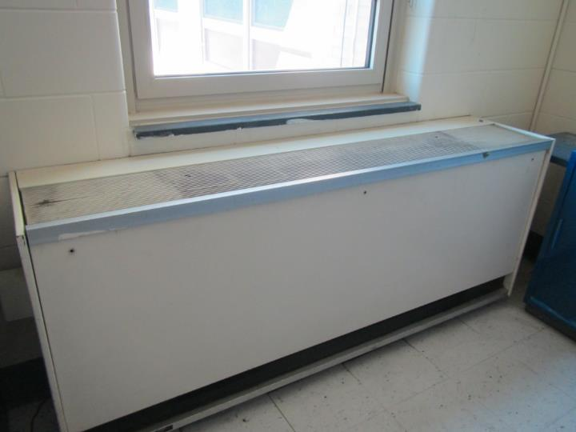
Unit ventilator (univent)
Picture 2
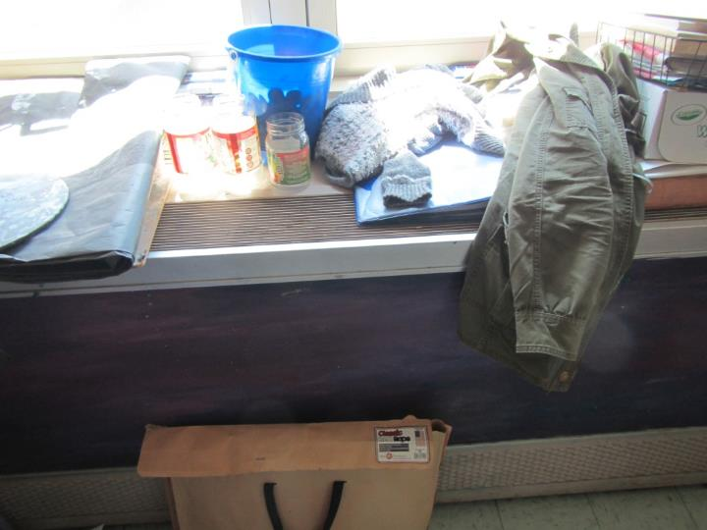
Univent shown with items blocking top and bottom/front vents
Picture 3
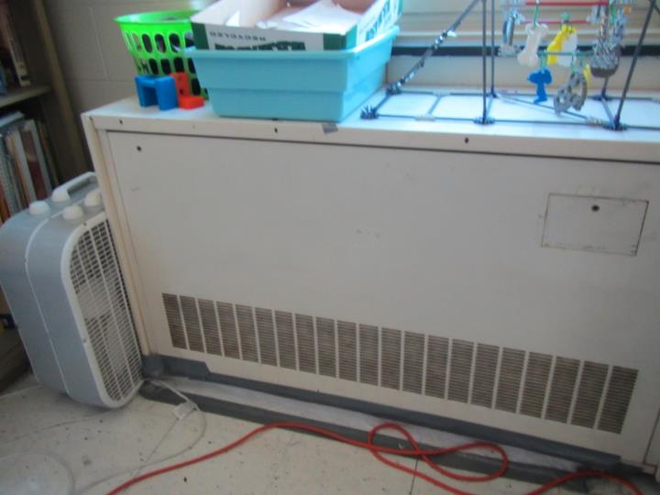
Unit exhaust in classroom
Picture 4
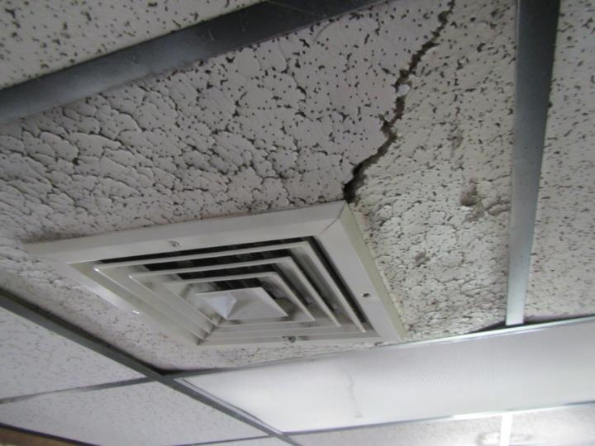
AHU supply air diffuser (note water-damaged ceiling tile)
Picture 5
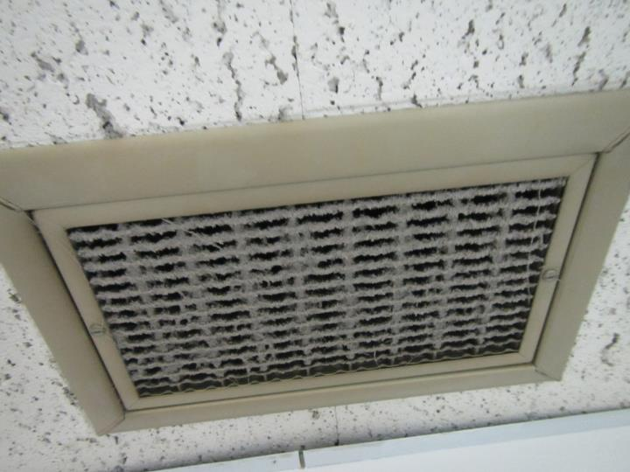
Dusty exhaust vent
Picture 6
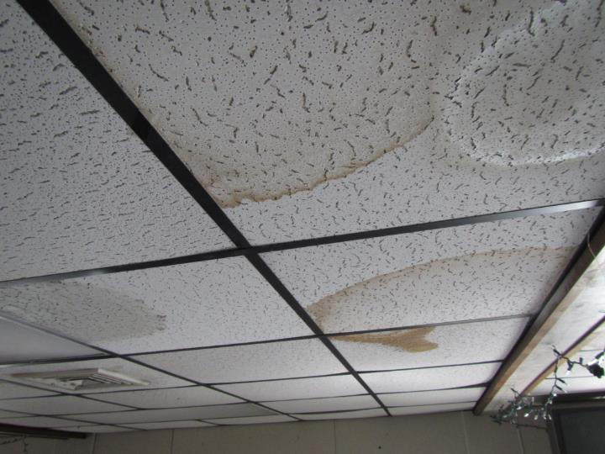
Water-damaged ceiling tiles
Picture 7
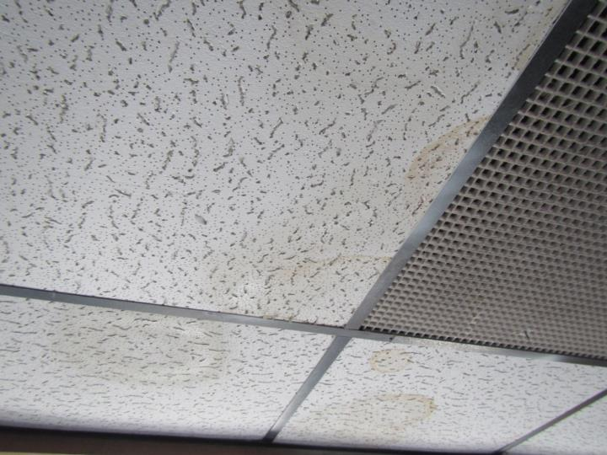
Water-damaged ceiling tiles around return vent
Picture 8
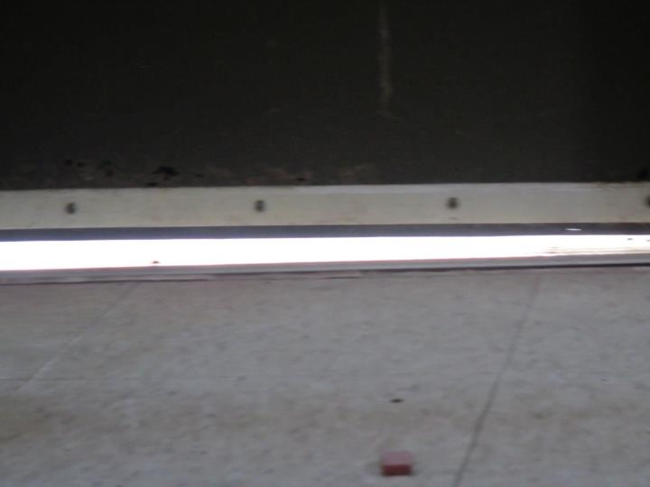
Gap under exterior door in modular classroom (note light penetrating)
Picture 9
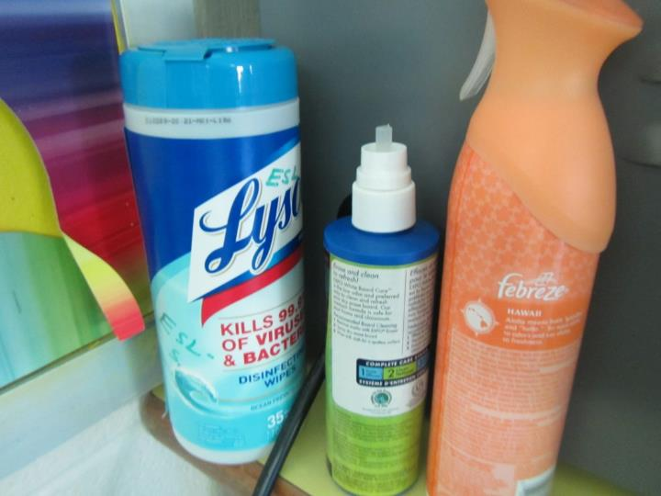
VOC-containing cleaners and air fresheners
Picture 10
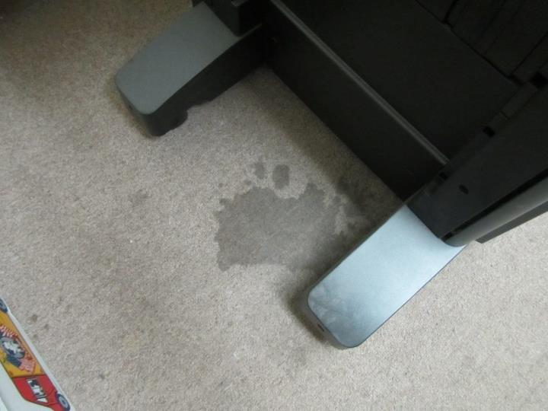
Worn/soiled carpeting
Picture 11
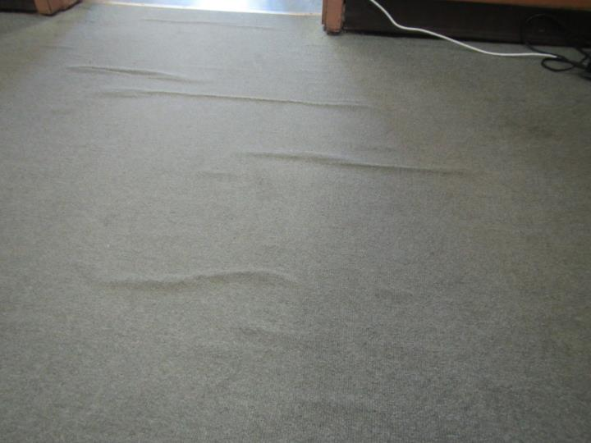
Water-damaged carpeting (note ripples)

Location | Carbon  Dioxide  (ppm) | Carbon Monoxide  (ppm) | Temp  (°F) | Relative  Humidity  (%) | PM2.5  (µg/m³) | Occupants  in Room | Windows  Openable | Ventilation |  | Remarks
 |  |  |  |  |  |  |  | Supply | Exhaust
Background (outside) | 412 | ND | 66 | 28 | 14 | - | - | - | - | Windy, clear
53 | 1108 | ND | 74 | 41 | 3 | 12 | Y | Y off | Y off | DEM, UV off
43 | 1326 | ND | 76 | 42 | 6 | 21 | Y | Y | Y | AI
51 | 1205 | ND | 75 | 41 | 2 | 0 | Y | Y | Y | DEM, AI, area carpet
49 | 2110 | ND | 76 | 49 | 38 | 3  (left 20 min) | N | Y off | Y off | AHU, stuffy
29 | 1601 | ND | 76 | 44 | 4 | 23 | Y | Y off | Y off | DEM
31 | 589 | ND | 72 | 27 | 5 | 0 | Y open | Y off | Y off
33 | 1124 | ND | 72 | 40 | 3 | 0 | Y | Y off | Y off
63 | 843 | ND | 72 | 39 | 5 | 0 | Y | Y off | Y off | Modular classroom, WD CTs, DEM
61 | 708 | ND | 72 | 38 | 6 | 0 | Y | Y on | Y on | Modular classroom, WD CTs, Gap under door to exterior
35 | 1316 | ND | 72 | 43 | 3 | 0 | Y | Y | Y
37 | 908 | ND | 72 | 37 | 2 | 0 | Y | Y off | Y off
39 | 822 | ND | 72 | 35 | 5 | 0 | Y open | Y off | Y off
41 | 1976 | ND | 74 | 50 | 4 | 19 | Y closed | Y off | Y off
47 | 2281 | ND | 75 | 54 | 6 | 17 | N | Y off | Y off | Reports of heat only (no fresh air?)
Gym | 912 | ND | 73 | 43 | 6 | 2 | N | Y | Y
59 | 962 | ND | 73 | 42 | 6 | 3 | Y | N | N
57 | 1576 | ND | 73 | 46 | 4 | (left 25 min) | N | N | N | Reported heat only, no fresh air?
27 | 1801 | ND | 75 | 44 | 3 | 15 | Y open | Y off | Y off | HS
25 | 2003 | ND | 76 | 47 | 5 | 17 | Y open | Y off | Y off
23 | 1962 | ND | 76 | 46 | 6 | 18 | Y | Y off | Y off | AI, DEM
21 | 1471 | ND | 76 | 36 | 7 | 15 | Y open | Y off | Y off
19 | 2007 | ND | 76 | 46 | 5 | 22 | Y | Y off | Y off
17 | 2461 | ND | 76 | 47 | 5 | 19 | Y | Y off | Y off
15 | 1445 | ND | 76 | 38 | 6 | 24 | Y | Y | Y | DEM, 9x9 tiles
13 | 1952 | ND | 75 | 45 | 7 | 16 | Y | Y off | Y off
11 | 1375 | ND | 75 | 37 | 7 | 19 | Y | Y | Y | Plants
9 | 1193 | ND | 75 | 37 | 7 | 25 | Y open | Y | Y | AI
7 | 1107 | ND | 75 | 33 | 8 | 14 | Y | Y off | Y off
5 | 1153 | ND | 74 | 34 | 5 | 14 | Y open | Y | Y | DEM
Café | 1383 | ND | 75 | 38 | 6 | >80 | Y | Y broke | Y broke | AHU reportedly broken
112 | 611 | ND | 73 | 30 | 1 | 0 | Y open | Y off | Y off | DEM, AI, HS
110 | 728 | ND | 72 | 34 | 2 | 0 | Y | Y off | Y off | HS, cleaning odor/AF
108 | 952 | ND | 72 | 35 | 2 | 0 | Y | Y off | Y off | Portable AC, AI, DEM
106 | 1164 | ND | 72 | 38 | 3 | 2 | Y | Y | Y | Portable AC unit
104 | 462 | ND | 71 | 28 | 4 | 1 | Y open | Y off | Y off | DEM
102 | 1130 | ND | 73 | 38 | 4 | 2 | Y | Y off | Y off | Plant, DEM
Copy room | - | - | - | - | - | - | - | - | - | Soiled carpet (below grade), dusty copier and vent
Drama | 1025 | ND | 73 | 38 | 3 | 0 | N | N | N | 1 vent off (heat only)
22 | 1035 | ND | 74 | 37 | 5 | 0 | N | Y off | Y off | AHU off, AI, ceiling UV off
120 | 985 | ND | 75 | 35 | 3 | 1 | Y open | Y | Y | Pipe wrap leaks, abandoned sinks
118A | 905 | ND | 74 | 34 | 3 | 0 | Y | N | N | Radiator
118 | 1311 | ND | 74 | 42 | 6 | 15 | Y | Y off | Y off | DEM, CPs
116 | 697 | ND | 73 | 32 | 2 | 11 | Y open | Y off | Y off | HS
114 | 1006 | ND | 74 | 40 | 4 | 1 | Y | Y | Y | AI, UF, area rug
Nurse | 643 | ND | 74 | 36 | 1 | 2 | Y open | N | N | WD carpet- rippled
Exam 1 | 583 | ND | 74 | 34 | 1 | 0 | N | N | Y | Exhaust only, interlocking tiles
Exam 2 | 531 | ND | 74 | 33 | 1 | 0 | N | N | Y | Exhaust only
Guidance | 652 | ND | 74 | 35 | 2 | 2 | Y | N | N | Carpet
Auditorium | 578 | ND | 73 | 37 | 4 | 22 | N | Y | Y | New chairs, carpet runner
Food pantry | 687 | ND | 74 | 36 | 2 | 0 | N | Y | N
Speech | 603 | ND | 73 | 35 | 2 | 3 | Y | N | N | Old carpet
Main office | 608 | ND | 73 | 36 | 1 | 4 | N | Y | N | Old carpet, wall AC
Principal | 614 | ND | 73 | 38 | 2 | 4 | N | Y | N
A | 613 | ND | 73 | 37 | 3 | 0 | Y | N | N | Old carpet
Literacy | 596 | ND | 73 | 36 | 3 | 1 | Y | N | N | Old carpet
G | 586 | ND | 73 | 36 | 1 | 2 | Y | N | N

The service life is the median time during which a particular system or component of …[an HVAC]… system remains in its original service application and then is replaced. Replacement may occur for any reason, including, but not limited to, failure, general obsolescence, reduced reliability, excessive maintenance cost, and changed system requirements due to such influences as building characteristics or energy prices (ASHRAE, 1991).

