WATER DAMAGE/REMEDIATION ASSESSMENT

Memorial Middle School
81 Central Avenue
Hull, Massachusetts

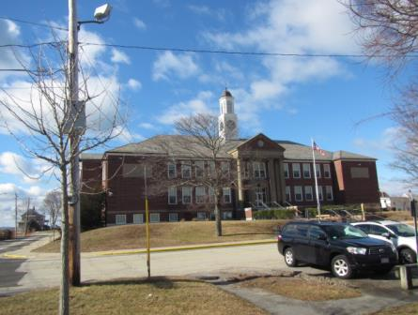

Prepared by:
Massachusetts Department of Public Health
Bureau of Environmental Health
Indoor Air Quality Program
February 2018

BACKGROUND
Building: | Memorial Middle School
Address: | 81 Central Avenue, Hull, MA
Assessment coordinated via: | Hull Health Department and Hull School Department
Reason for Request: | Water damage/remediation
Date of Assessment: | February 5, 2018
Massachusetts Department of Public Health/Bureau of Environmental Health (MDPH/BEH) Staff Conducting Assessment: | Cory Holmes, Environmental Analyst/Inspector, Indoor Air Quality (IAQ) Program
Date of Building Construction: | 1948
Building Description: | A multi-story, brick-faced building originally constructed in the late 1940s. The building underwent complete renovations in 2002.

METHODS
Please refer to the IAQ Manual and appendices for methods, sampling procedures, and interpretation of results (MDPH, 2015).

RESULTS and DISCUSSION

Microbial/Moisture Concerns
This assessment focused on areas of concern for water damage due to leaks and other penetration issues in the cafeteria, ELA classroom, Spanish classroom and a reported leak in the library.
Evidence of water leaks in the form of staining on ceiling surfaces was observed in the cafeteria (Picture 1). The ceiling appears to consist of metal and plaster, which are considered to be materials that do not become mold colonized if wet. No current signs of water damage and/or mold growth were observed on the ceiling or in the ceiling plenum by BEH/IAQ staff. Water most likely penetrated through breaches in exterior walls in the cafeteria during heavy wind/weather events (Pictures 2 and 3). Hull school officials reported that water-proofing/repointing work is planned to occur during the summer of 2018.
The ELA classroom (238) had evidence of water penetration in the form of staining on ceiling concrete and plaster (Pictures 4 and 5). Although this source of leaks should be addressed to avoid damage/staining of ceiling/wall surfaces, there were no porous building materials that can support mold growth (e.g., carpet, ceiling tiles, drywall) in the affected areas. Below the water stain is a wood cabinet containing text books (Picture 6). BEH/IAQ staff thoroughly examined materials stored in the cabinets and found no evidence of water damage/mold growth.
The Spanish classroom was reported to have had a pipe burst due to extreme cold during the first week of January 2018. As a result, ceiling tiles and carpeting were water-damaged. School officials, reported that Service Master, a flooding restoration company, responded to perform remediation/drying efforts. As mentioned, the MDPH/BEH assessment occurred on Monday February 5, 2018, it was reported a second leak occurred in the room (Picture 7) due to freezing of pipes over the weekend prior to the visit. Upon discovery of this subsequent pipe leak, maintenance personnel reportedly shut off the water source and conducted drying operations of carpeting. At the time of assessment, the classroom occupants had been relocated so repairs could be made. Moisture testing by BEH/IAQ staff was done and all building materials were dry (e.g., carpeting, ceiling tiles) and no visible mold growth/odors were observed.
BEH/IAQ staff also observed conditions above the ceiling and conducted moisture testing of carpeting in the library. No evidence of staining/water damage was observed or elevated moisture levels detected.
In order for building materials to support mold growth, a source of water exposure is necessary. The US Environmental Protection Agency (US EPA) and the American Conference of Governmental Industrial Hygienists (ACGIH) recommends that porous materials (e.g., wallboard, carpeting) be dried with fans and heating within 24 to 48 hours of becoming wet (US EPA, 2008; ACGIH, 1989). If porous materials are not dried within this time frame, mold growth may occur.

CONCLUSIONS and RECOMMENDATIONS
In view of the findings at the time of the visit, the following recommendations are made:
- Continue with plans to water-proof/repoint exterior brickwork and building envelope repairs.
- Once repointing/repairs are made, seal and repaint areas of water stains in cafeteria.
- Continue to monitor historic areas of leaks and damage/mold growth to porous classroom materials (e.g., books in ELA classroom 238/Picture 6), relocate if necessary.
- Continue to make repairs to HVAC unit in Spanish classroom.
- Determine why pipe freezes are reoccurring (lack of insulation, drafts/breaches in building envelope, etc.), and make repairs/modifications as needed.
- For more information about mold consult the US EPA’s “Mold Remediation in Schools and Commercial Buildings” published by the US Environmental Protection Agency (US EPA, 2008) (https://www.epa.gov/mold/mold-remediation-schools-and-commercial-buildings-guide).
- Refer to resource manual and other related IAQ documents located on the MDPH’s website for further building-wide evaluations and advice on maintaining public buildings. These documents are available at: http://mass.gov/dph/iaq.

REFERENCES
ACGIH. 1989. Guidelines for the Assessment of Bioaerosols in the Indoor Environment. American Conference of Governmental Industrial Hygienists, Cincinnati, OH.
MDPH. 2015. Massachusetts Department of Public Health. Indoor Air Quality Manual: Chapters I-III. Available at: http://www.mass.gov/eohhs/gov/departments/dph/programs/environmental-health/exposure-topics/iaq/iaq-manual/.
US EPA. 2008. Mold Remediation in Schools and Commercial Buildings. US Environmental Protection Agency, Office of Air and Radiation, Indoor Environments Division, Washington, D.C. EPA 402-K-01-001. http://www.epa.gov/mold/mold-remediation-schools-and-commercial-buildings-guide.
Picture 1
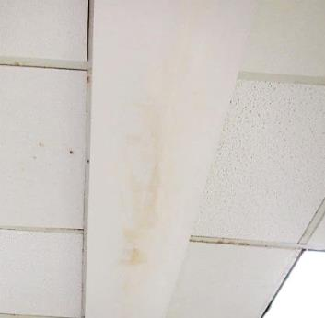
Staining of ceiling surface (metal)
Picture 2
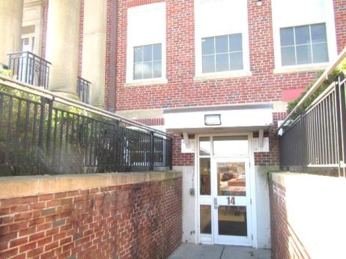
Area outside of cafeteria where water staining was observed
Picture 3
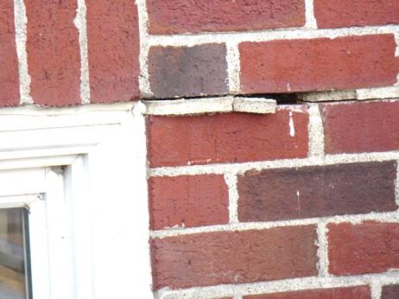
Missing/damaged mortar around brick outside cafeteria
Picture 4
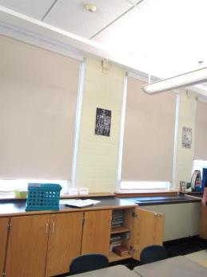
ELA classroom 238, arrow indicates area of water staining
Picture 5
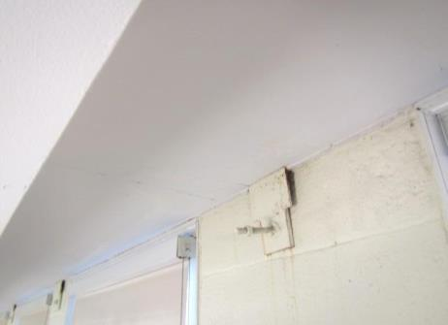
Close up of ELA classroom 238 area of water staining, note non-porous concrete and plaster building materials
Picture 6
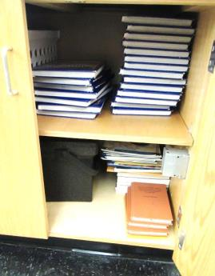
Textbooks in wooden cabinet directly beneath area of reported leaks
Picture 7
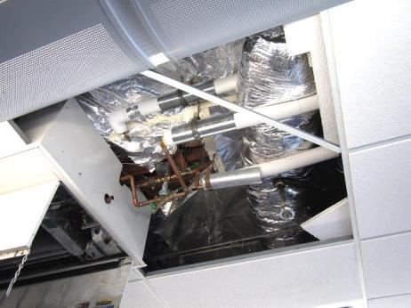
Pipes above ceiling in Spanish classroom that froze

