Massachusetts HIV Epidemiologic Profile: Data as of 1/1/2023
Population Report: Men Who Have Sex with Men
Accessible MS Word Version, optimized for screen reader use
Please note that while the content of this report is the same as the pdf version, the format and pagination have been modified significantly to optimize use with screen readers to ensure access for blind or visually impaired audiences.
Suggested citation:
Massachusetts Department of Public Health, Bureau of Infectious Disease and Laboratory Sciences. Massachusetts HIV Epidemiologic Profile: Data as of 1/1/2023, Population Report: Men Who Have Sex with Men, https://www.mass.gov/lists/hivaids-epidemiologic-profiles Published March 2024. Accessed [date].
Bureau of Infectious Disease and Laboratory Sciences
Massachusetts Department of Public Health
Jamaica Plain Campus/State Public Health Laboratory
305 South Street
Jamaica Plain, MA 02130
Questions about this report
Tel: (617) 983-6560
To reach the Reporting and Partner Services Line
Tel: (617) 983-6999
To speak to the on-call epidemiologist
Tel: (617) 983-6800
Questions about infectious disease reporting
Tel: (617) 983-6801
HIV Data Dashboard
https://www.mass.gov/info-details/hiv-data-dashboard
Requests for additional data
https://www.mass.gov/lists/infectious-disease-data-reports-and-requests
Slide sets for HIV Epidemiologic Profile Reports
https://www.mass.gov/lists/hivaids-epidemiologic-profiles

HIV INCIDENCE AND PREVALENCE AMONG MSM
N = 556, 39% of 1,419 new HIV diagnoses from 2019–2021 were among individuals with MSM exposure mode
N = 9,300, 40% of 23,393 persons living with HIV infection in MA as of 12/31/2021 were reported with MSM exposure mode
FIGURE 1. Percentage distribution of individuals diagnosed with HIV infection by exposure mode, Massachusetts 2012–2021
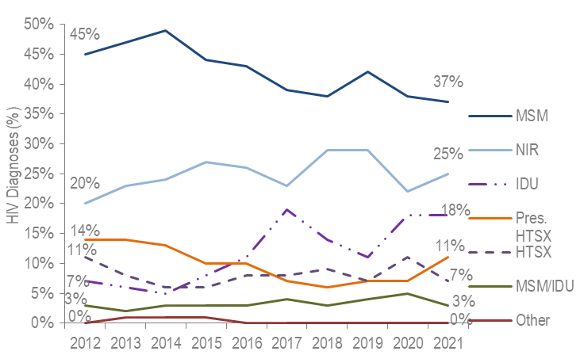
Figure 1 Note: Individuals Diagnosed with HIV Infection 2012-2021: N=6,011, MSM=Male-to-Male Sex; IDU=Injection Drug Use; HTSX=Heterosexual Sex; Pres. HTSX=presumed heterosexual exposure, includes individuals assigned female at birth with a negative history of injection drug use who report having sex with an individual that identifies as male of unknown HIV status and risk; NIR=No Identified Risk
- Among individuals assigned male at birth (AMAB), MSM was the exposure mode for 54% (N=556/1,022), and MSM/IDU an additional 5% (N=53/1,022), of HIV infection diagnoses from 2019 to 2021.
- KEY FACT From 2012 to 2021, MSM exposure mode accounted for the largest percentage of HIV diagnoses each year (with a low of 37% [N=163/446] in 2021 and a high of 49% [N=322/652] in 2014).
FIGURE 2. Estimated average HIV diagnosis rate per 100,000 population, MSM compared to non-MSM (males only) ages 18–64 years, Massachusetts 2019–2021
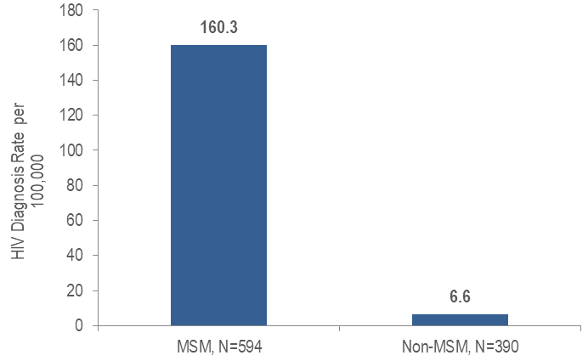
- KEY FACT At 160.3 per 100,000 population (95% confidence interval [CI]:135.1–201.2 per 100,000), the estimated average rate of HIV diagnosis from 2019 to 2021 among MSM (ages 18–64) was 24 times the rate of non-MSM individuals AMAB (6.6 per 100,000 [95%CI:6.5–6.7 per 100,000]).
- Additionally, at 7,046.5 per 100,000 population (95%CI:5,939.2–8,845.6 per 100,000), the estimated HIV prevalence rate among MSM (ages 18–64) was 28 times the rate of non-MSM individuals AMAB (256.4 per 100,000 [95%CI:253.2–259.4 per 100,000]).
RACE/ETHNICITY
- Thirty-eight percent of 556 MSM diagnosed with HIV infection during 2019–2021 were Hispanic/Latinx, 35% were white (non-Hispanic), 21% were black (non-Hispanic), 4% were Asian/Pacific Islander, and 2% were of other or unknown race/ethnicity.
- Among 9,300 MSM living with HIV infection on 12/31/2021, 59% were white (non-Hispanic), 22% were Hispanic/Latinx, 14% were black (non-Hispanic), 3% were Asian/Pacific Islander, and 2% were of other or unknown race/ethnicity.

FIGURE 3. Individuals diagnosed with HIV infection with MSM exposure mode by race/ethnicity and year of diagnosis, Massachusetts 2012–2021
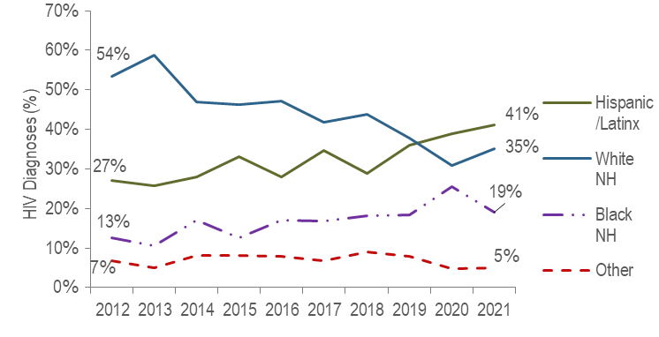
Figure 3 Note: MSM Diagnosed with HIV Infection 2012-2021: N=2,563, MSM=Male-to-male sex, NH=non-Hispanic
KEY FACTS
- From 2012 to 2021, the proportion of individuals AMAB diagnosed with HIV infection with MSM exposure mode who identified as Hispanic/Latinx increased from 27% to 41%.
- During the same time period, the proportion of individuals AMAB diagnosed with MSM exposure mode who identified as white (non-Hispanic) decreased from 54% to 35%.
AGE
- From 2019 to 2021, among individuals AMAB diagnosed with HIV infection during adolescence and young adulthood (13–24 years), MSM was the most frequently reported mode of exposure at 78% (N=107/137). Among individuals AMAB diagnosed with HIV infection aged 25 years or older, MSM accounted for 51% (N=449/885) of diagnoses during the same time period.

FIGURE 4. Individuals diagnosed with HIV infection with MSM exposure mode by age at diagnosis and year of diagnosis, Massachusetts 2012–2021
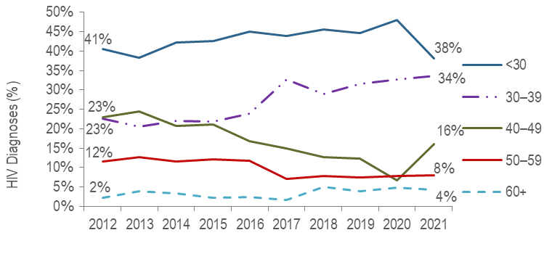
Figure 4 Note: MSM Diagnosed with HIV Infection 2012-2021: N=2,563
- KEY FACT: The largest proportion of MSM were diagnosed with HIV infection younger than 30 years of age each year from 2012 to 2021.
FIGURE 5. Individuals diagnosed with HIV infection with MSM exposure mode by age at diagnosis and race/ethnicity, Massachusetts 2019–2021
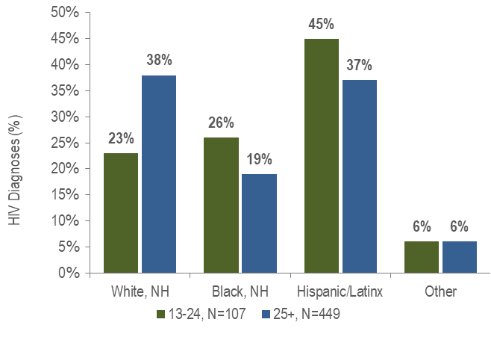
Figure 5 Note: Other includes Asian/Pacific Islander, American Indian/Alaska Native, and unknown., NH = non-Hispanic
- A larger proportion of MSM diagnosed with HIV between the ages of 13 and 24 years were racial/ethnic minorities, as compared to MSM diagnosed at age 25 years or older.
- The average age of HIV diagnosis was younger for Asian/Pacific Islander, black (non-Hispanic), and Hispanic/Latinx individuals AMAB recently diagnosed with MSM exposure mode (29.8, 31.3, and 31.6 years, respectively) compared to white (non-Hispanic) individuals AMAB with MSM exposure mode (38.3 years).
PLACE OF BIRTH
- The distribution of place of birth of 556 MSM diagnosed with HIV infection during 2019–2021 was: 61% born in the US, 35% born outside of the US, and 4% born in Puerto Rico.
- The distribution of place of birth among 9,300 MSM living with HIV infection on 12/31/2021 was: 75% born in the US, 21% born outside of the US, and 4% born in Puerto Rico or another US dependency.
FIGURE 6. Individuals diagnosed with HIV infection with MSM exposure mode by race/ethnicity and place of birth, Massachusetts 2019–2021
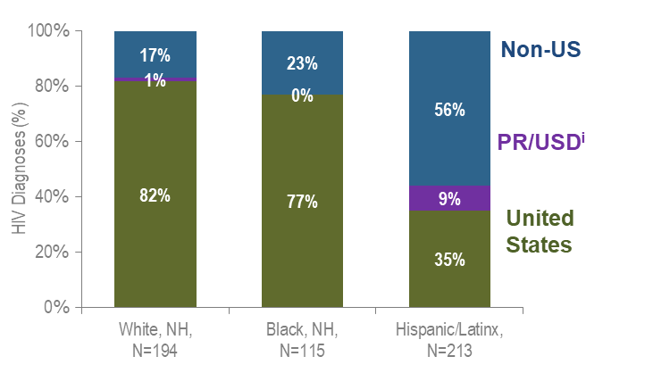
Figure 6 Note: All individuals diagnosed with HIV infection from 2019–2021 who were born in a US dependency were born in Puerto Rico, PR/USD=Puerto Rico/US Dependency
- KEY FACT: Fifty-six percent of Hispanic/Latinx MSM recently diagnosed with HIV infection were non-US born, compared to 23% of black (non-Hispanic) MSM and 17% of white (non-Hispanic) MSM. An additional 9% of Hispanic/Latinx MSM were born in Puerto Rico, compared to 1% of white (non-Hispanic) MSM and none of black (non-Hispanic) MSM.
PLACE OF RESIDENCE
FIGURE 7. HIV infection diagnoses by Health Service Region and exposure mode, Massachusetts 2019–2021
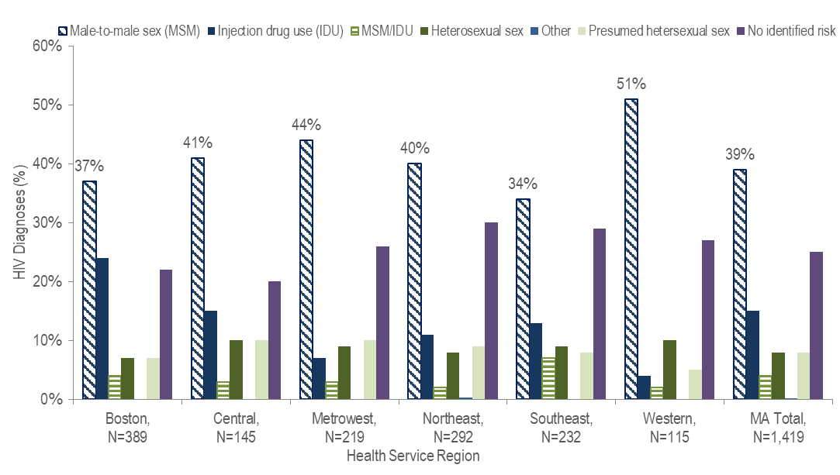
Figure 7 Note: HSR is based on residence at HIV infection diagnosis.
- MSM was the predominant exposure mode for HIV infection in all Health Service Regions of Massachusetts.

TABLE 1. Massachusetts cities/towns with the highest percentage of HIV diagnoses among MSM, 2019–2021
 | HIV Diagnoses Among MSM (N) | HIV Diagnoses Among MSM as Percent of Total HIV Diagnoses in City/Town(%)
Massachusetts Total | 556 | 39%
Top Cities/Towns
Malden | 17 | 59%
Cambridge | 14 | 56%
Springfield | 28 | 55%
Everett | 16 | 53%
Framingham | 11 | 52%
Quincy | 11 | 50%
Revere | 13 | 50%
Lawrence | 20 | 48%
Fall River | 9 | 38%
Worcester | 30 | 37%
All Other Cities/Towns | 387 | 36%

- Among cities and towns with at least 20 reported HIV diagnoses from 2019 to 2021, Malden, Cambridge, and Springfield had the highest percentages of HIV diagnoses among MSM. Each had at least 55% of new HIV diagnoses attributed to MSM exposure mode.
INFORMATION FROM ADDITIONAL DATA SOURCES
Behavioral Risk Factors: Recent statewide surveys describe sexual and drug use behaviors among MSM in Massachusetts.
Massachusetts Behavioral Risk Factor Surveillance Survey (BRFSS): An annual, anonymous telephone survey of adults ages 18 and older that collects data on a variety of health risk factors, preventive behaviors, chronic conditions, and emerging public health issues.
- Among sexually active individuals AMAB ages 18–64 years who responded to the BRFSS from 2019 to 2021:
  - 5.9% (95% confidence interval [CI]: 4.7% – 7.0%, n=2,028) reported having sex with individuals AMAB or with both individuals AMAB and AFAB;
  - 36.7% (95% CI: 27.1%–46.2%, n=127) who reported having sex with individuals AMAB or with both individuals AMAB and AFAB reported condom use at last sexual encounter, compared to 25.9% (95% CI: 23.5%–28.2%, n= 1,887) of sexually active individuals AMAB who reported sex with individuals AFAB only; and
  - 46.2% (95% CI: 36.2%–56.2%, n=126) who reported having sex with individuals AMAB or with both individuals AMAB and AFAB reported two or more sexual partners in the past year, compared to 13.3% (95% CI: 11.5%–15.1%, n=1,864) of sexually active individuals AMAB who reported sex with individuals AFAB only.
Data Source: Office of Data Management and Outcomes Assessment, Massachusetts Behavioral Risk Factor Surveillance System (BRFSS). For more information, see: Health Survey Program, Office of Data Management and Outcomes Assessment, Massachusetts Department of Public Health. A Profile of Health Among Massachusetts Adults, 2021, Results from the Behavioral Risk Factor Surveillance System, January 2023, https://www.mass.gov/doc/a-profile-of-health-among-massachusetts-adults-2021-0/download
Massachusetts Youth Risk Behavior Survey (YRBS): An anonymous survey of public high school students conducted every odd year that collects data on health-related behaviors that may threaten the health and safety of young people.
Sexual behaviors/identity
- In 2021, 73.6% (95% CI: 71.4%–75.8%) of public high school students (n=3,108) identified as heterosexual, 12.2% (95% CI: 10.7%–13.6%) identified as bisexual, 5.2% (95% CI: 4.1%–6.4%) were not sure of (questioning) their sexual identity, 4.3% (95% CI: 3.5%–5.1%) identified as something else, 3.0% (95% CI: 2.2%–3.7%) identified as gay or lesbian, and 1.7% (95% CI: 1.3%–2.1%) did not understand the question.
Data Source: Massachusetts Department of Elementary and Secondary Education (DESE) and Massachusetts Department of Public Health Office of Data Management and Outcomes Assessment. For more information, see: https://www.doe.mass.edu/sfs/yrbs/
HIV Surveillance Data Source: MDPH Bureau of Infectious Disease and Laboratory Sciences, data are current as of 1/1/2023 and may be subject to change.

Providers may use this number to report individuals newly diagnosed with a notifiable sexually transmitted infection, including HIV, or request partner services. Partner services is a free and confidential service for individuals recently diagnosed with a priority infection. The client-centered program offers counseling, linkage to other health and social services, anonymous notification of partners who were exposed and assistance with getting testing and treatment. For more information, see: https://www.mass.gov/service-details/partner-services-program-information-for-healthcare-providers)
Please consider the impact of the COVID-19 pandemic on infectious disease screening, treatment, and surveillance in the interpretation of 2020 and 2021 data.
Multiple source estimation method for MSM rate (2019-2021 BRFSS); as of 1/1/2020 BIDLS calculates rates using University of Massachusetts Donahue Institute population estimates using a modified Hamilton-Perry model. Note that rates calculated using previous population denominators cannot be compared to these. Please note that individuals AMAB with no identified risk for HIV infection were included in the non-MSM category for rate calculations.
Please consider the impact of the COVID-19 pandemic on infectious disease screening, treatment, and surveillance in the interpretation of 2020 and 2021 data.
Please consider the impact of the COVID-19 pandemic on infectious disease screening, treatment, and surveillance in the interpretation of 2020 and 2021 data.
Please consider the impact of the COVID-19 pandemic on infectious disease screening, treatment, and surveillance in the interpretation of 2020 and 2021 data.
Please consider the impact of the COVID-19 pandemic on infectious disease screening, treatment, and surveillance in the interpretation of 2020 and 2021 data
City/town is based on residence at HIV infection diagnosis.
All Other Cities/Towns includes individuals diagnosed in a correctional facility
Please consider the impact of the COVID-19 pandemic on infectious disease screening, treatment, and surveillance in the interpretation of 2020 and 2021 data

