
Massachusetts Department of Public Health
Bureau of Infectious Disease and Laboratory Sciences

Massachusetts HIV Epidemiologic Profile: Data as of 7/1/2025
Population Report: Men Who Have Sex with Men
Suggested citation:
Massachusetts Department of Public Health, Bureau of Infectious Disease and Laboratory Sciences. Massachusetts HIV Epidemiologic Profile: Data as of 7/1/2025, Population Report: Men Who Have Sex with Men, https://www.mass.gov/lists/hivaids-epidemiologic-profiles Published December 2025. Accessed [date].
Bureau of Infectious Disease and Laboratory Sciences
Massachusetts Department of Public Health
Jamaica Plain Campus/State Public Health Laboratory
305 South Street
Jamaica Plain, MA 02130
Questions about this report
Tel: (617) 983-6560
To reach the Reporting and Partner Services Line
Tel: (617) 983-6999
To speak to the on-call epidemiologist
Tel: (617) 983-6800
Questions about infectious disease reporting
Tel: (617) 983-6801
HIV Data Dashboard
https://www.mass.gov/info-details/hiv-data-dashboard
Requests for additional data
https://www.mass.gov/lists/infectious-disease-data-reports-and-requests
Slide sets for HIV Epidemiologic Profile Reports
https://www.mass.gov/lists/hivaids-epidemiologic-profiles

Table of Contents
HIV INCIDENCE AND PREVALENCE AMONG MSM 1
RACE/ETHNICITY 2
AGE 3
PLACE OF BIRTH 5
PLACE OF RESIDENCE 5
INFORMATION FROM ADDITIONAL DATA SOURCES 7

HIV INCIDENCE AND PREVALENCE AMONG MSM
N=652 | 41% | of 1,596 new HIV diagnoses from 2022–2024 were among individuals with MSM exposure mode | N=9,987 | 40% | of 24,838 persons living with HIV infection in MA as of 12/31/2024 were reported with MSM exposure mode
- Among individuals assigned male at birth (AMAB), MSM was the exposure mode for 56% (N=652/1,162), and MSM/IDU an additional 4% (N=42/1,162) of HIV infection diagnoses from 2022 to 2024.
FIGURE 1. Percentage distribution of individuals diagnosed with HIV infection by exposure mode, Massachusetts 2015–2024
KEY FACT
- From 2015 to 2024, MSM exposure mode accounted for the largest percentage of HIV diagnoses each year (with a low of 37% [N=163/435, N=165/451] in 2020 and 2021 and a high of 44% [N=266/609] in 2015).
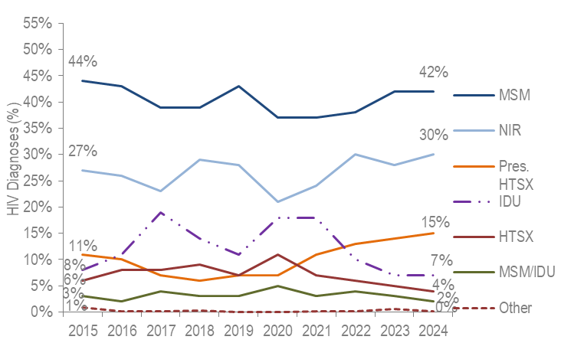
KEY FACT
- At 160.9 per 100,000 population (95% confidence interval [CI]: 133.1–203.4 per 100,000), the estimated average rate of HIV diagnosis from 2022 to 2024 among MSM (ages 18–64 years) was 21 times the rate of infection in men who did not report sex with men (7.6 per 100,000 [95% CI: 7.5–7.7 per 100,000]).
Figure 1 Note: Individuals Diagnosed with HIV Infection 2015–2024: N=5,534, MSM=Male-to-Male Sex; IDU=Injection Drug Use; HTSX=Heterosexual Sex; Pres. HTSX=presumed heterosexual exposure, includes individuals assigned female at birth with a negative history of injection drug use who report having sex with an individual that identifies as male of unknown HIV status and risk; NIR=No Identified Risk
FIGURE 2. Estimated average HIV diagnosis rate per 100,000 population, MSM compared to non-MSM (males only) ages 18–64 years, Massachusetts 2022–2024
- At 6,324.9 per 100,000 population (95%CI:5,231.7–7,995.7 per 100,000), the estimated HIV prevalence rate among MSM (ages 18–64) was 26 times the rate in men who did not report sex with men (245.3 per 100,000 [95%CI:241.6–249.0 per 100,000]).
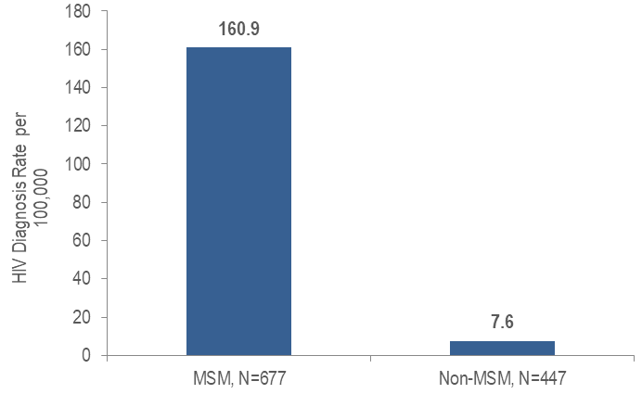

RACE/ETHNICITY
- Forty-two percent of 652 MSM diagnosed with HIV infection during 2022–2024 were Hispanic/Latinx, 32% were White (non-Hispanic), 21% were Black (non-Hispanic), 4% were Asian/Pacific Islander, and 1% was of other or unknown race/ethnicity.
- Among 9,987 MSM living with HIV infection on 12/31/2024, 55% were White (non-Hispanic), 25% were Hispanic/Latinx, 15% were Black (non-Hispanic), 3% were Asian/Pacific Islander, and 2% were of other or unknown race/ethnicity.
FIGURE 3. Individuals diagnosed with HIV infection with MSM exposure mode by race/ethnicity and year of diagnosis, Massachusetts 2015–2024
KEY FACT
- From 2015 to 2024, the proportions of individuals AMAB diagnosed with HIV infection with MSM exposure mode who identified as Hispanic/Latinx and Black (non-Hispanic) increased from 33% to 42% and from 13% to 24%, respectively, while the proportion who identified as White (non-Hispanic) decreased from 46% to 29%.
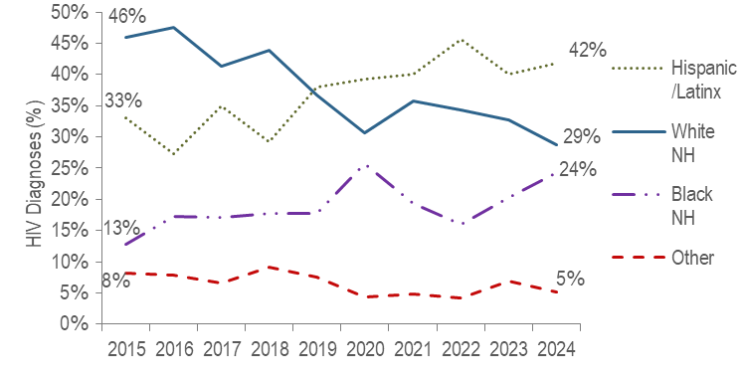
Figure 3 Note: MSM Diagnosed with HIV Infection 2015–2024: N=2,243, MSM=Male-to-male sex, NH=non-Hispanic

AGE
- From 2022 to 2024, among individuals AMAB diagnosed with HIV infection during adolescence and young adulthood (13–24 years), MSM was the most frequently reported mode of exposure at 81% (N=137/170). Among individuals AMAB diagnosed with HIV infection aged 25 years or older, MSM accounted for 52% (N=515/990) of diagnoses during the same time period.
FIGURE 4. Individuals diagnosed with HIV infection with MSM exposure mode by age at diagnosis and year of diagnosis, Massachusetts 2015–2024
KEY FACT
- Every year from 2015 to 2024, the largest proportion of MSM who were diagnosed with HIV infection were younger than 30 years of age.
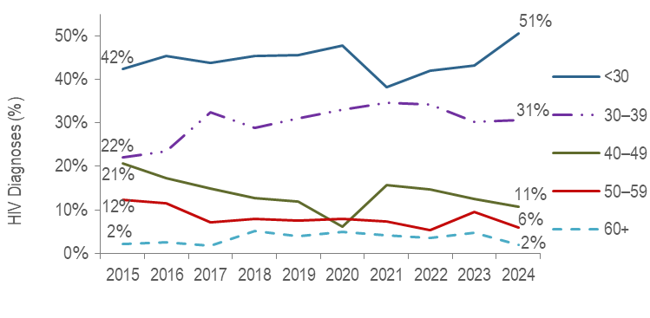
Figure 4 Note: MSM Diagnosed with HIV Infection 2015–2024: N=2,243
- A larger proportion of MSM diagnosed with HIV infection between the ages of 13 and 24 years was Hispanic/Latinx (56%), as compared to MSM diagnosed at age 25 years or older (38%).
FIGURE 5. Individuals diagnosed with HIV infection with MSM exposure mode by age at diagnosis and race/ethnicity, Massachusetts 2022–2024
- The average age of HIV diagnosis was younger for Asian/Pacific Islander, Hispanic/Latinx, and Black (non-Hispanic) individuals AMAB recently diagnosed with MSM exposure mode (29.3, 30.2, and 33.0 years, respectively) compared to White (non-Hispanic) individuals AMAB with MSM exposure mode (38.2 years).
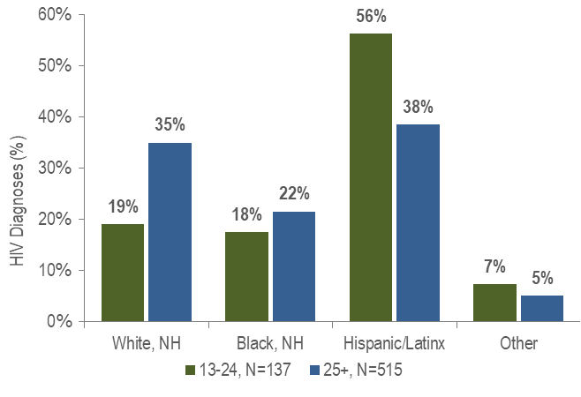
Figure 5 Note: Other includes Asian/Pacific Islander, American Indian/Alaska Native, and unknown., NH = non-Hispanic

PLACE OF BIRTH
- The distribution of place of birth of 652 MSM diagnosed with HIV infection during 2022–2024 was: 59% born in the US, 39% born outside of the US, and 2% born in Puerto Rico or another US Dependency.
- The distribution of place of birth among 9,987 MSM living with HIV infection on 12/31/2024 was: 71% born in the US, 26% born outside of the US, and 4% born in Puerto Rico or another US dependency.
FIGURE 6. Individuals diagnosed with HIV infection with MSM exposure mode by race/ethnicity and place of birth, Massachusetts 2022–2024
KEY FACT
- Fifty-eight percent of Hispanic/Latinx MSM recently diagnosed with HIV infection were non-US born, compared to 39% of Black (non-Hispanic) MSM and 11% of White (non-Hispanic) MSM. An additional 6% of Hispanic/Latinx MSM were born in Puerto Rico/US Dependencies, compared to none of White (non-Hispanic) and Black (non-Hispanic) MSM.
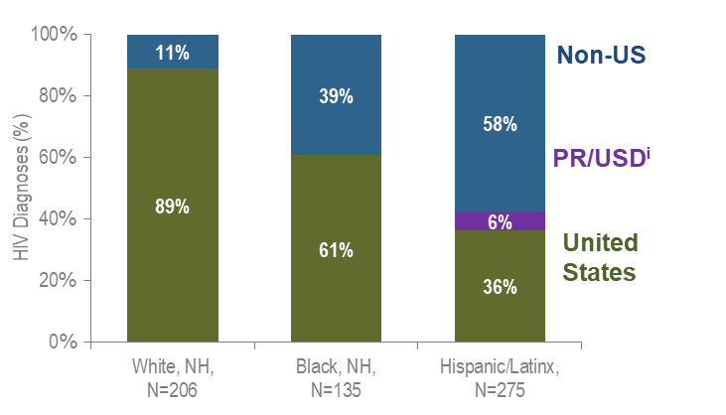
Figure 6 Note: 97% of individuals diagnosed with HIV infection from 2022–2024 who were born in a US dependency were born in Puerto Rico, PR/USD=Puerto Rico/US Dependency

PLACE OF RESIDENCE
FIGURE 7. HIV infection diagnoses by Health Service Region and exposure mode, Massachusetts 2022–2024
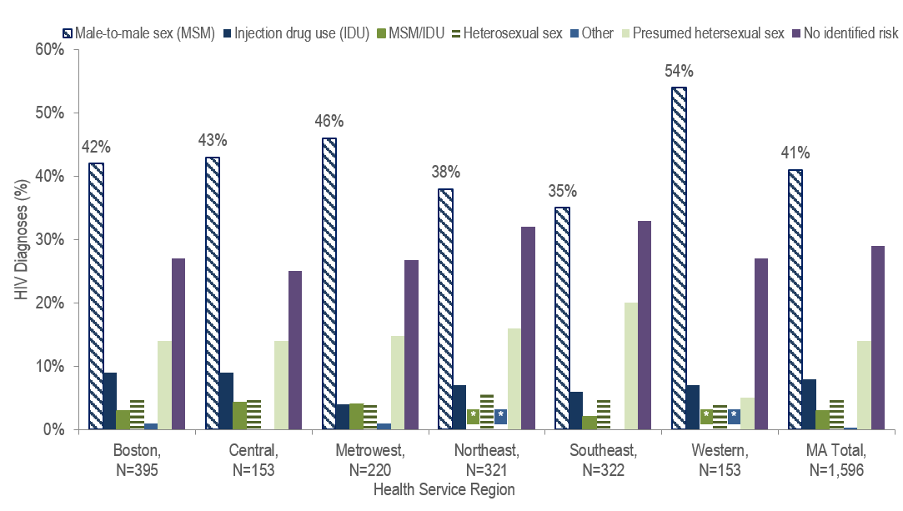
Figure 7 Note: HSR is based on residence at HIV infection diagnosis.
* Values less than five are suppressed for populations less than 50,000 or for populations of unknown size.
- MSM was the predominant exposure mode for HIV infection in all Health Service Regions of Massachusetts.
- Among cities and towns with more than 20 reported HIV diagnoses from 2022 to 2024, Chelsea, Springfield, Waltham, and Fall River had the highest percentages of HIV diagnoses among MSM. Each had over half of new HIV diagnoses attributed to MSM exposure mode.
TABLE 1. Massachusetts cities/towns with the highest percentage of HIV diagnoses among MSM, 2022–2024
 | HIV Diagnoses Among MSM (N) | HIV Diagnoses Among MSM as Percent of Total HIV Diagnoses in City/Town(%)
Massachusetts Total | 652 | 41%
Top Cities/Towns
Chelsea | 15 | 63%
Springfield | 37 | 55%
Waltham | 11 | 52%
Fall River | 13 | 52%
Everett | 15 | 48%
Worcester | 36 | 48%
Malden | 14 | 44%
Boston | 136 | 39%
New Bedford | 15 | 38%
Lynn | 16 | 34%
All Other Cities/Towns | 344 | 39%

INFORMATION FROM ADDITIONAL DATA SOURCES
Behavioral Risk Factors: Recent statewide surveys describe sexual and drug use behaviors among MSM in Massachusetts.
Massachusetts Behavioral Risk Factor Surveillance Survey (BRFSS): An annual, anonymous telephone survey of adults ages 18 and older that collects data on a variety of health risk factors, preventive behaviors, chronic conditions, and emerging public health issues.
- Among sexually active individuals AMAB ages 18–64 years who responded to the BRFSS from 2022 to 2024:
  - 6.7% (95% confidence interval [CI]: 5.3% – 8.1%, n=2,155) reported having sex with individuals AMAB or with both individuals AMAB and AFAB;
  - 38.3% (95% CI: 26.8%–49.7%, n=147) who reported having sex with individuals AMAB or with both individuals AMAB and AFAB reported condom use at last sexual encounter, compared to 23.1% (95% CI: 20.6%–25.5%, n=1,986) of sexually active individuals AMAB who reported sex with individuals AFAB only; and
  - 59.1% (95% CI: 48.4%–69.9%, n=147) who reported having sex with individuals AMAB or with both individuals AMAB and AFAB reported two or more sexual partners in the past year, compared to 15.4% (95% CI: 12.9%–17.8%, n=1,972) of sexually active individuals AMAB who reported sex with individuals AFAB only.
Data Source: Office of Data Management and Outcomes Assessment, Massachusetts Behavioral Risk Factor Surveillance System (BRFSS). For more information, see: Health Survey Program, Office of Data Management and Outcomes Assessment, Massachusetts Department of Public Health. A Profile of Health Among Massachusetts Adults, 2023, Results from the Behavioral Risk Factor Surveillance System, January 2024, https://www.mass.gov/lists/brfss-statewide-reports-and-publications

Massachusetts Youth Risk Behavior Survey (YRBS): An anonymous survey of public high school students conducted every odd year that collects data on health-related behaviors.
Sexual behaviors/identity
- In 2023, 74.1% (95% CI: 71.2%–77.0%) of public high school students (n=2,997) identified as heterosexual, 11.9% (95% CI: 10.3%–13.5%) identified as bisexual, 4.7% (95% CI: 3.8%–5.7%) identified as something else, 4.0% (95% CI: 3.1%–4.9%) were not sure of (questioning) their sexual identity, 3.4% (95% CI: 2.5%–4.3%) identified as gay or lesbian, and 1.8% (95% CI: 1.2%–2.5%) did not understand the question.
Data Source: Massachusetts Department of Elementary and Secondary Education (DESE) and Massachusetts Department of Public Health Office of Data Management and Outcomes Assessment. For more information, see: https://www.doe.mass.edu/sfs/yrbs/

HIV Surveillance Data Source: MDPH Bureau of Infectious Disease and Laboratory Sciences, data are current as of 7/1/2025 and may be subject to change.

Providers may use this number to report individuals newly diagnosed with a notifiable sexually transmitted infection, including HIV, or request partner services. Partner services is a free and confidential service for individuals recently diagnosed with a priority infection. The client-centered program offers counseling, linkage to other health and social services, anonymous notification of partners who were exposed and assistance with getting testing and treatment. For more information, see: https://www.mass.gov/service-details/partner-services-program-information-for-healthcare-providers)
Multiple source estimation method for MSM rate (2019-2021 BRFSS); as of 1/1/2020 BIDLS calculates rates using University of Massachusetts Donahue Institute population estimates using a modified Hamilton-Perry model. Note that rates calculated using previous population denominators cannot be compared to these. Please note that individuals AMAB with no identified risk for HIV infection were included in the non-MSM category for rate calculations, and individuals with MSM/IDU exposure mode were included in the MSM category.
Please consider the impact of the COVID-19 pandemic on infectious disease screening, treatment, and surveillance in the interpretation of data from 2020 to 2022.
Please consider the impact of the COVID-19 pandemic on infectious disease screening, treatment, and surveillance in the interpretation of data from 2020 to 2022.
Please consider the impact of the COVID-19 pandemic on infectious disease screening, treatment, and surveillance in the interpretation of data from 2020 to 2022
Please consider the impact of the COVID-19 pandemic on infectious disease screening, treatment, and surveillance in the interpretation of data from 2020 to 2022.
City/town is based on residence at HIV infection diagnosis.
Among cities and towns with more than 20 total HIV diagnoses from 2021–2023.
All Other Cities/Towns includes individuals diagnosed in a correctional facility

