INDOOR AIR QUALITY ASSESSMENT

Mendon Town Hall
Basement Offices
20 Main Street
Mendon, MA

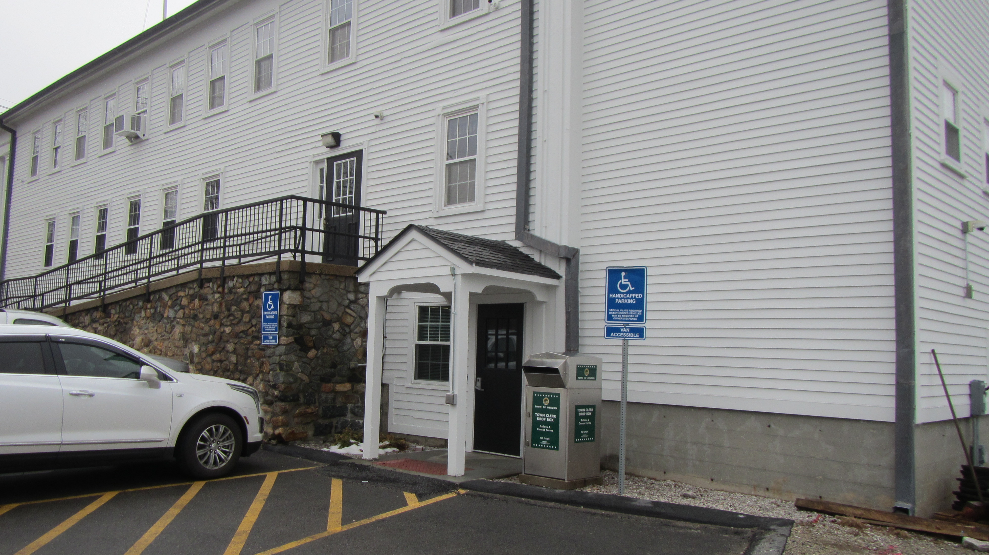

Prepared by:
Massachusetts Hall of Public Health
Bureau of Environmental Health
Indoor Air Quality Program
March 2023

BACKGROUND
Building: | Mendon Town Hall (MTH)
Address: | 20 Main Street, Mendon, MA
Reason for Request: | General IAQ and water damage concerns in basement
Date of Assessment: | March 2, 2023
Massachusetts Hall of Public Health/Bureau of Environmental Health (MDPH/BEH) Staff Conducting Assessment: | Michael Feeney, Director, IAQ  Program
Building Description: | Room located on the basement of the MTH. The MTH was constructed as a school in 1857 and has undergone renovations, including the subdivision of the basement into offices.
Building Population: | Approximately 3 employees
Year of Construction: | 1800s
Windows: | Openable

METHODS
Please refer to the IAQ Manual for methods, sampling procedures, and interpretation of results (MDPH, 2015).

RESULTS AND DISCUSSION
The following is a summary of indoor air testing results (Table 1).
- Carbon dioxide levels were below 800 parts per million (ppm) in all areas tested.
- Temperature was within or slightly below the recommended range of 70°F to 78°F in areas assessed.
- Relative humidity was below the recommended range of 40% to 60% in the areas assessed.
- Carbon monoxide levels outdoors was measured at 6 ppm. All areas indoors were measured in a range of 5-6 ppm, which matches outdoor levels. Due to weather conditions, temperature inversion was likely experienced in the Mendon area.
- Fine particulate matter (PM2.5) concentrations measured were below the National Ambient Air Quality Standard (NAAQS) level of 35 μg/m³ in all areas assessed.

Ventilation
A heating, ventilating, and air conditioning (HVAC) system has several functions. First it provides heating and, if equipped, cooling. Second, it is a source of fresh air. Finally, an HVAC system will dilute and remove normally occurring indoor environmental pollutants by introducing fresh air, and by filtering the airstream and ejecting stale air to the outdoors via exhaust ventilation. Even if an HVAC system is operating as designed, point sources of respiratory irritation may exist and cause symptoms in sensitive individuals.
The MTH basement offices have no observable operating mechanical HVAC system that can either provides fresh air or exhaust ventilation. A heat exchange system (Pictures 1 and 2) is present that is connected to ventilation openings in the hallway (Picture 3). This heat exchanger was unplugged from its power source and was not operating during this assessment.
While the Town Clerk’s office has openable windows, other occupied offices in the basement have no windows (Table 1). Without windows, and without mechanical ventilation, there is no means to provide fresh air or exhaust for these rooms. In order to increase comfort, hallway doors in these offices are frequently left open.
Installed in the basement are wall-mounted unit that provide heating and cooling [ductless minisplits (DMS)]. Each DMS (Picture 4) has a fan to draw air over coils. This heats or cools the air, which is expelled though a vent at the top of each unit. DMS have no fresh air supply; a DMS is designed to recirculate air only.
With no fresh air supply, exhaust ventilation or openable windows, normally occurring indoor pollutants can build up in the basement offices. In addition, if a significant outdoor pollutant source is introduced into the building (such as water vapor during hot humid weather from open windows in other areas of the building), pollutants will build up, and in the case of hot, humid air, may lead to condensation on chilled surfaces such as the outlet of the DMS.
Filters in the DMS provide minimum filtration for airborne particles. Without adequate filtration, and no means to exhaust stale air, a DMS can recirculate airborne particles as it operates.

Microbial/Moisture Concerns

Equipment Prone to Condensation
As noted above, DMSs were installed in a number of basement rooms. As reported by several building occupants, basement DMSs reportedly overflowed with water (condensation) in summer months. This condition indicates condensation is occurring on either the chilled exterior portion of the DMS or that an internal condensation collector is overflowing when operating in chilled air mode. Extended periods of hot, humid weather during the summer is likely to increase relative humidity inside the building as a result of a lack of mechanical ventilation and use of opening windows.
In addition, the closing device for the exterior entrance to basement offices was disconnected due to inoperability (Picture 5). As reported by building staff, MTH patrons would fail to close this door during summer months, which allows for hot, humid unconditioned air to enter the basement. This hot air would be drawn to operating DMS, which would generate condensation at a rate that exceed the pump capacity of the DMS drainage/pumps. Condensation would leak from DMS to wet walls and carpeting.
It is important to note that extreme weather conditions associated with condensation indoors occur increasingly frequently in Massachusetts. Massachusetts has experienced recent extended periods of relative humidity which can result in condensation on air chilling equipment. For example, July, 2021 was the wettest ever recorded in Massachusetts, and the three-month period from June through August 2021, known as the meteorological summer, was the fourth-wettest on record, according to the National Oceanic and Atmospheric Administration’s Centers for Environmental Information. The three-month period also was the third-warmest ever in the state and was tied for the warmest on record across the United States. (NOAA, 2021).
Due to these weather conditions, cleaning of HVAC equipment that chills air becomes important to prevent mold growth on/inside this equipment. Cleaning DMS when equipment switches air-conditioning modes (from heating to cooling and cooling to heating) is recommended. Cleaning should include at minimum:
- changing of filters (IAQ does not recommend the washing and reuse of filters),
- removing debris from coils and the drip pans,
- cleaning the condensation collection equipment,
- cleaning accumulated debris from DMS diffusers and cabinet.
Equipment should be serviced in a manner consistent with the DMS manufacturers’ recommendations.

Other Conditions
Based on the following factors, the IAQ Program recommends that basement offices be tested for the presence of radon gas:
- The basement mechanical room has a drain (Picture 6) that appears original to the constriction of the building and which likely drains water into the ground below floor.
- The mechanical room has a number of devices that generate waste heat. This can create an updraft/stack effect which can serve to draw air from the floor drain or beneath the foundation.
- Offices were retrofitted into the basement without any openable windows.
- Offices do not have any mechanical HVAC equipment to provide fresh air or exhaust.
- Mendon is located in Worcester County, which according to the US Environmental Protection Agency (EPA) has the highest radon exposure risk in buildings. Massachusetts Radon Zone Map (epa.gov).
- IAQ Staff was made aware that the MTH drinking water well was tested for radionuclides (analyzed on 2/6/2023), indicating the presence of radon.
The US EPA developed the Map of Radon Zones in 1993 to identify areas of the U.S. with the potential for elevated indoor radon levels. As part of that effort, the US EPA conducted a National School Radon Survey that surveyed schools, in which it discovered nearly one in five schools had “…at least one frequently occupied ground contact room with short-term radon levels above 4 [picocuries per liter] pCi/L” (US EPA, 1993). Based in this information the BEH/IAQ Program therefore recommends that every school be tested for radon, and that this testing be conducted during the heating season while school is in session in a manner consistent with USEPA radon testing guidelines. Radon testing in other occupied buildings is also encouraged. Radon measurement specialists and other information can be found at www.nrsb.org and http://aarst-nrpp.com/wp, with additional information at: http://www.mass.gov/eohhs/gov/departments/dph/programs/environmental-health/exposure-topics/iaq/radon.

CONCLUSIONS/RECOMMENDATIONS
The MTH has a number of issues, including those related to moisture in the building. One issue that is of significance is that management of the building without a mechanical HVAC system can be challenging. The following documents can provide guidance that can be used to reduce the impact of hot, humid weather in buildings:

- Preventing mold growth in Massachusetts schools during hot, humid weather: https://www.mass.gov/service-details/preventing-mold-growth-in-massachusettsschools-during-hot-humid-weather
- Remediation and prevention of mold growth and water damage in public schools and buildings to maintain air quality: https://www.mass.gov/servicedetails/remediation-and-prevention-of-mold-growth-and-water-damage-in-publicschools-and-buildings-to-maintain-air-quality
- Methods for increasing comfort in non-air-conditioned schools: https://www.mass.gov/doc/methods-for-increasing-comfort-in-non-airconditioned-schools/download

To address the variety of other IAQ issues observed at the time of assessment, the following is recommended:
- Routinely clean debris from surfaces of the DMSs.
- DMSs should be clean and serviced two times a year in accordance with manufacturer’s instructions.
- Improve the capacity of DMS to drain condensation.
- Examine the feasibility of increasing the DMS filters to an increased Minimum Efficiency Reporting Values (MERV) rating. Consult with manufacturer to determine if more efficient filters can be installed in DMS.
- Repair the closer for the basement exterior door. Keep windows closed in the basement when air conditioning is operating.
- Seal the drain in the floor of the mechanical room.
- Ascertain why the heat exchanger for the basement hallway is deactivated/inoperable.
- Conduct radon air testing in a manner consistent with US EPA recommendations in all Occupiable basement rooms.
- Refer to resource manual and other related IAQ documents located on the MDPH’s website for further building-wide evaluations and advice on maintaining public buildings. These documents are available at: http://mass.gov/dph/iaq.

REFERENCES

MDPH. 2015. Massachusetts Hall of Public Health. Indoor Air Quality Manual: Chapters I-III. Available at: http://www.mass.gov/eohhs/gov/Halls/dph/programs/environmental-health/exposure-topics/iaq/iaq-manual/.
NOAA. 2021. Summer 2021 neck and neck with Dust Bowl summer for hottest on record. National Oceanic and Atmospheric Administration, 1401 Constitution Avenue NW, Room 5128, Washington, DC 20230 https://www.noaa.gov/news/summer-2021-neck-and-neck-with-dust-bowl-summer-for-hottest-on-record

Picture 1
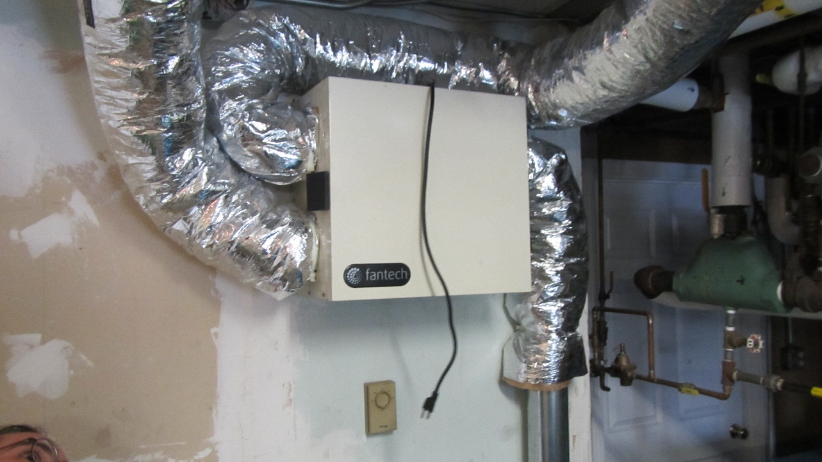
Heat exchanger system in mechanical room, note unit is unplugged
Picture 2
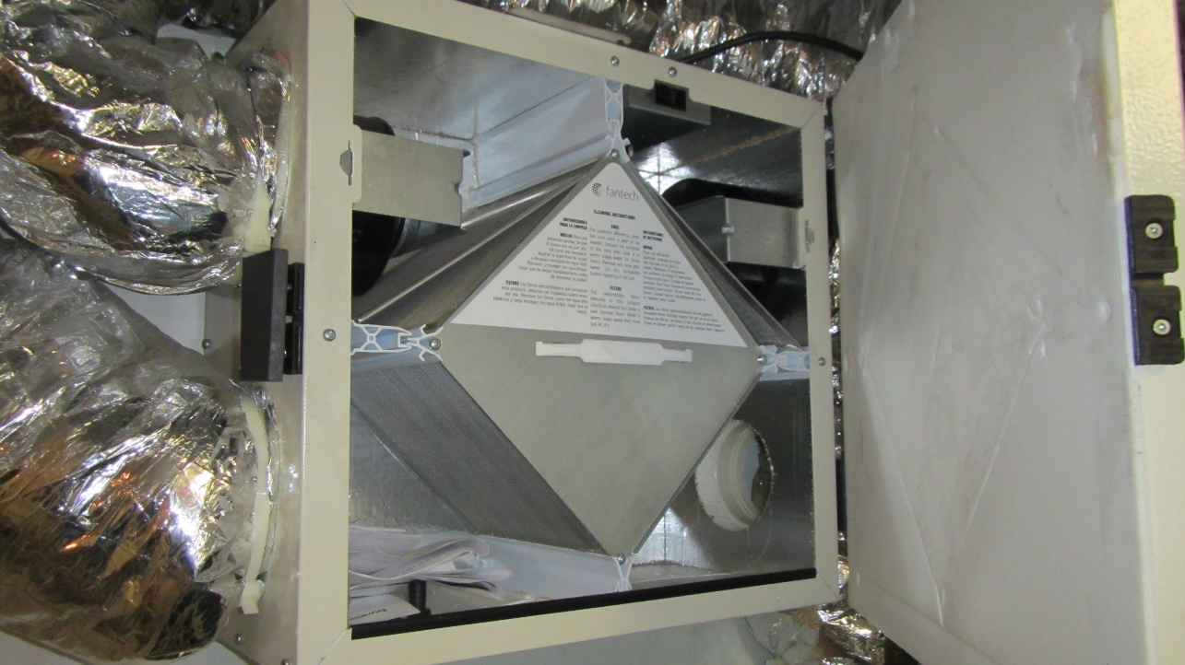
Heat exchanger contains paper instruction inside cabinet, indicating that this device has not been activated

Picture 3
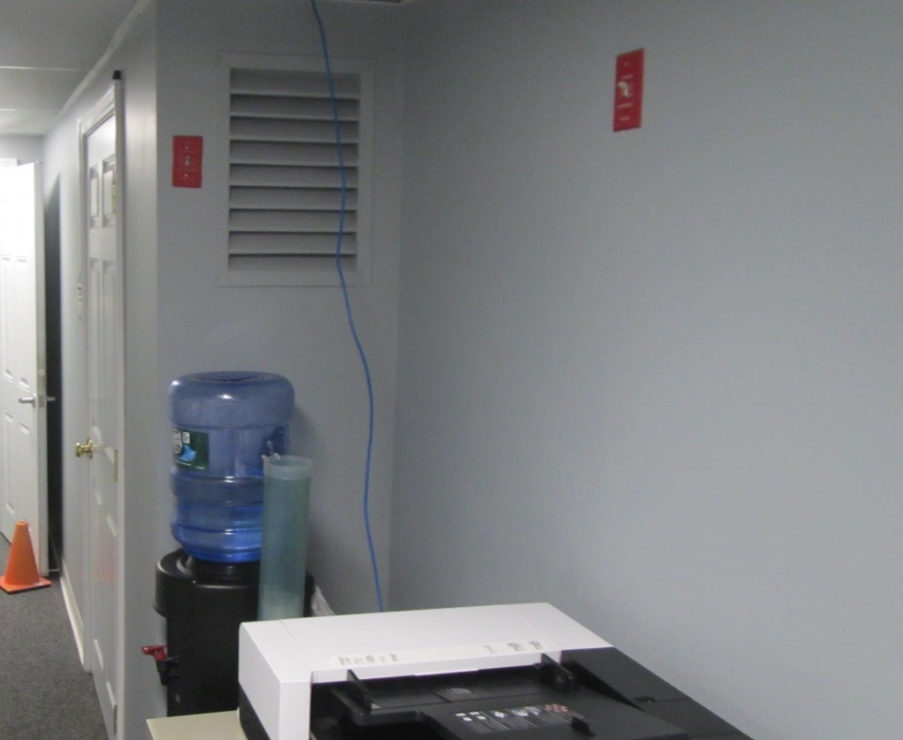
One vent in hallway, second behind water cooler
Picture 4
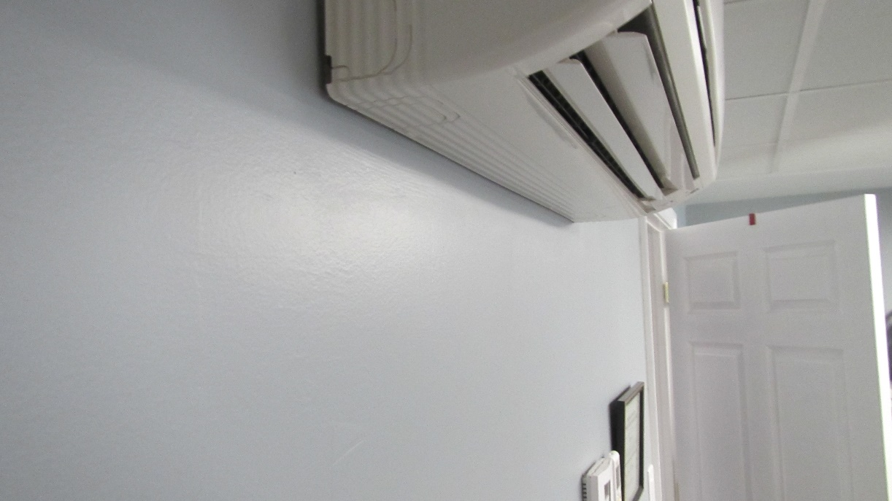
DMS in basement
Picture 5
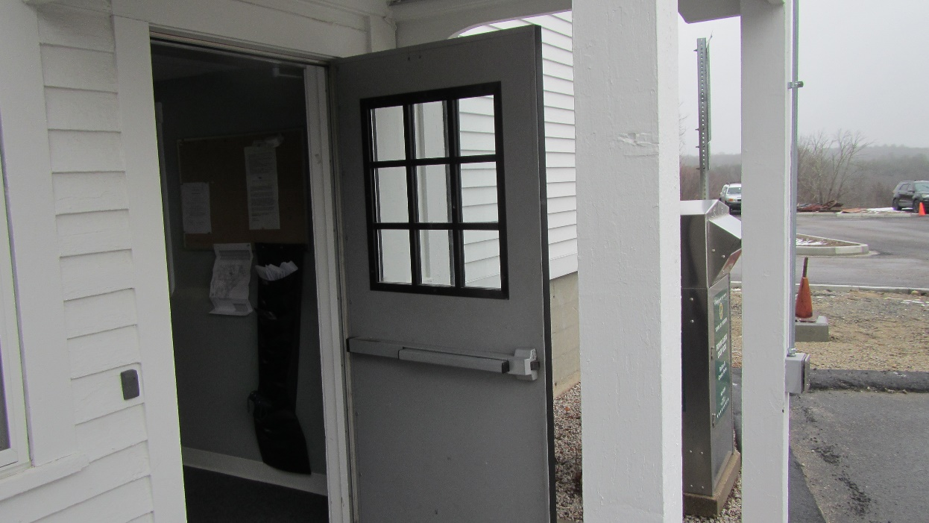
Basement exterior door disconnected from automatic closer
Picture 6
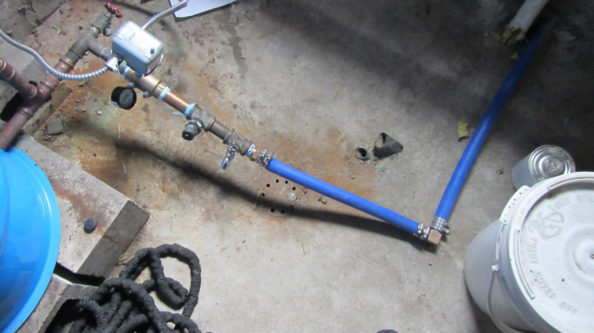
Drain in mechanical room floor
Location | Carbon  Dioxide  (ppm) | Carbon Monoxide  (ppm) | Temp  (°F) | Relative  Humidity  (%) | PM2.5  (µg/m³) | Occupants  in Room | Windows  Openable | Ventilation |  | Remarks
 |  |  |  |  |  |  |  | Supply | Exhaust
Background (outdoors) | 402 | 6 | 49 | 61 | 3
L3 | 688 | 5 | 69 | 36 | ND | 1 | N | N | N | Minisplits
L5 | 758 | 5 | 76 | 30 | ND | 0 | N | N | N
Town Clerk front room | 758 | 5 | 74 | 32 | ND | 2 | Y | N | N | Minisplits
Town clerk back room | 765 | 5 | 74 | 33 | ND | 0 | N | N | N
L4 | 580 | 5 | 70 | 31 | ND | 0 | N | N | N | Minisplit
L2 | 505 | 5 | 72 | 32 | ND | 0 | N | N | N | Minisplits
L6 restroom | 555 | 5 | 66 | 36 | ND | 0 | Y | N | N
L7 | 691 | 5 | 72 | 34 | ND | 0 | N | N | N

