INDOOR AIR QUALITY ASSESSMENT

Mendon Town Hall
20 Main Street
Mendon, Massachusetts

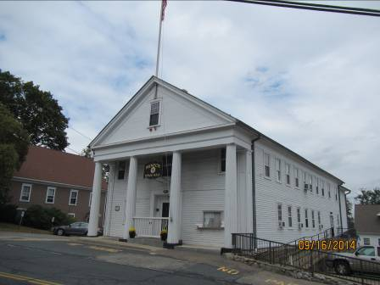

Prepared by:
Massachusetts Department of Public Health
Bureau of Environmental Health
Indoor Air Quality Program
October 2014

Background/Introduction
In response to a request from Leonard Izzo, Health Agent, Mendon Board of Health, the Massachusetts Department of Public Health (MDPH), Bureau of Environmental Health (BEH) provided assistance and consultation regarding indoor air quality (IAQ) concerns at the Mendon Town Hall (MTH) 20 Main Street, Mendon, Massachusetts. The request was prompted by general IAQ concerns in the building, including issues relating to sewer odors, mold growth in the basement, and reports of MTH staff having allergy symptoms. On September 16, 2014, the MTH was visited by Cory Holmes and Jason Dustin, Environmental Analysts/Inspectors in BEH’s IAQ Program to conduct an IAQ assessment.
The MTH is a two-story, wood building that was constructed in 1844. The building has a peaked roof with asphalt shingles. The building houses administrative offices for town departments as well as meeting rooms, a break room and record storage areas. Most windows are openable throughout the building although the basement area is limited to having only one. The building is heated by forced hot water radiators. There are a number of window-mounted air conditioning (AC) units to provide cooling for offices.

Methods
Air tests for carbon monoxide, carbon dioxide, temperature and relative humidity were conducted with the TSI, Q-Trak, IAQ Monitor, Model 7565. Air tests for airborne particle matter with a diameter less than 2.5 micrometers were taken with the TSI, DUSTTRAK™ Aerosol Monitor Model 8532. BEH/IAQ staff also performed a visual inspection of building materials for water damage and/or microbial growth.

Results
The MTH has an employee population of approximately 11 with the public conducting business daily. The tests were taken during normal operations and results appear in Table 1.

Discussion

Ventilation
It can be seen from Table 1 that carbon dioxide levels were above 800 parts per million (ppm) in 10 of 16 areas tested, indicating poor air exchange in the majority of the building at the time of the assessment (Table 1). It is also important to note, that many areas were sparsely populated or unoccupied at the time measurements were taken, which can greatly reduce carbon dioxide levels. Carbon dioxide levels would be expected to be higher with full occupancy.
The MTH does not have a mechanical ventilation system to introduce fresh air to occupied areas or to exhaust stale air from the building. Fresh air is introduced into the building solely by openable windows. Window AC units could potentially be set to “fan only” to provide a limited amount of fresh air to those areas equipped with these units, but this would prove impractical during winter months. Without supply/exhaust ventilation, indoor air pollutants can build up and lead to indoor air quality/comfort complaints.
Also, as mentioned previously, the basement area is limited to having only one window for the entire occupied space on this level. This would make proper ventilation in the basement extremely difficult to achieve at best.
Bathrooms at the MTH are not equipped with local exhaust vents but did have openable windows (Table 1). This may explain why MTH staff have complained of sewer odors in the bathroom and surrounding areas. Mechanical exhaust ventilation is necessary to effectively remove odors and moisture from these areas.
Minimum design ventilation rates are mandated by the Massachusetts State Building Code (MSBC). Until 2011, the minimum ventilation rate in Massachusetts was higher for both occupied office spaces and general classrooms, with similar requirements for other occupied spaces (BOCA, 1993). The current version of the MSBC, promulgated in 2011 by the State Board of Building Regulations and Standards (SBBRS), adopted the 2009 International Mechanical Code (IMC) to set minimum ventilation rates. Please note that the MSBC is a minimum standard that is not health-based. At lower rates of cubic feet per minute (cfm) per occupant of fresh air, carbon dioxide levels would be expected to rise significantly. A ventilation rate of 20 cfm per occupant of fresh air provides optimal air exchange resulting in carbon dioxide levels at or below 800 ppm in the indoor environment in each area measured. MDPH recommends that carbon dioxide levels be maintained at 800 ppm or below. This is because most environmental and occupational health scientists involved with research on IAQ and health effects have documented significant increases in indoor air quality complaints and/or health effects when carbon dioxide levels rise above the MDPH guidelines of 800 ppm for schools, office buildings and other occupied spaces (Sundell et al., 2011). The ventilation must be on at all times that the room is occupied. Providing adequate fresh air ventilation with open windows and maintaining the temperature in the comfort range during the cold weather season is impractical. Mechanical ventilation is usually required to provide adequate fresh air ventilation.
Carbon dioxide is not a problem in and of itself. It is used as an indicator of the adequacy of the fresh air ventilation. As carbon dioxide levels rise, it indicates that the ventilating system is malfunctioning or the design occupancy of the room is being exceeded. When this happens, a buildup of common indoor air pollutants can occur, leading to discomfort or health complaints. The Occupational Safety and Health Administration (OSHA) standard for carbon dioxide is 5,000 parts per million of air (ppm). Workers may be exposed to this level for 40 hours/week, based on a time-weighted average (OSHA, 1997).
The MDPH uses a guideline of 800 ppm for publicly occupied buildings. A guideline of 600 ppm or less is preferred in schools due to the fact that the majority of occupants are young and considered to be a more sensitive population in the evaluation of environmental health status. Inadequate ventilation and/or elevated temperatures are major causes of complaints such as respiratory, eye, nose and throat irritation, lethargy and headaches. For more information concerning carbon dioxide, please see Appendix A.
Temperature readings in occupied areas during the assessment ranged from 74ºF to 78ºF, which were within the MDPH recommended comfort guidelines (Table 1). The MDPH recommends that indoor air temperatures be maintained in a range of 70ºF to 78ºF in order to provide for the comfort of building occupants. In many cases concerning indoor air quality, fluctuations of temperature in occupied spaces are typically experienced, even in a building with an adequate fresh air supply. In addition, it is difficult to control temperature and maintain comfort without a functioning ventilation system.
The relative humidity measured in the building during the assessment ranged from 44 to 55 percent (Table 1), which was within the MDPH recommended comfort range. The MDPH recommends a comfort range of 40 to 60 percent for indoor air relative humidity. Due to the lack of mechanical ventilation system/air conditioning, it was reported that basement areas utilize portable dehumidifiers to maintain comfort and remove excess moisture. Relative humidity levels in the building would be expected to drop during the winter months due to heating. The sensation of dryness and irritation is common in a low relative humidity environment. Low relative humidity is a very common problem during the heating season in the northeast part of the United States.

Microbial/Moisture Concerns
Concerns were expressed by MTH staff relating to the growth of mold in basement areas. At the time of the assessment, BEH/IAQ staff noticed a strong musty odor in the Planning Board Meeting Room as well as the Planning Board Records Room both of which are located in the basement. Upon entering the Planning Board Records Room, BEH/IAQ staff observed water damage and visible mold on carpeting, plans, cardboard boxes, and on porous items located on shelving (Pictures 1 through 3). It was also observed that the painted surface of walls in the Planning Board Records Room had dark staining typical of mold colonization (Picture 4). BEH/IAQ staff observed a dehumidifier operating in this room. The dehumidifier was full to capacity with water and the carpeting beneath was water-damaged apparently from previous overflows of the dehumidifier due to lack of maintenance (Pictures 5 and 6). Improperly maintained dehumidifiers can be a source for water damage and microbial growth. The manufacturer’s recommendations should be followed regarding cleaning and proper maintenance procedures.
In order for building materials to support mold growth, a source of water exposure is necessary. Identification and elimination of the source of water moistening building materials is necessary to control mold growth. The MTH appears to have had a replacement roof installed recently. The gutter system and building envelope appear to be intact as well. However, a building contractor should be consulted regarding possible condensation/water intrusion contributing to chronically moist conditions in basement areas.
The US EPA and the American Conference of Governmental Industrial Hygienists (ACGIH) recommend that porous materials be dried with fans and heating within 24 to 48 hours of becoming wet (US EPA, 2001; ACGIH, 1989). If porous materials are not dried within this time frame, mold growth may occur. Once mold has colonized porous materials, they are difficult to clean and should be removed and discarded.
Water coolers were observed in carpeted areas. Spills or leaks from this equipment can moisten carpet and lead to microbial growth and degradation of the carpet. MDPH recommends placing rubber or plastic trays beneath this equipment to protect the carpet from leaks.
Plants were observed in some areas. Plants can be a source of pollen and mold, which can serve as respiratory irritants for some sensitive individuals. Plants should be properly maintained and equipped with drip pans to prevent water damage to porous building materials and be located away from ventilation sources to prevent the aerosolization of dirt, pollen or mold.

Other IAQ Evaluations
Indoor air quality can be negatively influenced by the presence of respiratory irritants, such as products of combustion. The process of combustion produces a number of pollutants. Common combustion emissions include carbon monoxide, carbon dioxide, water vapor, and smoke (fine airborne particle material). Of these materials, exposure to carbon monoxide and particulate matter with a diameter of 2.5 micrometers (μm) or less (PM2.5) can produce immediate, acute health effects upon exposure. To determine whether combustion products were present in the indoor environment, BEH/IAQ staff obtained measurements for carbon monoxide and PM2.5.

Carbon Monoxide
Carbon monoxide is a by-product of incomplete combustion of organic matter (e.g., gasoline, wood and tobacco). Exposure to carbon monoxide can produce immediate and acute health effects. Several air quality standards have been established to address carbon monoxide and prevent symptoms from exposure to these substances. The MDPH established a corrective action level concerning carbon monoxide in ice skating rinks that use fossil-fueled ice resurfacing equipment. If an operator of an indoor ice rink measures a carbon monoxide level over 30 ppm, taken 20 minutes after resurfacing within a rink, that operator must take actions to reduce carbon monoxide levels (MDPH, 1997).
The American Society of Heating Refrigeration and Air-Conditioning Engineers (ASHRAE) has adopted the National Ambient Air Quality Standards (NAAQS) as one set of criteria for assessing indoor air quality and monitoring of fresh air introduced by HVAC systems (ASHRAE, 1989). The NAAQS are standards established by the US EPA to protect the public health from six criteria pollutants, including carbon monoxide and particulate matter (US EPA, 2006). As recommended by ASHRAE, pollutant levels of fresh air introduced to a building should not exceed the NAAQS levels (ASHRAE, 1989). The NAAQS were adopted by reference in the Building Officials & Code Administrators (BOCA) National Mechanical Code of 1993 (BOCA, 1993), which is now an HVAC standard included in the Massachusetts State Building Code (SBBRS, 2011). According to the NAAQS, carbon monoxide levels in outdoor air should not exceed 9 ppm in an eight-hour average (US EPA, 2006).
Carbon monoxide should not be present in a typical, indoor environment. If it is present, indoor carbon monoxide levels should be less than or equal to outdoor levels. On the day of the assessment, outdoor carbon monoxide concentrations were non-detect (ND) (Table 1). No measureable levels of carbon monoxide were detected in the building during the assessment (Table 1).
However, MTH staff reported that on occasion, visitors park vehicles outside the building and leave engines idling, allowing vehicle exhaust to become entrained by window AC’s or open windows. M.G.L. chapter 90 section 16A prohibits the unnecessary operation of the engine of a motor vehicle for a foreseeable time in excess of five minutes (MGL, 1996). Anti-idling signs should be posted to discourage this behavior. Local police and health agents are given the authority to enforce this law.
Also of note were two large capacity oil boilers in the mechanical room. These units appear to be fairly new. In this room there is also a three-inch open pipe (Picture 7) which appears to be the combustion air source for the boilers. Based on the combustion rate/capacity of the boilers, this combustion source may be undersized. It is important to have an adequate source of combustion air for combustion of fuel and adequate venting of products of combustion (including CO) from the building. Without adequate combustion air, CO and other products of combustion may enter the mechanical room. This contingency becomes an acute safety issue since the basement is occupied by Mendon town employees.

Particulate Matter
The US EPA has established NAAQS limits for exposure to particulate matter. Particulate matter includes airborne solids that can be irritating to the eyes, nose and throat. The NAAQS originally established exposure limits to PM with a diameter of 10 μm or less (PM10). In 1997, US EPA established a more protective standard for fine airborne particulate matter with a diameter of 2.5 μm or less (PM2.5). This more stringent PM2.5 standard requires outdoor air particle levels be maintained below 35 μg/m³ over a 24-hour average (US EPA, 2006). Although both the ASHRAE standard and BOCA Code adopted the PM10 standard for evaluating air quality, MDPH uses the more protective PM2.5 standard for evaluating airborne PM concentrations in the indoor environment.
Outdoor PM2.5 concentrations were measured at 16 μg/m³ (Table 1). PM2.5 levels indoors ranged from 6 to 12 μg/m³ (Table 1), which were below the NAAQS PM2.5 level of 35 μg/m³. Frequently, indoor air levels of particulates (including PM2.5) can be at higher levels than those measured outdoors. A number of activities that occur indoors and/or mechanical devices can generate particulate matter during normal operations. Sources of indoor airborne particulates may include but are not limited to particles generated during the operation of fan belts in the HVAC system, use of stoves and/or microwave ovens in kitchen areas; use of photocopiers, fax machines and computer printing devices; operation of an ordinary vacuum cleaner and heavy foot traffic indoors.

Volatile Organic Compounds
Indoor air concentrations can be greatly impacted by the use of products containing volatile organic compounds (VOCs). VOCs are carbon-containing substances that have the ability to evaporate at room temperature. Total volatile organic compounds (TVOCs) can result in eye and respiratory irritation if exposure occurs. For example, chemicals evaporating from a paint can stored at room temperature would most likely contain VOCs. In an effort to identify materials that can potentially increase indoor VOC concentrations, BEH/IAQ staff examined rooms for products containing these respiratory irritants.
Several areas contained dry erase marker (DEM) boards and related materials. Materials such as dry erase markers and dry erase board cleaners may contain VOCs, such as methyl isobutyl ketone, n-butyl acetate and butyl-cellusolve (Sanford, 1999), which can be irritating to the eyes, nose and throat.
There are several photocopiers located throughout the MTH (Picture 8). Photocopiers can be sources of pollutants such as VOCs, ozone, heat and odors, particularly if the equipment is older and in frequent use. Both VOCs and ozone are respiratory irritants (Schmidt Etkin, 1992). Photocopiers should be kept in well ventilated rooms, and should be located near windows or exhaust vents.
Hand sanitizers were found in some offices and common areas (Table 1). Hand sanitizer products may contain ethyl alcohol and/or isopropyl alcohol, which are highly volatile and may be irritating to the eyes and nose and may contain fragrances to which some people may be sensitive.
Air fresheners and deodorizing materials were observed in some areas (Picture 9). Air deodorizers contain chemicals that can be irritating to the eyes, nose and throat of sensitive individuals. Many air fresheners contain 1,4-dichlorobenzene, a VOC which may cause reductions in lung function (NIH, 2006). Furthermore, deodorizing agents do not remove materials causing odors, but rather mask odors that may be present in the area.
Cleaning products contain chemicals that can be irritating to the eyes, nose and throat of sensitive individuals. These products should be properly labeled. Consideration should be given to working with building management to provide staff with compatible cleaning products and supplies to prevent any potential for adverse chemical interactions.

Other Conditions
Other conditions that can affect indoor air quality were observed during the assessment.
A number of wall heating units in the basement had accumulated dust/debris (Picture 10). One of these units appeared to be abandoned and covered with plastic sheeting (Picture 11). In addition, personal fans and AC filters also had accumulated dust/debris (Picture 12). Dust can be irritating to the eyes, nose and respiratory tract. These items should be cleaned periodically in order to prevent them from serving as a source of aerosolized particulates. Abandoned equipment should be repaired or properly removed/capped.
Most occupied areas had wall-to-wall carpeting (Table 1). The Institute of Inspection, Cleaning and Restoration Certification (IICRC), recommends that carpeting be cleaned annually (or semi-annually in soiled high traffic areas) (IICRC, 2012). The carpeting in the basement appears to be heavily soiled, worn and past its useful life (Pictures 6 and 13). Carpeting is generally not recommended in basement areas especially if exposed to chronic moisture. Since the average lifespan of carpeting is approximately eleven years (Bishop, 2002), consideration should be given to planning for the installation of new flooring. However, if asbestos containing tile is located beneath the soiled carpets, care should be taken not to disturb tiles. Where asbestos-containing materials are found damaged, these materials should be removed or remediated in a manner consistent with Massachusetts asbestos remediation laws (MDLI, 1993). Damaged tiles which may contain asbestos were observed in the mechanical room (Picture 14).
BEH/IAQ staff observed several gaps around utility pipes (Pictures 15 and 16) as well as spaces around windows which could allow moisture, odors and pests to enter the building envelope. These gaps to unconditioned spaces should be properly sealed.
Missing light covers were noted in a number of areas (Picture 17). Fixtures should be equipped with access covers installed with bulbs fully secured in their sockets. Breakage of glass can cause injuries and may release mercury and/or other hazardous compounds.
A bird’s nest was observed above a downspout in close proximity to a window (Picture 18) on the northwest (Library) side of the building. Birds and bird wastes can be sources of allergens and microbial contamination. The birds/nesting materials should be removed to avoid entrainment of these materials via nearby windows/AC units.
In some areas, accumulation of items, including papers, boxes and personal items were found stored on desks, tables and counters. Large numbers of items provide a source for dusts to accumulate. These items make it difficult for custodial staff to clean. Items should be relocated and/or cleaned periodically to avoid excessive dust build up.

Conclusions/Recommendations
In view of the findings at the time of the visit, the following recommendations are made:
- The plumbing department/fire department should be consulted as soon as possible to verify that the diameter of the combustion air source meets applicable codes given the window, ventilation and available air volume limitations in the basement. Mr. Izzo was notified of this concern by IAQ staff via an email on September 22, 2014.
- Use openable windows (in areas that have them) to bring fresh/outside air into occupied spaces. To facilitate airflow, operate AC’s in “fan only” setting. Utilize stand-up fans and open office doors to circulate air.
- Due to the lack of openable windows and mechanical ventilation, consideration should be given to relocating employees located in the basement until proper ventilation can be achieved.
- Consider installing an air handling unit (AHU) that incorporates both exhaust ventilation and fresh air intake to remove common indoor pollutants and alleviate health complaints. Consideration should be given during design to account for the location of local exhaust vents for point source pollutants such as copy areas, kitchen, and restrooms.
- Consult with a basement water intrusion prevention contractor and/or town engineers to prevent chronic water infiltration/condensation leading to microbial growth. Avoid storing porous items in areas subject to chronic moisture.
- Use dehumidifiers in the Planning Room and Planning Records Room to reduce relative humidity. Manufacturer’s recommendations concerning cleaning and regular maintenance should be followed to avoid water damage and microbial growth.
- Remove and discard porous items that have visible mold colonization (carpeting, plans, cardboard boxes, papers, etc.). Items of importance such as plans or important legal documents could be scanned or copied prior to discarding.
- Clean and disinfect mold-colonized nonporous surfaces with a mild detergent or antimicrobial agent according to EPA guidelines (US EPA, 2001).
- Consult “Mold Remediation in Schools and Commercial Buildings” published by the US Environmental Protection Agency (US EPA, 2001) for more information on mold. This document can be downloaded from the US EPA website at: http://www.epa.gov/mold/mold_remediation.html.
- Clean carpeting annually (or semi-annually in soiled high traffic areas) as per the recommendations of the Institute of Inspection, Cleaning and Restoration Certification (IICRC, 2012). Copies of the IICRC fact sheet are available at: http://www.iicrc.org/consumers/care/carpet-cleaning/#faq.
- Consider replacing carpeting over 10 years old with a non-porous surface (e.g., vinyl floor tiles) for basement areas and carpet squares in above grade levels for easier maintenance/replacement. Please note, due to the possibility of asbestos-containing materials (e.g., floor tiles/mastic) beneath carpeting, carpet removal should be conducted under conditions as to not disturb tiles. If not feasible, contact a licensed asbestos remediation firm as well as the Massachusetts Division of Labor and Industries (MDLI), Asbestos Program for guidance.
- Determine if floor tiles in the mechanical room contain asbestos. Where asbestos-containing materials are found damaged, these materials should be removed or remediated in a manner consistent with Massachusetts asbestos remediation laws (MDLI, 1993).
- Seal around all utility holes in walls/ceilings with fire proof expanding foam insulation or suitable material to prevent vapors and particulates from passing into occupied areas.
- For buildings in New England, periods of low relative humidity during the winter are often unavoidable. Therefore, scrupulous cleaning practices should be adopted to minimize common indoor air contaminants whose irritant effects can be enhanced when the relative humidity is low. To control for dusts, a high efficiency particulate arrestance (HEPA) filter equipped vacuum cleaner in conjunction with wet wiping of all surfaces is recommended. Avoid the use of feather dusters. Drinking water during the day can help ease some symptoms associated with a dry environment (throat and sinus irritations).
- Light fixtures should be equipped with access covers installed with bulbs fully secured in their sockets. Store fluorescent bulbs in a protective container and locate them in a secure area. Breakage of glass can cause injuries and may release mercury and/or other hazardous compounds.
- Anti-idling signs should be posted to discourage people from leaving vehicles idling adjacent to the building. Local police and health agents are given the authority to enforce this law (M.G.L. chapter 90 section 16A).
- Clean dust/debris from personal fans and wall heating units. Abandoned heating units should be repaired or removed and plumbing properly capped.
- Clean filters in window AC units and clean upholstered furniture regularly.
- To reduce exposure to VOC’s: locate photocopiers in well ventilated rooms and reduce or eliminate the use of dry erase boards, hand sanitizers, air fresheners and cleaners with high VOC content.
- Consider placing rubber or plastic trays beneath water coolers to protect the carpet from any water damage and microbial growth.
- Plants should be properly maintained and equipped with drip pans to prevent water damage to porous building materials and be located away from ventilation sources to prevent the aerosolization of dirt, pollen or mold.
- To prevent the potential for adverse chemical interactions, consideration should be given to working with building management to provide staff with compatible cleaning products and supplies.
- Consider discontinuing use of air fresheners/deodorizers to prevent exposure to VOCs.
- Remove birds/nesting materials located above downspout on northwest (Library) side of the building should be removed to avoid entrainment of these materials in the nearby windows or AC units.
- Large amounts of accumulated items on flat surfaces should be relocated and/or cleaned periodically to avoid excessive dust build up.
- Refer to resource manuals and other related indoor air quality documents for further building-wide evaluations and advice on maintaining public buildings. Copies of these materials are located on the MDPH’s website: http://mass.gov/dph/iaq.

References
ACGIH. 1989. Guidelines for the Assessment of Bioaerosols in the Indoor Environment. American Conference of Governmental Industrial Hygienists, Cincinnati, OH.
ASHRAE. 1989. Ventilation for Acceptable Indoor Air Quality. American Society of Heating, Refrigeration and Air Conditioning Engineers. ANSI/ASHRAE 62-1989.
Bishop. 2002. Bishop, J. & Institute of Inspection, Cleaning and Restoration Certification. A Life Cycle Cost Analysis for Floor Coverings in School Facilities.
BOCA. 1993. The BOCA National Mechanical Code/1993. 8th ed. Building Officials & Code Administrators International, Inc., Country Club Hills, IL.
IICRC. 2012. Institute of Inspection, Cleaning and Restoration Certification. Carpet Cleaning: FAQ. Retrieved from http://www.iicrc.org/consumers/care/carpet-cleaning/#faq.
MDLI. 1993. Regulation of the Removal, Containment or Encapsulation of Asbestos, Appendix 2. 453 CMR 6,92(I)(i).
MDPH. 1997. Requirements to Maintain Air Quality in Indoor Skating Rinks (State Sanitary Code, Chapter XI). 105 CMR 675.000. Massachusetts Department of Public Health, Boston, MA.
NIH. 2006. Chemical in Many Air Fresheners May Reduce Lung Function. NIH News. National Institute of Health. July 27, 2006. http://www.nih.gov/news/pr/jul2006/niehs-27.htm
MGL. 1996. Stopped motor vehicles; Operation of Engine; Time Limit; Penalty. Massachusetts General Laws. M.G.L. c. 90:16A.
OSHA. 1997. Limits for Air Contaminants. Occupational Safety and Health Administration. Code of Federal Regulations. 29 C.F.R 1910.1000 Table Z-1-A.
SBBRS. 2011. Mechanical Ventilation. State Board of Building Regulations and Standards. Code of Massachusetts Regulations, 8th edition. 780 CMR 1209.0.
Schmidt Etkin, D. 1992. Office Furnishings/Equipment & IAQ Health Impacts, Prevention & Mitigation. Cutter Information Corporation, Indoor Air Quality Update, Arlington, MA.
Sundell. 2011. Sundell, J., H. Levin, W. W. Nazaroff, W. S. Cain, W. J. Fisk, D. T. Grimsrud, F. Gyntelberg, Y. Li, A. K. Persily, A. C. Pickering, J. M. Samet, J. D. Spengler, S. T. Taylor, and C. J. Weschler. Ventilation rates and health: multidisciplinary review of the scientific literature. Indoor Air, Volume 21: pp 191–204.
US EPA. 2001. “Mold Remediation in Schools and Commercial Buildings”. Office of Air and Radiation, Indoor Environments Division, Washington, DC. EPA 402-K-01-001. March 2001. Available at: http://www.epa.gov/iaq/molds/mold_remediation.html.
US EPA. 2006. National Ambient Air Quality Standards (NAAQS). US Environmental Protection Agency, Office of Air Quality Planning and Standards, Washington, DC. http://www.epa.gov/air/criteria.html.
Picture 1

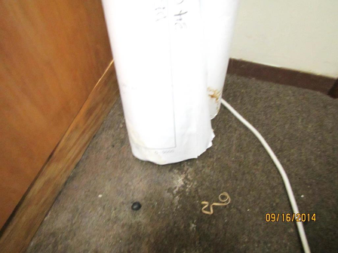

Water-damaged plans and mold along baseboard and carpet

Picture 2

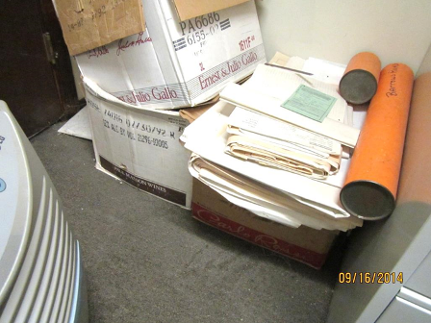

Water-damaged, mold-colonized boxes/papers
Picture 3

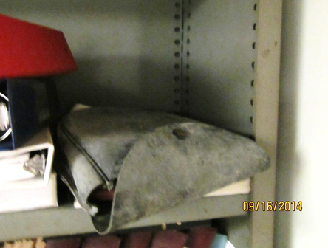

Mold-colonized porous items on shelving

Picture 4

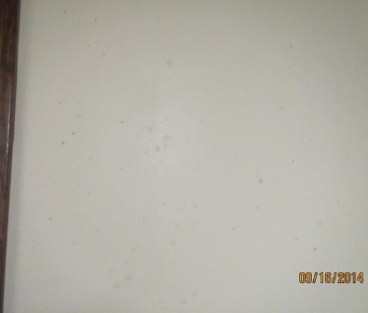

Visible mold on surface of wall in Planning Records Room

Picture 5

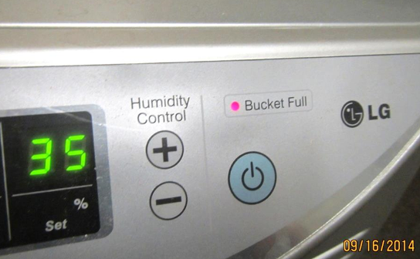

Dehumidifier showing water “bucket full” red light indicator

Picture 6

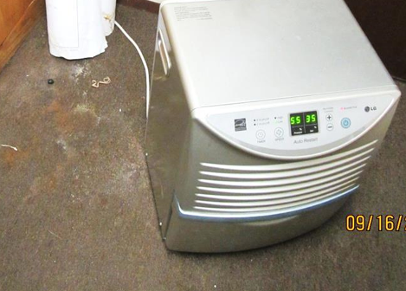

Water-damaged/mold-colonized carpeting under/beside dehumidifier

Picture 7

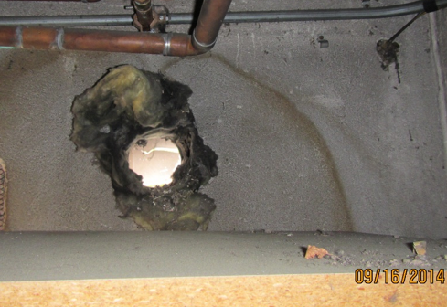

Combustion air source pipe exiting the mechanical room (arrow)

Picture 8

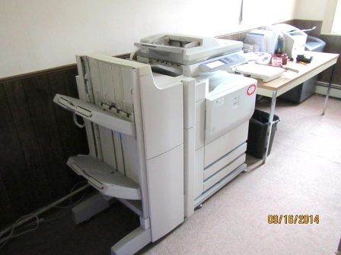

Photocopier lacking local exhaust vent

Picture 9

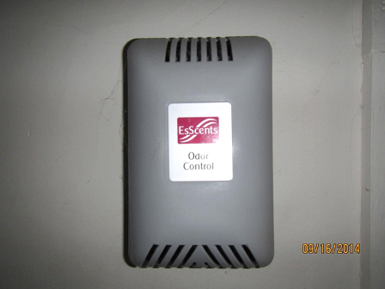

Air deodorizing unit located in bathroom

Picture 10

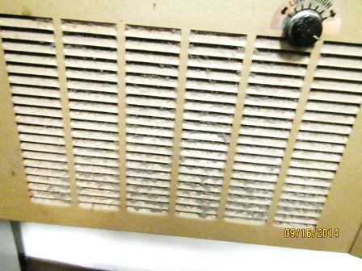

Wall heating unit occluded with dust/debris

Picture 11

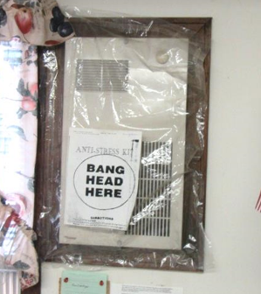

Abandoned wall heating unit covered with plastic sheeting

Picture 12

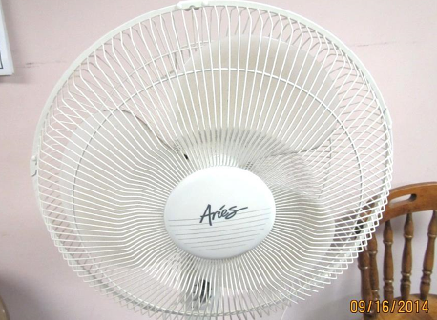

Personal fan with accumulated dust/debris

Picture 13

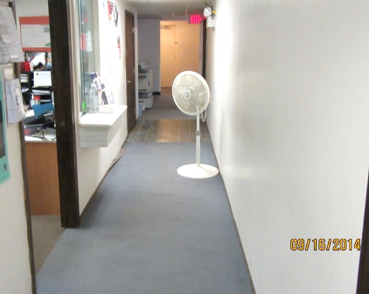

Worn carpeting >10 years old

Picture 14

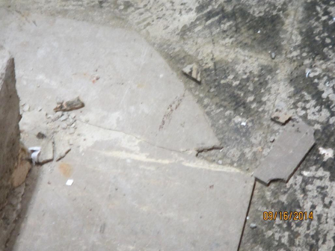

Damaged tile in mechanical room possibly containing asbestos

Picture 15

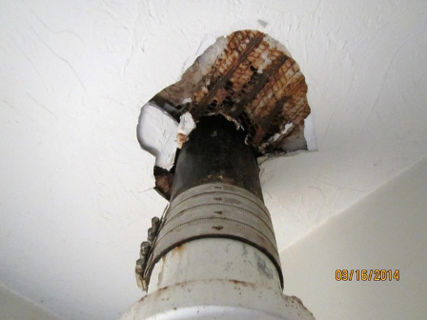

Gaps around sewer pipe in basement bathroom

Picture 16

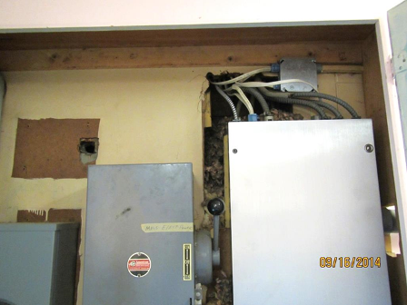

Gaps/breaches in wall in electrical closet leading to ZBA office space

Picture 17

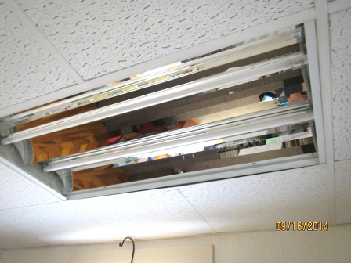

Light fixture missing cover

Picture 18

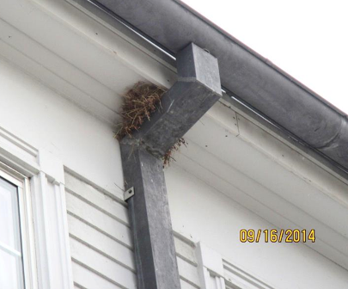

Bird nest above downspout near window
Location | Carbon  Dioxide  (ppm) | Carbon Monoxide  (ppm) | Temp  (°F) | Relative  Humidity  (%) | PM2.5  (µg/m³) | Occupants  in Room | Windows  Openable | Ventilation |  | Remarks
 |  |  |  |  |  |  |  | Supply | Exhaust | Remarks
Background | 360 | ND | 65 | 58 | 16 |  |  |  |  | Overcast, cool
Basement
Planning Board meeting room | 989 | ND | 76 | 55 | 11 | 4 | N | N | N | PF-dusty, old carpet, musty odor, passive door vents
Bathroom |  |  |  |  |  |  | Y | N | N | No local exhaust fan, gaps around soil pipe at ceiling, Air deodorizing unit
Planning Board records room |  |  |  |  |  |  | N | N | N | Dehumidifier full/overflowing, soiled carpet, strong musty odor, MT, WD carpet. Mold on carpet, papers/items and walls. Boxes of files stuck to carpet, Moldy items on shelf and in boxes, WD plans, fluorescent bulbs leaning against wall, cobwebs, dust and debris.
Conservation | 811 | ND | 78 | 48 | 12 | 2 | N | N | N | Carpet, PF, CT ajar
Board of Health | 722 | ND | 78 | 48 | 10 | 1 | N | N | N | DO, old carpet, missing light cover, passive vent on door
Mechanical Room |  |  |  |  |  |  |  |  |  | Damaged floor tiles, ensure sufficient make-up air for new boilers, open drain
Building Dept. | 773 | ND | 78 | 46 | 11 | 1 | Y | N | N | AC in window, old carpet, HS, dusty heating unit in wall
Building Dept. Office | 770 | ND | 77 | 49 | 11 | 0 | N | N | N | Carpet, files/plans
First Floor
Town Clerk-102 | 843 | ND | 74 | 48 | 10 | 1 | Y | N | N | Window AC, missing light cover, baseboard radiators
Mail Room/lunch | 909 | ND | 76 | 46 | 10 | 1 | Y | N | N | PC (not vented), carpet, missing light cover
Assessor’s-104 | 903 | ND | 77 | 46 | 9 | 1 | Y | N | N | PF, AI
Collector’s-103 | 868 | ND | 76 | 44 | 9 | 0 | Y | N | N | Missing light cover
Treasurer/Collector | 869 | ND | 78 | 45 | 8 | 2 | Y | N | N | PF
Administrative-106 | 948 | ND | 77 | 44 | 9 | 1 | Y | N | N | DO, carpet, AC in window
Town Adm. Office | 956 | ND | 77 | 44 | 9 | 2 | Y | N | N | Carpet, AC in window
Break Room | 859 | ND | 77 | 44 | 9 | 0 | Y | N | N | Floor tile, microwave, refrigerator, etc.
Bathrooms |  |  |  |  |  |  | Y | N | N | No exhaust vents
Second Floor
Selectmen’s Meeting Room | 757 | ND | 75 | 46 | 6 | 2 | Y | N | N | AC’s in windows
Town Accountant-205 | 761 | ND | 75 | 48 | 9 | 1 | Y | N | N | AC in window, missing light cover, carpet, ceiling fan
ZBA office | 715 | ND | 74 | 52 | 9 | 0 | Y | N | N | AC in window, gaps around electrical conduits in cabinet; uncapped wire

