# Enforcement APP – Cheat Sheet

1. Use Internet Explorer 11
2. Disable Pop-up blocker
3. Always hit “Clear” key before initiating new search on Enforcement Lookup Application
4. For password reset, send an email to [ole.registraion@state.ma.us](mailto:ole.registraion@state.ma.us)

# Disabling Pop-Up Blocker – IE 11

1. Open IE browser
2. Click on Tools -> Internet options.

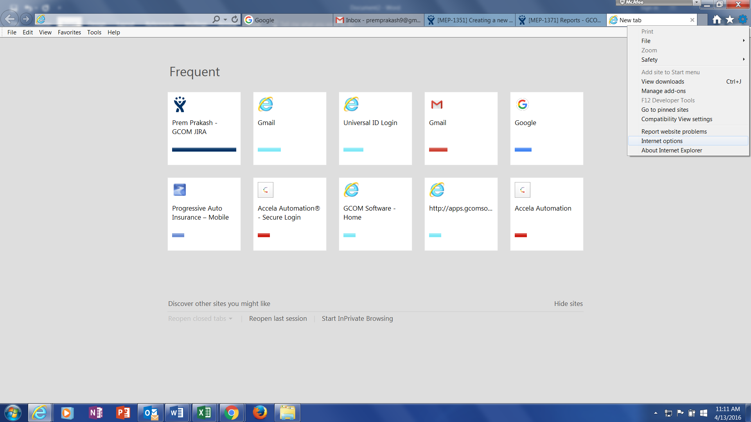

1. A new window will pop-up, Click on Privacy tab
2. Under Pop-up blocker section, check that "Turn on Pop-up blocker" check-box is not selected.
3. Click on "Apply" and then click on "OK"

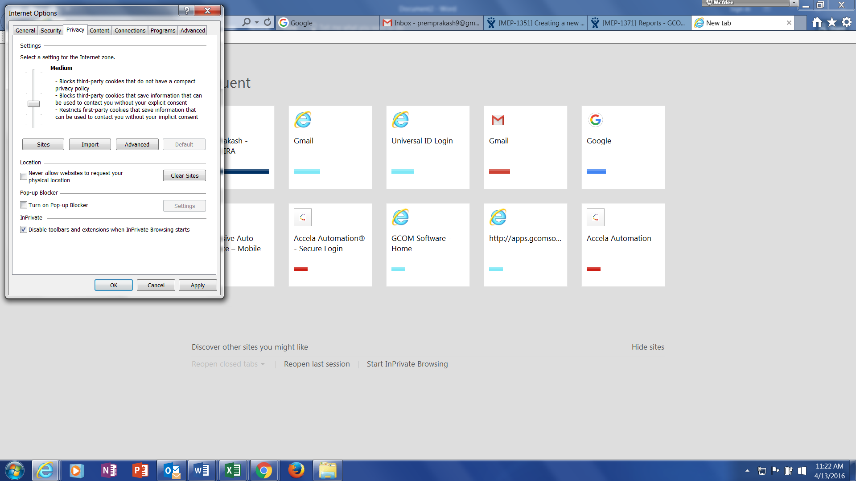

1. Close and restart the browser.

# Clearing Cache

1. Open IE browser
2. Click on Tools -> Internet options.



1. A new window will pop-up, you are in General tab.
2. Click delete.

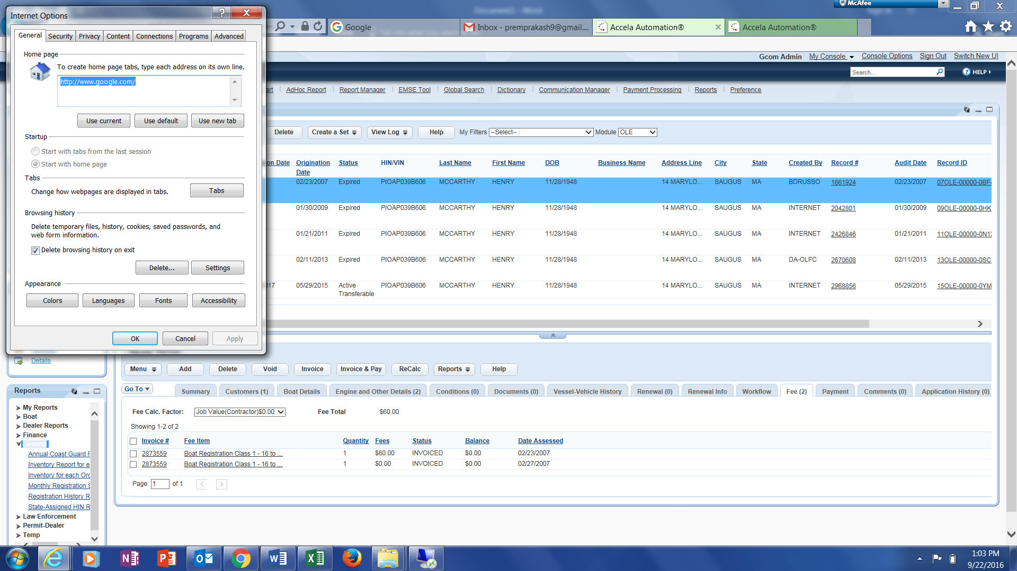

1. A new window will pop, check the boxes.
2. Click Delete.

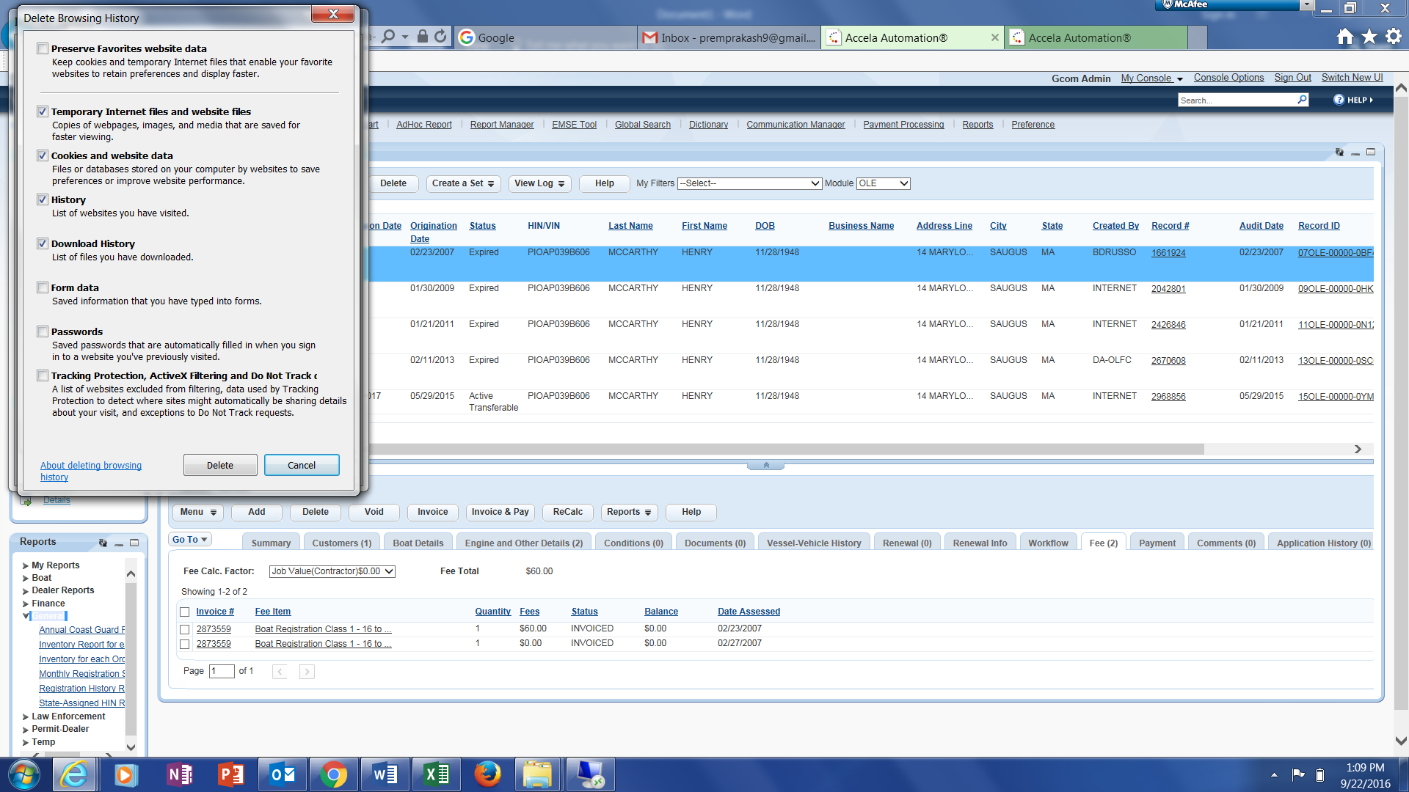

1. Click Ok.



1. Close and restart the browser.

# InPrivate Browsing – IE 11

1. Open IE browser
2. Open New Tab and click “Start InPrivate Browsing”

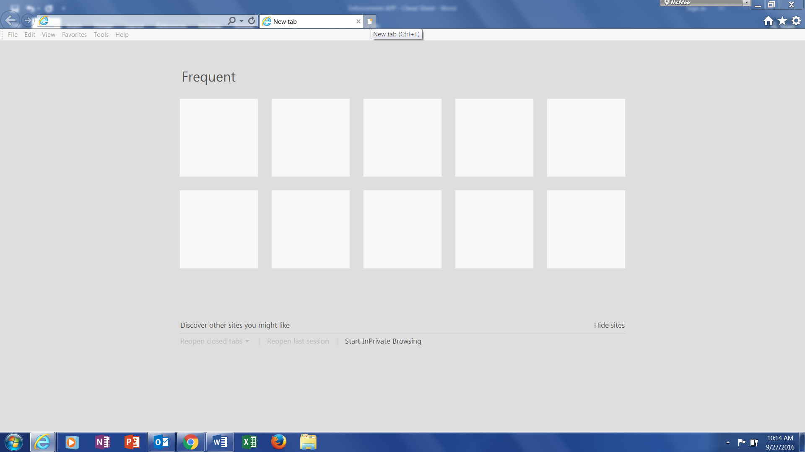

1. New window will open; user can start browsing.