

Massachusetts Environmental Police

Law Enforcement Lookup Guide

Table of Contents

Instructions for Enforcement Lookup Web Application 3

Search – Customer 5

Search – Registration Number 8

Exact Match 9

Starts With/Partial Information 11

Search - HIN/VIN 15

Reports 17

Registration History Report 17

Disabling Pop-Up Blocker – IE 11 21

# Instructions for Enforcement Lookup Web Application

Login to Enforcement Lookup Web Application:

* Access login page using **Internet Explorer 11**
* **Disable Pop-Up Blocker** (disabling instructions are provided on page 23)
* Enter User Name and Password provided
* Click Login

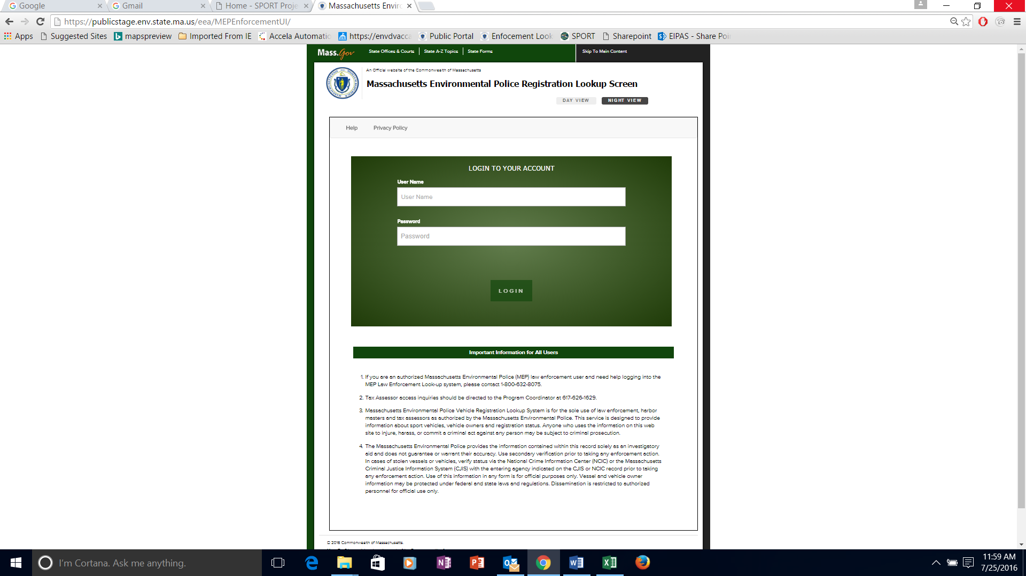

After successful login, Enforcement Lookup opens to the Search Page.

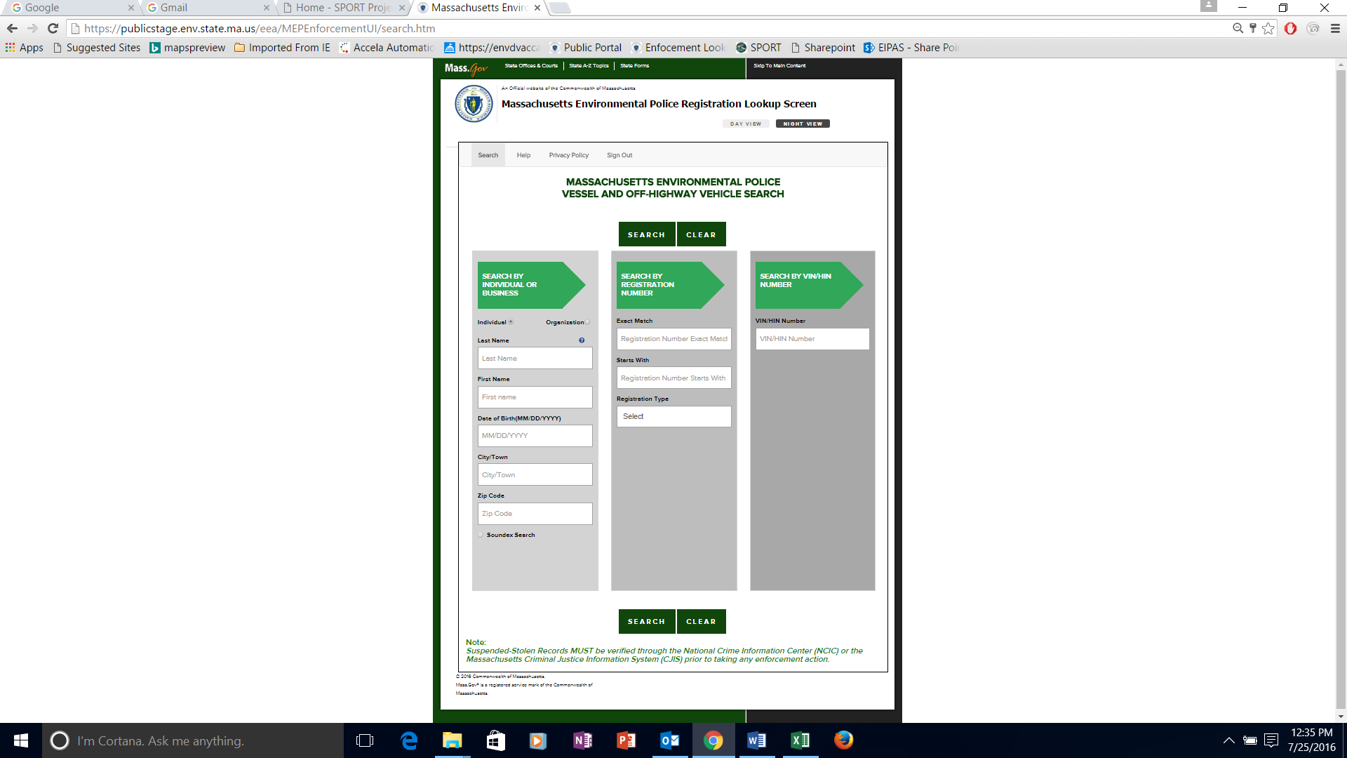

A search is initiated using customer information (individual/organization name), Registration Number, or HIN/VIN. Registration number searches can leverage exact information or partial information (Starts With).

# Search – Customer

Enter the individual or business information and click the Search button.

Note: Once a user enters information in the individual or business search fields, Registration Number and VIN/HIN search fields are disabled (greyed out).



Once the Search button is clicked, the system will navigate the user to the Owner Information page, which displays customers’ personal information and inventory.

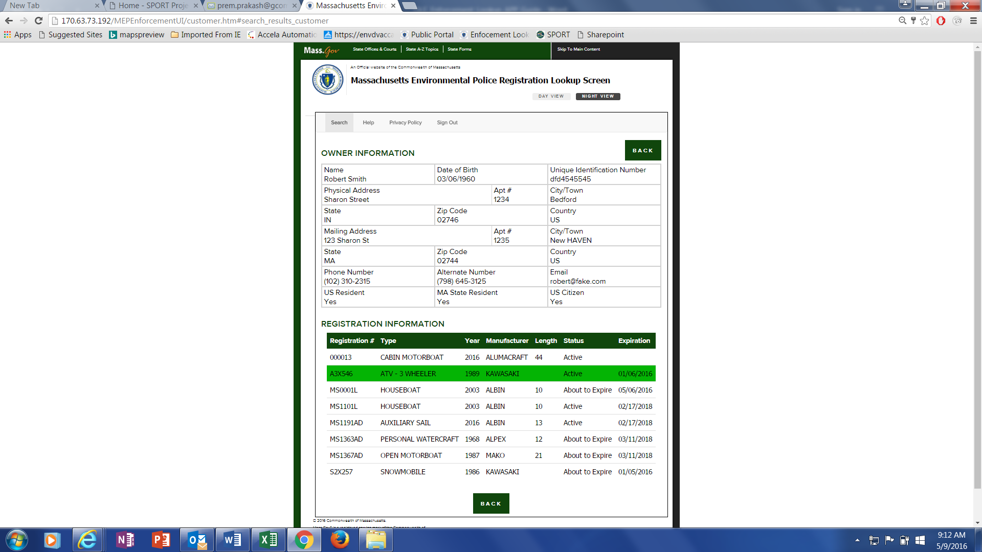

User can click on any particular registration record to check more information related to that record. Note: User can click on the Back button to return to the search page.

Upon selection of a record, the system will show vessel/vehicle information, engine information and owner information related to that record.

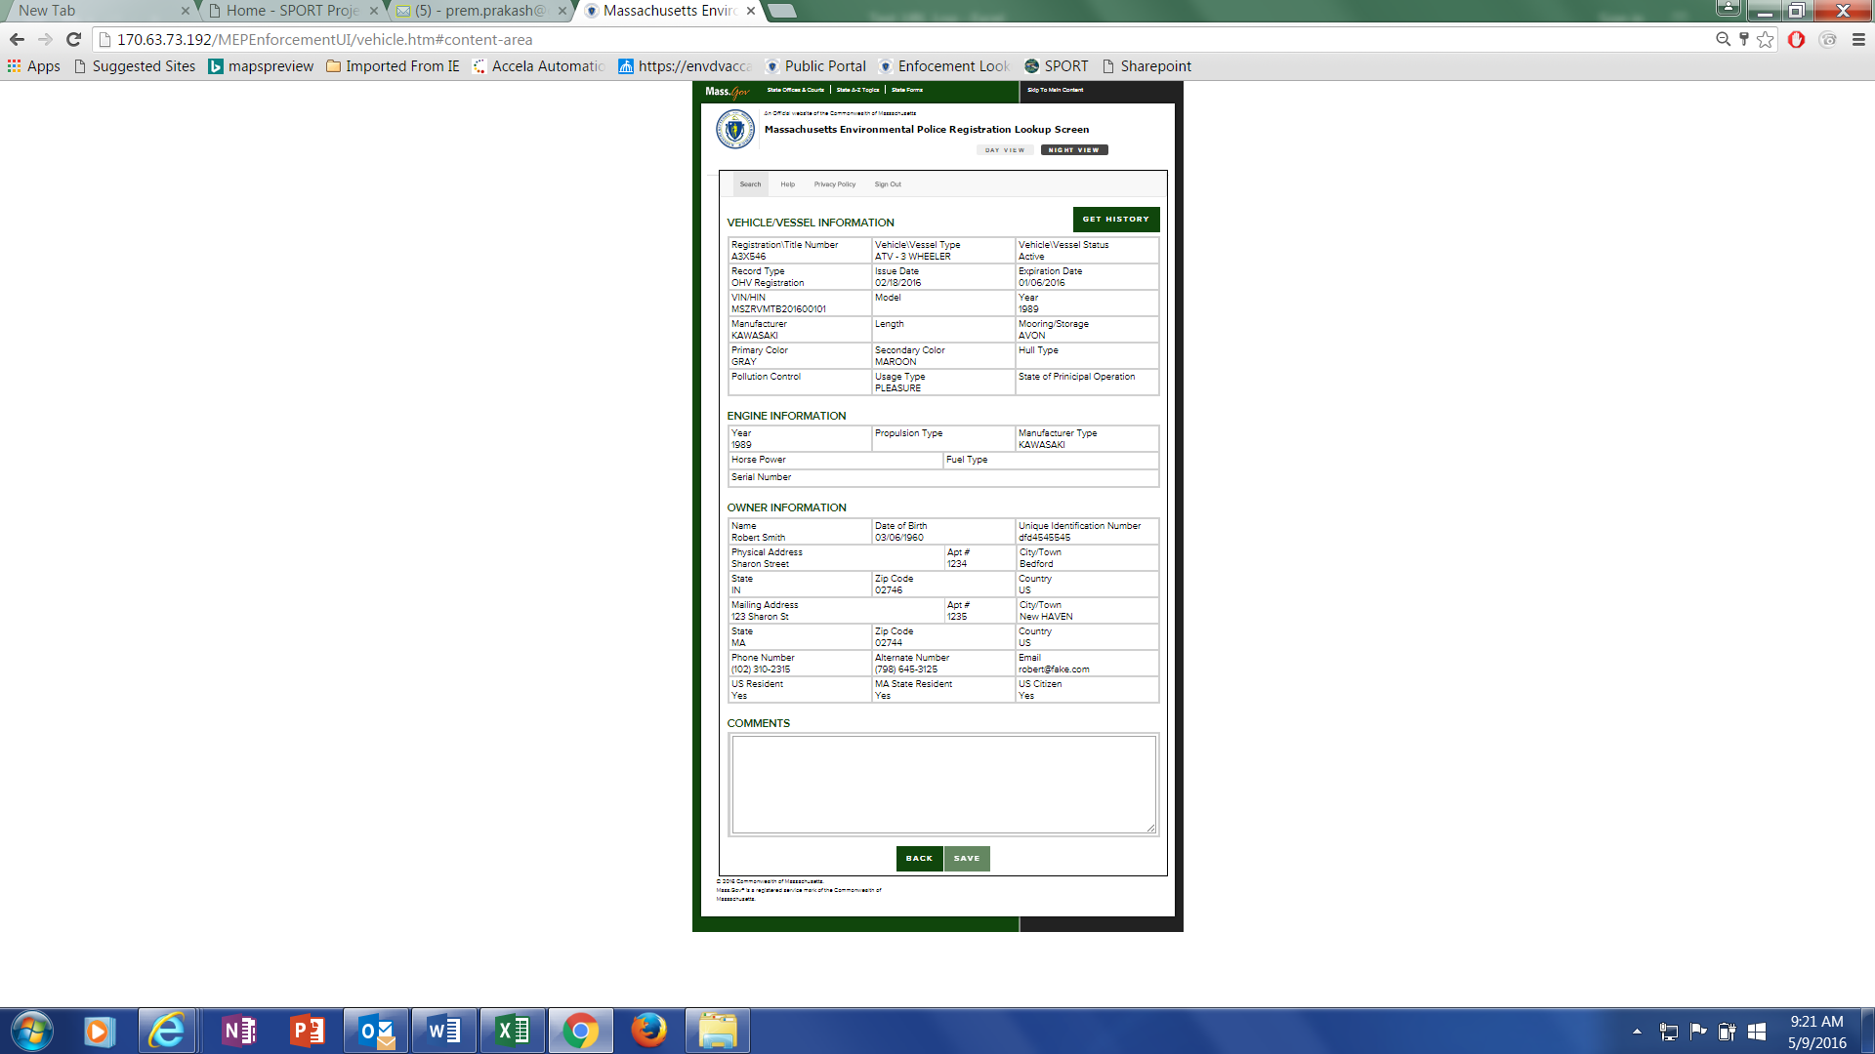

All information displayed is read only. Massachusetts Environment Police (MEP) officers can write and save a comment related to the record. All comments are logged and subject to public record inquiries.

# Search – Registration Number

An exact or partial search will include all registration and title types. Users can search for Dealer Permit and Title Numbers by entering information in this field. The search results can be narrowed by using the Registration Type drop-down menu.

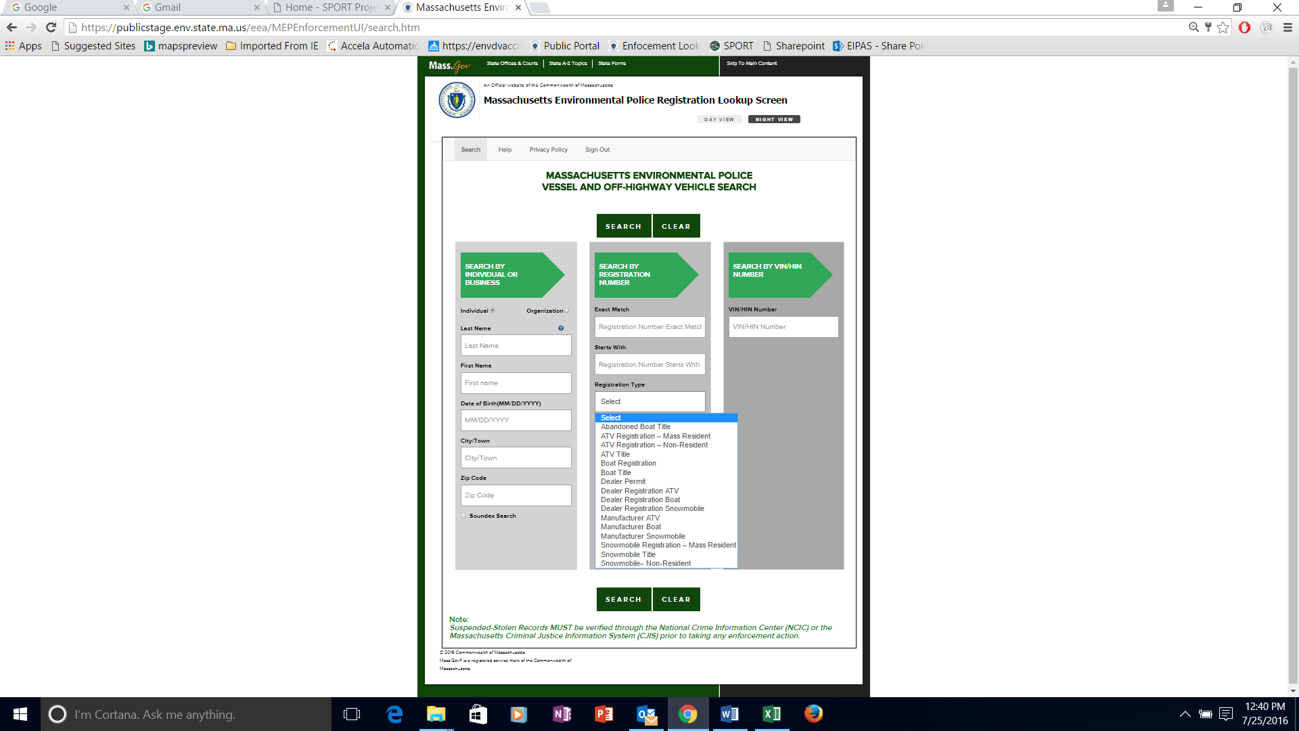

## Exact Match

Users can initiate a search using registration number.



Once the Search button is clicked, the system will show the search results.

All information displayed is read only. MEP officers can write and save a comment related to the record. All comments are logged and subject to public record inquiries.



All information displayed is read only. Massachusetts Environment Police (MEP) officers can write and save a comment related to the record. All comments are logged and subject to public record inquiries.

## Starts With/Partial Information

Users can initiate a search using Starts With (a partial information search) and the system will return with all the matched records.



Users will click on the particular record within the Search Results to view the record’s details.

Each row reflects a record. Click on a row/record to view the vessel/vehicle information, engine information and owner information related to that record.

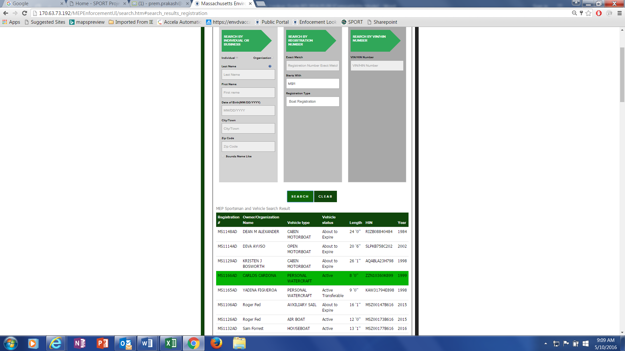

Once the record is clicked, the system will show vessel/vehicle information, engine information and owner information related to that record.



All information displayed is read only. MEP officers can insert and save a comment related to the record. All comments are logged and subject to public record inquiries.

# Search - HIN/VIN

Users can initiate a search using HIN/VIN.



Once the HIN/VIN is entered and searched, the most current registration will show. To see the HIN/VIN History see page 17.



All information displayed is read only. MEP officers can write and save a comment related to the record. All comments are logged and subject to public record inquiries.

# Reports

Two reports that can be retrieved from the vessel/vehicle information page are Registration History Report and Tax Assessor Report.

## Registration History Report

The Get History button generates the Registration History Report, which contains detailed registration and owner history for the vessel/vehicle.



Once clicked, the Registration History report will open in a new window.

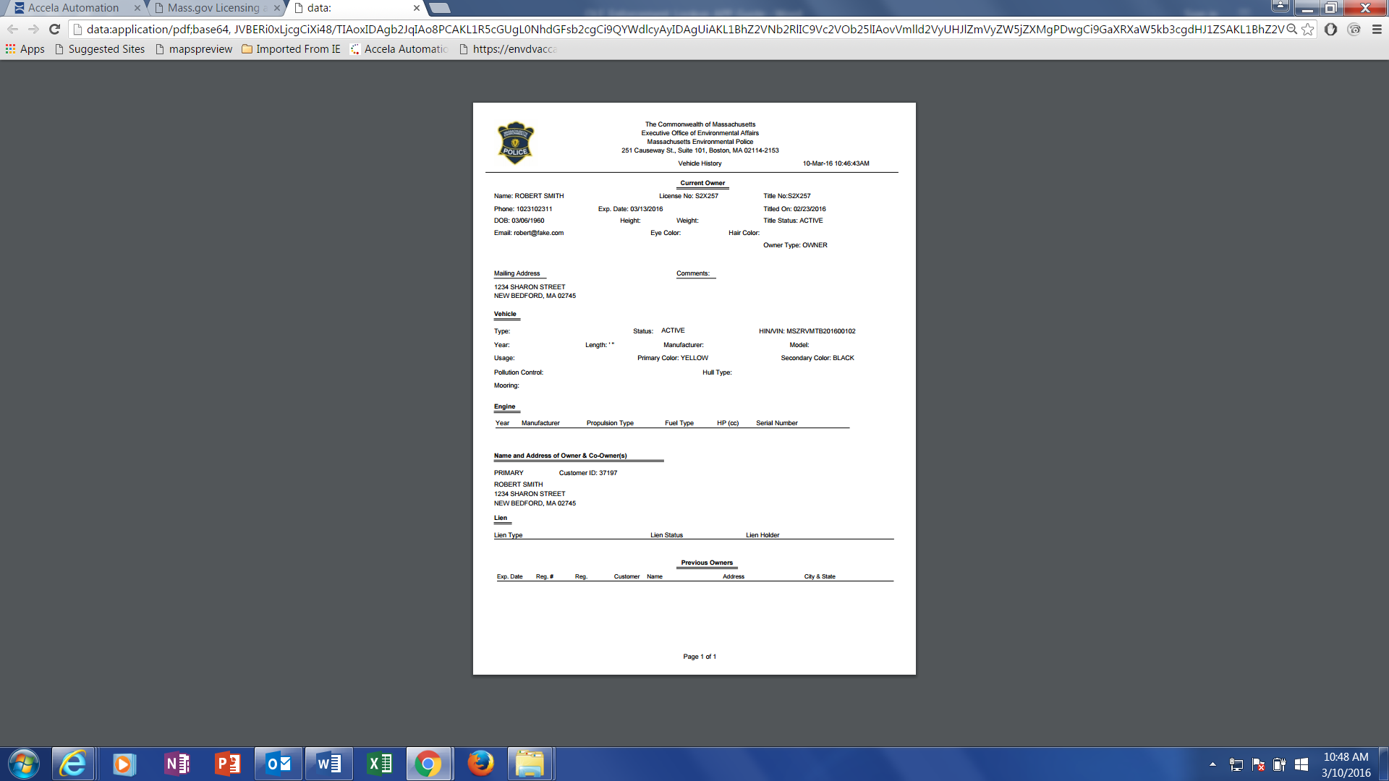

Night View

When operating in dark/night, users can switch their views for better vision.

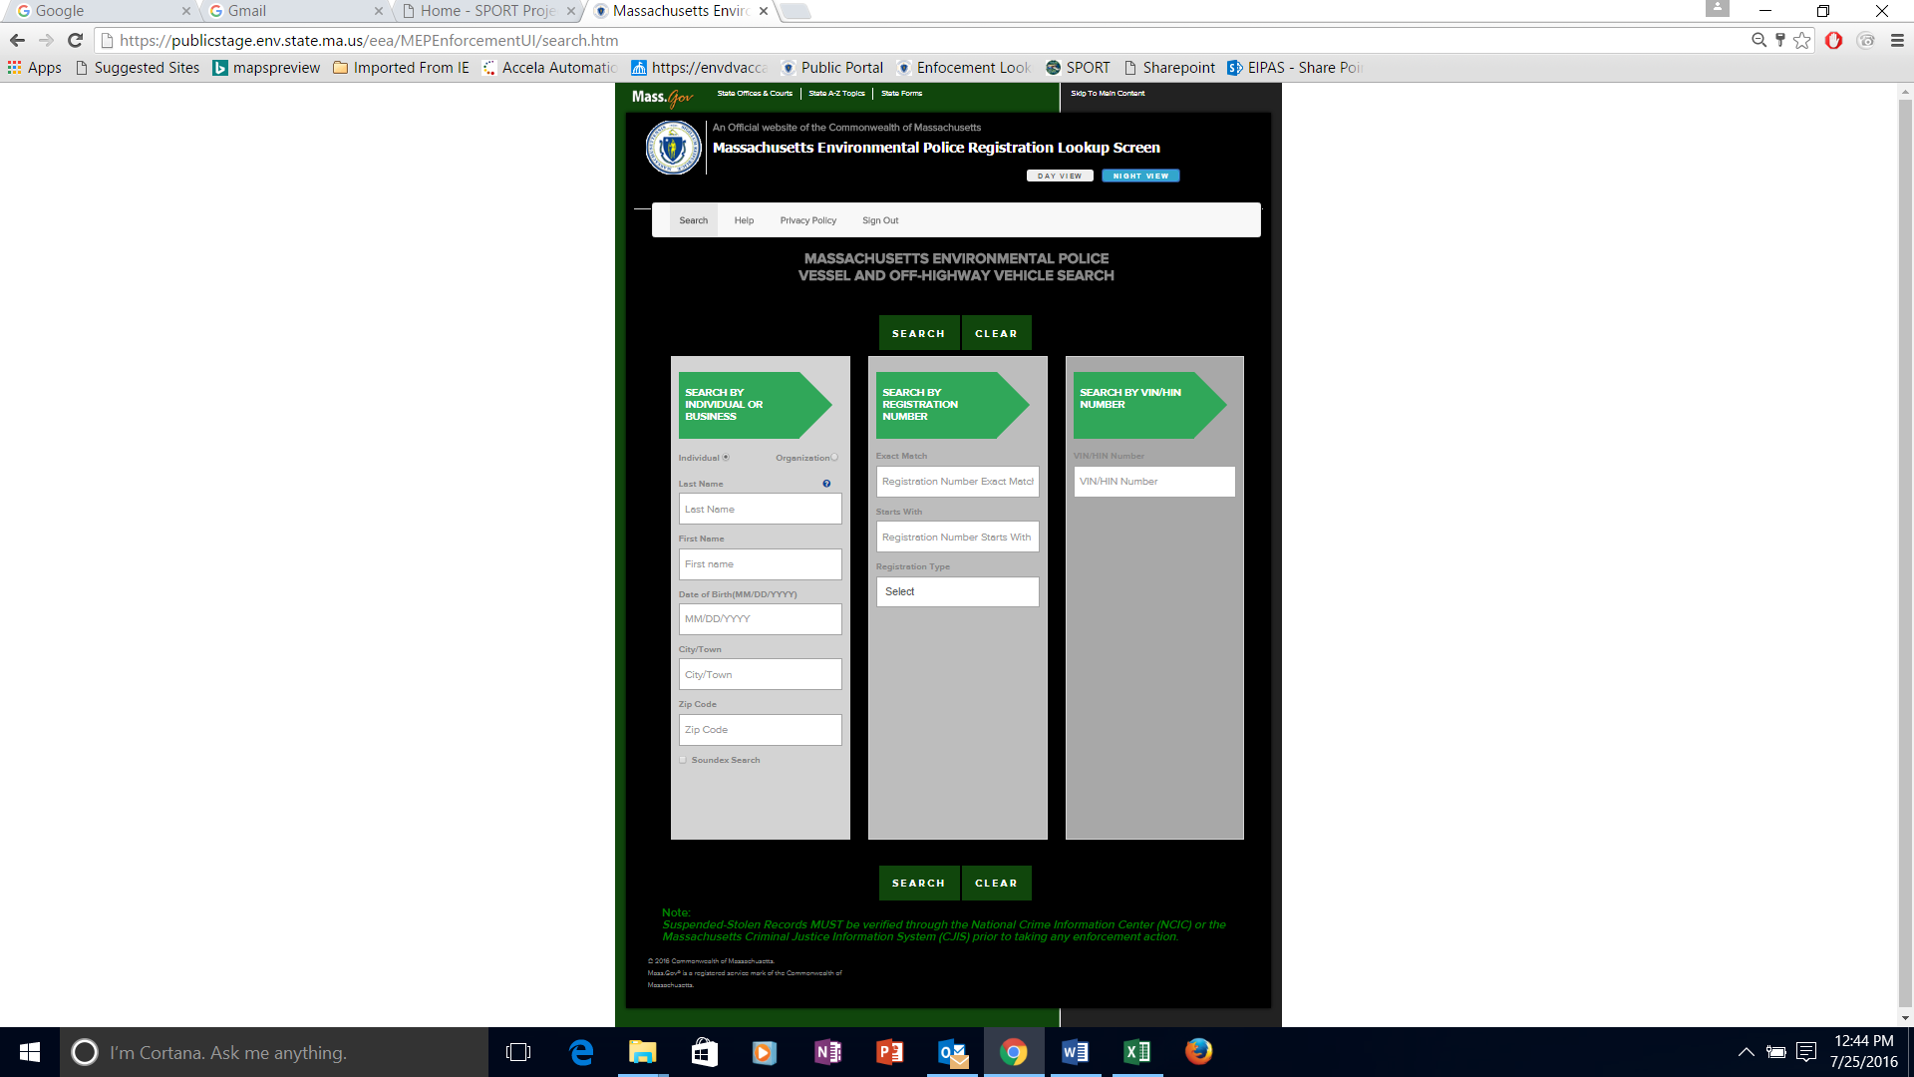

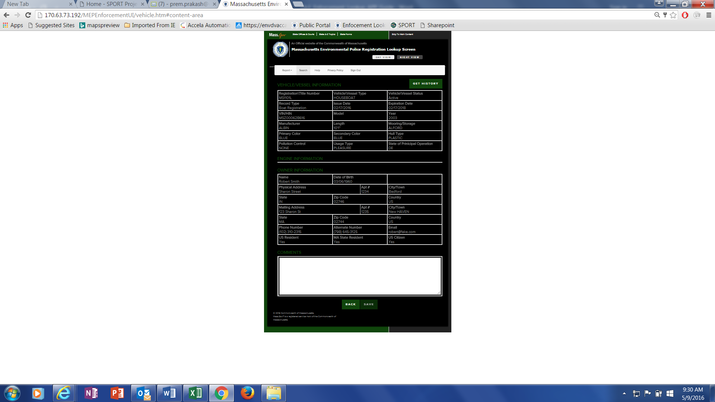

# Disabling Pop-Up Blocker – IE 11

1. Open IE browser  
2. Click on Tools -> Internet options.

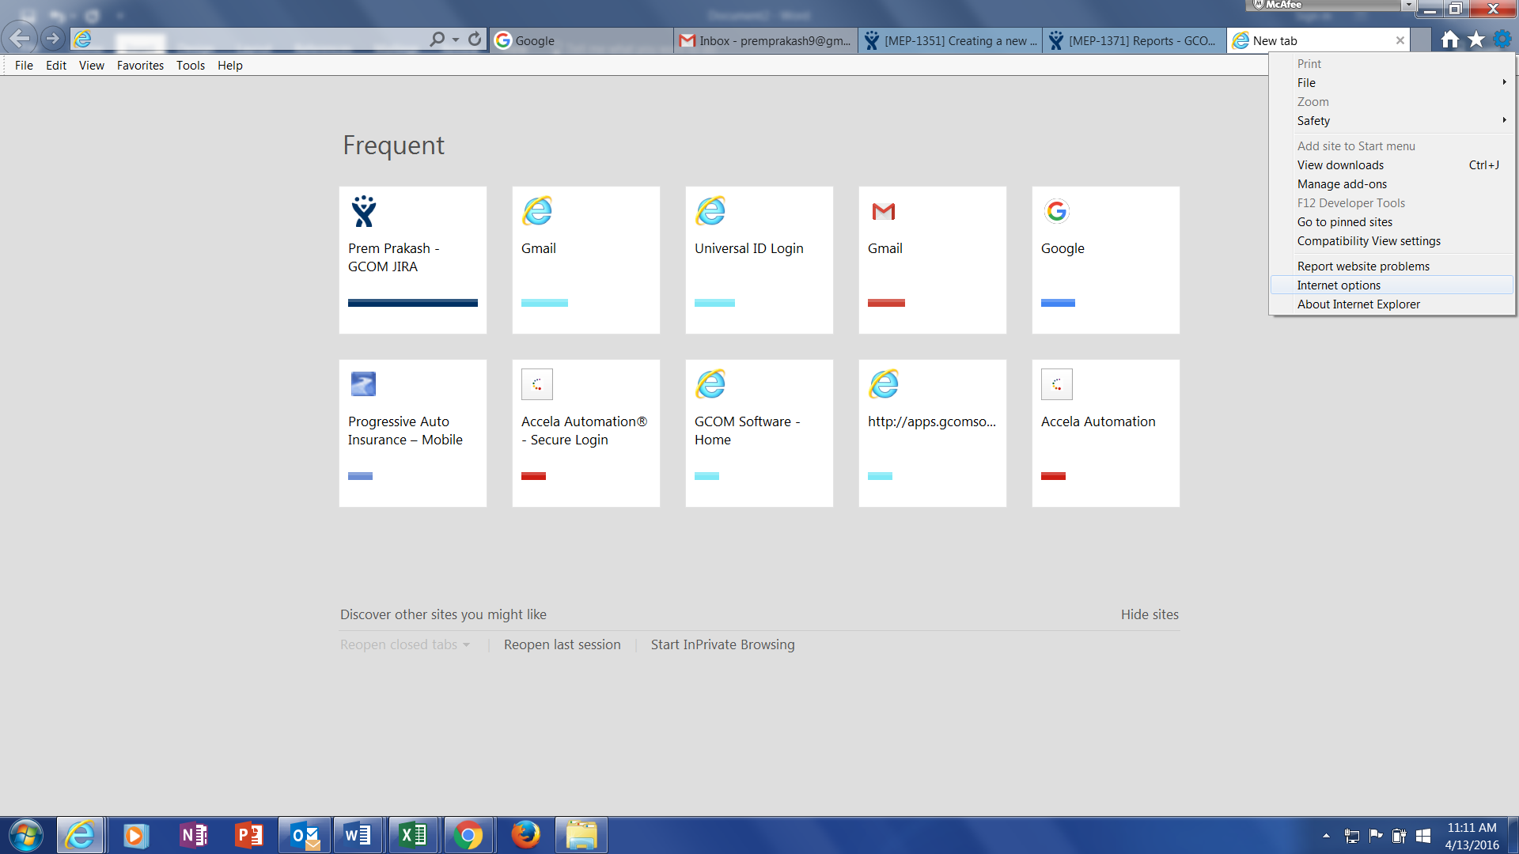  
3. A new window will pop-up, Click on Privacy tab  
4. Under Pop-up blocker section, check that "Turn on Pop-up blocker" check-box is not selected.  
5. Click on "Apply" and then click on "OK"

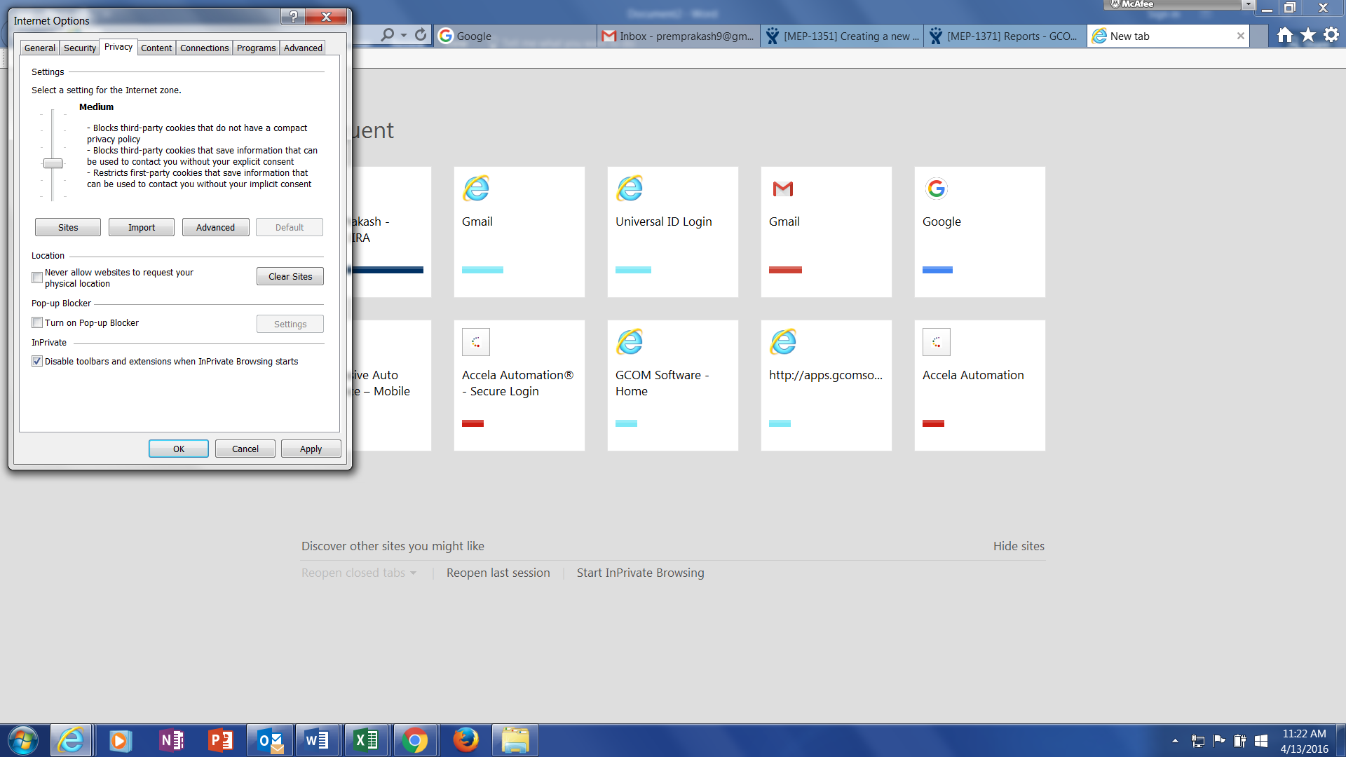  
6. Close and restart the browser. Open a new IE window and try to do the same transaction again.