INDOOR AIR QUALITY ASSESSMENT

Mercer Administration Building
269 First Street
Pittsfield, MA

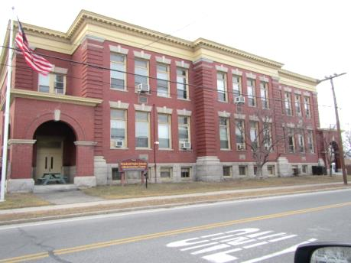

Prepared by:
Massachusetts Department of Public Health
Bureau of Environmental Health
Indoor Air Quality Program
April 2016
BACKGROUND
Building: | Mercer Building  Pittsfield Public Schools (PPS) Administration Center
Address: | 269 First Street, Pittsfield, MA
Assessment Requested by: | James Esoldi, LEA/Working Foreman  City of Pittsfield
Reason for Request: | Reports of respiratory problems in building.
Date of Assessment: | February 19, 2016
Massachusetts Department of Public Health/Bureau of Environmental Health (MDPH/BEH) Staff Conducting Assessment: | Mike Feeney, Director, Indoor Air Quality (IAQ) Program
Date Building Constructed: | 1904
Building Description: | Originally constructed as a brick schoolhouse.
Building Population: | Approximately 20 employees work at this office.

METHODS
Please refer to the IAQ Manual for methods, sampling procedures, and interpretation of results (MDPH, 2015).

RESULTS and DISCUSSION
The following is a summary of indoor air testing results (Table 1).
- Carbon dioxide levels were below the MDPH recommended level of 800 parts per million (ppm) in all areas surveyed, indicating adequate air exchange.
- Temperature was within the MDPH recommended range of 70°F to 78°F in most occupied areas surveyed. One reading was above 78°F and two rooms in the basement were below 70°F.
- Relative humidity was below the MDPH recommended range of 40 to 60% in all areas tested which is reflective of the heating season in the northeast.
- Carbon monoxide levels were non-detectable in all areas tested indoors.
- Particulate matter (PM2.5) concentrations measured were below the National Ambient Air Quality (NAAQS) level of 35 μg/m³ in all areas tested.

Ventilation
A heating, ventilating, and air conditioning (HVAC) system has several functions. First it provides heating and, if equipped, cooling. Second, it is a source of fresh air. Finally, an HVAC system will dilute and remove normally occurring indoor environmental pollutants by not only introducing fresh air, but also filtering the airstream and ejecting stale air to the outdoors via exhaust ventilation. Even if an HVAC system is operating as designed, point sources of respiratory irritation may exist and cause symptoms in sensitive individuals. The following analysis examines and identifies components of the HVAC system and likely sources of respiratory irritant/allergen exposure due to water damage, aerosolized dust, and/or chemicals found in the indoor environment.
This building was originally equipped with a natural/gravity feed ventilation system that has since been abandoned (Picture 1). At some point, a mechanical system was retrofitted into the building. Fresh air is provided by unit ventilators (univents) located in individual rooms along the outside wall (Picture 2). Ceiling-mounted univents were installed in the basement. Unit ventilators draw fresh air through an intake on the exterior wall (Picture 3). Air is mixed with return air from the room, filtered, heated (if needed) and delivered back to the room. In some locations, univents were found partly obstructed by items on top or in front, which can impair proper operation. Fresh air intakes on the exterior of the building were partially blocked (Picture 3) as a likely energy-saving measure. Univents in the basement were not operating.
Mechanical exhaust vents were installed inside the exhaust shaft of the gravity ventilation system (Picture 4). No draw of air was noted from the exhaust vents during the assessment, indicating either the vents were deactivated or fans/motors disabled. Most of these vents had material stored inside (Picture 4), which decreases its ability to draw air even with the fans running. A number of the original classrooms were subdivided into offices (Rooms 101 through 111A), which means the exhaust vents are in a hallway separated from the offices (Picture 5). With hallway doors closed, Rooms 101 through 111A do not have exhaust ventilation. Undercutting the doors in this area can allow the hallway exhaust vents to remove stale air from these areas.

Microbial/Moisture Concerns
The IT offices for the PPS are located in the basement and have carpeting on the below-grade floor (Picture 6). In addition, the installation of plastic coving at the base of exterior walls will hold moisture against the brick and carpeting. Plastic coving is not necessary in carpet installation and, in general, carpeting is not recommended for use in below-grade spaces.
Paint on the basement walls was significantly bubbled (Picture 7). The bubbled paint likely contains a powder called efflorescence. Efflorescence is a characteristic sign of water damage to building materials such as brick or plaster, but it is not mold growth. As moisture penetrates and works its way through mortar around brick, water-soluble compounds dissolve, creating a solution. As the solution moves to the surface of the brick or mortar, water evaporates, leaving behind white, powdery mineral deposits. This condition indicates that water from the exterior has penetrated into the building. This water penetration, along with condensation on the floor during hot, humid weather, may contribute to moistening of carpet and potential odors.
Water-damaged ceiling tiles were observed in some offices (Table 1). Water-damaged ceiling tiles indicate past leaks from plumbing and/or the building envelope and should be replaced once the leak has been repaired.
Plants were observed in several areas (Table 1). Plants can be a source of pollen and mold, which can be respiratory irritants to some individuals. Plants should be properly maintained, over-watering of plants should be avoided and drip pans should be inspected periodically for mold growth.

Other IAQ Evaluations
Some areas contained printed materials (Table 1). Inks contain a number of chemicals, including volatile organic compounds (VOCs). VOCs are materials that can cause eye, nose and respiratory irritation. Some individuals may experience irritant symptoms when exposed. Occupants reported that odors from newly printed materials have been problematic in this location since the renovations. Without adequate exhaust ventilation, VOCs and other related pollutants that are off-gassing from printed materials can build up in this location, leading to IAQ complaints.
An odor of operating computer equipment was noted in the basement mainframe room. The exhaust vent in this room was not drawing air. In this condition, pollutants such as odors from heated plastics and possibly ozone, can build up.
Some parts of the building contain wall-to-wall carpet that is likely over 15 to 20 years old. The average lifespan of carpeting is approximately eleven years (Bishop, 2002). It was unclear if the building has a regular carpet-cleaning program. The Institute of Inspection, Cleaning and Restoration Certification (IICRC), recommends that carpeting be cleaned annually (or semi-annually in soiled high traffic areas) (IICRC, 2012).

CONCLUSIONS/RECOMMENDATIONS
Based on conditions observed at the time of assessment, the following recommendations are provided:
- Repair all univents, including unblocking the fresh air intakes and operate during occupied hours. Remove items/furniture from obstructing univents.
- Repair and reactivate exhaust vents, including those in the basement.
- Remove all materials stored beneath exhaust vents.
- Undercut the hallway doors to Rooms 101 through 111A by 2-inches to provide a means for air to be drawn from these offices to the hallway exhaust vents.
- Consider having the HVAC system balanced every 5 years for all mechanical ventilation systems, as recommended by ventilation industrial standards (SMACNA, 1994).
- Consider removing water-damaged paint from foundation walls in the IT room. Identify if the paint contains lead and remove and dispose of in a manner consistent with state and federal law, as applicable. After completion, it is recommended to leave the wall unpainted.
- Remove plastic coving from the base of all basement exterior walls.
- Consider removing carpeting in the basement and replacing with an appropriate, non-porous flooring material. It is recommended that carpeting not be installed in below grade spaces due to the likely generation of condensation during hot, humid weather on a basement floor/foundation that is not insulated.
- For buildings in New England, periods of low relative humidity during the winter are often unavoidable. Therefore, scrupulous cleaning practices should be adopted to minimize common indoor air contaminants whose irritant effects can be enhanced when the relative humidity is low. To control for dusts, a high efficiency particulate arrestance (HEPA) filter equipped vacuum cleaner in conjunction with wet wiping of all surfaces is recommended. Avoid the use of feather dusters. Drinking water during the day can help ease some symptoms associated with a dry environment (throat and sinus irritations).
- Ensure leaks are repaired and replace water-damaged ceiling tiles. Inspect area above tiles for water damage and microbial growth and clean/repair as necessary.
- Consider reducing the number of plants. Indoor plants should be properly maintained and equipped with drip pans to prevent water damage to porous building materials and be located away from ventilation sources to prevent the aerosolization of dirt, pollen or mold.
- Store printed materials in closed containers/boxes and in locations with good exhaust ventilation away from occupied areas when possible.
- Clean carpeting regularly in accordance with The Institute of Inspection, Cleaning and Restoration Certification (IICRC) recommendations (IICRC, 2012).
- Refer to resource manual and other related IAQ documents located on the MDPH’s website for further building-wide evaluations and advice on maintaining public buildings. These documents are available at http://mass.gov/dph/iaq.

REFERENCES
Bishop. 2002. Bishop, J. & Institute of Inspection, Cleaning and Restoration Certification. A Life Cycle Cost Analysis for Floor Coverings in School Facilities.
IICRC. 2012. Institute of Inspection, Cleaning and Restoration Certification. Carpet Cleaning: FAQ. Retrieved from http://www.iicrc.org/consumers/care/carpet-cleaning/#faq.
MDPH. 2015. Massachusetts Department of Public Health. “Indoor Air Quality Manual: Chapters I-III”. Available from http://www.mass.gov/eohhs/gov/departments/dph/programs/environmental-health/exposure-topics/iaq/iaq-manual/
SMACNA. 1994. HVAC Systems Commissioning Manual. 1st ed. Sheet Metal and Air Conditioning Contractors’ National Association, Inc., Chantilly, VA.
Picture 1
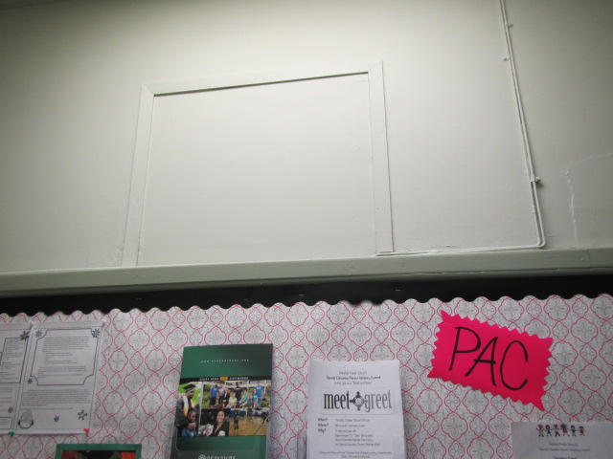
Abandoned and sealed supply vent of the gravity ventilation system
Picture 2
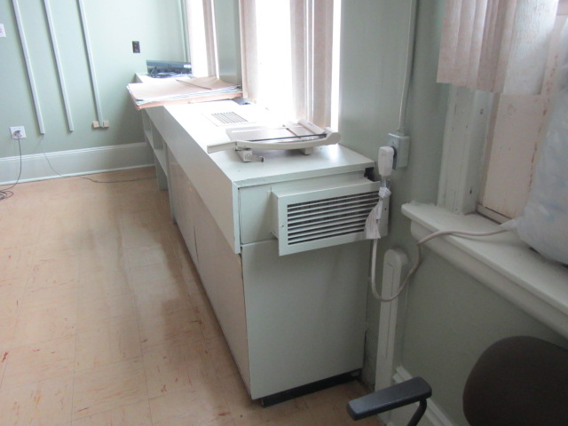
Unit ventilator (univent)
Picture 3
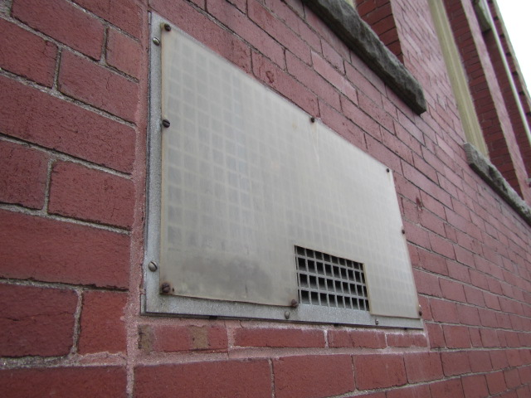
Fresh air intake partially sealed with plastic
Picture 4
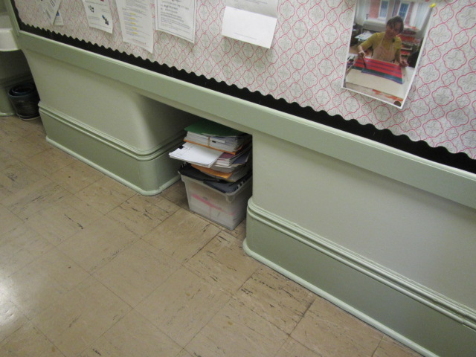
Retrofitted exhaust vent, obstructed with items
Picture 5
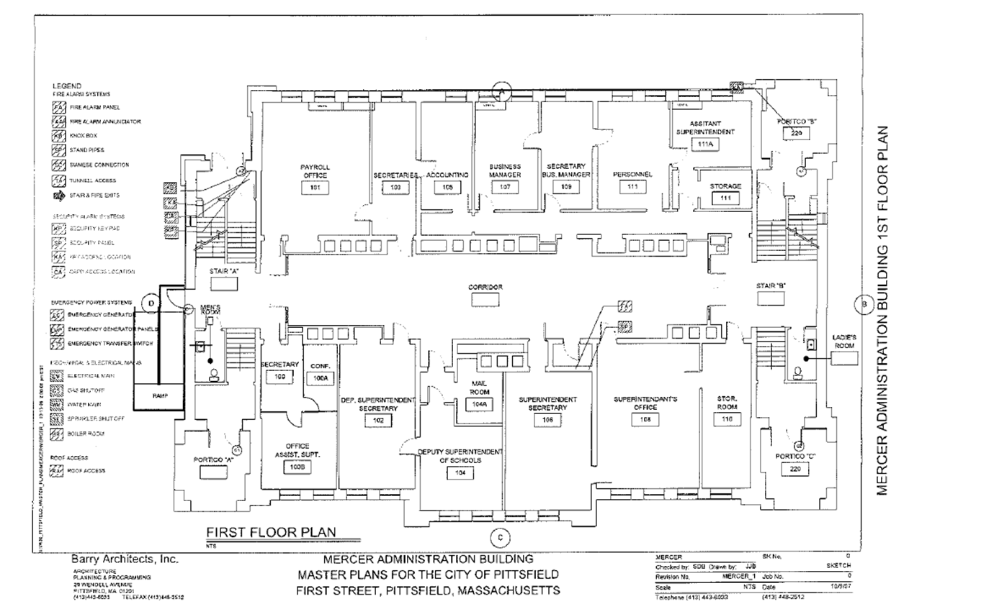
Floorplan
Picture 6
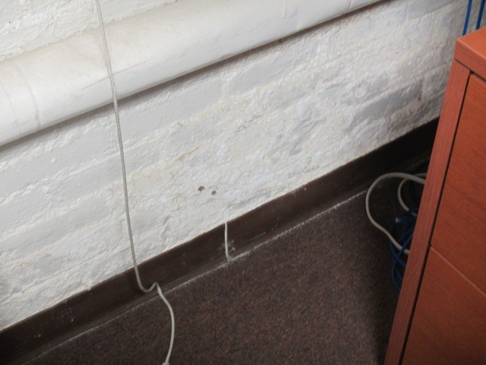
Carpet in IT office in the basement
Picture 7
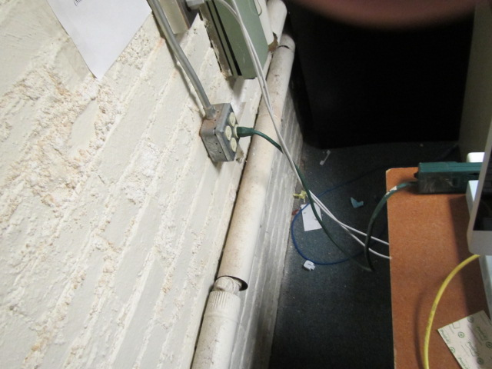
Bubbled paint with efflorescence

Location | Carbon  Dioxide  (ppm) | Carbon Monoxide  (ppm) | Temp  (°F) | Relative  Humidity  (%) | PM2.5  (µg/m³) | Occupants  in Room | Windows  Openable | Ventilation |  | Remarks
 |  |  |  |  |  |  |  | Supply | Exhaust
Background (outdoors) | 445 | 2 | 41 | 7 | 18
200 | 489 | ND | 71 | 13 | 4 | 0 | Y | N | N | Window-mounted air-conditioner
201 | 617 | ND | 75 | 10 | 5 | 0 | Y | Y | Y | Window-mounted air-conditioner
202 | 509 | ND | 72 | 12 | 5 | 0 | Y | Y | N | Window-mounted air-conditioner, 3 water-damaged ceiling tiles
203 | 524 | ND | 76 | 9 | 5 | 0 | Y | Y | Y | Window-mounted air-conditioner
204 | 569 | ND | 72 | 11 | 4 | 0 | Y | Y | N | Plant
206 | 603 | ND | 73 | 12 | 4 | 0 | Y | N | N | Door open
208 | 603 | ND | 75 | 11 | 4 | 1 | Y | Y | N | Window-mounted air-conditioner
210 | 622 | ND | 75 | 10 | 4 | 0 | N | Y | N
211 | 577 | ND | 77 | 9 | 5 | 0 | Y | Y | Y
Deputy Superintendent Reception | 510 | ND | 71 | 11 | 7 | 0 | Y | Y | Y | Ink odor
Hallway | 528 | ND | 72 | 10 | 6 | 0 | N | N | N | Photocopier
Breakroom | 551 | ND | 76 | 10 | 6 | 0 | Y | Y | N | Window-mounted air-conditioner
100 | 491 | ND | 71 | 10 | 8 | 0 | Y | Y | Y | Window-mounted air-conditioner
101 | 686 | ND | 79 | 9 | 5 | 4 | Y | Y | N | Window-mounted air-conditioner, plants
102 | 497 | ND | 71 | 12 | 6 | 0 | Y | Y | Y | Window-mounted air-conditioner
103 | 600 | ND | 77 | 9 | 5 | 1 | Y | Y | Y
104A | 537 | ND | 72 | 11 | 6 | 0 | N | N | N | Window-mounted air-conditioner, door open
105 | 575 | ND | 76 | 8 | 5 | 1 | N | Y | N
106 | 546 | ND | 72 | 10 | 5 | 1 | Y | N | N | Window-mounted air-conditioner
107 | 542 | ND | 76 | 8 | 6 | 0 | N | Y | N | Window-mounted air-conditioner
108 | 534 | ND | 72 | 10 | 5 | 0 | Y | Y | Y | Window-mounted air-conditioner
109 | 575 | ND | 74 | 10 | 6 | 1 | N | Y | N | Window-mounted air-conditioner, plants
110 | 528 | ND | 72 | 10 | 5 | 2 | N | Y | N | Window-mounted air-conditioner
111B | 594 | ND | 72 | 11 | 6 | 1 | Y | Y | N
111 | 572 | ND | 74 | 10 | 5 | 1 | Y | Y | N | Window-mounted air-conditioner, plants, door open
Basement hallway | 652 | ND | 63 | 26 | 6 | 0 | N | N | Y | 2 water-damaged ceiling tiles
Break room | 601 | ND | 67 | 23 | 5 | 0 | N | N | N
Computer lab/IT Office | 600 | ND | 70 | 21 | 1 | 3 | Y | Y | Y | Bubbled paint, carpeting
Mainframe room | 616 | ND | 71 | 21 | 2 | 0 | Y | Y | Y | Bubbled paint, carpeting

