INDOOR AIR QUALITY ASSESSMENT

Massachusetts Department of Transportation
Merit Rating Board
25 Newport Avenue Extension
Quincy, Massachusetts

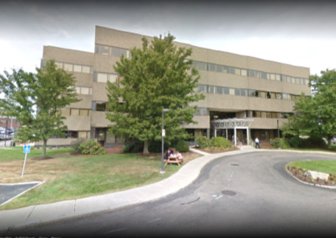

Prepared by:
Massachusetts Department of Public Health
Bureau of Environmental Health
Indoor Air Quality Program
February 2017

Background
Building: | Merit Rating Board (MRB)
Address: | 25 Newport Avenue, Extension, Quincy, MA
Assessment Requested by: | Tom Bowes, Director, MRB
Date of Assessment: | January 26, 2017
Indoor Air Quality (IAQ) Program Staff Conducting Assessment: | Cory Holmes, Environmental Analyst
Date of Building Construction: | 1985
Reason for Request: | General IAQ assessment
Building Type: | 4-story, flat-roofed office building
Building Population: | Approximately 60-65 employees
Windows: | unopenable

IAQ Testing Results
Please refer to the IAQ Manual for methods, sampling procedures, and interpretation of results (MDPH, 2015). The following is a summary of indoor air testing results (Table 1).
- Carbon dioxide levels were below 800 parts per million (ppm) in all areas surveyed, indicating adequate air exchange.
- Temperature was within the recommended range of 70°F to 78°F in all areas tested.
- Relative humidity was below the recommended range of 40 to 60% in all areas tested, which is typical in New England during winter months.
- Carbon monoxide levels were non-detectable (ND) in all areas tested.
- Total volatile organic compounds (TVOCs) were ND in all areas tested.
- Fine particulate matter (PM2.5) concentrations measured were below the NAAQS limit of 35 μg/m³ in all areas tested.

It is important to note that relative humidity levels in the building would be expected to be low during the winter months due to atmospheric conditions and heating. Low relative humidity can lead to common symptoms such as: dry skin, lips, and scalp; dry/scratchy throats and noses (nose bleeds); exacerbation of asthma, eczema, or allergies; dry/irritated eyes; and irritation of respiratory tract.

Ventilation
A heating, ventilating and air conditioning (HVAC) system has several functions. First it provides heating and, if equipped, cooling. Second, it is a source of fresh air. Finally, an HVAC system will dilute and remove normally-occurring indoor environmental pollutants by not only introducing fresh air, but by filtering the airstream and ejecting stale air to the outdoors via exhaust ventilation. Even if an HVAC system is operating as designed, point sources of respiratory irritation may exist and cause symptoms in sensitive individuals.
Mechanical ventilation is provided by rooftop air-handling units (AHUs, Picture 1). Outside air is drawn through a bank of pleated filters (Picture 2), heated or cooled and delivered to occupied areas via ducted supply diffusers (Pictures 3 and 4). The filters in use at the MRB are a Minimum Efficiency Reporting Value (MERV) of 8, which are adequate in filtering out pollen and mold spores (ASHRAE, 2012). Return air is drawn through grates or around light fixtures (Pictures 5 and 6) and returned back to the AHUs.

Microbial/Moisture Concerns
No active leaks were observed or reported. A few water-damaged ceiling tiles were observed in area 205, reportedly from an old leak (Picture 7). After the source of the leak above the ceiling tiles is repaired, water-damaged ceiling tiles should be removed and replaced.
The sink in the breakroom had a space between the countertop and backsplash in need of caulking (Picture 8). Chronic moistening of porous building materials can lead to mold growth.
Some areas of the MRB had water coolers placed directly on carpeting (Picture 9). Spills or leaks from this equipment can moisten carpet and may cause microbial growth and carpet degradation. Water coolers should be moved to non-carpeted areas or have waterproof trays/mats placed beneath them.
Plants were noted in a few areas (Table 1). Plants can be a source of pollen and mold, which can be respiratory irritants to some individuals. Plants should be properly maintained and equipped with drip pans and should be located away from air diffusers to prevent the aerosolization of dirt, pollen and mold.

Other IAQ Evaluations

Volatile Organic Compounds (VOCs)
Exposure to low levels of total VOCs (TVOCs) may produce eye, nose, throat, and/or respiratory irritation in some sensitive individuals. In addition to testing, IAQ staff examined rooms for products containing VOCs. IAQ staff noted air fresheners, scented hand sanitizers, cleaners, and dry erase materials within the building (Table 1). All of these products have the potential to be irritants to the eyes, nose, throat, and respiratory system of sensitive individuals and their use should be minimized. Hand sanitizer products may contain ethyl alcohol and/or isopropyl alcohol, which are highly volatile and may be irritating to the eyes and nose. These products may also contain fragrances to which some people may be sensitive.
A photocopier and lamination machine were located in area 221. Excess heat, odors, VOCs and ozone can be produced by laminators and photocopiers, particularly if the equipment is older and in frequent use. Ozone is a respiratory irritant (Schmidt Etkin, 1992). No dedicated exhaust ventilation was observed in this area.

Other Conditions
Some personal fans, supply and exhaust vents were observed to be dusty (Table 1). Dust can be reaerosolized from these items and they should be cleaned regularly. Dust accumulation was also observed on flat surfaces in some areas (Picture 10).
In several areas, items were observed on the floor, windowsills, tabletops, counters, bookcases, and desks. The large number stored items provide a source for dusts to accumulate. These items (e.g., papers, folders, boxes) make it difficult for custodial staff to clean. Once aerosolized, they can act as irritants to eyes and the respiratory system. Items should be relocated and/or be cleaned periodically to avoid excessive dust build up.
Most occupied areas had carpet squares. The Institute of Inspection, Cleaning and Restoration Certification (IICRC), recommends that carpeting be cleaned annually (or semi-annually in soiled high traffic areas) (IICRC, 2012). In many areas, the carpeting appears to be heavily soiled, worn and past its useful life (Table 1, Pictures 11 and 12).
Finally, many different models of portable air purifiers were in use in the office. It is important to note that filters in these units should be cleaned/changed as per the manufacturer’s instructions. One unit was a combination air cleaner and deodorizer (Picture 13). Air deodorizers can be irritating to sensitive individuals and are not recommended. Many air fresheners contain 1,4-dichlorobenzene, a VOC which can reduce lung function (NIH, 2006). Furthermore, deodorizing agents do not remove materials causing odors, but rather mask odors that may be present in the area.

Conclusions/Recommendations
In view of the findings at the time of the visit, the following recommendations are made:
- Consider limiting the use of hand sanitizers, dry erase materials, air fresheners/deodorizers and harsh/scented cleaning products, which can cause eye, nose and throat irritation in sensitive individuals.
- Ensure filters for all portable air purifiers are cleaned/changed as per manufactures’ instructions.
- Determine if air purifying unit shown in Picture 13 can be operated without its deodorizer component/cartridge.
- Ensure any building envelope or plumbing leaks are repaired and replace water-damaged ceiling tiles.
- Seal sink countertop/backsplash with caulking in breakroom.
- Consider placing water dispensers on non-carpeted areas or place a waterproof mat underneath them.
- Plants should be properly maintained and equipped with drip pans and should be located away from the airstream of air diffusers and portable filter units to prevent the aerosolization of dirt, pollen and mold.
- Consider installing exhaust ventilation in photocopier area to prevent the migration of odors and pollutants into occupied spaces.
- Clean personal fans, supply and return vents periodically of accumulated dust.
- Relocate or consider reducing the amount of stored materials to allow for more thorough cleaning. Clean items regularly with a wet cloth or sponge to prevent excessive dust build-up.
- Have the HVAC system re-balanced, as recommended (every 5 years) in accordance with SMACNA recommendations (SMACNA, 1994).
- Clean carpeting annually or semi-annually in soiled high traffic areas as per the recommendations of the Institute of Inspection, Cleaning and Restoration Certification (IICRC, 2012).
- Replace old, worn/soiled carpeting (over 10 years old).
- For buildings in New England, periods of low relative humidity during the winter are often unavoidable. Therefore, scrupulous cleaning practices should be adopted to minimize common indoor air contaminants whose irritant effects can be enhanced when the relative humidity is low. To control for dusts, a high efficiency particulate arrestance (HEPA) filter equipped vacuum cleaner in conjunction with wet wiping of all surfaces is recommended. Avoid the use of feather dusters. Drinking water during the day can help ease some symptoms associated with a dry environment (throat and sinus irritations).
- Refer to resource manual and other related indoor air quality documents located on the MDPH’s website for further building-wide evaluations and advice on maintaining public buildings. These documents are available at http://mass.gov/dph/iaq.

References
ASHRAE. 2012. American Society of Heating, Refrigeration and Air Conditioning Engineers. Standard 52.2-2012 -- Method of Testing General Ventilation Air-Cleaning Devices for Removal Efficiency by Particle Size (ANSI Approved).
IICRC. 2012. Carpet Cleaning FAQ 4 Institute of Inspection, Cleaning and Restoration Certification. Institute of Inspection Cleaning and Restoration. Vancouver, WA. Retrieved from http://www.iicrc.org/consumers/care/carpet-cleaning.
MDPH. 2015. Massachusetts Department of Public Health. “Indoor Air Quality Manual: Chapters I-III”. Available at: http://www.mass.gov/eohhs/gov/departments/dph/programs/environmental-health/exposure-topics/iaq/iaq-manual/
NIH. 2006. Chemical in Many Air Fresheners May Reduce Lung Function. NIH News. National Institute of Health. July 27, 2006. http://www.nih.gov/news/pr/jul2006/niehs-27.htm
Schmidt Etkin, D. 1992. Office Furnishings/Equipment & IAQ Health Impacts, Prevention & Mitigation. Cutter Information Corporation, Indoor Air Quality Update, Arlington, MA.
SMACNA. 1994. Sheet Metal and Air Conditioning Contractors’ National Association, Inc. HVAC Systems Commissioning Manual. 1st ed. Sheet Metal and Air Conditioning Contractors’ National Association, Inc., Chantilly, VA.
Picture 1
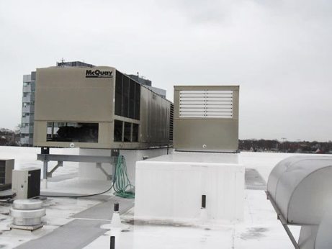
Rooftop air handling units (AHUs)
Picture 2
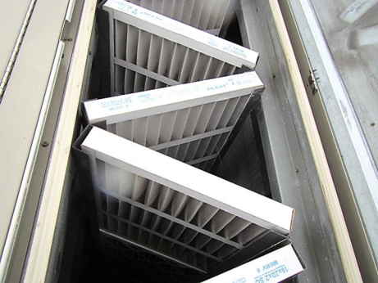
Bank of pleated MERV 8 filters in rooftop AHU
Picture 3
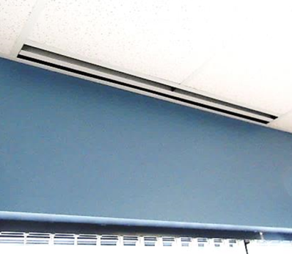
Slotted ceiling diffuser
Picture 4
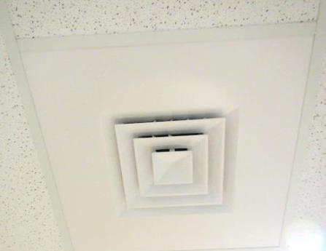
Supply air diffuser
Picture 5
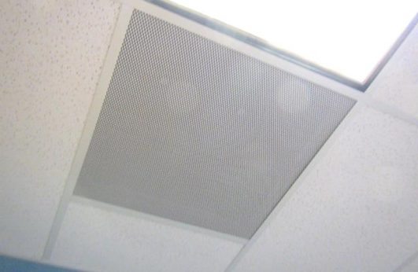
Return grate
Picture 6
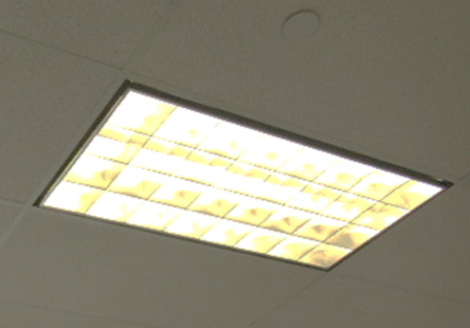
Spaces around light fixtures for return airflow
Picture 7
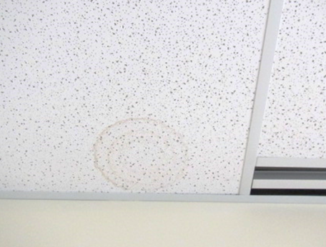
Water-damaged ceiling tile in room 205
Picture 8
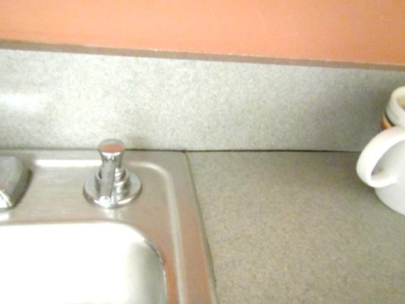
Space between sink countertop and backsplash
Picture 9
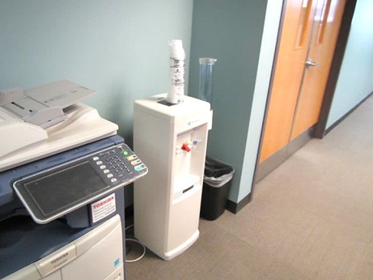
Water cooler on carpet
Picture 10
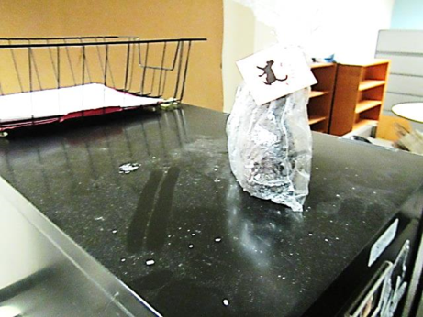
Dust accumulation on flat surface
Picture 11
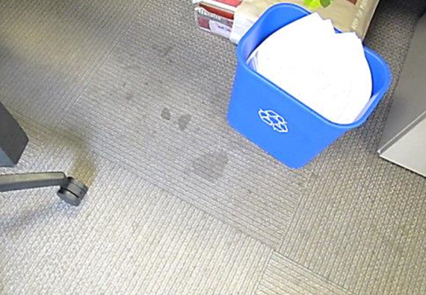
Soiled carpeting
Picture 12
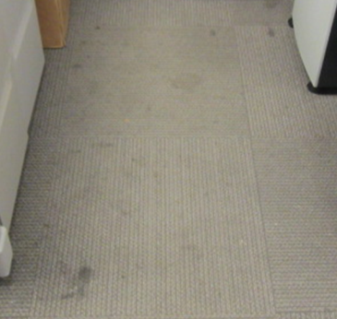
Soiled carpeting
Picture 13
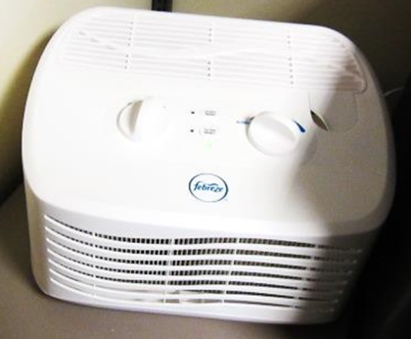
Air purifier/deodorizer

Location | Carbon  Dioxide  (ppm) | Carbon Monoxide  (ppm) | Temp  (°F) | Relative  Humidity  (%) | PM2.5  (µg/m³) | TVOCs  (ppm) | Occupants  in Room | Windows  Openable | Ventilation |  |  | Remarks
 |  |  |  |  |  |  |  |  | Intake | Exhaust
Background | 424 | ND | 49 | 58 | 13 | ND |  |  |  |  |  | Cool, cloudy
034-035 | 615 | ND | 74 | 29 | 5 | ND | 1 | N | Y |  | Y | HS, PF
036-038 | 645 | ND | 74 | 28 | 6 | ND | 0 | N | Y |  | Y | PF
141-142 | 634 | ND | 73 | 30 | 8 | ND | 1 | N | Y |  | Y | PF, HS
143-144 | 632 | ND | 73 | 30 | 10 | ND | 0 | N | Y |  | Y | HS, PF, dust-flat surfaces, AP “ionizer”
202 | 741 | ND | 74 | 28 | 8 | ND |  | N | Y |  | Y
205 | 679 | ND | 75 | 28 | 4 | ND | 7 | N | Y |  | Y | PF, 2 WD CT-old leak reported
207 | 783 | ND | 75 | 29 | 6 | ND | 12 | N | Y |  | Y | Dry erase materials
214 | 634 | ND | 75 | 28 | 6 | ND | 2 | N | Y |  | Y | PF, HS
215 Break Room | 637 | ND | 75 | 28 | 6 | ND | 0 | N | Y |  | Y | Countertop/backsplash sink-caulking
221 | 654 | ND | 74 | 30 | 6 | ND | 0 | N | Y |  | N | Laminator, PC-no local exhaust
222 | 655 | ND | 73 | 31 | 14 | ND | 0 | N | Y |  | Y | PF
223 | 693 | ND | 73 | 31 | 8 | ND | 2 | N | Y |  | Y | PF, HS
224 | 660 | ND | 72 | 31 | 25 | ND | 2 | N | Y |  | Y | PF, humidifier
225 | 629 | ND | 72 | 30 | 6 | ND | 0 | N | Y |  | Y | PF, plant, HS
226 | 642 | ND | 73 | 31 | 12 | ND | 0 | N | Y |  | Y | AP “Fabreeze”, HS, PF
227 | 606 | ND | 72 | 29 | 7 | ND | 0 | N | Y |  | Y | PF-dusty
Reception | 621 | ND | 74 | 28 | 8 | ND | 0 | N | Y |  | Y | PF, HS, plant
Customer Service | 646 | ND | 74 | 28 | 7 | ND | 5 | N | Y |  | Y | Stained/discolored carpet, PF, HS
Document Control | 705 | ND | 75 | 29 | 6 | ND | 4 | N | Y |  | Y | Stained carpet, PF, green cleaner spray
Citation Processing Civil | 642 | ND | 75 | 28 | 5 | ND | 7 | N | Y |  | Y | PF, HS, stained carpet, accumulated items
File Room | 522 | ND | 74 | 26 | 6 | ND | 1 | N | Y |  | Y | Odors-cardboard/paper products?
Citation Processing Criminal | 645 | ND | 75 | 28 | 4 | ND | 9 | N | Y |  | Y | HS, PF, AP, carpet stained
Feedback | 674 | ND | 74 | 29 | 6 | ND | 2 | N | Y |  | Y | Water cooler on carpet, Stand-up fan-dusty
Cab Excise | 682 | ND | 75 | 28 | 4 | ND | 5 | N | Y |  | Y | PF
Copy Area | 695 | ND | 75 | 29 | 9 | ND | 0 | N | Y |  | Y | Water cooler on carpet
Suspension Contact Center | 683 | ND | 75 | 27 | 6 | ND | 6 | N | Y |  | Y | PF, stained carpet

