INDOOR AIR QUALITY ASSESSMENT

Lillie B. Merrill Elementary School
687 Pleasant Street
Raynham, MA

Prepared by:
Massachusetts Department of Public Health
Bureau of Environmental Health
Indoor Air Quality Program
November 2017

Background

Building: | Merrill Elementary School (MES)
Address: | 687 Pleasant Street, Raynham, MA
Assessment Requested by: | Paul Fox Jr., Director of Facilities, Bridgewater-Raynham Regional School District
Reason for Request: | General indoor air quality (IAQ) concerns
Date of Assessment: | November 7, 2017
Massachusetts Department of Public Health/Bureau of Environmental Health (MDPH/BEH) Staff Conducting Assessment: | Cory Holmes, Environmental Analyst, IAQ Program
Date of Building Construction/Description: | The MES is a one-story, red-brick building constructed in 1959. An addition was built in the late 1960’s. The building underwent extensive renovations in 2003, which included new windows, mechanical ventilation, and interior renovation of building materials. The roof was replaced within the last several years.
Building Population: | Approximately 313 students in grades K-1 with a staff of approximately 40
Windows: | Openable

IAQ Testing Results
Please refer to the IAQ Manual for methods, sampling procedures, and interpretation of results (MDPH, 2015). The following is a summary of indoor air testing results (Table 1).
- Carbon dioxide levels were below 800 parts per million (ppm) in three fourths of the areas tested indicating adequate air exchange in most areas of the building. Some areas were empty/sparsely populated, which can reduce carbon dioxide levels.
- Temperature was within or close to the recommended range of 70°F to 78°F the day of assessment.
- Relative humidity was within or below the recommended range of 40 to 60% the day of assessment.
- Carbon monoxide levels were non-detectable in all areas tested.
- Fine particulate matter (PM2.5) concentrations measured were below the National Ambient Air Quality (NAAQS) limit of 35 μg/m³ in all areas tested.

Ventilation
A heating, ventilating and air conditioning (HVAC) system has several functions. First it provides heating and, if equipped, cooling. Second, it is a source of fresh air. Finally, an HVAC system will dilute and remove normally occurring indoor environmental pollutants by not only introducing fresh air, but by filtering the airstream and ejecting stale air to the outdoors via exhaust ventilation. Even if an HVAC system is operating as designed, point sources of respiratory irritation may exist and cause symptoms in sensitive individuals.
Fresh air is provided by a combination of unit ventilators (univents) located in individual classrooms (Picture 1) and air handling units (AHUs; Picture 2), which serve a few classrooms, the gym and office/common areas. The unit ventilators draw fresh air through a vent on the exterior wall (Picture 3). Fresh air is mixed with return air from the room, filtered, heated or cooled as needed (Figure 1) and delivered to rooms via ducted supply vents (Picture 4).
To maximize air exchange, the MDPH recommends that both supply and exhaust ventilation operate continuously during periods of occupancy. In addition, many univents were obstructed by items placed on top or in front (Pictures 1 and 5). Both the top and the vent at the bottom need to be kept clear of obstructions for the units to operate as designed.
Air is exhausted from ceiling-mounted exhaust vents on the opposite side of the room, in some cases near classroom doors (Picture 6). Note that when classroom doors are open, exhaust vents will tend to pull hallway air into the classroom instead of removing stale air/pollutants from the room and out the building.
The Title 1/Pupil Support suite appears to be a former classroom converted into several small rooms (Picture 7). This design has impeded proper airflow in that the one supply unit is located in a room at the end of the suite (Picture 8), whereas the other rooms have no supply but are equipped with exhaust vents (Picture 9). With the doors shut to all the rooms, little airflow is exchanged.
In order to have proper ventilation with a mechanical supply and exhaust system, these systems must be balanced to provide an adequate amount of fresh air while removing stale air from a room. It is recommended that existing ventilation systems be re-balanced every five years to ensure adequate air systems function (SMACNA, 1994). It is unknown the last time these systems were balanced.

Microbial/Moisture Concerns
The roof was replaced over the last several years. No current leaks were reported, however a few water-stained ceiling panels were observed (Picture 10; Table 1), which are likely from historic damage. Note, these ceiling tiles are not porous but rather a tactile/rubberized material that would be resistant to mold growth.
During a perimeter inspection of the building, several other issues were identified, which could lead to water penetration and/or potential mold issues, including:
- missing/damaged mortar/brickwork (Picture 11);
- plants growing against the foundation/exterior (Picture 12); and
- a damaged garage door (Pictures 13 and 14), off the kitchen area.
All of these conditions can serve to hold moisture against the building or provide a source for moisture, drafts, odors, or pests to enter the building.
Indoor plants were observed in a few areas (Table 1). Plants can be a source of pollen and mold, which can be respiratory irritants to some individuals. Plants should be properly maintained and equipped with drip pans and should be located away from air diffusers to prevent the aerosolization of dirt, pollen and mold.
A few areas had portable or window-mounted air conditioners (Table 1). These units remove moisture/reduce humidity, therefore must drain properly.

Other IAQ Evaluations
Exposure to low levels of total VOCs (TVOCs) may produce eye, nose, throat, and/or respiratory irritation in some sensitive individuals. To determine if VOCs were present, BEH/IAQ staff examined rooms for products containing VOCs. BEH/IAQ staff noted hand sanitizers, cleaners/spray bottles (Picture 15), plug-in air fresheners (Picture 16) and dry erase materials in use within the building (Table 1). All of these products have the potential to be irritants to the eyes, nose, throat, and respiratory system of sensitive individuals. In addition, spray bottles/cleaning products should be kept out of reach of children.
The univent fresh air intakes in this building have a design which makes them prone to collect debris (Picture 3). These intakes should be monitored for debris and cleaned periodically. Additionally, maintenance staff should take care when mowing, to direct clippings away from units.
Window-mounted air conditioners (ACs) or portable units (Table 1) are equipped with filters that should be cleaned or changed regularly in accordance with manufacturer’s instructions to prevent the build-up of dust and debris.
Most classrooms had personal fans or fans mounted on walls to provide circulation. Some of these had dusty blades/housing (Picture 17; Table 1). Some supply diffusers and exhaust/return vents (Picture 18) were also observed to be dusty. This dust can be reaerosolized when the equipment is activated.
In many areas, items, including books, papers, toys and decorative items were observed on floors, windowsills, tabletops, counters, bookcases, and desks (Picture 5). These items can make it difficult for custodial staff to clean.
Many classrooms/areas had carpeting. Carpeting should be cleaned annually or semi-annually in soiled high traffic areas as per the recommendations of the Institute of Inspection, Cleaning and Restoration Certification (IICRC, 2012). Many classrooms had area rugs, which should also be cleaned regularly and discarded when too worn out or soiled to be cleaned.
Note that the Environmental Protection Agency (EPA) conducted a National School Radon Survey in which it discovered nearly one in five schools had “…at least one frequently occupied ground contact room with short-term radon levels above 4 [picocuries per liter] pCi/L” (US EPA 1993). The BEH/IAQ Program therefore recommends that every school be tested for radon, and that this testing be conducted during the heating season while school is in session in a manner consistent with USEPA radon testing guidelines. Radon measurement specialists and other information can be found at www.nrsb.org and http://aarst-nrpp.com/wp, with additional information at: http://www.mass.gov/eohhs/gov/departments/dph/programs/environmental-health/exposure-topics/iaq/radon.

Conclusions/Recommendations
The following recommendations are made to assist in improving IAQ:
- Operate all supply and exhaust ventilation equipment continuously during occupied periods.
- Use openable windows to supplement fresh air during temperate weather. Ensure all windows are tightly closed at the end of the day.
- Remove items and furniture blocking univents both on top and along the front.
- Check exhaust vents (in classrooms and restrooms) for draw periodically and repair any non-operating motors/vents.
- Close classroom doors to facilitate exhaust function.
- Consider contacting an HVAC engineer to evaluate Title 1/Pupil Support Suite to improve air circulation, some methods may include; under cutting doors or installing passive vents on doors.
- Repair any missing/damaged exterior mortar/brickwork.
- Repair or replace damaged garage door off the kitchen area.
- Remove any vegetation within 5 feet of the foundation perimeter.
- Consider adopting a balancing schedule of every 5 years for all mechanical ventilation systems, as recommended by ventilation industrial standards (SMACNA, 1994).
- For buildings in New England, periods of low relative humidity during the winter are often unavoidable. Therefore, scrupulous cleaning practices should be adopted to minimize common indoor air contaminants whose irritant effects can be enhanced when the relative humidity is low. To control dusts, a high efficiency particulate arrestance (HEPA) filter equipped vacuum cleaner in conjunction with wet wiping of all surfaces is recommended. Avoid the use of feather dusters. Drinking water during the day can help ease some symptoms associated with a dry environment (throat and sinus irritations).
- Properly maintain plants, including drip pans, to prevent water damage to porous materials. Plants should also be located away from air diffusers to prevent the aerosolization of dirt, pollen, and mold.
- Reduce use of products and equipment that create VOCs (e.g., air fresheners).
- Keep spray bottles/cleaning products out of reach of children (e.g., in cabinets over sinks).
- Continue to change filters for HVAC equipment 2-4 times a year. The MDPH recommends using pleated filters of Minimum Efficiency Reporting Value (MERV) of 8, which are adequate in filtering out pollen and mold spores (ASHRAE, 2012), if these can be used with current equipment.
- Regularly clean/vacuum univent cabinets, supply/return/exhaust vents and fans to avoid aerosolizing accumulated particulate matter.
- Clean window-mounted/portable AC filters prior to the start of the cooling season and according to the manufacturer’s instructions.
- Consider reducing the amount of items stored in classrooms to make cleaning easier. Periodically move items to clean flat surfaces.
- Univent fresh air intakes should be monitored for debris and cleaned periodically. Ensure to direct clippings away from units when mowing.
- Clean carpeting annually (or semi-annually in soiled high traffic areas) as per the recommendations of the Institute of Inspection, Cleaning and Restoration Certification (IICRC). Clean area rugs similarly.
- The school should be tested for radon by a certified radon measurement specialist during the heating season when school is in session. Radon measurement specialists and other information can be found at: www.nrsb.org, and http://aarst-nrpp.com/wp.
- Consider adopting the US EPA (2000) document, “Tools for Schools”, as an instrument for maintaining a good IAQ environment in the building available at: http://www.epa.gov/iaq/schools/index.html.
- Refer to resource manual and other related IAQ documents located on the MDPH’s website for further building-wide evaluations and advice on maintaining public buildings. These documents are available at: http://mass.gov/dph/iaq.

References
ASHRAE. 2012. American Society of Heating, Refrigeration and Air Conditioning Engineers (ASHRAE) Standard 52.2-2012 -- Method of Testing General Ventilation Air-Cleaning Devices for Removal Efficiency by Particle Size (ANSI Approved).
IICRC. 2012. Institute of Inspection, Cleaning and Restoration Certification. Carpet Cleaning: FAQ. Retrieved from http://www.iicrc.org/consumers/care/carpet-cleaning.
MDPH. 2015. Massachusetts Department of Public Health. “Indoor Air Quality Manual: Chapters I-III”. Available at: http://www.mass.gov/eohhs/gov/departments/dph/programs/environmental-health/exposure-topics/iaq/iaq-manual/.
SMACNA. 1994. HVAC Systems Commissioning Manual. 1st ed. Sheet Metal and Air Conditioning Contractors’ National Association, Inc., Chantilly, VA.
US EPA. 1993. Radon Measurement in Schools, Revised Edition. Office of Air and Radiation, Office of Radiation and Indoor Air, Indoor Environments Division (6609J). EPA 402-R-92-014. https://www.epa.gov/sites/production/files/2014-08/documents/radon_measurement_in_schools.pdf
US EPA. 2000. Tools for Schools. Office of Air and Radiation, Office of Radiation and Indoor Air, Indoor Environments Division (6609J). EPA 402-K-95-001, Second Edition. http://www.epa.gov/iaq/schools/index.html.
Picture 1
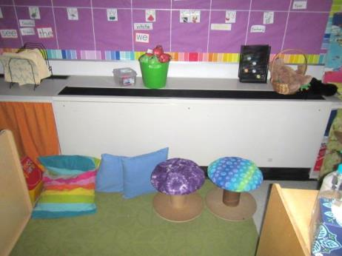
Classroom uninvent, note items obstructing vent along bottom front
Picture 2
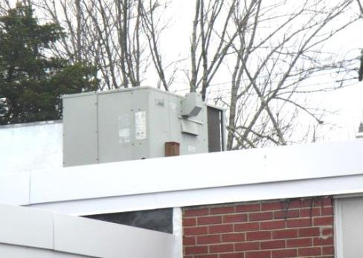
Rooftop air handling unit
Picture 3
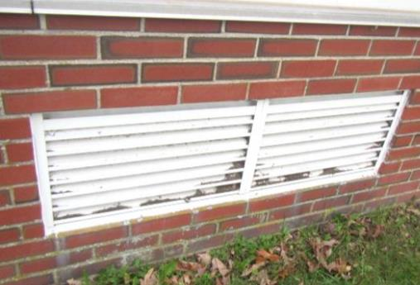
Univent fresh air intake, note debris in louvers
Picture 4
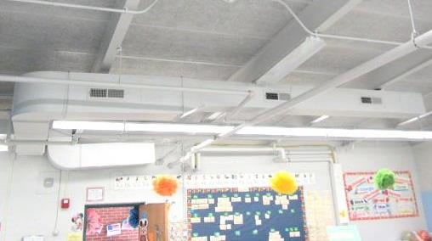
Ducted vents in classroom
Picture 5
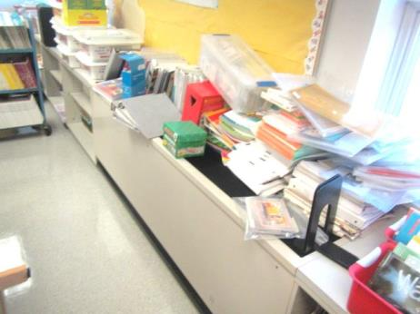
Items on classroom univent obstructing airflow
Picture 6
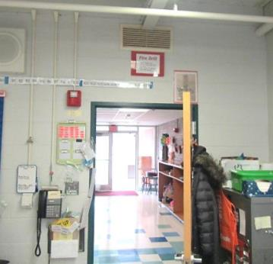
Classroom exhaust vent over open hallway door
Picture 7
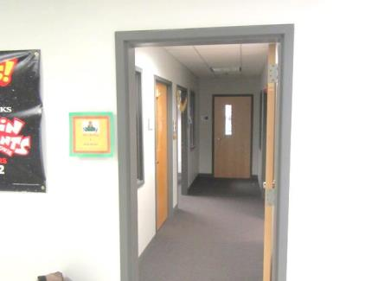
Title 1/Pupil Support suite, note room (with closed) door at end contains the fresh air supply
Picture 8
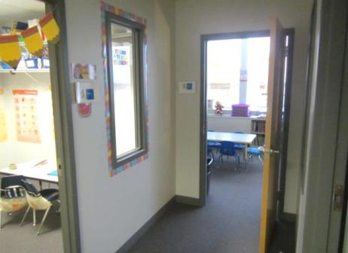
Title 1/Pupil Support suite, note room door at end contains the fresh air supply (arrow)
Picture 9
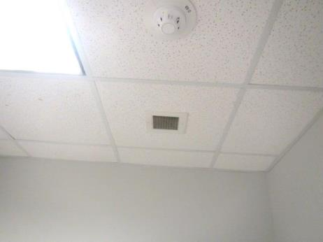
Ceiling-mounted exhaust vent in Title 1/Pupil Support suite
Picture 10
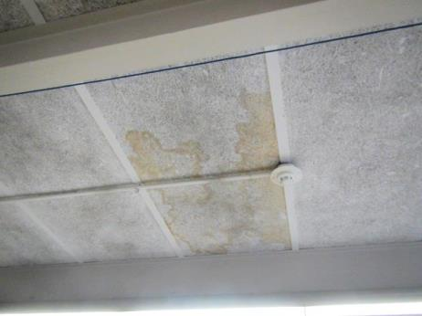
Water-stained tactile ceiling panels
Picture 11
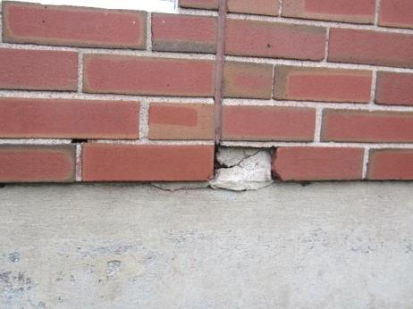
Damaged brick/mortar
Picture 12
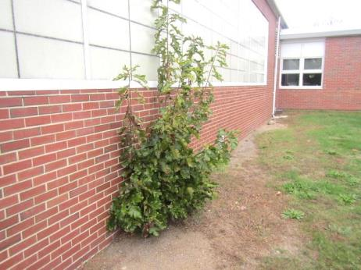
Plants growing against exterior wall
Picture 13
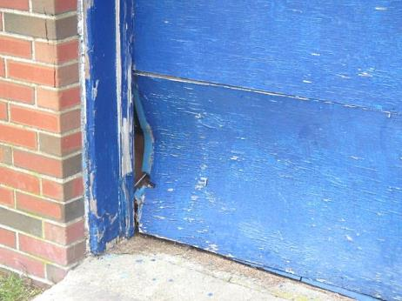
Damaged garage door near kitchen
Picture 14
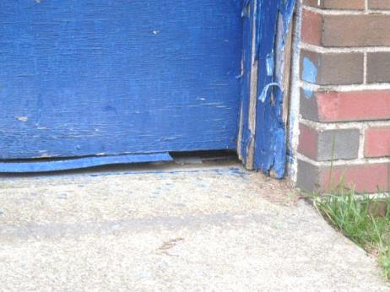
Damaged garage door near kitchen
Picture 15
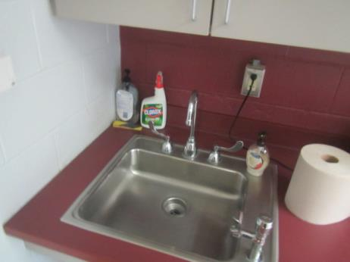
Spray cleaning product on sink countertop
Picture 16
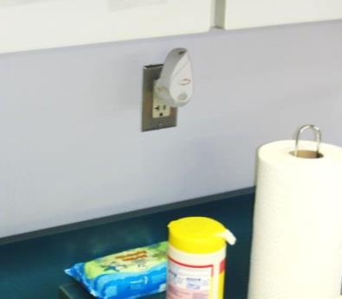
Plug-in air deodorizer
Picture 17
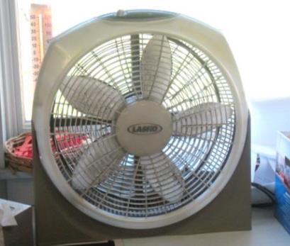
Accumulated dust/debris on fan blades
Picture 18
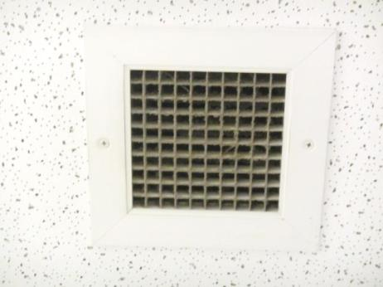
Accumulated dust/debris on exhaust vent
Location | Carbon  Dioxide  (ppm) | Carbon Monoxide  (ppm) | Temp  (°F) | Relative  Humidity  (%) | PM2.5  (µg/m³) | Occupants  in Room | Windows  Openable | Ventilation |  |  | Remarks
 |  |  |  |  |  |  |  | Intake | Exhaust
Background | 389 | ND | 52 | 50 | 3
Gym | 629 | ND | 70 | 43 | 3 | 22 | N | Y |  | Y
4 Staff Work Room | 471 | ND | 70 | 37 | 3 | 0 | Y  0/3 | Y |  | Y | PCs, laminators, AC
3 Library | 498 | ND | 70 | 34 | 4 | 22 | Y  ¼ | Y |  | Y | Wall to wall carpeting
5 | 804 | ND | 71 | 40 | 5 | 23 | Y  0/4 | Y |  | Y | PF, area rug
6 | 782 | ND | 70 | 35 | 4 | 25 | Y  ¼ | Y |  | Y | PF, CP-spray
7 | 435 | ND | 71 | 36 | 3 | 1 | Y  0/3 | Y |  | Y | AC, CP-spray
8 | 875 | ND | 72 | 38 | 4 | 21 | Y  0/4 | Y |  | Y | DO, PF, area rug
9 | 946 | ND | 72 | 40 | 5 | 24 | Y  0/4 | Y |  | Y | DO, PF, plants, area rug
10 | 891 | ND | 72 | 40 | 3 | 1 | Y  0/4 | Y |  | Y | 23 occupants gone ~5 mins, items in front of UV, PF
11 | 863 | ND | 71 | 39 | 4 | 21 | Y  0/4 | Y |  | Y | PF, area rug
12 | 895 | ND | 71 | 41 | 5 | 26 | Y  0/4 | Y |  | Y | AD, PF, area rug
13 | 564 | ND | 71 | 39 | 3 | 1 | Y  0/6 | Y |  | Y  Off | Water-stained ceiling panels, PF, DO
14 | 939 | ND | 72 | 44 | 4 | 19 | Y  0/6 | Y |  | Y  Off | Area rugs, plug-in AD, PF
15 | 729 | ND | 71 | 36 | 4 | 24 | Y  1/6 | Y |  | Y  Off | Area rug
16 | 1051 | ND | 71 | 49 | 5 | 22 | Y  0/6 | Y |  | Y  Off | Water-stained ceiling panels, area rug
17 | 662 | ND | 69 | 43 | 4 | 2 | Y  0/6 | Y |  | Y | Items in front of UV
18 | 645 | ND | 71 | 46 | 3 | 20 | Y  0/6 | Y |  | Y
19A | 449 | ND | 71 | 45 | 2 | 0 | Y | Y |  | Y
19B | 482 | ND | 71 | 48 | 2 | 17 | Y | Y |  | Y | AC, aquarium
Faculty Lounge | 509 | ND | 74 | 37 | 3 | 1 | Y  0/3 | Y |  | Y
101 | 799 | ND | 71 | 39 | 4 | 23 | Y  2/4 | Y |  | Y | PF, area rug
102 | 647 | ND | 71 | 37 | 3 | 4 | Y  0/3 | Y |  | Y | AC, area rug, plants
Title 1 | 307 | ND | 72 | 30 | 4 | 0 | Y  0/4 | Y |  | N | Wall to wall carpeting
Pupil Support 2 | 418 | ND | 70 | 37 | 4 | 0 | N | N |  | Y | Dusty vents, wall to wall carpeting
Pupil Support 3 | 409 | ND | 71 | 35 | 4 | 0 | N | N |  | Y | Dusty vents
Pupil Support 4 | 450 | ND | 71 | 39 | 3 | 0 | N | N |  | Y
Conference Room | 408 | ND | 71 | 38 | 3 | 0 | N | Y |  | Y | Wall to wall carpeting
School Psychologist | 444 | ND | 72 | 41 | 3 | 1 | Y  0/4 | Y |  | Y | PC, wall to wall carpeting
Work Room | 411 | ND | 71 | 37 | 3 | 0 | Y  0/4 | Y  Off |  | Y | Wall to wall carpeting, portable AC
138 Principal’s Office | 388 | ND | 70 | 37 | 3 | 0 | Y  0/6 | Y |  | Y | Plant, wall to wall carpeting
Main Office | 426 | ND | 71 | 39 | 3 | 1 | N | N |  | N | Wall to wall carpeting
Cafeteria | 429 | ND | 72 | 36 | 2 | 50 | Y  0/10 | Y |  | Y | Ceiling fans

