INDOOR AIR QUALITY ASSESSMENT

Merrimac Town Hall
2 School Street
Merrimac, Massachusetts



Prepared by:
Massachusetts Department of Public Health
Center for Environmental Health
Emergency Response/Indoor Air Quality Program
March, 2007

Background/Introduction
At the request of Eileen Hurley, Merrimac Board of Health, the Massachusetts Department of Public Health (MDPH), Center for Environmental Health (CEH) provided assistance and consultation regarding indoor air quality concerns at the Merrimac Town Hall (the town hall), 2 School Street, Merrimac, Massachusetts. On December 22, 2006, a visit was made to this building by Michael Feeney, Director of CEH’s Emergency Response/Indoor Air Quality (ER/IAQ) Program to conduct an indoor air quality assessment. Concerns about poor air exchange and water damage prompted the assessment.
The town hall is a two-story red brick building constructed in 1876 (see cover picture). The town hall was renovated in 2003, creating offices in the basement as well as the installation of a modern heating, ventilating and air conditioning (HVAC) system. Office walls consist of gypsum wallboard (GW). Floors are carpeted and a suspended ceiling was installed. The town hall contains an auditorium (Picture 1) on the top floor, with town offices on the first floor and basement. Some offices are also located on the second floor beneath the auditorium balcony. Windows are openable throughout the building.

Methods
Air tests for carbon dioxide, temperature and relative humidity were taken with the TSI, Q-Trak, IAQ Monitor. CEH staff also performed visual inspection of building materials for water damage and/or microbial growth.

Results
The town hall has an employee population of approximately 20. The tests were taken under normal operating conditions. Test results appear in Table 1.

Discussion
Ventilation
It can be seen from the Table 1 that carbon dioxide levels were below 800 parts per million (ppm) in all areas sampled, which typically indicates adequate air exchange. However, it is important to note that a number of areas were unoccupied or sparsely populated, which can greatly reduce carbon dioxide levels. Therefore, carbon dioxide levels would be expected to increase with increased occupancy.
The first floor and basement office areas were retrofitted with a mechanical ventilation system. Air is distributed to offices by an air handling unit (AHU) ducted to ceiling or wall-mounted fresh air diffusers. No mechanical fresh air supply or exhaust vent could be identified by CEH staff, therefore it appears that the system recirculates air only. Thus the sole source to introduce fresh air into the building is via openable windows. Without adequate supply and/or exhaust ventilation, normally occurring pollutants or odors can build-up and lead to indoor air quality/comfort complaints.
In order to have proper ventilation with a mechanical supply and exhaust system, the systems must be balanced to provide an adequate amount of fresh air to the interior of a room while removing stale air. It is recommended that HVAC systems be rebalanced every five years (SMACNA, 1994). The date of the last servicing and balancing of these systems was not available at the time of the assessment but is presumed to have occurred as part of the 2003 renovations.
The Massachusetts Building Code requires a minimum ventilation rate of 15 cubic feet per minute (cfm) per occupant of fresh outside air or have openable windows in each room (SBBRS, 1997; BOCA, 1993). The ventilation must be on at all times that the room is occupied. Providing adequate fresh air ventilation with open windows and maintaining the temperature in the comfort range during the cold weather season is impractical. Mechanical ventilation is usually required to provide adequate fresh air ventilation.
Carbon dioxide is not a problem in and of itself. It is used as an indicator of the adequacy of the fresh air ventilation. As carbon dioxide levels rise, it indicates that the ventilating system is malfunctioning or the design occupancy of the room is being exceeded. When this happens, a buildup of common indoor air pollutants can occur, leading to discomfort or health complaints. The Occupational Safety and Health Administration (OSHA) standard for carbon dioxide is 5,000 parts per million parts of air (ppm). Workers may be exposed to this level for 40 hours/week, based on a time-weighted average (OSHA, 1997).
The MDPH uses a guideline of 800 ppm for publicly occupied buildings. A guideline of 600 ppm or less is preferred in schools due to the fact that the majority of occupants are young and considered to be a more sensitive population in the evaluation of environmental health status. Inadequate ventilation and/or elevated temperatures are major causes of complaints such as respiratory, eye, nose and throat irritation, lethargy and headaches. For more information concerning carbon dioxide, consult Appendix A.
Temperature measurements ranged from 66º F to 75º F, which were below the lower end of the MDPH recommended comfort guidelines in several areas the day of the assessment. The MDPH recommends that indoor air temperatures be maintained in a range of 70 º F to 78 º F in order to provide for the comfort of building occupants. There were two areas in the building that had reported problems with temperature control, the vault and a storage closet that once served as an entrance into the basement. The vault (Picture 2) is a structure attached to the building with no discernable heat source. Temperature inside the vault during the assessment was 66º F.
Reports of cold drafts through the closet door (Picture 3) of the room adjacent to the former basement entrance were voiced. Inside the closet is a plywood plug, which did not appear to be sealed or insulated (Picture 4), allowing cold air to penetrate into the closet. Of note was the presence of a sprinkler head in the closet, which could be subject to freezing in extremely cold temperature. In many cases concerning indoor air quality, fluctuations of temperature in occupied spaces are typically experienced, even in a building with an adequate fresh air supply.
The relative humidity ranged from 19 to 30 percent, which was below the lower end of the MDPH recommended comfort range in all areas surveyed during the assessment. The MDPH recommends that indoor air relative humidity is comfortable in a range of 40 to 60 percent. During the heating season, relative humidity levels would be expected to drop below the recommended comfort range. The sensation of dryness and irritation is common in a low relative humidity environment. For buildings in New England, periods of low relative humidity during the winter are often unavoidable.

Microbial/Moisture Concerns
Building occupants reported that the basement of the town hall had flooded during the heavy rains that occurred in New England in the autumn of 2006. The floor in the southwest corner of the basement had standing water, which was reportedly removed and dried immediately after the flooding. MDPH staff examined the outside perimeter of the building and identified breaches in the building envelope that could also provide a source of water penetration.
- Cracks were observed between the sidewalk along the south wall (Picture 5) and in a number of areas along the front exterior wall (Pictures 6 and 7). Unsealed seams between the exterior wall and sidewalk can allow driving rain and runoff to accumulate in the seam and eventually migrate into the building through the foundation.
- Cement conduits were installed beneath downspouts to direct water away from the building. The height of the downspouts above the cement conduits would tend to create splashing, spilling water into the seams around the conduit (Picture 8).
- A mailbox cement base was placed against the foundation (Picture 9), which can allow water to accumulate against the building.
- An unsealed seam was observed between the building sill and the wooden window system (Picture 10). Under driving rain in certain wind conditions, water may penetrate through this seam.

It appears that efforts to remediate the flooding of the basement were successful, however the breaches identified along the exterior can serve as pathways for further water penetration. In addition, carpeting in below grade areas is generally not recommended, particularly those along the exterior wall. The US Environmental Protection Agency (US EPA) and the American Conference of Governmental Industrial Hygienists (ACGIH) recommends that porous materials be dried with fans and heating within 24 to 48 hours of becoming wet (US EPA, 2001; ACGIH, 1989). If carpeting is not dried within this time frame, mold growth may occur. Since carpeting is porous disinfection is likely to be ineffective. Removal of these materials is recommended to prevent exposure of building occupants to mold and other associated pollutants.
A water damaged widow frame was seen in the Assessor’s office (Pictures 11 and 12). The damage appeared to be located directly beneath a drip sill on the building’s exterior (Picture 13). It is likely that an open seam exists between the window frame and exterior wall in this location allowing for water penetration.

Other IAQ Evaluations
Respiratory irritation was reported by occupants in basement offices. Of note is a room that is used for storage. This room contains a supply vent (Picture 14) connected to the AHU which appears to pressurize the room, forcing storeroom pollutants (e.g., settled dust, odors) into the hallway through seams around the storeroom door. While an exhaust/return vent exists in this room, the vent was not drawing air (Picture 15). Storerooms in general should have exhaust ventilation to remove pollutants from stored materials.

Conclusions/Recommendations
In view of the findings at the time of the assessment, the following recommendations are made:
- Identify if fresh air supply and exhaust exist for the HVAC system. Consideration should be given to retrofitting these vents if none exist.
- Install weather-stripping and a door sweep on the basement storeroom door. Keep the door closed during business hours.
- Seal the fresh air supply vent in the storeroom to depressurize the storeroom.
- Seal all holes in walls of the storeroom to prevent the movement of pollutants from the building wall cavity into the storeroom.
- Remove water-damaged materials (e.g., carpeting and ceiling tiles) in a manner consistent with recommendations found in “Mold Remediation in Schools and Commercial Buildings” published by the US Environmental Protection Agency (US EPA, 2001). Consider replacing carpeting in below grade areas (or areas susceptible to water damage) with a non-slip, nonporous material (e.g., rubber matting, tile).
- Examine the exterior of the building and seal all seams between the sidewalk and foundation with an appropriate sealing compound.
- Seal all seams around the cement conduits with an appropriate sealing compound.
- Lower the height of the downspouts to reduce back-splashing.
- Seal the space behind the mailbox base or move mailbox to decrease water accumulation.
- Examine the seam between the window frames and building sills outside the Assessor’s office (and other areas) and seal with an appropriate material where necessary. Consider altering the slope of the drip sill above this area to prevent water from contact with the window frame. Once done, repair water damage to the window frame.
- For buildings in New England, periods of low relative humidity during the winter are often unavoidable. Therefore, scrupulous cleaning practices should be adopted to minimize common indoor air contaminants whose irritant effects can be enhanced when the relative humidity is low. To control for dusts, a HEPA filter equipped vacuum cleaner in conjunction with wet wiping of all surfaces is recommended. Drinking water during the day can help ease some symptoms associated with a dry environment (throat and sinus irritations).
- Consideration should be given to installing a heating system in the vault and closet shown in Picture 3.
- The plywood plug in Picture 4 should have all seams sealed and be appropriately insulated to prevent cold air penetration in the winter and hot, moist air in summer months.
- Refer to resource manuals and other related indoor air quality documents for further building-wide evaluations and advice on maintaining public buildings. Copies of these materials are located on the MDPH’s website: http://mass.gov/dph/indoor_air
References
ACGIH. 1989. Guidelines for the Assessment of Bioaerosols in the Indoor Environment. American Conference of Governmental Industrial Hygienists, Cincinnati, OH.
BOCA. 1993. The BOCA National Mechanical Code-1993. 8th ed. Building Officials & Code Administrators International, Inc., Country Club Hills, IL. M-308.1

OSHA. 1997. Limits for Air Contaminants. Occupational Safety and Health Administration. Code of Federal Regulations. 29 C.F.R. 1910.1000 Table Z-1-A.

SBBRS. 1997. Mechanical Ventilation. State Board of Building Regulations and Standards. Code of Massachusetts Regulations. 780 CMR 1209.0

SMACNA. 1994. HVAC Systems Commissioning Manual. 1st ed. Sheet Metal and Air Conditioning Contractors’ National Association, Inc., Chantilly, VA.

US EPA. 2001. Mold Remediation in Schools and Commercial Buildings. US Environmental Protection Agency, Office of Air and Radiation, Indoor Environments Division, Washington, D.C. EPA 402-K-01-001. March 2001.
http://www.epa.gov/iaq/molds/mold_remediation.html

Picture 1

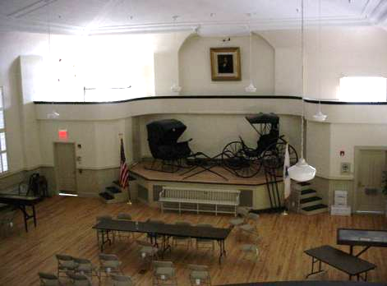

Auditorium

Picture 2



The Vault
Picture 3

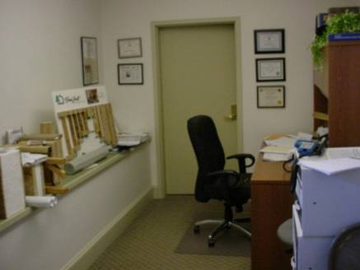

Closet Door Leading To Former Basement Entrance

Picture 4

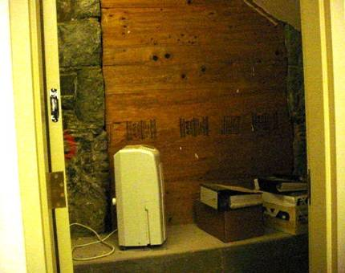

Plywood Plug over Former Basement Entrance
Picture 5

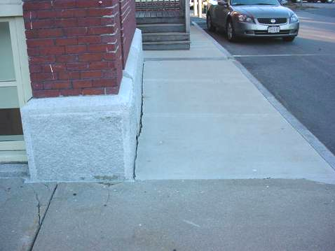

South Wall, Sidewalk/Exterior Wall Seam

Picture 6

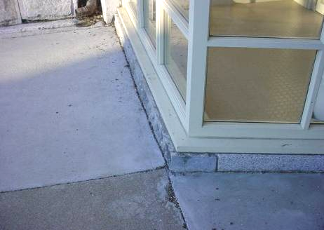

Front Wall, Sidewalk/Exterior Wall Seam
Picture 7

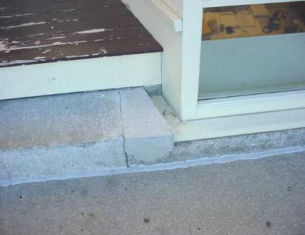

Front Wall, Sidewalk/Exterior Wall Sealed Seam, Note Crack in Step

Picture 8

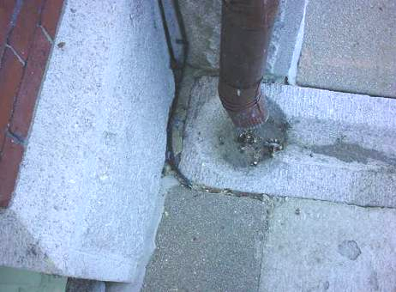

Downspout and Cement Conduit, Note Seams
Picture 9

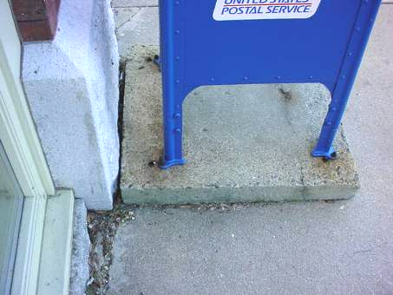

Mail Box Base

Picture 10

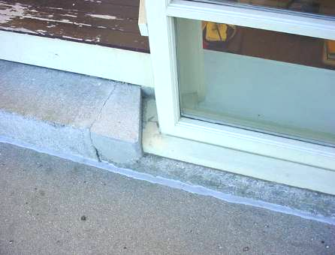

Open Seam between Building Sill and Window System
Picture 11

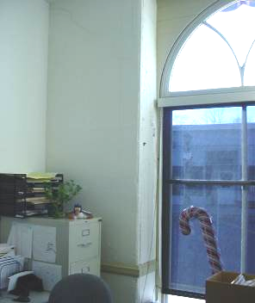

Window Assessor’s Office

Picture 12

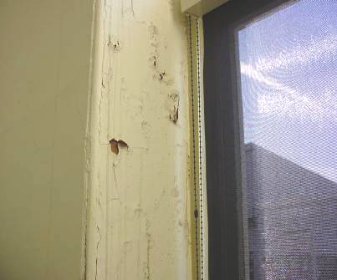

Close Up Of Water Damage in Picture 11
Picture 13

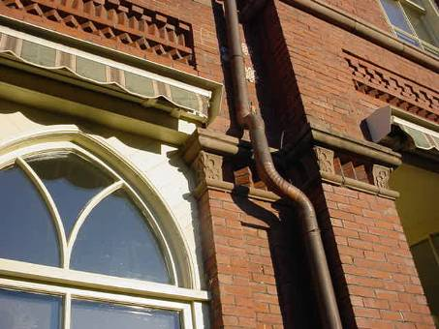

Drip Sill and Window Frame above Water Damage in Assessor’s Office

Picture 14

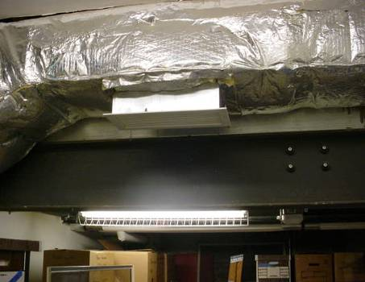

Fresh Air Supply, Basement Storeroom
Picture 15

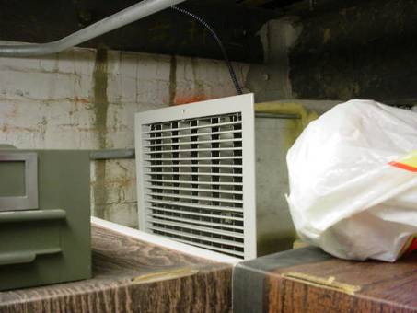

Return Vent, Basement Storeroom
Location | Carbon  Dioxide  (*ppm) | Temp  (°F) | Relative  Humidity  (%) | Occupants  in Room | Windows  Openable | Ventilation |  | Remarks
 |  |  |  |  |  | Supply | Exhaust | Remarks
Outside  (Background) | 342 | 42 | 62
Board of health | 508 | 68 | 30 | 30 | N | Y | Y | Door open
Meeting room B | 446 | 70 | 25 | 0 | N | Y | Y | Door open
Board of selectman | 544 | 71 | 25 | 1 | Y | Y | Y
Equipment room | 519 | 73 | 23 | 0 | N | Y | Y | Photocopier  Door open
Tax Collector | 661 | 74 | 23 | 2 | Y | Y | Y
Assessor | 652 | 75 | 23 | 2 | Y | Y | Y | Water damaged window frame
Finance director | 775 | 74 | 23 | 1 | Y | Y | Y
Town clerk | 588 | 74 | 22 | 2 | Y | Y | Y
Vault | 566 | 66 | 24 | 0 | N | N | N
Meeting room C | 558 | 73 | 24 | 0 | N | Y | Y
Kitchen | 524 | 73 | 22 | 0 | N | Y | Y
Inspectional Services | 510 | 73 | 21 | 2 | Y | Y | Y | Dry erase board
Committee office | 472 | 73 | 19 | 0 | N | Y | Y

