INDOOR AIR QUALITY ASSESSMENT
Merrymount Elementary School
4 Agawam Road
Quincy, Massachusetts

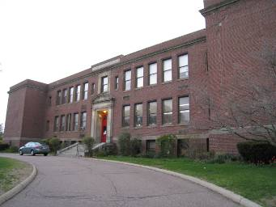

Prepared by:
Massachusetts Department of Public Health
Bureau of Environmental Health
Indoor Air Quality Program
July 2010

Background/Introduction
At the request of a parent, the Massachusetts Department of Public Health (MDPH), Bureau of Environmental Health (BEH) provided assistance and consultation regarding indoor air quality (IAQ) at the Merrymount Elementary School (MES) located at 4 Agawam Road, Quincy, Massachusetts. The assessment was coordinated through the Quincy Health Department (QHD) and Quincy Public Schools (QPS). Concerns about general IAQ conditions and excessive heat, prompted the request. On April 16, 2010, Cory Holmes, Environmental Analyst/Regional Inspector from BEH’s Indoor Air Quality (IAQ) Program, made a visit to the MES to conduct an assessment. During the assessment, BEH staff were accompanied by Cynthia DeCristofaro, QHD and Joe LaPierre, Senior Custodian; and for portions of the assessment by Kevin Murphy, Coordinator of Plant Facilities and Kevin Segalla, Supervisor of Custodians.
The MES is a two-story, brick building with an occupied basement built in 1928. The school houses general classrooms, science classrooms, small rooms for specialized instruction, a cafeteria/gymnasium, media center, art room, music room, teacher’s workrooms and office space. An addition was built in 1977 that contains the gym/cafeteria, two classrooms, elevator, staff lounge and storage areas. The school has had chronic issues with water penetration. A new section of roof was installed in 2007, which has reportedly reduced leaks. Mr. Murphy reported that a competitive process for additional roof work is currently out to bid. Windows are openable throughout the building.

Methods
Air tests for carbon dioxide, temperature, relative humidity and carbon monoxide were conducted with the TSI, Q-Trak, IAQ Monitor, Model 7565. Air tests for airborne particle matter with a diameter less than 2.5 micrometers were taken with the TSI, DUSTTRAK™ Aerosol Monitor Model 8520. MDPH staff also performed visual inspection of building materials for water-damage and/or microbial growth.

Results
The school houses approximately 325 students in grades K to 5 with approximately 20 staff members. Tests were taken during normal school operations and results appear in Table 1.

Discussion

Ventilation
It can be seen from Table 1 that carbon dioxide levels were above 800 parts per million (ppm) in 12 of 24 areas surveyed, which indicates poor air exchange in half of the areas surveyed during the assessment. The majority of elevated carbon dioxide levels appeared to be directly related to deactivated/non-functioning ventilation equipment, particularly in rooms with full occupancy. Several areas had open windows or were empty/sparsely populated at the time carbon dioxide measurements were taken, which can greatly reduce carbon dioxide levels. Carbon dioxide levels would be expected to increase with windows closed and higher occupancy.
Classroom temperature and airflow via the mechanical ventilation systems is apparently controlled by an automated computer system. Fresh air is supplied to classrooms by unit ventilator (univent) systems that were reportedly installed in the late 1970s (Picture 1). A univent draws outdoor air through an air intake located on the exterior wall of the building and return air from the room through an air intake located at the base of the unit (Figure 1). Fresh and return air are mixed, filtered, heated, and then delivered to the room through an air diffuser located in the top of the unit.
Univents have control settings of ‘off, low, and high’. At the time of the assessment, BEH staff found univent cabinets opened and switched ‘off’ in a number of areas (Picture 1). When univents are deactivated, no fresh air is introduced into these rooms (Table 1). In addition, univent air diffusers and return intakes were blocked by books, furniture and other stored items in front and on top of the unit, thereby limiting airflow (Picture 2). In order for univents to provide fresh air as designed, air diffusers and intakes must remain free of obstructions. Importantly, these units must remain “on” and be allowed to operate while rooms are occupied.
During the assessment, BEH staff were informed by QPS staff that univents are also equipped with carbon dioxide sensors to facilitate operation. These types of sensors are typically designed to activate and deactivate mechanical ventilation components. Once a pre-set reading is exceeded, the unit is activated to introduce fresh air. When a second, lower pre-set reading is measured by the sensor, the ventilation system is deactivated. No mechanical ventilation is provided until the sensor re-activates the system. It is important to note that any type of sensor requires periodic calibration to maintain proper function. School officials could not identify the last date and/or frequency of calibration recommended for the carbon dioxide sensors.
Exhaust ventilation in the majority of classrooms is provided by ceiling or wall-mounted vents ducted to rooftop motors (Pictures 3 through 6). The exhaust ventilation system is designed to continuously remove moisture, odors, excess heat and pollutants from the indoor environment. Exhaust vents were not functioning in the majority of areas surveyed at the time of the assessment (Table 1). BEH staff also found several exhaust vents blocked by furniture and other stored items (Pictures 3 and 4). In order to function properly, exhaust vents must be activated and allowed to operate without obstruction while rooms are occupied. Without adequate supply and exhaust ventilation, excess heat and environmental pollutants can build up leading to indoor air/comfort complaints. In subsequent correspondence, Mr. LaPierre reported that rooftop exhaust vents were being repaired.
Mechanical exhaust ventilation in the art room and room 12 is provided by unit exhaust ventilators (Picture 7). A unit exhaust ventilator is similar to a univent in appearance, except that it removes air from the classroom and expels it out of the building. Unit exhaust ventilators were not operating at the time of the assessment and appeared not to have been operated for some time.
Mechanical ventilation for internal rooms and common areas such as the cafeteria/gymnasium consist of rooftop or ceiling-mounted air handling units (AHUs). AHUs draw in outdoor air through intakes, filter, heat and/or cool the air, and distribute it to occupied areas via ceiling or wall-mounted air diffusers. Exhaust air is returned to the AHUs via return vents.
To maximize air exchange, the MDPH recommends that both supply and exhaust ventilation operate continuously during periods of school occupancy. In order to have proper ventilation with a mechanical supply and exhaust system, the systems must be balanced to provide an adequate amount of fresh air to the interior of a room while removing stale air from the room. It is recommended that HVAC systems be re-balanced every five years to ensure adequate air systems function (SMACNA, 1994).
The Massachusetts Building Code requires that each room have a minimum ventilation rate of 15 cubic feet per minute (cfm) per occupant of fresh outside air or openable windows (SBBRS, 1997; BOCA, 1993). The ventilation must be on at all times that the room is occupied. Providing adequate fresh air ventilation with open windows and maintaining the temperature in the comfort range during the cold weather season is impractical. Mechanical ventilation is usually required to provide adequate fresh air ventilation.
Carbon dioxide is not a problem in and of itself. It is used as an indicator of the adequacy of the fresh air ventilation. As carbon dioxide levels rise, it indicates that the ventilating system is malfunctioning or the design occupancy of the room is being exceeded. When this happens, a buildup of common indoor air pollutants can occur, leading to discomfort or health complaints. The Occupational Safety and Health Administration (OSHA) standard for carbon dioxide is 5,000 parts per million parts of air (ppm). Workers may be exposed to this level for 40 hours/week, based on a time-weighted average (OSHA, 1997).
The MDPH uses a guideline of 800 ppm for publicly occupied buildings. A guideline of 600 ppm or less is preferred in schools due to the fact that the majority of occupants are young and considered to be a more sensitive population in the evaluation of environmental health status. Inadequate ventilation and/or elevated temperatures are major causes of complaints such as respiratory, eye, nose and throat irritation, lethargy and headaches. For more information concerning carbon dioxide, consult Appendix A.
Temperature measurements in the building ranged from 64° F to 75° F, which were below the MDPH recommended range in several areas at the time of the assessment (Table 1). The MDPH recommends that indoor air temperatures be maintained in a range of 70º F to 78º F in order to provide for the comfort of building occupants. In many cases concerning indoor air quality, fluctuations of temperature in occupied spaces are typically experienced, even in a building with an adequate fresh air supply. In addition, it is difficult to control temperature and maintain comfort without operating the ventilation equipment as designed (e.g., univents/exhaust vents deactivated/obstructed).
As stated previously, excessive heat complaints have been made by building occupants. Excessive heat was reported primarily in classrooms along the front of the building. These rooms have large radiator units (Picture 8) that supplement unit ventilators to provide heat. In addition, these rooms have been known to absorb solar heat gain over the course of the day, further contributing to the heat load. Without mechanical supply to provide in cool outside air and exhaust ventilation to remove excessive heat, the building lacks airflow, resulting in comfort complaints.
The relative humidity measured in the building ranged from 33 to 42 percent, which were within or close to the lower end of the MDPH recommended comfort range (Table 1). The MDPH recommends a comfort range of 40 to 60 percent for indoor air relative humidity. Relative humidity levels in the building would be expected to drop during the winter months due to heating. The sensation of dryness and irritation is common in a low relative humidity environment. Low relative humidity is a very common problem during the heating season in the northeast part of the United States.

Microbial/Moisture Concerns
In order for building materials to support mold growth, a source of water exposure is necessary. Identification and elimination of the source of water moistened building materials is necessary to control mold growth. As previously mentioned, the building has had chronic issues with water penetration through the building envelope, much of which has been corrected through replacement of sections of the roof. Repairs to the building’s parapet roof/flashing and exterior brick (Pictures 9 and 10) is part of the current capital repair project that is out to bid. Water penetration from this area has resulted in efflorescence and water-damaged wall/ceiling plaster throughout the top floor (Pictures 11 through 13). Efflorescence is a characteristic sign of water-damage to brick and mortar, but it is not mold growth. As moisture penetrates and works its way through mortar, brick or plaster, water-soluble compounds dissolve, creating a solution. As the solution moves to the surface of the material, the water evaporates, leaving behind white, powdery mineral deposits. BEH staff examined the roof and found damaged and/or missing mortar around exterior brick/flashing in numerous areas (Picture 14); this issue should be addressed during the current roof repair project.
BEH staff examined building materials inside the building for water-damage and/or microbial growth. A number of areas had water-damaged ceiling tiles, which can indicate leaks from the roof/plumbing system or water penetration through the building envelope (Picture 15/Table 1). Ceiling tiles should be replaced after a water leak is discovered and repaired.
The US Environmental Protection Agency (US EPA) and the American Conference of Governmental Industrial Hygienists (ACGIH) recommend that porous materials be dried with fans and heating within 24 to 48 hours of becoming wet (US EPA, 2001; ACGIH, 1989). If not dried within this time frame, mold growth may occur. Once mold has colonized porous materials, they are difficult to clean and should be removed/discarded.
A number of classrooms had plants (Table 1). Plants can be a source of pollen and mold, which can serve as respiratory irritants for some sensitive individuals. Plants should be properly maintained and equipped with drip pans to prevent water-damage to porous building materials. Plants should also be located away from ventilation sources (e.g., univent air diffusers) to prevent the aerosolization of dirt, pollen or mold.

Other IAQ Evaluations
Indoor air quality can be negatively influenced by the presence of respiratory irritants, such as products of combustion. The process of combustion produces a number of pollutants. Common combustion emissions include carbon monoxide, carbon dioxide, water vapor and smoke (fine airborne particle material). Of these materials, exposure to carbon monoxide and particulate matter with a diameter of 2.5 micrometers (μm) or less (PM2.5) can produce immediate, acute health effects upon exposure. To determine whether combustion products were present in the indoor environment, BEH staff obtained measurements for carbon monoxide and PM2.5.

Carbon Monoxide
Carbon monoxide is a by-product of incomplete combustion of organic matter (e.g., gasoline, wood and tobacco). Exposure to carbon monoxide can produce immediate and acute health affects. Several air quality standards have been established to address carbon monoxide and prevent symptoms from exposure to these substances. The MDPH established a corrective action level concerning carbon monoxide in ice skating rinks that use fossil-fueled ice resurfacing equipment. If an operator of an indoor ice rink measures a carbon monoxide level over 30 ppm, taken 20 minutes after resurfacing within a rink, that operator must take actions to reduce carbon monoxide levels (MDPH, 1997).
The American Society of Heating Refrigeration and Air-Conditioning Engineers (ASHRAE) has adopted the National Ambient Air Quality Standards (NAAQS) as one set of criteria for assessing indoor air quality and monitoring of fresh air introduced by HVAC systems (ASHRAE, 1989). The NAAQS are standards established by the US EPA to protect the public health from six criteria pollutants, including carbon monoxide and particulate matter (US EPA, 2006). As recommended by ASHRAE, pollutant levels of fresh air introduced to a building should not exceed the NAAQS levels (ASHRAE, 1989). The NAAQS were adopted by reference in the Building Officials & Code Administrators (BOCA) National Mechanical Code of 1993 (BOCA, 1993), which is now an HVAC standard included in the Massachusetts State Building Code (SBBRS, 1997). According to the NAAQS, carbon monoxide levels in outdoor air should not exceed 9 ppm in an eight-hour average (US EPA, 2006).
Carbon monoxide should not be present in a typical, indoor environment. If it is present, indoor carbon monoxide levels should be less than or equal to outdoor levels. Outdoor carbon monoxide concentrations were non-detect (ND) at the time of the assessment (Table 1). No measurable levels of carbon monoxide were detected in the building during the assessment (Table 1).

Particulate Matter
The US EPA has established NAAQS limits for exposure to particulate matter. Particulate matter (PM) is airborne solids that can be irritating to the eyes, nose and throat. The NAAQS originally established exposure limits to PM with a diameter of 10 μm or less (PM10). According to the NAAQS, PM10 levels should not exceed 150 micrograms per cubic meter (μg/m³) in a 24-hour average (US EPA, 2006). These standards were adopted by both ASHRAE and BOCA. Since the issuance of the ASHRAE standard and BOCA Code, US EPA established a more protective standard for fine airborne particles. This more stringent PM2.5 standard requires outdoor air particle levels be maintained below 35 μg/m³ over a 24-hour average (US EPA, 2006). Although both the ASHRAE standard and BOCA Code adopted the PM10 standard for evaluating air quality, MDPH uses the more protective PM2.5 standard for evaluating airborne PM concentrations in the indoor environment.
Outdoor PM2.5 concentrations the day of the assessment were measured at 10 μg/m³. PM2.5 levels measured in occupied areas ranged from 8 to 52 μg/m³ (Table 1). Indoor PM 2.5 levels were below the NAAQS PM2.5 level of 35 μg/m³ in all classrooms surveyed at the time of the assessment. Areas where PM2.5 levels were above the NAAQS of 35 μg/m³ were the cafeteria and the 2nd floor hallway. Elevated PM2.5 levels in the cafeteria (50 μg/m³) were traced to the kitchen food prep area, which measured 100 μg/m³. It is important to note that the kitchen is equipped with a local exhaust hood that was not operating at the time the measurements were taken (Picture 16), which resulted in particulate matter accumulating rather than being removed from the building. The second floor hallway PM2.5 measurement of 52 μg/m³ was traced to plaster demolition work being conducted in the girls’ restroom, which had a PM2.5 level of 510 μg/m³ (Picture 17). Upon discovery, BEH staff recommended depressurizing the work zone by using fans placed in windows to draw airborne dusts away from occupied areas and out the window. QPS maintenance staff brought in fans and reduced hallway PM2.5 measurements to 11 μg/m³ within minutes after fans were activated.
Frequently, indoor air levels of particulates (including PM2.5) can be at higher levels than those measured outdoors. A number of mechanical devices and/or activities that occur indoors can generate particulate during normal operations. Sources of indoor airborne particulates may include but are not limited to: particles generated during the operation of fan belts in the HVAC system; cooking in the cafeteria stoves and microwave ovens; use of photocopiers, fax machines and computer printing devices; operation of an ordinary vacuum cleaner; and, heavy foot traffic indoors.

Volatile Organic Compounds
Indoor air concentrations can be greatly impacted by the use of products containing volatile organic compounds (VOCs). VOCs are carbon-containing substances that have the ability to evaporate at room temperature. Frequently, exposure to low levels of total VOCs (TVOCs) may produce eye, nose, throat and/or respiratory irritation in some sensitive individuals. For example, chemicals evaporating from a paint can stored at room temperature would most likely contain VOCs. In an effort to identify materials that can potentially increase indoor VOC concentrations, BEH staff examined rooms for products containing these respiratory irritants.
Cleaning products were found on countertops in several rooms (Table 1). Of particular concern was a spray bottle of degreaser that was found on a windowsill (Picture 18). The material safety data sheet (MSDS) for this product states “Immediate Concerns: Caution: Eye and Skin Irritant: May Be Harmful If Swallowed. Avoid contact with eyes. Do not taste or swallow. Avoid prolonged contact with skin. Use rubber gloves for sensitive skin” (Chemtura, 2007). Cleaning products contain chemicals that can be irritating to the eyes, nose and throat of sensitive individuals. These products should be properly labeled and stored in an area inaccessible to children. Additionally, an MSDS should be available at a central location for each product in the event of an emergency. Consideration should be given to providing teaching staff with school issued cleaning products and supplies to ensure that MSDS information is available for all products used at the school.
Several classrooms contained dry erase boards and related materials. Materials such as dry erase markers and dry erase board cleaners may contain VOCs, such as methyl isobutyl ketone, n-butyl acetate and butyl-cellusolve (Sanford, 1999), which can be irritating to the eyes, nose and throat.
Several areas that contain photocopiers and laminators are not equipped with local mechanical exhaust ventilation to help reduce excess heat and odors. Lamination machines melt plastic and give off odors and VOCs. VOCs and ozone can be produced by photocopiers, particularly if the equipment is older and in frequent use. Ozone is a respiratory irritant (Schmidt Etkin, 1992).
In an effort to reduce noise from sliding chairs, tennis balls were sliced open and placed on chair legs in some classrooms. Tennis balls are made of a number of materials that are a source of respiratory irritants. Constant wearing of tennis balls can produce fibers and off-gas VOCs. Tennis balls are made with a natural rubber latex bladder, which becomes abraded when used as a chair leg pad. Use of tennis balls in this manner may introduce latex dust into the school environment. Some individuals are highly allergic to latex (e.g. spina bifida patients) (SBAA, 2001). It is recommended that the use of materials containing latex be limited in buildings to reduce the likelihood of symptoms in sensitive individuals (NIOSH, 1997).

Other Conditions
Other conditions that can affect indoor air quality were observed during the assessment. In several classrooms, items were observed on windowsills, tabletops, counters, bookcases and desks. The large number of items stored in classrooms provides a source for dusts to accumulate. These items (e.g., papers, folders, boxes) make it difficult for custodial staff to clean. Items should be relocated and/or be cleaned periodically to avoid excessive dust build up. In addition, these materials can accumulate on flat surfaces (e.g., desktops, shelving and carpets) in occupied areas and subsequently be re-aerosolized causing further irritation.
Fluorescent light fixtures were missing covers in a number of areas (Picture 19/Table 1). Unshielded fluorescent lights can produce glare which can cause eye strain. Light fixtures should be equipped with access covers installed over fully secured bulbs. Breakage of glass can cause injuries and may release mercury and/or other hazardous compounds. For that reason, they must be stored, utilized and disposed of with care (refer to Appendix B for more information).
A number of personal fans, exhaust vents, air diffusers and surrounding ceiling tiles were observed to have accumulated dust/debris (Pictures 5 and 20/Table 1). Re-activated diffusers, vents or fans can aerosolize accumulated dust. If exhaust vents are not functioning, backdrafting can occur, which can re-aerosolize dust particles.
Finally, restrooms are equipped with mechanical exhaust vents that were not drawing air at the time of the assessment. Exhaust ventilation is necessary in restrooms to remove excess moisture and to prevent odors from penetrating into adjacent areas.

Conclusions/Recommendations
In view of the findings at the time of the assessment, the following recommendations are made to improve indoor air quality in the building:
- Operate all ventilation systems (e.g., univents, exhaust vents and AHUs) throughout the building continuously during periods of occupancy. To increase airflow in classrooms, set univent controls to “high”. School staff should be encouraged not to deactivate classroom univents; rather, report any temperature/comfort complaints to the facilities department.
- Inspect exhaust motors and belts on a regular schedule (e.g., 2-4 times per year) for proper function, and perform repairs and adjustments as necessary.
- Restore unit exhaust ventilators in rooms 12 and art and restroom exhaust vents to operate as designed.
- Remove all blockages from univents and exhaust vents to ensure adequate airflow.
- Contact the school’s HVAC engineer regarding the operation and function of the carbon dioxide monitors installed in univents. Maintain and calibrate in accordance with the manufacturer’s instructions. However, it is important to note that the MDPH recommends that mechanical ventilation operate continuously during periods of school occupancy, not subject to controls by carbon dioxide sensors.
- Use openable windows in conjunction with mechanical ventilation to facilitate air exchange. Care should be taken to ensure windows are properly closed at night and weekends to avoid the freezing of pipes and potential flooding.
- Consider adopting a balancing schedule of every 5 years for all mechanical ventilation systems, as recommended by ventilation industrial standards (SMACNA, 1994).
- In order to reduce temperatures and heat in classrooms along the front of the building several actions should be taken and/or considered:
  - Operate classroom univents continuously during occupied hours to draw in cool outside air (by lowering thermostat).
  - Ensure exhaust ventilation is operating to remove excess heat.
  - Consider mounting portable fans to facilitate air circulation.
  - Consider applying solar (tinted) film to windows as needed to reduce solar gain/excess heat.
- For buildings in New England, periods of low relative humidity during the winter are often unavoidable. Therefore, scrupulous cleaning practices should be adopted to minimize common indoor air contaminants whose irritant effects can be enhanced when the relative humidity is low. To control for dusts, a high efficiency particulate arrestance (HEPA) filter equipped vacuum cleaner in conjunction with wet wiping of all surfaces is recommended. Avoid the use of feather dusters. Drinking water during the day can help ease some symptoms associated with a dry environment (throat and sinus irritations).
- Continue with plans to make repairs to roof/parapet/exterior brick and flashing. In the interim, efflorescence, loose paint and plaster debris should be periodically cleaned using a vacuum with a brush attachment. Once repairs to the roof/parapet are completed, water-damaged plaster ceilings and walls should be prepped and refinished.
- Store cleaning products properly and out of reach of students. Ensure spray bottles are properly labeled. All cleaning products used at the facility should be approved by the school department with MSDS’ available at a central location.
- Operate local exhaust hood in kitchen during food preparation.
- Clean dry erase marker trays regularly to prevent the build-up of excessive particulates.
- Relocate photocopiers and lamination machines to areas with local exhaust ventilation or install local exhaust ventilation in areas where this equipment is used to reduce excess heat and odors.
- Consider discontinuing the use of tennis balls on chair legs or replace with latex-free tennis balls or alternative glides.
- Relocate or consider reducing the amount of materials stored in classrooms to allow for more thorough cleaning of classrooms. Clean items regularly with a wet cloth or sponge to prevent excessive dust build-up.
- Clean air diffusers, exhaust vents and personal fans periodically of accumulated dust. If soiled ceiling tiles cannot be cleaned, replace.
- Replace covers for fluorescent light fixtures.
- For future renovation/demolition activity consult MDPH guidance document “Methods Used to Reduce/Prevent Exposure to Construction/Renovation Generated Pollutants in Occupied Buildings” attached as Appendix C.
- Consider adopting the US EPA (2000) document, “Tools for Schools”, as an instrument for maintaining a good indoor air quality environment in the building. This document is available at: http://www.epa.gov/iaq/schools/index.html.
- Refer to resource manual and other related indoor air quality documents located on the MDPH’s website for further building-wide evaluations and advice on maintaining public buildings. These documents are available at: http://mass.gov/dph/iaq.
References
ACGIH. 1989. Guidelines for the Assessment of Bioaerosols in the Indoor Environment. American Conference of Governmental Industrial Hygienists, Cincinnati, OH.
ASHRAE. 1989. Ventilation for Acceptable Indoor Air Quality. American Society of Heating, Refrigeration and Air Conditioning Engineers. ANSI/ASHRAE 62-1989
BOCA. 1993. The BOCA National Mechanical Code/1993. 8th ed. Building Officials and Code Administrators International, Inc., Country Club Hill, IL.
Chemtura. 2007. Material Safety data Sheet (MSDS). Greased Lightning Super Strength Multi-Purpose Cleaner & Degreaser. HomeCare Labs, Inc., A Chemtura Company. MSDS No: HGRL112STB. Revision 1, Dated 05/17/2007
MDPH. 1997. Requirements to Maintain Air Quality in Indoor Skating Rinks (State Sanitary Code, Chapter XI). 105 CMR 675.000. Massachusetts Department of Public Health, Boston, MA.
NIOSH. 1997. NIOSH Alert Preventing Allergic Reactions to Natural Rubber latex in the Workplace. National Institute for Occupational Safety and Health, Atlanta, GA.
OSHA. 1997. Limits for Air Contaminants. Occupational Safety and Health Administration. Code of Federal Regulations. 29 C.F.R 1910.1000 Table Z-1-A.
Sanford. 1999. Material Safety Data Sheet (MSDS No: 198-17). Expo® Dry Erase Markers Bullet, Chisel, and Ultra Fine Tip. Sanford Corporation. Bellwood, IL.
SBAA. 2001. Latex In the Home And Community Updated Spring 2001. Spina Bifida Association of America, Washington, DC.
SBBRS. 1997. Mechanical Ventilation. State Board of Building Regulations and Standards. Code of Massachusetts Regulations. 780 CMR 1209.0
Schmidt Etkin, D. 1992. Office Furnishings/Equipment & IAQ Health Impacts, Prevention & Mitigation. Cutter Information Corporation, Indoor Air Quality Update, Arlington, MA.
SMACNA. 1994. HVAC Systems Commissioning Manual. 1st ed. Sheet Metal and Air Conditioning Contractors’ National Association, Inc., Chantilly, VA.
US EPA. 2000. Tools for Schools. Office of Air and Radiation, Office of Radiation and Indoor Air, Indoor Environments Division (6609J). EPA 402-K-95-001, Second Edition. http://www.epa.gov/iaq/schools/tools4s2.html
US EPA. 2001. Mold Remediation in Schools and Commercial Buildings. US Environmental Protection Agency, Office of Air and Radiation, Indoor Environments Division, Washington, D.C. EPA 402-K-01-001. March 2001.
US EPA. 2006. National Ambient Air Quality Standards (NAAQS). US Environmental Protection Agency, Office of Air Quality Planning and Standards, Washington, DC. http://www.epa.gov/air/criteria.html.
Picture 1

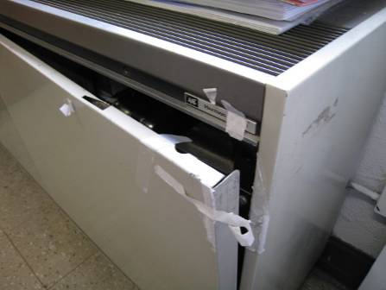

Classroom Univent Opened and Deactivated

Picture 2

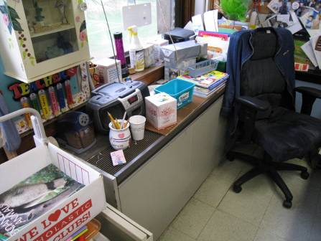

Items Obstructing Airflow from Univent Air Diffuser

Picture 3

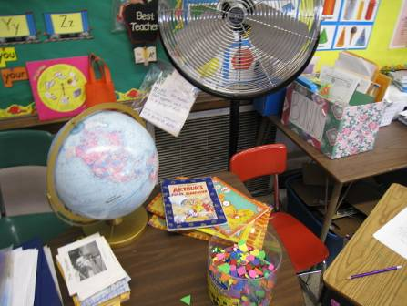

Exhaust Vent Partially Obstructed by Classroom Items

Picture 4

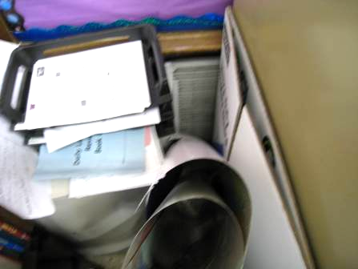

Exhaust Vent Partially Obstructed by Classroom Items

Picture 5

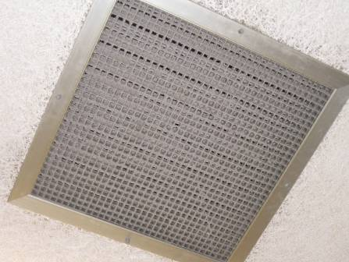

Ceiling-Mounted Exhaust, Note Accumulated Dust/Debris

Picture 6

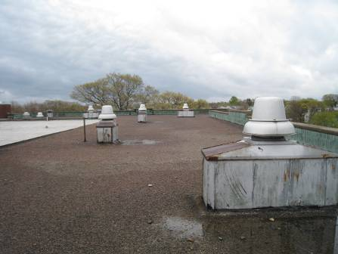

Rooftop Exhaust Motors

Picture 7

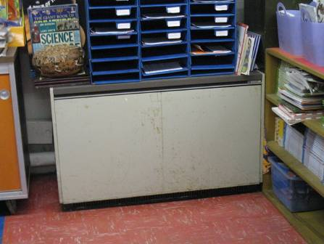

Unit Exhaust Ventilator as Seen in Room 12 and the Art Room

Picture 8

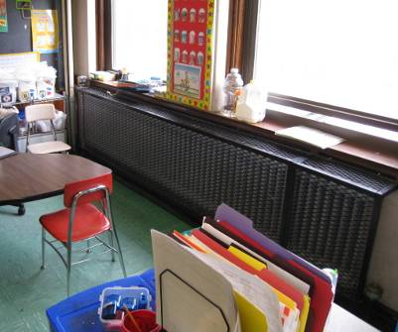

Large Radiator in Classroom

Picture 9

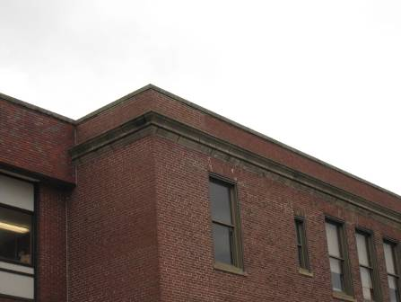

Parapet Roof and Exterior Brick

Picture 10

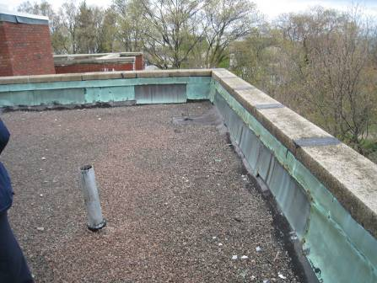

Parapet Roof and Flashing

Picture 11

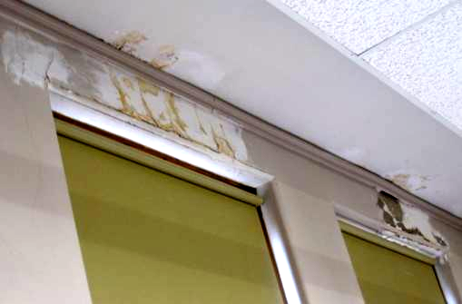

Water-Damaged Ceiling/Wall Plaster and Efflorescence in top Floor Classroom

Picture 12

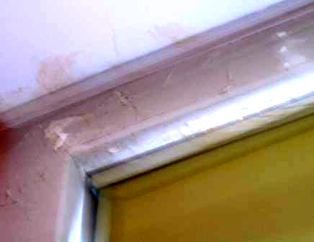

Water-Damaged Ceiling/Wall Plaster and Efflorescence in top Floor Classroom

Picture 13

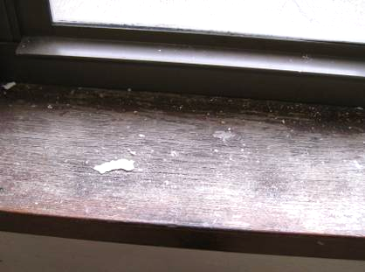

Flaking Paint/Plaster Debris on Window Sill in Classroom below
Damaged Ceiling/Wall Plaster

Picture 14

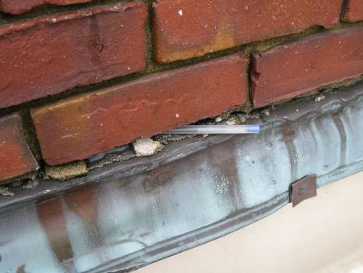

Missing/Damaged Mortar between Flashing and Brick along Parapet
(note: pen placed in breach for emphasis)
Picture 15

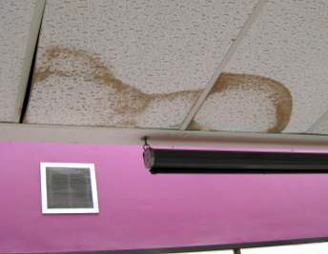

Water-Damaged Ceiling Tiles

Picture 16

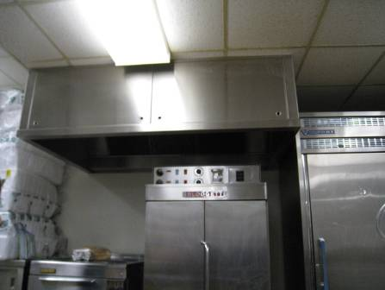

Kitchen Exhaust Hood

Picture 17

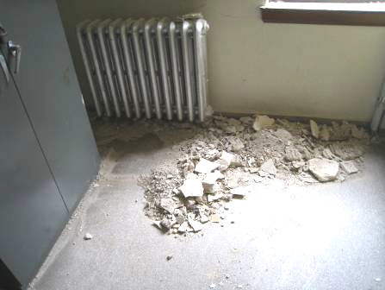

Plaster Demolition Dust/Debris in 2nd Floor Girls Restroom

Picture 18

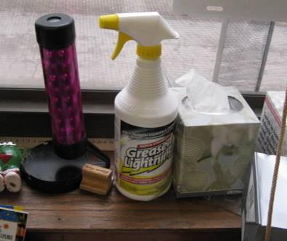

Spray Bottle of Degreasing Agent on Classroom Windowsill

Picture 19

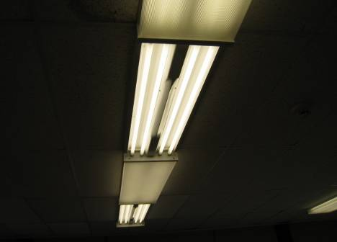

Missing Fluorescent Light Covers

Picture 20

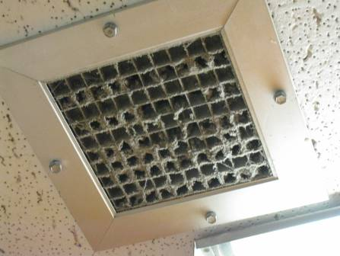

Exhaust Vent with Accumulated Dust/Debris
Location/ Room | Occupants  in Room | Temp  (°F) | Relative  Humidity  (%) | Carbon  Dioxide  (ppm) | Carbon Monoxide  (ppm) | PM2.5  (µg/m3) | Windows  Openable | Ventilation |  | Remarks
 |  |  |  |  |  |  |  | Supply | Exhaust
background |  | 50 | 89 | 374 | ND | 10 |  |  |  | Overcast, occasional rain, cool, winds NE 10-21 mph, gusts up to 25 mph
31 | 17 | 73 | 34 | 746 | ND | 8 | Y | Y | Y  Off
Boys Restroom |  |  |  |  |  |  |  |  | Y  Off
Manning | 1 | 70 | 33 | 940 | ND | 10 | N | N | N | Cold complaints
Charty | 18 | 69 | 37 | 1136 | ND | 16 | Y | Y  Off | Y  Off | Univent deactivated, 5 WD CTs, UF
Literacy | 0 | 64 | 39 | 477 | ND | 8 | N | Y | Y | Dust/debris vents/CTs, 2 WD CTS, 1 dislodged CT
Library | 18 | 65 | 39 | 378 | ND | 8 | N | Y | Y | WD CTs, dusty vents, UF, standing fan, missing fluorescent light covers
Hallway Outside Girls Restroom |  |  |  |  |  | 52/11* |  |  |  | *PM2.5 reading was 52, reduced to 11 after DPH recommendation to install negative exhaust fans to depressurize work area
Girls Restroom |  |  |  |  |  | 510 | Y  Open | Y | Y  Off | Plaster removal/demolition, window open-pressurized space
Teacher’s Lounge | 1 | 65 | 39 | 430 | ND | 16 | N | Y | Y | Carpet
37 | 0 | 66 | 38 | 652 | ND | 13 | Y | Y  Off | Y  Off | 12 WD CTs, WD CP, TB, univent deactivated
36 | 13 | 67 | 38 | 696 | ND | 10 | Y | Y | Y  Off | WD CP and efflorescence, exhaust vent dusty
35 | 17 | 72 | 36 | 867 | ND | 10 | Y | Y  Off | Y | Items on univent, exhaust partially obstructed
34 | 18 | 70 | 36 | 677 | ND | 12 | Y | Y  Off | Y  Off | DO
33B | 0 | 68 | 36 | 582 | ND | 9 | Y | Y | Y  Off | Plants, univent deactivated, peeling paint/plaster, 9 occupants gone ~1minute
33A | 20 | 72 | 37 | 832 | ND | 13 | Y | Y  Off | Y  Off | Univent deactivated reportedly due to excessive heat, peeling paint, efflorescence
Nurse | 0 | 71 | 35 | 645 | ND | 10 | Y  Open | N | N | WD plaster, peeling paint
20 | 19 | 73 | 36 | 1082 | ND | 20 | Y | Y | Y
21 | 20 | 75 | 37 | 914 | ND | 15 | Y | Y | Y
22 | 1 | 74 | 33 | 728 | ND | 12 | Y | Y | Y  Off | Exhaust vent off/obstructed, 18 occupants gone ~ 1 minute
Teachers Workroom | 0 | 75 | 33 | 704 | ND | 13 | Y | Y | N | PC, lamination machine
23 | 0 | 72 | 36 | 951 | ND | 12 | Y | Y | Y  Off | Univent and exhaust obstructed, occupants at lunch
24 | 1 | 71 | 37 | 923 | ND | 18 | Y | Y  Off | Y  Off | DO, 22 occupants gone ~ 5 minutes
25 | 0 | 71 | 38 | 823 | ND | 31 | Y | Y  Off | Y  Off | Univent and exhaust off/obstructed, spray bottle of degreaser
26 | 0 | 70 | 36 | 725 | ND | 20 | Y | Y | Y | WD CP, carbon monoxide monitor
Cafeteria/  Gym | ~110 | 69 | 42 | 926 | ND | 50* | N | Y | Y | Full-activity, gym floor/vents dusty, * PM2.5 tracked to kitchen = 100 μg/m³ Food Storage/Prep, vent hood not operating
Art | 20 | 69 | 41 | 1059 | ND | 24 | Y | Y | Y  Off | Ceiling univent, unit exhaust ventilator, plants, bathroom exhaust
12 | 12 | 70 | 39 | 910 | ND | 12 | Y | Y | Y | Unit exhaust ventilator-reportedly has not operated for some time, TB, WD CT, bathroom exhaust-dusty

PCB Fluorescent Light Cleanup Recommendations
During inventory of Light Fixtures for PCB-containing ballasts, there is a chance that spills could be discovered. The MDPH/BEH recommends the following to reduce exposures during cleanup of leaking PCB-containing light ballasts:
- Lock-out and deactivate the light fixture and remove persons from the room;
- Open the windows and use mechanical supply and exhaust ventilation for dilution and removal.
- Remove failed ballasts and wrap in newspaper (to absorb any leaks) and seal in plastic bag for proper disposal.
- Remove any visible contamination (smoky, tar-like, and/or brown molasses like) material using a putty knife (or similar utensil) and/or paper towel.
- Solid non-porous surfaces should be cleaned with a surfactant detergent in water (~ 5% solution) followed by cleaning with a water rinse.
- Non-porous contaminated materials (e.g., carpeting, ceiling tiles) cannot be adequately cleaned and should be removed and sealed in plastic bags for proper disposal.
- Wipe down general contact surfaces (such as desks, chairs, tables, etc.)

Persons conducting cleaning procedures should wear proper protective equipment (PPE) (i.e., protective gloves* to prevent skin contact with PCBs). (PCBs are readily absorbed through the skin and some glove materials). Gloves made of a fluoroelastomer material are recommended for this type of cleanup to prevent absorption, which can occur with other gloves.
If clean up is to be conducted in a room without windows or mechanical ventilation, personnel should wear a one-half face piece respirator equipped with a pre-filter and an organic vapor cartridge to prevent inhalation exposure.
If skin contact with PCBs occurs on the skin, remove contaminated clothing and wash contaminated skin thoroughly with soap and water. Seal any PCB contaminated clothes in plastic bags for proper disposal.
For proper disposal, comply with all federal, state and local hazardous waste laws. For more information on hazardous waste laws and regulations contact your local hazardous waste coordinator, the Massachusetts Department of Environmental Protection, Hazardous Waste Division (617)-556-1096 http://www.mass.gov/dep/recycle/hazwaste.htm or the US EPA Region I (888) 372-7341 http://www.epa.gov/epawaste/hazard/tsd/pcbs/pubs/laws.htm

