WATER DAMAGE ASSESSMENT
Merrymount Elementary School
Communication Center Classroom
4 Agawam Road
Quincy, Massachusetts
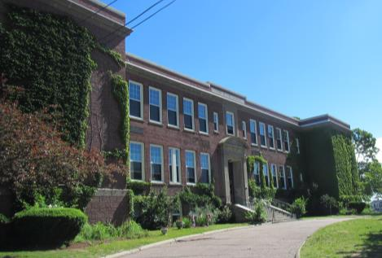
Prepared by:
Massachusetts Department of Public Health
Bureau of Environmental Health
Indoor Air Quality Program
June 2017

Background
Building: | Merrymount Elementary School
Address: | 4 Agawam Road, Quincy, MA
Assessment Requested by: | Kevin Segalla, Coordinator of Custodial Services, Quincy Public Schools
Reason for Request: | Water damage and indoor air quality (IAQ) assessment, respiratory issues and mold concerns in the Communication Center room and adjacent areas.
Date of Assessment: | June 9, 2017
Massachusetts Department of Public Health/Bureau of Environmental Health (MDPH/BEH) Staff Conducting Assessment: | Ruth Alfasso, Environmental Engineer/Inspector, IAQ Program
Building Description: | Two-story brick school building originally constructed in the 1920s. Assessment was limited to the Communications Center and adjacent interior rooms on the second floor.
Windows: | The school has openable windows, but the areas examined were interior rooms.

Methods
Please refer to the IAQ Manual and appendices for methods, sampling procedures, and interpretation of results (MDPH, 2015).

Results and Discussion
The following is a summary of indoor air testing results (Table 1).
- Carbon dioxide measurements were below the MDPH recommended level of 800 parts per million (ppm) in areas surveyed.
- Temperature was within the MDPH recommended range of 70°F to 78°F at the time of assessment.
- Relative humidity was within the MDPH recommended range of 40 to 60% in all areas tested.
- Carbon monoxide levels were non-detectable in all areas tested.
- Particulate matter (PM2.5) concentrations measured were below the National Ambient Air Quality (NAAQS) level of 35 μg/m³ in all areas tested.

Ventilation
A heating, ventilating and air-conditioning (HVAC) system has several functions. First it provides heating and, if equipped, cooling. Second, it is a source of fresh air. Finally, an HVAC system will dilute and remove normally occurring indoor environmental pollutants by not only introducing fresh air, but also filtering the airstream and ejecting stale air to the outdoors via exhaust ventilation.
Testing results suggest that sufficient fresh air was being introduced into the space at the time of assessment. Outside air is brought in via an air handling unit (AHU) and delivered to classrooms via ceiling-mounted supply diffusers. Air is exhausted from ceiling-mounted exhaust vents (Picture 1). Exhaust vents are located near classroom doors, so when classroom doors are open, exhaust vents will tend to pull hallway air into the classroom instead of removing stale air/pollutants from the room and out the building.
It is important to note that relative humidity levels in the building would be expected to be lower during the winter months due to atmospheric conditions and heating. Low relative humidity can lead to common symptoms such as: dry skin, lips, and scalp; dry/scratchy throats and noses (nose bleeds); exacerbation of asthma, eczema, or allergies; dry/irritated eyes; and irritation of respiratory tract.
It is recommended that AHUs be outfitted with pleated filters of a Minimum Efficiency Reporting Value (MERV) of 8, which are adequate in filtering out pollen and mold spores (ASHRAE, 2012). In addition, filters should be changed 2-4 times a year or in accordance with the manufacture’s recommendations. Mr. Segalla reported that AHU filters are MERV 8 and are changed 3 times per year.

Microbial/Moisture Concerns
In the Communication Center room, an area of water-damaged ceiling tiles was present next to a brick wall (Pictures 2 through 4). The brick portion of wall in this area is a chimney original to the building. The bricks in this area also show signs of efflorescence, white powdery deposits that are caused by water passing through brick and mortar and precipitating out minerals on the surface. While the roof has reportedly been recently replaced at this school, reducing water infiltration elsewhere, leaks have continued to occur in this room. This is likely due to wind-driven rain being forced either through the bricks and mortar of the chimney or through flashing or sealing around or near the chimney on the roof. Very small holes or gaps can allow enough water penetration during a heavy rain to result in stained tiles.
Note that the area above the ceiling was examined (Picture 3) and it is a high, open space containing no additional porous materials to hold water or become colonized with mold. Moistened ceiling tiles are likely to dry quickly in this situation, and not become mold-colonized. No moldy odors or mold growth was observed. It was also observed that a bookcase with books on top, and other items were placed directly adjacent to this wall (Picture 4). Until the source of the leak has been repaired, it is recommended that this wall be kept free of items to facilitate drying.
One of the rooms examined was a staff kitchen. The refrigerator had evidence of a recent spill (Picture 5). Refrigerators need to be kept clean to prevent microbial growth and odors.

Other IAQ Evaluations
Exposure to low levels of total volatile organic compounds (TVOCs) may produce eye, nose, throat, and/or respiratory irritation in some sensitive individuals. To determine if VOCs were present, BEH/IAQ staff examined rooms for products containing VOCs. BEH/IAQ staff noted hand sanitizers, cleaners, and dry erase materials in use within the building. All of these products have the potential to be irritants to the eyes, nose, throat, and respiratory system of sensitive individuals.
In a number of areas, items were observed on the floor, windowsills, tabletops, counters, bookcases and desks. The large number of items stored provides a source for dusts to accumulate. These items (e.g., papers, folders, boxes) make it difficult for custodial staff to clean. Items should be relocated and/or be cleaned periodically to avoid excessive dust build up. In addition, dusty materials can accumulate on flat surfaces (e.g., desktops, windowsills and carpets) in occupied areas and subsequently be re-aerosolized causing further irritation. Accumulated dust/debris was noted on vents and surrounding ceiling tiles, which should be cleaned periodically (e.g., after regular filter changes).
The Communications Center had an area rug. Carpets should be cleaned annually (or semi-annually in soiled/high traffic areas) in accordance with Institute of Inspection, Cleaning and Restoration Certification (IICRC) recommendations, (IICRC, 2012).
Several rooms examined had upholstered items, including one chair that was heavily worn and ripped (Picture 6). Ripped upholstery can be a source of irritating particulates and can no longer be properly cleaned. In order to remove dust mites and other pollutants, frequent vacuuming of upholstered furniture is recommended (Berry, M.A., 1994). It is also recommended that upholstered furniture (if present in schools), be professionally cleaned on an annual basis. If outdoor conditions or indoor activities (e.g., renovations) create an excessively dusty environment, cleaning frequency should be increased (every six months) (IICRC, 2000).
The staff kitchen had several cooking appliances, including a full-sized electric stove. The room did not have a range hood and did not appear to have a direct-vented exhaust. Kitchen areas can produce particulates and odors that should be removed from the building. Kitchen equipment should be kept clean and free of crumbs and debris to avoid odors, smoke and pests.
Note that the Environmental Protection Agency (EPA) conducted a National School Radon Survey in which it discovered nearly one in five schools had “…at least one frequently occupied ground contact room with short-term radon levels above 4 [picocuries per liter] pCi/L” (US EPA 1992). The BEH/IAQ Program therefore recommends that every school be tested for radon, and that this testing be conducted during the heating season while school is in session in a manner consistent with USEPA radon testing guidelines. Radon measurement specialists and other information can be found at www.nrsb.org and http://aarst-nrpp.com/wp, with additional information at: http://www.mass.gov/eohhs/gov/departments/dph/programs/environmental-health/exposure-topics/iaq/radon.

Conclusions and Recommendations
In view of the findings at the time of the visit, the following recommendations are made:
- Continue to work to identify/repair potential sources of leaks from the roof/chimney area into the Communications center.
- Remove furniture and items from impacted brick wall to facilitate drying.
- Replace water-damaged ceiling tiles as needed.
- For more information about mold/remediation consult “Mold Remediation in Schools and Commercial Buildings” published by the US Environmental Protection Agency (US EPA, 2008).
- Use openable windows in conjunction with mechanical ventilation to increase air exchange. Care should be taken to ensure windows are properly closed at night and weekends to avoid the freezing of pipes and potential flooding.
- Close classroom doors to maximize air exchange/improve exhaust capabilities.
- For buildings in New England, periods of low relative humidity during the winter are often unavoidable. Therefore, scrupulous cleaning practices should be adopted to minimize common indoor air contaminants whose irritant effects can be enhanced when the relative humidity is low. To control for dusts, a high efficiency particulate arrestance (HEPA) filter-equipped vacuum cleaner in conjunction with wet wiping of all surfaces is recommended. Avoid the use of feather dusters. Drinking water during the day can help ease some symptoms associated with a dry environment (throat and sinus irritation).
- Keep refrigerators clean to prevent odors and microbial growth.
- Ensure all cooking equipment is kept clean to prevent odors, smoke and pests. If no direct exhaust vent is present in the kitchen, consider installing one.
- Clean supply/exhaust/return vents and personal fans regularly to prevent aerosolization of debris.
- Reduce clutter building-wide and increase dust control.
- Continue to use pleated MERV 8 filters, which are adequate in filtering out pollen and mold spores (ASHRAE, 2012). Continue to change 2-4 times a year or in accordance with the manufacture’s recommendations.
- Clean carpeting, area rugs and upholstered items regularly and discard those that are worn out or too soiled to be cleaned.
- Reduce use of products and equipment that create VOCs.
- Continue to adopt the US EPA (2000) document, “Tools for Schools”, as an instrument for maintaining a good IAQ environment in the building available at: http://www.epa.gov/iaq/schools/index.html.
- The school should be tested for radon by a certified radon measurement specialist during the heating season when school is in session. Radon measurement specialists and other information can be found at: www.nrsb.org, and http://aarst-nrpp.com/wp/.
- Refer to resource manual and other related IAQ documents located on the MDPH’s website for further building-wide evaluations and advice on maintaining public buildings. These documents are available at http://mass.gov/dph/iaq

REFERENCES
ASHRAE. 2012. American Society of Heating, Refrigeration and Air Conditioning Engineers (ASHRAE) Standard 52.2-2012 -- Method of Testing General Ventilation Air-Cleaning Devices for Removal Efficiency by Particle Size (ANSI Approved).
Berry, M.A. 1994. Protecting the Built Environment: Cleaning for Health, Michael A. Berry, Chapel Hill, NC.
IICRC. 2000. IICRC S001. Reference Guideline for Professional On-Location Cleaning of Textile Floor Covering Materials. Institute of Inspection, Cleaning and Restoration Certification. Institute of Inspection Cleaning and Restoration, Vancouver, WA.
IICRC. 2012. Institute of Inspection, Cleaning and Restoration Certification. Carpet Cleaning: FAQ. Retrieved from http://www.iicrc.org/consumers/care/carpet-cleaning.
MDPH. 2015. Massachusetts Department of Public Health (MDPH). 2015. Indoor Air Quality Manual: Chapters I-III. Available at: http://www.mass.gov/eohhs/gov/departments/dph/programs/environmental-health/exposure-topics/iaq/iaq-manual/.
US EPA. 1992. Radon Measurement in Schools, Revised Edition. Office of Air and Radiation, Office of Radiation and Indoor Air, Indoor Environments Division (6609J). EPA 402-R-92-014. https://www.epa.gov/sites/production/files/2014-08/documents/radon_measurement_in_schools.pdf
US EPA. 2000. Tools for Schools. Office of Air and Radiation, Office of Radiation and Indoor Air, Indoor Environments Division (6609J). EPA 402-K-95-001, Second Edition. http://www.epa.gov/iaq/schools/index.html.
US EPA. 2008. “Mold Remediation in Schools and Commercial Buildings”. US EPA. Office of Air and Radiation, Indoor Environments Division, Washington, DC. EPA 402-K-01-001. Available at: http://www.epa.gov/mold/mold-remediation-schools-and-commercial-buildings-guide.

Picture 1
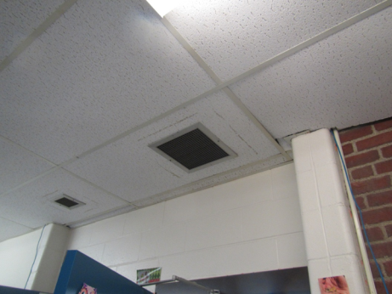
Exhaust vent, note door next to vent
Picture 2
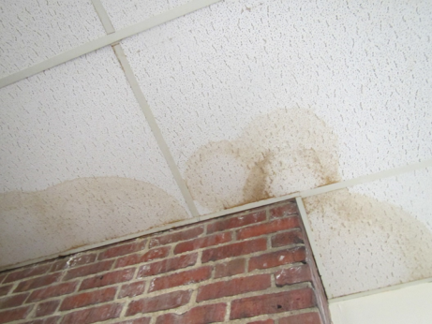
Water-damaged ceiling tiles and efflorescence on brick
Picture 3
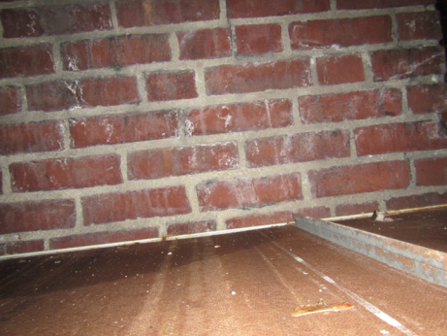
Open space above ceiling tiles next to brick wall showing large air space
Picture 4
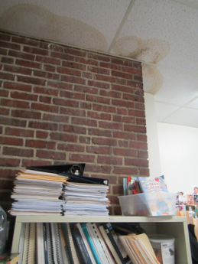
Bookshelf and papers next to water-impacted wall
Picture 5
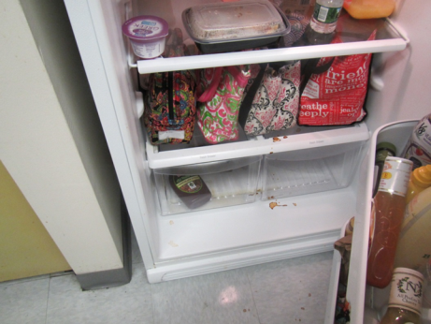
Spill in refrigerator
Picture 6
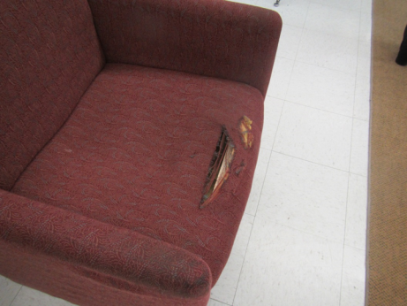
Worn/ripped upholstered furniture
Picture 7
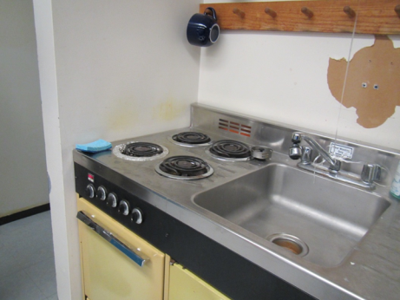
Stove and oven with no exhaust hood

Location | Carbon  Dioxide  (ppm) | Carbon Monoxide  (ppm) | Temp  (°F) | Relative  Humidity  (%) | PM2.5  (µg/m³) | Occupants  in Room | Windows  Openable | Ventilation |  | Remarks
 |  |  |  |  |  |  |  | Supply | Exhaust
Background (outdoors) | 375 | ND | 73 | 41 | 4 |  |  |  |  | Partly cloudy
Communication Center | 671 | ND | 75 | 48 | 8 | 0-2 | N | Y | Y | Supply and exhaust on/functioning, DO, PF, WD CT, area rug, upholstered items, books/cabinets against wall
Library | 730 | ND | 75 | 48 | 3 | Many just coming in | N | Y | Y | New England Aquarium displays, upholstered items (some worn)
Teachers Kitchen | 713 | ND | 75 | 47 | 4 | 0 | N | Y | Y | Spill in fridge, food, cooking equipment

