BACKGROUND

INDOOR AIR QUALITY
ASSESSMENT

Metacomet Emergency Communications Center
14 Sharon Avenue
Norfolk, MA

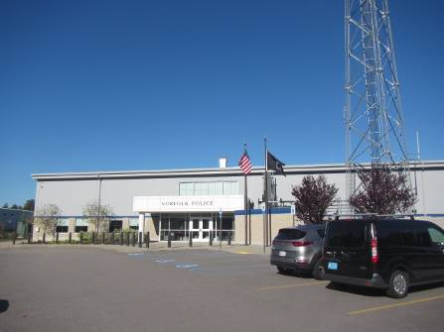

Prepared by:
Massachusetts Department of Public Health
Bureau of Environmental Health
Indoor Air Quality Program
November 2022
Building: | Metacomet Emergency Communications Center (MECC)
Address: | 14 Sharon Avenue, Norfolk, MA
Assessment Requested by: | Nicole Connors, Communications Manager, MECC
Reason for Request: | General indoor air quality (IAQ) assessment
Date of Assessment: | October 19, 2022
Massachusetts Department of Public Health/Bureau of Environmental Health (MDPH/BEH) Staff Conducting Assessment: | Cory Holmes, Assistant Director,  IAQ Program
Building Description: | The MECC is located above the Norfolk Police Department on the second floor of a two-story public service building constructed in 2018. The building has concrete construction and a flat roof. The space consists of suspended ceiling tiles, carpet squares and gypsum wallboard. The MECC is made up of a main communications center, with office space, training rooms, kitchen/breakroom, and storage areas.
Windows: | Not openable

METHODS
Please refer to the IAQ Manual for methods, sampling procedures, and interpretation of results (MDPH, 2015).

RESULTS and DISCUSSION
The following is a summary of indoor air testing results (Table 1).
- Carbon dioxide levels were below the MDPH guideline of 800 parts per million (ppm) in the majority of areas surveyed, indicating adequate air exchange, however two areas were slightly above 800, which may indicate an adjustment to introduce more fresh air.
- Temperature was within or very close to the MDPH recommended range of 70°F to 78°F in areas tested.
- Relative humidity was below the MDPH recommended range of 40 to 60% in most areas. Note, low relative humidity can lead to common symptoms such as: dry skin, lips, and scalp; dry/scratchy throats and noses (nose bleeds); exacerbation of asthma, eczema, or allergies; dry/irritated eyes; and irritation of respiratory tract. Low relative humidity conditions are typical in New England during the heating season. These conditions can be exacerbated in the communications center due to the amount of heat-generating computer/communications equipment.
- Carbon monoxide levels were non-detectable (ND) in all areas tested.
- Fine particulate matter (PM2.5) concentrations measured were below the National Ambient Air Quality Standard (NAAQS) limit of 35 μg/m³ in all areas tested.

Ventilation
A heating, ventilating, and air conditioning (HVAC) system has several functions. First it provides heating and, if equipped, cooling. Second, it is a source of fresh air. Finally, an HVAC system will dilute and remove normally occurring indoor environmental pollutants by not only introducing fresh air, but by filtering the airstream and ejecting stale air to the outdoors via exhaust ventilation. Even if an HVAC system is operating as designed, point sources of respiratory irritation may exist and cause symptoms in sensitive individuals.
The HVAC system for the communications center consists of two air handling units (AHUs) located in a mechanical room (Picture 1), which draw in outside air (Picture 2) and heat/cool it. Other areas in the MECC have ceiling-mounted units (Picture 3) or units located above the suspended ceiling (Picture 4). Conditioned air is ducted to slotted (Picture 5) or multi-directional (Picture 6) air diffusers and returned via ceiling vents (Picture 7) back to the AHUs.
The HVAC system is controlled by digital thermostats that feed into a computerized management system. The MDPH IAQ Program recommends that the fan be set to the “on” setting to provide continuous circulation/filtration during occupied hours.
AHUs have filters, which should be changed 2-4 times a year or per the manufacturer’s recommendations. Filters should be at least a Minimum Efficiency Rating Value (MERV) of 8 or higher, if they fit and the equipment can handle the pressure reductions caused by more restrictive filters. The interiors of AHU cabinets were inspected and found clean and dry with MERV 8 filters having been changed recently (Pictures 8 and 9).
In order to have proper ventilation with a mechanical ventilation system, the systems must be balanced after installation to provide an adequate amount of fresh air to the interior of a room while removing stale air from the room. It is recommended that HVAC systems be re-balanced every five years to ensure adequate air systems function (SMACNA, 1994).

Microbial/Moisture Concerns
A water-damaged ceiling tile was observed in room 209 (Picture 10). It appears that this likely stems from condensation from the AC system. When a water leak is discovered and repaired, water-damaged tiles should be changed. No other water-damaged materials, water stains or musty odors were observed in the MECC during the visit.

Other Concerns
Most of the floors are covered with carpet squares. Carpets should be vacuumed regularly with a high efficiency particulate arrestance (HEPA) filter equipped vacuum cleaner and cleaned annually (or semi-annually in soiled/high traffic areas) in accordance with Institute of Inspection, Cleaning and Restoration Certification (IICRC) recommendations, (IICRC, 2012).
Finally, some exhaust and return vents had light accumulations of dust and debris. This dust/debris can be reaerosolized under certain conditions, and should be cleaned periodically (e.g., during regular filter changes).

CONCLUSIONS and RECOMMENDATIONS
In view of the findings at the time of assessment, the following recommendations are made:

Ventilation recommendations
- Adjust HVAC system for an increase in fresh/outside air as needed.
- Continue with regular filter changes for HVAC equipment using the best quality/highest MERV rated filters that can be used with current equipment. During filter changes, vacuum debris from AHU cabinets.
- Have the HVAC system balanced every 5 years in accordance with SMACNA recommendations (SMACNA, 1994).

Water Damage recommendations
- Ensure all leaks are repaired and replace water-damaged ceiling tiles.

Other recommendations
- For buildings in New England, periods of low relative humidity during the winter are often unavoidable. Therefore, scrupulous cleaning practices should be adopted to minimize common indoor air contaminants whose irritant effects can be enhanced when the relative humidity is low. To control for dusts, a high efficiency particulate arrestance (HEPA) filter equipped vacuum cleaner in conjunction with wet wiping of all surfaces is recommended. Avoid the use of feather dusters. Drinking water during the day can help ease some symptoms associated with a dry environment (throat and sinus irritations).
- Clean supply, return, and exhaust vents regularly to remove accumulated dust/debris.
- Clean carpeting in accordance with IICRC recommendations (IICRC, 2012); annually (or semi-annually in soiled/high traffic areas).
- Refer to resource manual and other related IAQ documents located on the MDPH’s website for further building-wide evaluations and advice on maintaining public buildings. These documents are available at: http://mass.gov/dph/iaq.

REFERENCES
IICRC. 2012. Institute of Inspection, Cleaning and Restoration Certification. Carpet Cleaning: FAQ.
MDPH. 2015. Massachusetts Department of Public Health. “Indoor Air Quality Manual: Chapters I-III”. Available at: Indoor air quality - manual and appendices | Mass.gov
SMACNA. 1994. HVAC Systems Commissioning Manual. 1st ed. Sheet Metal and Air Conditioning Contractors’ National Association, Inc., Chantilly, VA.

Picture 1
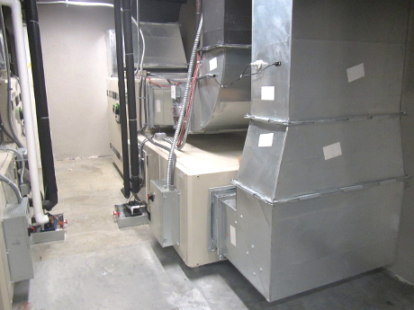
AHUs for the MECC in mechanical room

Picture 2
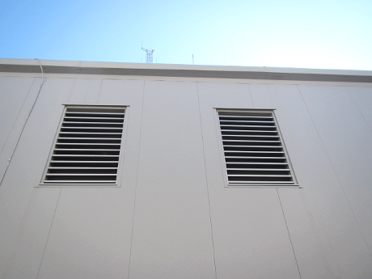
Outside air intakes for the MECC’s AHUs

Picture 3
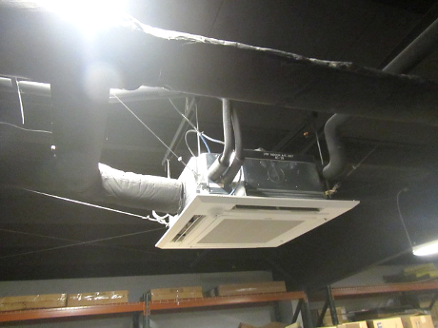
Ceiling-mounted AHU

Picture 4
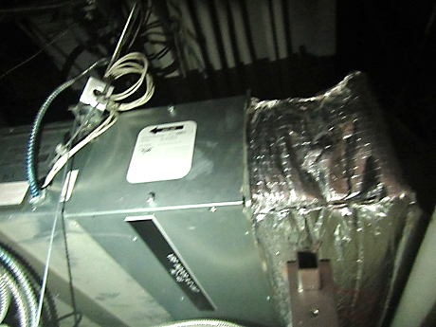
AHU located above suspended ceiling

Picture 5
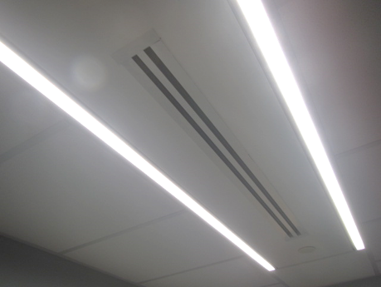
Slotted air diffuser

Picture 6
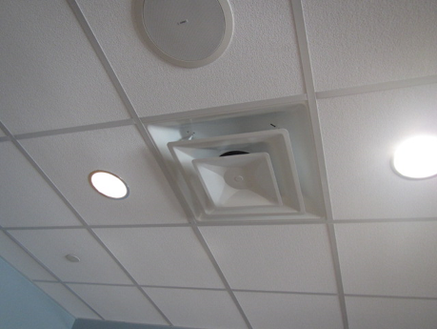
Multi-directional air diffuser

Picture 7
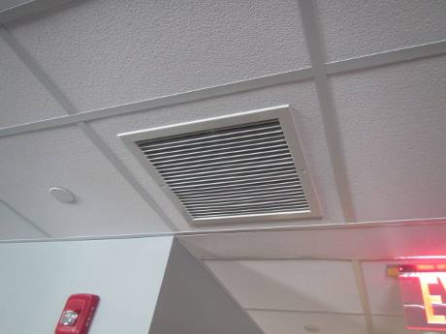
Ceiling-mounted return vent

Picture 8
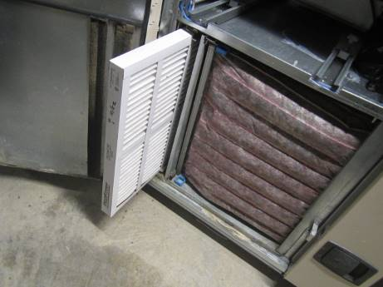
Clean/recently changed filters in AHU, 2nd floor mechanical room

Picture 9
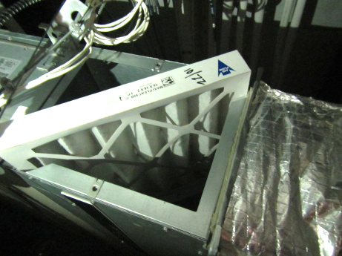
Clean/recently changed filters in AHU above ceiling in Training Room

Picture 10
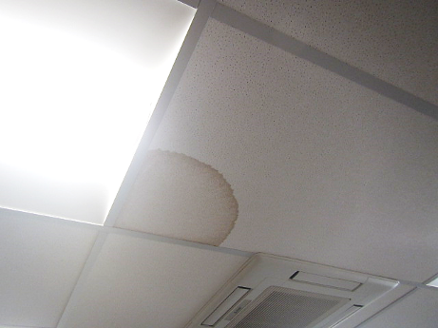
Water-damaged ceiling tile in room 209

Location | Carbon  Dioxide  (ppm) | Carbon Monoxide  (ppm) | Temp  (°F) | Relative  Humidity  (%) | PM2.5  (µg/m³) | Occupants  in Room | Windows  Openable | Ventilation |  | Remarks
 |  |  |  |  |  |  |  | Supply | Exhaust
Background | 425 | ND | 61 | 45 | 10 |  |  |  |  | Cool, clear, sunny, and breezy
207 Breakroom | 823 | ND | 71 | 37 | 1 | 3 | N | Y | Y | Dust/debris on exhaust vents
209 | 811 | ND | 71 | 39 | 1 | 2 | N | Y | Y | Computer network equipment
213 | 635 | ND | 72 | 34 | 1 | 0 | N | Y | Y
214 Operations | 725 | ND | 69 | 41 | 1 | 8 | N | Y | Y | Dust/debris/cobwebs on exhaust vents, door pegged open to computer network room
CTA (computer network room) | 707 | ND | 69 | 41 | 1 | 0 | N | Y | Y | Door pegged open to Operations
Gym | 576 | ND | 72 | 35 | 1 | 0 | N | Y | Y
Locker Room | 527 | ND | 69 | 35 | 1 | 0 | N | Y | Y
Locker Room Restrooms | 560 | ND | 70 | 35 | 1 | 0 | N | Y | Y | Strong odors detected; possible dry floor drain traps
Main Restrooms | 545 | ND | 70 | 34 | 1 | 0 | N | Y | Y | Floor drains (no odors)
Storage | 480 | ND | 72 | 36 | 1 | 0 | N | Y | Y
Training Classroom | 517 | ND | 71 | 36 | 1 | 0 | N | Y | Y

