**INDOOR AIR QUALITY ASSESSMENT**

**Methuen City Hall**

**41 Pleasant Street**

**Methuen, MA**



Prepared by:

Massachusetts Department of Public Health

Bureau of Environmental Health

Indoor Air Quality Program

June 2016

# Background

|  |  |
| --- | --- |
| Building: | Methuen City Hall (MCH) |
| Address: | 41 Pleasant Street, Methuen |
| Assessment Requested by: | Methuen Board of Health |
| Reason for Request: | Cancer/health concerns and general IAQ |
| Date of Assessment: | May 19, 2016 |
| Massachusetts Department of Public Health/Bureau of Environmental Health (MDPH/BEH) Staff Conducting Assessment: | Mike Feeney, Director, IAQ Program  Ruth Alfasso, Environmental Engineer/Inspector, IAQ Program  Jason Dustin, Environmental Analyst/Inspector, IAQ Program,  Brenda Netreba, Environmental Analyst, Community Assessment Program (CAP)  Carolyn Ariori, Environmental Analyst, CAP |
| Building Description: | Methuen City Hall occupies a former school built in the late 1800s. Exterior is brick and stone, with a complex peaked slate roof. Four floors, including a basement level, are occupied. |
| Building Population: | Approximately 70 staff work in the building. Members of the public visiting daily |
| Windows: | Some openable |

# Methods

Please refer to the IAQ Manual for methods, sampling procedures, and interpretation of results (MDPH, 2015).

# IAQ Testing Results

The following is a summary of indoor air testing results (Table 1).

* ***Carbon dioxide levels*** were below 800 parts per million (ppm) in all areas assessed, except for some Auditing Department areas.
* ***Temperature*** was within the recommended range of 70°F to 78°F in all areas assessed, apart from the IT area in the basement.
* ***Relative humidity*** was slightly below the recommended range of 40 to 60% in all areas assessed, apart from the IT area in the basement.
* ***Carbon monoxide*** levels were non-detectable (ND) in all indoor areas assessed.
* ***Fine particulate matter (PM2.5)*** concentrations measured were below the National Ambient Air Quality Standard (NAAQS) level of 35 μg/m3 in all areas assessed.
* ***Total Volatile Organic Compounds (TVOCs)*** was ND in all locations assessed.

## Ventilation

A heating, ventilating, and air conditioning (HVAC) system has several functions. First it provides heating and, if equipped, cooling. Second, it is a source of fresh air. Finally, an HVAC system will dilute and remove normally-occurring indoor environmental pollutants by not only introducing fresh air, but by filtering the airstream and removing stale air to the outdoors via exhaust ventilation. Even if an HVAC system is operating as designed, point sources of respiratory irritants may be present and produce symptoms in sensitive individuals. The following analysis examines and identifies components of the HVAC system and likely sources of respiratory irritant/allergen exposure due to water damage, aerosolized dust, and/or chemicals found in the indoor environment.

### Original Design of MCH Ventilation System

It is important to note that the MCH was originally constructed as the Searles High School in 1905 and was used as such until 1953. The building was not intended to be occupied year-round when it was operated as a school, and thus was largely unoccupied during the warmest, most humid, months of the year. After 1975, the building was converted and renovated into office space for year-round occupancy. It was rededicated as the City Hall in 1993.

The school building originally had a gravity ventilation system, which consisted of grated, louvered, wall-mounted exhaust vents and floor-level supply vents (Picture 1). Air shafts connected the floor vents to vault-like “air-mixing” rooms in the basement. Fresh air from the outdoors was drawn into the air-mixing rooms through open windows. Under operation, heating elements located in the base of the ventilation shaft of the air mixing room would warm the fresh air, which causes the air rise up the ventilation shaft (via the stack effect) and be distributed to classrooms by floor-level supply vents. Sinking cool air and rising warm air in the room would create air movement. Warm, stale air would exit rooms via wall-mounted exhaust vents (Picture 2) connected to chimney-like rooftop vents (Picture 3). In short, the natural gravity system provided heating, fresh air and exhaust ventilation. Large radiators located under classroom windows provided supplemental heat and facilitated air movement.

### Renovation and Installation of Fan Coil Units

When the building was converted to offices for year-round occupancy, it was renovated and fan coil units (FCU) were installed along exterior walls within the building (Picture 4). The FCUs are designed to provide both heat and cooling. Depending on the setting, heated or chilled water is pumped through a finned tube (i.e., a coil) that is connected to the furnace/chiller by copper pipes that are installed in the pipe chase. Water runs through the copper pipe into the coils, which heat/cool the air forced over the coils by the FCU fans. It is important to note that FCUs are designed to provide either heating or cooling, but do not have a fresh air supply. FCU units can only *recirculate* air (Picture 5).

It appears that the original gravity ventilation system was abandoned when the FCU system was installed. Exhaust vents for the gravity system were still present in a few locations in the building, but the majority of exhaust vents were sealed with gypsum wallboard (GW) as shown in Picture 2. At present, open windows are the only fresh air source to the building.

### Current condition of the MCH Ventilation System

Although most windows were originally designed to be openable, they are in poor condition (Picture 6). Many are stuck closed or are not able to remain open since the sash cord connecting the sash to the window counterweights is broken. Other windows have been sealed with plastic to prevent drafts (Picture 7). Because of the condition of the windows, many areas in the MCH *do not have any* source of fresh air.

FCUs were blocked or obstructed by desks, boxes, and other items (Picture 8). Airflow to and from FCUs should be unrestricted to allow the equipment to function properly. Most FCUs were in poor condition, with signs of rust and deterioration visible from the outside (Picture 4). Internal FCU components were also poor condition, with signs of corrosion and damage (Pictures 9 to 12). Note that these units were likely installed sometime around 1983, which would make them over 30 years old. Function of equipment of this age is difficult to maintain, since compatible replacement parts are often unavailable. According to the American Society of Heating, Refrigeration, and Air-Conditioning Engineers (ASHRAE), the service life for a unit heater (hot water or steam) is 20 years, assuming routine maintenance of the equipment (ASHRAE, 1991). Although attempts have been made to maintain the FCUs, the operational lifespan of the equipment has been exceeded.

BEH/IAQ staff noted a thick layer of dust and debris on FCU filters (Picture 13). In addition, filters are of the type that provides minimal filtration. The dust spot efficiency is the ability of a filter to remove particulate matter of a certain diameter from air passing through the filter. ASHRAE indicates that filters with a dust spot efficiency of a minimum of 40 percent would be sufficient to reduce many airborne particulates (Thornburg, 2000; MEHRC, 1997; ASHRAE, 1992). Pleated filters with a minimum efficiency reporting value (MERV) dust-spot efficiency of 8 or higher are recommended. Consideration should be given to installing pleated filters. Note that increasing filtration may require evaluation and adjustments to the FCUs to manage increased flow resistance created from using higher MERV value filters.

Many occupants reported that they did not use the FCUs due to exacerbation of allergy symptoms, as well as noise, drafts, and odors. Instead, occupants reported that they rely on portable heaters and fans. Although temperatures were within the MDPH recommended range during the visit, occupants expressed concerns regarding thermal discomfort. Without functioning mechanical ventilation and fresh air, temperature control is difficult.

In addition, the MCH *does* *not* have mechanical exhaust ventilation in occupant areas or, in particular, high moisture and odor areas such as restrooms. Without exhaust ventilation, any waste products generated in the building, including carbon dioxide, water vapor, and odors, have no means of escape and will accumulate within the building.

## Microbial/Moisture Concerns

BEH staff were asked to examine the MCH regarding health concerns related to water damage. It is important to note that the primary construction of the building is of materials such as stone, brick, plaster, and hard wood floors that are unlikely to support mold growth even when exposed to periodic water leaks. BEH staff did note accumulations of powdery, white material in areas with brick and mortar along the tunnel entrance to the building (Picture 13) as well as within the abandoned subterranean restroom, which is discussed further below. The white material is called efflorescence; efflorescence is a characteristic sign of water damage to building materials such as brick, mortar, or plaster, but it is not mold growth. As moisture penetrates and works its way through mortar around brick, water-soluble compounds dissolve, creating a solution. As the solution moves to the surface of the brick or mortar, water evaporates, leaving behind white, powdery mineral deposits. This condition indicates that water from the exterior has penetrated into the building. Plaster and brick do not typically support mold growth because these materials are not carbon-based; however paint, items, or debris near the walls that are moistened may become a mold-colonized. When present, efflorescence can be readily cleaned.

### The FCU System

The operation of FCUs during hot, humid weather creates a significant source of water that can cause damage to building components. FCUs with cooling capacity are equipped with drip pans that drain condensation. The drain pan is located beneath the cooling coils and empties into a condensation collector, which is connected to a plastic drainage hose within the pipe chase. The following FCU conditions were noted:

* The FCU configuration makes cleaning drip pans labor intensive. IAQ staff could not examine the drip pans of FCUs since it would necessitate disassembly of the FCU. Considering this difficulty, it is unlikely that the drip pan or coils of each FCU are cleaned routinely.
* The condensation collectors were uniformly coated with scale (Pictures 9 to 11). Scale refers to metal corrosion and mineral deposits that can occur when standing water remains in drip pans or on coils. Standing water can cause metal corrosion. As water evaporates over time, mineral and debris can coat the drip pans, coils, and pipes.
* Scale is a sign that stagnant water is accumulating in the drip pans due to lack of pitch towards drainage. Stagnant water in drip pans can create odors, and microbes may grow on debris in the pans if they are not cleaned regularly.
* The plastic hoses connecting the condensation collectors is made of a flexible plastic. These flexible plastic hoses were coated with scale, dust, and the remnants of biofilm (Picture 15). It is likely that these hoses lay flat on the floor of the pipe chase, with no pitch to aid drainage. Without proper drainage, the plastic hoses are susceptible to clogs from scale, debris, and biofilm; clogs cause water to back up into the FCU. Biofilm is a layer of slime produced by microorganisms in wet or damp environments including coils, drip pans, and drains. Biofilm can produce odors and be resistant to cleaning and disinfection.
* Some FCU did not have plastic hoses, which would allow condensate to drain into the pipe chase.
* Pipes supplying chilled water to coils lacked insulation and were corroded. During hot, humid weather, uninsulated chilled water pipes will collect condensation that can drip into the pipe chase.
* Some of the condensation collectors had pumps that had evidence of leaking.
* There is significant evidence of chronic condensation on the outer surfaces of FCUs including rust spots and more substantial corrosion of the cabinets. Numerous FCUs were retrofitted with a secondary fixed louver (Pictures 3) due to corrosion of the original diffuser. Humid air coming in contact with the chilled cabinets is likely the cause of condensation. Sources contributing to humid air and subsequent damage include:
  + Lack of condensate drainage in the units, leading to a cycle of evaporation and condensation.
  + Lack of proper airflow around the units due to both internal (clogged filter) and external (furniture and items) obstructions.
  + Entry of hot, humid outside air during the cooling season through poorly-sealed, stuck, or intentionally-opened windows.

Water damage occurring due to the conditions described above has also impacted materials on or adjacent to the FCUs. Signs of damage include mold growth spots from debris settled on FCUs (Picture 16) stained walls above the top of the FCU (Picture 17), green staining from copper pipe corrosion at the front of the units (Pictures 11 and 12), and stained carpeting.

Due to design, lack of routine maintenance, and equipment deterioration, it is likely that the FCU and its surroundings may be a source of microbial growth and airborne pollutants when operating. These conditions will become more prominent when the FCUs are in cooling mode.

### Abandoned Restroom Area

Building occupants had specific concerns related to a separate section of the building where a large, abandoned restroom is located. Although the abandoned restroom is connected to the main building, it is important to note that this building structure exists outside the footprint of the occupied MCH building. The structure’s ceiling is below the stairs/walkway that leads to the first floor entrance of the building (Pictures 18 and 19). Since the abandoned bathroom structure is separated from the main building, it does not share any old ventilation shafts or other deliberate pathways with the main building.

The abandoned area is connected to the main building by a hallway that terminates at a series of stairways located near Room 119. The entrance to the abandoned restroom building from the interior of the MCH main building is an archway (Picture 20). An emergency exit has been retrofitted to the archway, and the remainder of the archway opening has been filled with GW. However, the GW wall does not fill the arched space completely. The area above the GW is a pathway that can allow air from the former restroom, which has a slight cellar odor, to penetrate into the adjacent hallway and be distributed to other parts of the main building. Note that the stone of the archway is discolored due to water exposure, but does not have mold colonization. The interior side of the GW around the archway door does have mold colonization (Picture 21), due to exposure to moisture.

The stairwell/hallway leading to the abandoned building had exposed metal lathe due to rainwater damage to plaster (Picture 22). The location of the exposed lathe is directly below the outdoor door threshold for the first floor entrance (Picture 18). Cracked/spalling cement likely provides a pathway for water to enter, resulting in damaged ceiling plaster and cement stains (Picture 23). BEH/IAQ staff did not note musty odors beneath the damaged plaster.

The abandoned restroom was completely decommissioned, with all restroom fixtures, pipes, and drains sealed (Picture 24 and 25). Peeling paint and efflorescence on walls indicate water exposure; however, no mold growth was noted on the brick walls of this structure. Other than two containers, nothing is stored within this area, and it is never occupied by MCH staff or building visitors.

### Other Water-Related Issues

Additional signs and sources of water damage noted inside the MCH building include:

* Water-damaged wall and ceiling plaster and ceiling tiles (Pictures 26 to 28), indicating leaks from the building envelope (e.g. roof, windows, and walls). Reported ice dams from the previous winter also contribute to leaks and damage.
* Lack of exhaust ventilation in restrooms, which results in the accumulation of restroom-generated moisture.
* Water coolers and small refrigerators were observed on carpeting (Picture 29). Spills and leaks from these appliances can moisten carpeting, which can lead to microbial growth and odors.
* Plants were observed in a few areas (Table 1), including on porous surfaces (e.g. carpet). Plants can be a source of pollen and mold, which are respiratory irritants to some individuals. Plants should be properly maintained and equipped with drip pans to prevent water damage to porous materials. Plants should also be located away from air diffusers to prevent the aerosolization of dirt, pollen, and mold.

The exterior of the building was also examined for sources of water damage and odors. The following was noted:

* Missing slate tiles from a few areas of the roof that can lead to leaks.
* Several downspouts were broken/incomplete (Pictures 30 and 31). Lack of proper drainage can cause water to splash against the walls and pool along the foundation, which may lead to damage to the building envelope and infiltration.
* BEH/IAQ staff noted vegetation on or against the building exterior (Picture 32). Vegetation holds moisture against the building envelope. The plants and moisture may damage mortar, leading to increased water infiltration.
* Missing mortar and damaged brick were noted in some areas. Damage to the brickwork/mortar and flashing may compromise the building envelope and lead to increased water infiltration.
* Several windows were noted to have plant vines growing within the window system (Picture 33). This will increase moisture infiltration, damage, and pest entry.
* Some window wells had water and debris accumulated in them. Standing water and debris can attract pests and be a source of odors, which can enter occupied spaces when the windows are open.

## Other IAQ Evaluations

### VOCs

Exposure to low levels of total volatile organic compounds (TVOCs) may produce eye, nose, throat, and/or respiratory irritation in some sensitive individuals. To determine if VOCs were present, BEH/IAQ measured TVOCs in occupied areas. No detectable levels of TVOCs were found. Staff also examined rooms for products containing VOCs. BEH/IAQ staff noted air fresheners, hand sanitizers, cleaners, and dry erase materials in use within the building (Table 1). All of these products have the potential to be irritants to the eyes, nose, throat, and respiratory system of sensitive individuals. Sensory irritation is particular concern in a building with no functioning exhaust ventilation.

### Other conditions

Accumulated items were observed on desks, floors, and other flat surfaces (Pictures 34 to 36). Boxes, papers, and other items were found stored directly in contact with floors, which may be subject to condensation that leads to water damage. In addition, large quantities of paper can provide harborage for pests and may present a fire hazard. A systematic review of stored paperwork and other items should be conducted, with a goal of reducing the overall amount of items and reorganizing the remaining items to be stored in a manner that will prevent further damage, deterioration, and odors (e.g. contained and away from floors).

Restroom odors were reported in the Auditing Department on the third floor. It was determined that there had originally been a doorway between the affected offices and a restroom that was closed off. This enclosure is not airtight. This door should be sealed completely to prevent odor migration.

Food and food/cooking odors were observed in several areas of MCH (Table 1). Due to the lack of exhaust ventilation, any cooking odors will linger in the indoor environment. It is therefore very important to keep cooking equipment clean and free of debris to prevent smoke or odors that can occur when food is heated. Food should be stored in pest-proof containers, and food storage areas should be kept clean to avoid attracting pests.

Both living and dead bees were noted inside and outside near the windows of the MCH in several second floor rooms (Picture 37; Table 1). Bees were also reported on the third floor. Bee activity suggests the presence of one or more beehives in close proximity to the building or even within the building envelope, such as between the inner and outer walls or in the eaves of the building. A pest control company with a specialization in bee relocation should be contacted to determine the location and removal methods of the hive(s). If a hive is within the building envelope, an effort to remove hive-related products such as honey is required in order to prevent future infestation with bees or other pests. The lack of screens on windows in the building contributes to the bee issue. Open windows or gaps/breaches around deteriorating windows can also allow flying pests to enter the building.

Heaters, personal fans, and air purifiers were observed in offices (Table 1). Dust on these appliances can be re-aerosolized and cause irritation when they operate. Heaters should only be used if there is sufficient space around them to operate safely. Papers, cloth, and other flammable materials should not be located near, on top of, or underneath heaters. Air purifiers should be maintained in accordance with manufacturer’s instructions, including filter changing/cleaning, so that they don’t become a source of irritants.

The building has an emergency generator that is tested periodically. This testing should be conducted only when the building is unoccupied to avoid occupant exposure to products of combustion that enter the building.

Most offices are carpeted. Carpets should be cleaned regularly in accordance with Institute of Inspection, Cleaning, and Restoration Certification (IICRC) recommendations (IICRC, 2012). Some carpeting is beyond its service life and should be replaced.

# Health Concerns

At the request of the Mayor of the City of Methuen, BEH staff from the Community Assessment Program (CAP) conducted in-person interviews with interested city hall employees at the time of the IAQ Assessment on May 19, 2016. The interviews included the administration of a questionnaire by BEH/CAP staff to obtain information on the type and frequency of symptoms experienced by some city hall employees. The questionnaire was closely modeled on surveys used previously by BEH as well as those used by the National Institute of Occupational Safety and Health (NIOSH) and the U.S. Environmental Protection Agency (US EPA). The questionnaire elicited information on specific symptoms that have been reported in the scientific/medical literature as commonly experienced by occupants of buildings with indoor air quality problems, as well as information on perceived air quality and personal health factors. These types of questionnaires are used to systematically collect building-related health and environmental complaints. The information collected, in conjunction with the assessment of the indoor environment, can be used to evaluate possible associations between indoor air quality and health and to recommend appropriate follow-up, if warranted.

The Methuen City Hall has an employee population of approximately 70 and 16 individuals (23%) participated in the BEH interview. All responses were reviewed to identify the types of diseases and symptoms that were reported, their frequency of occurrence, and whether any unusual patterns emerged suggestive of a possible association with indoor environmental conditions in the city hall building (Appendix A).

## Employee Interview Results

Information from the 16 individuals is summarized below. Under both state and federal regulations, personally-identifying information shared by employees is confidential; therefore, the following discussion provides summary information only.

## Health Effects

The average age of the employees was approximately 55 years old and the average length of employment at the administration building at its current location was 17 years. Smoking status was obtained in the interviews due to the role of smoking in respiratory health. Among the 16 employees, six reported that they were current or former smokers, and ten had never smoked.

The three most commonly reported symptoms (with 13 of the 16 employees reporting that they experienced the symptom at least once in the four weeks prior to the interview) were: dry, itching, burning, watering, or irritated eyes; a stuffy or runny nose and sinus congestion not related to an infection; and sneezing. Of those who reported experiencing eye irritation, 8 reported experiencing these symptoms almost every day. Of those who reported a stuffy or runny nose or sinus congestion, 6 reported experiencing these symptoms almost every day and 3 reported experiencing these symptoms 1-3 days per week for the past four weeks. Of those who reported sneezing, 6 reported experiencing these symptoms almost every day and 4 reported experiencing these symptoms 1-3 days per week for the past four weeks.

Other commonly reported symptoms (with at least 8 of the 16 employees reporting that they experienced the symptom at least once in the four weeks prior to the interview) were: pain or stiffness in the neck, shoulders or back; sore, hoarse or dry throat; dizziness, lightheadedness, or loss of balance; unusual tiredness, fatigue or drowsiness; and coughing.

Respondents were asked if they experienced these symptoms primarily inside the building, outside the building, or both. Employees who reported experiencing the following conditions reported experiencing the symptoms primarily inside the building: sneezing (11), eye irritation (9), unusual fatigue (9), sore, hoarse, or dry throat (8), headaches (7), a stuffy nose (7), coughing (7), and pain or stiffness in neck, shoulders or back (6). Respondents were asked if there was a particular time of day or week when their symptoms became worse or occurred more frequently. Overall, there did not appear to be a consistent pattern among respondents as most employees reported no observable pattern, though 6 reported that their symptoms became worse or occurred more frequently in the morning.

Concerned employees were also asked if they had been diagnosed by a doctor with any of the following conditions: asthma, eczema, hay fever, or migraine headaches. Of the 16 participating employees, less than five reported being diagnosed with either asthma, migraine headaches or hay fever. All individuals who reported being diagnosed with asthma were diagnosed after starting work at the city hall building. The majority of the individuals with a reported diagnosis of migraines or hay fever reported to MDPH that they had been diagnosed with their condition prior to working at the city hall building.

Employees who participated in the interviews were asked if they had any other health or building related concerns at the Methuen City Hall that had not yet been discussed. Eight participants mentioned cancer concerns in the building, primarily breast cancer diagnoses that had occurred among employees in the building within the past 10 years.

A small number of employees mentioned concerns about frequent occurrence of bronchitis in the building. A few other specific health conditions of concern were reported; however, these conditions do not appear to be related to one another, having different risk factors and/or etiologies, and are not discussed further in order to protect confidentiality.

## Building Concerns

BEH/CAP also asked the administration building employees several questions about their perceptions of environmental conditions in their work surroundings. The most commonly reported conditions as reported by at least 8 of the 16 interviewees were as follows:

* Air was too dry (14)
* Air was too stuffy (13)
* Unusual dust (12)
* Moldy odors (10)
* Indoor air temperatures that are too hot (11)

A few participants mentioned concerns about the building being very dusty. Others mentioned moldy or musty odors originating from the heating units inside many of the offices. Several employees mentioned concerns with the heating units, including the insides of the units being very dirty. Many employees mentioned a preference to use personal space heaters rather than using the heating units due to odors and filth inside the vents. Additionally, several people reported that they could not open the windows in their office and that they experienced poor circulation in the building. A few people mentioned concerns about the basement and lower levels of the building.

## Symptomology and Building Location

The locations where individuals reported working in the building and their health concerns were evaluated with respect to the results from the environmental testing conducted by BEH/IAQ staff. All 16 employees reported that there were specific locations within the administration building where they spend the majority of their time. All individuals reported working primarily in one location throughout the course of a given day.

## Health Discussion

The respiratory/irritant and other symptoms reported among participants in this health investigation are generally those most commonly experienced in buildings with indoor air quality problems. These included stuffy or runny nose or sinus congestion not related to an infection; sore, hoarse or dry throat; headaches; unusual tiredness, fatigue or drowsiness; and itchy, runny, or watery eyes; and coughing. Such symptoms are commonly associated with ventilation problems in buildings, although other factors (e.g., odors, microbiological contamination) may also contribute (Passarelli, 2009; Norbäck, 2009; Burge, 2004; Stolwijk, 1991).

Results from environmental sampling indicate a number of opportunities for exposure to allergens, i.e., mold growth from water damage and dust. Given that exposure to excessive dust and mold can exacerbate pre-existing symptoms (e.g., asthma, allergies) and promote skin irritation, it is possible that some individuals may be reacting to mold and excessive dust differently than the general population. Allergic responses include hay fever type symptoms such as runny nose and red eyes. It is important to note that the onset of an allergic reaction to triggers such as mold/moisture can be either immediate or delayed.

### Cancer and Other Health Concerns

As mentioned previously, the incidence of cancer among employees of Methuen City Hall was a concern expressed by several of those interviewed. According to the American Cancer Society, one out of three women and one out of two men develop cancer in their lifetime (ACS, 2016a). For this reason, cancers often appear to occur in “clusters,” and it is understandable that someone may perceive that there are an unusually high number of cancer cases in their neighborhood, workplace, or town. Upon close examination, many of these “clusters” are not unusual increases, as first thought, but are related to such factors as local population density, variations in reporting, or chance fluctuations in occurrence. In other instances, the “cluster” in question includes a high concentration of individuals who possess related behaviors or risk factors for cancer. Some, however, are unusual; that is, they represent a true excess of cancer in a workplace, a community, or among a subgroup of people. A suspected cluster is more likely to be a true cancer cluster if it involves a high number of diagnoses of one type of cancer in a relatively short time period rather than several different types diagnosed over a long period of time (i.e., 20 years), a rare type of cancer rather than common types, and/or a large number of diagnoses among individuals in age groups not usually affected by that cancer. These types of clusters may warrant further public health investigation.

The Massachusetts Cancer Registry (MCR), a division in the MDPH Office of Data

Management and Outcomes Assessment, is a population-based surveillance system that has been monitoring cancer incidence in the Commonwealth since 1982. All new diagnoses of invasive cancer, along with several types of in situ (localized) cancer, occurring among

Massachusetts residents are required by law to be reported to the MCR within six months of the date of diagnosis (M.G.L. c.111. s 111b). This information is collected and kept in a confidential database. Data are collected and reviewed for accuracy and completeness. Individuals diagnosed with cancer in Massachusetts are reported to the MCR based on their residence at diagnosis and not their workplace. For that reason, calculating an expected rate of cancer is difficult at best for a place of employment, such as a city hall. The most practical first step in evaluating cancer in the workplace is to determine the types of cancer reported and whether they represent an unusual pattern.

In Massachusetts, breast cancer has been the most common type of cancer diagnosed among female residents for more than a decade (MCR 2006, 2011, 2016). Breast cancer accounted for approximately 29.4% of new cancer diagnoses among females during 2009-2013 (MCR 2016). The chance of developing invasive breast cancer at some time in a woman’s life is about 1 in 8 (12%). A woman’s risk of developing breast cancer increases with age, with most breast cancers diagnosed in women aged 55 and older (ACS 2016b). Several studies have found that women who work in professional jobs tend to have an increased risk of developing breast cancer (Ruben et al. 1993; Threlfall et al., 1985; MacArthur et al., 2007; King et al., 1994; Pollan and Gustavsson, 1999) while other studies have not (Calle et al., 1998; Petralia et al., 1999). No occupational exposures have been identified in these studies. Rather, researchers suspect that established risk factors for breast cancer such as later maternal age at first birth and lower parity (the number of times a woman has given birth) may be more prevalent in women working in a professional setting than in women who do not (such as homemakers). A more detailed discussion of breast cancer risk factors can be found in Appendix B.

Due to the long latency period for most types of cancer, it is difficult to identify exposures that may have contributed to cancer development. The latency period refers to the time between exposure to a cancer causing agent and the appearance of clinical symptoms and/or diagnosis of the disease. As a solid tumor, breast cancer is believed to have a long development period, estimated to be no shorter than 10 years and possibly as long as 30 years or more (Bang, 1996; Frumkin, 1995).

# Conclusions/Recommendations

Although the incidence of cancer among employees of the Methuen City Hall was a concern expressed by several of those interviewed, it is important to consider the following:

* Different types of cancer are individual diseases with separate causes and risk factors.
* Cancers in general have long latency or development periods that can range from 10 to 30 years in adults, particularly for solid tumors such as breast cancer.
* A great deal of research has been reported and more is being done to understand possible environmental influences on breast cancer risk. To date, however, there are no established environmental risk factors.

The BEH/IAQ staff identified a number of concerns stemming from the conditions, installation, and operation of the FCUs. Drainage issues, damage, and lack of maintenance contribute to the symptoms reported by MCH occupants. Based on observations at the time of assessment, a two-phase approach is required for remediation. The first consists of short-term measures to improve air quality and the second consists of long-term measures that will require planning and resources to adequately address overall concerns.

## Short-term Recommendations:

1. Seal the gap below the archway (Picture 20) until item 2 can be completed.
2. When the MCH is unoccupied, remove water-damaged GW adjacent to the archway in a manner consistent with the recommendation made in the US EPA (2008) document *Mold Remediation in Schools and Commercial Buildings*. Replace the GW with cement board and completely seal the archway. Apply a sealant between the cement board and archway stone. Install weather-stripping on the door frame and install a door sweep at the bottom of the door to render this wall airtight.
3. Use openable windows where possible to provide fresh air when the cooling system is not in use. Ensure that all windows are closed tightly at the end of the day. Do not open windows while air conditioning/cooling is operating to prevent condensation.
4. Repair windows, sashes, sash cords, and screens where possible to restore functionality and allow windows to open and close tightly.
5. Repair/maintain the FCUs to the greatest extent possible, given the age and current condition of the units. Inspect the condition of the drip pans beneath the coils in each FCU to ensure proper drainage and prevent clogs.
6. Remove obstructions from in front of and on top of FCUs to allow for airflow.
7. Change FCU filters a minimum of 2 times a year. Vacuum unit interiors thoroughly, and clean the drip pans. Consider using MERV 8 or better filters.
8. Use a mild detergent to thoroughly clean the outside of the FCUs of dust and debris.
9. Remove any carpeting that in the past had been wet and not properly dried.
10. Repair roof leaks, and replace missing slate.
11. Examine the exterior of the building for leaks in interior areas where efflorescence is observed.
12. Replace stained ceiling tiles. Inspect and clean the area above the stained tiles to remove dust/debris that may be colonized with mold.
13. Repair/repaint areas of peeling plaster on walls and the ceiling. If lead paint is a concern, ensure that lead-safe procedures are used in accordance with the Department of Labor Standards Regulations, 454 CMR 22.
14. Consider installing fans or working windows in restrooms to provide exhaust ventilation and remove odors and moisture outdoors.
15. Seal the doorways between restrooms and Auditing Department office areas with moisture-resistant, airtight construction.
16. Consider relocated refrigerators and water dispensers to areas with vinyl floor tiles, or place waterproof mats beneath these appliances.
17. Keep plants in good condition, avoid overwatering, and avoid placing them on porous items such as carpets or paper.
18. Repair the gutter/downspout system to direct water away from the building.
19. Clean the basement window wells of debris and check drainage to prevent the accumulation of water.
20. Reduce the use of VOC-containing cleaners, sanitizers, and scented products, especially given the lack of ventilation in this building. Consider using HEPA-equipped vacuuming, wet wiping, and soap and water for regular cleaning tasks to prevent the introduction of VOCs and other potentially irritating chemicals into the indoor air.
21. Consider a comprehensive program of records management to reduce the amount of paper generated and needing storage.
22. Keep stored porous items off the floor and contained in an organized manner (e.g., shelves, cabinets or totes) to make them easier to clean. Non-porous stored items should be cleaned periodically using a HEPA-filter-equipped vacuum cleaner followed by wet wiping to prevent the buildup of dusts that can become re-aerosolized or dampened and mold-colonized.
23. Consult with a professional exterminator or bee-removal/relocation company to address issues with bees inside and outside the building. Merely removing the bees will create conditions that will cause the bees to return. Any remaining honey in the walls will need to be extracted to prevent microbial growth and additional pest issues.
24. Keep all food preparation equipment scrupulously clean to prevent smoke, odors, and pests.
25. Clean personal fans and heaters regularly to prevent aerosolization of debris. Ensure that air purifiers are maintained in accordance with manufacturer’s instructions.
26. Clean carpeting and upholstered items regularly in accordance with IICRC recommendations (IICRC, 2012).
27. Refer to resource manual and other related IAQ documents located on the MDPH’s website for further building-wide evaluations and advice on maintaining public buildings. These documents are available at: <http://mass.gov/dph/iaq>.

## Long-term recommendations:

1. Consult a ventilation engineer regarding the function of the FCUs. Due to the configuration, age, and condition of the FCU system, consideration should be given to replacing damaged FCUs.
2. Consult with a building and HVAC engineer to determine the feasibility of installing supply and exhaust ventilation in the MCH.
3. Consult a building engineer to examine the feasibility of repairing or replacing the window system.
4. Consider consulting a building engineer regarding the best practices to prevent ice dams.

# References

American Cancer Society (ACS). 2016a. Cancer Facts and Figures 2016. Available at [www.cancer.org](http://www.cancer.org/)

American Cancer Society (ACS). 2016b. Detailed Guide: Breast Cancer. Available at [www.cancer.org](http://www.cancer.org/)

American Society of Heating, Refrigeration and Air Conditioning Engineers (ASHRAE). 1991. ASHRAE Applications Handbook, Chapter 33 “Owning and Operating Costs”. American Society of Heating, Refrigeration and Air Conditioning Engineers, Atlanta, GA.

American Society of Heating, Refrigeration and Air Conditioning Engineers (ASHRAE). 1992. Gravimetric and Dust-Spot Procedures for Testing Air-Cleaning Devices Used in General Ventilation for Removing Particulate Matter. American Society of Heating, Refrigeration and Air Conditioning Engineers. ANSI/ASHRAE 52.1-1992.

Bang KM. 1996. Epidemiology of occupational cancer. J Occup Med; 11(3):467-85.

Burge, PS. 2004. Sick building syndrome. Occupational and Environmental Medicine 61:185-190.

Calle, E.E. et al. 1998. Occupation and breast cancer mortality in a prospective cohort of US women. American Journal of Epidemiology 148(2):191-197.

Frumkin H. 1995. Carcinogens. In: Levy BS and Wegman DH, editors. Occupational Health--Recognizing and Preventing Work-Related Disease. 3rd ed. Boston: Little, Brown and Company. p. 293.

Institute of Inspection, Cleaning and Restoration Certification (IICRC). 2012. Carpet Cleaning: FAQ. Retrieved from <http://www.iicrc.org/consumers/care/carpet-cleaning/#faq>.

King, A.S. et al. 1994. Mortality among female registered nurses and school teachers in British Columbia. American Journal of Industrial Medicine 26(1):125-132.

MacArthur, A.C. et al. 2007. Occupational female breast cancer and reproductive cancer mortality in British Columbia, Canada, 1950-94. Occupational Medicine 57:246-253.

Massachusetts Cancer Registry (MCR). 2006. Cancer Incidence and Mortality in Massachusetts 1999-2003: Statewide Report. Available at [www.mass.gov/dph/mcr](http://www.mass.gov/dph/mcr)

Massachusetts Cancer Registry (MCR). 2011. Cancer Incidence and Mortality in Massachusetts 2004-2008: Statewide Report. Available at [www.mass.gov/dph/mcr](http://www.mass.gov/dph/mcr)

Massachusetts Cancer Registry (MCR). 2016. Cancer Incidence and Mortality in Massachusetts 2009-2013: Statewide Report. Available at [www.mass.gov/dph/mcr](http://www.mass.gov/dph/mcr)

Massachusetts Department of Public Health (MDPH). 2015. Indoor Air Quality Manual: Chapters I-III. Available at: <http://www.mass.gov/eohhs/gov/departments/dph/programs/environmental-health/exposure-topics/iaq/iaq-manual/>.

Mid-Atlantic Environmental Hygiene Resource Center (MEHRC). 1997. Indoor Air Quality for HVAC Operators & Contractors Workbook. Mid-Atlantic Environmental Hygiene Resource Center, Philadelphia, PA.

Norbäck, D. 2009. An update on sick building syndrome. Current Opinion in Allergy and Immunology 9:55-59.

Passarelli, GR. 2009. Sick building syndrome: an overview to raise awareness. Journal of Building Appraisal 5(1):55-66.

Petralia, S.A. et al. 1999. Risk of premenopausal breast cancer and patterns of established breast cancer risk factors among teachers and nurses. American Journal of Industrial Medicine 35(2):137-141.

Pollan, M. and Gustavsson, P. 1999. High-risk occupations for breast cancer in the Swedish female working population. American Journal of Public Health 89(6):875-881.

Ruben, C.H. et al. 1993. Occupation as a risk identifier for breast cancer. American Journal of Public Health 83(9):1311-1315.

Stolwijk, J. 1991. Sick-building syndrome. Environmental Health Perspectives 95:99-100.

Thornburg, D. 2000. Filter Selection: a Standard Solution. Engineering Systems 17:6 pp. 74-80.

Threlfall, W.J. et al. 1985. Reproductive variables as possible confounders in occupational studies of breast and ovarian cancer in females. Journal of Occupational Medicine 27(6):448-450.

United States Environmental Protection Association (US EPA). 2008. *Mold Remediation in Schools and Commercial Buildings*. Available at: <https://www.epa.gov/sites/production/files/2014-08/documents/moldremediation.pdf>

**Picture 1**

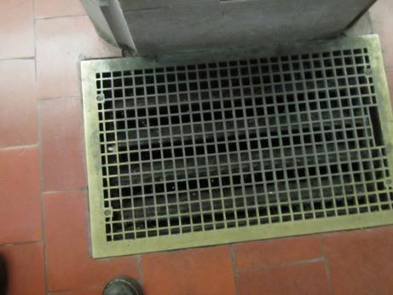

**Old floor-mounted supply vent**

**Picture 2**

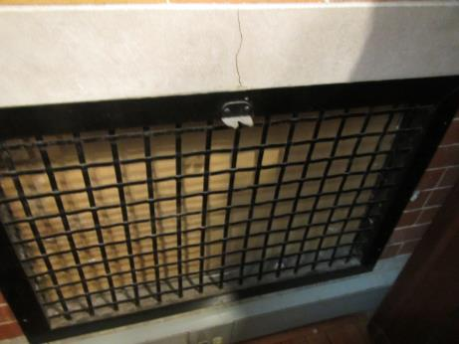

**Exhaust vent, now boarded up with gypsum wallboard**

**Picture 3**



**Chimney-like exhaust vents from the old gravity system (top right, arrow)**

**Picture 4**

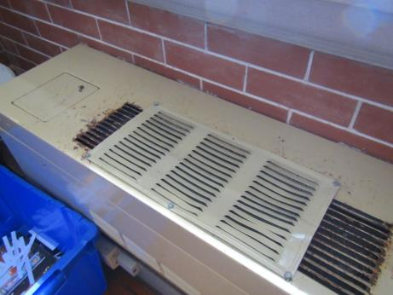

**Fan coil unit showing rust and modified louver vent attached**

**Picture 5**

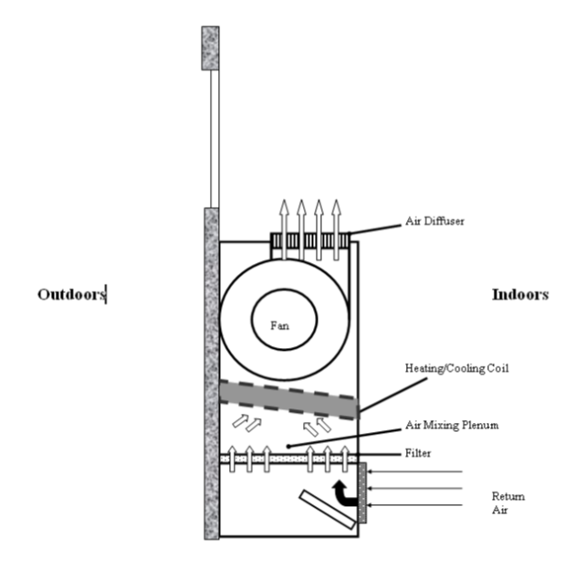

**Fan coil unit rendering**

**Picture 6**

**Windows showing missing/partial screens and deterioration 

**

**Windows showing missing/partial screens and deterioration**

**Picture 7**

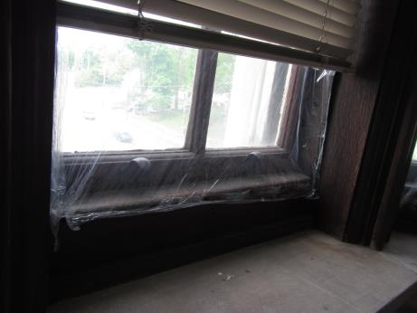

**Window with plastic sheeting**

**Picture 8**

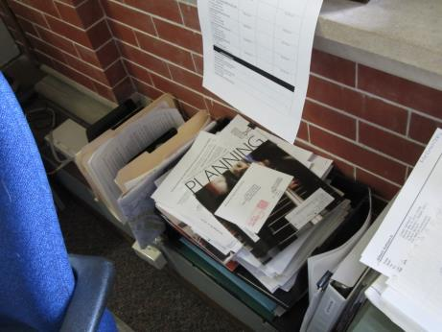

**FCU covered with items**

**Picture 9**

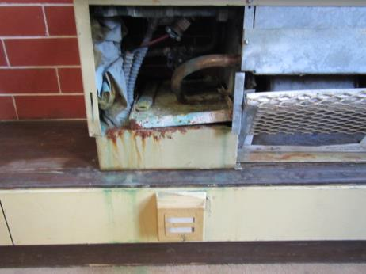

**Fan coil unit with corrosion to internal components**

**Picture 10**

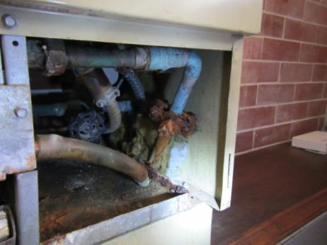

**Internal components of fan coil unit showing corrosion**

**Picture 11**

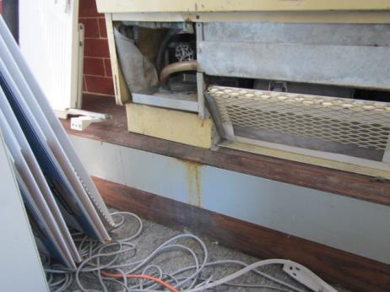

**Corrosion on fan coil units and water damage to wood, wall and carpeting due to FCU leaks**

**Picture 12**

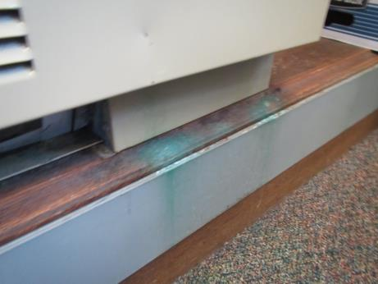

**Evidence of corrosion from FCU and leaks onto wood and carpeting**

**Picture 13**

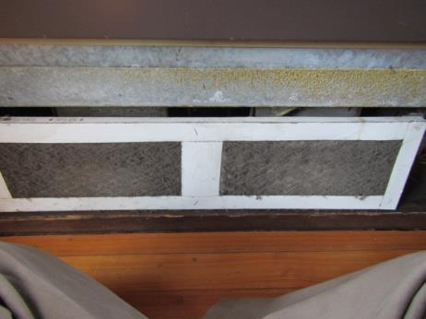

**Fan coil unit showing filter occluded with dust and debris**

**Picture 14**

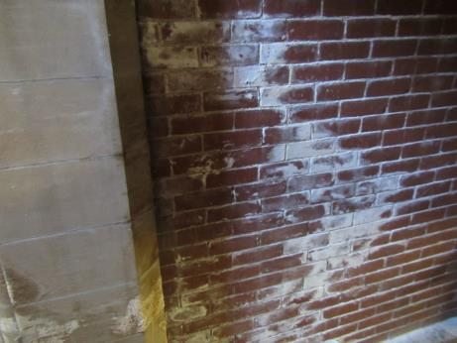

**Brick work showing efflorescence**

**Picture 15**

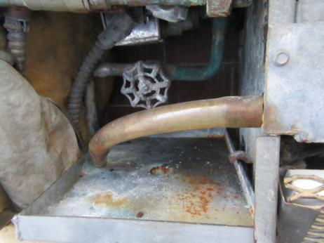

**Dirty hose to drip pan**

**Picture 16**

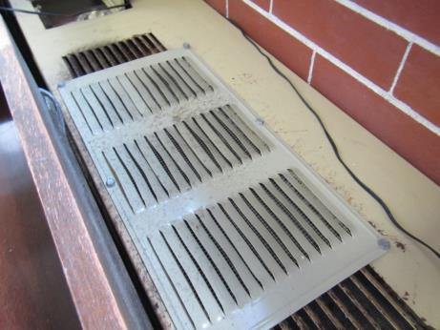

**Dark staining that is likely mold growing on debris on top of FCU**

**Picture 17**

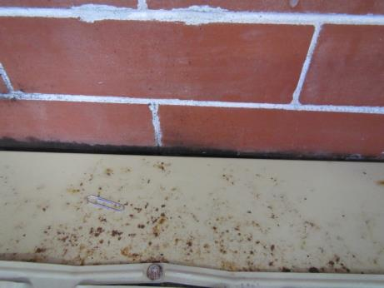

**Rust on FCU and staining and water damage on bricks above FCU**

**Picture 18**

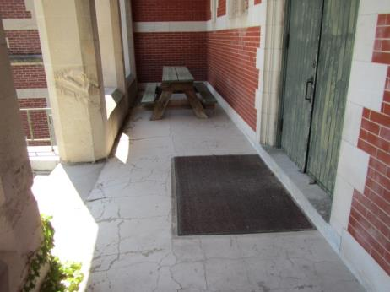

**Location of abandoned restroom underneath patio, note spalling of concrete and entry door**

**Picture 19**



**Archway entrance**

**Hall- way**

**Abandoned bathroom**

**General location of abandoned restroom (image source: Bing Maps, 2016)**

**Picture 20**

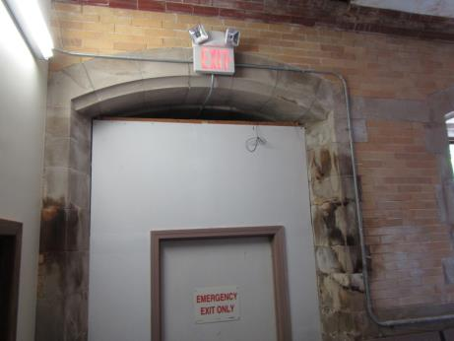

**Partially-sealed archway between the abandoned restroom and the occupied areas of the MCH**

**Picture 21**

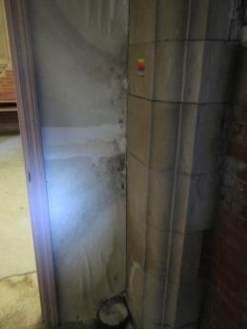

**Water-damaged gypsum wallboard at entry to main hall from abandoned restroom**

**Picture 22**

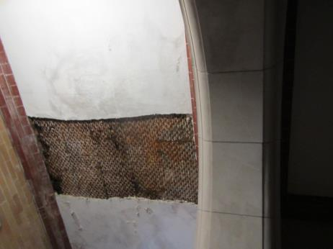

**Corroded metal and missing plaster adjacent to the doorway**

**Picture 23**

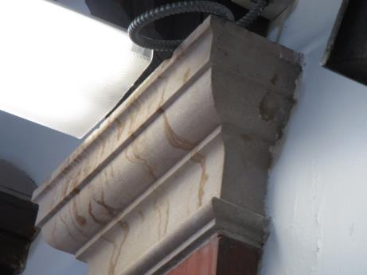

**Water stains on concrete pillar**

**Picture 24**

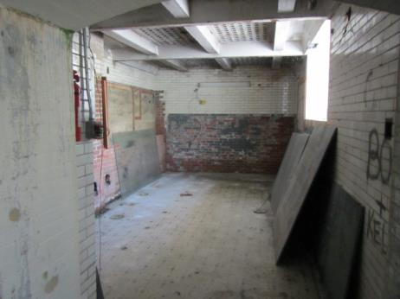

**Inside abandoned restroom**

**Picture 25**

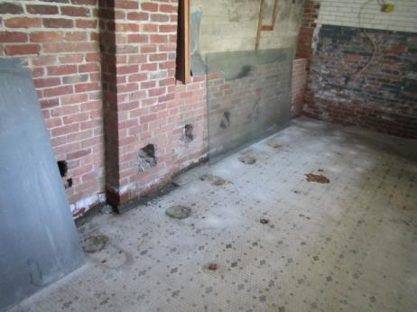

**Sealed fixtures inside abandoned restroom**

**Picture 26**

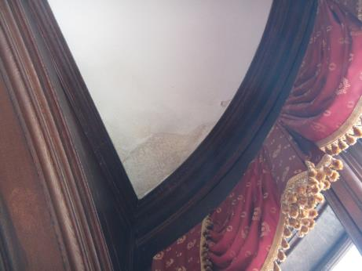

**Water-damaged plaster ceiling**

**Picture 27**

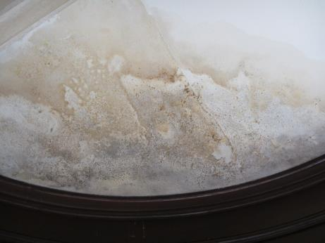

**Water-damaged plaster ceiling**

**Picture 28**

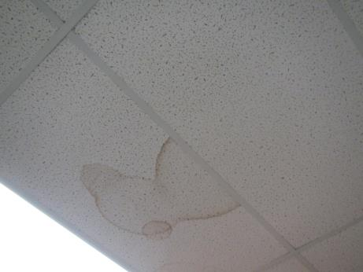

**Water-damaged ceiling tile**

**Picture 29**

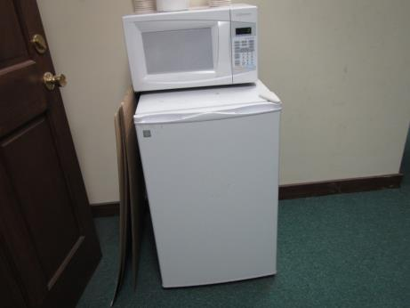

**Refrigerator placed directly on carpet**

**Picture 30**

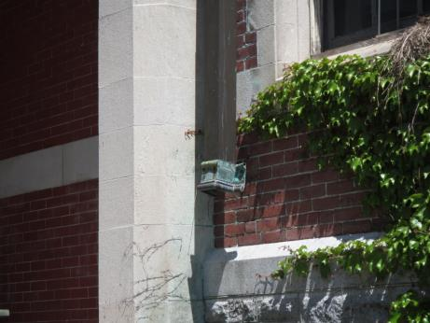

**Downspout missing lower connection to drainage system**

**Picture 31**

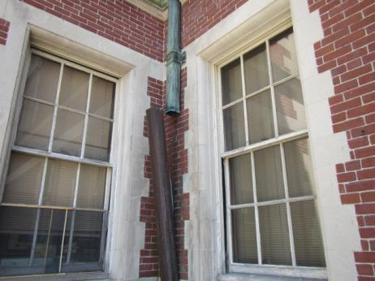

**Disconnected downspout**

**Picture 32**

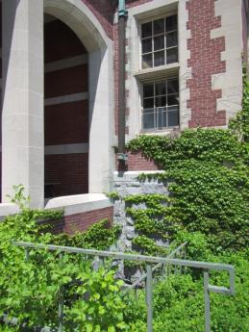

**Vegetation against building envelope (note missing downspout section also)**

**Picture 33**

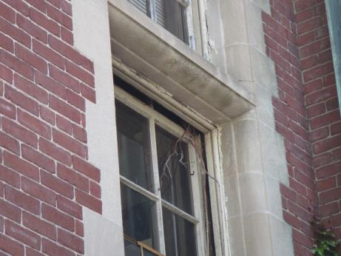

**Window shown partially ajar and having vine growth**

**Picture 34**

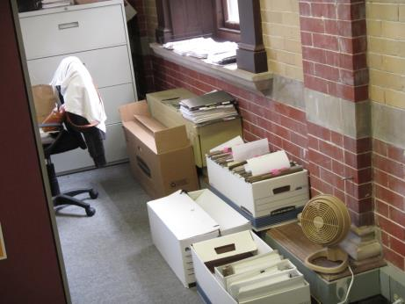

**Boxes on the floor**

**Picture 35**



**Papers and items on flat surfaces**

**Picture 36**

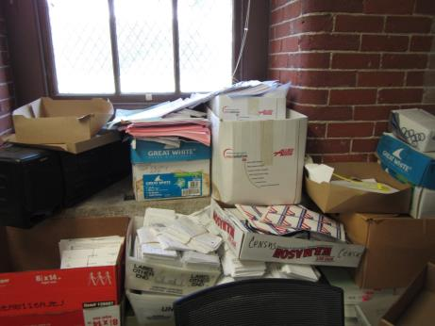

**Items in a storage area**

**Picture 37**

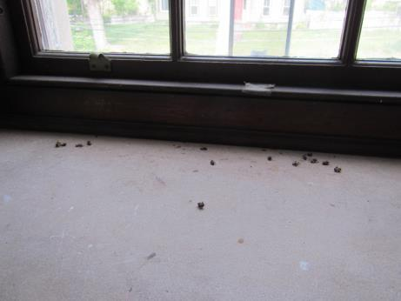

**Dead bees on a windowsill**

| Location | **Carbon**  **Dioxide**  **(ppm)** | **Carbon Monoxide**  **(ppm)** | **Temp**  **(°F)** | **Relative**  **Humidity**  **(%)** | **TVOCs**  **(ppm)** | **PM2.5**  **(µg/m3)** | **Occupants**  **in Room** | **Windows**  **Openable** | **Ventilation** | | | **Remarks** |
| --- | --- | --- | --- | --- | --- | --- | --- | --- | --- | --- | --- | --- |
| **Intake** | **Exhaust** | |
| Background (outdoors) | 408 | ND | 68 | 35 | ND | 8 | - | - | - | |  | Partly cloudy, very light wind |
| 3rd floor | | | | | | | | | | | | |
| Accounting/ Payroll/Auditor | 733 | ND | 75 | 33 | ND | 10 | 5 | Y | N | | N | CPs, fridge, AI, dust, corrosion on FCU- evidence of condensation/leaks |
| 306 -Mayor reception area | 654 | ND | 76 | 33 | ND | 10 | 1 | Y | N | | N |  |
| Council meeting room | 587 | ND | 75 | 32 | ND | 11 | 2 | Y | N | | N |  |
| Council office | 585 | ND | 75 | 33 | ND | 9 | 2 | Y | N | | N | Carpet, PF |
| City auditing | 915 | ND | 74 | 34 | ND | 11 | 2 | Y | N | | N | DEM, AI, DO, carpet |
| Auditing | 922 | ND | 75 | 33 | ND | 12 | 2 | Y | N | | N | Boxes, HS |
| Auditing food area | 1074 | ND | 76 | 34 | ND | 11 | 1 | Y | N | | N | Fridge, microwave, toaster and toaster oven, carpeted |
| Auditing report | 1070 | ND | 78 | 31 | ND | 10 | 1 | Y | N | | N | HS, PC, carpet |
| Auditing staff | 806 | ND | 77 | 30 | ND | 10 | 1 | N | N | | N | Report of bees, old grate, WD, heater |
| Ladies restroom |  |  |  |  |  |  |  | N | N | | N |  |
| Moloney | 689 | ND | 76 | 31 | ND | 11 | 1 | Y open | N | | N | NC |
| Camera control | 570 | ND | 76 | 31 | ND | 0 | 0 | Y open | N | | N | WD plaster, computer equipment, NC |
| 310 city council | 640 | ND | 76 | 32 | ND | 7 | 1 | Y | N | | N | coffee, fridge, moldy/stained carpeting, PF on |
| Council conf room | 792 | ND | 76 | 32 | ND | 7 | 0 | Y | N | | N | Plant on paper |
| 311 solicitor’s | 619 | ND | 76 | 32 | ND | 9 | 0 | Y | N | | N | NC, plant, candles |
| City solicitor | 629 | ND | 76 | 32 | ND | 6 | 0 | N | N | | N | Items on windowsill, WD plaster, CP |
| Solicitor assistant | 705 | ND | 76 | 32 | ND | 7 | 1 | N | N | | N | Microwave, PC, scented candles/oil, CP, food |
| 2nd floor | | | | | | | | | | | | |
| Health department nurse (Engineering) | 577 | ND | 76 | 31 |  | 6 | 0 |  | N | | N | fridge, NC - wood, bees and dead bees |
| Plans storage | 655 | ND | 76 | 32 |  | 7 | 0 | y | N | | N | CP, microwave, fridge, tin ceiling, NC |
| Zoning office | 585 | ND | 76 | 32 |  | 7 | 0 | y | N | | N | NC - wood |
| 217 conservation commission | 630 | ND | 75 | 34 |  | 6 | 1 | y | N | | N |  |
| Rear office | 649 | ND | 75 | 34 | ND | 6 | 0 | Y | N | | N | sunny, plans. AI, paper |
| Side office | 642 | ND | 75 | 33 | ND | 7 | 0 | Y | N | | N | HS, interior partition walls |
| Cubes in conservation | 709 | ND | 76 | 33 | ND | 7 | 0 | Y | N | | N | DEM, plants, boxes, lemon odor, PC, WD wall and ceiling plaster |
| Copy area | 722 | ND | 75 | 33 | ND | 13 | 1 | Y | N | | N | PC, fridge, WC, NC - wood, CP, food |
| Women’s restroom |  | ND |  |  | ND |  |  | Y | N | | N | door to adjacent office |
| 210 rear/conference | 460 | ND | 75 | 33 | ND | 5 | 0 | Y | N | | N | NC - wood, HS, drop ceiling |
| 210 small room | 480 | ND | 75 | 33 | ND | 6 | 1 | Y | N | | N | paper |
| Engineering/water and sewer | 571 | ND | 76 | 33 | ND | 6 | 2 |  | N | | N |  |
| Water and sewer office | 605 | ND | 76 | 33 | ND | 6 | 1 |  | N | | N | PC CP, food plants |
| Restroom |  |  |  |  |  |  |  | N | N | | N |  |
| 2nd floor benefits office | 637 | ND | 72 | 36 |  | 5 | 1 | N | N | | N | heater, food odor, AF, HS, plant, DEM |
| 208 conference/media | 626 | ND | 73 | 36 |  | 6 | 0 | N | N | | N | WD plaster, carpeted |
| Building dept. | 561 | ND | 75 | 34 | ND | 7 | 4 | Y | N | | N | Window open, bee problems, DEM, PF, historic WD plaster |
| Community development | 605 | ND | 74 | 34 | ND | 7 | 3 | Y | N | | N | HS, CPs, DEM, AI, carpet |
| Engineering-main room | 522 | ND | 74 | 34 | ND | 6 | 4 | N | N | | N | AI, HS, plans |
| Public works | 769 | ND | 74 | 37 |  | 13 | 4 | Y | N | | N | FCU, PC |
| 205 public works office | 646 | ND | 75 | 34 |  | 11 | 0 | Y | N | | N | FCU, WD plaster and efflorescence |
| 203 health department | 662 | ND | 74 | 36 |  | 9 | 1 | Y | N | | N | FCU |
| HR | 639 | ND | 74 | 35 |  | 9 | 1 | Y | N | | N | FCU - black dust |
| Water supply/  Engineering | 650 | ND | 74 | 36 |  | 8 | 3 | Y | N | | N | Plants |
| 1st floor | | | | | | | | | | | | |
| Assessor-waiting | 575 | ND | 72 | 34 | ND | 6 | 0 | N | N | | N | Old gravity vent (blocked) |
| Assessor- entry office space | 594 | ND | 73 | 35 | ND | 6 | 4 | Y | N | | N |  |
| Assistant Assessor’s office | 499 | ND | 73 | 34 | ND | 6 | 2 | Y | N | | N | Plants, DEM |
| 112 City Clerk –customer service | 479 | ND | 72 | 35 | ND | 6 | 5 | Y | N | | N | Carpet, fridge, WD plaster, CPs, PF, AI |
| Clerk | 589 | ND | 71 | 38 | ND | 8 | 3 | Y | N | | N | Papers/WD boxes against exterior wall showing efflorescence, boxes of papers on floor of foundation |
| 103 treasurer | 680 | ND | 73 | 33 | ND | 6 | 3 | N | N | | N | open area, PC, plants, NC - wood, CP |
| Treasurer office | 682 | ND | 73 | 33 | ND | 6 | 0 | N | N | | N | Items on FCU, CP, food |
| Assessor main office | 608 | ND | 73 | 34 | ND | 6 | 0 | N | N | | N | plants, candle, curtains, area rug |
| Veteran’s affairs | 551 | ND | 73 | 34 | ND | 5 | 1 | N | N | | N | heater, fridge, AT, items on FCU |
| Customer services | 481 | ND | 73 | 34 | ND | 6 | 3 | N | N | | N | WD Ceiling plaster, CP, scented candles. WC on carpet, PC |
| Mail room | 498 | ND | 73 | 34 | ND | 6 | 0 | N | N | | N |  |
| 110 recreation | 745 | ND | 72 | 38 | ND | 6 | 1 | N | N | | N | paper, NC, reported skin rashes |
| Clerk left office | 668 | ND | 71 | 39 | ND | 6 | 1 | N | N | | N | PC, carpet, WD CT |
| Clerk inner office | 670 | ND | 71 | 38 | ND | 7 | 1 | N | N | | N | carpet, efflorescence |
| Vault | 608 | ND | 73 | 38 | ND | 7 | 0 | N | N | | N | NC - cement, old books, odor, paper |
| Basement | | | | | | | | | | | | |
| Basement IT | 579 | ND | 63 | 45 | 4 |  | 1 | Y | N | | N | Mainframe |

Appendix A: Methuen City Hall Employee Survey Response

**How to Use this Factsheet**

This risk factor summary was developed to serve as a general fact sheet. It is an overview and should not be considered exhaustive. For more information on other possible risk factors and health effects being researched, please see the References section.

A risk factor is anything that increases a person’s chance of developing cancer. Some risk factors can be controlled while others cannot. Risk factors can include *hereditary conditions*, *medical conditions or treatments*, *infections*, *lifestyle factors*, or *environmental exposures*. Although risk factors can influence the development of cancer, most do not directly cause cancer. An individual’s risk for developing cancer may change over time due to many factors, and it is likely that multiple risk factors influence the development of most cancers. Knowing the risk factors that apply to specific concerns and discussing them with your health care provider can help to make more informed lifestyle and health care decisions.

For those cancer types with environmentally-related risk factors, an important factor in evaluating cancer risk is the route of exposure. This is particularly relevant when considering exposures to chemicals in the environment. For example, a particular chemical may have the potential to cause cancer if it is inhaled, but that same chemical may not increase the risk of cancer through skin contact. In addition, the dose and duration of time one might be exposed to an environmental agent is important in considering whether an adverse health effect could occur.

Gene-environment interactions are another important area of cancer research. An individual’s risk of developing cancer may depend on a complex interaction between their genetic makeup and exposure to an environmental agent (for example, a virus or a chemical contaminant). This may explain why some individuals have a fairly low risk of developing cancer as a result of an environmental factor or exposure, while others may be more vulnerable.

**Key Statistics**

Breast cancer is the most frequently diagnosed cancer among women in the United States, except for skin cancers. The American Cancer Society estimates that in 2015, approximately 231,840 women in the U.S. and 5,890 women in Massachusetts will be diagnosed with breast cancer. The disease is expected to account for approximately 29% of all new cancer diagnoses in females.1 Between 2007 and 2011, invasive breast cancer accounted for 29.0% of cancer diagnoses in females in Massachusetts.11

In the United States, breast cancer rates stabilized in the early 1990s, increased in the latter half of the 1990s, and dropped sharply between 2002 and 2003. The sharp drop has been attributed to decreased use of menopausal hormones following the 2002 publication of the Women’s Health Initiative study results. This study linked the use of hormone therapy to an increased risk of breast cancer.2 In Massachusetts, the incidence of invasive breast cancer in females remained stable over the years 2007-2011.11

The chance of developing invasive breast cancer at some time in a woman's life is about 1 in 8. Women are 100 times more likely than men to develop this disease.2 Men can also develop breast cancer, but male breast cancer is rare, accounting for 1% of all breast cancer cases.1, 9 For more information on breast cancer in men, visit the American Cancer Society website at www.cancer.org.5

A woman’s risk of developing breast cancer increases with age. About 12-13% of invasive breast cancers are found in women younger than 45, while about 66% are found in women age 55 or older. White women are slightly more likely to develop breast cancer than women of other races and ethnicities.2

**Types of Breast Cancer**

The term "cancer" is used to describe a variety of diseases associated with abnormal cell and tissue growth. Cancers are classified by the location in the body where the disease originated (the primary site) and the tissue or cell type of the cancer (histology).

There are several types of breast cancer, although some of them are quite rare. In some cases a single breast tumor can have a combination of these types or have a mixture of invasive and *in situ* cancer.

*In situ* breast cancers are considered the earliest stage of cancer, when it is confined to the layer of cells where it began. They have not invaded into deeper tissues in the breast or spread to other organs in the body, and are sometimes referred to as non-invasive breast cancers.2 The remainder of this risk factor summary pertains to invasive breast cancers. Additional information on *in situ* breast cancers and other benign breast conditions can be found at www.cancer.org (American Cancer Society).3

An invasive, or infiltrating, cancer is one that has already grown beyond the layer of cells where it started (as opposed to carcinoma *in situ*). Most breast cancers are invasive carcinomas – either invasive ductal carcinoma or invasive lobular carcinoma.2

Breast cancer most commonly involves either the milk-producing lobules or the tubular ducts that connect the lobules to the nipple.6 Roughly 80% of all breast cancers originate in the ducts, and are known as invasive ductal carcinoma (IDC). An additional 10% begin in the lobules, and are known as invasive lobular carcinoma (ILC). Invasive lobular carcinoma may be harder to detect by a mammogram than invasive ductal carcinoma. Both types of cancer can spread (metastasize) from the original site to other parts of the body.2, 6

Other less common types of invasive breast cancer2 include:

* inflammatory breast cancer
* triple-negative breast cancer
* medullary carcinoma
* metaplastic carcinoma
* mucinous carcinoma
* Paget’s disease
* tubular carcinoma
* papillary carcinoma
* Phyllodes tumor
* adenoid cystic carcinoma or adenocystic carcinoma
* angiosarcoma

**Established Risk Factors**

*Hereditary Conditions*

Having a family history of breast cancer increases a woman’s risk of developing the disease. Women who have a first-degree relative (i.e., mother, sister) with breast cancer have about twice the risk of developing breast cancer themselves. Having two first-degree relatives with this disease increases a woman’s risk by three- to five-fold.2, 6 The risk is also elevated if several close relatives from either side of the family have been diagnosed with breast or ovarian cancer, especially before age 50.6, 13 Overall, less than 15% of women with breast cancer have a family member with the same disease. Therefore, over 85% of women who have breast cancer have no familial link to the disease.2

About 5-10% of breast cancer diagnoses are thought to be due to an inherited genetic mutation.2, 15 Most of these mutations occur in the *BRCA1* and *BRCA2* genes. Other genes that may lead to an increased risk for developing breast cancer include *ATM*, *CHEK2*, *TP53* and *PTEN*. Women who inherit these gene mutations have up to an 80% chance of developing breast cancer during their lifetime.2

*Medical Conditions and Treatments*

Certain benign breast conditions may increase one’s risk for breast cancer. Women with proliferative lesions without atypia (i.e., abnormal or unusual cells), which have excessive growth of cells in the ducts or lobules of breast tissue, are 1.5 to 2 times more likely to develop breast cancer compared with women who have non-proliferative lesions.15 Proliferative lesions with atypia, when the cells are excessively growing and no longer appear normal, raise one’s risk by 3.5 to 5 times. Women with denser breast tissue (as seen on a mammogram) have more glandular tissue and less fatty tissue, and have a higher risk of breast cancer.2

A woman with cancer in one breast is 3 to 4 times more likely to develop a new cancer in the other breast or in another part of the same breast. In addition, a previous diagnosis of an *in situ* breast cancer puts a woman at increased risk for an invasive breast cancer.2

Cumulative exposure of the breast tissue to estrogen is associated with breast cancer risk. Several factors can influence estrogen levels. Women who started menstruating at an early age (before age 12) and/or went through menopause at a later age (after age 55) have a slightly higher risk of breast cancer. Also, women who have had no children or those whose first pregnancy occurred when they were over the age of 30 have an increased risk for developing breast cancer.2 Women who have had more children and those who have breast-fed seem to be at lower risk.15

Use of hormone replacement therapy is another factor that may affect breast cancer risk. Long-term use (several years or more) of combined post-menopausal hormone therapy (PHT) increases the risk of breast cancer. The increased risk from combined PHT appears to apply only to current and recent users. A woman's breast cancer risk seems to return to that of the general population within 5 years of stopping combined PHT. The use of estrogen-only replacement therapy (ERT) does not appear to increase the risk of breast cancer significantly but when used long-term (for more than 10 years), ERT has been found to increase the risk of ovarian cancer in some studies.2, 15

Women who had radiation therapy to the chest area as treatment for another cancer (i.e., ionizing radiation for Hodgkin disease) are at significantly increased risk for breast cancer.15 This risk appears to be highest if the radiation is given during adolescence or puberty, when the individual’s breasts are developing.2

From the 1940s through the 1960s some pregnant women were given the drug diethylstilbestrol (DES) because it was thought to lower their chances of miscarriage. These women have a slightly increased risk of developing breast cancer. A woman whose mother took DES while pregnant may also have a slightly higher risk of breast cancer.2

*Lifestyle Factors*

Alcohol consumption has also been associated with increased risk for breast cancer. Compared with non-drinkers, women who consume one alcoholic drink a day have a very small increase in risk whereas those who have 2 to 5 drinks daily have about 1½ times the risk of women who drink no alcohol.2

**Possible Risk Factors**

*Environmental Exposures*

A great deal of research has been reported and more is being done to understand possible environmental influences on breast cancer risk. Of special interest are compounds in the environment that have been found in animal studies to have estrogen-like properties, which could in theory affect breast cancer risk. For example, substances found in some plastics, certain cosmetics and personal care products, pesticides (such as DDE), and PCBs (polychlorinated biphenyls) seem to have such properties. To date, however, there is not a clear link between breast cancer risk and exposure to these substances.2

*Lifestyle Factors*

For a long time, the role of cigarette smoking in the development of breast cancer was unclear. Recent research, however, supports a consistent association between smoking and an increased risk of breast cancer, with long-term heavy smokers at highest risk.16, 2

Some studies suggest a relationship between secondhand smoking and an increased risk for breast cancer; however, confirming this relationship has been difficult and is still the subject of active research.2, 15, 16

Recent studies have indicated that being overweight or obese after menopause may put a woman at increased risk of breast cancer.2, 6, 15  Similarly, women who are physically inactive throughout life may have an increased risk of breast cancer.2

Studies have found that women using oral contraceptives (birth control pills) have a slightly greater risk of breast cancer than women who have never used them, but this risk seems to decline once their use is stopped. Women who stopped using oral contraceptives for more than 10 years do not appear to have any increased breast cancer risk. When thinking about using oral contraceptives, women should discuss their other risk factors for breast cancer with their physician.2

Lifetime risk of breast cancer is increased in women of higher socioeconomic status (SES) (e.g. income, education). Research suggests that this may be due to reproductive and lifestyle factors (age at first full-term birth, physical activity, diet, cultural practices, etc.).6, 15

Several recent studies have also suggested that working the night shift may be associated with an increased risk of breast cancer. The light-sensitive hormone melatonin may play a role in this link, and further research is being conducted in this area.2, 10

**Other Risk Factors That Have Been Investigated**

*Lifestyle Factors*

Though links have been suggested, antiperspirants, bras, and breast implants have all been investigated as possible risk factors for breast cancer but no associations have been found.2, 15

Dietary fat intake is another factor that has been suggested to increase a woman’s risk for breast cancer. Though studies have found decreased breast cancer rates in countries with a diet typically lower in fat, studies in the U.S. have not shown an association between the amount of fat in the diet and increased risk of breast cancer.2, 15

**References/For More Information**

*Much of the information contained in this summary has been taken directly from the following sources. This material is provided for informational purposes only and should not be considered as medical advice. Persons with questions regarding a specific medical problem or condition should consult their physician.*

American Cancer Society (ACS). [http://www.cancer.org](http://www.cancer.org/)

1. ACS. 2015. Cancer Facts & Figures 2015.
2. ACS. 2015. Detailed Guide: Breast Cancer.
3. ACS. 2015. Non-Cancerous Breast Conditions.
4. ACS. 2014. Inflammatory Breast Cancer.
5. ACS. 2015. Detailed Guide: Breast Cancer in Men.

American Society of Clinical Oncology (ASCO). [http://www.cancer.net](http://www.cancer.net/)

1. ASCO. 2013. Guide to Breast Cancer.
2. ASCO. 2013. Guide to Breast Cancer – Inflammatory.
3. ASCO. 2014. Guide to Breast Cancer – Metaplastic.
4. ASCO. 2014. Guide to Breast Cancer – Male.

International Agency for Research on Cancer (IARC). <http://www.iarc.fr/>

1. IARC. 2010. IARC Monographs on the Evaluation of Carcinogenic Risks to Humans, Volume 98: Painting, Firefighting and Shiftwork. Available at: <http://monographs.iarc.fr/ENG/Monographs/vol98/index.php>

Massachusetts Cancer Registry (MCR), Massachusetts Department of Public Health.

1. MCR. 2014. Cancer Incidence and Mortality in Massachusetts 2007-2011: Statewide Report. Available at: [http://www.mass.gov/eohhs/docs/dph/cancer/state/registry-statewide-report-07-11.pdf](http://www.mass.gov/eohhs/docs/dph/cancer/state/registry-statewide-report-07-11.pdf" \o "11.MCR. 2014. Cancer Incidence and Mortality in Massachusetts 2007-2011: Statewide Report)

National Cancer Institute (NCI). [http://www.cancer.gov](http://www.cancer.gov/)

1. NCI. 2012. What You Need to Know About Breast Cancer.
2. NCI. 2015. Genetics of Breast and Gynecologic Cancers.
3. Surveillance, Epidemiology, and End Results Program (SEER). 2014. Interactive Tools: Fast Stats. Statistics by Cancer Site. Incidence of Breast Cancer, Females, 1975-2011. Generated at: <http://seer.cancer.gov/faststats/index.php>

Schottenfeld and Fraumeni.

1. Colditz GA, Baer HJ and Tamimi RM. 2006. Breast Cancer, Chapter 51 in Cancer Epidemiology and Prevention. 3nd ed. Schottenfeld D and Fraumeni JF Jr.,eds. Oxford University Press. pp: 995-1012.

U.S. Department of Health and Human Services (USDHHS).

1. Cancer, Chapter 6 in 50 Years of Progress: A Report of the Surgeon General, 2014. Available at <http://www.surgeongeneral.gov/library/reports/50-years-of-progress/50-years-of-progress-by-section.html>