**INDOOR AIR QUALITY ASSESSMENT**

**Methuen Police Department**

**Communications Office**

**90 Hampshire Street**

**Methuen, MA**

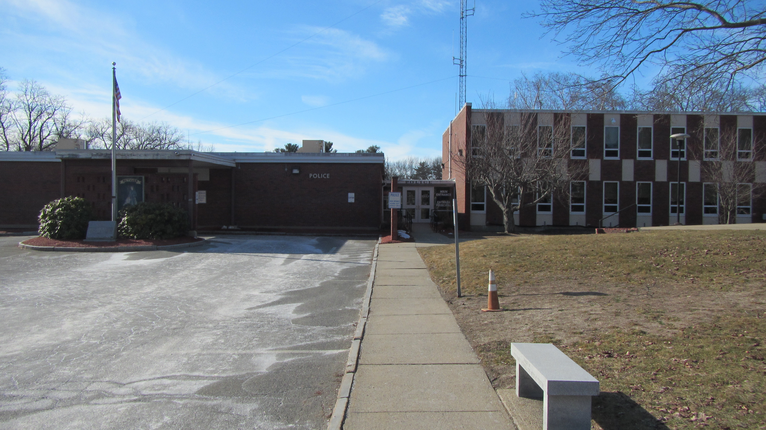

Prepared by:

Massachusetts Department of Public Health

Bureau of Environmental Health

Indoor Air Quality Program

March 2023

# BACKGROUND

|  |  |
| --- | --- |
| Building: | Methuen Police Department (MPD) |
| Address: | 90 Hampshire Street, Methuen |
| Reason for Request: | Mold on air conditioning equipment |
| Date of Assessment: | March 10, 2023 |
| Massachusetts Department of Public Health/Bureau of Environmental Health (MDPH/BEH) Staff Conducting Assessment: | Michael Feeney, Director, IAQ  Program |
| Building Description: | The Communications Office is located on the south wing of the MPD building complex |
| Building Population: | Approximately 3 employees |
| Year of Construction: | 1950’s |
| Windows: | Openable |

# METHODS

Please refer to the IAQ Manual for methods, sampling procedures, and interpretation of results (MDPH, 2015).

# RESULTS AND DISCUSSION

The following is a summary of indoor air testing results (Table 1).

* ***Carbon dioxide (CO2) levels*** were below 800 parts per million (ppm) during initial measurement with the interior hallway door open. When retested, with the hallway doors closed for 20 minutes, CO2 levels were above 800 ppm.
* ***Temperature*** was within the recommended range of 70°F to 78°F in areas assessed.
* ***Relative humidity*** was below the recommended range of 40% to 60% in the areas assessed. Low indoor relative humidity is common during the heating season.
* ***Carbon monoxide*** levels were non-detectable in all areas assessed.
* ***Fine particulate matter (PM2.5)*** concentrations measured were below the National Ambient Air Quality Standard (NAAQS) level of 35 μg/m3 in all areas assessed.

## Ventilation

A heating, ventilating, and air conditioning (HVAC) system has several functions. First it provides heating and, if equipped, cooling. Second, it is a source of fresh air. Finally, an HVAC system will dilute and remove normally occurring indoor environmental pollutants by not only introducing fresh air, but by filtering the airstream and ejecting stale air to the outdoors via exhaust ventilation. Even if an HVAC system is operating as designed, point sources of respiratory irritation may exist and cause symptoms in sensitive individuals.

The MPD south wing, where the Communications Office (CO) is located, has no observable operating mechanical HVAC system to provide fresh air or exhaust ventilation. While other rooms along exterior walls have windows capable of opening, the CO is located in the center of the building with no openable windows. In order to increase comfort, the CO hallway door is frequently left open.

Installed in the CO (and in other adjacent areas) are wall-mounted units that provide heating and cooling [ductless minisplits (DMS)]. Each DMS has a fan to draw air over coils. This heats or cools the air, which is expelled though a vent at the top of each unit. DMS units have no fresh air supply; a DMS is designed to recirculate air only.

With no fresh air supply, exhaust ventilation, or openable windows, normally occurring indoor pollutants can build up in the CO. In addition, if a significant outdoor pollutant source is introduced into the building (such as water vapor during hot humid weather from open windows in other areas of the building), pollutants cannot be vented to the outdoors and would build up. In the case of hot, humid air, this can lead to condensation on chilled surfaces. The air testing in the CO shows that with hallway doors closed, carbon dioxide levels in the room increased after 20 minutes (Table 1), indicating minimal air supply or exhaust of air in this location.

Filters in the DMS provide minimum filtration for airborne particles. Without adequate filtration, and no means to exhaust stale air, the DMS can recirculate airborne particles as it operates.

## Microbial/Moisture Concerns

### Equipment Prone to Condensation

A coating of dust and debris was noted along the bottom of the DMS unit in the CO (Picture 1). This suggests that during operation, condensation occurs on the surfaces of the DMS when operating in chilling mode, which then leads to dust and debris sticking to the unit. DMS in other areas in the building also have a similar debris accumulation (Picture 2). Given the conditions observed in this area of the building, it is likely that extended periods of hot, humid weather (e.g., a heat wave) would increase relative humidity inside the building, particularly when windows are open while air conditioning is operating. This would create conditions where condensation on chilled surfaces such as those near the outlet of the DMS would occur.

It is important to note that extreme weather conditions associated with condensation indoors have occurred. Massachusetts has experienced recent extended periods of relative humidity which can result in condensation on air chilling equipment and other chilled surfaces. For example, July 2021 was the wettest ever recorded in Massachusetts, and the three-month period from June through August, known as the meteorological summer, was the fourth wettest on record, according to the National Oceanic and Atmospheric Administration’s Centers for Environmental Information. The three-month period also was the third warmest ever in the state and was tied for the warmest on record across the United States. (NOAA, 2021).

Condensation that moistens dust and debris can lead to microbial growth and associated odors. Deposits of dust and debris can be removed with regular cleaning. Cleaning DMS when equipment switches air-conditioning modes (from heating to cooling and cooling to heating) is recommended at the minimum. Cleaning should include:

* changing of filters (IAQ does not recommend washing and reuse of filter),
* removing debris from coils and the drip pans,
* cleaning the condensation collection equipment, and
* clean accumulated debris from DMS diffusers and cabinet.

In addition, the DMS equipment should be serviced in a manner consistent with the manufacturer’s recommendations.

**CONCLUSIONS/RECOMMENDATIONS**

Based on observations at the time of assessment, the following is recommended:

1. Consider providing mechanical fresh air supply and exhaust ventilation for the Communications Office.
2. Routinely clean debris from surfaces of all DMS in the building.
3. DMS should be cleaned at least two times a year during changeover from heating to cooling and cooling back to heating.
4. Examine the feasibility of increasing the DMS filters to an increased Minimum Efficiency Reporting Values (MERV) rating. Consult with manufacturer to determine if more efficient filters can be installed in DMS.
5. Service DMS in a manner consistent with manufacturer’s instructions.
6. Refer to resource manual and other related IAQ documents located on the MDPH’s website for further building-wide evaluations and advice on maintaining public buildings. These documents are available at: <http://mass.gov/dph/iaq>.

# REFERENCES

MDPH. 2015. Massachusetts Department of Public Health. Indoor Air Quality Manual: Chapters I-III. Available at: <https://www.mass.gov/lists/indoor-air-quality-manual-and-appendices>.

NOAA. 2021. Summer 2021 neck and neck with Dust Bowl summer for hottest on record. National Oceanic and Atmospheric Administration, 1401 Constitution Avenue NW, Room 5128, Washington, DC 20230 <https://www.noaa.gov/news/summer-2021-neck-and-neck-with-dust-bowl-summer-for-hottest-on-record>

**Picture 1**

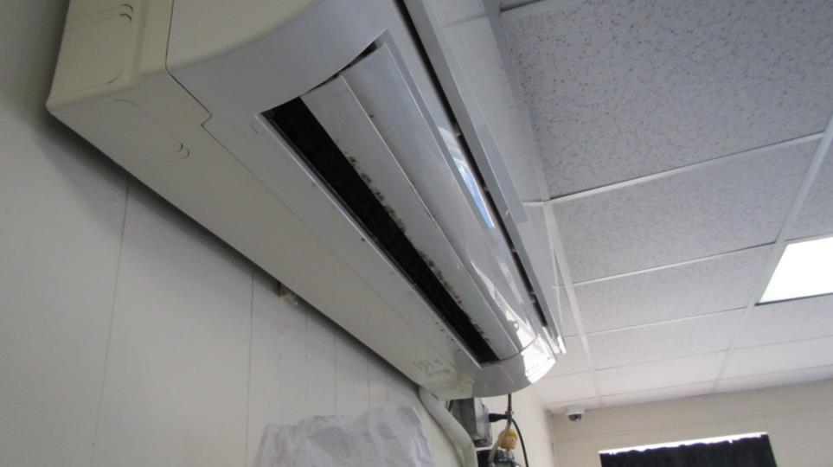

**DMS in Communications Room; note staining on unit**

**Picture 2**

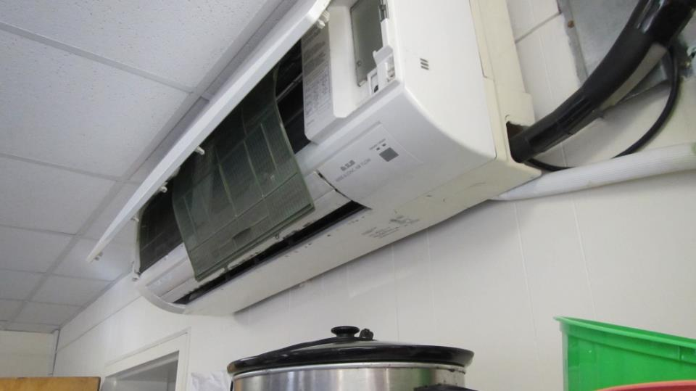

**DMS in Meeting Room; note staining around diffuser**

| **Location** | **Carbon**  **Dioxide**  **(ppm)** | **Carbon Monoxide**  **(ppm)** | **Temp**  **(°F)** | **Relative**  **Humidity**  **(%)** | **PM2.5**  **(µg/m3)** | **Occupants**  **in Room** | **Windows**  **Openable** | **Ventilation** | | **Remarks** |
| --- | --- | --- | --- | --- | --- | --- | --- | --- | --- | --- |
| **Supply** | **Exhaust** |
| Background (outdoors) | 390 | ND | 58 | 28 | 1 |  |  |  |  |  |
| Communication Room with doors open | 625 | ND | 71 | 28 | 1 | 2 | N | N | N | Hallway door open,  Water damage on DMS |
| Communication Room with doors closed for 20 minutes | 803 | ND | 72 | 28 | 1 | 2 | N | N | N | Hallway door closed |