Expired Password
If your password is already expired and you try to login, you will get the following screen (assuming you entered your expired password correctly).
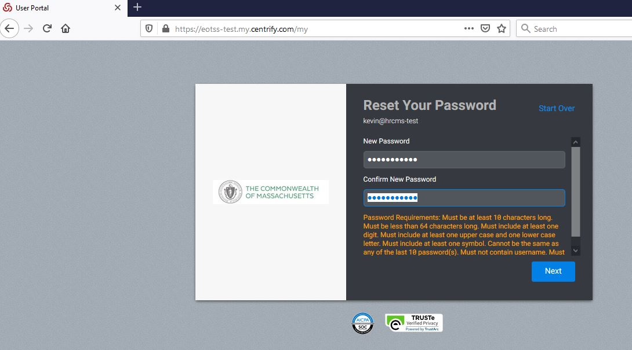
If you successfully enter and confirm a password that adheres to the password policy, you will get the following screen.
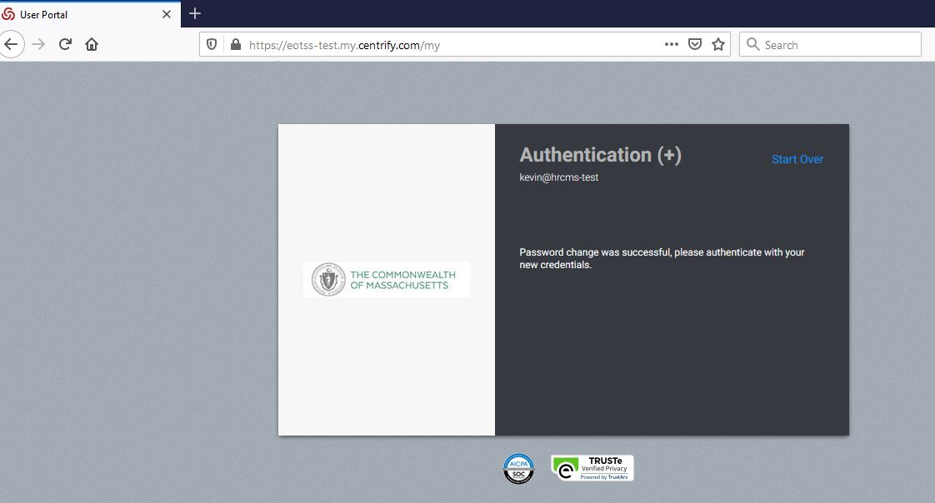
At this point just refresh the page or hit the "Start Over" link and login with your new password.

Password about to Expire (Normal Window)
If your password is about to expire (less than Password Expiration Notification (default 14 days)), you will get the following screen after successful authentication. NOTE: there is no indication during authentication that your password is about to expire.
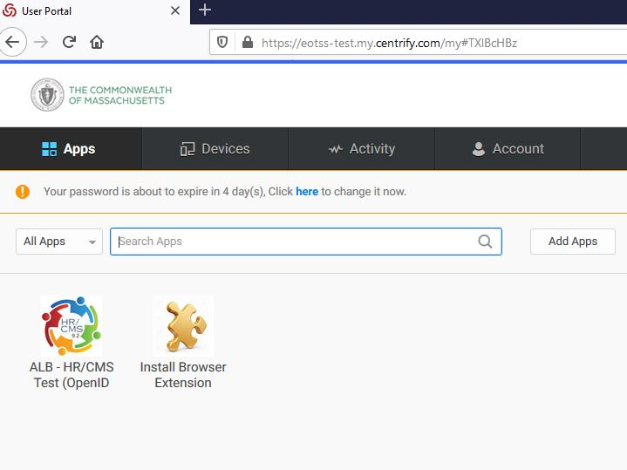
If you click "here" to change it now, you will get the following screen.
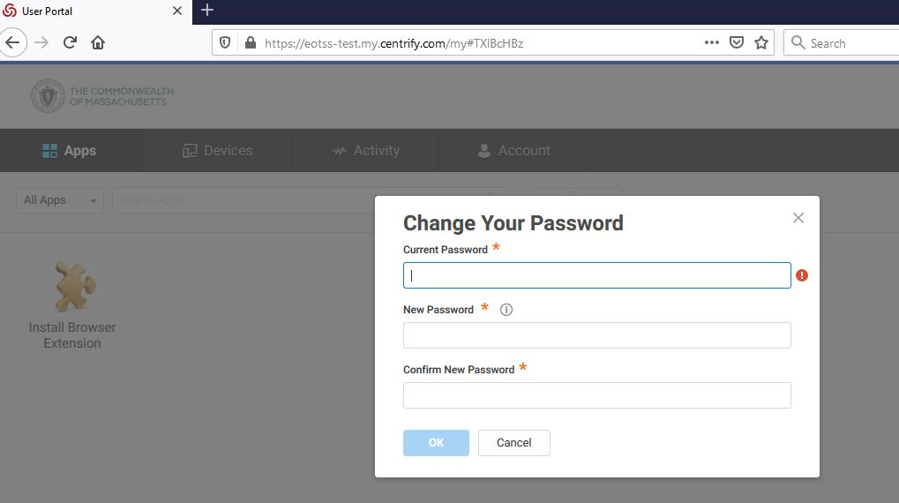

Password about to Expire (Escalated Window)
NOTE: If your password is about to expire (Escalated Password Expiration Notification (default 48 hours)), you will get the above screen immediately after successful authentication (doesn't wait for you to "click here"). You can hit cancel to delay changing your password until next login attempt.
NOTE: If you browse to the Account tab you will see the following notification in red text. This appears only during the "Escalated Password Expiration" window, it does not appear during the normal Password Expiration Window.
