MFIRS Coding of Lithium-ion Battery Fires

NFIRS/MFIRS does not directly allow for coding any specific type of battery fires. This includes Lithium-ion batteries.

The National Fire Data Center (NFDC) has previously published two NFIRSGrams on how to code fires with Lithium-ion batteries:
- E-Cigarette Fires
https://www.usfa.fema.gov/nfirs/coding-help/nfirsgrams/nfirsgram-electronic-cigarettes.html
- Electric/Hybrid Vehicle Fires
https://www.usfa.fema.gov/nfirs/coding-help/nfirsgrams/nfirsgram-electric-hybrid-vehicle-fires.html

We can also track invaluable information on the Hazardous Materials Module. So please also use the Module when you have Lithium-ion batteries involved in a fire or even if they are just impacted by a fire or somehow damaged – for example in a collision.

Basic Module Fields

If the fire occurs inside or on a building (whether or not the building itself becomes involved).
- Incident Type = 111 - Building fire
  - Fire Module is required.
  - Structure Fire Module is required.
If fire is outside of a building or structure.
- Incident Type = 162 – Outside equipment fire
  - Fire Module is required.

Fire Module Cause & Origin Fields

Example: A fire caused by lithium-ion battery in a cellphone left on a sofa.

- Area of Origin = Where the fire started.
- Heat Source = 12 – Radiated or conducted heat from operating equipment.
- Item 1st Ignited = Should be the item contacted by the battery such as a curtain or chair cushion.
- Type of Material 1st Ignited = What the Item 1st Ignited is made of.
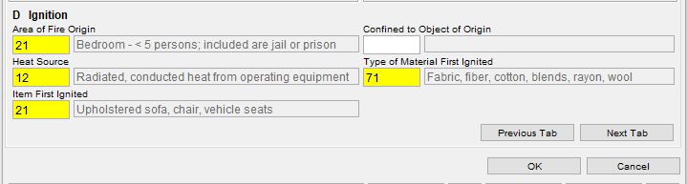

Fire Module Contributing Factors & Equipment Fields

- Factors Contributing to Ignition:
  - Fails during charging = 50 - Operational deficiency, other
  - Fails any other time = 40 – Design, manufacturing, installation deficiency, other
- Equipment Involved in Ignition = 229 - Battery. (This code is for all battery types.)
  - Equipment Power Source = 12 – Batteries and low voltage (<50 volts)
  - Equipment Portability = 1 – Portable
- Always put Lithium-ion battery in the Remarks/Narrative section.
  - Please use proper spelling!
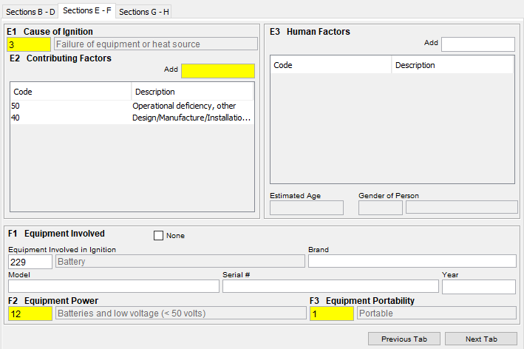

Coding an Electric or Hybrid Vehicle Fire

Electric Vehicle is a vehicle with electricity as a sole power source whether from an internal or external battery.
- Overhead power lines used to power a streetcar.
- Tesla Model S, Y or 3, Chevy Bolt, Nissan Leaf, etc.
Hybrid Vehicle uses more than 1 means of energy, combining a gasoline or diesel engine with an electric motor.
- Toyota Prius.
- Can include bicycles, motorcycles, cars, trucks or boats.

The Incident Type code when the vehicle is the cause of a fire will be from the 13x series - Mobile property (vehicle) fire.

The Mobile Property section is used to identify a hybrid or electric vehicle in the MFIRS report.
Please use the Mobile Property Model field to define “electric” or “hybrid.” Please use proper spelling!

Example: A fire caused by an all electric car.

Incident Type code 131 – Passenger vehicle fire
- Fire Module fields:
  - Mobile Property Involved = 3 – Involved in ignition & burned
  - Mobile Property Type = 11 – Passenger car
  - Mobile Property Make = OO – Other
  - Mobile Property Model = ‘Model’ (Electric or Hybrid)

Fire Module Mobile Property Fields

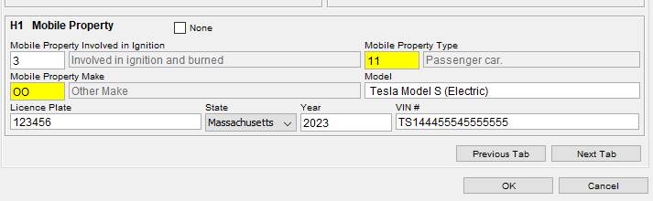
If the charging station is the cause of the fire:
- If the charger is in or attached to a structure
  - Incident Type = 111 - Building fire
    - Fire Module is required.
    - 11Structure Fire Module is required.
- If charger is outside of a building or structure (i.e. standalone).
  - Incident Type = 162 – Outside equipment fire
    - Fire Module required.
    - Equipment Involved in Ignition = 228 – Battery charger.
    - Equipment Brand and Model should be completed if information is available to identify the specifics of the charger manufacturer.
    - Note that the charger is for an electric or hybrid motor vehicle in the Remarks/Narrative section.

Fire Module Contributing Factors & Equipment Fields
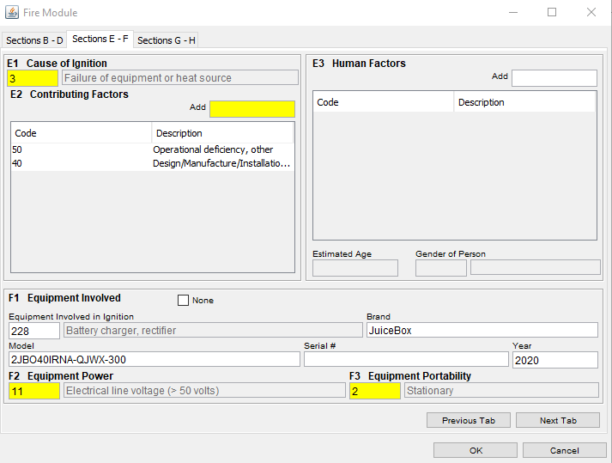

HazMat Module Coding

We need to treat any fire that involves a Lithium-ion battery as a (potential) hazardous materials release. Here is some guidance on how to code the various fields of the Hazardous Materials Module. If you feel another code is more representative of what happened at the incident please use it.

HazMat ID: Lithium-ion Battery
UN Number =
- 3480 – Lithium-ion batteries
- 3481 – Lithium-ion batteries contained in equipment
Container Type = 40 – Mobile container, other.
- Use for motor vehicle fires.

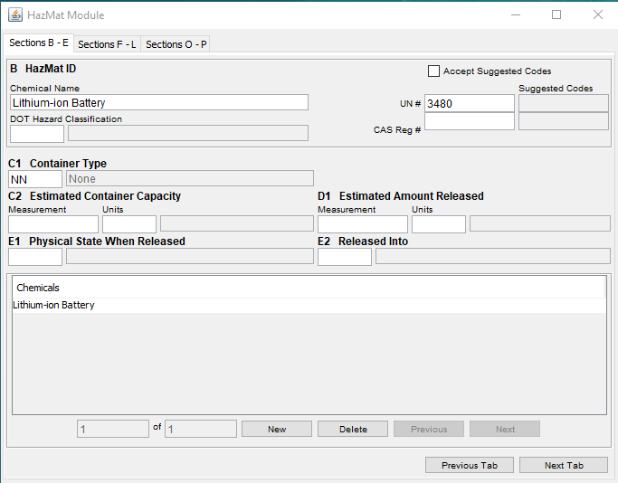
Released From
- Inside or on structure
  - If the fire and the batteries were inside or on the structure.
- Outside of structure
  - If the fire and the batteries were not inside or on the structure

Population Density
- Answer as appropriate to the incident.
  - 1 – Urban center
  - 2 – Suburban
  - 3 – Rural

Area Affected
- Answer as appropriate to the incident.
  - 1 – Square feet
  - 2 – Blocks
  - 3 – Square miles

Area Evacuated
- Answer as appropriate to the incident if the area was evacuated.
  - 1 – Square feet
  - 2 – Blocks
  - 3 – Square miles

HazMat Actions Taken
- 15 – Remove hazard or hazardous materials.
- Any other HazMat Actions Taken codes that may apply to the incident.

Cause of Release
- 2 – Unintentional release
  - For fires not started by the batteries but where the batteries were impacted by the fire.
- 3 – Container or containment failure
  - For fires where the batteries were the cause of the fire.

Factors Contributing to Release – Use these codes but not limited to…
- 50 series – Mechanical Failure, Malfunction
- 60 series – Design, Construction, Installation Deficiency
- 71 – Collision, overturn, knockdown
  - Mainly in the case of motor vehicle crashes.
- 74 – Equipment overload.
- 78 – Equipment not being operated properly.
  - Includes situations where safety or control devices are bypasses.

Mitigation Factors
- 23 – Combination of release and fire impeded mitigation of HazMat incident.
- 21 – Release of extremely dangerous agent.
  - Includes chemical or biohazard agent; population at risk.
- 15 – Released in occupied building.
  - If applicable.
- 30 series – Impediment or Delay Factors
  - If applicable
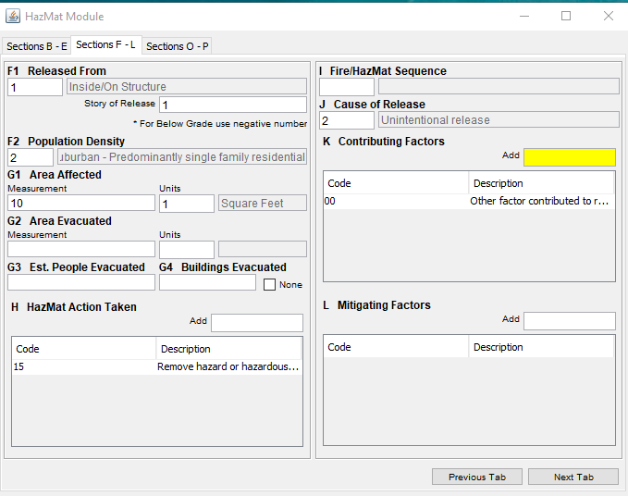
In the Hazardous Materials Module you can complete both the Equipment Involved in Release and the Mobile Property Involved in Release.

Equipment Involved in Release
- 229 – Battery
  - Equipment Power Source = 12 – Batteries and low voltage (<50 volts)
  - Equipment Portability = 1 – Portable
- Always put Lithium-ion battery in the Remarks/Narrative section.
  - Please use proper spelling!

Mobile Property Involved in Release
- If applicable.
  - The Mobile Property Type, Make, Model fields
  - Mobile Property Involved = 3 – Involved in ignition & burned
  - Mobile Property Type = 11 – Passenger car
  - Mobile Property Make = OO – Other
  - Mobile Property Model = ‘Model’ (Electric or Hybrid)

HazMat Disposition
- Choose the code that is most applicable.

HazMat Civilian Casualties
- Number of Civilian Deaths and Injuries attributed to the Hazardous Materials release.
- Separate from Civilian Fire Casualties.
- Do not need a Civilian Fire Casualty Module for these.

