INDOOR AIR QUALITY ASSESSMENT
Michael E. Smith Middle School
100 Mosier Street
South Hadley, MA
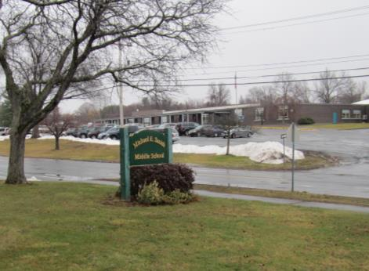
Prepared by:
Massachusetts Department of Public Health
Bureau of Environmental Health
Indoor Air Quality Program
May 2017

Background

Building: | Michael E Smith Middle School (MSMS)
Address: | 100 Mosier Street, South Hadley, MA
Assessment Requested by: | Paul Plummer, Principal, MSMS
Reason for Request: | General indoor air quality (IAQ)  concerns
Date of Assessment: | March 31, 2017
Massachusetts Department of Public Health/Bureau of Environmental Health (MDPH/BEH) Staff Conducting Assessment: | Michael Feeney, Director, IAQ Program  Ruth Alfasso, Environmental Engineer, IAQ Program
Date of Building Construction: | 1961, renovated in 2000
Building Description: | Middle School with brick construction, flat roofs, and courtyards with a complex shape
Building Population: | Approximately 650 students in grades 5 through 8 with a staff of approximately 200
Windows: | Mostly openable

IAQ Testing Results
Please refer to the IAQ Manual for methods, sampling procedures, and interpretation of results (MDPH, 2015). The following is a summary of indoor air testing results (Table 1).
- Carbon dioxide levels were above 800 parts per million (ppm) in about one third of the locations assessed, indicating that additional fresh air could be supplied in some areas.
- Temperature was within the recommended range of 70°F to 78°F in most areas and slightly below in the remaining areas assessed.
- Relative humidity was below the recommended range of 40 to 60% in all areas tested except the pool area. This is typical of winter conditions.
- Carbon monoxide levels were non-detectable in all indoor areas tested. Background (outside) levels were 0.8 ppm, likely due to vehicle traffic.
- Fine particulate matter (PM2.5) concentrations measured were below the NAAQS limit of 35 μg/m³ in all areas tested.

Ventilation
A heating, ventilating and air conditioning (HVAC) system has several functions. First it provides heating and, if equipped, cooling. Second, it is a source of fresh air. Finally, an HVAC system will dilute and remove normally occurring indoor environmental pollutants by not only introducing fresh air, but by filtering the airstream and ejecting stale air to the outdoors via exhaust ventilation. Even if an HVAC system is operating as designed, point sources of respiratory irritation may exist and cause symptoms in sensitive individuals. The following analysis examines and identifies components of the HVAC system and likely sources of respiratory irritant/allergen exposure due to water damage, aerosolized dust and/or chemicals found in the indoor environment.
Fresh air is provided by a combination of unit ventilators (univents) located in individual classrooms along the outside wall (Picture 1) and rooftop air handing units (AHU) which serve central areas such as the gym, the cafeteria, and office areas. The unit ventilators draw fresh air through a vent on the outside wall or roof. Air is mixed with return air from the room, filtered, heated (if needed) and delivered back to the room (Figure 1). Air from the AHUs is filtered, heated or cooled as needed, and delivered to rooms via ducted supply vents (Picture 2). Exhaust vents are located on the walls or ceilings of rooms (Pictures 3 and 4) and are ducted to fans on the roof. Additional exhaust vents are located in toilet rooms and other areas which produce pollutants.
Carbon dioxide levels above 800 ppm were primarily measured in classrooms with univents (Table 1). While nearly all of the univents were operating at the time of the assessment, air from the supply vents of a few units tested had carbon dioxide concentrations of near or above 800 ppm. This suggests that the amount of outside air being supplied to the univents needs to be increased. It was reported by facility staff that many of the univent functions, including ratio of outside air, are controlled remotely by computer. These settings may need to be adjusted.
Some of the univents and many exhaust vents were all or partially blocked by items or furniture (Picture 3; Table 1) which will reduce the effectiveness of the equipment. Additionally, in many classrooms, exhaust vents are located near the classroom doors and many of these doors were open, which reduces the effectiveness of the exhaust vent to draw stale air from the classroom; in some cases, the open door itself blocked the exhaust vent. A few of the exhaust vents examined had no draw of air. Non-functioning exhaust systems are common in schools; the vents should be tested periodically and repaired as needed.
In order to have proper ventilation with a mechanical supply and exhaust system, these systems must be balanced to provide an adequate amount of fresh air while removing stale air from a room. The date of the last balancing of these systems was not available at the time of the assessment. It is recommended that existing ventilation systems be re-balanced every five years to ensure adequate air systems function (SMACNA, 1994).

Microbial/Moisture Concerns
Water-damaged ceiling tiles were observed in some classrooms and hallways (Picture 5; Table 1) which indicate leaks from the building envelope or plumbing system. These tiles should be replaced after the leak is found and repaired. Facilities staff reported that the roof was recently repaired which reduced incidence of leaking. However, some of the small lower roof areas had water pooling on them and the drains were higher than some areas of the roof, preventing drainage (Picture 6). Pooling water can lead to leaks inside the building.
In a few first-floor classrooms and storerooms, signs of water damage were noted on and near the floor, including floor tiles with the mastic (glue) coming out between the tiles (Picture 7), and an area of mold-colonized building materials on the wall in contact with the floor (Picture 8). This indicates that the floor in a few areas is frequently damp due to either leaks or condensation. The substrate of the wall shown in Picture 8 is brick/cement block, a material which does not support mold growth, so it is likely that mold is colonizing paint or dust on the surface and can be cleaned. These areas should be monitored for dampness and cleaned as needed; no items should be stored in these areas to allow for air circulation and drying.
This school has an indoor swimming pool. Pool odors were noted in the hallways adjacent to the pool area. The air from pools contains chlorine and byproducts that may be irritating to the respiratory system. As shown by the humidity reading in the pool area of 59%, the air from pools is also moist, and this may lead to condensation on cool surfaces outside the pool room. Doors between the pool and adjacent hallways lacked weather-stripping, which is necessary to keep the air in the pool area separate from the rest of the school (Picture 9). In addition, the pool chemistry should be properly maintained in accordance with good practices, and exhaust ventilation in the pool area and adjacent locker rooms should be used to remove odors and excess moisture from the building.
The backsplash of a sink in the staff room (Room 103) was unsealed (Picture 10), which can lead to water damage of building materials. This should be resealed with water resistant material or replaced with a one-piece backsplash. A refrigerator in this room had evidence of spills inside. Refrigerators should be cleaned regularly to prevent odors and microbial growth.
Sinks in some of the science classrooms appeared to be unused (Picture 11; Table 1). The drain traps in unused sinks can become dry and allow sewer gases to enter occupied areas. Drains should be filled with water periodically to maintain the trap seal, or, if the sinks are not going to be used again, they should be removed and properly cut and capped. Note that if not properly shut off, disused plumbing may leak unexpectedly; storage of porous materials on/in sinks should be avoided.
Plants were observed in a few areas (Picture 1; Table 1). Plants can be a source of pollen and mold, which can be respiratory irritants to some individuals. Plants should be properly maintained and equipped with drip pans and should be located away from air diffusers to prevent the aerosolization of dirt, pollen and mold. A small aquarium was found in a classroom (Picture 12). Aquariums should be kept clean to prevent odors.
Ductless and portable air conditioners were observed in a few areas. These units create condensation that should be drained to outside. Condensation drains and any associated pumps should be examined periodically for clogs to prevent stagnant water and leaks.
Outside the building, plants, including bushes and trees, were observed close to the foundation both along the outer envelope and in the internal courtyards (Picture 13). Shrubs/trees in close proximity to the building hold moisture against the building exterior and prevent drying. The growth of roots against exterior walls can bring moisture in contact with the foundation. Plant roots can eventually penetrate the wall, leading to cracks and/or fissures in the foundation. Over time, these conditions can undermine the integrity of the building envelope and provide a means of water entry into the building via capillary action through exterior walls, foundation concrete and masonry (Lstiburek & Brennan, 2001). The freezing and thawing action of water during the winter months can create cracks and fissures in the foundation that can result in additional penetration points for both water and pests. Trees and shrubs can also be a source of pollen, debris and mold into univents, windows and rooftop AHUs. Consideration should be given to removing landscaping in close proximity, including in courtyards to the building so as to maintain a space of 5 feet between plants and the building.
When near air intakes outdoor plants can also be a source of odors, pollen and debris to the inside of the building. This is compounded by the design of the air intake louvers, which have a lip on the louver edge that forms a checkmark-shape (Picture 14). This particular design will accumulated dirt, dust, pollen and other debris that would normally be washed from the louver edge in rainstorms. A number of louvers appear to have accumulated grass clipping trapped on louvers which are likely from lawn mowing with the discharge chute for the lawn mower directed towards the univent fresh air intakes. This can eject grass clipping, dirt, pollen and other debris into the univent fresh air intake.

Other IAQ Evaluations
Exposure to low levels of total VOCs (TVOCs) may produce eye, nose, throat, and/or respiratory irritation in some sensitive individuals. To determine if VOCs were present, BEH/IAQ staff examined rooms for products containing VOCs. BEH/IAQ staff noted hand sanitizers, cleaners, and dry erase materials in use within the building (Table 1). All of these products have the potential to be irritants to the eyes, nose, throat, and respiratory system of sensitive individuals. Photocopiers were located in various areas of the building. Photocopiers can emit ozone and TVOCs, especially when they are older or heavily used. Equipment that may produce ozone and TVOCs should be used in well-ventilated areas.
In a few classrooms, tennis balls were found sliced open and placed around chair legs to reduce noise (Picture 15). Tennis balls are made of a number of materials that are a source of respiratory irritants. Constant wearing of tennis balls can produce fibers and off-gas VOCs. Tennis balls are made with a natural rubber latex bladder, which becomes abraded when used as a chair leg pad. Use of tennis balls in this manner may introduce latex dust into the school environment. Some individuals are highly allergic to latex (e.g., spina bifida patients) (SBAA, 2001). It is recommended that the use of materials containing latex be limited to reduce the potential for symptoms in sensitive individuals (NIOSH, 1997). Latex-free glides should be used for this purpose.
A univent was opened and the filter examined. It was determined to be a type that provides minimal filtration. Pleated filters Minimum Efficiency Reporting Value (MERV) of 8 which are adequate in filtering out pollen and mold spores (ASHRAE, 2012) would be useful, particularly with the design of the univent intakes shown in Picture 14. Note, however, that an increase in filtration can cause stress on equipment, which needs to be evaluated to determine if the higher-rated filters will allow adequate function. Filters are reported to be changed in both univents and the AHUs three to four times a year.
Window air conditioners were observed in classrooms in addition to ductless and portable units (Table 1). Air conditioners have filters that need to be cleaned regularly to prevent the build-up of dust and debris.
Items were observed hanging from the ceiling tile system in a few classrooms (Picture 16; Table 1). Hanging items from the ceiling tiles can collect and reaerosolize dust and allow debris from above the tiles into occupied spaces.
In some classrooms, chalk dust and dry erase marker debris was observed in trays (Picture 17). This material can be reaerosolized and cause irritation. These trays should be cleaned out regularly with a vacuum cleaner and/or a damp cloth.
Some personal fans, supply and exhaust vents were observed to be dusty (Table 1). In some areas, items were observed on the floor, windowsills, tabletops, counters, bookcases, and desks (Table 1). Some classrooms had area rugs (Picture 15; Table 1), which should be cleaned regularly.

Conclusions/Recommendations
The following recommendations are made to assist in improving IAQ:
- Clean the outside of univents of grass clippings and other debris periodically. Instruct the maintenance staff to use a lawn mowing pattern that directs the mower discharge chute away from the exterior wall of the building.
- Consider upgrading to a pleated filter of MERV 8 in univents and the AHUs, if these can be used with the current equipment. Continue to change filters quarterly as reported.
- Clean debris from the interior of univents with particular attention to the fresh air intake vent.
- Operate all supply and exhaust ventilation equipment continuously during occupied periods.
- Check settings for the HVAC management system and univent louvers to ensure that they are configured to provide fresh air.
- Use openable windows for fresh air during temperate weather. Ensure all windows are tightly closed at the end of the day.
- Remove items and furniture blocking univents and exhaust vents.
- Check exhaust vents for air draw periodically and repair any non-operating vents.
- In rooms with exhaust vents near doors, ensure doors are closed during occupancy for optimal operation.
- Consider adopting a balancing schedule of every 5 years for all mechanical ventilation systems, as recommended by ventilation industrial standards (SMACNA, 1994).
- Repair leaks leading to water-damaged ceiling tiles and replace the tiles.
- Consider having a roofing contractor examine the roof pitch and drains such as those shown in Picture 6 to reduce water accumulation.
- Clean the wall shown in Picture 8 with an antimicrobial solution. Clean any mastic that has come up between tiles. Monitor these areas for leaks or condensation and repair the source if possible. Refrain from storing materials in this area to prevent moistening of porous items and ensure airflow.
- Add weather-stripping to doors between the pool and adjacent hallways. Check around doors for light penetration, odors or drafts to ensure the doors are sealed.
- Properly maintain pool chemical balances to minimize irritating byproducts. Operate exhaust in the pool area and locker rooms to remove chlorine odors and excess moisture.
- Repair backsplash on staff room sink.
- Ensure refrigerators are cleaned regularly to prevent odors and microbial growth.
- Turn off water service to science sinks that are not currently used. Ensure drains are either sealed or have water poured into them regularly to maintain the trap seal. Do not store porous materials in, on, or adjacent to sinks.
- If these sinks are no longer needed, have them properly removed with piping cut/capped.
- Plants should be properly maintained and equipped with drip pans to prevent water damage to porous materials. Plants should also be located away from air diffusers to prevent the aerosolization of dirt, pollen, and mold.
- Properly maintain aquariums to prevent odors.
- Inspect the condensation drains and associated pumps of ductless and portable air conditioners periodically to ensure they are not clogged or leaking.
- Reduce use of products and equipment that create VOCs and ozone; only use in well-ventilated areas.
- Replace tennis balls on chair footings with latex-free glides.
- Regularly clean/vacuum univent cabinets and supply/return vents to avoid aerosolizing accumulated particulate matter.
- Consideration should be given to removing landscaping in close proximity to the building, including inside courtyards to maintain a space of 5 feet between plants and the building.
- Avoid hanging items from the ceiling tile system and ensure the tiles are flush in the grid.
- Clean chalk and dry erase marker trays regularly with a damp cloth.
- Clean carpeting and area rugs regularly and discard those that are worn out or too soiled to be cleaned.
- Ensure photocopiers are used in areas with local exhaust ventilation or well-ventilated areas.
- Consider adopting the US EPA (2000) document, “Tools for Schools”, as an instrument for maintaining a good IAQ environment in the building. This document is available at: http://www.epa.gov/iaq/schools/index.html.
- Refer to resource manual and other related IAQ documents located on the MDPH’s website for further building-wide evaluations and advice on maintaining public buildings. These documents are available at: http://mass.gov/dph/iaq.

References
ASHRAE. 2012. American Society of Heating, Refrigeration and Air Conditioning Engineers (ASHRAE) Standard 52.2-2012 -- Method of Testing General Ventilation Air-Cleaning Devices for Removal Efficiency by Particle Size (ANSI Approved). 2012.
Lstiburek, J. & Brennan, T. 2001. Read This Before You Design, Build or Renovate. Building Science Corporation, Westford, MA. U.S. Department of Housing and Urban Development, Region I, Boston, MA.
MDPH. 2015. Massachusetts Department of Public Health. “Indoor Air Quality Manual: Chapters I-III”. Available at: http://www.mass.gov/eohhs/gov/departments/dph/programs/environmental-health/exposure-topics/iaq/iaq-manual/.
NIOSH. 1997. NIOSH Alert Preventing Allergic Reactions to Natural Rubber latex in the Workplace. National Institute for Occupational Safety and Health, Atlanta, GA.
SBAA. 2001. Latex In the Home And Community Updated Spring 2001. Spina Bifida Association of America, Washington, DC.
SMACNA. 1994. HVAC Systems Commissioning Manual. 1st ed. Sheet Metal and Air Conditioning Contractors’ National Association, Inc., Chantilly, VA.
US EPA. 2000. Tools for Schools. Office of Air and Radiation, Office of Radiation and Indoor Air, Indoor Environments Division (6609J). EPA 402-K-95-001, Second Edition. http://www.epa.gov/iaq/schools/index.html.
Picture 1
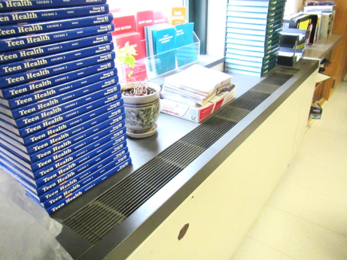
Unit ventilator, note plant on top
Picture 2
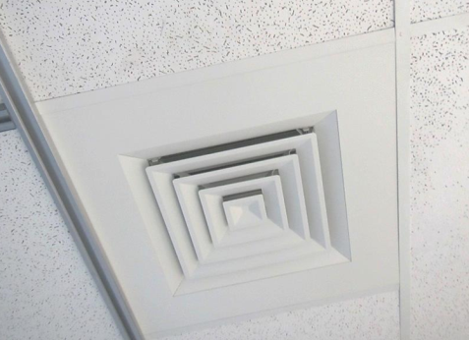
Typical supply vent from rooftop AHU
Picture 3
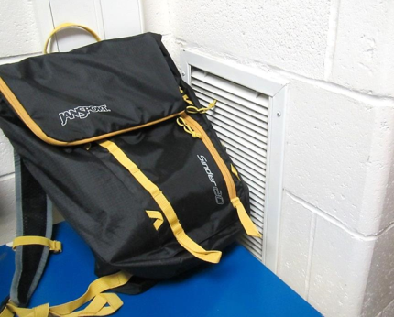
Exhaust vent on classroom wall, note obstructions
Picture 4
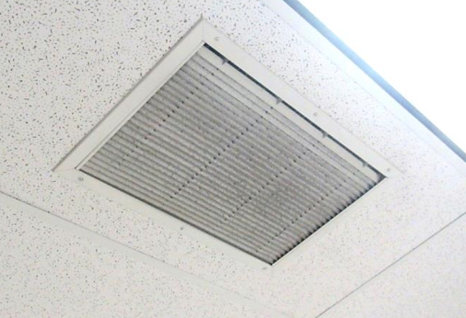
Ceiling-mounted exhaust vent, note dust on louvers
Picture 5
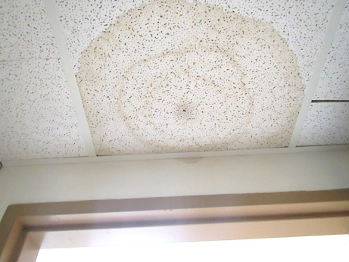
Water-damaged ceiling tile and wall
Picture 6
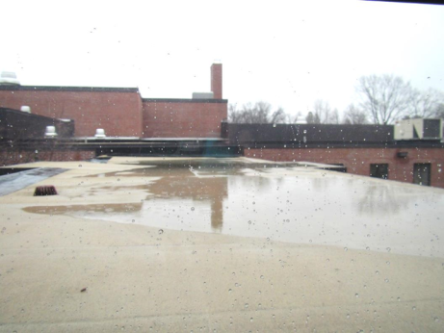
Poorly-draining roof area
Picture 7
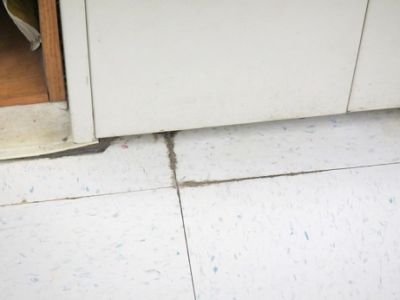
Floor mastic coming up between tiles indicating water exposure
Picture 8
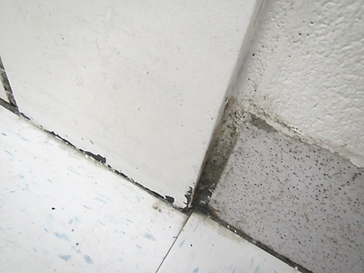
Likely mold colonization on the surface of the wall next to the floor
Picture 9
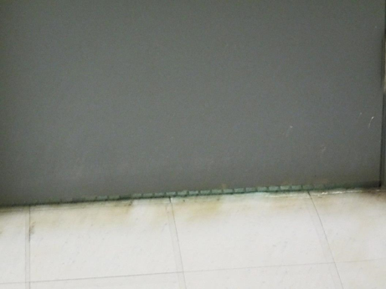
Light showing underneath door to pool area
Picture 10
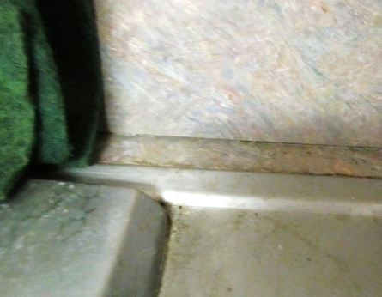
Unsealed sink backsplash in staff room
Picture 11
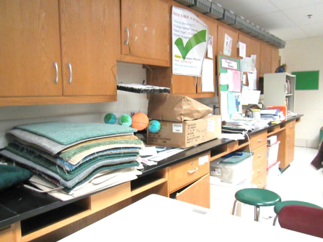
Unused science sinks under items
Picture 12
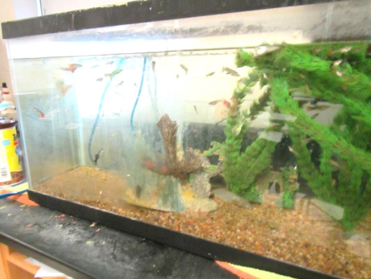
Classroom aquarium
Picture 13
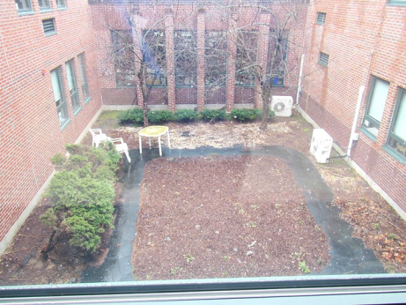
Plants and trees in a courtyard
Picture 14
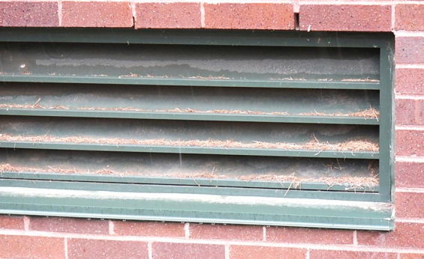
Univent intake louvers loaded with grass clippings
Picture 15
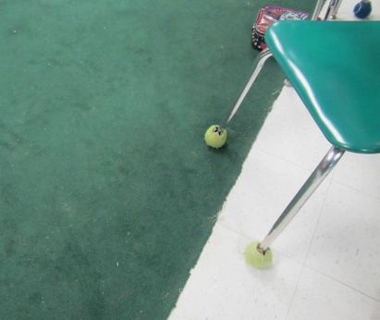
Tennis balls on chair legs and area rug
Picture 16
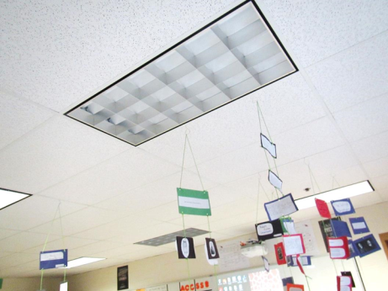
Items hanging from the ceiling tile system
Picture 17
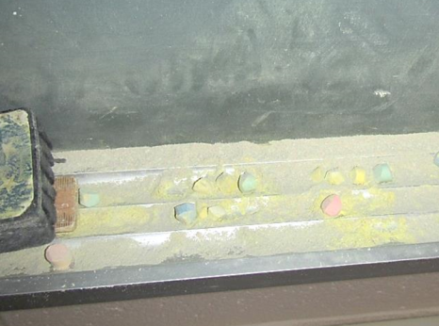
Chalk dust in tray

Location | Carbon  Dioxide  (ppm) | Carbon Monoxide  (ppm) | Temp  (°F) | Relative  Humidity  (%) | PM2.5  (µg/m³) | Occupants  in Room | Windows  Openable | Ventilation |  | Remarks
 |  |  |  |  |  |  |  | Supply | Exhaust
Background | 438 | 0.8 | ~32 | 42 | 10 |  |  |  |  | Snow/rain and wind
103 staff | 537 | ND | 72 | 29 | 8 | 2 | Y | Y | Y | WAC, refrigerator has spills, PC, sink backsplash open
106 | 569 | ND | 72 | 27 | 7 | 2 | Y | Y | Y | PF dusty, area rug, DEM, HS
112 | 798 | ND | 72 | 31 | 9 | 14 | Y | Y | Y | DEM, items on UV, PF, dirt/stain on baseboards
113 | 688 | ND | 72 | 28 | 7 | 1 (class left half hour ago) | Y | Y | Y | DEM, chalk dust, PF dusty
114 | 610 | ND | 72 | 27 | 8 | 0 | Y | Y | Y | WD CT, chalk and DEM debris, exhaust blocked
117 | 910 | ND | 72 | 32 | 7 | 14 | Y | Y | Y | Exhaust blocked and near open door, UV has items/blocked, PFs, DEM
119 | 973 | ND | 73 | 31 | 7 | 10 | Y | Y | Y | Portable AC (not connected), exhaust part blocked, DEM
120 | 1037 | ND | 73 | 32 | 7 | 14 | Y | Y | Y | HS
120 science storage | 703 | ND | 73 | 26 | 8 | 0 | N | N | Y | Unused sink, items
122 science | 833 | ND | 72 | 31 | 7 | 19 | Y | Y | Y | Portable AC (not connected), unused sinks, carpet squares and items on counters, HS
123 | 917 | ND | 72 | 31 | 8 | 21 | Y | Y | Y | TB, area rug, items and plants on UV
125 | 1096 | ND | 73 | 33 | 8 | 21 | Y | Y | Y | Exhaust partly blocked, DEM
127 | 1109 | ND | 72 | 33 | 9 | 20 | Y | Y | Y | DEM, items hanging from ceiling, exhaust partly blocked
129 | 667 | ND | 71 | 29 | 8 | 0 | Y | Y | Y | DEM, PF
131 | 1032 | ND | 71 | 32 | 7 | 20 | Y | Y | Y | UV on, items on it
132 computer | 767 | ND | 71 | 30 | 7 | 0 (class just left) | Y | Y | Y | UV and ductless AC, DEM
133 | 1030 | ND | 72 | 33 | 9 | 21 | Y | Y | Y | TB, area rug, items on UV
135 | 978 | ND | 71 | 33 | 6 | 18 | Y | Y | Y | UV on, DEM, HS, plant
140 | 468 | ND | 69 | 38 | 5 | 25 | Y | Y | N
201 | 889 | ND | 72 | 29 | 9 | 17 | Y | Y | Y | Plants, science sinks, DEM
203 storage | 776 | ND | 71 | 29 | 10 | 0 | N | N | Y | 2 WD CT
204 reading | 588 | ND | 71 | 28 | 7 | 1 | Y | Y | Y | DEM, plant, HS
206 | 670 | ND | 74 | 26 | 8 | 4 | Y | Y | Y | DEM, PF
212 | 421 | ND | 72 | 26 | 8 | 1 | Y | Y | Y | WAC
213 | 975 | ND | 73 | 30 | 8 | 18 | Y | Y | Y | DEM, hallway has WD CT
214 | 506 | ND | 72 | 28 | 9 | 0 | Y | Y | N | DEM
215 | 651 | ND | 72 | 26 | 7 | 0 | Y | Y | Y | Several WD CT
217 | 751 | ND | 73 | 28 | 8 | 0 | Y | Y | Y | DEM
219 | 757 | ND | 72 | 28 | 8 | 11 | Y | Y | Y | DEM, exhaust blocked next to open door, plants,
222 team room | 666 | ND | 72 | 30 | 8 | 2 | Y | Y | Y | Fridge and microwave, PC, WAC, HS
223 | 576 | ND | 70 | 27 | 8 | 0 | Y | Y | Y | DEM, CP, PF, chalk
224 | 562 | ND | 72 | 28 | 9 | 1 | Y | Y | Y | PF, DEM, CP
225 | 640 | ND | 72 | 28 | 9 | 12 | Y | Y | Y | DEM
227 | 847 | ND | 72 | 30 | 9 | 13 | Y | Y | Y | Carpeted area, DEM
229 | 992 | ND | 72 | 31 | 10 | Class leaving | Y | Y | Y | DEM, items hanging from ceiling
231 | 820 | ND | 70 | 28 | 8 | 0 | Y | Y | Y | TBs, chalk
232 science | 958 | ND | 72 | 31 | 10 | 18 | Y | Y | Y | Unused sinks, AI, exhaust off and partly blocked
233 | 850 | ND | 73 | 31 | 9 | 15 | Y | Y | Y
234 | 616 | ND | 72 | 27 | 10 | 8 | Y | Y | Y | AQ, unused sinks, plants, DEM, DO, AI
234 storage | 613 | ND | 71 | 27 | 9 | 0 | N | Y | N | Fridge, science items, CP, food
235 | 1050 | ND | 73 | 31 | 9 | 12 | Y | Y | Y | Exhaust partly blocked, DEM, HS
237 | 1058 | ND | 73 | 31 | 9 | 21 | Y | Y | Y | DEM, DO
295 science | 1040 | ND | 71 | 32 | 9 | 18 | Y | Y | Y | Sinks, debris in UV, DEM
Band | 539 | ND | 68 | 29 | 4 | 0 | Y | Y on | Y
Cafetorium | 883 | ND | 70 | 34 | 6 | 100+ | Y | Y | Y | 5 WD CT
Gym | 575 | ND | 69 | 30 | 4 | 40+ | N | Y | Y
Library | 763 | ND | 73 | 31 | 9 | 30 | Y | Y | Y | Carpet, DEM, computers, PC
Library/facility director office | 716 | ND | 74 | 31 | 8 | 1 | N | Y | Y | AI, carpet
Men’s locker | 484 | ND | 71 | 29 | 6 | 0 | N | Y | Y
Music | 615 | ND | 69 | 32 | 6 | 15 | N | Y | Y | 3 WD CT
Music office | 604 | ND | 69 | 31 | 5 | 0 | N | N | Y
Nurse (main) | 642 | ND | 67 | 38 | 6 | 4 | Y | Y | Y
Nurse’s office | 690 | ND | 68 | 37 | 6 | 0 | Y | Y | Y
Nurse’s restroom |  |  |  |  |  | 0 | N | N | Y | WD CT
Pool | 475 | ND | 74 | 59 | 8 | 20+ | N
Pool Hallway |  |  |  |  |  |  |  |  |  | Pool odors, doors to pool need sweeps/sealing
Staff workroom | 618 | ND | 69 | 34 | 6 | 0 | Y | Y | Y
Stairwell 1, 2nd floor | 712 | ND | 71 | 30 | 9 | 0 | N | N | N | WD CT
Stairwell 4 2nd floor | 618 | ND | 72 | 27 | 8 | 2 | N | Y | Y

