INDOOR AIR QUALITY ASSESSMENT

Career Place
Middlesex Community College
TradeCenter
100 Sylvan Road
Woburn, Massachusetts

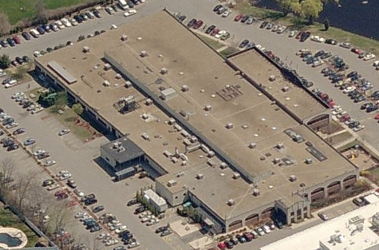

Prepared by:
Massachusetts Department of Public Health
Bureau of Environmental Health
Indoor Air Quality Program
June 2011

Background/Introduction
In response to a request from Lisa Verrochi, Project Manager, Division of Capital Asset Management (DCAM), the Massachusetts Department of Public Health (MDPH), Bureau of Environmental Health (BEH) conducted an indoor air quality (IAQ) evaluation at the Middlesex Community College’s Career Place (CP) center located at the TradeCenter, 100 Sylvan Road, Woburn, Massachusetts. On May 31, 2011, a visit was made to the CP by Sharon Lee, Environmental Analyst/IAQ Inspector within BEH’s IAQ Program. The purpose of the assessment was to aid DCAM in identifying building related issues/concerns for remediation and/or corrective actions as part of a lease renewal process.
The CP is located on the ground floor of a multi-story building constructed in 1952 and renovated entirely in 1996. The remainder of the building is occupied by medical and social service offices. The CP space, which consists of small offices and common meeting areas, has wall-to-wall carpeting, gypsum wallboard (GW), and dropped ceilings. Windows are openable.

Methods
Air tests for carbon monoxide, carbon dioxide, temperature and relative humidity were conducted with the TSI, Q-Trak, IAQ Monitor, Model 7565. Air tests for airborne particle matter with a diameter less than 2.5 micrometers were taken with the TSI, DUSTTRAK™ Aerosol Monitor Model 8520. Screening for total volatile organic compounds (TVOCs) was conducted using a MiniRAE 2000 Portable VOC Monitor, Model PGM 7600. BEH staff performed visual inspection of building materials for water damage and/or microbial growth.

Results
The CP has an employee population of approximately 40 and can be visited by up to 75 to 150 members of the public daily. The tests were taken during normal operations and results appear in Table 1.

Discussion

Ventilation
It can be seen from Table 1 that carbon dioxide levels were above 800 parts per million (ppm) in all areas surveyed, indicating a lack of air exchange at the time of the assessment. Fresh air ducted into the ceiling plenum via an air intake located on the buildings roof (Picture 1) is heated or cooled by the buildings chiller system (Picture 2). Heat pumps located above the suspended ceiling system draw air from the ceiling plenum and distribute it to occupied areas via ceiling-mounted air diffusers (Picture 3). In general, offices are not designed to have return vents. Offices have fresh air diffusers that pressurize the space, forcing air into hallways. Passive vents/transfer air vents located above doorways in some areas aid in the movement of air into hallways/common areas (Picture 4). Air is then drawn into the ceiling plenum by return vents in hallways and other common areas (Picture 5). Filters are installed in the return vents to aid in removing airborne particulates.
Digital wall-mounted thermostats control the heating, ventilation and air-conditioning system at the CP. Thermostats have fan settings of on and automatic. One thermostat was in the automatic setting, while two others were found in the on setting during the assessment (Picture 6). The automatic setting on the thermostat activates the heating, ventilation and air-conditioning (HVAC) system at a preset temperature. Once a preset temperature is reached by the thermostat, the HVAC system is deactivated. Therefore, no mechanical ventilation is provided until the thermostat re-activates the system. MDPH recommends that thermostats be set to the on position during occupied periods, as this setting provides a continuous source of air circulation.
A dedicated exhaust system for the office space could not be identified. Without adequate fresh air supply and/or dedicated exhaust ventilation, pollutants that may exist in the building will remain inside the building and be continuously recirculated.
To maximize air exchange, the MDPH recommends that both supply and exhaust ventilation operate continuously during periods of occupancy. In order to have proper ventilation with a mechanical supply and exhaust system, the systems must be balanced to provide an adequate amount of fresh air to the interior of a room while removing stale air from the room. It is recommended that HVAC systems be re-balanced every five years to ensure adequate air systems function (SMACNA, 1994). The date of the last system balancing was unknown at the time of the assessment.
The Massachusetts Building Code requires that each area have a minimum ventilation rate of 20 cubic feet per minute (cfm) per occupant of fresh outside air or openable windows (SBBRS, 1997; BOCA, 1993). The ventilation must be on at all times that the room is occupied. Providing adequate fresh air ventilation with open windows and maintaining the temperature in the comfort range during the cold weather season is impractical. Mechanical ventilation is usually required to provide adequate fresh air ventilation.
Carbon dioxide is not a problem in and of itself. It is used as an indicator of the adequacy of the fresh air ventilation. As carbon dioxide levels rise, it indicates that the ventilating system is malfunctioning or the design occupancy of the room is being exceeded. When this happens a buildup of common indoor air pollutants can occur, leading to discomfort or health complaints. The Occupational Safety and Health Administration (OSHA) standard for carbon dioxide is 5,000 parts per million parts of air (ppm). Workers may be exposed to this level for 40 hours/week, based on a time-weighted average (OSHA, 1997).
The Department of Public Health uses a guideline of 800 ppm for publicly occupied buildings. A guideline of 600 ppm or less is preferred in schools due to the fact that the majority of occupants are young and considered to be a more sensitive population in the evaluation of environmental health status. Inadequate ventilation and/or elevated temperatures are major causes of complaints such as respiratory, eye, nose and throat irritation, lethargy and headaches. For more information concerning carbon dioxide, please see Appendix A.
Temperature readings were measured in a range of 73º F to 78º F, which were within the MDPH recommended comfort range in several areas. The MDPH recommends that indoor air temperatures be maintained in a range of 70º F to 78º F in order to provide for the comfort of building occupants. In many cases concerning indoor air quality, fluctuations of temperature in occupied spaces are typically experienced, even in a building with an adequate fresh air supply.
CP staff expressed concerns regarding uneven temperature control and excess heat building-wide, particularly in the IT room. As discussed previously, the HVAC system deactivates due to the thermostat setting. Additionally, without dedicated exhaust ventilation, heat and moisture can accumulate within the occupant space.
With regards to the IT room, measures should be taken to ensure the room is maintained at an appropriate temperature. Computers and servers produce waste heat that can build up in the room. While an exhaust vent was observed in this room, it may not be sufficient to remove waste heat produced by the equipment. Excessive heat can result in damage to the computers’ hardware. Measures to prevent prolonged heat buildup in this space should be considered (i.e. installation of a wall-mounted air-conditioning unit) to ensure the equipment is operating in an appropriate environment.
Relative humidity measurements ranged from 48 to 60 percent, within the MDPH recommended comfort guidelines. The MDPH recommends that indoor air relative humidity is comfortable in a range of 40 to 60 percent. Relative humidity levels in the building would be expected to drop during the winter months due to heating. The sensation of dryness and irritation is common in a low relative humidity environment. Low relative humidity is a very common problem during the heating season in the northeast part of the United States.

Microbial/Moisture Concerns
Water-damaged ceiling tiles were observed in a storage hallway (Table 1). Water-damaged ceiling tiles indicate leaks from either the roof or plumbing system. If repeatedly moistened, ceiling tiles can be a medium on which mold can grow.
A water dispenser was located in a carpeted area (Picture 7); spills/leaks from such appliances can be a source of moisture in carpeting that can lead to water damage and mold growth. When possible, these units should be located in tiled areas or placed on a waterproof mat.
The US Environmental Protection Agency (US EPA) and the American Conference of Governmental Industrial Hygienists (ACGIH) recommend that porous materials be dried with fans and heating within 24 to 48 hours of becoming wet (US EPA, 2001; ACGIH, 1989). If not dried within this time frame, mold growth may occur. Once mold has colonized porous materials, they are difficult to clean and should be removed/discarded.

Other IAQ Evaluations
Indoor air quality can be negatively influenced by the presence of respiratory irritants, such as products of combustion. The process of combustion produces a number of pollutants. Common combustion emissions include carbon monoxide, carbon dioxide, water vapor, and smoke (fine airborne particle material). Of these materials, exposure to carbon monoxide and particulate matter with a diameter of 2.5 micrometers (μm) or less (PM2.5) can produce immediate, acute health effects upon exposure. To determine whether combustion products were present in the indoor environment, BEH staff obtained measurements for carbon monoxide and PM2.5.

Carbon Monoxide
Carbon monoxide is a by-product of incomplete combustion of organic matter (e.g., gasoline, wood and tobacco). Exposure to carbon monoxide can produce immediate and acute health effects. Several air quality standards have been established to address carbon monoxide and prevent symptoms from exposure to these substances. The MDPH established a corrective action level concerning carbon monoxide in ice skating rinks that use fossil-fueled ice resurfacing equipment. If an operator of an indoor ice rink measures a carbon monoxide level over 30 ppm, taken 20 minutes after resurfacing within a rink, that operator must take actions to reduce carbon monoxide levels (MDPH, 1997).
The American Society of Heating Refrigeration and Air-Conditioning Engineers (ASHRAE) has adopted the National Ambient Air Quality Standards (NAAQS) as one set of criteria for assessing indoor air quality and monitoring of fresh air introduced by HVAC systems (ASHRAE, 1989). The NAAQS are standards established by the US EPA to protect the public health from six criteria pollutants, including carbon monoxide and particulate matter (US EPA, 2006). As recommended by ASHRAE, pollutant levels of fresh air introduced to a building should not exceed the NAAQS levels (ASHRAE, 1989). The NAAQS were adopted by reference in the Building Officials & Code Administrators (BOCA) National Mechanical Code of 1993 (BOCA, 1993), which is now an HVAC standard included in the Massachusetts State Building Code (SBBRS, 1997). According to the NAAQS, carbon monoxide levels in outdoor air should not exceed 9 ppm in an eight-hour average (US EPA, 2006).
Carbon monoxide should not be present in a typical, indoor environment. If it is present, indoor carbon monoxide levels should be less than or equal to outdoor levels. Outdoor carbon monoxide concentrations were non-detect (ND) at the time of the assessment (Table 1). No measureable levels of carbon monoxide were detected in the building during the assessment (Table 1).

Particulate Matter
The US EPA has established NAAQS limits for exposure to particulate matter. Particulate matter is airborne solids that can be irritating to the eyes, nose and throat. The NAAQS originally established exposure limits to particulate matter with a diameter of 10 μm or less (PM10). According to the NAAQS, PM10 levels should not exceed 150 micrograms per cubic meter (μg/m³) in a 24-hour average (US EPA, 2006). These standards were adopted by both ASHRAE and BOCA. Since the issuance of the ASHRAE standard and BOCA Code, US EPA established a more protective standard for fine airborne particles. This more stringent PM2.5 standard requires outdoor air particle levels be maintained below 35 μg/m³ over a 24-hour average (US EPA, 2006). Although both the ASHRAE standard and BOCA Code adopted the PM10 standard for evaluating air quality, MDPH uses the more protective PM2.5 standard for evaluating airborne particulate matter concentrations in the indoor environment.
Outdoor PM2.5 concentrations were measured at 13 μg/m³ (Table 1). PM2.5 levels measured indoors ranged from 8 to 15 μg/m³ (Table 1), which were reflective of outside ambient conditions and below the NAAQS level. Frequently, indoor air levels of particulates (including PM2.5) can be at higher levels than those measured outdoors. A number of activities that occur indoors and/or mechanical devices can generate particulate during normal operations. Sources of indoor airborne particulates may include but are not limited to particles generated during the operation of fan belts in the HVAC system, use of stoves and/or microwave ovens in kitchen areas; use of photocopiers, fax machines and computer printing devices; operation of an ordinary vacuum cleaner and heavy foot traffic indoors.

Volatile Organic Compounds
Indoor air concentrations can be greatly impacted by the use of products containing volatile organic compounds (VOCs) within the building. VOCs are carbon-containing substances that have the ability to evaporate at room temperature. Frequently, exposure to low levels of total volatile organic compounds (TVOCs) may produce eye, nose, throat and/or respiratory irritation in some sensitive individuals. For example, chemicals evaporating from a paint can stored at room temperature would most likely contain VOCs.
In an effort to determine whether VOCs were present in the building, air monitoring for TVOCs was conducted. Outdoor air samples were taken for comparison. Outdoor TVOC concentrations the day of the assessment were ND (Table 1). No measurable levels of TVOCs were detected in the building during the assessment, except for in the kitchen where a level of up to 2 ppm was measured (Table 1). Measurable levels in the kitchen can be attributed to use of VOC-containing cleaning products.

Other Conditions
An ajar ceiling tile was observed in one area of the building (Table 1). Ceiling tiles should be flush with the tile system to prevent movement of materials from the plenum into the occupied space.
Personal fans were observed in some areas. Fan blades from these units can accumulate dust/debris. Re-activated fans can aerosolize accumulated dust. Fans should be cleaned regularly to prevent aerosolization of dust.

Conclusions/Recommendations
In view of the findings at the time of the assessment, the following recommendations are made to improve indoor air quality in the building:
- Increase the provision of fresh air to the CP space to dilute/reduce airborne pollutants and increase comfort.
- Consider lowering the thermostat set point to increase occupant comfort.
- Program thermostats to operate HVAC equipment with the fan in the on setting during occupied hours to increase air movement and comfort and prevent future occurrences of cooling coils from freezing.
- Consider installing additional transfer air vents in offices lacking vents to increase movement of air.
- Change filters regularly to ensure proper filtration. Ensure filters are in place and that they fit properly.
- Clean air diffusers, return vents and personal fans periodically of accumulated dust/debris.
- Consider installing a wall-mounted air-conditioning unit in the IT room. Ensure condensation drains for the unit are installed properly to prevent water damage.
- For buildings in New England, periods of low relative humidity during the winter are often unavoidable. Therefore, scrupulous cleaning practices should be adopted to minimize common indoor air contaminants whose irritant effects can be enhanced when the relative humidity is low. To control for dusts, a high efficiency particle arrestance (HEPA) filter-equipped vacuum cleaner in conjunction with wet wiping of all surfaces is recommended. Drinking water during the day can help ease some symptoms associated with a dry environment (throat and sinus irritations).
- Remove water-damaged ceiling tiles and examine for source of water. Replace all missing and ajar ceiling tiles and monitor for future leaks.
- Clean carpeting annually or semi-annually in soiled high traffic areas as per the recommendations of the Institute of Inspection, Cleaning and Restoration Certification (IICRC). Copies of the IICRC fact sheet can be downloaded at: http://www.cleancareseminars.com/carpet_cleaning_faq4.htm (IICRC, 2005).
- Refer to resource manuals and other related indoor air quality documents for further building-wide evaluations and advice on maintaining public buildings. Copies of these materials are located on the MDPH’s website: http://mass.gov/dph/iaq.

References
ACGIH. 1989. Guidelines for the Assessment of Bioaerosols in the Indoor Environment. American Conference of Governmental Industrial Hygienists, Cincinnati, OH.
ASHRAE. 1989. Ventilation for Acceptable Indoor Air Quality. American Society of Heating, Refrigeration and Air Conditioning Engineers. ANSI/ASHRAE 62-1989
BOCA. 1993. The BOCA National Mechanical Code/1993. 8th ed. Building Officials and Code Administrators International, Inc., Country Club Hill, IL.
IICRC. 2005. Carpet Cleaning FAQ 4 Institute of Inspection, Cleaning and Restoration Certification. Institute of Inspection Cleaning and Restoration, Vancouver, WA.
MDPH. 1997. Requirements to Maintain Air Quality in Indoor Skating Rinks (State Sanitary Code, Chapter XI). 105 CMR 675.000. Massachusetts Department of Public Health, Boston, MA.
OSHA. 1997. Limits for Air Contaminants. Occupational Safety and Health Administration. Code of Federal Regulations. 29 C.F.R 1910.1000 Table Z-1-A.
SBBRS. 1997. Mechanical Ventilation. State Board of Building Regulations and Standards. Code of Massachusetts Regulations. 780 CMR 1209.0
SMACNA. 1994. HVAC Systems Commissioning Manual. 1st ed. Sheet Metal and Air Conditioning Contractors’ National Association, Inc., Chantilly, VA.
US EPA. 2001. Mold Remediation in Schools and Commercial Buildings. US Environmental Protection Agency, Office of Air and Radiation, Indoor Environments Division, Washington, D.C. EPA 402-K-01-001. March 2001.
US EPA. 2006. National Ambient Air Quality Standards (NAAQS). US Environmental Protection Agency, Office of Air Quality Planning and Standards, Washington, DC. http://www.epa.gov/air/criteria.html.
Picture 1

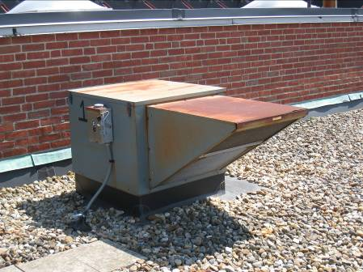

Fresh air intake

Picture 2

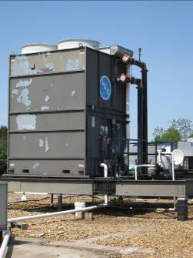

Cooling Tower

Picture 3

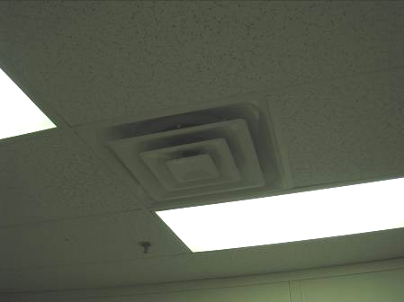

Supply vent

Picture 4

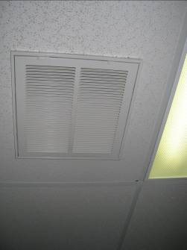

Return vent

Picture 5

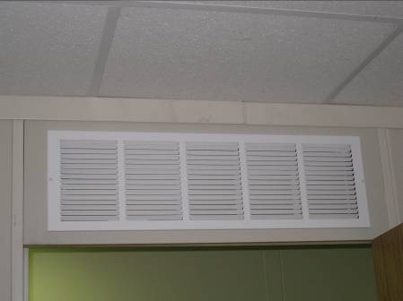

Passive vent above door

Picture 6

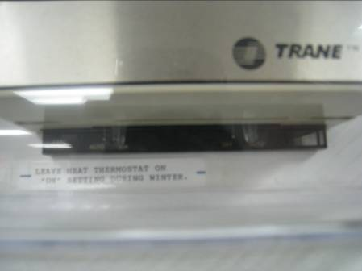

Thermostat fan set to auto

Picture 7

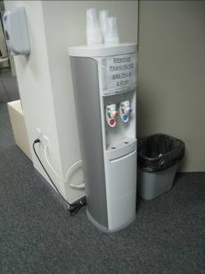

Water dispenser on carpeting
Location | Carbon Dioxide (*ppm) | Carbon Monoxide (*ppm) | Temp (°F) | Relative Humidity (%) | TVOCs (*ppm) | PM2.5 (ug/m3) | Occupants in Room | Windows Openable | Ventilation |  | Remarks
 |  |  |  |  |  |  |  |  | Intake | Exhaust | Remarks
Background | 488 | ND | 87 | 22 | ND | 13 |  |  |  |  | Sunny
Executive director’s office | 1861 | ND | 77 | 54 | ND | 8 | 1 | Y | Y | N
Small Conference room | 1769 | ND | 78 | 51 | ND | 8 | 0 | N | Y | Y | DO, DEM
Director of Career Services | 1814 | ND | 78 | 51 | ND | 8 | 0 | N | Y | Passive | PF
Youth Services Staff 1 | 1760 | ND | 78 | 50 | ND | 11 | 2 | N | Y | Y
Staff Kitchen | 1799 | ND | 77 | 51 | ND-2 | 15 | 2 | N | Y | Y | DO, staff using cleaning products
staff cubicles/office production | 1732 | ND | 77 | 51 | ND | 10 | 1 | N | Y | Y | 2 PC
re-employment office/cubcle | 1483 | ND | 76 | 48 | ND | 11 | 2 | N | Y | Y
Youth Services Staff 2 | 1389 | ND | 76 | 49 | ND | 11 | 0 | N | Y | passive
Business Services | 1391 | ND | 76 | 49 | ND | 11 | 1 | N | Y | passive
Executive Assistant | 1900 | ND | 78 | 49 | ND | 8 | 1 | Y | Y | Y
Career Services | 1352 | ND | 76 | 49 | ND | 12 | 1 | N | Y | passive
Back Hallway | 1106 | ND | 73 | 50 | ND | 13 | 0 | N | Y | N | 2 WD-CT
IT room | 1324 | ND | 78 | 51 | ND | 10 | 1 | N | Y | Y | both ducted and passive vents
Computer Room | 2861 | ND | 76 | 52 | ND | 9 | 1 | N | Y | Y | approx 20 computers
Manager 1 | 1339 | ND | 76 | 48 | ND | 11 | 1 | N | Y | passive | 1 AT, DO
Manager 2 | 1490 | ND | 76 | 49 | ND | 11 | 3 | N | Y | passive | PF, DO
Manager 3 | 1613 | ND | 75 | 50 | ND | 10 | 2 | N | Y | passive | DO
Manager 5 | 1557 | ND | 75 | 50 | ND | 10 | 0 | N | Y | N | DO
Career Resources Library | 1771 | ND | 75 | 53 | ND | 10 | 20 | N | Y | Y
Training Room 1 | 1758 | ND | 75 | 53 | ND | 9 | 0 | N | Y | N
Training Room 2 | 3460 | ND | 78 | 60 | ND | 10 | 3 | N | Y | Y
Interview 3 | 1808 | ND | 76 | 55 | ND | 9 | 0 | N | Y | passive | DO
Interview 2 | 1809 | ND | 76 | 53 | ND | 9 | 7 | N | Y | passive | DO
Staff 1 | 1727 | ND | 76 | 53 | ND | 10 | 0 | N | Y | passive
reception | 1718 | ND | 76 | 53 | ND | 9 | 7 | N | Y
interview 1 | 1809 | ND | 76 | 54 | ND | 8 | 0 | N | Y | passive | DO
staff 2 | 1809 | ND | 76 | 54 | ND | 9 | 0 | N | Y | passive
large conference | 2021 | ND | 78 | 53 | ND | 8 | 2 | Y | Y | N | PF

