September 16, 2026

Via Electronic Mail: Fabiola.Catulle@mass.gov; DPH.DON@MassMail.State.MA.US

Fabiola Catulle, MPH
Application Manager, Determination of Need Program Department of Public Health
67 Forest Street
Marlborough, MA 01752

Re: DoN 26042710-RE

Dear Ms. Catulle,

We, the undersigned residents and taxpayers of the Commonwealth of Massachusetts, hereby request recognition as a Ten Taxpayer Group and the rights associated with such a designation including notice concerning, and participation in, the review of the above captioned Determination of Need (“DoN”) Application filed with the Department of Public Health (“Department”) on August 18, 2026 by Atrius Health, Inc. (“Atrius”) for the expansion of imaging services across several practice locations including MRI services Atrius Health’s Concord practice located at 220 Baker Avenue, Concord, MA 01742. Attachment A. Charles Denault is the taxpayer designated to receive all written correspondence relative to the above-captioned DoN Application on behalf of this Ten Taxpayer Group known as Middlesex County Partners for Patients and Communities. Materials may be sent to 133 Old Rd to 9 Acre Corner, Concord, MA 01742 or via email to bartmgt@gmail.com.The undersigned are acting as agents of Emerson Hospital,133 Old Rd to 9 Acre Corner, Concord, MA 01742

In addition, pursuant to 105 CMR 100.435, we provide the following written comments. Please also see the attached slides. Attachment B.

Emerson Health (“Emerson”) serves over 300,000 patients annually in 39 towns through Emerson Hospital in Concord and nine outpatient locations throughout the region. Emerson Hospital is a 179-bed full-service non-profit independent community hospital located in Concord and provides MRI services at two locations: its main campus in Concord and its satellite in Westford. Both locations are accredited by The Joint Commission and the American College of Radiology.

In recent years, Emerson has made significant investments in its MRI capabilities resulting in faster scan times, improved access and the availability of more complex imaging in the community. These investments include the replacement of its Westford unit in 2024 with a 3T GE HERO MRI+ AI providing faster scans and advanced imaging including prostate fusion imaging. In addition, in 2026 GE Advanced AI Software was added in Concord providing reduced scan times and improved image quality. With these new capabilities, Emerson Hospital reduced scan times by 20-40% depending on scan type.

Reduced scan times have in turn resulted in increased capacity per scanner by up to 50%. In addition, both locations operate expanded hours including early morning, late evening and weekends. The investments that Emerson has made in its MRI service have resulted in more than adequate MRI capacity already available in the community as further highlighted by the operating capacity of each of the hospital’s units. As demonstrated in the table below, both units are operating well below capacity.

- | FY25 | FY26
Westford | - | -
Scans | 8,479 | 9,060
Utilization | 64% | 68%
Concord | - | -
Scans | 6,652 | 6,900
Utilization | 78% | 54%*
*Capacity decrease is attributed to AI enabling faster scan times.

Wait times for MRI at Emerson’s locations are significantly shorter than at other MRIs in the community. Currently, patients are only waiting five days for the next available appointment at the Westford location and 11 days for an appointment at the Concord location. In addition to timely access to MRI scans, imaging result turnaround times are significantly faster than the American College of Radiology turnaround time average of 30 hours by 46% in Concord and 56% in Westford. Emerson’s efforts to provide high-quality MRI services to the community are evidenced by exceptional patient satisfaction scores for both locations with over 97% of patients reporting they were happy with the MRI services they received.

Despite the availability of existing resources that are meeting the patient panel needs, the Atrius project will result in shifting patients from a demonstrated high-quality community-based MRI provider to a part-time mobile unit. Emerson Health and Atrius currently have an affiliation agreement that allows for Atrius patients to receive care locally from Emerson Hospital and its specialists. Atrius recently acquired Acton Medical Associates, a primary care practice located in Acton. Both Atrius Concord and Acton Medical Associates refer patients to Emerson where MRIs are often ordered by Emerson specialists. The following tables demonstrate the number of MRI referrals made by Atrius Health and Acton Medical Associates to Emerson Hospital MRIs for the two most recent calendar years.

Atrius Health
- | 2025 | YTD July 2026
Total Atrius Referrals to Concord MRI | 120 | 50
Atrius Concord Referrals to Concord MRI | 78 | 24
Total Atrius Referrals to Westford MRI | 117 | 60
Atrius Concord Referrals to Westford MRI | 72 | 38
Total | 237 | 110

Acton Medical Associates

Site | 2025 | YTD July 2026
Emerson-Concord | 181 | 87
Emerson-Westford | 464 | 275
Total | 645 | 362
In order to achieve the projected volume in the DoN application for a second day of operation, Atrius and Acton Medical Associates will need to refer patients to the Atrius mobile unit in Concord resulting in unnecessary duplication of healthcare resources. We urge the Department to thoroughly review the Atrius DoN and, at a minimum, consider the following issues because the DoN application does not demonstrate that the proposed project meets all the required factors of review:

- Emerson Hospital currently meets the MRI needs of the patient panel and is not experiencing capacity constraints in serving its patients. The application states that patients are receiving care at local hospitals, resulting in “overcapacity” of hospital machines; however, it provides no current data to support this claim.

- Emerson Hospital wait times are reasonable. The applicant has not provided its wait times for its Concord MRI and for all other MRI locations as is historically required by the Department. By only providing an aggregate wait time, the applicant has not demonstrated that the proposed project components, expanded MRI services in Concord and new MRI services in Burlington, are needed by the patient panel.

- Emerson Hospital has significant capacity to meet any increased current and future demand. The historical volume for MRI at Atrius Concord does not support the 5-year projections provided in the application. Volume at Atrius Concord decreased in 2025. It is

unclear if Atrius Concord’s 2026 volume also decreased as the application does not provide current data for 2026. However, the applicant projects a 28% increase in volume compared to 2025 and a 45% total increase by year five. It is clear that a large portion of this projected volume will be achieved by reducing referrals to Emerson Hospital, an existing non-profit MRI provider affiliated with Atrius Health that is already serving the patient panel.

- Continuing to send patients to Emerson Hospital is a viable alternative to the proposed project. The application does not provide two alternatives to meet the requirements of Factor 5: Relative Merit and this option should be considered.

- The total capital expenditure provided in the application does not include the fair market value of the equipment that is leased as required by 105 CMR 100.100 Capital Expenditure: “where leased equipment is to be installed, the fair market value of such property or equipment […] shall be used in calculating the proposed Capital Expenditure attributed to such property or equipment.” By providing a capital expenditure that does not include the fair market value of the Burlington MRI and the Peabody CT, the applicant will benefit from a lower CHI obligation.

The DoN application has not demonstrated that the proposed MRI expansions are needed. Accordingly, we respectfully request that the Department deny the MRI components of the application. These project components are counter to ensuring the viability of independent non-profit community hospitals such as Emerson Hospital and result in unnecessary duplication of existing resources.

In addition, we request that the Department conclude that the existing condition imposed in 2025 remains in effect as there is no precedent for removing a condition issued by the Public Health Council.

We appreciate your time and careful review of this application and our comments. Please do not hesitate to contact Charles Denault at bartmgt@gmail.com if you have any questions.

Sincerely,
The Undersigned

Attachment 1

Name | Home Address | Signature
- David Caponera | [redacted] | [signature on file]
- Philip S. Lotane | [redacted] | [signature on file]
- Matthew W. Boger | [redacted] | [signature on file]
- Charles A. Denault | [redacted] | [signature on file]
- William P. Boger III | [redacted] | [signature on file]
- John C. MacKeen | [redacted] | [signature on file]
- Kenneth Anderson | [redacted] | [signature on file]
- Liza Carey | [redacted] | [signature on file]
- Sandra A. Schelzi | [redacted] | [signature on file]
- Benjamin Matys | [redacted] | [signature on file]

Attachment 2



Emerson Health MRI Background and Data

September 3, 2026

Executive Summary

- Emerson Health has demonstrated the ability to meet the growing community need for MRI scans.

- Significant investment in new AI-Enabled technology allows for faster scans, improved access, and more complex imaging in the community setting.

- Both MRIs operate seven days per week to meet patient requests with no interference with emergency department or inpatient MRI scans.

- Next available appointments and turnaround times are significantly better than other MRIs in the community.

- Both locations receive outstanding patient satisfaction feedback.

Emerson has invested in upgrading the MRI technology over time to support patient demand and can more than support additional growth while maintaining access and a positive patient experience.

About Emerson Health

- 179-bed full-service non-profit, acute care hospital and ambulatory services

- 9 outpatient locations throughout region

- Serving over 300,000 patients in 39 towns

- ~785 medical staff members

- ~2,200 employees

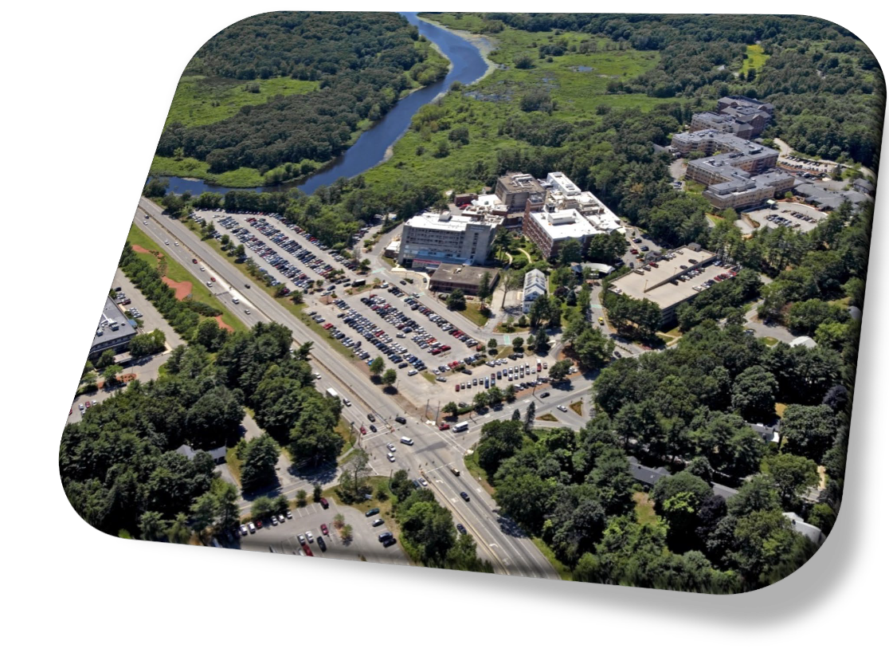

MRI History and Background

- Emerson has 2 fixed MRI locations with extensive hours available every day:
  - Concord: Main Hospital Campus
  - Westford: Emerson Ambulatory Care Health Center

- In 2021, Emerson entered into a Joint Venture with Shields to grow MRI and expand services in the community

- Both locations are Accredited by The Joint Commission and American College of Radiology

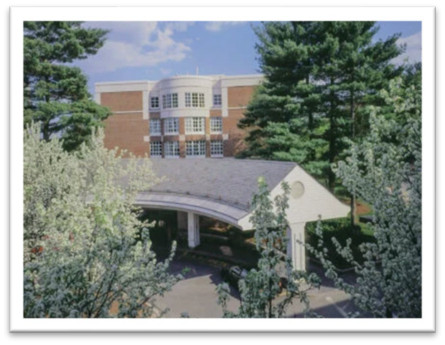

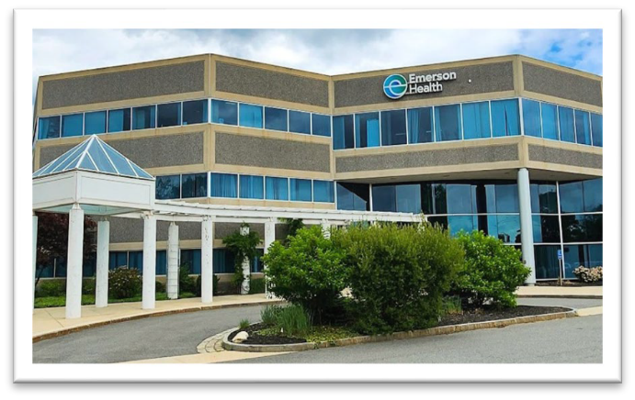

Emerson has invested in state-of-the art technology to improve access and patient experience

Westford • 2024
3T GE Hero MRI + AI Software
Faster scans and advanced imaging, including prostate fusion imaging.

CONCORD • 2026
1.5T GE + Advanced AI Software
Reduced scan times and improved image quality.

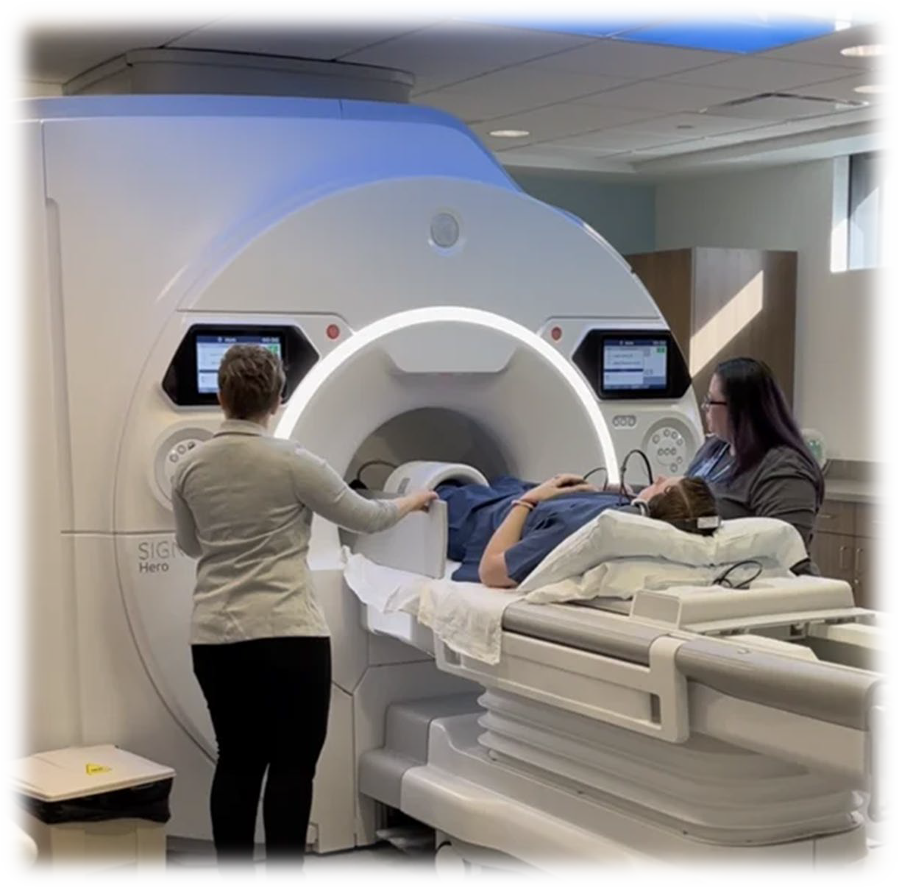

AI Software has reduced scan time and increased available patient slots

Concord Avg. Slot Time
−29%
36 → 24 min | Pre vs Post AI
AI Upgrades Concord • AR DL Recon software • 2026

Westford Avg. Slot Time
−30%
35 → 24 min | Pre vs Post AI
Westford • GE Hero 3T + AR DL Recon • 2024

Slot-Time Improvements
Minutes per exam | Pre-AI → Post-AI
Scan Type | Concord | Concord | Westford | Westford
Brain (C-) | 25 → 20 | −20% | 30 → 20 | −33%
Cervical Spine (C-) | 30 → 20 | −33% | 30 → 20 | −33%
Thoracic Spine (C-) | 30 → 25 | −17% | 40 → 25 | −38%
Hip Unilat (C-) | 40 → 25 | −38% | 40 → 20 | −50%
Knee (C-) | 25 → 20 | −20% | 30 → 15 | −50%
Abdomen (C-/C+) | 50 → 30 | −40% | 50 → 30 | −40%
Notes: C- = non-contrast; C+ = contrast; C-/C+ = w & wo contrast

AI Impact
~30%
average slot-time reduction at both locations

Up To
50%
Slot time reduction in select exam types
More Capacity / Scanner

MRI Volume Growth and Capacity

- Emerson continues meet the increasing community demand:

  - Emerson continues to absorb MRI growth in both locations
  - Hours of operation were expanded to meet the patient needs
  - Fast access for next appointment
  - Quick turnaround time by Radiologists

MRI Volume Growth by Location

Location | 2023 | 2024 | 2025 | 2026  Projected | Growth
Emerson-Concord | 6,309 | 6,580 | 6,652 | 6,900 | 9.3%
Emerson-Westford | 5,369 | 5,758 | 8,479 | 9,060 | 69%
Total | 11,678 | 12,338 | 15,131 | 15,960 | 37%

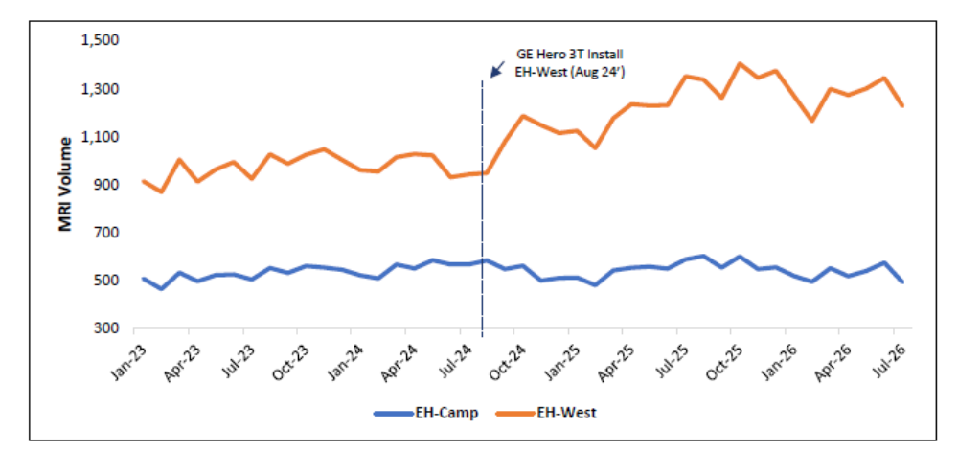

Extensive Hours of Operation

Operating Hours by Location
Emerson-Concord | Emerson-Westford

MRI Hours | MRI Hours
Sun: 8:30 a.m. – 4:30 p.m.  Mon-Fri: 6:30 a.m. – 11:00 p.m.  Sat: 8:00 a.m. – 4:30 p.m. | Mon-Fri: 6:30 a.m. – 10:00 p.m.  Sat-Sun: 6:30 a.m. – 7:00 p.m.
99 Operating Hrs/Wk | 102.5 Operating Hrs/Wk

Location | Sunday | Monday | Tuesday | Wednesday | Thursday | Friday | Saturday
Emerson-Concord | 8:30A - 4:30P | 6:30A - 11:00P | 6:30A - 11:00P | 6:30A - 11:00P | 6:30A - 11:00P | 6:30A - 11:00P | 8:00A - 4:30P
Emerson-Westford | 6:30A - 7:00P | 6:30A - 10:00P | 6:30A - 10:00P | 6:30A - 10:00P | 6:30A - 10:00P | 6:30A - 10:00P | 6:30A - 7:00P

Access and Turnaround Time

Next Available Appointment for non-emergent MRI

MRI Location | Next Available
Emerson-Concord | 11 days
Emerson-Westford | 5 days
As of 8/24/2026
Turnaround Time (Hours)

MRI Location | YTD July 2026
Emerson-Concord | 13.4
Emerson-Westford | 16.1
American College of Radiology Average is 30 hours

Emerson, Atrius, and Acton Affiliation

- Emerson physicians have provided specialty care in the community to Atrius Concord and Acton Medical Associates primary care patients for decades.
- Both Atrius Concord and Acton Medical refer to Emerson specialists where MRIs are often ordered by the Emerson specialist: orthopedics, general surgery, urology, spine, and oncology, to name a few.
- Emerson and Atrius have a clinical affiliation agreement for specialty care to ensure continuity of care in the Emerson Service Area:
  - An Emerson urologist is located onsite in Atrius Burlington office to provide care to Atrius patients
  - Atrius GI providers perform procedures both at Emerson Hospital and Emerson’s outpatient GI Ambulatory Surgical Center in Concord
  - Acton Medical leases medical office space from Emerson in Hudson contiguous with Emerson specialists and Urgent Care Center.

Summary: The Referral Data on the following slides illustrates:

    - Emerson has the capacity to administer MRI scans to our service area and beyond with minimal to no wait time

    - Emerson radiologist reading times are significantly below the American College of Radiology turnaround time average: (46% in Concord; 56% in Westford)

    - Emerson has a strong referral base for MRI Scans from Acton Medical Associates and multiple Atrius sites including:
      - Concord
      - Boston
      - Chelmsford
      - Burlington
      - Somerville.

    - As such, Emerson has availability to accommodate additional patients in the Emerson hospital service area and beyond.

Referrals from Atrius and Acton Medical

Atrius Health
- | 2025 | YTD Jul. 2026
Total Atrius Referrals to  Concord MRI | 120 | 50
Atrius Concord Referrals to Concord MRI | 78 | 24
Total Atrius Referrals to  Westford MRI | 117 | 60
Atrius Concord Referrals to Westford MRI | 72 | 38
Total | 237 | 110
Atrius Health by Referring Office
Atrius Office | 2025 | YTD Jul. 2026
Concord | 150 | 62
Boston | 19 | 13
Chelmsford | 26 | 5
Burlington | 13 | 6
Somerville | 5 | 7
Other | 24 | 17
Total | 237 | 110

Acton Medical Associates
Site | 2025 | YTD Jul. 2026
Emerson-Concord | 181 | 87
Emerson-Westford | 464 | 275
Total | 645 | 362

Data Source:
- 2025 calendar year
- 2026: year to date through July.

Patient Satisfaction Summary

      - Each Emerson MRI patients in both locations are surveyed.

      - In both locations, the survey shows:
        - In Concord: 97% of patients were happy with their experience.
        - In Westford: 98% of patients were happy with their experience.

Positive Patient Satisfaction Scores
Concord
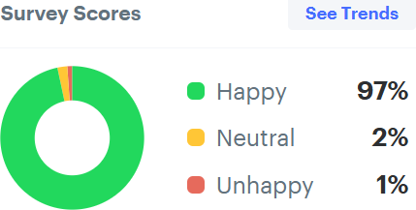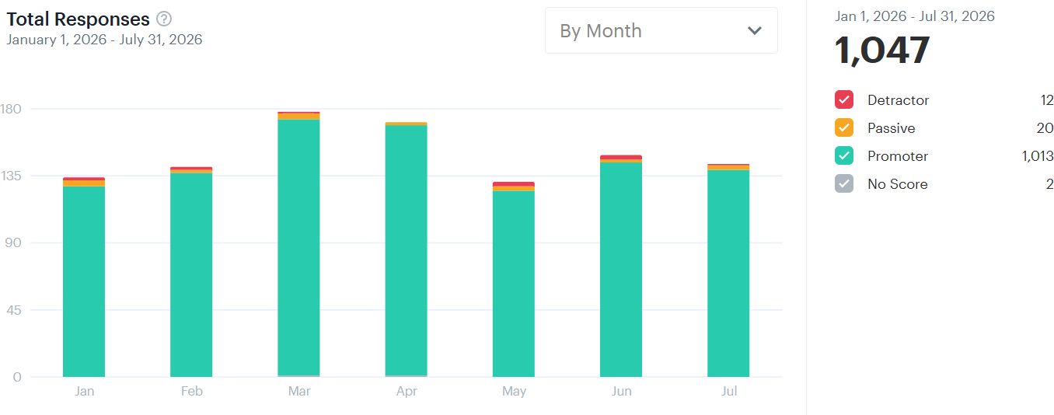

Westford


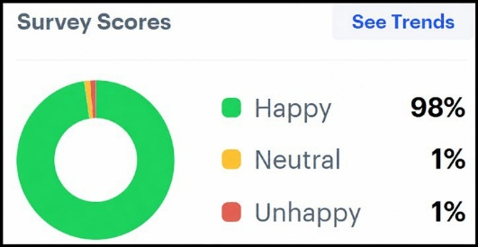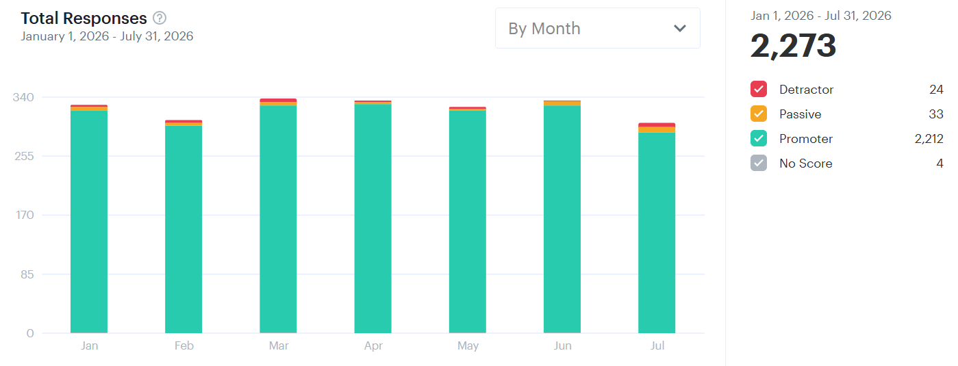
14


Questions?

Christine Schuster, RN, MBA President and CEO cschuster@emersonhosp.org 978-496-4890

Eric Stastny, MHA Chief Operating Officer
estastny@emersonhosp.org
617-460-5167

15

