

October 31, 2023

Chair Michael Rodrigues

Senate Committee on Ways and Means 24 Beacon Street

Room 212 – State House Boston, MA 02133

Chair Aaron Michlewitz

House Committee on Ways and Means 24 Beacon Street

Room 243 – State House Boston, MA 02133

Governor Maura Healey 24 Beacon Street

Room 280 – State House Boston, MA 02133

Senator John Velis, Chair

Joint Committee on Mental Health, Substance Use and Recovery

24 Beacon Street

Room 513 – State House Boston, MA 02133

Representative Adrian Madaro, Chair Joint Committee on Mental Health, Substance Use and Recovery

24 Beacon Street Room 33 – State House Boston, MA 02133

Senator Cindy F. Friedman, Senate Chair Joint Committee on Health Care Financing 24 Beacon Street

Room 313 – State House Boston, MA 02133

John J. Lawn, House Chair

Joint Committee on Health Care Financing 24 Beacon Street

Room 236 – State House Boston, MA 02133

Secretary Terrence Reidy

Executive Office of Public Safety and Security

1 Ashburton Place, Suite 2133

Boston, MA 02108

Secretary Kate Walsh

Executive Office of Health and Human Services

1 Ashburton Place, 11th Fl. Boston, MA 02108

Dear Senate Clerk Hurley and House Clerk James, Governor Healy, Chairs Velis and Madaro, and Secretaries Reidy and Walsh:

We write as the co-chairs and legislative members of the Restoration Center Commission (“Commission”) established under *An Act Relative to Criminal Justice Reform*, Chapter 69 of the Acts of 2018 (“Act”) and amended under *An Act Making Appropriations for the Fiscal Year 2023*, Chapter 126 of the Acts of 2022. The Act directs the Commission to provide an annual report to the legislature by November 1.

The attached Year Five Findings and Recommendations were compiled by ForHealth Consulting at UMass Chan Medical School on behalf of the Commission and detail the following:

* Commission meetings, administration, and activities in Year Five,
* Work to procure a Restoration Center vendor and a siting and community engagement consultant,
* Activities that the siting and community engagement consultant and planning grant recipients have accomplished, and
* Findings and recommendations.

We look forward to reporting to you a year from now on the successes and lessons learned in implementing the Middlesex County Restoration Center pilot.

Sincerely,



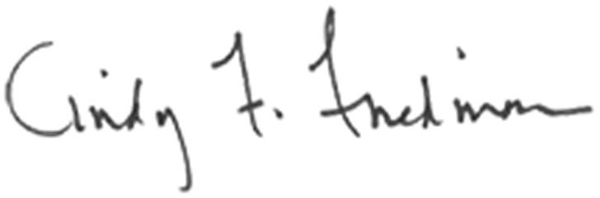Co-Chair, Sheriff Peter J. Koutoujian Co-Chair, President and CEO Danna Mauch, PhD Middlesex County Massachusetts Association for Mental Health

Senator Cindy F. Friedman Representative Kenneth Gordon cc: Senate President Karen Spilka

House Speaker Ronald Mariano