**Middlesex County Restoration Center Commission**

**Year Four Findings and Recommendations**

Prepared for:

**Senate Committee on Ways and Means**

**House Committee on Ways and Means**

**Joint Committee on Mental Health and Substance Abuse**

**Governor Charles D. Baker**

**Executive Office of Public Safety and Security**

**Executive Office of Health and Human Services**

Prepared by:

**Middlesex County Restoration Center Commission**

Supported by Commonwealth Medicine, UMass Chan Medical School

**Catia Sharp, MPP**

Health Policy Associate

**Tamika Jeune, JD**

Health Policy Associate

**Katharine London, MS**

Principal for Health Law & Policy

**April 13, 2022**

Table of Contents

Introduction 2

Executive Summary 3

Commission Processes 4

Commission Meetings 4

Commission Administration 4

Commission Activities 4

Identified and Operationalized Funding Sources 4

Refined Service Model 5

Identified Licensure Requirements 5

Aligned with Other State Initiatives 6

Drafted Procurement Documents 7

Restoration Center Pilot Program Service Model 9

Service Model Components 9

Access to Services 9

Same-Day Services 10

Connections to Care 13

Multi-Day Services 13

Staffing 16

Facility 17

Findings and Recommendations 17

Implementation Plan and Timeline 17

Legislation 18

APPENDIX: Potential Restoration Center Licensing and Billing Options 19

# Introduction

The Middlesex County Restoration Center Commission (Commission), established under Chapter 69 of the Acts of 2018, *An Act relative to criminal justice reform* (Act), hereby submits its Year Four Findings and Recommendations to the General Court as required by the Act. The Commission worked since its inception to do the following:

* Investigate the gaps and needs in behavioral health and diversionary services in Middlesex County that could prevent arrest and unnecessary emergency department (ED) utilization among individuals with behavioral health conditions
* Develop a service model for a Restoration Center pilot program in Middlesex County
* Implement a Restoration Center pilot program in Middlesex County

The Act tasked the Commission with planning and implementing “a county restoration center and program to divert persons suffering from mental illness or substance disorder who interact with law enforcement or the court system during a pre-arrest investigation of the pre-adjudication process from lock-up facilities and hospital emergency departments to appropriate treatment.”[1] This report summarizes the activities the Commission completed in Year Four and includes updates to the pilot program model.

Commonwealth Medicine (CWM), the health care consulting and operations division of UMass Chan Medical School (UMass Chan), compiled this report on behalf of the Middlesex County Restoration Center Commission.

Commission members included:

* Sheriff Peter J. Koutoujian, Middlesex, co-chair
* Dr. Danna Mauch, President and CEO, Massachusetts Association for Mental Health, co-chair
* Senator Cindy Friedman, 4th Middlesex District
* Representative Kenneth Gordon, Middlesex 21st District
* Honorable Paula M. Carey, Chief Justice of the Trial Court
* Chief Robert Bongiorno, Bedford Police Department
* Lydia Conley, President/CEO, Association for Behavioral Healthcare
* Scott Taberner, Special Adviser, Executive Office for Health and Human Services
* Nancy Connolly, Assistant Commissioner for Forensic Services, Department of Mental Health
* Deirdre Calvert, Director, Bureau of Substance Addiction Services
* Eliza Williamson, Director of Community Education and Training, National Alliance on Mental Illness of Massachusetts

# Executive Summary

First, this report describes activities the Commission completed in Year Four, which include the following:

* Summary of Commission meetings held in Year Four
* Description of the change in the Commission administration to involve CWM
* Description of the complex braided funding supporting the Restoration Center pilot program
* Discussion of refinement to the service model
* Overview of licensing requirements to implement the model
* Review of the drafting of procurement documents

Next, this report describes the changes made to the service model for the Restoration Center pilot program, which includes these components:

* Categorization of the services
* Resolution of key implementation questions
* Adjustments to the staffing requirements of the Restoration Center pilot program
* Specifying final facility requirements for the Restoration Center pilot program

Finally, this report outlines findings and recommendations, which include:

* An implementation plan and timeline for the Restoration Center pilot program
* Necessary legislation to support the Restoration Center pilot program

# Commission Processes

This section describes the Commission processes to finalize the service model for the Restoration Center pilot program and prepare for implementation.

## Commission Meetings

In Year Four, the Commission met seven times to do the following:

* Determine the legal structure for the procurement by making a recommendation to the Massachusetts Executive Office of Health and Human Services (EOHHS) that CWM serves as the procuring and contracting entity for the Restoration Center pilot program
* Ascertain progress made by the Procurement Subcommittee and CWM in developing a procurement for a contractor to operate the Restoration Center pilot program
* Define the Commission’s role beyond Year Four and the process established by statute to develop and implement a Restoration Center pilot program
* Identify sources of funding and secure such funding to support the Restoration Center pilot program

Additionally, the Procurement Subcommittee met eight times to:

* Work with CWM on developing procurement documents for a contractor to operate the Restoration Center pilot program
* Discuss ongoing workforce challenges in behavioral health that impact the cost and implementation timeline for the Restoration Center pilot program
* Determine the required licensure and provider types to support the service model developed in the Commission’s Year Three Findings and Recommendations
* Finalize refinements to the service model and budget for the Restoration Center pilot program

## Commission Administration

The state fiscal year 2022 budget allocated funding for the Commission to EOHHS in line item 4000-0300. EOHHS entered into an Intergovernmental Service Agreement (ISA) with CWM to finalize the service model for the Restoration Center pilot program and procure the Restoration Center pilot program in Middlesex County.

## Commission Activities

This section describes Year Four activities for the Commission.

### Identified and Operationalized Funding Sources

CWM updated the draft Restoration Center pilot program budget, which included expected cost increases due to workforce shortages, as well as updates to billing assumptions and phase-in approaches, described further below. CWM estimated that a Restoration Center pilot program would cost roughly $6.75 million to $7.25 million annually, or $20 million to $25 million over four years, including a phase-in period.

The Restoration Center pilot program relies on a complex braiding of funds. CWM estimated that revenue from these sources could range from $3 million to $4 million annually at full capacity. Details of the funding include:

* *An Act relative to COVID-19 recovery needs*, Chapter 102 of the Acts of 2021, appropriated $5 million into the Criminal Justice and Community Support Trust Fund held by the Department of Mental Health (DMH). These funds flow through an ISA from DMH to CWM. Up to $1.4 million can support startup costs, including the creation of a physical environment matching the Commission’s vision.
* An annual appropriation of $1 million in EOHHS line item 4000-0300. These funds flow through an ISA from EOHHS to CWM.
* Community Project Funding in the amount of $1.65 million in the federal fiscal year 2022 budget.
* Respite bed funding included in the Restoration Center pilot program service model at the DMH funding rate. CWM estimated that revenue from this source could range from $500,000 to $700,000 annually.
* Revenue from the Department of Public Health (DPH) as the payer of last resort for substance use treatment services provided to uninsured individuals. CWM estimated the revenue from this source as $100,000 annually.

The Commission aimed to identify an additional $4 million to $10 million in resources to sustain the Restoration Center pilot program financially over four years. Commission members engaged in conversations to obtain additional sources of revenue for the Restoration Center pilot program.

### Refined Service Model

The Procurement Subcommittee worked closely with CWM to refine the service model for the Restoration Center pilot program based on the service model described in the Commission’s Year Two Findings and Recommendations. New information and implementation considerations included the following:

* Reorganization of services into discrete functional types
* Completion of operational details
* Engagement with relevant state agencies to identify concerns
* Identification of a process for innovation and continuous quality improvement

For additional details on the refined service model, refer to *Final Pilot Program Model Components* below.

### Identified Licensure Requirements

CWM sought to identify the licensure required to establish a pilot program using the model developed by the Commission. The identification of appropriate licensure supported the drafting of procurement documents that accurately reflected how a Restoration Center pilot program could operate within the existing regulatory structure of Massachusetts. Additionally, the procurement documents detailed how to enhance revenue for a Restoration Center pilot program to leverage available funding streams. The identification of licensure requirements occurred in the context of a changing behavioral health services landscape due to EOHHS’ Roadmap for Behavioral Health Reform (Roadmap), described in *Aligned with Other State Initiatives* below.

The Commission sought to braid funding for the Restoration Center pilot program. By leveraging existing funding streams to the maximum extent possible, the Commission sought to ensure the long-term viability of the service model. Licensure played a key role in supporting the braided funding.

Many MassHealth members will access the Restoration Center pilot program. The Restoration Center pilot program can receive reimbursement from MassHealth for serving MassHealth members through the following:

* MassHealth-covered behavioral health services
* DPH licensure, which supports MassHealth covered services
* Attestations or other processes determined by MassHealth

CWM identified two separate criteria for requiring the Restoration Center pilot program contractor to obtain a particular license. The criteria are:

* To meet state or federal safety requirements
* To be eligible for state agency payments for services rendered

For additional details regarding the licensure and billing options, please refer to *Appendix A*.

### Aligned with Other State Initiatives

The Roadmap, developed by EOHHS, accomplished goals aligned with the Restoration Center pilot program, including increasing access to urgent and crisis behavioral health services that can prevent hospitalization and arrest. In implementing a Restoration Center pilot program in Middlesex County, the Commission considered several changes to the larger behavioral health system. The Massachusetts state fiscal year 2016 budget (Chapter 46 of the Acts of 2015, Section 92-93) established Mobile Integrated Health at the DPH. The Roadmap includes the following components with relevance to the Restoration Center pilot program:

* Community Behavioral Health Centers (CBHCs)
* MassHealth Behavioral Health Urgent Care Program
* 24/7 Behavioral Health Help Line

An additional new program launched by MassHealth is also aligned with the Restoration Center pilot program: the Behavioral Health Supports for Justice-Involved Individuals program

Implementation of these new behavioral health programs and services included changes to licensure, provider requirements, billing requirements, and payment rates for services included in the Restoration Center pilot program. Additionally, the tight timelines required the behavioral health provider community to respond to multiple procurements at once. CWM worked closely with MassHealth during Year Four to address some of these challenges by aligning timelines and content of the respective procurements.

#### Community Behavioral Health Centers

The Massachusetts Behavioral Health Partnership (MBHP) seeks to procure CBHCs to create a single point of care for behavioral health conditions. The CBHCs will provide rapid access to behavioral health care. CBHCs also include the mental health crisis response system, formerly known as the Emergency Service Provider system. The Restoration Center pilot program included many services provided by CBHCs. The goals and mission of the CBHCs align well with the Restoration Center model. CBHCs will receive enhanced MassHealth payment rates, which could increase the Restoration Center pilot program’s projected revenue.

#### MassHealth Behavioral Health Urgent Care Program

MassHealth Managed Care Entity Bulletin 76 outlines a process for mental health clinics to attest to having expanded hours for access to behavioral health care services. If MassHealth certifies a clinic as a Certified Behavioral Health Urgent Care program, the program becomes eligible to receive enhanced MassHealth payment rates. The Restoration Center pilot program included many services provided by Certified Behavioral Health Urgent Care programs, which provided an additional opportunity for the Restoration Center pilot program to obtain enhanced revenue from existing funding streams.

#### 24/7 Behavioral Health Help Line

A statewide, 24/7 Behavioral Health Help Line will facilitate access to behavioral health services across the Commonwealth, including the Restoration Center pilot program. This new, centralized service will enable people to call or text to get connected to behavioral health treatment. The 24/7 Behavioral Health Help Line will expedite connections to a provider for routine or urgent behavioral health care in their community or at home. The 24/7 Behavioral Health Help Line may refer individuals to the Restoration Center pilot program for triage and crisis assessment.

#### Mobile Integrated Healthcare and Community Emergency Medical Services Programs

DPH implemented the Mobile Integrated Healthcare (MIH) and Community Emergency Medical Services (Community EMS) programs pursuant to 105 CMR 173.000. The MIH and Community EMS programs provide a special licensing structure as an alternative to ambulances dropping off individuals exclusively at hospitals with emergency departments (EDs). The Restoration Center pilot program can apply for an MIH or Community EMS license. With this license, all Community EMS providers within a given radius of the Restoration Center can transport an individual to the Restoration Center pilot program instead of an ED.

#### Behavioral Health Supports for Justice-Involved Individuals

MassHealth implemented the Behavioral Health Supports for Justice-Involved Individuals (BH-JI) program to provide care navigation supports for individuals with complex behavioral health needs leaving correctional settings. The goal of BH-JI is to better connect individuals to behavioral health care and related supports that can prevent future arrest and subsequent detention or incarceration. These goals align with those of the Restoration Center pilot program.

### Drafted Procurement Documents

CWM drafted a Request for Proposals (RFP) and worked with the Procurement Subcommittee to improve and finalize the documents with the following considerations in mind:

#### Procurement and Bidder Considerations

Open procurements conducted by MassHealth will rapidly change the behavioral health service landscape in Massachusetts. CWM worked to ensure that the Restoration Center pilot program used the most up-to-date information from those processes to inform expectations about licensure and provider type. CWM also worked with MassHealth to avoid precluding potential bidders on the Restoration Center pilot program procurement from submitting bids on any procurement due to time constraints and overlap of response deadlines.

#### Phase-In Approach

Given the current behavioral health workforce challenges, acquiring space and hiring staff can take additional time. Therefore, the procurement asked bidders to specify a phase-in approach for portions of the service model.

CWM modeled two phase-in approaches for the Restoration Center pilot program to support budget estimation. One approach assumed ramp-up to full services could take a full calendar year; the other assumed that some services could phase in earlier than others. To do the latter phase-in approach, some services will begin earlier than one year, and some services will begin later than one year.

#### Commitment to Innovation and Continuous Quality Improvement

The Commission viewed the Restoration Center pilot program as a trial of a service model developed to address the problem of high rates of arrest and ED utilization among individuals with behavioral health conditions. CWM and the Commission developed a plan to measure the success of the service model in achieving the stated goals of the Restoration Center pilot program. CWM and the Commission constructed a plan for continuously improving the service model over time. The commitment to innovation and continuous quality improvement plans includes:

* Innovation and continuous quality improvement by the contractor, CWM, and the Commission
* Monthly outcome reporting by the contractor
* Monthly meetings between the contractor and CWM to review outcomes reported and troubleshoot barriers
* Bi-monthly presentations to the Commission and CWM, including an overview of outcomes to date, barriers to achieving the goals of the service model, and proposals for improvements to the service model, if any
* A feedback loop whereby CWM and the contractor may implement ongoing improvements to the service model
* Program evaluation for the Restoration Center pilot program during the initial contract period

# Restoration Center Pilot Program Service Model

The Commission, supported by CWM, finalized the Restoration Center pilot program service model components and prepared for implementation.

­­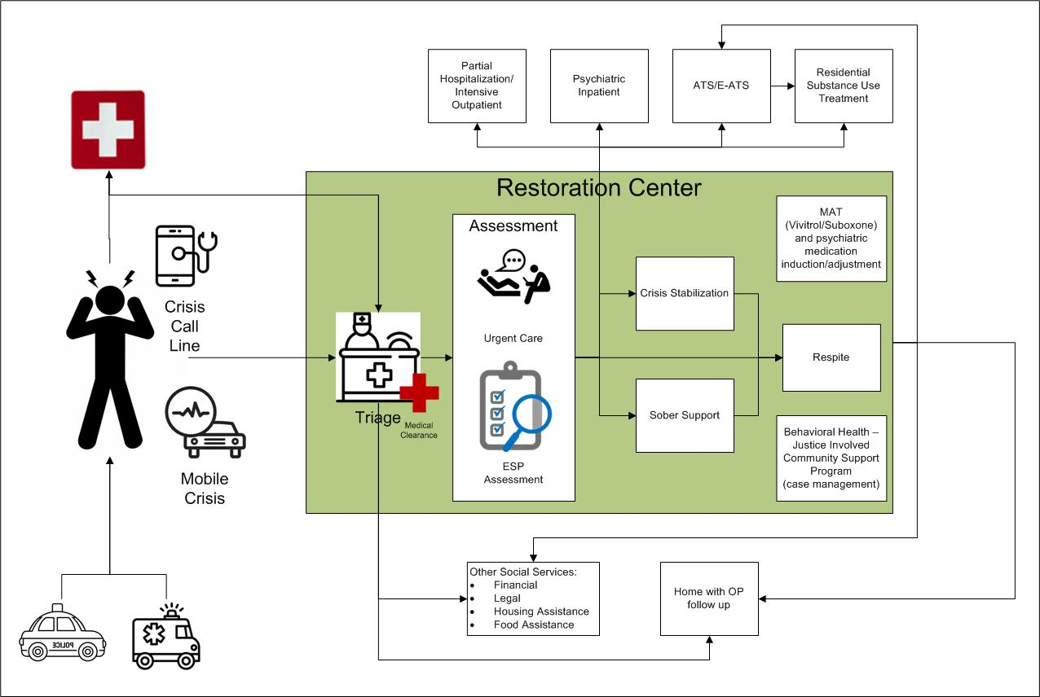

## Service Model Components

The Procurement Subcommittee revised and finalized the service model components of the Restoration Center pilot program. They organized the service model components into the categories of *Access to Services*, *Same-Day Services*, *Multi-Day Services*, and *Connections to Care*.

### Access to Services

The Restoration Center pilot program will increase access to behavioral health urgent and crisis services to prevent arrest and unnecessary hospitalization. This stated goal appeared in prior Commission reports as the “No Wrong Door” policy. Following on the “No Wrong Door” policy involves the following:

* The Restoration Center pilot program will operate 24 hours per day, 7 days per week, 365 days per year.
* The Restoration Center pilot program will not turn away any individual arriving at the Restoration Center pilot program seeking treatment due to their type of insurance or planned method of payment. However, the service model seeks to protect standing bed capacity by not admitting individuals who have already received a crisis assessment of their immediate behavioral health needs elsewhere, except for local Adult Mobile Crisis Intervention teams.
* Individuals may arrive at the Restoration Center pilot program in many ways, including walk-ins or drop-offs by first responders, police, or ambulances.
* The Restoration Center pilot program will pick up individuals seeking care, as requested, by operating two vehicles to transport individuals to and from the program.
* The contractor will work with local providers of ambulance services to create an MIH or Community EMS program, which will allow ambulances responding to local 911 calls to transport individuals to the Restoration Center pilot program.

### Same-Day Services

The Procurement Subcommittee identified the set of services available to all individuals at the Restoration Center pilot program, including:

#### Triage

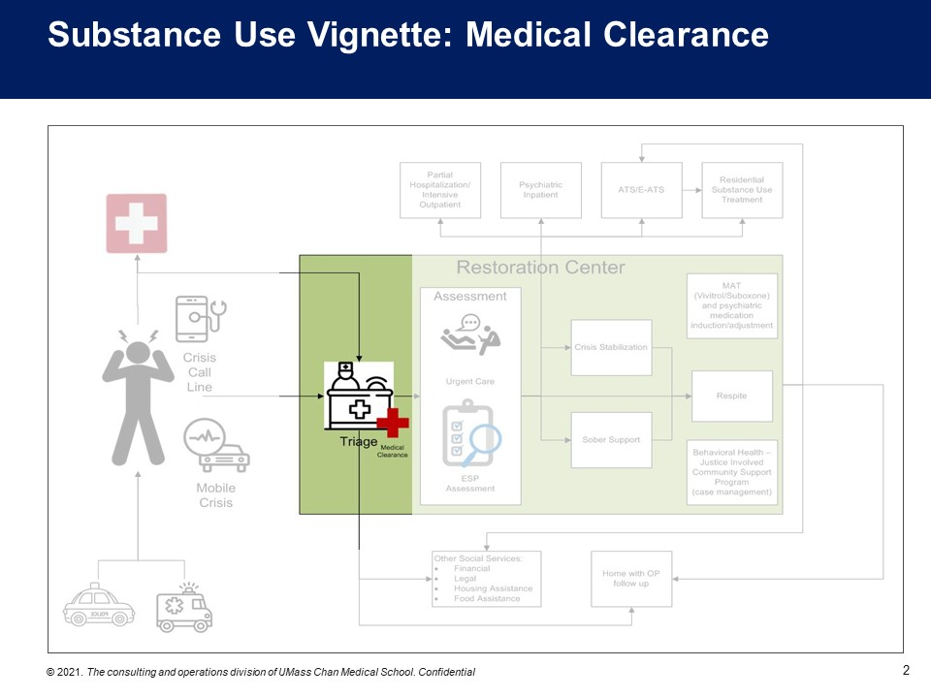

The triage and medical clearance processes serve as a key element of the Restoration Center pilot program model. The Restoration Center pilot program must determine whether an individual requires an ED level of care for a medical emergency. If so, it must arrange for emergency transport to the ED. If the triage process determines the individual qualifies for safe management at the Restoration Center pilot program, the triage process must assess the urgency of behavioral health stabilization, including withdrawal management. To effectively make such determinations, the triage process must include:

* Qualified staff to conduct a medical evaluation. The Restoration Center pilot program could bill MassHealth and commercial insurers for medical evaluations if conducted by certain personnel, including registered nurses (RNs).
* Laboratory services to accurately manage withdrawal symptoms. Laboratory services will also support testing for medical emergencies. A laboratory licensed by DPH must provide laboratory services to allow for MassHealth billing. The Restoration Center pilot program provider can also sub-contract laboratory services. Laboratory services for the purpose of medical clearance must occur on-site and in a rapid manner to support immediate medical decisions. Laboratory services provided at the Restoration Center pilot program can occur through a license or point-of-care service provided by a licensed laboratory. The Restoration Center pilot program can also utilize a Clinical Laboratory Improvement Amendment (CLIA) waiver. Laboratory services may be reimbursable for individuals with commercial insurance.
* A limited services clinic license from the DPH, as MassHealth will not pay for medical evaluations without this licensure.

#### Assessment

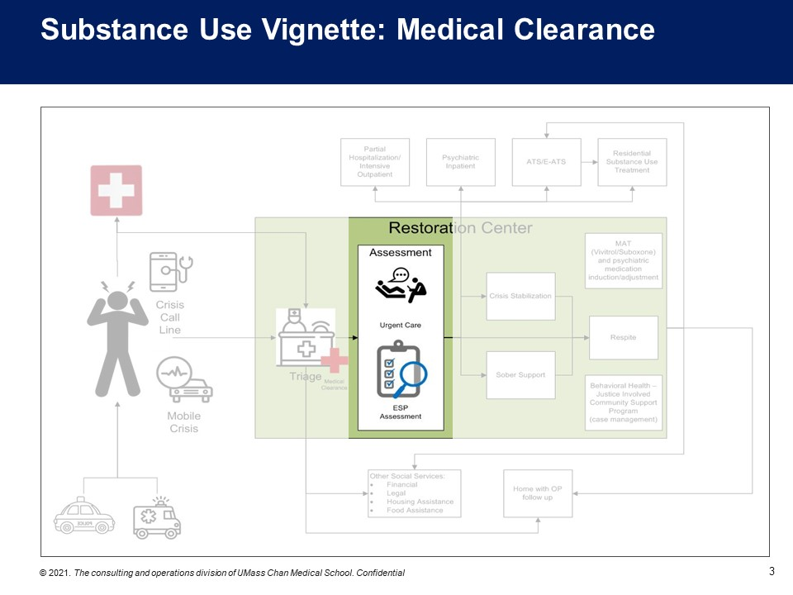

Following triage, the Restoration Center pilot program will conduct a behavioral health crisis assessment. The crisis assessment will determine the individual’s risk of harm to self or others. The crisis assessment will also specify needed crisis services. The individual might require a hospital level of care, and the Restoration Center pilot program will transport the individual to such a level of care. The Restoration Center pilot program can bill MassHealth for crisis assessments if the Restoration Center pilot program qualifies as a designated CBHC provider.

Currently, commercial insurers are not required to cover behavioral health crisis assessments, but the Restoration Center pilot program may contract with commercial insurers for coverage of such assessments.

#### Peer Support and Recovery Coaching

Peer support and recovery coaching remain essential elements of a Restoration Center pilot program model. Research shows that peer support and recovery coaching can improve an individual’s experience with behavioral health services and increase their engagement in treatment.[2] The Restoration Center pilot program includes peer support and recovery coaches in the lobby and waiting room, recovery coaches in the Sober Support unit, and peer support and recovery coaches supporting individuals seeking care throughout their time at the Restoration Center pilot program.

MassHealth covers peer support hours provided by a Certified Peer Specialist certified through a DMH Peer Support Training and Certification Program, and recovery coach hours provided by a Certified Addiction Recovery Coach credentialed by the Massachusetts Board of Substance Abuse Counselor Certification.

Currently, commercial insurers are not required to cover peer support and recovery coaching, but the Restoration Center pilot program could contract with commercial insurers for coverage of such services.

#### Behavioral Health Urgent Care

Behavioral health urgent care remains a core component of the Restoration Center pilot program service model. The Restoration Center pilot program will provide behavioral health urgent care to individuals who do not require overnight crisis stabilization. Behavioral health urgent care includes psychiatry, counseling, post-crisis planning, and other urgent supports.

The Roadmap introduced two new enhancements to the behavioral health services continuum intended to increase access to behavioral health urgent care: the CBHC and Certified Behavioral Health Urgent Care Centers. The CBHC provides the most comprehensive set of behavioral health urgent care supports. Certified Behavioral Health Urgent Care Centers increase access to urgent care for behavioral health conditions. CBHCs receive a higher payment rate than Certified Behavioral Health Urgent Care Centers, which receive a higher payment rate than traditional mental health clinics.

The Restoration Center pilot program could bill MassHealth for behavioral health urgent care services under **one** of the following:

* An entity designated as a CBHC, providing Restoration Center pilot program services at its designated CBHC location. This designation would enable the Restoration Center pilot program to receive the highest possible payment rate for urgent care services.
* A Certified Behavioral Health Urgent Care Center, eligible for enhanced payment rates but at a lower level than the CBHC option.
* An entity holding a mental health clinic license and substance use clinic license from DPH, which would be eligible for standard payment rates.

Commercial insurers are not required to cover all behavioral health urgent care services.

#### Pharmacy, Including Medication for Addiction Treatment

To prescribe and provide medications on-site at the Restoration Center pilot program, the program will require the following:

* Licensed prescribing physicians on staff
* A pharmacy designation on the clinic license from DPH to allow for medication administration

MassHealth covers these services for members, and commercial insurers also cover these services.

The Restoration Center pilot program must serve individuals already on or seeking induction on Medication for Addiction Treatment (MAT) and Medications for Opioid Use Disorder (MOUD). The Restoration Center pilot program staffing model requires at least one provider holding an X-waiver, which allows prescribing of buprenorphine. MOUD medications require a high degree of oversight from both state and federal authorities. The Procurement allows the Restoration Center pilot program provider to sub-contract with Office-Based Opioid Treatment (OBOT) providers and Opioid Treatment Program (OTP) providers to perform guest dosing for MOUD.

### Connections to Care

The Commission noted the need for facilitated connections to ongoing behavioral health care services, social services, and related supports. The procurement documents required a provider entity to implement a connection to care, including collaboration with existing case management and care coordination available to individuals accessing the Restoration Center pilot program.

### Multi-Day Services

The Procurement Subcommittee distinguished multi-day services to describe bed capacity at the Restoration Center pilot program, which could support crisis stabilization and connections to follow-up care and supports. The Restoration Center pilot program will give priority for beds to individuals arriving from local first responder transports and walk-ins experiencing crisis in the geographical area of the Restoration Center pilot program.

#### Mental Health Crisis StabilizationDiagram of Restoration Center Pilot Program Service Model with Crisis Stabilization highlighted

Mental health crisis stabilization overnight beds allow for individuals in need of more lengthy stabilization to be treated over the course of 24 hours, referred to as Community Crisis Stabilization (CCS). MBHP re-procured this service as part of the CBHC model. If designated as a CBHC, the Restoration Center pilot program can bill MassHealth for CCS services provided to MassHealth members.

Currently, commercial insurers are not required to cover CCS, but the Restoration Center pilot program may work to contract with commercial insurers for coverage of CCS services.

#### Substance Use Crisis Stabilization (Sober Support/SUD Support)

Diagram of Restoration Center Pilot Program Service Model with Sober Support highlighted 



The Commission identified Sober Support as a vital component of the example restoration centers in other jurisdictions. Unfortunately, a Sober Support level of care does not currently exist in Massachusetts. The Procurement Subcommittee accepted the recommendation of the Bureau of Substance Addiction Services to rename the Sober Support to “SUD Support.”

A range of substance use treatment programming along the American Society of Addiction Medicine (ASAM) continuum remains available in Middlesex County. MassHealth covers the following levels of care for individuals who meet strict medical necessity criteria:

* Level 4: inpatient SUD treatment, which provides the most intensive medical management of withdrawal symptoms.
* Level 3.7: Acute Treatment Services (ATS), which provide medical monitoring of withdrawal symptoms and have five days as the average or anticipated length of stay.
* Level 3.5: Clinical Stabilization Supports (CSS), which provide high-intensity stabilization for those having completed withdrawal management or who do not require medical monitoring of withdrawal symptoms. Fourteen days is the average or anticipated length of stay for CSS.
* Level 3.1: multiple program models in Massachusetts include:
* Residential Rehabilitation Services (RRS) for poly-substance users in the early stages of recovery, vulnerable to relapse; provide clinically managed residential stabilization. Ninety days is the average or anticipated length of stay for RRS.
* Transitional Support Services (TSS) for individuals who completed withdrawal management and need clinically managed transitional stabilization. Twenty-two days is the anticipated length of stay for TSS.
* Level 2.1: Intensive Outpatient Programs for two to three hours daily for multiple days per week of treatment on an outpatient basis.
* Level 1: Outpatient treatment that includes MAT and MOUD.

The ASAM continuum includes multiple levels of treatment; some involve overnight care.

The Restoration Center pilot program service model seeks to replicate the harm reduction models for sober support found in Tucson, Arizona, San Antonio, Texas, and Detroit, Michigan. Such models provide medical management of withdrawal symptoms, stabilization, counselors, peer support workers, up to 24-hour lengths of stay, and often direct access to the next step in SUD treatment on-site or through facilitated community linkages.

The Procurement Subcommittee learned that SUD Supports in Massachusetts might encompass multiple ASAM levels of care. From a user-centric perspective, removing the need for first responders or individuals and their family members to identify the appropriate level of care based on medical necessity criteria would improve access to the system of care. The Procurement Subcommittee created this user-centered approach by combining the capacity to provide ATS and CSS with a harm reduction model for SUD Support that does not require a license. A Restoration Center pilot program with DPH licensure remains eligible for MassHealth payment for MassHealth members who meet the medical necessity criteria for ATS and CSS. Currently, MassHealth does not cover a harm reduction model of SUD Supports. The Procurement Subcommittee seeks to require the Restoration Center pilot program provider to contract with DPH for eligibility for a DPH payer of last resort funding to cover ATS and CSS services provided to uninsured individuals who meet relevant medical necessity criteria. Commercial insurers may also pay for this level of care.

#### Respite Care

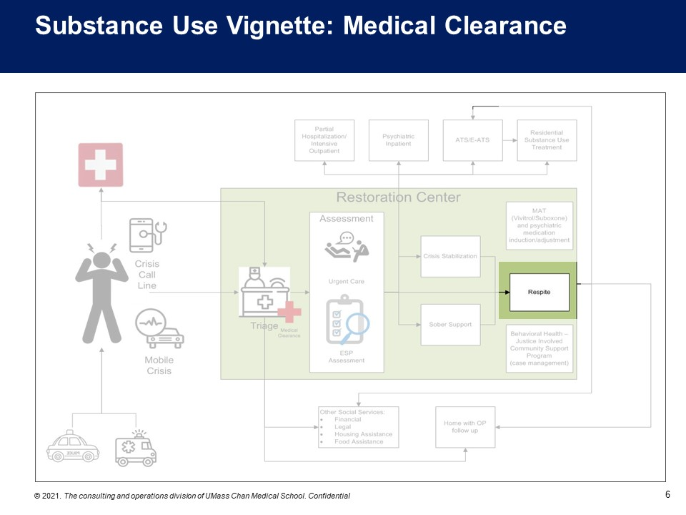

Respite care supports individuals that need some level of crisis behavioral health care and have housing needs or residential placement needs. The Commission found that respite care can provide flexible support allowing the Restoration Center pilot program to continue to treat individuals waiting for placement.

The DMH funds respite care programs across Massachusetts and seeks to fund respite care at the Restoration Center pilot program pending a response by the Restoration Center pilot program provider to the DMH respite procurement.

## Staffing

The Procurement Subcommittee updated the staffing plan and budget for the Restoration Center using licensure and revenue considerations.

The Commission raised the problem of workforce shortages in the behavioral health field, exacerbated by the COVID-19 pandemic. Commission members asked CWM to update assumed staffing costs in the Restoration Center pilot program model budget that account for the added difficulty of staffing such a program under the current workforce conditions. These assumptions include the following:

* Assume higher rates of pay across many roles
* Allow for as much flexibility in the use of certain clinical staff as possible within the parameters of licensure requirements and safety

CWM estimated that workforce shortage adjustments increased the total cost of the Restoration Center pilot program by 12 to 21 percent.

Minimum staffing requirements include:

* Program director
* Certified Peer Specialists (all shifts)
* Certified Addiction Recovery Coaches (all shifts)
* At least one staff person trained in cardiopulmonary resuscitation during all shifts
* 24/7 availability of a psychiatric clinician to prescribe MAT/MOUD
* Nurse manager
* Licensed Practical Nurse and RN staff
* Master’s level clinicians
* Milieu staff during all shifts
* Case manager or navigator
* Administrative support
* Security staff or contract

CWM expects to monitor the Restoration Center pilot program contractor’s hiring capacity and ability to retain talent through the process for innovation and continuous quality improvement.

## Facility

The Procurement Subcommittee and CWM documented the Restoration Center pilot program facility requirements, including:

* A comfortable lobby or waiting area for individuals
* A welcoming, trauma-informed, and therapeutic environment which encourages de-escalation
* A separate and secure entrance for drop-off by first responders
* Sufficient space to accommodate the components of the service model

# Findings and Recommendations

CWM and the Commission sought a vendor to implement the Restoration Center pilot program by the end of SFY 2022, completing the contemplated work of the Commission as described in its enabling legislation below:

*“The commission shall develop and implement a 3-year plan to build a restoration center in the former county of Middlesex. In the first year, the commission shall: (i) perform an examination of state and national best practices…and (ii) review the current capacity of mental health providers within the former county of Middlesex to provide behavioral health services to individuals suffering from mental illness or substance use disorders who interact with law enforcement or the court system and the barriers they face to accessing treatment. In the second year, the commission shall develop a jail diversion program and an initial pilot focused on providing integrated community-based services from a centralized location and perform an analysis of potential costs and cost savings. In the third year, the commission shall develop a restoration center and secure funding for a subsequent 2-year period.”[3]*

## Implementation Plan and Timeline

CWM drafted an RFP with input and policy guidance of the Procurement Subcommittee. CWM expects to implement the Restoration Center pilot program on the following schedule:

**April 2022:** RFP posted to CWM procurement portal BuyWays

**May 2022:** Deadline for proposal submission in response to RFP

**June 2022:** Contract awarded for Restoration Center pilot program

**July-December 2022:** Contractor readiness activities including finding a location for a Restoration Center pilot program in Middlesex County, renovating the physical space in accordance with facility requirements, hiring and training staff, etc.

**January 2023:** Estimated launch date of some or all Restoration Center pilot program services

**February 2023-June 2026:** Ongoing innovation and continuous quality improvement to measure outcomes, success in achieving specified goals, and improvement of the service model in collaboration between the contractor, CWM, and the Commission

**June 2026:** Recommendations to be made regarding the continuation of the Restoration Center pilot program

## Legislation

As described in the enabling legislation, the Commission must include proposed legislation necessary to carry out its recommendations.

In Year Four, the Commission discussed its role in the oversight of the Restoration Center pilot program, how its role might improve, and the roles the Commission can take in the future. The Commission continues to review the scope of activities that will facilitate the Commission’s objectives in the long-term beyond the initially envisioned four-year pilot and expects to make recommendations to the legislature.

The Commission also supports legislation already proposed to require commercial insurance coverage of crisis behavioral health services. Commercial insurers are not required to cover behavioral health diversionary levels of crisis care. This lack of coverage presents a barrier to care for the many individuals whose insurance plan does not pay for these services or does not contract with specific local providers of these services. The Restoration Center pilot program’s primary purpose is to increase access to such services for all individuals regardless of insurance status, in a way that specifically streamlines first responders’ resolution of emergency situations. The Restoration Center pilot program can effectively achieve this result using its braided funding mechanisms, coupled with a requirement for commercial insurers to cover behavioral health crisis services as proposed in H. 1040/S. 672 *An Act to require health care coverage for emergency psychiatric services*.

# APPENDIX: Potential Restoration Center Licensing and Billing Options

| Restoration Center Model Component | Specific  Service | License/ Provider Type Options | Required to  Provide | Required for MassHealth Coverage |
| --- | --- | --- | --- | --- |
| **Triage and Assessment** | Medical Evaluation | Program license from DPH for ATS or CSS allows for medical evaluation as an element of SUD treatment. |  |  |
| Limited Services Clinic license from DPH allows for billing for medical evaluation. |  | **✓** |
| Nursing staff |  | **✓** |
| Laboratory Testing | Contract with Clinical Laboratory or hold a Clinical Laboratory license from DPH to perform point-of-care (POC) testing | **✓** |  |
| Hold Clinical Laboratory Improvement Amendment (CLIA) waiver allowing non-lab staff to conduct certain approved testing | **✓** |  |
| BH Assessment | Selected as a CBHC by MBHP |  | **✓** |
| **Peer Support/ Recovery Coaching** | Peer Support | Certified Peer Specialist(s) (CPS) on staff |  | **✓** |
| Recovery Coaching | Certified Addiction Recovery Coach(es) (CARC) on staff |  | **✓** |
| **Behavioral Health Urgent Care** | Behavioral Health Urgent Care | Selected as a CBHC by MBHP through procurement |  | **✓** |
| Certified BHUCC through the MassHealth attestation process |  | **✓** |
| MD psychiatrists and other billable providers on staff |  | **✓** |
| Outpatient Mental Health Services | Clinic license from DPH with a Mental Health designation |  | **✓** |
| Outpatient Substance Use Treatment | Substance Abuse Treatment Program license from DPH with an Outpatient Services designation |  | **✓** |
| **Pharmacy** | Prescribing | Have a psychiatric prescriber on staff |  | **✓** |
| Storing and Administering Medications | Clinic license from DPH with a Clinic Pharmacy designation | **✓** |  |
| Register on the MA Controlled Substances Registration (MCSR) and register as a Narcotics Treatment Provider with the Drug Enforcement Agency | **✓** |  |
| Contracts with OTP/OBOT providers to do guest dosing for induction and maintenance of MAT/MOUD | **✓** |  |
| **Mental  Health Crisis Stabilization** | Community Crisis Stabilization | Designated as a CBHC by MBHP |  | **✓** |
| **SUD Support** | Acute Treatment Services (ASAM 3.7) | Substance Abuse Treatment Program licensed by DPH with an Inpatient Detoxification Services designation | **✓** | **✓** |
| Crisis Stabilization and Supports (ASAM 3.5) | Substance Abuse Treatment Program licensed by DPH with an Inpatient Detoxification Services designation | **✓** | **✓** |
| Harm Reduction Model | No requirements |  |  |
| **Respite** | DMH Respite | DMH funding |  | **✓** |
| **Triage and Assessment** | Medical Evaluation | Program license from DPH for ATS or CSS allows for medical evaluation as an element of SUD treatment. |  |  |
| Limited Services Clinic license from DPH allows for billing for medical evaluation. |  | **✓** |

1. Chapter 69 of the Acts of 2018.
2. Middlesex County Restoration Center Commission Year One Findings and Recommendations.
3. Chapter 69 of the Acts of 2018.