**Middlesex County Restoration Center Commission**

**Year One Findings and**

**Recommendations**



**Narrative Volume June 2019**

**TABLE OF CONTENTS**

# Narrative Volume

1. Executive Summary 2
2. Introduction 6
   1. Legislative mandate
   2. Contributors
3. Framework for Commission Work 10
4. Completed Work – Year One 12
   1. Definitions
   2. Summary of meetings and materials
   3. Summary of data collection and investigation
   4. Summary of Abt Associates consulting engagement
   5. Identifying Promising Models and Recommendations
5. Summary of Findings from Year One 48
   1. Problem Statement
   2. Target Population
   3. Goals
   4. Service Model
   5. Ownership and Contracting Structure
6. Plans for Year 2 Activities 57
   1. Legislative Mandate
   2. Plan
7. Conclusion 59

# Appendices Volume

Appendices 60

Appendix A: Restoration Center Commission Meetings and Documents Appendix B: Notes from Merrifield Center Site Visit

Appendix C: Lowell, Somerville/Medford, and MetroWest Sequential Intercept Model Maps Appendix D: Abt Consulting Engagement Report

Appendix E: Draft Budget Legislation

**SECTION 1: EXECUTIVE SUMMARY**

Individuals with mental illness and/or substance use disorders (collectively referred to as behavioral health conditions) interact with law enforcement at high rates. This has resulted in a **disproportionate share of inmates and detainees in county jails and Houses of Corrections who have behavioral health conditions**. Approximately 45% of inmates and detainees in the Middlesex County Jail & House of Correction have a mental illness and 80% have a substance use condition. National studies show that as many as 68% of inmates and detainees with co- occurring mental health and substance use conditions recidivate within three years. The human dimension of this crisis is one of tragic proportions, costly to individuals, families, communities, and the Commonwealth. The risk of incarceration to these individuals’ clinical stability, reputation, family integrity, future housing, employment prospects, safety, and hope is substantial. Police departments across Massachusetts, including in Middlesex County, have increasingly sought to implement diversion programs that can connect these individuals with the care they need to prevent law enforcement interaction in the first place, instead of arresting them for crimes that are often related to the person’s behavioral health. However, the **easiest and safest place to divert these individuals is often the hospital emergency department, which often cannot provide the appropriate level of care for the individual, and can fail to adequately triage the individual to an appropriate lower level of care**.

Jurisdictions around the country have been experimenting with **restoration centers, which are behavioral healthcare facilities that can provide urgent psychiatric care and/or crisis stabilization services and other related social and health services in less restrictive settings than hospitals or jails**. The Middlesex County Sheriff’s Office, in conjunction with the Massachusetts state legislature and several public health and behavioral health stakeholders, has been exploring the question of whether a restoration center could help intervene to reduce arrest and emergency department utilization among individuals with behavioral health conditions. The Middlesex County Restoration Center Commission was created by the Massachusetts Legislature to study this issue, and has been co-chaired for the past year by Sheriff Peter J. Koutoujian and Dr. Danna Mauch of the Massachusetts Association for Mental Health. The Commission’s legislative sponsor is Senator Cindy Friedman. Appointed members include leaders from the judicial, legislative, and executive branches of state, county, and local government; peer, family, and policy organizations; and hospital and community behavioral health provider organizations. This report presents the Commission’s findings and recommendations after its first year of operation.

Despite difficulty obtaining robust county-level data to answer many questions it sought to answer, the Commission found both **qualitative and quantitative evidence of gaps in the availability, accessibility, affordability, accommodation, acceptability, and experience of services along the jail diversion and behavioral health continuums in Middlesex County**:

* While most police departments are implementing at least one diversion program, such programs are not consistently available and are not well coordinated with each other or with the behavioral health system. Investments in diversion programs, made by local

police departments, county justice, Department of Mental Health, and foundation grants are important but modest given the extensive need. Co-responder resources particularly valued to facilitate diversion, are in short supply.

* Similarly, despite finding evidence of availability of a wide range of behavioral healthcare services, the Commission found the following barriers to and gaps in behavioral health services:
  + Gaps in the availability of urgent psychiatric care;
  + Bifurcation of mental health and substance use services despite evidence of high rates of co-occurring disorders;
  + Evidence of inadequate geographical dispersion of some levels of behavioral healthcare;
  + The perception among stakeholders of a gap in acute inpatient psychiatric levels of care;
  + Long wait times and difficulty accessing outpatient levels of care due to poor reimbursement rates and high complexity of administrative requirements of insurance payers;
  + Lack of parity between behavioral and physical health, especially among commercial insurers;
  + Information shortages and barriers to communication among those actors who are at the front lines in terms of decision making for diversion (police and first responders);
  + Gaps in availability of medical clearance earlier in the process;
  + Gaps in continuity of care/aftercare planning; and
  + Limited behavioral health programming specifically addressing criminogenic risk and needs.

## The Commission found that a restoration center in Middlesex County, in combination with improvements to the behavioral healthcare system, could help to address many of these gaps, thereby reducing arrest and emergency department utilization and generating cost savings to the state government on net.

These savings are not only for unnecessary emergency room and inpatient care but also for police, courts, jails, and social welfare services. The Commission recommends addressing barriers and gaps it identified by developing a restoration center pilot in Middlesex County. The restoration center would:

* Use an integrated care model for delivery of mental health and substance use service. Key aspects of this model would incorporate:
  + A training component for first responders and law enforcement to improve utilization of the center, in coordination with the Community Policing and Behavioral Health Advisory Council;
  + An ability to accept both police drop-offs and walk-in clients with the goal of preventing law enforcement involvement in the first place, as well as attempt to divert individuals from civil commitment to voluntary behavioral health treatment;
  + A clinically competent alternative to overburdened emergency departments and a viable alternative to district courts presented with behavioral health commitment petitions;
  + Increased utilization of community-based behavioral healthcare services while reducing utilization of hospitalization and jail/prison;
  + A wide array of services available to all clients, *regardless of insurance type or status*, including:
    - Assessment of behavioral health needs and triage to appropriate levels of care,
    - Medical clearance,
    - Crisis stabilization services,
    - Behavioral health urgent care,
    - Respite services,
    - Mobile crisis teams,
    - Case management,
    - A sober support unit, and
    - Psychopharmacology;
  + Integration through partnerships with existing services provided by the Department of Public Health, the Department of Mental Health, MassHealth, and the relevant community partners;
  + Be in a high-need, high-population-density, service-poor community; and
  + Be designed with additional stakeholder and consumer input.
* Targeted improvements to existing services to improve access and the continuity of care, including:
  + *Requiring commercial insurers to cover behavioral healthcare services in parity with physical healthcare services*, including mandated coverage of crisis stabilization services; and
  + Encouraging the Executive Office for Health and Human Services undertake their “Creating a Behavioral Health Ambulatory Treatment System” listening sessions taking into account recommendations in this report to improve the Emergency Service Provider program and improve continuity of care by focusing on aftercare at the point of discharge from emergency departments and inpatient hospitalization.
* Improved data sharing and coordination between law enforcement and behavioral health system actors, including by leveraging the Data Driven Justice Initiative at the Middlesex Sheriff’s Office.

Based on these findings and recommendations, the Commission’s plan for its second year includes:

* Collect additional data to specify the size and dimensions of the target population, including:
  + Data from specific police departments and emergency departments (or from payers) in target jurisdictions to clarify the specific target population for the restoration center, and the dispositions of their current law enforcement and hospital interactions,
  + Offenses committed by detainees and inmates in the Middlesex Jail & House of Corrections to hone in on those offenses that law enforcement officers are likely to be able to divert, and connect records to MassHealth records to obtain community-based service utilization patterns for that group,
  + Waitlist information for services along the behavioral healthcare continuum, and
  + Data on Section 12 evaluations, which is currently unavailable;
* Conduct further analyses of need and opportunity to solve challenges for individuals, families, police, courts, crisis clinicians, emergency departments, and community behavioral health providers;
* Further define the core program elements of and ancillary services required for an effective community restoration center with a focus on closing gaps to reduce arrest and emergency department utilization;
* Develop an implementation plan for the initial restoration center pilot, to be implemented in years 3 and 4, that contains the core program elements necessary in the first phase of a restoration center;
* Identify any barriers to implementing the pilot center and propose solutions to those barriers;
* Work with the Executive Office for Health and Human Services to develop specific recommendations for improvements to existing programs and services through their “Creating a Behavioral Health Ambulatory Treatment System” listening sessions; and
* Establish metrics to measure success at diversion and improvements to access to appropriate and quality treatment for a restoration center and related diversion program.

Research shows that *individuals with serious mental illness (SMI), opioid use condition, and other substance use conditions are disproportionately represented in the criminal justice system*,1 which is not an appropriate care setting for treatment. There can be a high level of administrative complexity in the behavioral healthcare system and individuals often face long delays in accessing outpatient treatment. Historically, behavioral health has lacked “parity” with physical health in insurance coverage. Researchers estimate that, on average, *people with mental illnesses wait five years before receiving appropriate treatment*.2 In the meantime, their condition may deteriorate, and they may ultimately enter a behavioral health crisis and/or interact with law enforcement. Treatment for mental health and substance use conditions is often separate, and it can be hard to find treatment specifically addressing co-occurring substance use and mental illness.

**SECTION 2: INTRODUCTION**

Increasingly, *these individuals are also disproportionately represented in emergency departments* (EDs) seeking entry to the behavioral healthcare system. Some individuals presenting in EDs have behavioral healthcare needs that are non-acute (not requiring hospitalization). As evidenced by their voluntary or involuntary attempt to acquire urgent behavioral healthcare at the ED, these individuals do require some level of care, but many are released from the ED without any treatment. Others who do require acute inpatient psychiatric treatment spend days or weeks in the ED awaiting a hospital bed, receiving little urgent psychiatric treatment in the meantime. “ED boarding,” as this long wait period for the appropriate next treatment level is referred to, is increasingly problematic in Massachusetts hospitals, and the *proportion of ED boarding attributable to patients presenting with a primary behavioral health condition is growing* rapidly.3 The increase in individuals seeking behavioral health treatment in EDs may in part be driven by efforts to divert these same individuals from arrest when police are dispatched. The emergency response system, including 911 dispatch, plays a significant role in ED utilization for behavioral health conditions.

Communities across the country and in Massachusetts are working to develop programs to divert these individuals from arrest, and to find appropriate alternatives to expensive and often unnecessary ED utilization and placement in police lock-up. One such model is a *restoration center, which provides a physical location with crisis stabilization and related services to triage individuals with behavioral health conditions to appropriate levels of care, and help access and navigate complex systems of care on-demand*. Restoration centers can provide a place for police to drop individuals off instead of arrest or transport to the ED during a 911 emergency situation

1 Steadman HJ, Osher FC, Robbins PC, et al. Prevalence of serious mental illness among jail inmates. Psychiatry Serv. 2009;60(6);731-5.

2 Crane and Mauch. Model Jail Diversion and Reentry Services Programs: Updated Literature and Resource Review. Office of the *Trueblood* Court Monitor, February 2018.

3 Health Policy Commission. Behavioral Health-Related Emergency Department Boarding in Massachusetts. November 2017. Accessed at [https://www.mass.gov/files/documents/2017/12/13/20171113-hpc-ed-boarding-](https://www.mass.gov/files/documents/2017/12/13/20171113-hpc-ed-boarding-chart-pack.pdf) [chart-pack.pdf](https://www.mass.gov/files/documents/2017/12/13/20171113-hpc-ed-boarding-chart-pack.pdf)

or other law enforcement interaction, and can also be an on-demand resource for individuals and their loved ones, potentially preventing a law enforcement interaction in the first place.

Led by Sheriff Peter J. Koutoujian, Senator Cindy Friedman, and Dr. Danna Mauch, stakeholders across Middlesex County have expressed an interest in establishing a restoration center to serve a subset of individuals whose needs are not being met and are instead interacting regularly with the criminal justice system. Section 225 of Chapter 69 of the Acts of 2018, “An Act Relative to Criminal Justice Reform,” established a Middlesex County Restoration Center Commission (hereinafter, the “Commission”) to examine this proposal. The Commission was tasked with examining the mental health and addiction treatment system in Middlesex County, investigating existing restoration centers in operation across the country, and making recommendations to the state legislature on ways to move forward with the implementation of a center in Massachusetts.

This report will review diversion programs in Middlesex County and nationally; review the behavioral health continuum of care in Massachusetts and the gaps in that continuum; and summarize findings and recommendations for improvements to the Massachusetts diversion and behavioral health continuum of care as well as for the creation of a restoration center in Middlesex County that would help to address gaps in this landscape.

# Legislative Mandate

Section 225 of Chapter 69 of the Acts of 2018, “An Act Relative to Criminal Justice Reform,” establishes a Middlesex County Restoration Center

*“to plan and implement a county restoration center and program to divert persons suffering from mental illness or substance use disorder who interact with law enforcement or the court system during a pre-arrest investigation or the pre-adjudication process from lock-up facilities and hospital emergency departments to appropriate treatment.*

*In the first year, the commission shall:*

1. *perform an examination of state and national best practices…; and*
2. *review the current capacity of mental health providers within the former county of Middlesex to provide behavioral health services to individuals suffering from mental illness or substance use disorders who interact with law enforcement or the court system and the barriers they face to accessing treatment.*

*Within 1 year after the effective date of this act, the commission shall submit its findings and recommendations for a restoration center, together with drafts of legislation necessary to carry out those recommendations, including a report on the current capacity to provide behavioral health services to individuals suffering from mental illness or substance use disorder, which shall include, but not be limited to, the type of services pre-arrest, pre-release, and post-release, location of services, types of patients served and barriers to diverting individuals … into treatment.”*

# Contributors

Current Commission members include:

* Co-chair Sheriff Peter J. Koutoujian, Middlesex Sheriff’s Office
* Co-chair Danna Mauch, PhD, President and CEO, Massachusetts Association for Mental Health (MAMH)
* Senator Cindy Friedman, 4th Middlesex District
* Representative Kenneth Gordon, Middlesex 21st District
* Honorable Paula M. Carey, Chief Justice of the Trial Court
* Honorable Rosemary Minehan, Justice (ret.), Assistant for Special Projects, Trial Court
* Chief Robert Bongiorno, Bedford Police Department
* Vicker V. DiGravio III, President/CEO, Association for Behavioral Healthcare (ABH)
* Scott Taberner, Chief of Behavioral Health and Supportive Care, MassHealth
* Nancy Connolly, Assistant Commissioner of Forensic Services, Department of Mental Health (DMH)
* Jennifer Barrelle, Chief of Staff, Department of Public Health (DPH)
* Eliza Williamson, Director of Community Education and Training, National Alliance on Mental Illness (NAMI) of Massachusetts
* Steven Mastandrea, Chief Probation Officer, Lowell District Court

The following individuals served as Commission members or represented Commission members at meetings or site visits:

* Chief Frederick Ryan (ret.), Arlington Police Department
* Rebecca Tsopelas, former Jail Diversion Clinician, Arlington Police Department
* June Binney, former Director of Criminal Justice Diversion, NAMI Massachusetts
* Kati Mapa, former Director of Policy and Planning, NAMI Massachusetts
* Amanda Gilman, Senior Director of Policy and Research, ABH
* Marisa Hebble, Manager of the Massachusetts Community Justice Project, Trial Court
* Courtney DeWolfe, Director of Behavioral Health Policy and Finance, MassHealth
* Rachel Bishop, Senior Manager of Behavioral Health Policy, MassHealth The Commission also thanks the input and assistance of the following individuals:

Catia Sharp

Commission staff

Middlesex Sheriff’s Office:

Kathleen Skarin Chief of Staff

David Ryan Policy Director

Sonya Khan

DDJ Project Manager

Shawn Jenkins

Special Sheriff

Dawn Reeby Former DDJ Data

Integration Specialist

Laura Dempsey Director of Mental Health

David Swanson Chief of Staff MA Senate

Cody Case

Legislative Aide MA House of Representatives

Department of Public Health:

Jim Cremer

Deputy Director, BSAS

Sarah Ruiz

Director Planning and Development

Department of Mental Health:

Brooke Doyle

Deputy Commissioner

Beth Lucas Assistant Commissioner

Matthew Broderick Manager Forensic Operations & Policy

Karin Orr

Area Forensic Director

Lester Blumberg General Counsel

Emilia Dunham

Manager, Special Projects MassHealth

Robert Ciccia

Assistant General Counsel EOHHS

Abt Associates: Dana Hunt, PhD

Principal Associate

Meg Chapman Senior Associate

Kimberly Burnett Senior Associate/ Scientist

Alicia Sparks, PhD Associate

Jenna Sirkin, PhD Associate

Sue Pfefferle, PhD Associate

Anna Robinson Research Assistant

Caroline Bays Constituent

Mass. Health & Hospital Association:

Leigh Simons Youmans Senior Manager

Janice Peters Manager Healthcare Policy

Sarah Abbott, PhD Program Director, Jail Diversion

Advocates

Chief Craig Davis (ret.) Ashland Police Department

Danielle Smith Crime Analyst Arlington Police Department

Bedford Police Department Scott Jones

Detective Lieutenant

Lieutenant James F. Graham

Nicole Gagne President and CEO Community Healthlink

Behavioral Health Network:

Steven Winn, PhD Chief Operating Officer

Justin Mehl

BH Program Manager

Dr. Debra Pinals

Forensic Medical Director State of Michigan

Dan Holloway

Jail Diversion Coordinator Oakland Community Health Network

Common Ground:

Heather Rae President and CEO

Vickie Krigner

VP Business Operations

Rosa Thomas

VP Programs and Services

Jeffrey Kapuscinski Dir. Business Development

Kyle Glasgow Dir. Impact/Data Analysis

Brian Nicholson Program Director

Malcolm Hohmann Court Liaison

Lieutenant Christine Miller Southfield MI Police Dept.

Center for Health Care Services:

David Pan

Community Initiatives

Marisol Lucio External Relations

Cynthia Dandridge Counselor

San Antonio Police Department:

Ernest Stevens Officer, Mental Health

Joe Smarro

Officer, Mental Health

Art Vela

Director of Life Safety Haven for Hope

In its first year, the Commission set out to answer several key questions about the need for a restoration center in Middlesex County:

1. 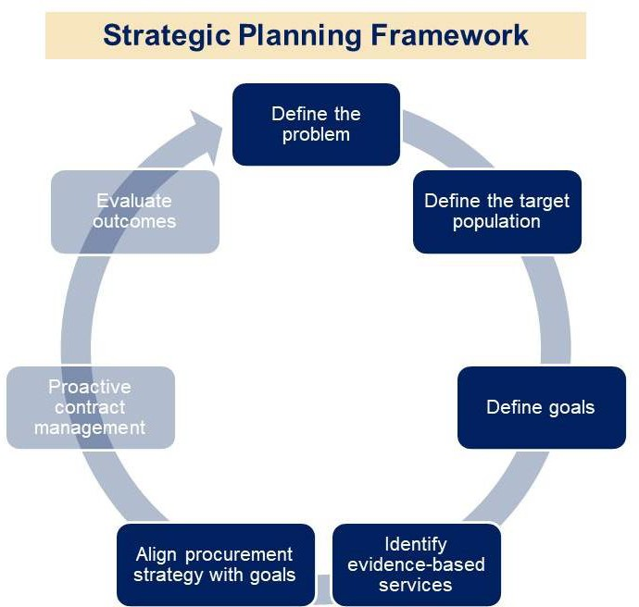The guiding **problem statement** was identified in the enabling legislation: *Individuals living with mental illness and/or substance use disorder too often interact with law enforcement and the court system, or are incarcerated or hospitalized.*

More data were needed to better understand this universe of individuals. For example, how often do these individuals interact with law enforcement and the court system? How frequently are they incarcerated or hospitalized? The Commission sought the data presented in this report to answ

*Source: Catia Sharp for Middlesex County Restoration Center Commission.*

er these questions.

**SECTION 3: FRAMEWORK FOR COMMISSION WORK**

1. The Commission then addressed the questions “for whom is this a problem?” and **“**for whom is this Commission solving this problem?” Commission member proposals for **target populations** include individuals suffering from mental illness and/or substance use disorder who are:
   1. *Already involved with the criminal justice system through, at a minimum, interaction with law enforcement or the court system; OR*
   2. *At high risk of becoming involved with the criminal justice system due to their behavioral health status, and who could benefit from urgent access to behavioral healthcare that could prevent initial law enforcement contact.*

The Commission then sought to collect additional data to determine the approximate number of individuals in these groups, and to inform decisions about the need for a restoration center in Middlesex County, which would indicate who ought to be served as part of the target population. How successful might services under consideration be in diverting each group from criminal justice involvement?

1. The Commission raised the question of “what specific diversion goals do we have for our target population?” **Goals** might include:
   1. *Reduce arrest* by providing a safe treatment alternative;
   2. *Reduce arraignment* by providing a safe treatment alternative to police lock-up;
   3. *Reduce reconviction* by providing improved community-based treatment options to those reentering community from incarceration;
   4. *Improve health outcomes and community tenure* by more effectively triaging individuals with behavioral healthcare needs;
   5. *Reduce days spent incarcerated* by improving health outcomes;
   6. *Reduce emergency department visits* by providing urgent behavioral healthcare for individuals who can be served in this less-restrictive setting;
   7. *Reduce emergency department boarding* by reducing emergency department utilization and improving health outcomes;
   8. *Increase use of community-based behavioral health care* by more effectively triaging individuals to less-restrictive, community-based care settings; and
   9. *Increase use of services* by supporting social determinants of health by more effectively linking individuals to other human services.

The Commission collected information to inform outcome targets, including baseline data from the current system to use in comparison, as well as information about outcomes that are tracked at other restoration centers around the country.

1. The primary task of the Commission was **identifying the services needed** in Middlesex County to address the problem statement. The Commission reviewed such services as:
   1. *Crisis stabilization*
   2. *Respite*
   3. *Mobile crisis teams*
   4. *Case management and navigation services*
   5. *Transportation services*
   6. *Outpatient treatment*
   7. *Urgent psychiatric treatment*
   8. *Psychopharmacology, including medication-assisted treatment*

The Commission also worked to understand the full continuum of behavioral health and criminal justice diversion services in Middlesex County, asking questions like:

* What are other jurisdictions’ approaches?
* What services already exist in Middlesex County?
* What initiatives are state and local agencies already undertaking in Middlesex County that could address the problem described above?
* What are the costs and benefits of services in relation to outcomes of interest?

Additionally, the Commission sought information that could inform the specific location or region where a restoration center might be best suited.

1. How will the state purchase these services? What **ownership/contracting structures**

would best support a restoration center?

**SECTION 4:**

**COMPLETED WORK – YEAR ONE**

# Definitions

Before diving into the data, we make some important definitional distinctions.

**Behavioral health crisis** refers to symptoms or behaviors related to a mental health condition or addiction that are severe enough to pose a *serious threat of harm to themselves or others* and/or which require immediate intervention.4

**Behavioral health emergency** refers to a *dangerous or life-threatening situation* in which an individual needs *immediate attention* for risk of harm to self, risk of harm to others, or acute changes in behavior or thinking.5

**Behavioral health urgent care** refers to *same-day* behavioral health interventions, including 24/7 crisis services.6

**Crisis stabilization service** refers to services intended to *de-escalate the risk* an individual in crisis poses to themselves or others. Crisis stabilization must be available as an urgent care service, in that it must be available on-demand to meet the needs of those in crisis.

A **restoration center** refers to services intended to divert individuals from arrest and emergency department (ED) utilization. This may include behavioral health urgent care and crisis stabilization services, as well as additional services that address continuity of care, social determinants of health, and other issues that might prevent adequate diversion.

# Summary of Meetings and Materials

The Commission held 10 meetings, received 15 presentations, went on four site visits to restoration and/or crisis stabilization centers, held 3 subcommittee meetings and convened the county’s Jail Diversion Clinicians in its first year. Agendas, minutes, presentations, and other materials from meetings and site visits are attached as Appendix A.

4 EOHHS. Creating a Behavioral Health Ambulatory Treatment System. May 2019. Power point presentation, accessed at <https://www.mass.gov/files/documents/2019/05/28/bh-presentation_0.pdf>.

5 Adapted from the American Academy of Child and Adolescent Psychiatry. 2018. Facts for Families: What is a Psychiatric Emergency? Accessed at [https://www.aacap.org/AACAP/Families_and_youth/facts_for_families/FFF-](https://www.aacap.org/AACAP/Families_and_youth/facts_for_families/FFF-Guide/What_is_a_Psychiatric_Emergency_126.aspx)

[Guide/What_is_a_Psychiatric_Emergency_126.aspx](https://www.aacap.org/AACAP/Families_and_youth/facts_for_families/FFF-Guide/What_is_a_Psychiatric_Emergency_126.aspx) .

6 EOHHS. Creating a Behavioral Health Ambulatory Treatment System. May 2019. Power point presentation, accessed at <https://www.mass.gov/files/documents/2019/05/28/bh-presentation_0.pdf>.

Presentations

* *Middlesex County Restoration Center Commission Launch Meeting, Sheriff Koutoujian* – Sheriff Koutoujian presented the background and reason for the Commission’s work, including statistics from the Middlesex Sheriff’s Office (MSO), which has witnessed a reduction in the overall population, but the number of people awaiting trial is outpacing the number of sentenced individuals. In addition, the MSO has seen an increase in the rates of reported mental illness. The number of individuals self-reporting mental illness at intake has surpassed the number reporting substance use disorder (SUD).

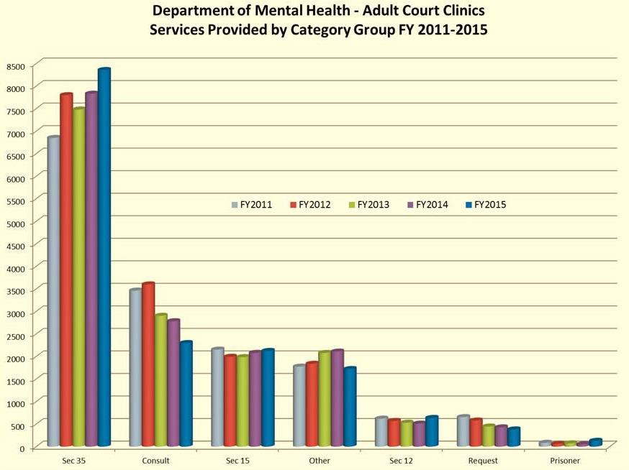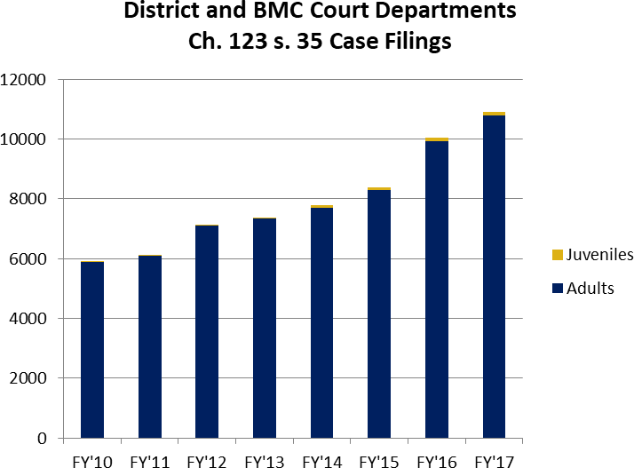

* *G.L. c. 123, § 35 (Involuntary Treatment), Honorable Rosemary Minehan* – Judge Minehan presented the process and treatment options for involuntary treatment under Section 35 for SUD and Section 12 for mental illness (MI), including the number of Section 35 petitions and Section 12 evaluations included here.

*Source: G.L. c. 123, § 35, Rosemary Minehan.*

*Source: G.L. c. 123, § 35, Rosemary Minehan.*

* *MSO Behavioral Health Services Overview, Kathleen Shultz and Laura Dempsey, MSO* – The Directors of Health Services and Mental Health Services, respectively, discussed behavioral health conditions at the Middlesex Jail & House of Corrections (HOC):
  + Population: The MSO is the largest mental health facility in Middlesex County; 42% of the population is on psychiatric medication and 51% have “open mental health cases.” The most common psychiatric disorders in the facility include Major Depressive Disorder, Bipolar Disorder, trauma related disorders, and Post- Traumatic Stress Disorder. 40% of new intakes report some history of head trauma. The typical new admission has discontinued prescribed psychiatric medication and is actively using substances.
  + Treatment: All intakes receive a medical assessment and mental health evaluation. They may be referred to a psychiatrist for medications, and are routinely met with by a licensed mental health staff member. They may be placed into the inpatient mental health unit within the facility for evaluation and stabilization, or referred to Department of Mental Health (DMH) facilities for more acute care.
* *The Co-Responder Jail Diversion Program, Chief Craig Davis, Ashland Police Department, and Dr. Sarah Abbott, Jail Diversion Program Director* – Chief Davis and Dr. Abbott presented the Advocates co-responder model, which partners with Ashland and neighboring police departments. They reviewed outcomes of arrest diversions and associated cost savings, as well as police culture outcomes like compassion, kindness, and tolerance measured on a scale of 0-5 (shown here).

|  |  |
| --- | --- |
| **Outcome** | **%**  **change** |
| Compassion | +15% |
| Kindness | +9% |
| Perceived Dangerousness | -8% |
| Community Inclusion | +1% |
| Tolerance | +11% |

* *Massachusetts Community Justice Project: Sequential Intercept Mapping, Marisa Hebble, MA Trial Court* – Ms. Hebble presented the Sequential Intercept Model (SIM), created by the Substance Abuse and Mental Health Services Administration (SAMHSA) Gather, Assess, Integrate, Network, and Stimulate (GAINS) Center7 to identify behavioral health diversion programs at each step in the criminal justice system, as well as the MA Trial Court’s efforts to help communities across the Commonwealth map their services (SIM mappings in three parts of Middlesex County are discussed in this report).

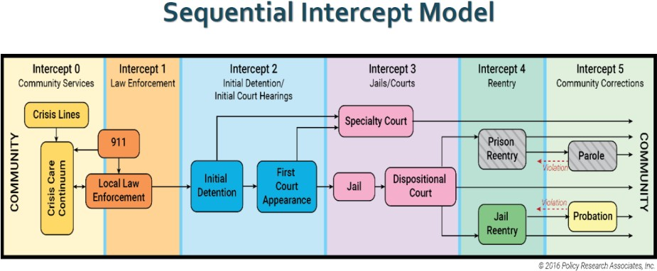

*Source: SAMHSA GAINS Center.*

7 SAMHSA GAINS Center. Sequential Intercepts for Developing CJ-BH Partnerships. Accessed at <https://www.prainc.com/wp-content/uploads/2015/10/SIMBrochure.pdf>.

* *Model Jail Diversion and Reentry Services Programs Updated Literature and Resource Review, Kathleen Crane and Danna Mauch* – This white paper reviews evidence bases for diversion programs at each intercept of the SIM. Crane and Mauch find:
  + Intercept 0: Researchers estimate that, on average, people with mental illnesses wait five years before receiving appropriate treatment. Prevention/early intervention services are essential to jail diversion, like **First Episode Psychosis (FEP) Care**, a multidisciplinary team approach that may improve life outcomes.
  + Intercept 1: Evidence-based programs include **Crisis Intervention Teams (CIT)**, which reduce officer injuries, subsequent justice system involvement, and justice costs; improve access to crisis and other supportive services, and increase treatment costs. Promising interventions (those with less rigorous or more mixed evidence bases) include *Law-Enforcement Assisted Diversion (LEAD)*, which may increase housing, employment, and legitimate income (all of which are associated with recidivism reductions); and *Mobile Crisis Teams*, which may reduce psychiatric hospitalizations, arrests, and costs per case; and increase police and consumer satisfaction and referrals to community care, in combination with *Crisis Centers with 24/7 drop-off capability,* which may reduce jail costs of public intoxication and mental health and reduce ED costs.
  + Intercept 2: The justice system should use specific, **evidence-based screening, risk assessments, and behavioral health assessments** to identify individuals with behavioral health conditions entering the justice system and provide appropriate treatment. Promising interventions include *Mental Health Courts* used for pre-trial diversion, which may increase use of mental health services and quality of life; and reduce contact with crisis services and contact with police.
  + Intercept 3: Evidence suggests that Mental Health Courts can lead to small reductions in recidivism, but points to small or no changes in symptoms.
  + Intercept 4: Evidence-based programs include **Critical Time Intervention**, which shows high rates of success at reducing homelessness among behavioral health/justice involved individuals. Promising programs include *Transitional Care Management*, which may reduce arrest rates; *SSI/SSDI Outreach, Access, and Recovery (SOAR)*, which may reduce recidivism; and *Peer Support Specialists*, which may reduce hospitalization rates.
  + Intercept 5: Evidence-based programs include **Individual Placement and Support (IPS) Supported Employment** model; and **Behavioral Health Evidence-Based Practices** like **Motivational Interviewing, Moral Reconation Therapy, Dialectical Behavioral Therapy (DBT), Cognitive Behavioral Therapies (CBT), Integrated Dual Disorder Treatment, and Medication Assisted Treatment (MAT)**. Promising programs include *Specialty Probation Caseloads*, which may reduce re-arrest; *Forensic Assertive Community Treatment (FACT)*; *Community-Based Competency Restoration programs*, which may reduce the cost of treatment and improve rates and speed of competency restoration; *Supported Housing*, which may decrease criminal convictions and days incarcerated, improve housing stability, and save money; and *Wellness Plans*, which may reduce symptom severity and improve hopefulness and quality of life.
* *Summary of Site Visit to Merrifield Center, Shawn Jenkins* – Special Sheriff Jenkins presented findings from a peer exchange visit to the Merrifield Crisis Response Center in Fairfax County, Virginia. The peer exchange was funded by the U.S. National Institute of Corrections (NIC). Notes from this site visit are included in Appendix B to this report.
* *Community-Based Behavioral Healthcare in Massachusetts, Amanda Gilman, Association for Behavioral Healthcare* – Ms. Gilman reviewed community-based behavioral healthcare services provided by Association for Behavioral Healthcare (ABH) member organizations. In particular, most behavioral healthcare is community-based; **MassHealth spends 75% of its behavioral health dollars on community-based care** (25% on hospital-based care). Of note, Emergency Services Providers (ESPs) diverted 62% of adults served to services other than inpatient hospitalization.
* *MassHealth Overview, Scott Taberner, MassHealth* – Mr. Taberner summarized the continuum of services within the MassHealth benefit as well as recent and ongoing payment and care delivery innovation efforts, including Accountable Care Organizations (ACOs) and **Behavioral Health Community Partners (BH CPs)**, which provide care management and coordination for members with behavioral health conditions. The description of the continuum included:
  + Outpatient and **Community Mental Health Center (CMHC)** providers and ESPs;
  + 24-hour diversionary programs (i.e., Community Support Program (CSP), Partial Hospitalization (PHP), Psychiatric Day, and Intensive Outpatient Program (IOP));
  + 24-hour diversionary levels of care (i.e., Community Crisis Stabilization (CCS), Community-Based Acute Treatment for Children and Adolescents (CBAT), Acute Treatment Services (ATS) for Substance Use Disorders (ASAM level 3.7), Clinical Support Services (CSS) (ASAM level 3.7), and Transitional Care Unit (TCU) for DCF youth); and

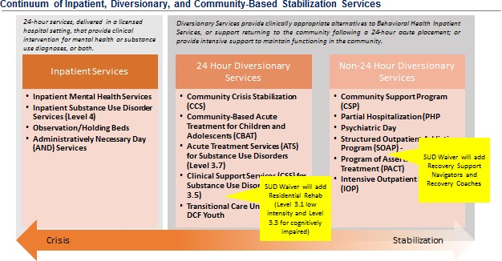

*Source: MassHealth Overview, Scott Taberner, MassHealth.*

* + Inpatient services (i.e., Inpatient Mental Health Services, Inpatient Substance Use Disorder Services (ASAM level 4), Observation/Holding Beds, and Administratively Necessary Day (AND) Services).

Included here are a MassHealth Continuum of Inpatient, Diversionary, and Community- Based Stabilization Services and a list of standard behavioral health outpatient services available to MassHealth members. Mr. Taberner also previewed Community Support Program for Justice-Involved individuals (BH-JI), which provides care navigation for those reentering community from incarceration to promote continuity of care and reduce recidivism.

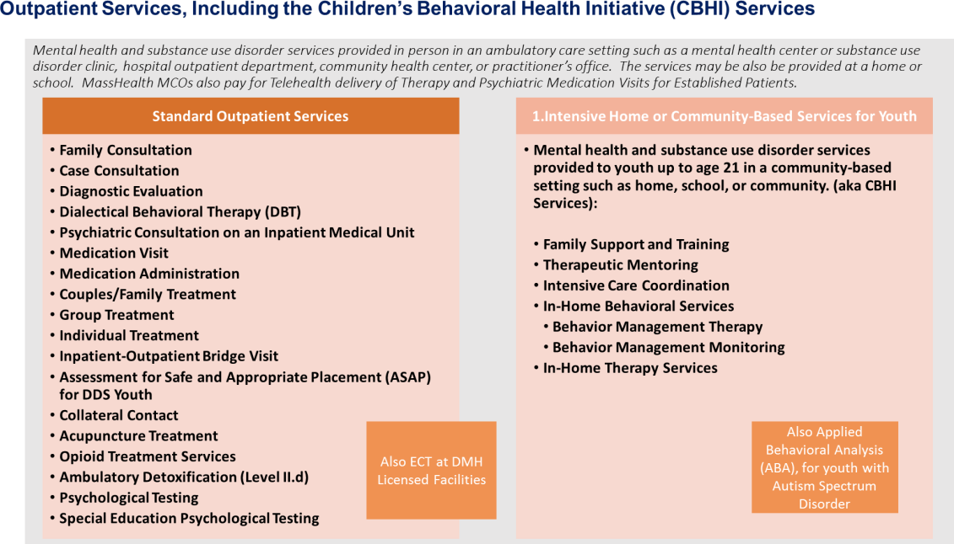

*Source: MassHealth Overview, Scott Taberner, MassHealth.*

* *ED Improvements to Behavioral Healthcare, Leigh Simons Youmans and Janice Peters, Massachusetts Health & Hospital Association (MHA)* – MHA provided an overview of:
* A new program to initiate Medication-Assisted Treatment (MAT) in ED’s;
* A program of Expedited Psychiatric Inpatient Admission (EPIA) in hospital ED’s to reduce ED boarding; and
* 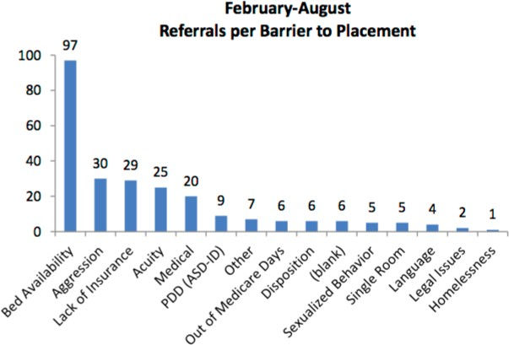preManageED, an application to streamline coordination of care for frequent ED users.

The presentation showed the proportion of referrals to acute inpatient psychiatric treatment by barrier to placement – the most common barriers are bed availability (more than three times the second-place barrier), patient aggression, lack of insurance, and acuity of need.

*Source: ED Improvements, Youmans and Peters, MHA.*

* *Data-Driven Justice Initiative (DDJI), Sonya Khan, Middlesex Sheriff’s Office* – Ms. Khan presented a new initiative funded by Arnold Ventures to link police department and behavioral health data, identifying high-frequency users of health care and public safety systems and finding ways to better address the needs of these individuals. A case study of one such individual is included here. Ms. Khan indicated that DDJI could inform the work of the Commission once initial results are available, and ongoing data integration from the project could be incorporated into the management structure of a restoration center once both projects are active.

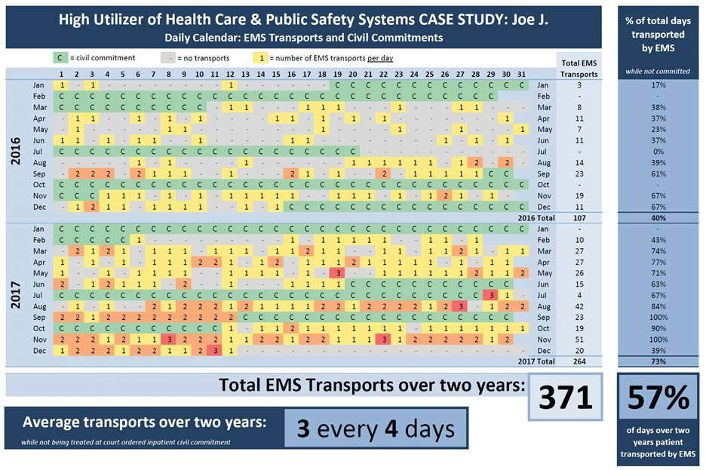

*Source: Sonya Khan, Cambridge Police Department for DDJI.*

* *Jail Diversion Case Studies, Rebecca Tsopelas, Arlington Police Department Jail Diversion Clinician* – Ms. Tsopelas handed out case studies and a summary of the barriers they experienced in accessing services. The Commission ran out of time for presentation and discussion.
* **Referral difficulties:** finding the right provider for the needs of the family; understanding eligibility criteria, including insurance; finding services that address criminogenic needs; and long wait times for assessments and services. These gaps repeat throughout our research.
* **Lack of intermediary/transitional resources** to bridge gaps between an acute crisis episode and enrollment in long-term supports. Co-responders may support transitions by following up with individuals and families, but this is outside their scope, and they struggle to obtain information from providers and hospitals.
* **Police, even with co-responders, have limited diversion options (particularly for individuals who decline services)**; as a result, ED and protective orders are prominent.

## Special populations face specific barriers.

* **Transportation** for basic needs; doctor’s appointments; to crisis services (ambulance can only transport to ED). This gap repeats throughout our research.
* **Individuals declining help**, some due to fear or bad prior experiences, some due to their mental health status. After a crisis is over, family members may feel additional services are unnecessary, which interrupts continuity of care.
* **No single provider or agency is responsible for the holistic needs** of the individual and family that would reduce law enforcement involvement in the case.

Site Visits

Commission members traveled to four restoration or crisis stabilization centers:

* *Bexar County Restoration Center, San Antonio, TX* – run by a non-profit state-designated Local Mental Health Authority, this is the most well-known national model. It serves 2,000 individuals per month, 80% of whom is uninsured, and diverted almost 700 individuals from arrest in 2017. The center provides rapid assessment, care coordination, medical clearance, crisis stabilization, mobile crisis teams, Assertive Community Treatment (ACT), outpatient SUD treatment, MAT, residential and ambulatory detox, a sobering unit, a resource center with office space for providers like financial and legal services, and is across the street from Haven for Hope, a housing complex that houses fully half of San Antonio’s homeless population. The County runs a Jail Diversion Program based on the SIM, tracking overall progress at diverting individuals with behavioral health conditions from arrest. The Restoration Center is primarily funded through state block grants, but also bills commercial insurance and obtains private philanthropy and grants; Haven for Hope, which serves homeless individuals from the community and is located adjacent to the Restoration Center, is completely privately funded. More extensive notes from the site visit are attached in Appendix A.
* *Common Ground Resource and Crisis Center, Pontiac, MI* – Common Ground contracts with the county mental health services program (state-funded regional mental health payer) to provide crisis services to Oakland County, which is of similar geographic size as Middlesex County with a slightly lower population. Services include crisis stabilization, crisis call line, mobile crisis teams, legal clinic, a court liaison team, victim assistance program, respite, sober support unit, and transportation. The center serves over 550 clients per month: about half are walk-ins, one third come by ambulance, and the rest are dropped off by police. The center diverted almost 4,000 ED visits and 100 arrests in 2017. Oakland County also runs a jail diversion program, which convenes stakeholders to monitor progress and advocate for new programs and funding. More extensive notes from the site visit are attached in Appendix A.
* *Behavioral Health Network (BHN), Springfield, MA* – BHN provides CCS, respite, The Living Room, ESP, and CSS at this campus. They also noted that the organization builds relationships with police departments to promote diversion. They cited barriers to diversion including behavioral health workforce shortages (echoed by ABH), lack of shower and ability to provide longer stays at the Living Room (which would change the

model to be more of a peer respite model, like one operated in Northampton MA), a shortage of programming for individuals with co-occurring mental illness and SUD (new Co-Occurring Enhanced ATS (ASAM level 3.1) beds are being opened statewide, including some operated by BHN; these are described in more detail in the Summary of Abt Associates Consulting Engagement, and will add capacity for co-occurring disorders), commercial insurance coverage of services, long wait times for residential treatment, clients getting banned from shelters, security, and lack of case management funding. More extensive notes from the site visit are attached in Appendix A.

* *UMass Memorial Community Healthlink (CHL), Worcester, MA* – CHL provides ESP services, CCS, outpatient counseling, CSP, intensive outpatient treatment, a developmental disabilities unit specifically designed to provide mental health services to individuals with intellectual disabilities, a range of mental health services for geriatric patients, Program for Assertive Community Treatment (PACT), behavioral health and addiction urgent care, detox, CSS, Transitional Support Services (TSS), MAT, and a Screening and Treatment of Early Psychosis clinic. CHL is perhaps the only location in Massachusetts with joint capacity for ESP walk-in clients and drop-off for SUD treatment. CHL staff cited barriers to diversion including local shelter capacity (which is hindered by shelter restrictions like sobriety), lack of physical space on their campus to expand using lessons learned since launching the program, being able to store and provide comfort medications like anti-nausea and anti-anxiety medications, and access to medications. More extensive notes from the site visit are attached in Appendix A.

# Summary of Data Collection and Investigation

While the legislative mandate is to study target population needs, service solutions, program capacity and gaps in Middlesex County, health and human services data are kept differently. The Commission performed additional data collection and analysis summarized below to support meetings and the consultant report, following the framework presented in Section 3. We note that the Commission encountered a significant challenge in facilitating the consultant, Abt Associates’ data collection and in collecting supplemental data to respond to the mandate.

Defining the Target Population

The Commission sought data on individuals who interact with law enforcement or the court system and are ultimately arrested or transported to the ED in order to identify the size and characteristics of the target population. The Commission sought police data that could address the following questions.

1. *What proportion of police incidents involve people with behavioral health conditions?*

Anecdotally, the MSO’s DDJI team heard from police chiefs in Middlesex County that the answer to this question is 75 to 90 percent. Commission data collection efforts are inconclusive in affirming or correcting these anecdotal estimates, primarily due to a lack of available data.

At the request of the leadership of the Commission, Arlington Police Department and Bedford Police Department reviewed calls for service and incidents over a two week period (Arlington) and a three month period (Bedford), recording those involving individuals in behavioral health crisis. Of 429 police interactions over two weeks in Arlington, 26 interactions (or 6%) were identified as behavioral health-related (shown in graphic here). Of the 26 behavioral health interactions, 17 (65%) were left in

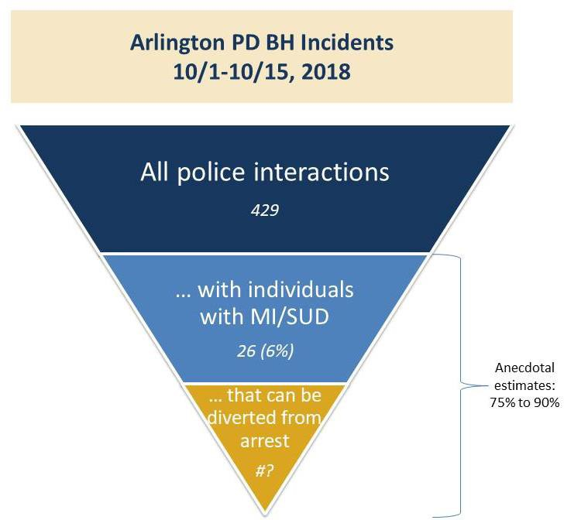

*Source: Arlington Police Department for Restoration*

*Center Commission.*

place, 4 (15%) were voluntarily taken to the ED, 5 (19%) were involuntarily taken to the ED via a Section 12 order

(35% total were transported to the ED), and none were arrested. In Bedford, 23 (1%) of 3,723 incidents between July 25, 2018 and October 23, 2018 were behavioral health-related; of the 23, 15 (65%) were left in place, 3 were transported to a “safe place” to sober up from alcohol, 2 were arrested, and 3 were transported to the ED. Additionally, in its initial data pull and analysis, the DDJI project found that 2% of the individuals represented in law enforcement data across 10 departments represented 13-15% of overall calls for service.8

This analysis suffered from significant data quality challenges that the Commission will need to work to overcome in its second year, including:

* **Percent of time vs percent of incidents:** Analysis focused on 911 calls and incident reports, but it is possible that behavioral health-involved incidents take longer to resolve, taking a higher percentage of officer time than the percentage of incidents would indicate.
* **911 dispatch scripts and data systems are not designed to identify behavioral health:** 911 dispatchers and officers are not often trained to recognize behavioral health condition symptoms, so calls resulting from an underlying condition might not get recognized. Even if the dispatcher or officer recognizes a behavioral health condition, information systems typically do not have specific codes or requirements to note behavioral health incidents. Some jurisdictions have added such codes to their databases, but they are typically limited to cases in which the behavioral health condition is the primary incident of note – if the person is alleged to have committed a criminal offense to which a mental illness or SUD contributed, the offense is the primary code (examples include crimes of homelessness). In contrast, many jurisdictions have codes for overdose (the MSO DDJI team identified 10 departments who have a 911 call code for overdose) 9, which is easily discernable. The target population for a restoration center in Middlesex County includes individuals who might otherwise be arrested. Commission staff did not identify any

8 Sonya Khan. Middlesex Sheriff’s Office. DDJI Pilot Analysis Results. May 2019.

9 Sonya Khan. Middlesex Sheriff’s Office. Notes from DDJI Meetings. Ed., Sonya Khan, December 2018.

jurisdictions maintaining secondary codes for behavioral health or who specifically updated their 911 call scripts to elicit this information.

* **Police data are not stored in and analytically-friendly way:** 911 call data and incident reports are maintained separately; lack of ability to clearly link fields complicates any attempt to perform a large-scale analysis. 911 data may not even identify the individual in question by name. Crime analysts in Arlington and Bedford were forced to undertake a complex and non-automated methodology, which limited us to a small sample size.
* **Limitations of municipal-level, rather than regional, data collection systems:** Individuals with multiple incidents interact with many police departments, so capturing the full picture would require linking data between jurisdictions (the goal of DDJI). The complexity and lack of automation prevented this analysis in all 54 police departments in Middlesex County, but DDJI staff seek to provide data to the Commission as it becomes available.
* **Inflated anecdotal estimates:** Behavioral economics may also inflate anecdotal estimates of behavioral health-related incidents; humans tend to inflate their estimates of the prevalence of incidents that are noteworthy.

As a result of these limitations, the Commission did not draw conclusions. However, these data and documented data quality challenges can guide a more thorough review of police records for the second year of the Commission’s work. For example, we might explore why Arlington had fewer arrests and more ED transports than Bedford to provide indicators of case management or jail diversion opportunities.

1. *What percentage of calls have the following dispositions?*
   1. *Arrested* (within this cohort, how many individuals might be diverted due to the arrest being attributable to a low-level alleged offense?)
   2. *Transported to the ED, either by a police officer in their cruiser or in an ambulance* (within this cohort, how many individuals are subsequently hospitalized on an inpatient basis for psychiatric needs? How many receive an assessment, but no immediate treatment?)
   3. *De-escalated and remained in the community* (within this cohort, how many individuals never receive any connection to appropriate levels of non-acute psychiatric treatment?)

To address the first disposition, the MSO reviewed its data on inmates and detainees in the Middlesex County Jail & HOC to address the question of connection to care after arrest. The data presented here are limited in that these data only reflect individuals who are detained pre- trial after their arrest. To capture a complete picture of connection to behavioral healthcare after arrest, the Commission will need to look for data on individuals detained in police lock-up and those released on bail or on personal recognizance pre-trial. MSO data analysis included:

* Statistics relating to the **prevalence and treatment of behavioral health conditions**:
  + Almost 50% of inmates and detainees have a mental illness, 75% of whom have a co-occurring SUD; 80% of inmates and detainees have an SUD.
  + 40% of inmates require detox protocol upon intake. Included here is a breakdown of the substances they are detoxing from, presented in Sheriff Koutoujian’s initial presentation to the Commission.
  + The standard treatment protocol for inmates/detainees was described in a presentation discussed above by the Health and Mental Health Directors, but generally includes assessment, detox, psychiatric medications, and mental health staff oversight of a mental health caseload. MSO also provides some specific voluntary programming for behavioral health, including the MATADOR program, providing MAT upon reentry to the

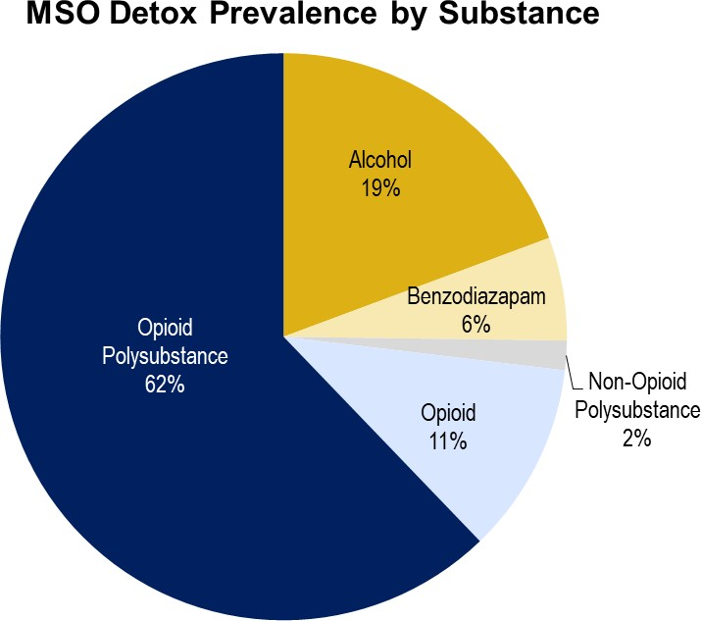

*Source: Middlesex Sheriff’s Office.*

community, and Middlesex County Reentry Initiative (MCRI), providing care

navigation services upon reentry.

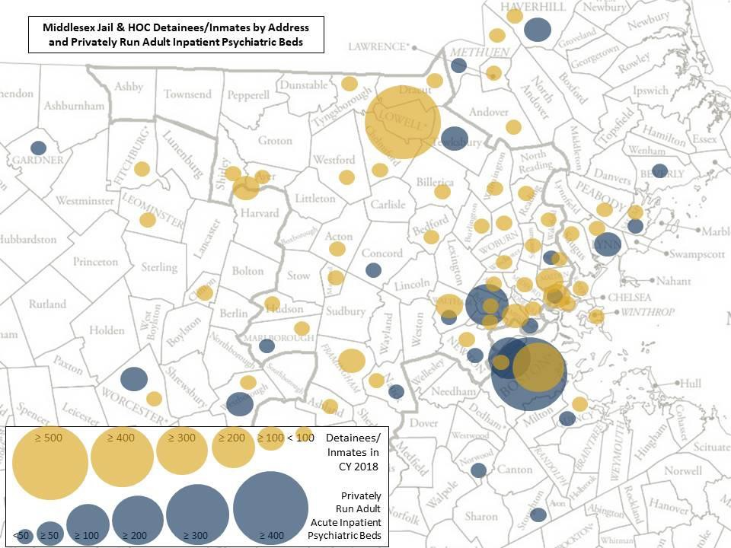

*Source: Middlesex*

*Sheriff’s Office and Department of Mental Health.*

* Statistics and information relating to the **geographical distribution** of inmates/detainees:
* The city or town of residence of inmates and detainees, based on their listed address. Roughly one third of inmates reside in the Lowell region; one third

reside in the “Metro North” of Boston region (between Cambridge/Somerville and Woburn); and one third reside in the balance of the county. Presented here is a map showing the number of inmates and detainees at the Middlesex Jail & HOC in 2018 who reside in each town (among cities/towns that had more than 10 residents), compared to the number of adult acute psychiatric inpatient beds in each town. As shown, the population distribution of inmates and detainees does not match the distribution of beds (though the distribution of acute inpatient psychiatric beds mirrors the general population distribution in Middlesex County and the Boston area). While one third of inmates and detainees at the Middlesex Jail & HOC reside in Lowell, only about 7% of the population of Middlesex County resides in Lowell.

* The court of jurisdiction presiding over their case or which sentenced the individual – an indication of where alleged crimes have been committed, as opposed to where individuals reside, roughly reflects the same distribution described above with regard to residence of inmates/detainees.
* Statistics and information relating to the charges alleged against inmates and detainees. Information about the charges alleged against inmates and detainees with behavioral health conditions would help the Commission to determine what range of charges might be diverted from arrest to a restoration center in Middlesex County.

Individuals who are ultimately detained pre-trial after arrest receive behavioral healthcare treatment and additional voluntary programming at the Middlesex Jail & HOC. What remains unclear is the extent to which individuals detained in police lock-up facilities for a period of time before arraignment and those who are released receive any treatment or connections to service.

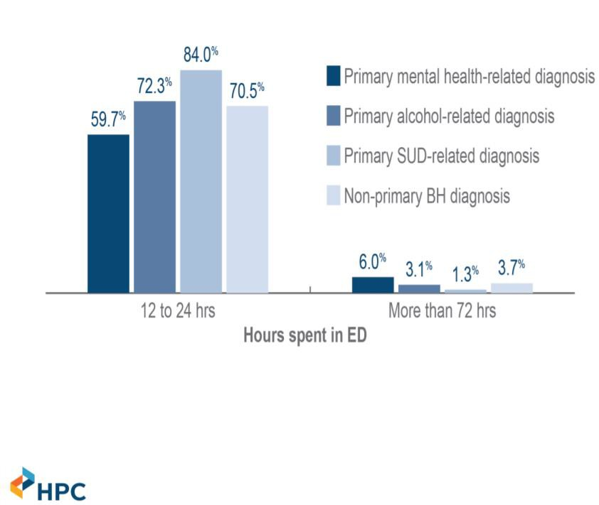To address the second disposition, hospitalization, data would need to be collected from hospitals and/or from health insurance utilization records like from MassHealth. The Commission was unable to collect relevant hospitalization data and/or health insurance utilization records in its first year. Commission staff was able to review two reports by the Health Policy Commission (HPC) which provide insight into the problem of behavioral health boarding in the ED.10 11 HPC found that patients with a behavioral health diagnosis were more likely to board in an ED, and had significantly longer lengths of stay in an ED

*Source: Health Policy Commission.*

10 Health Policy Commission. Behavioral Health-Related Emergency Department Boarding in Massachusetts. November 2017. Accessed at [https://www.mass.gov/files/documents/2017/12/13/20171113-hpc-ed-boarding-](https://www.mass.gov/files/documents/2017/12/13/20171113-hpc-ed-boarding-chart-pack.pdf) [chart-pack.pdf](https://www.mass.gov/files/documents/2017/12/13/20171113-hpc-ed-boarding-chart-pack.pdf)

11 Health Policy Commission. Special Legislative Commission on Behavioral Health Promotion and Upstream Prevention. June 6, 2017. Accessed at <https://docs.wixstatic.com/ugd/10ea3f_f0b5cf40a2194253b8d5a35dc893a4de.pdf>

than patients without a behavioral health diagnosis. Though individuals with a behavioral health diagnosis only accounted for 14% of ED visits in 2015, they accounted for 71% of all ED visits that boarded. In 2011, 17% of all individuals boarding in EDs had behavioral health diagnoses. That percentage increased to 23% in 2015. Among behavioral health patients who boarded, those with primary mental health conditions and those with MassHealth were most likely to board. HPC also found that higher spending on individuals with behavioral health conditions in commercial insurance and Medicare plans is concentrated in inpatient and ED spending (contrary to the bulk of MassHealth behavioral health spending, which is on community-based levels of

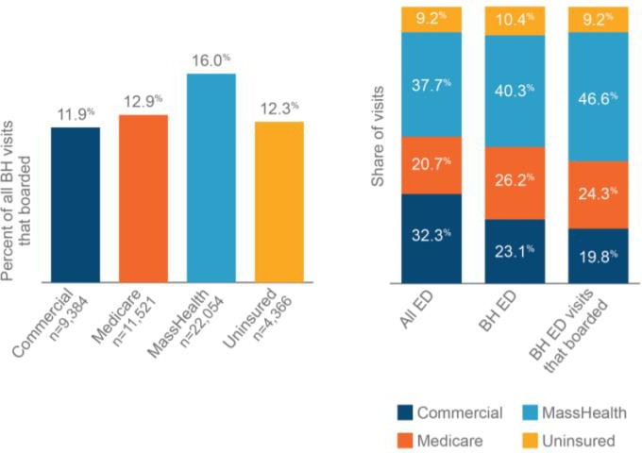care as highlighted in the ABH presentation to the Commission). HPC also found that ED visits with a primary diagnosis of behavioral health increased by 41% in the “West Merrimack/Middlesex” region (northern Middlesex County) and 27% in MetroWest (including the southwestern portion of Middlesex County), but only 9% in Metro Boston (including the southeastern portion of Middlesex County, covering Cambridge, Somerville, and other suburban communities). The Commission may seek

*Source: Health Policy*

*Commission.*

specific information from hospitals in Middlesex County next year.

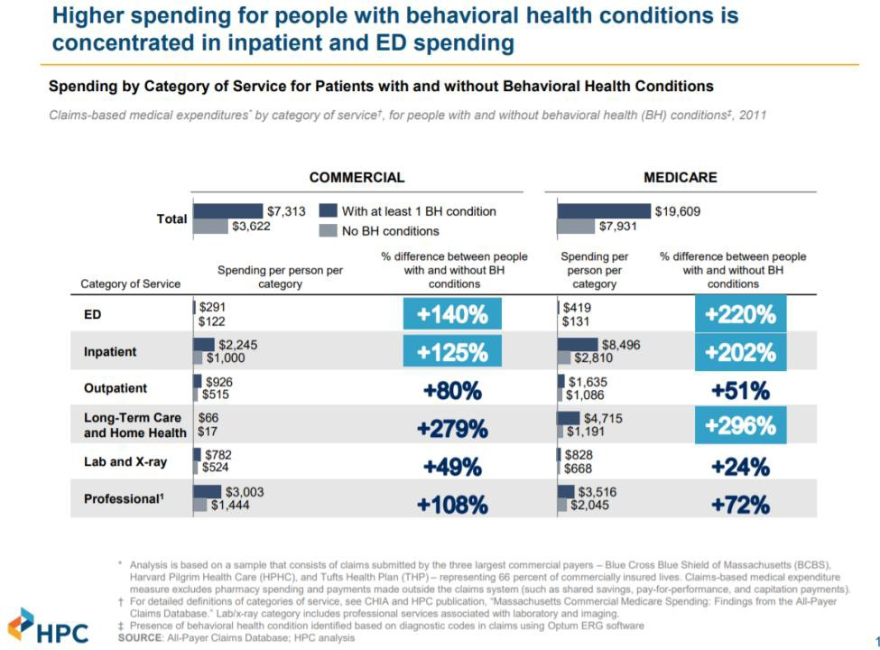

*Source: Health Policy Commission.*

To address the third disposition, “leave in place,” data would need to be collected from health insurance utilization records from MassHealth and other insurance providers on a variety of treatments running from outpatient to inpatient treatment. Additionally, data would need to be collected across law enforcement entities to assess the frequency of interaction of individuals with behavioral health conditions, ideally linked to the individual’s specific health care utilization records to determine whether interactions decreased following specific treatment modalities. While the Abt Associates consulting engagement looked at the gaps in the range of community-based services, the Commission was unable to specifically and systematically look at the access and utilization of those services by individuals who interact with law enforcement.

The Abt Associates consulting engagement highlighted the role of CMHCs, which operate licensed outpatient clinics and other critical services within and around Middlesex County, in the outpatient and urgent care landscape in Massachusetts.

Identifying Gaps and Needs in Services for Members of the Target Population

To supplement the data collection efforts above, the Commission also sought qualitative data on the behavioral health continuum of care in Middlesex County and its ability to divert individuals from arrest and/or ED utilization to more appropriate care settings.

There are many differently delineated geographical boundaries for service provision; the map included here illustrates varied geographical boundaries and complex emergency medical services (EMS) system. 12 13 14 15 16 17

* Middlesex County provides the geographical boundary for many criminal justice system services, including the MSO Jail & HOC, the Middlesex District Attorney’s Office, the 12 District Court jurisdictions, and the Middlesex Superior Court jurisdiction.
* In contrast, the health and human services and behavioral healthcare systems generally do not use county boundaries. The Executive Office for Health and Human Services (EOHHS) organizes into regional service areas not aligned with county boundaries, and some hospitals provide regional emergency medical services (EMS) to their ED.
* MassHealth ESP contracts are organized into their own regional jurisdictions.
* Law enforcement is done at the municipal level. Each municipality also ensures EMS coverage through direct provision of basic or paramedic life support by the Fire Department and/or contracts with private providers of basic and advanced life support to do primary or back-up 911 coverage.

12 Lowell General Hospital Advanced Life Support Paramedics. Accessed at <https://www.lowellgeneral.org/services/advanced-life-support-als/paramedics>

13 Emerson Hospital Emergency Medicine Paramedics and Advanced Life Support. Accessed at <https://www.emersonhospital.org/clinical-services/emergency-medicine/paramedics-als>

14 ProEMS Service Areas: Emerson Paramedics. Accessed at [http://proems.com/who-we-are/service-](http://proems.com/who-we-are/service-areas/emerson-paramedics/) [areas/emerson-paramedics/](http://proems.com/who-we-are/service-areas/emerson-paramedics/)

15 Cataldo Ambulance: Areas We Serve. Accessed at <http://cataldoambulance.com/areas-we-serve/>

16 Trinity EMS. Accessed at <https://trinityems.com/>

17 Commonwealth of Massachusetts Department of Public Health: Find an Ambulance Service. Accessed at <https://www.mass.gov/service-details/find-an-ambulance-service-in-massachusetts>

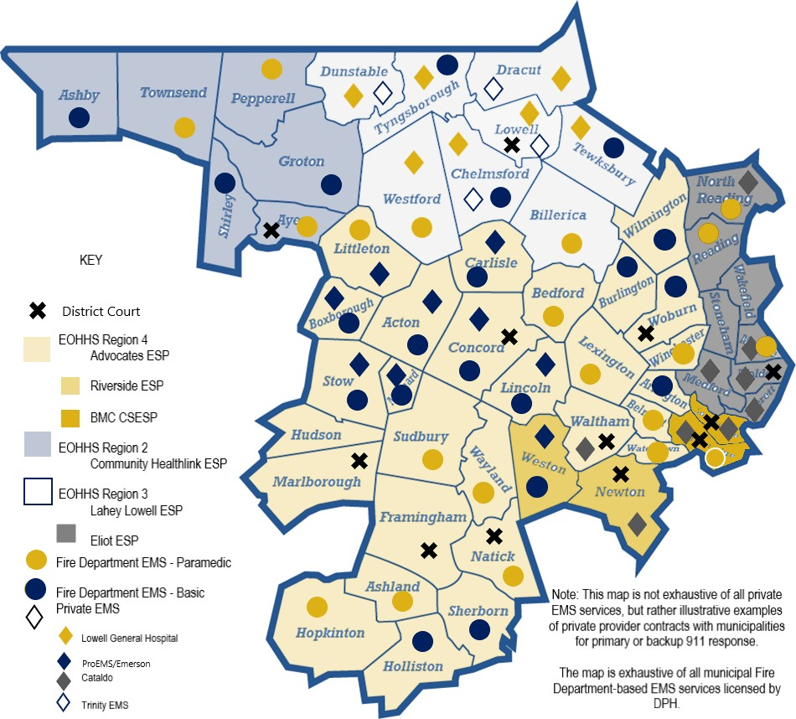

*Source: Catia Sharp for*

*Middlesex County*

*Restoration Center*

This complex map of overlapping, non-concurrent geographical boundaries contributes to challenges faced by patients, families, law enforcement, and first responders in accessing behavioral health services including urgent care, crisis stabilization, and emergency/acute care.

Commission staff participated in SIM mappings in Lowell and Medford/Somerville, facilitated by the Massachusetts Community Justice Project of the MA Trial Court (discussed above in presentations),18 and an additional SIM for the MetroWest area (Ashland, Framingham, Hudson, Natick, and Marlborough) was released in 2018. These three SIM maps cover distinct geographic service catchment areas of Middlesex County, which we refer to as the Lowell region, Metro North, and MetroWest – each region has distinct resources and needs, but there are common themes as well.

18 Additional information about the Massachusetts Community Justice Project can be found at this address: <https://www.mass.gov/massachusetts-community-justice-project>.

An overview of the identified gaps in diversionary services and improvement priorities in each region is in the table below, and each of the three SIMs referenced in this report is attached in Appendix C. We provide highlights below:

* *Common problems* across all three regions of the county include the following. Commission members noted EOHHS plans to address many of these challenges, described in more detail under the heading Identifying Promising Models and Recommendations.
  + **Medical clearance** at ED’s (the need for additional medical clearance options).
  + **Insurance barriers** to mental health treatment.
  + **Information exchange barriers** between criminal justice and behavioral health entities, which create barriers to continuity of care.
  + **Siloed mental health and addiction services**, and a lack of treatment options for individuals with co-occurring disorders.
  + **Lack of transportation** to treatment, court, and other services.
  + Lack of adequate evaluation and treatment resources in **police lock-up facilities**.
  + **Lack of timely access** to behavioral health evaluations, including probation intake, forensic inpatient, and Section 35.
  + The options for treatment under **Section 35**, and the Section 35 process itself.
  + **Not enough funding to HOCs, DOC, and community-based organizations for reentry planning**, like connection to community-based services, information sharing, and overdose prevention protocols.
  + Need for **case management** and more coordinated community-based care.
  + Not enough resources for **police co-response** and follow-up.
  + Lack of behavioral health treatment that specifically addresses **criminogenic needs**/criminal justice involvement.
* Access to **acute inpatient psychiatric beds** varies: stakeholders believe it is extremely **limited in the Lowell region**; a wide variety of choice exists in the Metro North Region, contributing to complexity in decision-making among first responders; and access was not raised as a specific problem in MetroWest.
* **Utilization of ESP services vary** across the county, but are generally regarded as not well-connected to law enforcement responses. Lack of coverage by commercial insurance, particularly for site-based ESP services, is commonly cited.
* The **need for walk-in crisis stabilization services** is commonly cited, particularly in the Lowell and Metro North regions. Lowell cites particular challenges with individuals who are publicly intoxicated, and Lowell General Hospital does not accommodate that need.
* **Lowell** has particularly acute needs in the areas of **housing, acute inpatient psychiatric care, and case management** compared to Metro North and MetroWest.

# SEQUENTIAL INTERCEPT MAPS IN MIDDLESEX COUNTY IDENTIFIED THE FOLLOWING GAPS AND PRIORITIES IN BEHAVIORAL HEALTH AND CRIMINAL JUSTICE DIVERSION SERVICES

|  |  |  |  |  |
| --- | --- | --- | --- | --- |
|  | **Lowell Region** | **Metro North Region** | | **MetroWest Region** |
| **Somerville** | **Medford** |
| **Intercepts 0**  **and 1: Community Crisis Services and Law Enforcement** | **Timely access to evaluation and treatment** in the community. | | |  |
| **Acute inpatient psychiatric hospitalization**  **– no beds** at Lowell General Hospital, the only ED; particular boarding difficulty for hard-to-place individuals; law enforcement  cited challenges with ED drop-offs. | **Acute inpatient psychiatric hospitalization – confusion** in navigating ED options, limited beds cited. Lawrence Memorial Hospital closed its ED. | |  |
| **Medical clearance** can only happen in an ED. | | | |
| **ESP** services, including crisis stabilization,  not covered by commercial insurance. Room to improve ESP-police collaboration. | Long **ESP** response  time; walk-in site recently closed. | **ESP** services not covered by commercial insurance. | |
| No 24/7 **drop-off/walk-in center**. Specific need for **sobering center** as an alternative to protective custody (Lowell General Hospital won’t take individuals who are drunk).  Living Room model also identified as a need. | Walk-in crisis site needed. More sites/providers for **diversion programs** identified as a need. Specifically, need for BSAS peer support center identified. | |  |
| People were not sure who the local CSP provider is. **Case management** identified as a need for adults with complex needs.  Service navigation post-assessment needed. | Timely access to **case management** needed. Long wait times for CSP identified (Riverside and Eliot). | | Timely access to treatment needed. Lack of **coordinated community- based care** for non-DMH clients  with severe mental illness cited. |
| **Training**: Need for MH training for 911 dispatchers, EMS, and law enforcement; cultural competency training for law enforcement; trauma training for law enforcement and across all intercepts; specific resources on adolescent mental health. | | | |
| No police **co-responder;** identified as a need. | More post-incident engagement needed. | | Additional 24/7capacity for police  **co-response** needed. Lots of co- responder activities are not billable. |
| **Insurance barriers to treatment** – MassHealth barriers and commercial insurance both cited. | | | |
| **Homelessness** identified as major issue: 30+ homeless encampments with 200+ homeless individuals. Only one shelter, which is dry  half the year. | More safe and stable housing needed. | | |

|  |  |  |  |
| --- | --- | --- | --- |
|  | **Information exchange** between law enforcement and provider community – perception and reality of allowable sharing.  Specific instances cited include post-discharge from hospitals. Lowell PD CAD code for mental health identified as a need. Post-overdose information sharing specifically cited in MetroWest. | | |
| **Siloed mental health and addiction services.** Lack of treatment capacity for dual-diagnosis. | | |
|  | Long **wait lists** for services, and process for accessing SUD beds is confusing. |  |
|  | Difficult to engage with people not interested in treatment. |  |
| **Transportation** to programs, court, and treatment. MetroWest specifically cited from court to detox. | | |
| Need **cross-sector stakeholder meetings.** |  | Need **cross-sector stakeholder meetings.** |
| **Language barriers** particularly acute. |  |  |
| **Intercept 2: Initial Detention and Initial Court Hearings** | **Police lock-up** lacks resources for BH screening or providing needed medications. Regional lock-up could provide this. | | |
| **Timely access to evaluation**: forensic psychiatrists doing 18A evaluations; BH evaluation on intake to probation; and Section 35 evaluations at courts were all cited. | | |
| **Training** on trauma, mental health, and addiction for attorneys and court officers needed. | |  |
| **Need for pre-trial services** like OCC. | **Pre-trial services**: bar advocates need access to social workers for clients. | |
| **Section 35 and 15A**: alternative treatment options needed for Section 35 – Level 4 detox cited as need by MetroWest. After- hours Section 35 cited as issue in MetroWest. Information exchange/release of information and case management needed for  Section 35 aftercare. Donut hole of services and guardianship for those found not competent to stand trial . | | |
|  | Specialty MH or SUD court available in Medford. | No drug court available. Only 1 court clinician in Framingham. Need more mentors, recovery  coaches for veterans court. |
| **Intercepts 3,**  **4 and 5: Jails and Courts; Reentry; Community Supervision** | Probation has a hard time accessing residential and other treatment with commercial insurance. | Gaps in access to:   * Safe and sober housing * Transportation * Timely residential treatment |  |
| **Reentry planning**:   * Jail-based case managers don’t know pre-trial release dates, making release planning difficult – this includes MassHealth reactivation * HOC should share reentry planning information with probation for individuals with split sentences. * HOC doesn’t do overdose risk screen, overdose prevention training, or have resources to provide naloxone on release. | | |
| BH providers don’t address risk/needs/responsivity factors. |  | Lack of treatment for criminogenic factors of BH. |

**Summary of Abt Associates Consulting Engagement**

The Commission contracted Abt Associates to:

1. *Gaps Analysis*: Review the behavioral health and diversion continuum of care in Middlesex County and assess the gaps in that continuum, including reviewing the literature on jail and emergency department diversion for individuals with behavioral health conditions;
2. *Stakeholder Interviews*: Conduct stakeholder interviews of individuals providing direct services to the target population for a restoration center to inform what is working and what is not working in Middlesex County;
3. *Cost-Benefit Analysis*: Perform a cost-benefit analysis of a proposed restoration center; and
4. *Recommendations*: Make recommendations to the Commission based on these findings for a restoration center, as well as improving diversion and the behavioral health continuum in Middlesex County.

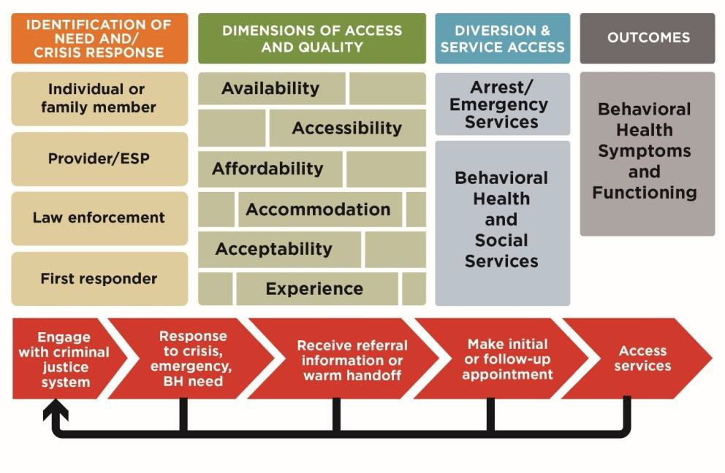Abt Associates reviewed the Middlesex County system of behavioral healthcare and existing criminal justice diversion programs using a model of access to healthcare treatment shown here. The initial identification of need for behavioral healthcare services in response to an emerging condition or behavioral health crisis can be identified by a variety of actors, including the individual themselves, a family member, a provider, law enforcement, or a first responder. Once the need is identified, there are a variety of dimensions along which access to adequate behavioral healthcare services can be measured. For example, even if a service is available, it might not be accessible, affordable, accommodating, acceptable to the patient, or provide a therapeutic experience for the patient. Gaps in any of these dimensions can result in poor outcomes like arrest or overuse of ED. The capacity of various actors to divert patients from the criminal justice system, or from unnecessary institutionalization more generally, to more appropriate levels of care can be evaluated using the SIM.

*Source: Abt Associates.*

Because data on critical elements of a gaps analysis specific to Middlesex County are often unavailable, Massachusetts and national data is used to supplement these gaps. Additionally, because data on the behavioral health needs of individuals involved in sequential intercept 1 (law enforcement) is generally unavailable as described in detail in the previous section,

MSO data from Intercepts 3 and 4 (jails/courts and reentry) were used to supplement. A discussion of what we know about how prevalence rates differ between the sequential intercepts is included in Section 5 of this document, but we generally acknowledge that our utilization of Intercept 3 and 4 data may be an overestimation of prevalence at other intercepts.

Availability

Abt Associates quantitatively reviewed available services in Middlesex County based on licensing data from DMH and the DPH Bureau of Substance Addiction Services (BSAS), as well as payer data from DMH, DPH, and MassHealth at sequential intercepts 1 (law enforcement) and 0 (community), because these are the intercepts impacted by a restoration center. This review was hampered by the fact that service delivery and services data for these state agencies are not reported at a county level. The state agencies report at site area and regional levels that do not align with counties in the Commonwealth. Middlesex County has cities and towns, for example, in three different DMH areas, with each of these areas extending beyond the boundary of Middlesex County.

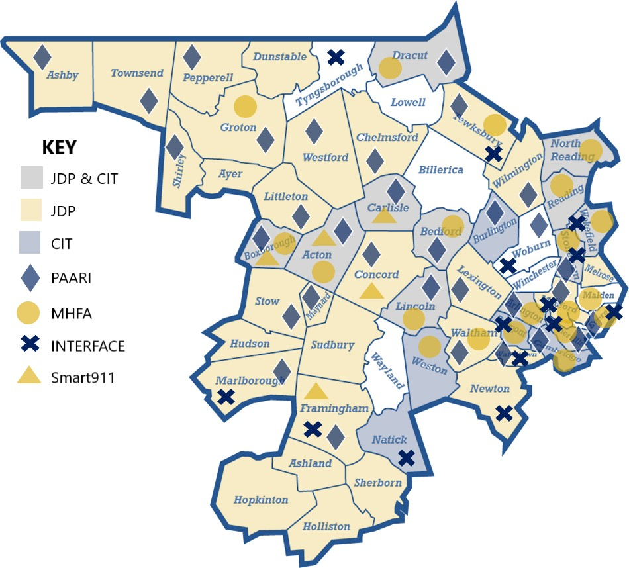*Source: Abt Associates; Catia Sharp for Middlesex County Restoration Center Commission.*

At Intercept 1, Law Enforcement, Abt Associates found the following services – it should be noted that the absence of a service in this list does not mean it doesn’t exist, but rather that Abt Associates did not find evidence of the program:

* *Jail Diversion Program (JDP)* – evidence-based DMH grant program for police-based clinician co-responders (co-responder testimony presented above was from a DMH grantee). In SFY2017, co-responders responded to 5,000 behavioral health incidents, 1,000 of which could have been criminally charged. Officers diverted 85% of those potential arrests. In SFY2018, 500 arrests and 250 ED transports were avoided.
* *Mental Health First Aid* – evidence-based eight-hour training identifying signs and symptoms of mental illness. 17 Middlesex County police departments have offered this training to their officers in the last three years with various grants, some from SAMHSA.
* *Crisis Intervention Team (CIT)* – evidence-based (see Crane and Mauch above) 40-hour training in behavioral health and de-escalation tactics for law enforcement. DMH funds two training centers and four police-based teams.
* *William James INTERFACE Referral Service* – run by William James University in partnership with the Massachusetts Child Psychiatry Access Project, this service connects individuals in subscribing communities to a Resource and Referral Counselor to navigate mental health services, and is used by 15 Middlesex County Communities.
* *Police-Assisted Addiction & Recovery Initiative (PAARI)* – nonprofit group that helps law enforcement agencies establish and run pre-arrest SUD and recovery programs.
* *Smart911* – mobile phone application used by some Middlesex County 911 dispatch centers containing pre-programmed personal information pertinent to emergency events.
* *Data-Driven Justice (DDJI)* – MSO program described previously in presentations.
* *Police-Mental Health Collaborative* – U.S. Bureau of Justice Assistance (BJA)-funded project at APD to implement a six-step process to build mental health response capacity.

Diversion services vary widely by community. There is no regional or state-level planning to coordinate the strategic investment of diversion services for law enforcement agencies, and as a result, utilization is sporadic and uncoordinated. For example, Lowell is home to one third of MSO inmates and detainees, but Abt Associates did not review any diversion programs in Lowell, though Commission members raised a pre-adjudication diversion program run by Lowell House. Law enforcement largely determines whether individuals access these resources, or whether to pursue funding for any of the available diversion services outlined here.

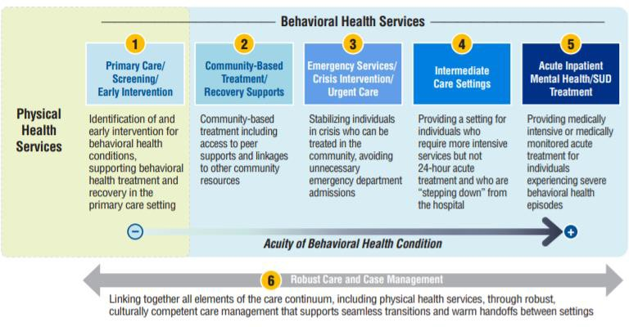

*Source: Blue Cross Blue Shield of Massachusetts Foundation.*

At Intercept 0, Community, Abt Associates cataloged services in Middlesex County, organized mirroring the BCBS Foundation Behavioral Health Services Continuum.19

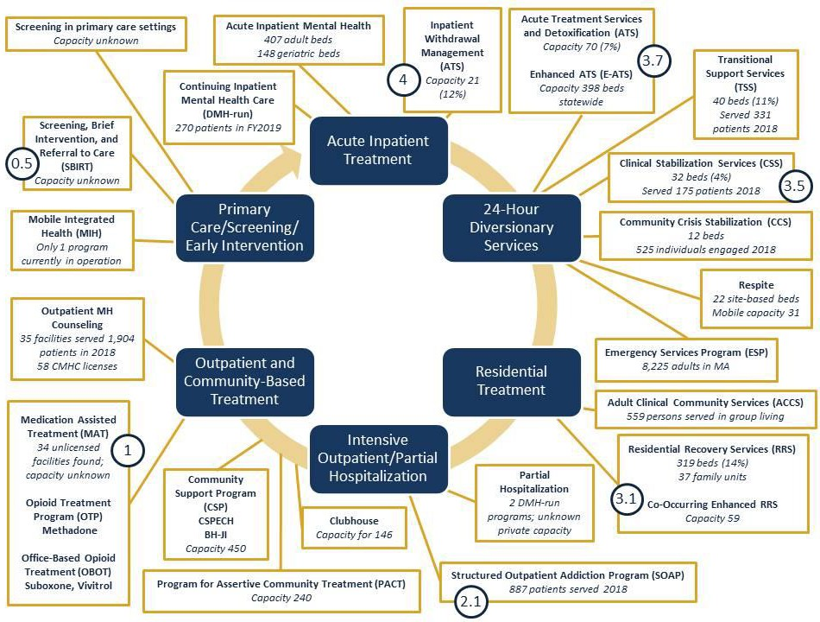**INTEREPT 0: Middlesex County Continuum of Behavioral Healthcare**

*Source: Catia Sharp for Middlesex County Restoration Center Commission.*

The continuum is presented as a circle to illustrate the goal of moving individuals into the least restrictive environment possible while meeting their needs. For a description of the programs, see Abt Associates Consulting Engagement Report, Appendix D. Additionally, Abt Associates notes that many of the services are accessible by both Middlesex County residents and residents from outside the county, and residents of Middlesex County may obtain services outside of the county – county boundaries are not used to define health and human services boundaries.

Abt Associates reported that there are services at each level of care in Middlesex County, but they were not able to determine whether the appropriate capacity existed. There is not enough county-level data to make this determination, and the county-level view doesn’t align with health

19 Abt Consulting Engagement Report, from BCBS of MA Foundation, “Ready for Reform: Behavioral Healthcare in Massachusetts,” January 2019.

and human services boundaries. Very few waitlists exist for state services and the service capacity can change over time.

Some findings are presented below:

* **It is unclear how much behavioral health urgent care is available** through CMHCs, and whether it is available at all to commercially insured individuals.
* **Bifurcation of mental health and substance use services fails to accommodate the many individuals accessing these services who have co-occurring disorders**, despite evidence presented suggesting that the rate of co-occurring MI/SUD is high, particularly among justice involved individuals (76% of those in MSO custody with MI also have an SUD). This finding is supported by SIM findings, as well as a HPC report on Co- Occurring Disorder Care in Massachusetts published in 2019 – see prior section for the proportion of clinics they found to serve individuals with co-occurring disorders.20

## Evidence of inadequate geographical dispersion of some levels of behavioral healthcare within Middlesex County and between the county and state , and difficulty coordinating across multiple service area boundaries:

* + Middlesex County may have disproportionately less capacity in most SUD service levels than the state as a whole given its proportion of the state population. Despite representing 23% of the state population, Middlesex County only hosts: 11% of Opioid Treatment Program (OTP) facilities; 17% of Office-Based Opioid Treatment (OBOT) facilities (note that OTP and OBOT facilities are not the only providers of MAT services); 14% of Residential Recovery Services (RRS) beds; 11% of Transitional Support Services (TSS) beds; 4% of Clinical Stabilization Services (CSS) beds; 7% of Acute Treatment Services (ATS) American Society of Addiction Medicine (ASAM) level 3.7 beds; and 12% of ATS ASAM level 4 beds. Note that the healthcare and behavioral healthcare systems are not organized on a county-level in Massachusetts, and insurance plans typically use a metric looking at the availability of the level of care within a particular driving distance. Such information was not available to Abt Associates at the time of their report, but may be helpful to the Commission if it could be obtained.
  + As noted and mapped in the Summary of Data Collection section, the volume of acute inpatient psychiatric capacity in Middlesex County generally aligns with population density, but does not align with the distribution of justice-involved individuals. This finding is supported by the SIM mappings referenced in this report.
* **Difficulty assessing the capacity of a system with public and commercial payers**: This analysis focused on public payers and public licensure to review the capacity of the behavioral healthcare system in Middlesex County, but misses services not licensed by state agencies or funded by commercial payers and patients. Many data sources referenced above anecdotally noted significant gaps in commercial coverage of behavioral healthcare services, including SIM mappings, notes from the BHN site visit, and the co-responder testimony.

20 Co-Occurring Disorders Care in Massachusetts: A Report on the Statewide Availability of Health Care Providers Serving Patients with Co-Occurring Substance Use Disorder and Mental Illness, Health Policy Commission, May 2019.

* **Processes for involuntary treatment of mental illness and SUD are complicated and not well understood by actors in the system,** and data on the number of people using these processes are not uniformly collected. A more efficient triage and access system should reduce the necessary number of involuntary commitments in the system.
  + We do know, based on the information presented by Judge Minehan, that the number of Section 35 filings nearly doubled between 2010 and 2017 (Commission members point out that this is the result of additional service capacity), and that most Section 12 filings do not go through the court system, which makes tracking the number, disposition, and change over time nearly impossible. Data suggests that acute inpatient psychiatric commitments (Section 12) for youth may be affected by capacity limits, and that complex care needs of certain adult populations may be a limiting factor. There appears to be adequate capacity for general adult acute inpatient treatment needs.

Commission members from MassHealth, DPH, and DMH shared that CMHC capacity was missing from the Abt Associates review. CMHC’s offer services including diagnostic services; psychological testing; long-term, short-term, individual, couples, family, and group therapy; medication visits; case consultations with other treatment providers; family consultation; psychotherapy for crisis intervention and emergency services; after-hours telephone service; and home visits. They are also required to provide urgent psychiatric care – specifically, same-day availability of therapy or psychiatry. There are 58 CMHCs in Middlesex County.

According to the National Survey on Drug Use and Health (NSDUH) state estimates for Massachusetts, 9.2% of adults reported needing but not receiving treatment for an SUD; the problem is particularly acute for young adults ages 18-24, 19% of whom report needing but not receiving SUD treatment.21 The Massachusetts Health Reform Survey found that 23% of the state population had sought care for a mental health or SUD for themselves or a family member in 2018; 57% of them reported difficulty obtaining that care, 46% of them reported difficulty finding a provider who would see them, and 44% of them reported challenges getting a timely appointment.22 These latter findings suggest not only gaps in the availability of behavioral healthcare services, but **gaps in the other dimensions of access** discussed below.

Accessibility, Affordability, Accommodation, Acceptability, and Experience

Abt Associates also presented qualitative evidence on the gaps in accessibility, affordability, accommodation, acceptability, and experience dimensions of the Middlesex County behavioral healthcare continuum based on a series of interviews and focus groups conducted with

21 Abt Consulting Engagement Report, from Substance Abuse and Mental Health Services Administration (SAMHSA). 2016-2017 NSDUH state-specific tables. 2017.

22 Abt Report Consulting Engagement Report, from Long SK, Aarons J. “Massachusetts adults seeking care for mental health and/or substance use disorders face health care access and affordability barriers: summary of key

findings. Boston, MA: Blue Cross Blue Shield of Massachusetts Foundation. Urban Institute, December 2018. [https://bluecrossmafoundation.org/sites/default/files/2018_MHRS%20Chartpack%20MH%20SUD%20Care%20Me](https://bluecrossmafoundation.org/sites/default/files/2018_MHRS%20Chartpack%20MH%20SUD%20Care%20Measures_final.pdf) [asures_final.pdf](https://bluecrossmafoundation.org/sites/default/files/2018_MHRS%20Chartpack%20MH%20SUD%20Care%20Measures_final.pdf)

individuals with lived experience of behavioral health conditions, family members of individuals with lived experience, policy makers, and first responders. Findings include:

* ED and ESP stakeholders perceive a **shortage in the availability of acute inpatient psychiatric beds**, supported by the evidence collected above, including the SIM mappings. Wait times for crisis stabilization and acute psychiatric beds are longest for specialized populations: those with complex medical needs, the elderly, children (especially those with cognitive disabilities), those who exhibit aggressive or violent behavior, deaf or hard of hearing, those with limited English proficiency, those without insurance, and those with co-occurring MI/SUD.

## Accessibility and affordability problems that prevent diversion include:

* + **First responder decision making** is based on options that are or are perceived to be available, which determines access to care during behavioral health crisis.
    - Arrest diversion is happening (non-uniformly), but is limited in the range of cases and depth of need addressed without a restoration center.
      * Continuing to invest in specialized training of law enforcement will expand these efforts.
      * EMS lacks similar training to appropriately triage behavioral health cases – EMS field-based medical clearance (mobile integrated health (MIH) or otherwise) will require this.
    - **ED diversion** is less common than arrest diversion because it is often the most convenient and/or feasible option for officers – ED diversion is seen as the **key to addressing capacity challenges in the system.**
      * Law enforcement perception of a revolving door between ED and community is reinforced by voluntary and involuntary transports.
      * Law enforcement encourages voluntary ED where possible, but Section 12 is a major contributing factor to ED boarding**.**
    - **ESP service improvements would improve use and effectiveness.** This finding is supported by other information presented in this report, including from SIMs.
      * Long and varied response times contribute to varying levels of law enforcement interest. While a 40 minute average response time is viewed by MassHealth as a success, this is too long for officers compared to alternatives like ambulance/ED. Officers find ESPs most useful for urgent, not crisis or emergency care.
      * MassHealth funds ESPs; commercial insurance is unlikely to cover these services, which may contribute to officer frustration.
      * Geographical boundaries of ESPs do not always reflect how individuals move through systems and may lead to disruptions, gaps, and discontinuities in care. When a client is transported to a hospital outside of the ESP region, the ESP can no longer be reimbursed for provision of services.
      * ESPs cannot transport to site-based crisis stabilization, so they rely on public transportation, ride-sharing services, or family members.
      * Connections to care rely on informal relationship networks – systemic, formalized connections could improve navigation.
    - Additional challenges to diversion interventions include the need for **medical clearance** to be performed only in an ED and lack of **transportation alternatives** to existing crisis stabilization resources.

## There are long wait times for some services.

* + - **Outpatient treatment** (which, if readily accessible, would reduce the severity and frequency of BH crises) suffers from long waitlists and many doctors who accept no insurance. This is supported by a BCBS MA Foundation study published in 2017, which cited wait times of a month or more, and wait times being longer for MassHealth members than for those with commercial insurance. Providers cited low reimbursement rates, onerous insurance plan processes like prior authorization and continuing review, and credentialing.23 Long wait times may also be attributable to high turnover rates of behavioral health clinicians and pay discrepancies between clinicians and social workers in outpatient behavioral health settings compared to inpatient settings and other health fields.
    - Long wait times for **DMH residential services** and services for those with co-occurring MI/SUD (DMH Commission member notes that the roll out of the Adult Community Clinical Services (ACCS) program may help with these challenges).

*“There is no parity for psychiatric and medical conditions, if someone comes in with a heart attack, we call them a bed in a hospital. We don’t stop and check their insurance, we don’t say go have your heart attack in the street. Or have you wait in the ED for three days until we can get clearance from your insurance company to treat you. With psychiatric conditions they don’t look at it with urgency or as an emergency.” – ED stakeholder*

* + **Commercial insurance lacks parity** in covering a range of crisis options, driving ED boarding and undercutting diversion;

MassHealth is more comprehensive, despite having longer wait times. This finding is supported by multiple sources above, including SIM mappings, site visits to BHN and CHL, and others.

* + **Systemic complexity** contributes to barriers in accessibility of services. This finding is supported by the co-responder testimony cited above.
    - **Information shortages** contribute to accessibility problems.
      * Front-line workers lack real-time availability information, but timing is critical to improving voluntary treatment rates.
      * Certain services like respite and the Program for Assertive Community Treatment (PACT) are available to non-DMH clients in special circumstances, but stakeholders are unaware of how to obtain enrollment for clients.
      * Cross-sector data sharing regulatory barriers and privacy concerns.
    - Complexity of insurance status and individual needs in finding acute beds.

23 Sirkin, Olsho, Sheedy, McClellan, Walsh, Access to Outpatient Mental Health Services in Massachusetts: A Summary of Findings, BCBS of MA Foundation and Abt Associates, October 2017. [https://bluecrossmafoundation.org/sites/default/files/download/publication/Outpatient_MH_Access_SUMMARY_](https://bluecrossmafoundation.org/sites/default/files/download/publication/Outpatient_MH_Access_SUMMARY_v05_final.pdf) [v05_final.pdf](https://bluecrossmafoundation.org/sites/default/files/download/publication/Outpatient_MH_Access_SUMMARY_v05_final.pdf)

* + - Self-advocacy is necessary to make service connections, but the system is too complex to expect those with mental illness to navigate on their own. Warm hand-offs and case management can facilitate continuity of care.
    - **Continuity of care** is lacking, especially when people are being released from institutions, including lack of aftercare from involuntary treatment, which was cited by Rebecca Tsopelas in her provided materials, and lack of reentry planning after detention/incarceration. This contributes to overuse of administratively necessary days in hospitals (days spent awaiting placement in an inpatient setting).

## Accommodation, Acceptability, and Experience also present barriers to care:

* + Medical clearance requires ED utilization. This finding is supported by many sources above, including co-responder testimony and SIM mappings.
  + Lack of transportation. This finding is supported by many sources above, including co-responder testimony and SIM mappings.
  + Lack of warm handoffs/aftercare. This finding is supported by co-responder testimony discussed above.
  + Outpatient provider fit is important, but finding each provider is a challenge; people value different qualities in clinicians. The BCBS Foundation report supports this finding as well – they found that consumers face challenges identifying providers with specialized experience to meets individual needs.24
  + Involuntary treatment “doesn’t promote accountability or recovery, or personal agency, it promotes compliance” – therefore, voluntary treatment is preferred.
* **Housing**: Additional impediments to accessing and maintaining treatment are posed by a lack of stable housing, which can make keeping appointments challenging. There is high prevalence of behavioral health conditions among homeless individuals and those who are justice-involved, and they may only be able to access care through involuntary hospitalization. Many sources above support this finding: the SIM mapping, co- responder testimony, and CHL site visit.
  + More resources are needed for housing first/permanent supportive housing.
  + Need more outreach, peer support, and community health workers within shelters.

Recommendations from stakeholders based on these findings include:

* **A restoration center is a viable alternative to the ED** for non-acute behavioral health crisis or needs, in contrast to the existing arrest diversion focus, and should:
  + Be insurance agnostic, requiring braiding MassHealth coverage, regulatory requirements for commercial insurance parity, and supplemental state funding.
  + Be the easiest alternative for first responders, including by funding safe, fast, and reliable transportation for law enforcement and locating near public transit.
  + Be sited in the geographical area of highest need. Most stakeholders want the center in their area, but most stakeholders noted in interviews their belief that Lowell is the area of highest need and lowest access to services and supports.

24 Sirkin, Olsho, Sheedy, McClellan, Walsh, Access to Outpatient Mental Health Services in Massachusetts: A Summary of Findings, BCBS of MA Foundation and Abt Associates, October 2017. [https://bluecrossmafoundation.org/sites/default/files/download/publication/Outpatient_MH_Access_SUMMARY_](https://bluecrossmafoundation.org/sites/default/files/download/publication/Outpatient_MH_Access_SUMMARY_v05_final.pdf) [v05_final.pdf](https://bluecrossmafoundation.org/sites/default/files/download/publication/Outpatient_MH_Access_SUMMARY_v05_final.pdf)

* + Leverage existing local services; don’t duplicate.
  + Be a welcoming, non-stigmatizing environment focused on the mutuality of care with timely connections to next steps; include peer professionals.
  + Have housing resources or staff to help individuals connect to local resources and permanent supportive housing.
  + Provide support for clients to navigate post-release, parole, probation, and scheduling/transportation for appearing in court.
  + Provide water, food, telephone and internet access, and child care for clients.
  + Include officer and EMS training in rollout of the center.
  + Include field-based medical clearance to appropriately triage between ED and restoration center transports at the initial point of contact.
* **Address availability of existing services**: Increase the number of crisis stabilization and intermediary services for those being triaged. The Pontiac, Michigan Common Ground Crisis and Resource Center is currently experiencing increases in boarding due to a lack of inpatient beds available for transferring patients, mirroring local ED boarding problems. Consideration should be given to availability of options for those who require a different level of care after their utilization of a restoration center in Middlesex County to avoid the same problem.

## Address accessibility of existing services:

* + The ESP program should be improved by:
    - Updating geographical boundaries to align with other service catchment areas;
    - Allowing ESP’s to follow clients transported to hospitals outside ESP jurisdiction;
    - Allowing them to transport clients to site-based crisis stabilization.
  + Continuity of care should be enhanced by improving partnerships and communica

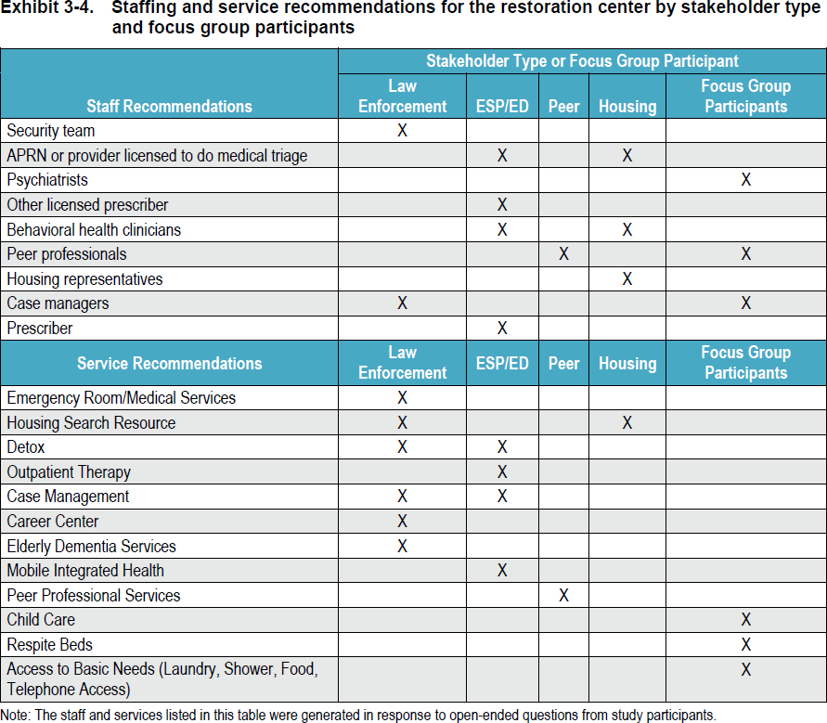tion protocols between EDs and CMHCs.

Additional recommendations from stakeholders regarding the specific design of a restoration center in Middlesex County are included in a table here.

*Source: Abt Associates.*

|  |  |  |  |  |  |  |  |  |  |  |  |  |  |
| --- | --- | --- | --- | --- | --- | --- | --- | --- | --- | --- | --- | --- | --- |
| **Summary of Reviewed Restoration Centers** | | | | | | | | | | | | | |
|  | San Antonio, TX | | Bloomfield Hills, MI | Denver, CO | Fairfax, VA | Multnomah County, Portland, OR | Unity Center, Portland, OR | Kansas City, MO | Tucson, AZ | Worcester, MA | Seattle, WA | Spring- field, MA | Miami, FL |
| **Target Population** | MI | √ | √ | √ | √ | √ | √ | √ | √ | √ | √ | √ | √ |
| SUD | √ | √ | √ | √ |  |  | √ | √ | √ | √ | √ | √ |
| Homeless | √ | √ | √ |  |  |  |  | √ | √ | √ | √ | √ |
| Involuntary | √ |  |  | √ |  |  |  |  |  |  |  | √ |
| Youth | √ | √ | √ | √ |  |  |  | √ | √ |  | √ |  |
| Veterans | √ |  | √ |  |  |  |  |  | √ |  | √ |  |
| IDD | √ |  |  | √ |  |  |  |  | √ |  | √ |  |
| Police drop-off | √ | √ | √ | √ | √ | √ | √ | √ | √ | √ |  | √ |
| Walk-in | √ | √ | √ | √ | √ | √ |  | √ | √ | √ | √ |  |
| **Services** | Medical clearance | √ |  |  |  | √ |  |  |  |  |  |  | √ |
| Respite |  | √ |  | √ | √ |  | √ | √ | √ | √ | √ | √ |
| Detox | √ | √ |  | √ |  |  | √ | √ | √ |  | √ | √ |
| Peer Support |  | √ |  | √ | √ | √ | √ | √ | √ |  | √ |  |
| Case management | √ | √ | √ | √ | √ | √ | √ | √ | √ | √ | √ | √ |
| Urgent psych. | √ | √ | √ | √ | √ | √ | √ | √ | √ | √ | √ | √ |
| Residential | √ | √ | √ |  | √ | √ |  | √ | √ | √ | √ | √ |
| Primary care | √ |  |  |  | √ |  |  |  | √ |  |  | √ |
| Mobile crisis |  | √ |  | √ | √ |  | √ | √ | √ | √ | √ |  |
| MAT |  |  |  | √ |  |  |  |  | √ |  | √ |  |
| LCSW | √ | √ | √ |  | √ | √ | √ |  | √ |  | √ | √ |
| Psychiatrist | √ | √ | √ | √ | √ | √ | √ |  | √ |  | √ |  |
| MH counselor | √ | √ | √ | √ | √ | √ | √ | √ | √ |  | √ | √ |
| SUD counselor | √ |  |  |  |  |  |  |  |  | √ | √ | √ |
| Medical doctor | √ |  |  | √ | √ | √ |  | √ | √ |  |  |  |
| RN/NP | √ | √ |  |  | √ | √ | √ | √ | √ |  | √ | √ |
| Peer specialist | √ | √ | √ | √ | √ | √ |  | √ | √ |  | √ | √ |

Restoration Center Best Practices

Abt Associates reviewed best practices and literature on restoration/crisis stabilization centers across the country. Abt Associates compares centers by their service components, target populations, costs, self-reported outcome data, and other metrics to find best practices. A summary of that review is included here. The Commission highlights some findings of interest:

* Some of the services commonly found in restoration centers are already available in Middlesex County, including through CMHCs, but are not well coordinated and could be more efficient if co-located.
* All reviewed centers include crisis stabilization services and case management.
* Almost all reviewed centers include peer specialists, an important component of a center that works to improve the experience provided by the center.
* Almost all reviewed centers include some medical staff, though not many of them explicitly perform medical clearance on site.
* Most reviewed centers accept both police drop-offs and walk-ins.
* 75% of reviewed centers include respite, which provides flexibility in aftercare planning.
* Just under 75% of reviewed centers include mobile crisis teams for field-based triage.

Cost-Benefit Analysis

The cost-benefit analysis uses data from other restoration/crisis stabilization centers across the country and data on costs from Middlesex County to estimate outcomes for a restoration center in Middlesex County and compare the savings produced by those outcomes to the costs of services. While the analysis is constrained by limitations in the quality and volume of outcome data, it shows potential savings from a restoration center. The analysis assumes:

* That a restoration center is used for police for drop-offs, walk-ins, and transfers from EDs of individuals who either do not require acute inpatient psychiatric levels of care or would benefit from step-down services after inpatient hospitalization.
* A Base Model of essential services, evidenced by the review of centers above, including triage and assessment, medical clearance, crisis stabilization, and respite.
* An Enhanced Model of additional services that the Commission considered separately:
  + Additional mobile crisis intervention capacity – while ESPs already do this, stakeholders identified availability, accessibility, and affordability concerns, and this is a core component of other centers reviewed above.
  + Transportation – while not a core component of other reviewed centers (which could be in part due to the use of mobile crisis teams to transport clients), this was cited by stakeholders, in each SIM mapping in Middlesex County, by the co- responder presentation to the Commission, and in various other places as a key need; it is assumed to increase utilization by law enforcement and walk-ins.
  + Sobering unit – a common component of reviewed centers cited by police in stakeholder interviews, SIM mappings, the co-responder presentation, and elsewhere as a need. This is assumed to increase utilization by law enforcement. Sobering units vary greatly in terms of service models, and can run from units which provide a safe space to nap while awaiting the end of symptoms related to alcohol or drugs (more of a harm reduction model) to units which provide comfort

medications during the same. They typically are meant to allow stays of 24 hours or less before transitioning patients to treatment or other levels of care.

* More savings from reductions in ED utilization than arrest diversion because of findings above showing that ED diversion is the key challenge and probation and court savings were not able to be included in criminal justice savings estimates.

|  |  |  |
| --- | --- | --- |
| **Cost-Benefit Analysis** | **Base Model** | **Enhanced Model** |
| **One-time, up-front costs** | **$440,000** | **$899,000** |
| Planning and Implementation, Year 2 | $250,000 | $250,000 |
| Up-front orientation for police officers and co-responders | $190,000 | $649,000 |
| **Annual Operating Costs** | **$6,096,000** | **$8,554,000** |
| Management, administration, and overhead | $667,000 | $667,000 |
| Security | $282,000 | $282,000 |
| Salaries and benefits for clinicians | $4,449,000 | $4,449,000 |
| Indirect costs of additional treatment | $698,000 | $698,000 |
| Mobile response team |  | $400,000 |
| Sobering beds |  | $957,000 |
| Case management |  | $642,000 |
| Transportation |  | $459,000 |
| **Annual Benefits** | **$6,769,000** | **$7,521,000** |
| ED savings | $6,164,000 | $6,187,000 |
| Criminal justice system savings | $605,000 | $704,000 |
| **Annual Net Cost-Benefit** | **$923,000** | **$1,417,000** |

As the projected net costs and benefits show, a restoration center has high fixed costs. Maximizing utilization is key to achieving the projected net benefits. This can be done by:

* Siting the center in a part of the county with both a high population density and low existing service array to maximize utilization.
* Including funding for transportation to increase utilization among officers who would otherwise find it easier to send people to the ED.
* Include or co-locate with a sobering unit, which would increase utilization by officers.

# Identifying Promising Models and Recommendations

Commission members from MassHealth, DPH, and DPH noted that a handful of programs have recently launched which address some of the needs identified by the SIM mappings, including:

* *Behavioral Health Community Partners (BH CPs)*, discussed in Scott Taberner’s presentation described in the Summary of Meetings and Materials, will expand access to case management and outpatient treatment for individuals with behavioral health needs, will have a focus on integrating mental illness and substance use disorder treatment, and will improve the continuity of care for clients of the BH CPs.
* Additional *specialized RRS* (listed in the behavioral health continuum of care included in this report), which offers an ASAM level 3.1 of care *for individuals with co-occurring MI/SUD*, will begin to address the lack of programming in this area.
* As noted in the Abt Associates report, *DMH recently redesigned the ACCS program*. Commission members from MassHealth, DPH, and DMH highlighted that the new design is more responsive to the needs of individuals with co-occurring disorders.
* New *recovery support centers* that provide education and non-judgmental support for individuals in recovery, help prevent relapse, and promote sustained recovery. Services include financial management, parenting, stress management, child support education, CORI assistance, and employment preparation.
* DPH pilot for *Opioid Urgent Care Centers (OUCC)*, which include walk-in access to triage and assessment, medical clearance, and treatment placement. One of the sites, the Boston Medical Center Faster Paths Program includes buprenorphine prescribing, where people can receive daily services for a short period of time while they are stabilized and referred to an appropriate longer-term placement in the community.
* A new type of *Community Support Program for justice-involved individuals (“BH-JI")*, discussed by Scott Taberner in his presentation to the Commission described in the Summary of Meetings and Materials, which will begin to address the lack of reentry planning cited in the SIM mappings and the lack of programming that specifically addresses criminogenic needs, improving the continuity of care after incarceration.
* The *Community Policing and Behavioral Health Advisory Council* (“Advisory Council”), co-chaired by Commission member Scott Taberner, was established by §20 of Ch. 208 of the Acts of 2018 to advise DMH on establishing police training protocols. The Council may recommend additional training for law enforcement and other first responders, which could address the gap raised in all three SIM mappings.
  + The Chelsea Police Department presented the *Hub model* to the Advisory Council. Now adopted by Lawrence, Medford, Jamaica Plan, East Boston, and Lynn, the Hub identifies individuals or families facing complex challenges, and coordinates services across silos to address these needs. In the Hub, (1) a service provider identifies an individual or family not adequately served whose needs pose a significant, imminent risk; (2) the provider presents the de-identified case to other provider and government agencies, who vote on the case; (3) if approved, the presenting agency shares identifying information; agencies who know the person or family come forward; (4) a select group (to protect patient privacy) of agencies discuss how best to help. Presenters reported the Hub improved agency coordination to more effectively manage existing resources, resulting in a 50% reduction in arrests. Though other eligibility criteria apply, behavioral health needs the most commonly cited (over 70%). Major contributors to Chelsea Hub’s success are two recovery coaches who do outreach and follow-up and the ESP.
* *Expedited Psychiatric Inpatient Admission (EPIA)*, run by DMH, as noted in the MHA

presentation, is intended to help address challenges that providers face in placing individuals in inpatient psychiatric beds once they arrive at the ED.25

* Two information sources address the problem cited above of finding service openings:
  + The *Massachusetts Helpline*,26 a statewide public resource for finding licensed and approved substance use treatment and recovery services, funded by BSAS.
  + *Massachusetts Behavioral Health Access (MABHA)*27, which helps providers and members locate openings in mental health and substance use condition services, administered by the Massachusetts Behavioral Health Partnership.

25 Peters and Youmans, Massachusetts Health and Hospital Association. ED Improvements to Behavioral Healthcare. Presentation to Middlesex County Restoration Center Commission September 27, 2018.

26 Accessible at [https://helplinema.org](https://helplinema.org/)

Commission members from MassHealth, DPH, and DMH have also noted the recently announced listening sessions on Creating a Behavioral Health Ambulatory Treatment System.28 Through this process (hereafter referred to as “ambulatory behavioral health redesign”), EOHHS will solicit specific feedback on many of the challenges raised by the SIM mappings, Abt Associates report, and other materials presented in this section, including:

* The availability of psychiatric urgent care;
* The accessibility of outpatient care, including barriers to treatment posed by commercial and MassHealth insurance;
* Siloed mental health and addiction services for individuals with co-occurring disorders;
* Continuity of care;
* Transportation to behavioral health services;
* Access to behavioral health evaluations in police lock-up, probation intake, forensic inpatient, and Section 35 treatment facilities;
* The ESP program, including the potential role of ESPs in addressing access to behavioral health evaluations and limited police co-response and follow-up, including through the use of Hub models like the one discussed in this report from Chelsea; and
* Medical clearance.

Recommendations

The Commission took away from the consulting engagement and other reviewed materials the following recommendations:

* **Address gaps in availability, accessibility, affordability, accommodation, acceptability, and experience** in the current continuum of behavioral healthcare with a focus on promoting diversion from arrest and hospitalization:
  + Train all first responders (law enforcement and EMS) to improve identification, response, and triage of individuals with behavioral health conditions, possibly through recommendations from the Advisory Council.
  + Improve coordination and data sharing among police, co-responders, and ESPs, guided by the Plymouth County model cited in the Abt report and the Chelsea Hub model, including through EOHHS ambulatory behavioral health redesign.
  + Make targeted improvements to existing programs to improve the delivery of emergency, crisis, and urgent behavioral healthcare.
    - Build a more robust behavioral health urgent care system in the outpatient setting by building off of the existing CMHC infrastructure and enhancing the justice-involved capacity/specialization.
    - Consider improvements to the current ESP program through the EOHHS ambulatory behavioral health redesign process, including:
      * Increase funding for crisis stabilization and mobile crisis intervention;

27 Accessible at <https://www.mabhaccess.com/>

28 EOHHS. Attend a Listening Session on Creating a Behavioral Health Ambulatory Treatment System. Accessed at [https://www.mass.gov/service-details/attend-a-listening-session-on-creating-a-behavioral-health-ambulatory-](https://www.mass.gov/service-details/attend-a-listening-session-on-creating-a-behavioral-health-ambulatory-treatment) [treatment](https://www.mass.gov/service-details/attend-a-listening-session-on-creating-a-behavioral-health-ambulatory-treatment).

* + - * Investigate whether allowing programs to follow individuals to hospitals outside of their geographical territory would be beneficial by examining how many cases this becomes a barrier in;
      * Compel commercial insurers to cover both site-based crisis stabilization and mobile crisis intervention;
      * Allow and fund transportation by mobile crisis intervention teams or find alternative methods of transportation; and
      * Establish systematic, formal relationships between ESPs and other actors in the system for more coordinated care.
      * Gather data from ESPs to clarify the need for these improvements.
  + Make targeted improvements in existing services to improve continuity of care, including expanding the use of recovery coaches at discharge from the ED. Recommend that EOHHS ambulatory behavioral health redesign consider this.
  + Increase capacity to support ED diversion by creating opportunities for mobile/field-based medical clearance and transport to non-ED settings, possibly through a Mobile Integrated Health (MIH) program.
  + Prioritize housing access for those with MI/SUD and justice-involved.

## Collect additional data to refine service capacity and target population:

* + To determine the capacity of behavioral health services:
    - Recommend that DPH and DMH collect wait list information to determine gaps between need for service and current availability of services. Recommend that MassHealth collect information on average wait times for care in each category of service on the behavioral healthcare continuum identified above. Recommend that the state compel reporting among commercial payers on utilization and access to services in each category on the continuum.
    - Survey availability and payment of outpatient providers by city/town.
    - Map existing services to better understand geographic distribution of services and identify areas of high need.
    - Explore getting data on percent of county residents living within driving distance of various service types from commercial insurers, understanding that county data is challenging to obtain as discussed in this report.
  + To better understand the target population:
    - Collect data in two ways from police departments:
      * Survey Middlesex County police departments about current diversion policies and procedures and dispositions.
      * Target one or more specific police departments in high volume jurisdictions that are also potential locations for a restoration center to collect 90 days of data on incidents involving individuals with behavioral health conditions that goes beyond a primary mental health call code, and the dispositions of those calls to confirm or add precision to anecdotal estimates likely to be found in a survey. Explore leveraging DDJI work.
    - Collect data from ED’s in Middlesex County (focusing on potential restoration center jurisdictions) on individuals seeking care for primary behavioral health concerns, including average length of stay in the ED.

Explore leveraging DDJI work. Explore working with HPC to look at ED utilization and disposition.

* + - Use data from the MSO to identify individuals who are detained or incarcerated and have behavioral health conditions to identify their service utilization in the community by linking them to MassHealth records. This would provide a better understanding of the utilization of the types of individuals who might ultimately be diverted using a restoration center.
  + Develop recommendations to collect data on Section 12, which is very relevant to the problem with law enforcement-involved behavioral health crises.

## Restoration center planning should:

* + Specify the *target population* with the intention of maximizing utilization. The target population should include walk-ins to provide connection to service potentially before law enforcement interaction. Additional considerations include whether there are any disqualifying conditions or offenses and whether the center will assess or treat individuals involuntarily. Use the data collected pursuant to the above recommendations to inform specification of the target population.
  + Determine accessibility for those with commercial or no insurance. The center should have a “*no wrong door” policy*. This is important both from the perspective of maximizing utilization and to encourage police to use the center.
    - Leverage existing funding streams.
  + Specify a *location to maximize utilization* – close to public transportation and maximizing the amount of police drop-offs that can come from a 20 minute driving radius. Select a region with high need and low service availability. Finally, co-locate a center with specific partners like CMHCs, hospitals, etc. to improve utilization and cost-effectiveness. Co-locate related services like detox beds, intensive outpatient treatment, benefits, advocacy, and housing access.
  + *Determine transportation options*, as this could be a key driver of utilization.
  + Include *triage/assessment, medical clearance, crisis stabilization, respite, and sobering beds* and make the center welcoming from an experience standpoint.
  + Develop a *staffing plan* that is 24/7, includes security, medical staff, and peer support workers.
  + Include field-based or site-based *medical clearance*.
  + Perform a landscape analysis of the CMHCs and other related providers that could be leveraged to support a restoration center.
  + Develop a mechanism for *engaging and maintaining relationships with stakeholders* from across criminal justice and behavioral health landscapes – partners should meet regularly. Ensure the center is firmly embedded in the existing pre-booking diversion landscape, the broader care system (with written working agreements between related and collaborating entities to ensure comprehensiveness and continuity of care), and has adequate focus on aftercare.
  + Consider a simulation model, which could incorporate more dynamic ranges of possibilities, including systemic effects of adding a restoration center to the continuum of care.
  + Review Arnold Ventures report on best practices, when available.
  + *Evaluate the pilot phase* and establish ongoing performance management.

The above data collection and findings helped the Commission to answer the questions posed in Section 3: Framework for Commission Work. Below is a summary weaving each of the disparate data sources and findings into a cogent response to the initial key questions posed by the Commission.

**SECTION 5: SUMMARY OF FINDINGS FROM YEAR ONE**

# Problem Statement

*Individuals living with mental illness and/or substance use disorder too often interact with law enforcement and the court system, or are incarcerated or hospitalized.*

The Commission found that individuals with mental illness

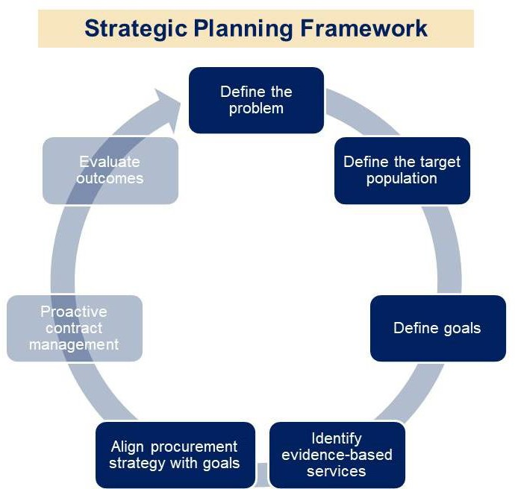

*Source: Catia Sharp for Middlesex County Restoration Center Commission.*

and/or substance use disorders are disproportionately represented in the criminal justice system as compared to the general population. In fact, as can be seen below in the table of prevalence of behavioral health conditions at each level of the SIM, the portion of the population with behavioral health conditions rises with each sequential intercept. In addition to the sequential intercepts, the Commission was interested in the number of individuals who use EDs for behavioral health crisis. As cited in this report from the HPC, ED patients presenting with behavioral health conditions spend longer in the ED and are a large contributor to ED boarding.

Barriers to preventing initial law enforcement contact (Intercept 0)

Stakeholder interviews conducted by Abt Associates may provide insight into why increasing rates of behavioral health conditions at each intercept is happening. As discussed above, early identification and outpatient treatment are the earliest and most effective methods of diversion from the justice system – if a person’s behavioral health condition can be adequately addressed as part of activities of daily living, behavioral health crisis frequency and severity may be limited. However, as also discussed above, significant accessibility, affordability, accommodation, acceptability, and experience barriers exist that prevent individuals from accessing outpatient care. Significant barriers to accessing outpatient care exist, including poor reimbursement rates from MassHealth and commercial insurance, long wait times, and insurance complexity.

|  |  |  |  |  |
| --- | --- | --- | --- | --- |
| **Prevalence of BH Conditions Among Adults 18+ in Middlesex County by Intercept** | | | | |
| **Sequential**  **Intercept** | **Description of**  **Population** | **% with MI**  **(#)** | **% with SUD**  **(#)** | **% Co-Occurring**  **(#)** |
| **Intercept 0 Community** | The general adult population | 20.6% any MI  (332,000)29  4.7% SMI  (75,800)33  ~500 §12 annually through court system  53 §12(e) evaluations;  22 commitments 2018 | 10% SUD  (161,400) 33  9.2% needed but didn’t receive treatment for SUD (19% for 18-25  year olds – 306,700) 33  12,690 used SUD  services in 2017 (50%  heroin drug of choice, 36% alcohol use) 33 | 3.4%  (236,000)30  Of those who used SUD services in 2017, 44% had prior  MH treatment31 |
|  |  | 23% (~995,900) sought BH care for self or family member in 201832  57% of adults who sought care reported difficulty (insurance coverage, time to appointment, etc.) obtaining36  44% reported difficulty getting a timely appointment36 | | |
| **Intercept 1 Law Enforcement** | Adults who interact with law enforcement | 6%33 - 75%34  Stakeholders interviewed thought BH is disproportionately represented among law enforcement interactions | | |
| **Emergency Departments\*** | Adults who use the ED for a behavioral health crisis | 26 per 1,000 residents in 2015  (41,600 in Middlesex County)35  53 Section 12(e) evaluations; 22 commitments in 2018 (41.5%) 36 | | |
| **Intercept 2 Initial Detention/ Court** | Adults who are arrested and arraigned. | 1,081 §35 evaluations across 12 district courts in 2018 (36% of them in Lowell; 16% in Woburn)  These evaluations resulted in 818 involuntary commitments in 2018  ~2,000 §15(b) competency evaluations annually  No quantitative data collected on police lockup/criminal arraignments. | | |
| **Intercept 3 Jails/Courts** | Adults who are held pre-trial at Jail or are released  awaiting trial. | No data for those released pre-trial  50% MI in jail37  No data for those sentenced to DOC facilities | No data for those released pre-trial  80% in jail41  No data for those sentenced to DOC facilities | No data for those released pre-trial  37.5% in jail41  No data for those sentenced to DOC facilities |
| **Intercept 4 Reentry** | Adults who are detained pre-trial or sentenced inmates. |
| **Intercept 5**  **Community Corrections** | Adults who are on Probation or Parole. | No data specifically collected, but could be obtained in year 2 | | |
| * Not a sequential intercept, but a population of interest. | | | | |

29 Abt Consulting Engagement Report, based on SAMHSA 2016-2017 NSDUH State-Specific Tables.

30 Abt Consulting Engagement Report, based on HPC and SAMHSA.

31 Abt Consulting Engagement Report, based on BSAS Substance Abuse Treatment Admissions Statistics.

32 Abt Consulting Engagement Report, based on Massachusetts Health Reform Survey

33 Abt Consulting Engagement Report, based on Arlington Police Department data

34 Abt Consulting Engagement Report, based on Data-Driven Justice meetings

35 Health Policy Commission, “Behavioral Health-Related ED Boarding in Massachusetts.” 2017.

36 Abt Consulting Engagement Report, based on DMH Adult Court Clinic data

37 Abt Consulting Engagement Report, based on MSO data

Barriers to diversion from arrest and emergency department utilization (Intercept 1)

In the absence of outpatient treatment, individuals may interact with law enforcement more frequently. First responder decision making – both law enforcement and EMS – is key in unlocking a path to treatment. But these actors may lack the training, information, or access to timely services that would be needed to divert individuals from arrest or unnecessary hospitalization. Diversion from arrest is happening sporadically and non-uniformly throughout Middlesex County, but it could be increased and improved by continuing and expanding a host of diversion programs, as well as by launching a restoration center. Diversion from EDs, for the most part, is much more challenging due to a lack of availability, accessibility, and affordability of alternative crisis and/or urgent services, as well as timely outpatient care. A restoration center could provide an alternative to the ED that could reduce the number of patients who board, but must be established with several factors in mind to ensure that this happens.

Barriers to keeping people in care once they have been diverted (behavioral health system)

Finally, in order to prevent future law enforcement interactions, barriers to the continuity of care must be addressed. These include real and perceived barriers to data sharing; a systematic focus on aftercare at each stage in the behavioral health system, but in particular after acute inpatient hospitalization and Section 35 treatment; and the difficulty in navigating an enormously complex system of care that impedes not only individuals with behavioral health conditions themselves, but treatment providers, first responders, and other actors that are a part of that very system.

# Target Population

The Commission set out to divert individuals with behavioral health conditions from arrest and unnecessary ED utilization. An obvious initial target population includes individuals *who are involved with the criminal justice system through, at a minimum, interaction with law enforcement or the court system.*

The first component of this mandate involves **law enforcement interactions**. As presented above, estimates of the proportion of law enforcement time spent interacting with individuals with behavioral health conditions range widely from 6% of Arlington Police Department police incidents attributable to a primary behavioral health concern to 75% anecdotal estimates from Middlesex County police departments. As discussed in detail above, the Commission was unable in its first year to obtain information on the dispositions of those interactions to the following outcomes, and whether these outcomes included treatment:

* *Arrest –* 8% of Bedford Police Department’s reviewed primary behavioral health incidents ended in arrest; no one in Arlington was arrested. The Commission is unaware of the proportion of individuals who are in police lock-up, arraigned, and released on bail or personal recognizance who have behavioral health conditions. However, from MSO data, the Commission found that 80% of those booked into the Middlesex County Jail have an SUD, 50% have a mental illness, and 75% of those with a mental illness have a co-occurring disorder.
* *ED –* 35% of Arlington Police Department’s reviewed primary behavioral health incidents resulted in ED utilization (about half voluntary and the other half pursuant to Section 12); that number was 16% in Bedford. Bedford additionally needed to find a safe place for 16% of reviewed cases to sober up, an indication that a sobering unit component to a restoration center would be beneficial. From HPC data presented above, the Commission is aware that once an individual goes to the ED for a primary behavioral health concern, 23% of them will board at the ED awaiting the next level of care.
* *Leave in place –* 65% of reviewed cases in both police departments were left in community. The Commission is unaware as to what portion of those individuals ultimately received care for the condition that caused the incident, or what portion of those individuals might have benefited from behavioral health urgent care available in a non-hospital setting like a restoration center that could have connected them to longer term care that might prevent future law enforcement interaction/911 calls.

The second component of the mandate involves **court system involvement**. Criminal involvement in the court system is addressed through the arrest disposition of a law enforcement interaction, but individuals going through civil commitment to treatment through the court system may also have the potential to be diverted to a restoration center.

* *Section 35 –* There were 1,081 Section 35 evaluations performed in the 12 Middlesex County District Courts in 2018. 818 of those individuals were subsequently involuntarily committed to treatment. Of the 263 (24%) of petitions that did not succeed, presumably all of those individuals are struggling to access services to intervene in their SUD, as evidenced by a family member or other person petitioning for their treatment to avoid imminent risk of self-harm. Urgent care services at a restoration center might provide an on-demand access point to services that was not previously available for these individuals. It might be able to divert some of the 818 successfully committed individuals before their families resort to a civil commitment process.
* *Section 12 –* The Commission was unable to obtain quality data on the number of Section 12 petitions in Middlesex County. Judge Minehan presented data showing that about 500 Section 12 petitions are processed by the court each year, but the G.L. c. 123 § 12(e) numbers may not be an accurate indicator of need for acute psychiatric treatment for persons in the community since the courts cannot access beds in the acute behavioral health system under the terms of § 12(e), and thus, many family members may avoid utilizing Section 12 as it often results in a transport to the ED. The law and expressed preferences of some persons with lived experience interviewed by Abt align in a preference for voluntary treatment. For those persons meeting the standard for civil commitment, who are unable or unwilling to agree to voluntary treatment, Section 12 provides for involuntary commitment to care. If restoration centers were available and were structured in a welcoming atmosphere with peer support workers present, it is possible that Section 12 petitions could also be diverted.
  + *Section 12(e) –* Abt Associates reported 53 Section 12(e) evaluations and 22 commitments in Middlesex County in 2018.38 These filings are specific to individuals with a high risk of violence, so they go through the court instead of

38 Abt consulting Engagement Report, based on DMH Adult Court Clinic data, 2019.

directly through an ED; therefore, these cases are unlikely to be able to be diverted to a restoration center.

* *Section 15(b) –* Judge Minehan presented data suggesting that about 2,000 Section 15(b) petitions to evaluate competency to stand trial are processed by the courts each year. DMH reports that the numbers of Section 15(b) petitions increased significantly over the last few years, with a portion of those sent to forensic beds meeting the civil commitment standard for hospitalization. For those that do not, the lack of timely and adequate service alternatives may be a factor on their arrest and subsequent Section 15(B) petitions. The Commission may further investigate whether any of these individuals could be diverted pre-arrest or post-competency evaluation.

In addition to the above-cited target population, the Commission found evidence that an additional population might benefit from a restoration center. The Commission found significant barriers to the prevention of initial law enforcement interaction resulting from a lack of available, accessible, affordable, accommodating, acceptable community-based services that provide positive experiences to clients. As discussed above, to address this problem, all but two reviewed restoration centers allow walk-ins. Walk-ins allow a restoration center to not only address the gap in availability of crisis stabilization services, but also the gap in availability of behavioral health urgent care (ie, on-demand access to triage that can be an entry point to longer- term, community-based treatment). Therefore, the Commission also seeks to include in the target population individuals *who are at* ***high risk of becoming involved with the criminal justice system*** *as a result of their behavioral health status.* An additional benefit of allowing walk-ins at a restoration center would be to maximize utilization, which, as seen in the cost- benefit analysis, is necessary to support the high fixed costs of a center.

A Middlesex County restoration center should address all three of these target populations (those who interact with law enforcement, those at risk of involuntary commitment, and those at risk of law enforcement interaction), as well as Middlesex County residents who are voluntarily seeking services. Additional work can be done in the Commission’s second and third years, during pilot and implementation phases, to collect the missing data on the number of individuals in the groups above and to review additional specific characteristics of the population. For example, what types of specific conditions do these individuals have, and how many of them have co- occurring disorders at each level? What types of offenses might they be alleged to have committed, if any? Individuals with which specific conditions and/or types of offenses might be well served by a restoration center?

The Commission was also unable to analyze the types of offenses that are currently alleged to have been committed by individuals with behavioral health conditions interacting with law enforcement due to the above-described lack of extensive police department data on the target population. Such analysis of offenses committed by individuals in MSO custody (which data is readily available) could supplement the lack of police data. The Commission can also work with police departments to gather this data, in combination with conversations with police to better describe the types of offenses that might warrant diversion from arrest to a restoration center.

Finally, the question of whether a restoration center should accept involuntary assessments and/or commitments poses a challenge from many perspectives: whether involuntary treatment

satisfies the dimensions of accommodation, acceptability, and experience; the security implications; and the systemic efficiency implications. These are all questions that the Commission cannot answer with the available data, but could be reviewed at future stages.

# Goals

The enabling legislation provided two goals for a restoration center in Middlesex County: *reduce arrest* and *reduce emergency department visits* for individuals with behavioral health conditions. Based on the information collected in its first year, the Commission has found additional goals that flow directly from the enabling legislation, reflect the combined experience and insight of Commission members and key informants, and that may be of value for a restoration center in Middlesex County:

* *Reduce ED boarding* – as evidenced by stakeholder interviews and the HPC report discussed in this report, ED boarding among patients presenting with a primary behavioral health diagnosis is high. Boarding is costly and delays the delivery of appropriate acute care. Diversion from ED’s could reduce boarding by providing an urgent, crisis care alternative. A restoration center alone will not resolve the problem of ED boarding, which also has to do with the availability and accessibility of acute psychiatric inpatient treatment, in particular for individuals with special needs as outlined above, but can alleviate pressure on EDs to conserve resources for those who truly require the level of care provided in an ED.
* *Increase use of community-based behavioral health care* – as discussed above, early connection to accessible, affordable, accommodating, acceptable, and pleasant experience in outpatient treatment can prevent initial law enforcement involvement. It is also more stabilizing and more therapeutic than institutionalization for the individual. Therefore, an appropriate goal of a restoration center that seeks to address the gap in availability of behavioral health urgent care specifically might be to increase the timely use of levels of care at lower threshold parts of the behavioral healthcare continuum.
* *Increase use of services supporting social determinants of health in the community* – in addition to increasing utilization of lower threshold behavioral healthcare services, an appropriate goal for a restoration center might be to increase the use of other social services that support social determinants of health. Specifically, stakeholders overwhelmingly cited housing as an area of concern for individuals with behavioral health conditions who become involved with the criminal justice system.
* *Strengthen police co-responder program and Crisis Intervention Training* – to expand the number of jurisdictions with such resources. This could also improve restoration center utilization.
* *Reduce arraignment and forensic commitments* – the Commission did not collect information on post-arrest diversion, but could explore this in year two. The Commission did find that forensic commitments of incarcerated and/or detained individuals to DMH hospitals have grown substantially due to lack of diversion alternatives.
* *Reduce recidivism* – as discussed in this report, the MSO and MassHealth are working to launch programs to help individuals reentering the community from incarceration connect with behavioral healthcare and other services to promote re-integration and reduce recidivism, based on the premise that better continuity of behavioral health care and social determinants of health can stabilize individuals in the community and prevent

future criminal justice involvement. Based on this premise, the Commission could investigate in year two possible methods by which a restoration center could also explicitly address the reduction in high rates of recidivism among formerly incarcerated individuals with behavioral health conditions (up to 68% for those with co-occurring conditions),39 and whether they could expect the focus on reducing arrest in the first place to contribute to this goal, or whether additional steps would be needed to achieve the goal of reduction in recidivism.

* *Reduce involuntary treatment petitions (§12, 35, and 15(b))* – as discussed above, one component of the target population for the restoration center could be individuals who would otherwise be involuntarily committed to treatment. If a restoration center were able to reduce petitions for involuntary treatment, that could be an indicator that the center is welcoming and inviting to individuals who otherwise decline care. Voluntary treatment is always preferable to involuntary treatment.

# Service Model

Potential service components of a restoration center include:

* *Triage and assessment* – While Abt Associates did not specifically review this component of reviewed centers, it is a critical component of any restoration center. An added benefit of triage and assessment would be collecting data during the pilot phase of a restoration center on the modes by which individuals entered the center, what coinditions they present with, the appropriate level of care determined, and the ease or difficulty of making a placement in that level of care. This would answer many of the questions the Commission was unable to answer in this report for lack of data.
* *Medical clearance* – Abt Associates found medical clearance to be a relatively uncommon component of centers they reviewed. However, stakeholders felt that medical clearance will need to be addressed through field-based clearance, site-based clearance, or both in order for the restoration center to effectively divert ED utilization. A pathway has been cleared for this to occur through Mobile Integrated Health (MIH) legislation.
* *Crisis stabilization* – Abt Associates found that all reviewed centers include urgent psychiatric care – this is a core component of any restoration center. MassHealth already funds some crisis stabilization through the CCS program, but evidence from SIMs and stakeholder interviews suggest more may be needed. Additionally, the center will need to find a way to finance these beds for commercially insured and uninsured individuals.
* *Behavioral health urgent care –* Abt Associates did not review all behavioral health urgent care programs, though MassHealth, DPH, and DMH Commission members suggest that urgent care is a component of some CMHCs. The Commission visited BHN and CHL, whose respective crisis stabilization sites provide key elements of an urgent care response in the Springfield and Worcester communities. Blue Cross Blue Shield of Massachusetts Foundation is funding 5 planning grants to be followed by demonstration grants for models of urgent care for adults with behavioral health conditions, and the

39 Amy Blank Wilson, Jeffrey Draineb, Trevor Hadley, Steve Metraux, Arthur Evans (2011). Examining the impact of mental illness and substance use on recidivism in a county jail. *International Journal of Law and Psychiatry, v34*, n4, July-August, p264-268. Accessed at <http://www.sciencedirect.com/science/article/pii/S0160252711000641>.

Children’s Mental Health Campaign recently released a report written by MAMH outlining a model for pediatric behavioral health urgent care in Massachusetts. Both the Foundation and Children’s Mental Health Campaign initiatives stress the central role of comprehensive community behavioral health organizations in delivering and coordinating a comprehensive behavioral health response. Crisis stabilization is an element of a comprehensive urgent care response.

* *Respite* – Abt Associates found that three quarters of all crisis stabilization centers reviewed include respite. Respite is a critical service that allows for additional therapeutic support or transition time to the next level of care. In a system characterized by long wait times for ATS, acute psychiatric inpatient treatment, particularly for populations with additional special needs, partial hospitalization programs, and outpatient treatment, respite can provide a key pressure release valve to the system that can help to facilitate improved continuity of care. DMH already funds some respite beds around the state, and some – like at BHN – are co-located with CCS beds funded by MassHealth, but more systematic co-location and funding of a “no wrong door” approach is needed.
* *Mobile crisis teams* – Abt Associates found that just under three questers of reviewed centers co-locate mobile crisis teams. This critical component of a restoration center allows for triage in the community – appropriate diversions go to the restoration center, and those who require a hospital level of care go to the ED. They can also do a better job than traditional first responders at stabilizing an individual in the field with no transport needed. MassHealth already funds some of these through the ESP program, but evidence from stakeholder interviews, data, and SIMs suggest more availability is needed. Response times are not currently rapid enough to make mobile crisis intervention a viable alternative to EMS transport to ED for many police departments. Further, additional improvements to ESP programs as recommended above are needed to give them a “no wrong door” approach, and better connect mobile crisis intervention to site-based CCS.
* *Case management* – Abt Associates found that all reviewed centers include a case management component. This improves continuity of care after crisis, which is a goal of the Commission. As noted above, Massachusetts has some case management through state agencies – MassHealth funds CSP, CSPECH, and the soon-to-be-launched BH-JI programs, as well as the recently launched BH CP program, while DMH runs respite which has a mobile outreach component and state-operated case management. However, these programs are limited to individuals who qualify. Individuals with commercial insurance and/or who do not qualify for DMH services cannot receive these services. Therefore, the restoration center may need to find alternative mechanisms for funding expanded case management to improve continuity of after care, establishing protocols and rates for commercial insurers to cover this service, and/or allocating specific state funding for uninsured persons.
* *Transportation services* – While Abt Associates did not review whether most crisis stabilization centers provide transportation services, this is a well-identified need from the perspective of stakeholders in Middlesex County. Funding for transportation services, potentially through a MIH program, will be critical to maximizing utilization of a restoration center in Middlesex County.
* *Sober support unit* – While Abt Associates did not review whether most crisis stabilization centers include a sober support unit, their cost-benefit analysis found that such a unit would greatly increase utilization of a restoration center in Middlesex County

by law enforcement. Stakeholder interviews and SIM mappings also revealed that law enforcement finds it challenging to address public intoxication, and resort to using protective custody (holding individuals in police lock-up while they sober up) as a last resort for a safe resolution to the problem. The Bedford Police Department data includes several individuals who would have benefited from a sobering center. This could include withdrawal management/medically supervised outpatient withdrawal and stabilization for persons who are intoxicated by alcohol and/or other substances, coupled with a stable environment. Since it is required that CMHCs have this service available and accessible to people experiencing a crisis at the time of crisis, co-location with a CMHC could leverage that resource.

* *Psychopharmacology –* MassHealth, DPH, and DMH Commission members suggest the inclusion of psychopharmacology for mental health and substance use, inclusive of MAT, to improve continuity of care.
* *Integrated care model –* Given the high rate of co-occurring disorders among the target population, care at a restoration center ought to follow a care model that integrates mental health and substance use treatment.

Additional service model considerations include:

* *Staffing –* a restoration center should be staffed 24/7. Medical staff should be included, and the inclusion of peer support workers in any staffing plan would improve the welcoming nature of the center. Staffing should also include security, which is important to keep clients safe, as evidenced by the review of other centers around the country
* *Physical environment –* a restoration center should include a sally port for quick, efficient, and secure police drop-off to maximize police utilization. Additionally, a living room feel (as opposed to an institutional feel) is preferred by consumers, as evidenced by site visits and stakeholder interviews.
* *Location –* a region and specific site should be chosen to maximize utilization by police and walk-ins. Evidence presented in this report suggests that police will only drive about 20 minutes to a center. A high-need, low-service, densely populated region should be identified, and a specific site should be proximate to related services like an ED (to leverage existing service utilization patterns), housing services, and public transportation.
* *Evaluation and stakeholder engagement –* a pilot oversight structure ought to be implemented to evaluate achievement of established goals and work with various stakeholders to improve the achievement of goals over time. Oversight could leverage the existing Commission structure, as many of the relevant stakeholders are already at the table. Additionally, consumers of behavioral health services should be engaged. Finally, data collection and data sharing has been identified as a challenge, and will need to be addressed during the pilot phase of the project to establish procedures that promote achievement of the goals of the restoration center while also protecting patient privacy.

# Ownership/Contracting Structure

In its second year, the Commission expects to procure a service provider entity with which to develop the above service model, data sharing arrangements, stakeholder engagement, etc. through a planning grant. A long-term contract to operate a restoration center could then be constructed and begin in the Commission’s third year.

# Legislative Mandate

**SECTION 6: PLANS FOR YEAR 2 ACTIVITIES**

**Plan**

*“In the second year, the commission shall develop a jail diversion program and an initial pilot focused on providing integrated community-based services from a centralized location and perform an analysis of potential costs and cost savings. In the third year, the commission shall develop a restoration center and secure funding for a subsequent 2- year period. Within 2 years after the effective date of this act, the commission shall report on the outcome of the pilot programs and provide a full implementation plan for a restoration center including, but not limited to, deliverables, barriers to implementation and costs… The commission shall thereafter produce an annual report.”*

Based on the above findings, the Commission will perform the following activities in year two:

* Collect additional data to specify the size and dimensions of the **target population**:
  + Conduct a survey of Middlesex County police departments, including questions about EMS contracts;
  + Work with a single, large, urban police department in a target region for the restoration center to generate data on interactions with individuals with behavioral health conditions and the dispositions of those interactions.
  + Analyze MSO data identifying individuals with behavioral health conditions, and link to MassHealth data to look at utilization patterns of levels of service in the community (outpatient, inpatient, crisis, and other levels of service), including by alleged offense to identify the offenses most likely to be diverted. Review average length of stay and alleged charges for inmates/detainees with behavioral health conditions compared to the general population at the Jail & HOC.
  + Work with hospital(s) in potential target region(s) of Middlesex County to obtain specific data on the number of behavioral health patients presenting in the ED, both voluntary and involuntary, and the dispositions of their cases.
  + Work with courts and DMH to examine Section 15 cases to determine opportunities for diversion to a restoration center.
* Award a **planning grant** to a service provider to work with the Commission to specify the pilot for the restoration center, including:
  + *Specify the specific service model and amount of services*, based on further review of the target population. Take into account existing services and leverage the infrastructure and expertise within existing treatment facilities in Middlesex County. It will be critical to leverage existing limited workforce in a thoughtful way to efficiently serve this population. Leverage existing funding streams to improve continuity of care and reduce the number and intensity of crises.
    - At a minimum, a restoration center in Middlesex County should include triage and assessment, medical clearance, crisis stabilization, respite,

mobile crisis intervention, transportation services (explore using MIH to accomplish this), and a sobering unit.

* + - Consider including case management, especially for those who will not be eligible for existing publicly-funded case management programs like BH CP’s, CSP, DMH state-operated case management and respite, etc.
    - Determine the specific location of a restoration center by doing additional mapping of services and target populations focusing on communities with high levels of need and comparatively low levels of service access.
    - Develop a staffing plan that is 24/7, includes security, includes field-based or on-site medical clearance, and peer support workers.
    - Determine components of physical layout that must be included – at a minimum, a sally port for police access and a welcoming physical environment that is inviting to clients and non-institutional.
    - Establish data sharing protocols to further improve continuity of care.
    - Work with EOHHS to leverage existing and planned services.
    - Explore potential payment models to ensure a “no wrong door” approach in which no insurance status is turned away from services.
    - Review the Arnold Ventures report when it is available.
* **Develop specific recommendations for improvements to existing programs and services** that would strengthen the system’s ability to divert individuals from arrest and ED utilization and enhance a restoration center.
  + Work through the EOHHS ambulatory behavioral health redesign process to build a more robust behavioral health urgent care system.
  + Develop recommendations to improve the ESP program, including strategies that:
    - Increase the number of crisis stabilization beds and funding for mobile crisis intervention;
    - Allow programs to follow individuals to hospitals outside of their geographical territory;
    - Compel commercial insurers to cover both site-based crisis stabilization and mobile crisis intervention;
    - Allow and fund transportation by mobile crisis intervention teams; and
    - Establish systematic, formal relationships between ESPs and other actors in the system for more coordinated care.
  + Work with the Community Policing and Behavioral Health Advisory Council to expand DMH CIT training programs to include other first responders like EMS.
  + Work with DMH to expand the Jail Diversion Program to more jurisdictions, and consider targeting grants to SIM gaps and high-need jurisdictions.
  + Develop recommendations to expand access to housing first programs.
* **Establish metrics by which success at diversion and access to appropriate and quality treatment will be measured** for the restoration center – this would be part of developing a reporting structure for the annual reporting to the legislature required by the enabling legislation for the Commission. Establish an oversight mechanism which will bring community stakeholders together to maintain focus on outcomes and continuously make recommendations on improvements to the BH continuum of care, the restoration center, and general systemic functioning.

The results of Commission research and deliberation in year one confirm the need for criminal justice diversion services in Middlesex County. A restoration center, in combination with reforms to and investments in diversionary and behavioral health services as described above, would help to address gaps in availability, accessibility, affordability, accommodation, acceptability, and experience within the current behavioral healthcare continuum. Addressing these gaps is necessary to, in turn, divert individuals with behavioral health conditions from arrest and ED utilization. Additional notable goals include reducing the number of petitions for involuntary commitments.

**SECTION 7: CONCLUSION**

In its second year, the Commission will work through a planning grant with a provider agency to develop a specific service model for a restoration center, including the service array, amounts of services, staffing plan, specific location, and physical layout of a center, all based on the recommendations in this document. The Commission will also pursue additional data in its second year to support this decision making, refine the service model, and devise client admission criteria and service protocols.

The Commission will also work to develop recommendations in its second year for improvements to existing state services related to a restoration center and diversion program, including the ESP program and DMH-funded diversion programs. These recommendations will aim to improve the diversion outcomes of these programs while also integrating these systemic components into a cohesive strategy of targeted behavioral health diversion. This will also include recommendations for weaving together funding streams that can support the creation of a “no wrong door” approach to the restoration center.

Budget language and legislative and executive action are needed to allocate funding to the Commission to staff these activities and engage a service provider in a planning grant capacity. Budget language that includes a trust fund which could accept private funding to finance portions of a restoration center would enhance the project’s ability to leverage outside funding streams. Draft legislation to this effect is attached to this report as Appendix E.

The Commission found extensive evidence to support legislation that has already been filed as Senate Bill 590 to require commercial insurers to cover ESP mobile crisis intervention services. This would improve the behavioral health continuum by closing a gap in affordability and accessibility of the current system. The Commission supports the passage of that legislation.