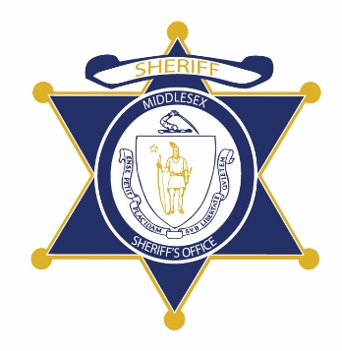Flag of the Commonwealth of Massachusetts


**Middlesex County Restoration Center Commission**

**Public Meeting Notice**

The next meeting of the Middlesex County Restoration Center Commission will take place on Tuesday, January 18 from 12:30 pm to 2 pm.

Please note that due to social distancing guidelines, this meeting will be virtual. If members of the public would like to attend, they may do so by requesting a Zoom link at any time up until the end of the meeting by emailing MCRCinfo@umassmed.edu.

Flag of the Commonwealth of Massachusetts


**Middlesex County Restoration Center Commission**

**Tuesday, January 18, 2022**

**12:30 PM – 2:00 PM**

**Virtual**

**AGENDA**

12:30PM – 12:35PM Welcome and Introductions

*Co-Chairs, Sheriff Koutoujian and Danna Mauch*

12:35PM – 12:40PM Legislative and Budget Update

*Senator Friedman and* *Representative Gordon*

12:40PM – 12:45PM Approval of Minutes from Last Meeting

*Co-Chairs, Sheriff Koutoujian and Danna Mauch*

12:45PM – 1:15PM Update on Procurement and Work Plan

*Commonwealth Medicine*

* CBHC alignment
* Phase-in of services
* Questions?

1:15PM – 1:45PM Financing Update

*Sheriff Koutoujian*

1:45PM – 2:00PM Next Steps and Closing

*Co-Chairs, Sheriff Koutoujian and Danna Mauch*