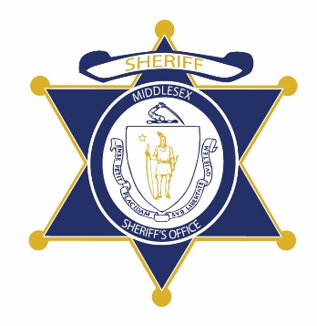Flag of the Commonwealth of Massachusetts


**Middlesex County Restoration Center Commission**

**Public Meeting Notice**

The next meeting of the Middlesex County Restoration Center Commission will take place on Thursday, January 28 from 2 to 3 pm.

Please note that due to social distancing guidelines, this meeting will be virtual. If members of the public would like to attend, they may do so by requesting a Zoom link at any time up until the end of the meeting from Catia Sharp at catiasharp@mamh.org.

Flag of the Commonwealth of Massachusetts


**Middlesex County Restoration Center Commission**

**Thursday, January 28, 2021**

**2:00 PM – 3:00 PM**

**Virtual**

**AGENDA**

2:00PM – 2:05PM Welcome and Introductions

*Co-Chairs, Sheriff Koutoujian and Danna Mauch*

2:05PM – 2:10PM Legislative and Budget Update

*Senator Friedman and* *Representative Gordon*

2:10PM – 2:15PM Approval of Minutes from Last Meeting

*Co-Chairs, Sheriff Koutoujian and Danna Mauch*

2:15PM – 2:35PM Work Plan for FY21, including subcommittee structure

*Co-Chairs, Sheriff Koutoujian and Danna Mauch*

2:35PM – 2:40PM Next Steps and Closing

*Co-Chairs, Sheriff Koutoujian and Danna Mauch*

2:40PM – 3:00PM Executive Session