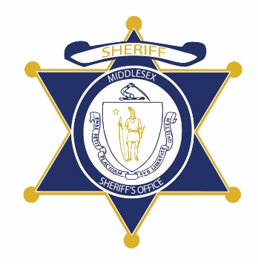Flag of the Commonwealth of Massachusetts


**Middlesex County Restoration Center Commission**

**Tuesday, January 29, 2019**

**Community Healthlink, Worcester MA**

**AGENDA**

1:00PM – 2:00PM Tour Community Healthlink

2:00PM – 3:30PM Commission Meeting

2:00PM – 2:05PM

Welcome

*Danna Mauch, Sheriff Koutoujian*

2:05PM – 2:10PM

Legislative Update

*Senator Friedman*

2:10PM – 2:30PM

Q&A with Community Healthlink

2:30PM – 3:00PM

Introduction to Abt Associates; Key Decision Points; Consulting Plan

3:00PM – 3:25PM

Discussion, Site Visits

3:25PM – 3:30PM

Next Steps & Closing