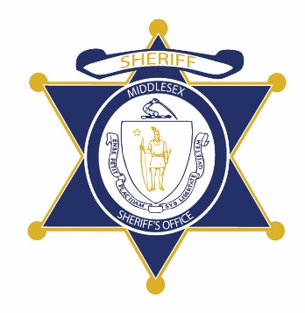Flag of the Commonwealth of Massachusetts


**Middlesex County Restoration Center Commission**

**Public Meeting Notice**

The next meeting of the Middlesex County Restoration Center Commission will take place on Thursday, February 24 from 10:30 am to 12 pm.

Please note that due to social distancing guidelines, this meeting will be virtual. If members of the public would like to attend, they may do so by requesting a Zoom link at any time up until the end of the meeting by emailing MCRCinfo@umassmed.edu.

Flag of the Commonwealth of Massachusetts


**Middlesex County Restoration Center Commission**

**Thursday, February 24, 2022**

**10:30 AM – 12:00 PM**

**Virtual**

**AGENDA**

10:30AM – 10:35AM Welcome and Introductions

*Co-Chairs, Sheriff Koutoujian and Danna Mauch*

10:35AM – 10:40AM Legislative and Budget Update

*Senator Friedman and* *Representative Gordon*

10:40AM – 10:45AM Approval of Minutes from Last Meeting

*Co-Chairs, Sheriff Koutoujian and Danna Mauch*

10:45AM – 11:00AM Update on Procurement and Work Plan

*Commonwealth Medicine*

11:00AM – 11:15AM Financing Update

*Danna Mauch*

11:15AM – 11:55AM Discussion: Statute

*All Commission Members*

11:55AM – 12:00PM Next Steps and Closing

*Co-Chairs, Sheriff Koutoujian and Danna Mauch*