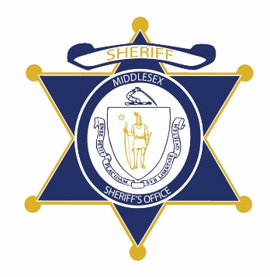Flag of the Commonwealth of Massachusetts


**Middlesex County Restoration Center Commission**

**Friday, March 1, 2019**

**400 Mystic Ave., 4th Fl., Medford MA**

**AGENDA**

11:00AM – 11:05AM Welcome and Introductions

*Co-Chairs, Sheriff Koutoujian and Danna Mauch*

11:05AM – 11:10AM Legislative Update

*Senator Friedman and Representative Gordon*

11:10AM – 12:50PM Presentation on Gaps Analysis and Stakeholder Interviews

*Alicia Sparks, Jenna Sirkin, Meg Chapman, Abt Associates*

Lunch (provided)

12:50PM – 12:55PM Next Steps

*Catia Sharp*

12:55PM – 1:00PM Closing

*Co-Chairs, Sheriff Koutoujian and Danna Mauch*