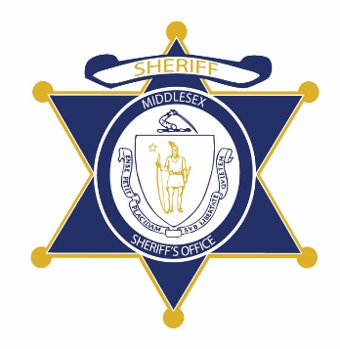Flag of the Commonwealth of Massachusetts


**Middlesex County Restoration Center Commission**

**Tuesday, March 3, 2020**

**10 am – 12 pm**

**400 Mystic Ave, Medford, MA**

**AGENDA**

10:00AM – 10:05AM Welcome and Introductions

*Co-Chairs, Sheriff Koutoujian and Danna Mauch*

10:05AM – 10:20AM Legislative Update

*Senator Friedman and Representative Gordon*

10:20AM – 10:30AM Approval of Minutes from Year One

*Co-Chairs, Sheriff Koutoujian and Danna Mauch*

10:30AM – 10:45AM Update on Police Survey

*Catia Sharp*

10:45AM – 11:55AM Consulting Update

*Brenda Miele Soares and Opal Stone*

11:55AM – 12:00PM Next Steps and Closing

*Co-Chairs, Sheriff Koutoujian and Danna Mauch*