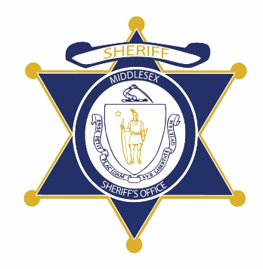Flag of the Commonwealth of Massachusetts


**Middlesex County Restoration Center Commission**

**Tuesday, April 7, 2020**

**3:30 pm – 5 pm**

**Virtual –** [**Zoom**](https://zoom.us/j/514697588)

**AGENDA**

3:30PM – 3:35PM Welcome and Introductions

*Co-Chairs, Sheriff Koutoujian and Danna Mauch*

3:35PM – 3:45PM Legislative Update

*Representative Gordon*

3:45PM – 3:50PM Approval of Minutes from Last Meeting

*Co-Chairs, Sheriff Koutoujian and Danna Mauch*

3:50PM – 4:55PM Draft Consultant Report Presentation and Questions

*Brenda Miele Soares, Advocates*

4:55PM – 5:00PM Next Steps and Closing

*Co-Chairs, Sheriff Koutoujian and Danna Mauch*