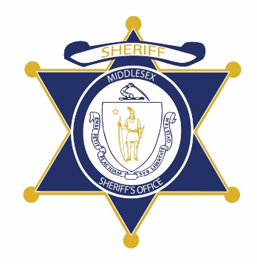Flag of the Commonwealth of Massachusetts


**Middlesex County Restoration Center Commission**

**Public Meeting Notice**

The next meeting of the Middlesex County Restoration Center Commission will take place on Wednesday, April 7 from 10 am to 12 pm.

Please note that due to social distancing guidelines, this meeting will be virtual. If members of the public would like to attend, they may do so by requesting a Zoom link at any time up until the end of the meeting from Catia Sharp at catiasharp@mamh.org.

Flag of the Commonwealth of Massachusetts


**Middlesex County Restoration Center Commission**

**Wednesday, April 7, 2021**

**10:00 AM – 12:00 PM**

**Virtual**

**AGENDA**

10:00AM – 10:05AM Welcome and Introductions

*Co-Chairs, Sheriff Koutoujian and Danna Mauch*

10:05AM – 10:10AM Legislative and Budget Update

*Senator Friedman and* *Representative Gordon*

10:10AM – 10:15AM Approval of Minutes from Last Meeting

*Co-Chairs, Sheriff Koutoujian and Danna Mauch*

10:15AM – 10:30AM Update on Subcommittee on Fundraising

*Co-Chairs, Sheriff Koutoujian and Danna Mauch*

10:30AM – 11:55AM Annual Report Discussion

*All Commission members*

11:55AM – 12:00PM Next Steps and Closing

*Co-Chairs, Sheriff Koutoujian and Danna Mauch*