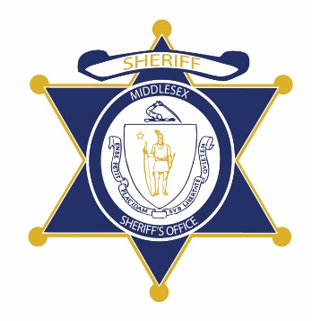Flag of the Commonwealth of Massachusetts


**Middlesex County Restoration Center Commission**

**Tuesday, April 28, 2020**

**3 – 5 pm**

**Virtual –** [**Zoom**](https://zoom.us/j/91544358274)

**AGENDA**

3:00PM – 3:05PM Welcome and Introductions

*Co-Chairs, Sheriff Koutoujian and Danna Mauch*

3:05PM – 3:15PM Legislative Update

*Senator Friedman and* *Representative Gordon*

3:15PM – 3:20PM Approval of Minutes from Last Meeting

*Co-Chairs, Sheriff Koutoujian and Danna Mauch*

3:20PM – 4:45PM Discussion of Consultant Report

4:45PM – 4:55PM SFY 2021 Budget Request

4:55PM – 5:00PM Next Steps and Closing

*Co-Chairs, Sheriff Koutoujian and Danna Mauch*