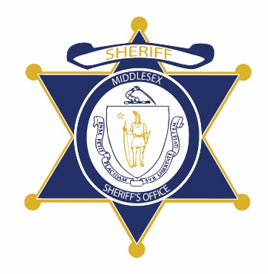Flag of the Commonwealth of Massachusetts


**Middlesex County Restoration Center Commission**

**Public Meeting Notice**

The next meeting of the Middlesex County Restoration Center Commission will take place on Wednesday, July 14 from 12 pm to 2 pm.

Please note that due to social distancing guidelines, this meeting will be virtual. If members of the public would like to attend, they may do so by requesting a Zoom link at any time up until the end of the meeting from Catia Sharp at catia.sharp@umassmed.edu.

Flag of the Commonwealth of Massachusetts


**Middlesex County Restoration Center Commission**

**Wednesday, July 14, 2021**

**12:00 PM – 2:00 PM**

**Virtual**

**AGENDA**

12:00PM – 12:05PM Welcome and Introductions

*Co-Chairs, Sheriff Koutoujian and Danna Mauch*

12:05PM – 12:20PM Legislative and Budget Update

*Senator Friedman and* *Representative Gordon*

12:20PM – 12:25PM Approval of Minutes from Last Meeting

*Co-Chairs, Sheriff Koutoujian and Danna Mauch*

12:25PM – 12:40PM MacArthur IMPACT Network

*Catia Sharp*

12:40PM – 1:40PM Year 4/SFY22 Work Plan Presentation and Discussion

*Scott Taberner, Commonwealth Medicine*

1:40PM – 1:55PM Update on External Funding Sources

*Sheriff Koutoujian*

1:55PM – 2:00PM Next Steps and Closing

*Co-Chairs, Sheriff Koutoujian and Danna Mauch*