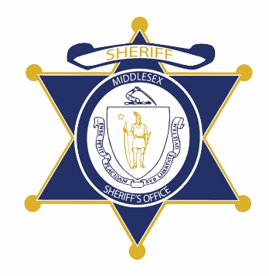Flag of the Commonwealth of Massachusetts


**Middlesex County Restoration Center Commission**

**Tuesday, September 22, 2020**

**10 AM – 12 PM**

**Virtual**

**AGENDA**

10:00AM – 10:05AM Welcome and Introductions

*Co-Chairs, Sheriff Koutoujian and Danna Mauch*

10:05AM – 10:30AM Legislative and Budget Update

*Senator Friedman and* *Representative Gordon*

10:30AM – 10:45AM Approval of Minutes from Last Meeting

*Co-Chairs, Sheriff Koutoujian and Danna Mauch*

10:45AM – 11:45AM Leveraging Commission Research and Experience to Contribute to the Police and Justice Reform Conversations – Discussion

*All Commission members*

11:45AM – 12:00PM Next Steps and Closing

*Co-Chairs, Sheriff Koutoujian and Danna Mauch*