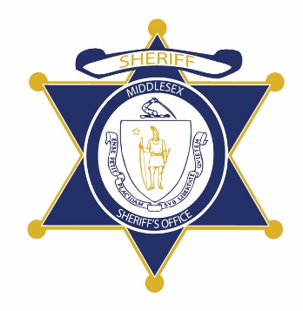Flag of the Commonwealth of Massachusetts


**Middlesex County Restoration Center Commission**

**Public Meeting Notice**

The next meeting of the Middlesex County Restoration Center Commission will take place on Tuesday, October 20 from 3:30 to 5 pm.

Please note that due to social distancing guidelines, this meeting will be virtual. If members of the public would like to attend, they may do so by requesting a Zoom link at any time up until the end of the meeting from Catia Sharp at catiasharp@mamh.org.

Flag of the Commonwealth of Massachusetts


**Middlesex County Restoration Center Commission**

**Tuesday, October 20, 2020**

**3:30 PM – 5 PM**

**Virtual**

**AGENDA**

3:30PM – 3:35PM Welcome and Introductions

*Co-Chairs, Sheriff Koutoujian and Danna Mauch*

3:35PM – 3:45PM Legislative and Budget Update

*Senator Friedman and* *Representative Gordon*

3:45PM – 3:50PM Approval of Minutes from Last Meeting

*Co-Chairs, Sheriff Koutoujian and Danna Mauch*

3:50PM – 3:55PM Media Update

*Sheriff Koutoujian*

3:55PM – 4:25PM Massachusetts 1115 Waiver Update

*Scott Taberner*

4:25PM – 4:55PM Massachusetts Telehealth Successes and Challenges Discussion

*Deirdre Calvert, Lydia Conley, Nancy Connolly*

4:55PM – 5:00PM Next Steps and Closing

*Co-Chairs, Sheriff Koutoujian and Danna Mauch*