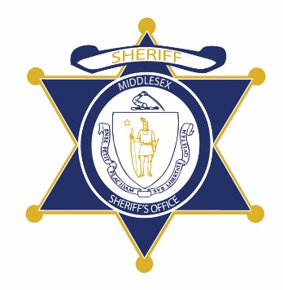Flag of the Commonwealth of Massachusetts


**Middlesex County Restoration Center Commission**

**Tuesday, November 12, 2019**

**400 Mystic Ave, Medford, MA**

**AGENDA**

12:00PM – 12:05PM Welcome and Introductions

*Co-Chairs, Sheriff Koutoujian and Danna Mauch*

12:05PM – 12:10PM Legislative Update

*Senator Friedman and Representative Gordon*

12:10PM – 12:20PM Approval of Minutes from Year One

*Co-Chairs, Sheriff Koutoujian and Danna Mauch*

12:20PM – 12:50PM Police Survey Presentation and Discussion

*Catia Sharp*

12:50PM – 1:00PM Update on Planning Grant Procurement

*Sheriff Koutoujian*

1:00PM – 1:30PM Update to Diversion White Paper

*Danna Mauch*

1:30PM – 1:55PM EOHHS Request for Information Commission Response

*Danna Mauch*

1:55PM – 2:00PM Next Steps and Closing

*Co-Chairs, Sheriff Koutoujian and Danna Mauch*