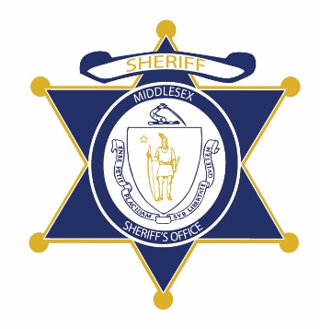Flag of the Commonwealth of Massachusetts


**Middlesex County Restoration Center Commission**

**Public Meeting Notice**

The next meeting of the Middlesex County Restoration Center Commission will take place on Monday, November 7 from 12:30 pm to 2 pm.

Please note that due to social distancing guidelines, this meeting will be virtual. If members of the public would like to attend, they may do so by requesting a Zoom link at any time up until the end of the meeting from Catia Sharp at catia.sharp@umassmed.edu.

Flag of the Commonwealth of Massachusetts


**Middlesex County Restoration Center Commission**

**Tuesday, December 7, 2021**

**12:30 PM – 2:00 PM**

**Virtual**

**AGENDA**

12:30PM – 12:35PM Welcome and Introductions

*Co-Chairs, Sheriff Koutoujian and Danna Mauch*

12:35PM – 12:40PM Legislative and Budget Update

*Senator Friedman and* *Representative Gordon*

12:40PM – 12:45PM Approval of Minutes from Last Meeting

*Co-Chairs, Sheriff Koutoujian and Danna Mauch*

12:45PM – 1:05PM Follow Up on Legal Framework: Discussion

*Co-Chairs, Sheriff Koutoujian and Danna Mauch*

VOTE: “The Middlesex County Restoration Center Commission requests that Commonwealth Medicine be the procuring entity for the Middlesex County Restoration Center pilot.”

1:05PM – 1:20PM Update on Work Plan and Discussion

*Commonwealth Medicine*

* Procurement development process and status

1:20PM – 1:40PM Financing Update

*Sheriff Koutoujian*

1:40PM – 1:55PM Communications Discussion

*All Commission Members*

* Commission website for public meeting materials and reports
* Engaging stakeholders as part of the rollout of the pilot restoration center:
  + Individuals and families who may use the center
  + Police departments and other first responders who may use the center
  + Health plans
  + Relevant healthcare, behavioral healthcare, and social service providers
  + Others?

1:55PM – 2:00PM Next Steps and Closing

*Co-Chairs, Sheriff Koutoujian and Danna Mauch*