INDOOR AIR QUALITY ASSESSMENT

Middlesex County Superior Court
200 Trade Center Drive
Woburn, MA

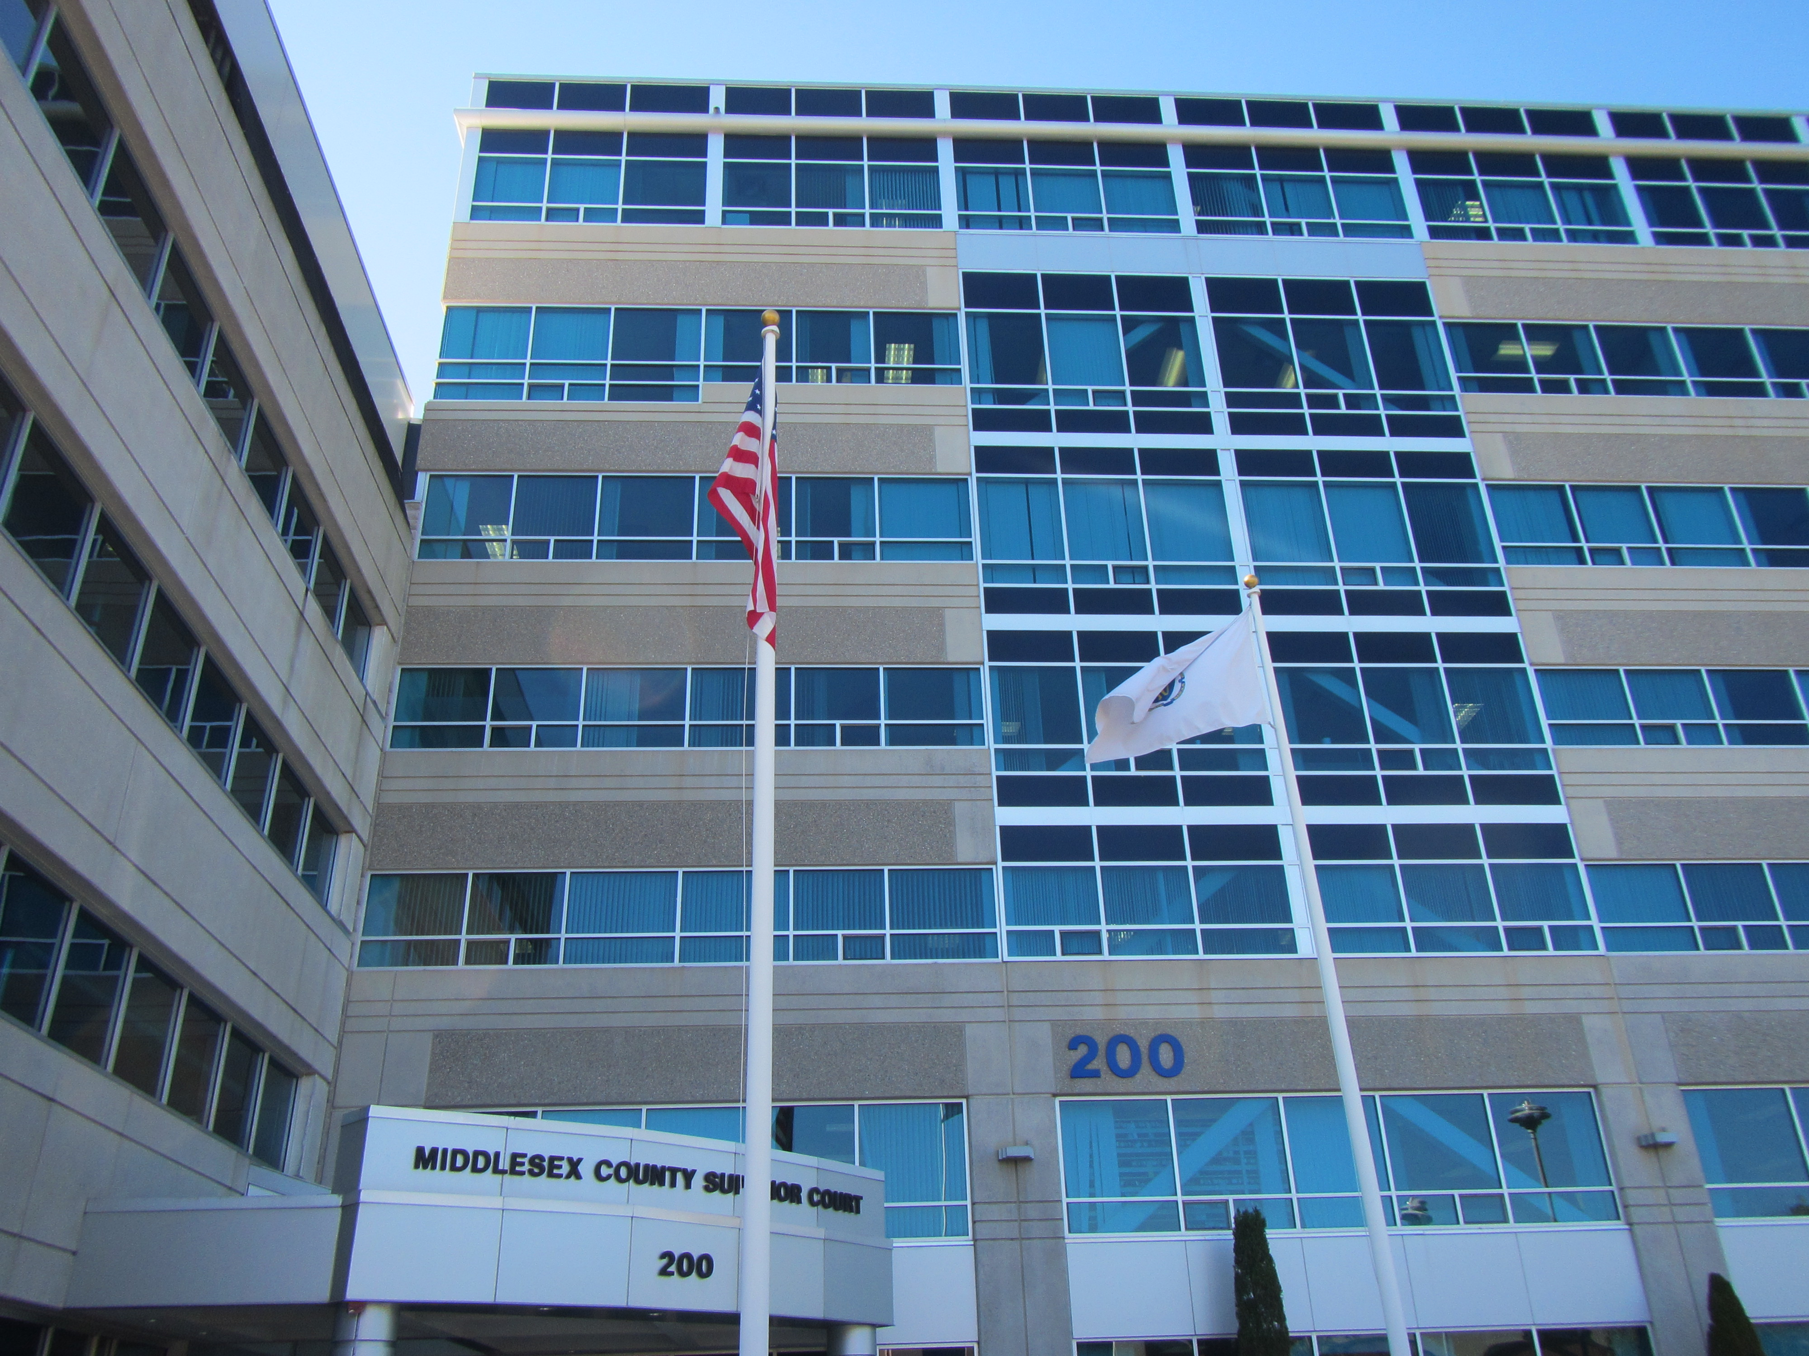

Prepared by:
Massachusetts Department of Public Health
Bureau of Environmental Health
Indoor Air Quality Program
December 2019

Background
Building: | Middlesex County Superior Court (MCSC)
Address: | 200 Trade Center Drive, Woburn
Assessment Requested by: | Mike Lane, Environmental Health & Safety Manager, Facilities Management & Capital Planning, Massachusetts Trial Courts
Reason for Request: | General indoor air quality (IAQ) and allergy concerns
Date of Assessment: | October 15, 2019
Massachusetts Department of Public Health/Bureau of Environmental Health (MDPH/BEH) Staff Conducting Assessment: | Mike Feeney, Director, IAQ Program  Jason Dustin, Environmental Analyst/Inspector, IAQ Program
Building Description: | Steel and concrete building with glass window façade containing 132,000 square feet and built in 2008
Building Population: | The building is used by approximately 400 people daily (employees & visitors)
Windows: | Openable in some areas

METHODS
Please refer to the IAQ Manual for methods, sampling procedures, and interpretation of results (MDPH, 2015).

IAQ Testing Results
The following is a summary of indoor air testing results (Table 1).
- Carbon dioxide levels were below the MDPH recommendation of 800 parts per million (ppm) in 90 of 92 areas tested, indicating adequate fresh air in the space. It should be noted some areas had low occupancy during this assessment which can reduce carbon dioxide levels.
- Temperature was within the MDPH recommended range of 70°F to 78°F in the majority of areas tested.
- Relative humidity was below the MDPH recommended range of 40% to 60% in the majority of areas tested. Low relative humidity is common in the Northeast during the heating season.
- Carbon monoxide levels were non-detectable in all indoor areas tested.
- Fine particulate matter (PM2.5) concentrations measured were below the National Ambient Air Quality Standard (NAAQS) level of 35 μg/m³ in all areas tested.

Ventilation
A heating, ventilating and air conditioning (HVAC) system has several functions. First it provides heating and, if equipped, cooling. Second, it is a source of fresh air. Finally, an HVAC system will dilute and remove normally occurring indoor environmental pollutants by not only introducing fresh air, but by filtering the airstream and ejecting stale air to the outdoors via exhaust ventilation. Even if an HVAC system is operating as designed, point sources of respiratory irritation may exist and cause symptoms in sensitive individuals. The following analysis examines and identifies components of the HVAC system and likely sources of respiratory irritant/allergen exposure due to water damage, aerosolized dust and/or chemicals found in the indoor environment.
Fresh air is provided by air handling units (AHUs) located on the roof. Fresh air is drawn into the AHUs via vents outside of the building. Air from the AHUs is filtered, heated/cooled and delivered to rooms via ducted supply vents (Picture 1). Stale air is drawn into ceiling-mounted return vents (Picture 2) and returned to the AHUs.
BEH/IAQ staff noted that some thermostats were set to the fan “auto” setting (Picture 3). This setting only allows for fresh air introduction and filtration when the thermostat is calling for heat or cooling. MDPH recommends the thermostats to be set on fan “on” to allow for continuous fresh air exchange, exhaust, and filtration.
It is recommended that HVAC systems be re-balanced every five years to ensure adequate air systems function (SMACNA, 1994). It was unknown when the last time these systems had been balanced.

Microbial/Moisture Concerns
Using a moisture meter, BEH/IAQ staff noted that water-damaged gypsum wallboard (GW) and carpeting were moist at the time of this assessment in room #119 of the lower level (Picture 4). These materials are considered porous and may be at risk for microbial colonization if subjected to chronic moisture. It is likely that the window frame and or the exterior wall are allowing water to infiltrate this room. There is a large exterior concrete planter box which contains mulch and landscaping directly abutting the GW wall that was found to be moist. The mulch in the planter box could be holding moisture against the exterior wall/foundation and any cracks in the wall/foundation would allow for water infiltration into the space behind the GW. The waterproofing and the concrete wall behind the planter box were also observed to have visible damage (Picture 5).
The US Environmental Protection Agency (US EPA) and the American Conference of Governmental Industrial Hygienists (ACGIH) recommends that porous materials (e.g., wallboard, carpeting) be dried with fans and heating within 24 to 48 hours of becoming wet (US EPA, 2008; ACGIH, 1989). If porous materials are not dried within this time frame, mold growth may occur. Since the porous building materials in room #119 have been chronically moistened without immediate drying, these materials should be removed and discarded. Due to the likelihood of continued water infiltration, these materials should be replaced with nonporous building materials not conducive to mold colonization (e.g., cement board, rigid foam insulation, vinyl flooring).
Occupants reported that the lower level of the MCSC has experienced chronic water infiltration through an exit door near the Probation department. Evidence of water-damaged/rippled carpeting was noted in the Probation hallway as well as the Probation cubicle area (Picture 6). Water-damaged carpeting can become a source of microbial colonization on the carpeting and/or debris within/beneath the carpet itself. Further, rippled carpeting can pose a tripping hazard. Facilities staff reported that work to increase the drain capacity outside the exit door has been completed which should help to resolve this source of water infiltration. BEH/IAQ staff noted a large gap under this exit door which may allow moisture and unconditioned air into occupied areas (Picture 7).
Carpeting is typically not recommended in below grade spaces or on slabs which may be subject to condensation. Condensation occurs when warm, moist air comes in contact with the surface of the slab/carpet which is cooled below the dew point temperature. This is very common especially in summer during high humidity events. It is especially important to note that windows should not be opened while air conditioning is operating.
Occupants of the lower level space should also be aware that other porous items (e.g., boxes, files, area rugs) brought into this space should not be placed directly on floors or against walls (Picture 8). Humidity and water infiltration or condensation may moisten these items and they could become mold-colonized. Dehumidifiers should also be used during wet or humid weather as necessary.
The rear of the Civil Clerk file storage area was noted to have plastic sheeting between the file shelves and the files (Picture 9). Facilities staff reported that this area has been subjected to past water infiltration during driving rain storms. Facilities staff stated that efforts have been made to address this issue and that no recent water damage has been reported.
Water-damaged ceiling tiles were observed in several areas of the MCSC (Picture 10, Table 1). Stained ceiling tiles may be due to leaks from the roof, HVAC equipment, or plumbing. Water-damaged ceiling tiles can provide a source of mold and should be replaced after a water leak is discovered and repaired.
Plants were observed in a few areas (Table 1) including on porous surfaces (e.g., carpet). Plants can be a source of pollen and mold, which can be respiratory irritants to some individuals. Plants should be properly maintained and equipped with drip pans to prevent water damage to porous materials. Plants should also be located away from air diffusers to prevent the aerosolization of dirt, pollen and mold. Water coolers and refrigerators were found located on carpet (Table 1), where they can moisten the carpet and lead to microbial growth.
Some secure file rooms were noted to have strong musty odors due to records that were water-damaged while stored in a previous building. Water-damaged paper materials should be sorted and either professionally restored, copied to fresh paper, or discarded as they may be colonized with mold or a source of odors. Any actions taken should be cleared with appropriate legal authorities and in compliance with record keeping regulations. Until such time, closed record rooms having musty odors may benefit from depressurization with local exhaust to avoid odors from permeating occupied areas.

Other IAQ Evaluations
Exposure to low levels of total volatile organic compounds (TVOCs) may produce eye, nose, throat, and/or respiratory irritation in some sensitive individuals. To determine if VOCs were present, BEH/IAQ staff examined rooms for products containing VOCs. BEH/IAQ staff observed air fresheners, hand sanitizers, cleaners, and dry erase materials in use within the building (Table 1). All of these products have the potential to be irritants to the eyes, nose, throat, and respiratory system of sensitive individuals. Note that scented products such as air fresheners do not remove odors; they only mask odors with another scent. BEH/IAQ staff also noted strong dry cleaning odors in some judges lobbies or office areas (Picture 11). Dry –cleaned clothing can off gas compounds that may have strong irritant effects.
In some areas, items such as books, papers, and other items were on floors, tabletops and desks, which may make it more difficult to clean. Surfaces should be kept clear of items, or items should be moved periodically for thorough cleaning.
Carpets should be cleaned regularly in accordance with the Institute of Inspection, Cleaning and Restoration Certification (IICRC) recommendations (IICRC, 2012). Upholstered furniture should also be cleaned regularly. Wet wiping of surfaces and the use of a high efficiency particulate arrestance (HEPA) filter equipped vacuum cleaner for daily vacuuming will help to keep aerosolized dust from acting as an irritant.

Conclusions/Recommendations
Based on observations at the time of assessment, a two-phase approach is required for remediation. The first consists of short-term measures to improve air quality and the second consists of long-term measures that will require planning and resources to adequately address overall concerns.

Short-term Recommendations
- Operate supply and exhaust ventilation continuously in all areas during occupied periods.
- Investigate the source of water infiltration in room #119 and make necessary modifications to eliminate this source to the maximum feasible extent. Remove water-damaged porous materials (e.g., GW, paper-backed insulation, carpeting). Replace these materials with nonporous building materials (e.g., cement board, rigid foam insulation, vinyl flooring). Remediate any water-damaged materials in accordance with the US EPA guidance “Mold Remediation in Schools and Commercial Buildings” (US EPA, 2008).
- Replace any water-damaged, rippled or soiled carpeting (e.g. Probation area). Consider replacing carpeting with non-porous flooring in areas on slab or below grade due to the potential for condensation.
- Monitor the drain outside of the exit door near the Probation area to ensure it is allowing for proper drainage.
- Consider using dry cleaning alternatives or storing dry cleaned clothing in areas with local exhaust ventilation (e.g., private restroom).
- Continue to use MERV 8 or higher filters in the AHUs and change them on a regular schedule two to four times a year.
- Have the HVAC system balanced every five years to ensure proper functioning.
- Continue to monitor the Civil Clerk file area for any window leaks. Make further repairs as necessary.
- Consider utilizing local exhaust vents in closed file rooms having musty odors to depressurize the space.
- Ensure that occupants in the lower level are regularly reminded not to store porous items such as boxes, rugs or posters on the floor or against walls and to keep air space between furniture and the outside walls.
- Use dehumidifiers in the below-grade spaces to reduce humidity during humid and wet seasonal weather. Ensure the units can drain properly or are emptied regularly to prevent stagnant water and that they are monitored and maintained on a regular schedule.
- Keep windows closed while the air conditioning system is operating to prevent entry of hot, humid air which may cause condensation/mold colonization of porous surfaces.
- Repair roof/plumbing leaks and replace water-damaged ceiling tiles.
- Install a tight-fitting door sweep/weather stripping in exit door near Probation department.
- For more information on mold refer to the US EPA’s “Mold Remediation in Schools and Commercial Buildings”. Available at: http://www.epa.gov/mold/mold-remediation-schools-and-commercial-buildings-guide.
- Keep plants in good condition, avoid overwatering, and avoid placing them on porous items such as carpets or paper.
- Consider locating water coolers and refrigerators in areas without carpet, replacing the carpet in these areas with non-porous flooring, or using waterproof mats to protect carpeting.
- Reduce the use of VOC-containing cleaners and sanitizers and avoid the use of air fresheners and scented candles.
- Reduce accumulated materials and store in an organized manner to allow for thorough cleaning.
- Clean carpeting in accordance with IICRC recommendations (IICRC, 2012).
- For buildings in New England, periods of low relative humidity during the winter are often unavoidable. Therefore, scrupulous cleaning practices should be adopted to minimize common indoor air contaminants whose irritant effects can be enhanced when the relative humidity is low. To control for dusts, a high efficiency particulate arrestance (HEPA) filter equipped vacuum cleaner in conjunction with wet wiping of all surfaces is recommended. Avoid the use of feather dusters. Drinking water during the day can help ease some symptoms associated with a dry environment (throat and sinus irritations).
- Clean supply and exhaust vents and personal fans regularly to prevent aerosolization of debris.
- Refer to resource manual and other related IAQ documents located on the MDPH’s website for further building-wide evaluations and advice on maintaining public buildings. These documents are available at: http://mass.gov/dph/iaq.

Long-term recommendations:
- If legally acceptable, consider scanning/copying or professionally restoring any severely water-damaged/mold-colonized records in an offsite location. Proper precautions should be taken when handling these records to both preserve the content and protect personnel from unnecessary exposure.
- If not feasible to process or re-package moldy records/evidence materials, consideration should be given to placing this storage area under exhaust ventilation only to prevent further direct water vapor exposure to stored materials, especially during hot, humid weather. Providing special dedicated exhaust ventilation to draw conditioned air from adjoining hallways is highly recommended. Staff handing these materials should wear appropriate protective equipment to prevent/limit exposure to possibly mold contaminated evidence items.
- Consideration should be given to removing exterior wall planters that are a likely source of water that is entering the offices in the cell block area.

References
ACGIH. 1989. Guidelines for the Assessment of Bioaerosols in the Indoor Environment. American Conference of Governmental Industrial Hygienists, Cincinnati, OH.
IICRC. 2012. Institute of Inspection, Cleaning and Restoration Certification. Carpet Cleaning: FAQ.
MDPH. 2015. Massachusetts Department of Public Health. Indoor Air Quality Manual: Chapters I-III. Available at: http://www.mass.gov/eohhs/gov/departments/dph/programs/environmental-health/exposure-topics/iaq/iaq-manual/.
SMACNA. 1994. HVAC Systems Commissioning Manual. 1st ed. Sheet Metal and Air Conditioning Contractors’ National Association, Inc., Chantilly, VA.
US EPA. 2008. Mold Remediation in Schools and Commercial Buildings. US Environmental Protection Agency, Office of Air and Radiation, Indoor Environments Division, Washington, D.C. EPA 402-K-01-001. http://www.epa.gov/mold/mold-remediation-schools-and-commercial-buildings-guide.
Picture 1
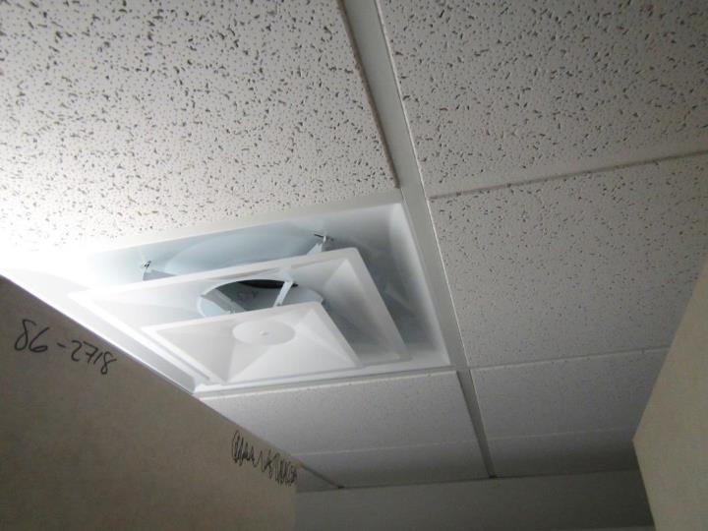
Supply air diffuser
Picture 2
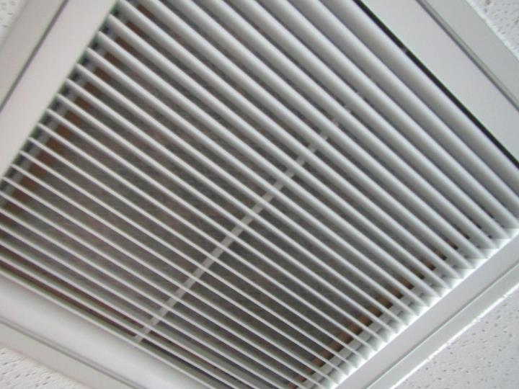
Ceiling-mounted return vent
Picture 3
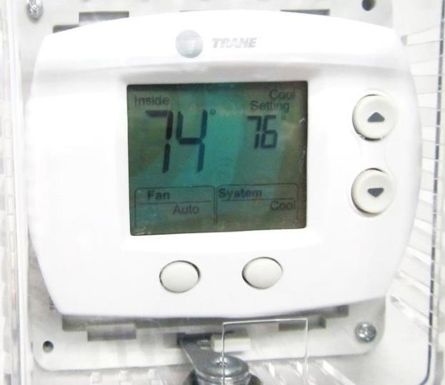
Thermostat showing fan “auto” setting
Picture 4
Water-damaged gypsum wallboard in room #119
Picture 5
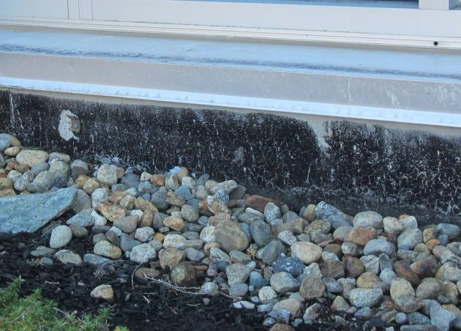
Concrete planter box containing mulch; note damage to foundation and water proofing
Picture 6
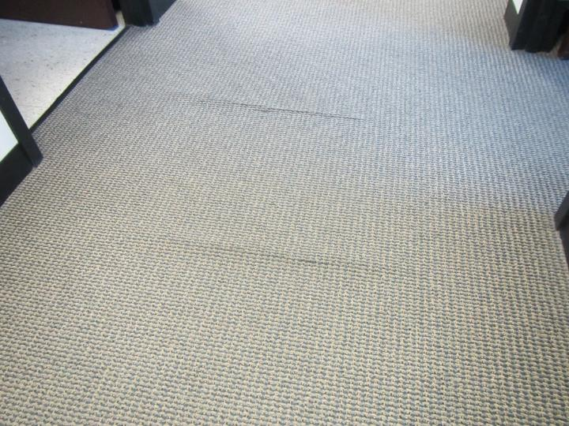
Water-damaged/rippled carpeting in Probation area
Picture 7
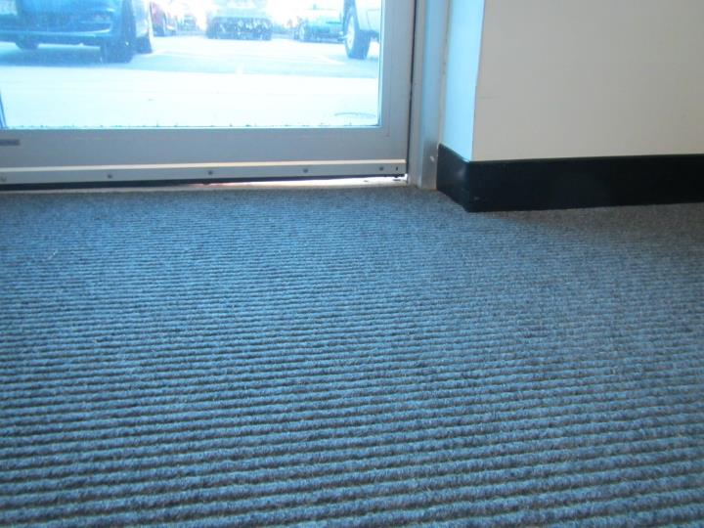
Large gap under exit door on lower level near Probation area
Picture 8
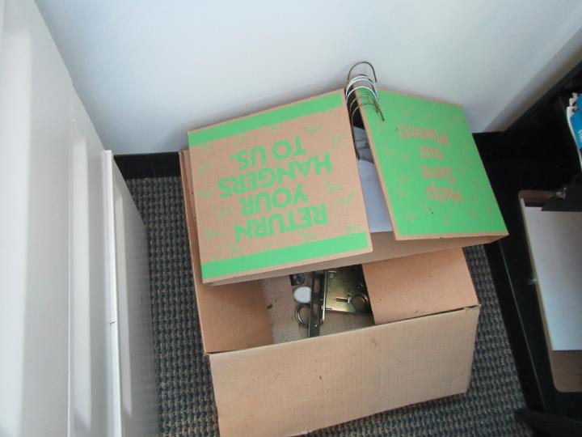
Porous items on floor in lower level
Picture 9
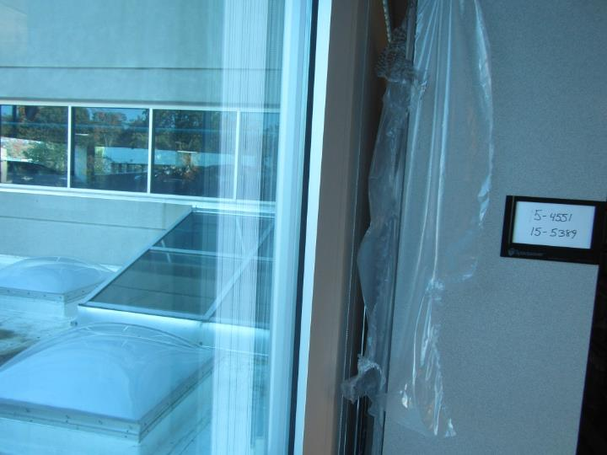
Plastic sheeting protecting records from former window leaks
Picture 10
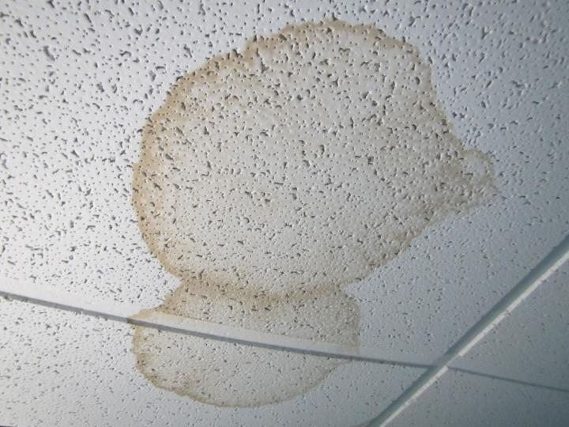
Water-damaged ceiling tiles
Picture 11
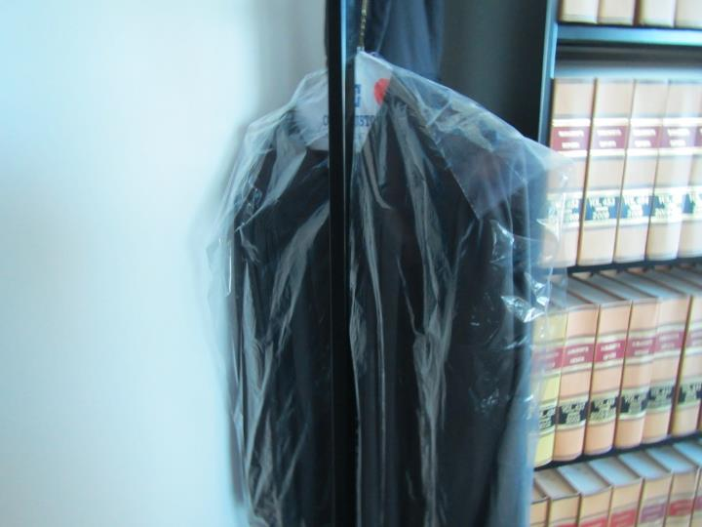
Dry cleaning stored in judge lobby

Location | Carbon  Dioxide  (ppm) | Carbon Monoxide  (ppm) | Temp  (°F) | Relative  Humidity  (%) | PM2.5  (µg/m³) | Occupants  in Room | Windows  Openable | Ventilation |  | Remarks
 |  |  |  |  |  |  |  | Supply | Exhaust
Background | 423 | ND | 61 | 40 | 10 | - | - | - | - | Clear
706 | 631 | ND | 76 | 37 | 1 | 1 | Y | Y | Y | Dry cleaning odor, HS
706 lobby | 550 | ND | 78 | 32 | 1 | 1 | Y | Y | Y | Dry cleaning, boxes on floor
7th floor elevator lobby | 622 | ND | 74 | 32 | 2 | 7 | N | Y | Y | Carpet soiled
731 | 676 | ND | 73 | 38 | 1 | 1 | Y | Y | Y
731 lobby | 716 | ND | 73 | 40 | 1 | 3 | Y | Y | Y
730 Courtroom | 752 | ND | 74 | 39 | 2 | 3 | Y | Y | Y | Soiled carpet, vinyl odor near window area
740 Courtroom | 441 | ND | 73 | 28 | 1 | 1 | Y | Y | Y
736 | 475 | ND | 72 | 33 | 1 | 1 | Y | Y | Y
717 | 518 | ND | 74 | 34 | 1 | 0 | Y | Y | Y
717 Lobby | 615 | ND | 74 | 37 | 1 | Y open | Y | Y | Y | heater & refrigerator
715 | 585 | ND | 76 | 37 | 1 | 0 | Y | Y | Y
Elevator lobby | 652 | ND | 73 | 35 | 1 | 4 | N | Y | Y
736 | 539 | ND | 73 | 36 | 1 | 1 | Y | Y | Y
736 Lobby | 472 | ND | 73 | 35 | 1 | 0 | Y | Y | Y
728 | 764 | ND | 73 | 40 | 1 | 0 | N | Y | Y
601 | 630 | ND | 72 | 36 | 1 | 0 | Y | Y | Y
607 | 578 | ND | 72 | 34 | 2 | 0 | N | Y | Y
608 | 548 | ND | 72 | 34 | 1 | 0 | N | Y | Y | Carpet
617 | 912 | ND | 76 | 38 | 2 | 1 | Y | Y | Y | AF odor, fan auto, DEM
617 Lobby | 733 | ND | 76 | 34 | 1 | 1 | Y | Y | Y | HS, CPs
615 | 741 | ND | 74 | 33 | 1 | 0 | Y | Y | Y
620 Courtroom | 551 | ND | 73 | 28 | 1 | 15 | Y | Y | Y
631 | 522 | ND | 73 | 34 | 1 | 1 | Y | Y | Y
631 lobby | 521 | ND | 73 | 34 | 1 | 1 | Y | Y | Y | WD CT
630 Courtroom | 641 | ND | 75 | 39 | 2 | 1 | Y | Y | Y
606 | 606 | ND | 77 | 28 | 2 | 3 | Y | Y | Y
606 Lobby | 525 | ND | 77 | 26 | 2 | 1 | Y | Y | Y
610 | 600 | ND | 77 | 28 | 2 | 1 | Y | Y | Y
636 | 486 | ND | 73 | 36 | 1 | 1 | Y | Y | Y
636 Lobby | 478 | ND | 73 | 35 | 1 | 1 | Y | Y | Y
635 Jury | 608 | ND | 73 | 39 | 1 | 0 | Y | Y | Y | WD CT x 2
514 | 633 | ND | 73 | 37 | 2 | 0 | N | Y | Y
514 Lobby | 631 | ND | 73 | 38 | 2 | 1 | Y | Y | Y
520 Courtroom | 466 | ND | 73 | 28 | 1 | 1 | Y | Y | Y
508 | 516 | ND | 72 | 35 | 1 | 1 | Y | Y | Y
508 Lobby | 489 | ND | 72 | 36 | 2 | 1 | Y | Y | Y
510 Courtroom | 461 | ND | 72 | 40 | 2 | 1 | Y | Y | Y
536 | 416 | ND | 72 | 33 | 1 | 0 | Y | Y | Y
535 | 437 | ND | 72 | 37 | 2 | 0 | Y | Y | Y
540 | 400 | ND | 70 | 30 | 1 | 0 | Y | Y | Y
529 | 452 | ND | 71 | 37 | 1 | 0 | Y | Y | Y
529 Lobby | 450 | ND | 70 | 37 | 1 | 0 | Y | Y | Y
530 | 466 | ND | 70 | 42 | 1 | 0 | Y | Y | Y
434 | 567 | ND | 72 | 36 | 1 | 1 | Y | Y | Y | AI
434 Lobby | 555 | ND | 72 | 35 | 1 | 1 | Y | Y | Y | WD CT in bathroom
440 Courtroom | 436 | ND | 71 | 29 | 1 | 1 | Y | Y | Y
427 | 613 | ND | 70 | 40 | 1 | 1 | Y | Y | Y | Fridge on carpet
427 Lobby | 675 | ND | 70 | 43 | 1 | 1 | Y | Y | Y
430 Courtroom | 1024 | ND | 71 | 42 | 1 | 1 (session break) | Y | Y | Y
404 | 520 | ND | 73 | 54 | 4 | 1 | Y | Y | Y
404 Lobby | 487 | ND | 73 | 32 | 1 | 4 | Y | Y | Y
406 | 529 | ND | 73 | 36 | 1 | 0 | N | Y | Y | WD CT, Missing CT
408 | 479 | ND | 73 | 38 | 1 | 0 | N | Y | Y
415 | 446 | ND | 73 | 31 | 1 | 0 | Y | Y | Y
415 Lobby | 426 | ND | 74 | 31 | 1 | 0 | Y | Y | Y
413 | 462 | ND | 74 | 34 | 1 | 0 | N | Y | Y
420 | 417 | ND | 74 | 28 | 1 | 1 | Y open | Y | Y
412 | 430 | ND | 74 | 33 | 1 | 0 | N | Y | Y
401 | 586 | ND | 74 | 30 | 3 | 0 | Y | Y | Y
Library –front | 575 | ND | 73 | 37 | 2 | 7 | Y | Y | Y
Library – rear/left | 501 | ND | 73 | 38 | 1 | 2 | Y | Y | Y | Carpet
Library –rear corner | 503 | ND | 73 | 38 | 1 | 1 | Y | Y | Y | Carpet
301 | 543 | ND | 74 | 37 | 2 | 2 | Y | Y | Y
Jury Pool | 554 | ND | 73 | 39 | 1 | 0 | Y | Y | Y
311 | 572 | ND | 73 | 41 | 1 | 0 | Y | Y | Y
Civil doc | 594 | ND | 74 | 35 | 2 | 0 | Y | Y | Y
213 | 538 | ND | 74 | 35 | 2 | 4 | Y | Y | Y
215 | 459 | ND | 74 | 30 | 1 | 0 | Y | Y | Y
216 | 461 | ND | 74 | 33 | 1 | 0 | Y | Y | Y
File room | 512 | ND | 75 | 35 | 1 | 2 | Y | Y | Y | File odor, carpet
Civil Clerk File room rear | 542 | ND | 74 | 35 | 1 | 1 | Y | Y | Y | Reported water infiltration during wind driven rain, plastic sheeting in place
Docket room | 613 | ND | 74 | 38 | 2 | 5 | Y | Y | Y
-Open area | 520 | ND | 74 | 35 | 2 | 3 | Y | Y | Y | AI, plants
106 | 585 | ND | 72 | 33 | 3 | 5 | Y | Y | Y | HS
103 | 578 | ND | 72 | 34 | 2 | 1 | Y | Y | Y
102 | 635 | ND | 73 | 34 | 2 | 1 | Y | Y | Y | Previous flooding reports, leaks from rear door, WD carpeting
Probation hallway | - | - | - | - | - | - | - | - | - | WD carpeting, rippled
134 | 567 | ND | 67 | 47 | 1 | 0 | Y | Y | Y
132 | 567 | ND | 71 | 41 | 2 | 0 | N | Y | Y | Vinyl tile
Security | 477 | ND | 71 | 41 | 2 | 0 | N | Y | Y | Vinyl tile, DEM, food, HS, AF
Lockup | 468 | ND | 72 | 31 | 1 | 4 | N | Y | Y | Floor drain
118 Break | 572 | ND | 72 | 41 | 1 | 0 | N | Y | Y | Vinyl flooring
120 | 615 | ND | 72 | 40 | 3 | 1 | N | Y | Y
112 | 653 | ND | 73 | 42 | 2 | 1 | N | Y | Y | HS carpet, AI, boxes on floor
Conference | 623 | ND | 72 | 43 | 5 | 0 | N | Y | Y | Boxes on slab, HS
119 | 589 | ND | 72 | 45 | 5 | 0 | N | Y | Y | WD gypsum wallboard, WD carpet, (window or wall leak), wall = 18% moisture, carpet = 26-46% moisture
104 | 532 | ND | 73 | 32 | 2 | 0 | N | Y | Y
135 | 529 | ND | 69 | 34 | 2 | 0 | Y | Y | Y
Probation cubes | 552 | ND | 70 | 43 | 1 | 4 | Y | Y | Y | Rippled carpet
127 | 544 | ND | 72 | 40 | 3 | 0 | N | Y | Y
Interview 4 | 604 | ND | 72 | 37 | 2 | 0 | N | Y | Y | WD CT
Interview 5 lockup | 501 | ND | 72 | 32 | 2 | 0 | N | Y | N
Cell block 112 | 470 | ND | 72 | 32 | 3 | 0 | N | Y | Y

