INDOOR AIR QUALITY ASSESSMENT

Middleton Town Hall
48 South Main Street
Middleton, MA

Prepared by:
Massachusetts Department of Public Health
Bureau of Environmental Health
Indoor Air Quality Program
September 2016

Background
Building: | Middleton Town Hall (MTH)
Address: | 48 South Main Street, Middleton
Assessment Requested by: | Middleton Board of Health
Reason for Request: | Odor complaints and general indoor air quality (IAQ)
Date of Assessment: | August 17, 2016 and August 23, 2016
Massachusetts Department of Public Health/Bureau of Environmental Health (MDPH/BEH) Staff Conducting Assessment: | Jason Dustin, Environmental Analyst/Inspector, IAQ Program
Building Description: | MTH occupies a two-story, wooden structure built in approximately 1837. Exterior has wood siding, with a peaked asphalt roof. A small addition in the rear has a newer, membrane flat roof.
Building Population: | Approximately 14 staff members work in the building with members of the public visiting daily.
Windows: | Most openable

Methods
Please refer to the IAQ Manual for methods, sampling procedures, and interpretation of results (MDPH, 2015).

IAQ Testing Results
The following is a summary of indoor air testing results (Table 1).
- Carbon dioxide levels were below 800 parts per million (ppm) in most areas assessed. Windows were closed and air conditioning (AC) units were shut off in the two areas where slight elevations were noted.
- Temperature was within the recommended range of 70°F to 78°F in all areas assessed.
- Relative humidity was within or just below the recommended range of 40 to 60% in all areas assessed.
- Carbon monoxide levels were non-detectable (ND) in all areas assessed.
- Fine particulate matter (PM2.5) concentrations measured were below the National Ambient Air Quality Standard (NAAQS) level of 35 μg/m³ in all areas assessed.
- Total Volatile Organic Compounds (TVOCs) were ND in all locations assessed.

Ventilation
A heating, ventilating, and air conditioning (HVAC) system has several functions. First it provides heating and, if equipped, cooling. Second, it is a source of fresh air. Finally, an HVAC system will dilute and remove normally-occurring indoor environmental pollutants by not only introducing fresh air, but by filtering the airstream and removing stale air to the outdoors via exhaust ventilation. Even if an HVAC system is operating as designed, point sources of respiratory irritants may be present and produce symptoms in sensitive individuals. The following analysis examines and identifies components of the HVAC system and likely sources of respiratory irritant/allergen exposure due to water damage, aerosolized dust, and/or chemicals found in the indoor environment.
The MTH building originally had a gravity ventilation system, which consisted of grated, louvered, wall-mounted exhaust vents and floor-level supply vents. Air shafts connected the floor vents to “air-mixing” chambers in the basement. Fresh air from the outdoors was drawn into the air-mixing chambers. Under operation, heating elements located in the base of the ventilation shaft of the air mixing chamber would warm the fresh air, which causes the air to rise up the ventilation shaft (via the stack effect) and be distributed to rooms by floor-level supply vents. Sinking cool air and rising warm air in the room would create air movement. Warm, stale air would exit rooms via wall-mounted exhaust vents connected to chimney-like rooftop vents. In short, the natural gravity system provided heating, fresh air and exhaust ventilation. Large radiators located under windows provided supplemental heat and facilitated air movement.
The MTH does not currently have mechanical fresh air ventilation in most occupied areas. The Collector’s and Treasurer’s offices have been retrofitted to include ceiling-mounted energy recovery ventilator (ERV) units which supply tempered fresh air and exhaust stale air in these two areas (Pictures 1 and 2). MTH staff reported that these units operate continuously during occupied hours. All other areas rely on open windows or window AC units to bring in fresh air. In addition, the second floor restroom was noted to lack local exhaust ventilation. Without exhaust ventilation, any common indoor air pollutants generated in the building, including carbon dioxide, water vapor, and odors will accumulate within the building.

Microbial/Moisture Concerns
BEH staff noted water-damaged ceiling tiles in some areas (Picture 3). MTH staff reported that these stains were likely from historic leaks. The US Environmental Protection Agency (US EPA) and the American Conference of Governmental Industrial Hygienists (ACGIH) recommends that porous materials (e.g., wallboard, ceiling tiles) be dried with fans and heating within 24 to 48 hours of becoming wet (US EPA, 2008; ACGIH, 1989). If porous materials are not dried within this time frame, mold growth may occur.
The Collector’s office was observed to have a window AC unit which had accumulated debris and possible microbial colonization in the supply vent (Picture 4). These units should be cleaned regularly to avoid dust/debris accumulation. Windows should remain closed during humid weather while AC units are operating to avoid chronic condensation and microbial growth. In addition, any washed filters should be allowed to dry completely before replacing and operating the units.
The basement was noted to have an open sump pump (Picture 5). MDPH typically recommends having a tightly sealed sump cover to prevent moisture, odors, and pests from entering the building.
Plants were observed in a few areas. Plants can be a source of pollen and mold, which are respiratory irritants to some individuals. Plants should be properly maintained and equipped with drip pans to prevent water damage to porous materials. Plants should also be located away from air diffusers to prevent the aerosolization of dirt, pollen, and mold.
The old gravity ventilation system should be inspected for pathways which lead to occupied spaces. Some gaps around piping in the mixing chambers were noted (Picture 6). These gaps may allow moisture and odors to travel to occupied areas if the old vents are not sealed properly. Some abandoned vents in occupied areas were observed to be blocked with a porous material (Picture 7). These vents should be sealed with either cement board or other nonporous building material and caulking to render them airtight and moisture resistant.

Other IAQ Evaluations

VOCs
Exposure to low levels of total volatile organic compounds (TVOCs) may produce eye, nose, throat, and/or respiratory irritation in some sensitive individuals. To determine if VOCs were present, BEH staff measured TVOCs in occupied areas. No detectable levels of TVOCs were found. Staff also examined rooms for products containing VOCs and noted air fresheners, hand sanitizers, cleaners, and dry erase materials in use within the building. All of these products have the potential to be irritants to the eyes, nose, throat, and respiratory system of sensitive individuals. Sensory irritation is of particular concern in offices with no functioning exhaust ventilation.

Odor Investigation
The primary reason for this visit was to investigate the source of a “burnt plastic” odor. MTH staff reported that odors have been occurring for approximately three years. MTH staff have been investigating and attempting to mitigate these odors since their inception. Prior to the BEH visit, an industrial hygienist/consultant was hired to investigate and remedy the issue. The consultant reportedly found elevated TVOC levels within the wall cavities and gypsum wall board. Wallboard is typically not a source for TVOCs but may act as a reservoir to store and later off gas TVOCs that were previously absorbed from another source. The consultant recommended venting the wall cavities to the outside (Picture 8) and installing ERV units to provide for additional fresh air/exhaust ventilation to dilute TVOC concentrations within the most affected areas.
During the first visit, on August 17, BEH staff detected a moderate plastic odor in halls and offices on the south side of the MTH on both the first and second floors. This visit was made during the afternoon since reports of the odor were noted to be strongest at these times. No detectable levels of TVOCs were measured during the visit and the source of the odor could not be isolated at this time as it was pervasive in the Southern areas of the MTH.
A second visit was made on the morning of August 23. BEH staff did not detect an odor in South or Western facing offices. While opening windows, BEH staff did note a strong plastic odor in many areas. A moderate plastic odor was also detected in the East facing Town Administrator office suite. This confirmed reports that the odor is noted in the morning in East facing spaces, in the early afternoon in South facing spaces, and then in later afternoon in Western facing offices. MTH staff reported that new window jamb liners were previously installed and that storm windows were installed approximately 3 years ago. This coincided with the reports of when the odor first began. It is likely that the placement of storm windows over the existing windows and plastic jamb liners created a condition where excessive heat is allowed to build up and accelerate the off gassing of the softer window jamb liners (Pictures 9 and 10). The window screens may be a contributing factor as well since they are also exposed to this solar heating. The source of the odor is likely an additive or plasticizer that is semi-volatile in nature thus cannot be measured during TVOC testing. Also, many plastic additives have very low odor thresholds so that they will be detected by smell long before reaching levels of concern. However, low levels of TVOCs and semi-volatile organic compounds (SVOCs) can have irritant effects.
With the assistance of MTH personnel, BEH staff opened all of the Southern/Western storm windows at both the tops and bottoms of the windows to allow for venting between the windows and prevent the excessive heat buildup from the sun. This should prevent the off gassing of plastic odors back into occupied areas until a permanent remedy such as storm window removal and replacement window installation is feasible. East facing storm windows should also be vented in this manner to avoid continued odor issues in those areas. It should be noted that some windows were in disrepair and could not be opened.

Other Conditions
Some occupants reported that mice were a problem at the MTH. MDPH typically recommends adopting a comprehensive integrated pest management program (IPM) to more effectively control rodents and other pests which can trigger allergic reactions in some people.
Bird droppings were observed in a South facing window sill in the Accountant office. Birds and bird wastes can be sources of allergens and microbial contamination. The bird waste should be removed to avoid aerosolizing this material when this window is opened.
Dehumidifiers and air purifiers were noted in the MTH (Picture 11). These appliances should be maintained in accordance with manufacturer’s instructions, including filter changing/cleaning, so that they don’t become a source of irritants.

Conclusions/Recommendations
Based on observations at the time of assessment, a two-phase approach is required for remediation. The first consists of short-term measures to improve air quality and the second consists of long-term measures that will require planning and resources to adequately address overall concerns.

Short-term Recommendations:
- Keep tops and bottoms of storm windows open to allow for ventilation between storm windows and building windows. This should prevent odors due to excessive heat buildup and off gassing from soft vinyl window jamb liners and or window screens.
- Use openable windows where possible to provide increased fresh air in occupied areas. Ensure that all windows are closed tightly at the end of the day. Do not open windows while AC is operating to prevent condensation.
- Continue to utilize the two ceiling-mounted ERV units to provide fresh air and exhaust ventilation. Maintain these units according to manufacturer recommendations.
- Clean bird waste in the South facing window sill of the Town Accountant’s office.
- Repair any broken windows, sashes, and screens where possible to restore functionality and allow windows to open and close tightly.
- Thoroughly clean the AC units of any accumulated dust and debris. Follow manufacturer recommendations for proper maintenance including regular filter cleaning.
- Replace water-damaged ceiling tiles. Monitor these areas to confirm that historic water leaks have been properly repaired.
- Consider installing exhaust fans in restrooms which are not equipped with them to remove odors and moisture outdoors.
- Inspect the old gravity ventilation system for any gaps in the mixing chamber which may lead to occupied areas. Also, consider replacing material used to block the old vents with cement board or other nonporous material that is resistant to moisture. Use caulking or sealant to render these vent openings and gaps airtight to avoid them serving as pathways from the unconditioned basement area.
- Reduce the use of VOC-containing cleaners, sanitizers, and scented products, especially given the lack of mechanical ventilation in most of the building. Consider using high efficiency particulate arrestance (HEPA)-equipped vacuuming, wet wiping, and soap and water for regular cleaning tasks to prevent the introduction of VOCs and other potentially irritating chemicals into the indoor air.
- Consider adopting an integrated pest management (IPM) plan to effectively control reported mice issues and other pests. The guideline can be found at: http://www.mass.gov/eea/docs/agr/pesticides/publications/ipm-kit-for-bldg-mgrs.pdf
- Ensure that dehumidifiers and air purifiers are maintained in accordance with manufacturer’s instructions.
- Keep plants in good condition, avoid overwatering, and avoid placing them on porous items such as carpets or paper.
- Consider installing a sealed sump pump cover to prevent moisture, odors, and pests from entering the building.
- Refer to resource manual and other related IAQ documents located on the MDPH’s website for further building-wide evaluations and advice on maintaining public buildings. These documents are available at: http://mass.gov/dph/iaq.

Long-term recommendations:
- Consider removing the storm windows and installing replacement windows on the South and Western sides of the MTH and other areas affected by odor (Town Manager’s suite).
- Consult with an HVAC engineer to determine the feasibility of installing an air handling unit for fresh air supply and exhaust ventilation throughout the MTH.

References
ACGIH. 1989. Guidelines for the Assessment of Bioaerosols in the Indoor Environment. American Conference of Governmental Industrial Hygienists, Cincinnati, OH.
Massachusetts Department of Public Health (MDPH). 2015. Indoor Air Quality Manual: Chapters I-III. Available at: http://www.mass.gov/eohhs/gov/departments/dph/programs/environmental-health/exposure-topics/iaq/iaq-manual/
United States Environmental Protection Association (US EPA). 2008. Mold Remediation in Schools and Commercial Buildings. Available at: https://www.epa.gov/sites/production/files/2014-08/documents/moldremediation.pdf

Picture 1
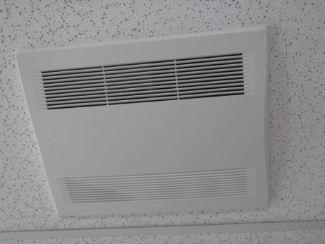
Energy Recovery Ventilator (ERV)
Picture 2
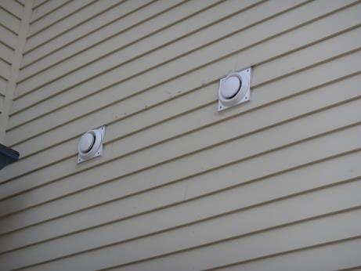
Intake and exhaust vents for ERV unit
Picture 3
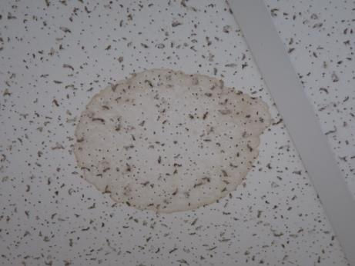
Water-damaged ceiling tile
Picture 4
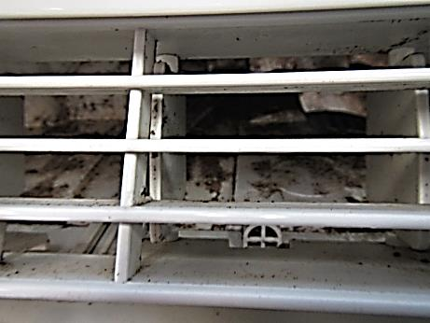
AC unit with debris/possible microbial colonization
Picture 5
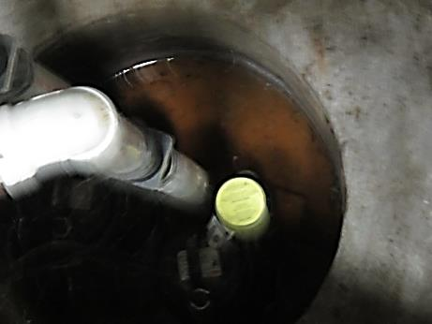
Open sump pit with no cover
Picture 6
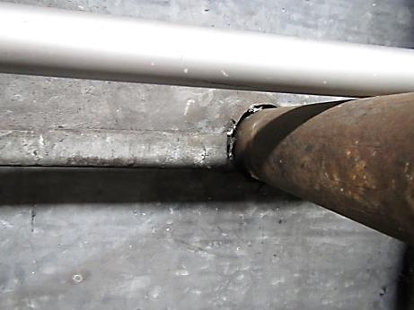
Abandoned gravity ventilation chamber with gaps around old steam pipes
Picture 7
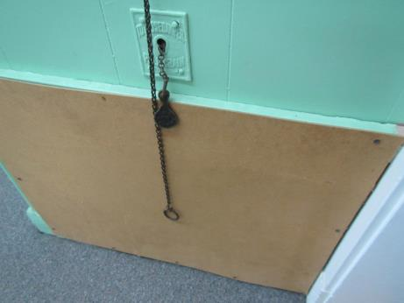
Abandoned gravity wall vent blocked with porous fiber board
Picture 8
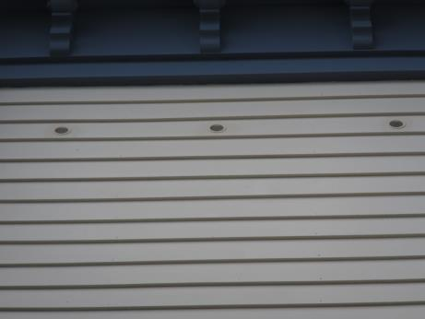
Wall cavity vents on the exterior of the MTH
Picture 9
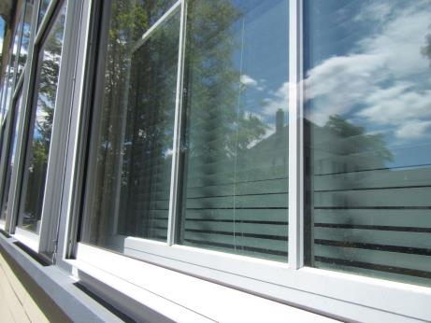
South facing windows with storm windows closed over aluminum clad/wood windows
Picture 10
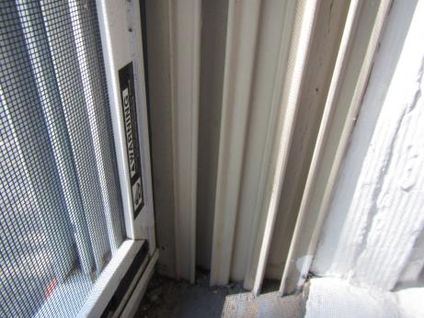
Flexible vinyl jamb liner that is heated between storm and building windows
Picture 11
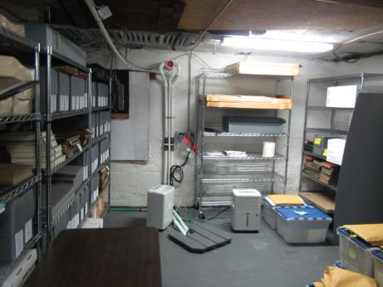
Dehumidifiers in use in the basement of the MTH

Location | Carbon  Dioxide  (ppm) | Carbon Monoxide  (ppm) | Temp  (°F) | Relative  Humidity  (%) | PM2.5  (µg/m³) | TVOCs  (ppm) | Occupants  in Room | Windows  Openable | Ventilation |  | Remarks
 |  |  |  |  |  |  |  |  | Supply | Exhaust
Background | 357 | ND | 83 | 52 | 10 | ND | - | - | - | - | Sunny, breezy, industrial area
Town Clerk | 852 | ND | 76 | 46 | 12 | ND | 3 | Y | Y | Y | Ventilator unit, AC off, HS, WD CT, windows closed
Collectors | 555 | ND | 76 | 53 | 9 | ND | 3 | Y | Y | Y | Ventilator unit, plants, HS, AC unit on
Registrars | 453 | ND | 77 | 54 | 12 | ND | 0 | Y | N | N | AC, records, AI
Town Accountant-front office | 843 | ND | 77 | 51 | 16 | ND | 0 | Y | N | N | Plastic odor, AC off, windows closed
Town Accountant-rear office | 788 | ND | 77 | 50 | 14 | ND | 0 | Y | N | N | Plastic odor, bird droppings in window well
Assessor’s | 639 | ND | 76 | 43 | 10 | ND | 1 | Y | N | N
Assessors rear office | 683 | ND | 72 | 46 | 8 | ND | 1 | Y | N | N | AC, carpet
Asst. Town Manager | 445 | ND | 72 | 37 | 8 | ND | 3 | Y | N | N | AC, HS
Town Manager | 481 | ND | 76 | 42 | 4 | ND | 1 | Y | N | N | Carpet
Veterans office | 756 | ND | 76 | 57 | 10 | ND | 0 | Y | N | N

