Background/Introduction

INDOOR AIR QUALITY ASSESSMENT

Milford High School
31 West Fountain Street
Milford, MA

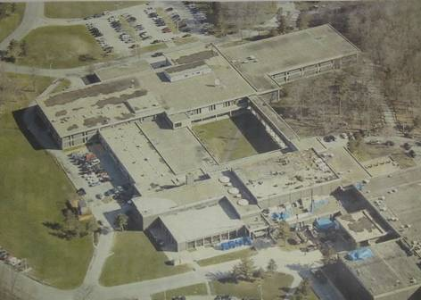

Prepared by:
Massachusetts Department of Public Health
Bureau of Environmental Health
Indoor Air Quality Program
June 2015
At the request of Mr. Paul Mazzuchelli, Health Officer, Milford Board of Health, the Massachusetts Department of Public Health (MDPH), Bureau of Environmental Health (BEH) provided assistance and consultation regarding indoor air quality (IAQ) concerns at Milford High School (MHS) located at 31 West Fountain Street, Milford, MA. On April 9, 2015, Cory Holmes, Environmental Analyst/Regional Inspector and Ruth Alfasso, Environmental Engineer/Inspector in BEH’s IAQ Program visited the MHS to conduct an IAQ assessment. The assessment was coordinated through Mr. Rob Quinn, Facilities Director, Milford Public Schools and focused on classrooms and common areas of the Language Department, which was the locus of concerns.
The school is a two-story brick and concrete building built in the late 1960s/early 1970s. It was reported that mechanical ventilation control systems were upgraded between 2004-2007. Classrooms have tiled floors and drop ceiling tile systems. Perimeter classrooms have openable windows. Interior rooms in the center of the wing do not have windows and therefore rely solely on mechanical ventilation for the introduction of fresh/outside air and air exchange.

Methods
Air tests for carbon monoxide, carbon dioxide, temperature and relative humidity were conducted with the TSI, Q-Trak, IAQ Monitor, Model 7565. Air tests for airborne particle matter with a diameter less than 2.5 micrometers were taken with the TSI, DUSTTRAK™ Aerosol Monitor Model 8532. BEH/IAQ staff also performed a visual inspection of building materials for water damage and/or microbial growth.

Results
The school houses approximately 1,200 students in grades 9 through 12 with a staff of approximately 150. Tests were taken during normal operations. Results appear in Table 1.

Discussion

Ventilation
It can be seen from Table 1 that carbon dioxide levels were above 800 parts per million (ppm) in 4 of 8 areas surveyed at the time of the assessment, indicating a lack of air exchange in half the areas surveyed. Please note that a few areas were vacant or sparsely populated at the time tests were taken, which can greatly reduce carbon dioxide levels. Carbon dioxide levels would be expected to be higher with full occupancy.
Outside air for the some interior classrooms and the Language office is provided by rooftop air handling units (AHUs). Fresh air is drawn in through intakes, where it is filtered, heated or cooled and ducted to wall (Picture 1) or ceiling-mounted supply diffusers. Return air is drawn in through wall (Picture 1) or ceiling-mounted return vents and ducted back to AHUs.
Fresh air in perimeter classrooms is supplied by unit ventilators (univents) (Picture 2). A univent is designed to draw air from outdoors through a fresh air intake located on the exterior wall of the building (Picture 3). Note that some interior classrooms have univents that are ducted to the roof for introduction of fresh air. Return air is drawn through an air intake located at the base of each unit where fresh and return air are mixed, filtered, heated and provided to classrooms through an air diffuser located in the top of the unit (Figure 1). Univents were found obstructed with items in a few areas (Pictures 4 and 5). Not only does this inhibit the introduction of fresh air to occupants, but it can also be detrimental to the machinery. In order for univents to provide fresh air as designed, they must remain free of obstructions. Importantly, these units must remain on and be allowed to operate while rooms are occupied.
Although it was reported that mechanical ventilation control systems have been replaced (2004-2007), is important to note that univents are original to the building’s construction (late 1960s/early 1970s), which makes them over 45 years old. Efficient function of equipment of this age is difficult to maintain, since compatible replacement parts are often unavailable. According to the American Society of Heating, Refrigeration and Air-Conditioning Engineering (ASHRAE), the service life for a unit heater, hot water or steam is 20 years, assuming routine maintenance of the equipment (ASHRAE, 1991). Despite attempts to maintain the equipment, the optimal operational lifespan of this equipment has been exceeded.
To maximize air exchange, the MDPH recommends that both supply and exhaust ventilation operate continuously during periods of occupancy. In order to have proper ventilation with a mechanical supply and exhaust system, the systems must be balanced to provide an adequate amount of fresh air to the interior of a room while removing stale air from the room. It is recommended that heating, ventilating and air conditioning (HVAC) systems be re-balanced every five years to ensure adequate air systems function (SMACNA, 1994). The date of the last balancing of these systems was not available at the time of the assessment.
Minimum design ventilation rates are mandated by the Massachusetts State Building Code (MSBC). Until 2011, the minimum ventilation rate in Massachusetts was higher for both occupied office spaces and general classrooms, with similar requirements for other occupied spaces (BOCA, 1993). The current version of the MSBC, promulgated in 2011 by the State Board of Building Regulations and Standards (SBBRS), adopted the 2009 International Mechanical Code (IMC) to set minimum ventilation rates. Please note that the MSBC is a minimum standard that is not health-based. At lower rates of cubic feet per minute (cfm) per occupant of fresh air, carbon dioxide levels would be expected to rise significantly. A ventilation rate of 20 cfm per occupant of fresh air provides optimal air exchange resulting in carbon dioxide levels at or below 800 ppm in the indoor environment in each area measured. MDPH recommends that carbon dioxide levels be maintained at 800 ppm or below. This is because most environmental and occupational health scientists involved with research on IAQ and health effects have documented significant increases in indoor air quality complaints and/or health effects when carbon dioxide levels rise above the MDPH guidelines of 800 ppm for schools, office buildings and other occupied spaces (Sundell et al., 2011). The ventilation must be on at all times that the room is occupied. Providing adequate fresh air ventilation with open windows and maintaining the temperature in the comfort range during the cold weather season is impractical. Mechanical ventilation is usually required to provide adequate fresh air ventilation.
Carbon dioxide is not a problem in and of itself. It is used as an indicator of the adequacy of the fresh air ventilation. As carbon dioxide levels rise, it indicates that the ventilating system is malfunctioning or the design occupancy of the room is being exceeded. When this happens, a buildup of common indoor air pollutants can occur, leading to discomfort or health complaints. The Occupational Safety and Health Administration (OSHA) standard for carbon dioxide is 5,000 parts per million parts of air (ppm). Workers may be exposed to this level for 40 hours/week, based on a time-weighted average (OSHA, 1997).
The MDPH uses a guideline of 800 ppm for publicly occupied buildings. A guideline of 600 ppm or less is preferred in schools due to the fact that the majority of occupants are young and considered to be a more sensitive population in the evaluation of environmental health status. Inadequate ventilation and/or elevated temperatures are major causes of complaints such as respiratory, eye, nose and throat irritation, lethargy and headaches. For more information concerning carbon dioxide, consult Appendix A.
Indoor temperature measurements the day of the assessment ranged from 67°F to 72°F (Table 1), which were within the MDPH recommended comfort range with the exception of the Language Arts office. The MDPH recommends that indoor air temperatures be maintained in a range of 70°F to 78°F in order to provide for the comfort of building occupants. In many cases concerning indoor air quality, fluctuations of temperature in occupied spaces are typically experienced, even in a building with an adequate fresh air supply.
The relative humidity measured in the building during the assessment ranged from 27 to 33 percent, which was below the MDPH recommended comfort range in all areas surveyed (Table 1). The MDPH recommends a comfort range of 40 to 60 percent for indoor air relative humidity. Relative humidity levels in the building would be expected to drop during the winter months due to heating. The sensation of dryness and irritation is common in a low relative humidity environment. Low relative humidity is a very common problem during the heating season in the northeast part of the United States.

Microbial/Moisture Concerns
Water-damaged ceiling tiles were observed in several classrooms and hallway areas (Picture 6; Table 1). These indicate current/historic roof leaks, plumbing leaks or other water infiltration. Water-damaged ceiling tiles can provide a source of mold and should be replaced after a water leak is discovered and repaired.
A small refrigerator in room C-62 was examined and found to have visible mold growth/staining of gaskets (Picture 7). The gaskets are composed of non-porous material that should be cleaned and disinfected using an appropriate antimicrobial. A clogged sink was observed in classroom C-58 (Picture 8). This sink should be repaired (or properly capped if not needed) to prevent overflow/stagnant water, which can lead to water damage/mold conditions. In contrast, dry traps can result in the backup of sewer gas/odors from the plumbing system into the classroom.

Other IAQ Evaluations
Indoor air quality can be negatively influenced by the presence of respiratory irritants, such as products of combustion. The process of combustion produces a number of pollutants. Common combustion emissions include carbon monoxide, carbon dioxide, water vapor and smoke (fine airborne particle material). Of these materials, exposure to carbon monoxide and particulate matter with a diameter of 2.5 micrometers (μm) or less (PM2.5) can produce immediate, acute health effects upon exposure. To determine whether combustion products were present in the indoor environment, BEH/IAQ staff obtained measurements for carbon monoxide and PM2.5.

Carbon Monoxide
Carbon monoxide is a by-product of incomplete combustion of organic matter (e.g., gasoline, wood and tobacco). Exposure to carbon monoxide can produce immediate and acute health effects. Several air quality standards have been established to address carbon monoxide and prevent symptoms from exposure to these substances. The MDPH established a corrective action level concerning carbon monoxide in ice skating rinks that use fossil-fueled ice resurfacing equipment. If an operator of an indoor ice rink measures a carbon monoxide level over 30 ppm, taken 20 minutes after resurfacing within a rink, that operator must take actions to reduce carbon monoxide levels (MDPH, 1997).
The American Society of Heating Refrigeration and Air-Conditioning Engineers (ASHRAE) has adopted the National Ambient Air Quality Standards (NAAQS) as one set of criteria for assessing indoor air quality and monitoring of fresh air introduced by HVAC systems (ASHRAE, 1989). The NAAQS are standards established by the US EPA to protect the public health from six criteria pollutants, including carbon monoxide and particulate matter (US EPA, 2006). As recommended by ASHRAE, pollutant levels of fresh air introduced to a building should not exceed the NAAQS levels (ASHRAE, 1989). The NAAQS were adopted by reference in the Building Officials & Code Administrators (BOCA) National Mechanical Code of 1993 (BOCA, 1993), which is now an HVAC standard included in the Massachusetts State Building Code (SBBRS, 2011). According to the NAAQS, carbon monoxide levels in outdoor air should not exceed 9 ppm in an eight-hour average (US EPA, 2006).
Carbon monoxide should not be present in a typical, indoor environment. If it is present, indoor carbon monoxide levels should be less than or equal to outdoor levels. On the day of the assessment, outdoor carbon monoxide concentrations were measured at 1.2 ppm (Table 1), most likely due to vehicle exhaust/parking lot activity. No measurable levels of carbon monoxide were detected inside the building (Table 1).

Particulate Matter
The US EPA has established NAAQS limits for exposure to particulate matter. Particulate matter includes airborne solids that can be irritating to the eyes, nose and throat. The NAAQS originally established exposure limits to PM with a diameter of 10 μm or less (PM10). In 1997, US EPA established a more protective standard for fine airborne particulate matter with a diameter of 2.5 μm or less (PM2.5). This more stringent PM2.5 standard requires outdoor air particle levels be maintained below 35 μg/m³ over a 24-hour average (US EPA, 2006). Although both the ASHRAE standard and BOCA Code adopted the PM10 standard for evaluating air quality, MDPH uses the more protective PM2.5 standard for evaluating airborne PM concentrations in the indoor environment.
Outdoor PM2.5 concentrations were measured at 18 μg/m³ (Table 1). PM2.5 levels measured in the building ranged from 2 to 20 μg/m³ (Table 1), which were below the NAAQS PM2.5 level of 35 μg/m³. Frequently, indoor air levels of particulate matter (including PM2.5) can be at higher levels than those measured outdoors. A number of activities that occur indoors and/or mechanical devices can generate particulate matter during normal operations. Sources of indoor airborne particulate matter may include but are not limited to particles generated during the operation of fan belts in the HVAC system, use of stoves and/or microwave ovens in kitchen areas; use of photocopiers, fax machines and computer printing devices; operation of an ordinary vacuum cleaner and heavy foot traffic indoors.

Volatile Organic Compounds
Indoor air concentrations can be greatly impacted by the use of products containing volatile organic compounds (VOCs). VOCs are carbon-containing substances that have the ability to evaporate at room temperature. Frequently, exposure to low levels of total VOCs (TVOCs) may produce eye, nose, throat and/or respiratory irritation in some sensitive individuals. For example, chemicals evaporating from a paint can stored at room temperature would most likely contain VOCs. In an effort to identify materials that can potentially increase indoor VOC concentrations, BEH/IAQ staff examined rooms for products containing these respiratory irritants.
Classrooms contained dry erase boards and related materials. Materials such as dry erase markers and dry erase board cleaners may contain VOCs, such as methyl isobutyl ketone, n-butyl acetate and butyl-cellusolve (Sanford, 1999), which can be irritating to the eyes, nose and throat.

Other Conditions
Other conditions that can affect IAQ were observed during the assessment. The type of filter medium observed to be in univents at the MHS provides minimal filtration (Picture 9). The dust spot efficiency is the ability of a filter to remove particulate matter of a certain diameter from air passing through the filter. Filters that have been determined by ASHRAE to meet its standard for a dust spot efficiency of a minimum of 40 percent would be sufficient to reduce many airborne particulate matter (Thornburg, D., 2000; MEHRC, 1997; ASHRAE, 1992). Pleated filters with a Minimum Efficiency Reporting Value dust-spot efficiency of 9 or higher are recommended. Note that increasing filtration can reduce airflow (called pressure drop), which can subsequently reduce the efficiency of the unit due to increased resistance. Prior to any increase of filtration, each univent should be evaluated by a ventilation engineer to ascertain whether it can maintain function with more efficient filters.
In many classrooms, large numbers of items were on floors, windowsills, tabletops, counters, bookcases and desks, which provide a source for dusts to accumulate (Pictures 10 through 13). These items (e.g., papers, folders, boxes) make it difficult for custodial staff to clean. Items should be relocated and/or be cleaned periodically to avoid excessive dust build up. In addition, dust and debris can accumulate on flat surfaces (e.g., desktops, shelving and carpets) in occupied areas and subsequently be re-aerosolized causing further irritation.
A number of air diffusers, exhaust/return vents, personal fans and in particular; univents (exterior and interiors) were found to have accumulated dust/debris (Pictures 14 and 15; Table 1). Re-activated univents/supply vents and fans can aerosolize dust/materials accumulated in equipment or on vents/fan blades. If exhaust vents are not functioning, backdrafting can occur, which can re-aerosolize accumulated dust particles.

Conclusions/Recommendations
In view of the findings at the time of the visit, the following recommendations are made:
- Operate all supply and exhaust ventilation systems throughout the building continuously during periods of occupancy to maximize air exchange. Remove obstructions from the top and front of univents.
- Adjust the percentage of fresh air supplied to and/or exhausted by the HVAC system to improve air exchange in areas where carbon dioxide was measured over 800 ppm.
- Close classroom doors for proper operation of mechanical ventilation system/air exchange.
- Consider capital plans for the future to replace air handling equipment that are past their useful service life (e.g., univents, rooftop AHUs). Consider contacting an HVAC engineering firm for a complete building-wide assessment of all ventilation systems and controls. Based on the age, physical condition and availability of parts for ventilation components, such an evaluation is necessary to determine the operability and feasibility of repairing/replacing the equipment for future use.
- Change filters for air handling equipment (univents and AHUs) 2-4 times a year. Vacuum interior of units prior to activation to prevent the aerosolization of dirt, dust and particulate matter. Ensure filters fit flush in their racks with no spaces in between allowing bypass of unfiltered air into the unit.
- Consider replacing existing filters with properly fitting disposable filters with a greater dust-spot efficiency (e.g., MERV 9). Prior to any increase of filtration, each piece of air handling equipment should be evaluated by a ventilation engineer as to whether it can maintain function with more efficient filters.
- Consider adopting a balancing schedule of every 5 years for all mechanical ventilation systems, as recommended by ventilation industrial standards (SMACNA, 1994).
- For buildings in New England, periods of low relative humidity during the winter are often unavoidable. Therefore, scrupulous cleaning practices should be adopted to minimize common indoor air contaminants whose irritant effects can be enhanced when the relative humidity is low. To control dusts, a high efficiency particulate arrestance (HEPA) filter equipped vacuum cleaner in conjunction with wet wiping of all surfaces is recommended. Avoid the use of feather dusters. Drinking water during the day can help ease some symptoms associated with a dry environment (throat and sinus irritations).
- Ensure roof/plumbing leaks are repaired and replace any remaining water-damaged ceiling tiles and other building materials. Disinfect areas of water leaks with an appropriate antimicrobial, as needed.
- Make repairs to clogged sink in classroom C-58; if not needed ensure fixture is disconnected and properly capped.
- Clean and disinfect mold-colonized refrigerator/freezer gaskets with a mild detergent or antimicrobial agent; if they cannot be adequately cleaned, replace.
- Particular attention should be paid to thorough cleaning of univents (interior/exterior) and flat surfaces (e.g., floors, shelves, table/cabinet tops) several times a year/as needed.
- Clean personal fans, ceiling fans, supply and exhaust/return vents on a regular basis.
- Relocate or consider reducing the amount of materials stored in classrooms to allow for more thorough cleaning of classrooms. Clean items regularly with a wet cloth or sponge to prevent excessive dust build-up.
- Consider adopting the US EPA (2000) document, “Tools for Schools”, as an instrument for maintaining a good indoor air quality environment in the building. This document is available at: http://www.epa.gov/iaq/schools/actionkit.html.
- Refer to resource manual and other related indoor air quality documents located on the MDPH’s website for further building-wide evaluations and advice on maintaining public buildings. These documents are available at: http://mass.gov/dph/iaq.

References
ASHRAE. 1989. Ventilation for Acceptable Indoor Air Quality. American Society of Heating, Refrigeration and Air Conditioning Engineers. ANSI/ASHRAE 62-1989.
ASHRAE. 1991. ASHRAE Applications Handbook, Chapter 33 “Owning and Operating Costs”. American Society of Heating, Refrigeration and Air Conditioning Engineers, Atlanta, GA.
ASHRAE. 1992. Gravimetric and Dust-Spot Procedures for Testing Air-Cleaning Devices Used in General Ventilation for Removing Particulate Matter. American Society of Heating, Refrigeration and Air Conditioning Engineers. ANSI/ASHRAE 52.1-1992.
BOCA. 1993. The BOCA National Mechanical Code/1993. 8th ed. Building Officials and Code Administrators International, Inc., Country Club Hill, IL.
MDPH. 1997. Requirements to Maintain Air Quality in Indoor Skating Rinks (State Sanitary Code, Chapter XI). 105 CMR 675.000. Massachusetts Department of Public Health, Boston, MA.
MEHRC. 1997. Indoor Air Quality for HVAC Operators & Contractors Workbook. MidAtlantic Environmental Hygiene Resource Center, Philadelphia, PA.
OSHA. 1997. Limits for Air Contaminants. Occupational Safety and Health Administration. Code of Federal Regulations. 29 C.F.R 1910.1000 Table Z-1-A.
Sanford. 1999. Material Safety Data Sheet (MSDS No: 198-17). Expo® Dry Erase Markers Bullet, Chisel, and Ultra Fine Tip. Sanford Corporation. Bellwood, IL.
SBBRS. 2011. Mechanical Ventilation. State Board of Building Regulations and Standards. Code of Massachusetts Regulations, 8th edition. 780 CMR 1209.0
SMACNA. 1994. HVAC Systems Commissioning Manual. 1st ed. Sheet Metal and Air Conditioning Contractors’ National Association, Inc., Chantilly, VA.
Sundell. 2011. Sundell, J., H. Levin, W. W. Nazaroff, W. S. Cain, W. J. Fisk, D. T. Grimsrud, F. Gyntelberg, Y. Li, A. K. Persily, A. C. Pickering, J. M. Samet, J. D. Spengler, S. T. Taylor, and C. J. Weschler. Ventilation rates and health: multidisciplinary review of the scientific literature. Indoor Air, Volume 21: pp 191–204.
Thornburg, D. 2000. Filter Selection: a Standard Solution. Engineering Systems 17:6 pp. 74-80.
US EPA. 2000. Tools for Schools. Office of Air and Radiation, Office of Radiation and Indoor Air, Indoor Environments Division (6609J). EPA 402-K-95-001, Second Edition. http://www.epa.gov/iaq/schools/actionkit.html.
US EPA. 2006. National Ambient Air Quality Standards (NAAQS). US Environmental Protection Agency, Office of Air Quality Planning and Standards, Washington, DC. http://www.epa.gov/air/criteria.html.
Picture 1
Wall-mounted supply and return vents (arrows)
Picture 2
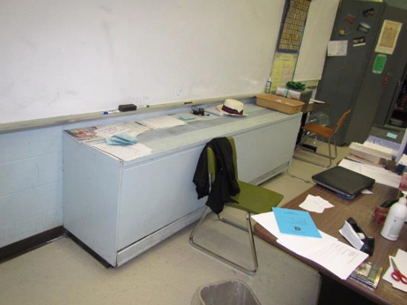
Classroom univent 1960s/1970s vintage
Picture 3
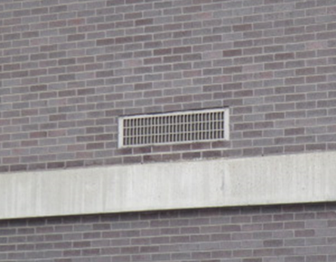
Univent fresh air intake
Picture 4
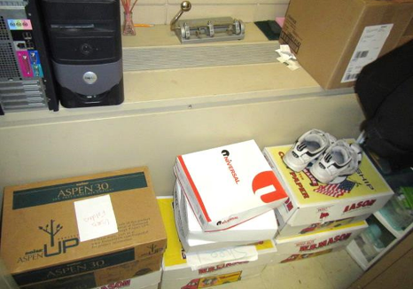
Classroom univent obstructed by various items, note diffuser on top and return vent along bottom front
Picture 5
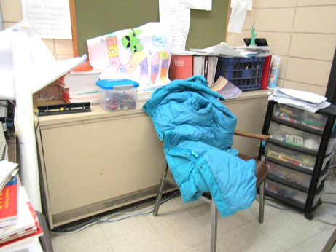
Accumulated items on/around univent
Picture 6
Water-damaged ceiling tiles in classroom
Picture 7
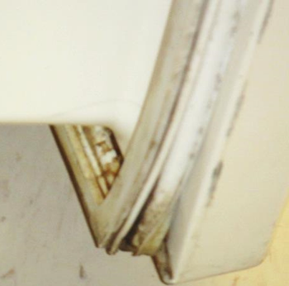
Mold/staining on refrigerator gasket
Picture 8
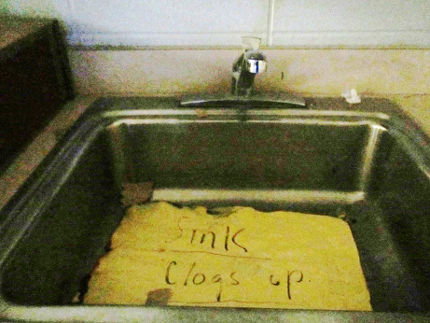
Clogged sink in classroom C-58
Picture 9
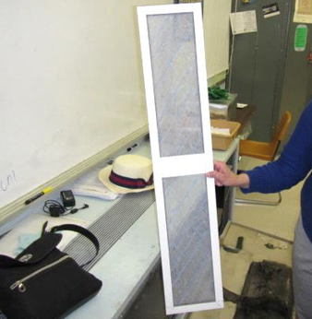
Fibrous mesh filter for univents
Picture 10
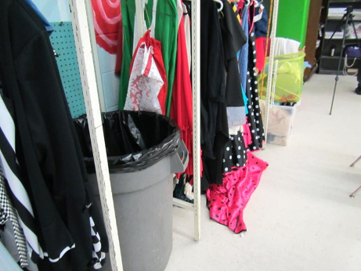
Accumulated items in classroom
Picture 11
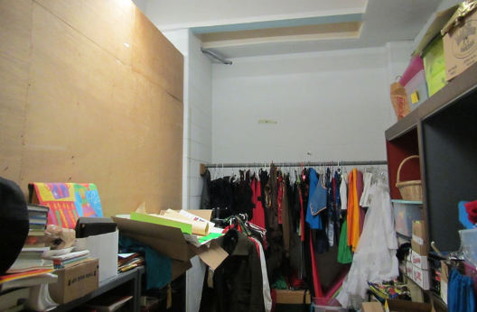
Accumulated items in classroom
Picture 12
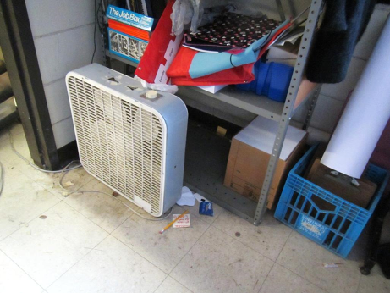
Accumulated items, dirt/dust/debris on floor and fan
Picture 13
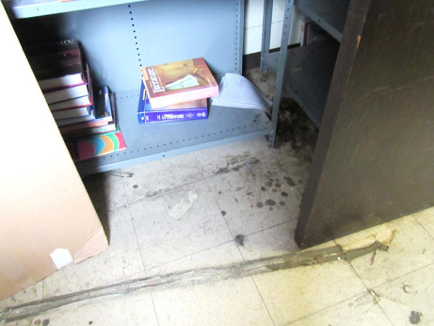
Accumulated items, dirt/dust/debris on floor and flat surfaces
Picture 14
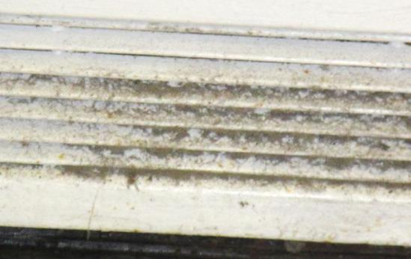
Univent return vent (bottom front)
Picture 15
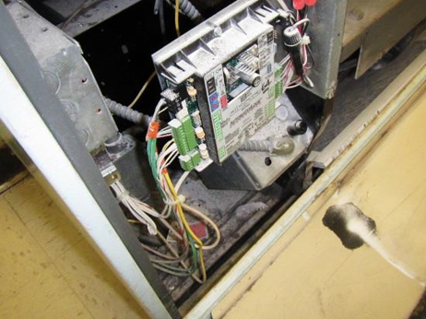
Accumulated dust/debris in univent interior

Location | Carbon  Dioxide  (ppm) | Carbon Monoxide  (ppm) | Temp  (°F) | Relative  Humidity  (%) | PM2.5  (µg/m³) | Occupants  in Room | Windows  Openable | Ventilation |  | Remarks
 |  |  |  |  |  |  |  | Supply | Exhaust
Background | 462 | 1.2 | 45 | 44 | 18 |  |  |  |  | Light rain, cold
Language arts office | 667 | ND | 67 | 31 | 11 | 0 | N | Y | Y | DO, NC, PC, stored items including boxes and clothing, added walls (paneling, not to ceiling)
C-57 | 955 | ND | 71 | 31 | 2 | 19 | N | Y | Y | DO, DEM, 3 WD CT
C-58 | 993 | ND | 70 | 33 | 20 | 23 | N | Y | Y | NC, sink (note: sink clogged), CF very dusty
C-59 | 617 | ND | 72 | 27 | 4 | 0 | N | Y | Y | CF, dust/debris accumulation on flat surfaces and in/on UV, PF-dusty, cooking appliances
C-60 | 706 | ND | 72 | 28 | 15 | 15 | Y | Y | N | DO, items on UV, bowed CT, DEM
C-60 storage |  |  |  |  |  |  |  |  |  | Floor very dirty, cardboard on floor, PF dusty, heater
C-61 | 934 | ND | 70 | 31 | 14 | 20 | Y | Y | N | Bowed CT, NC, DEM, plants
C-62 | 720 | ND | 71 | 30 | 3 | 12 | Y | Y |  | PF, CF, UV obstructed front/top, DEM, dust/debris accumulation on UV top/front, 1 WD CT, fridge gasket-mold, DO, dust/debris on flat surfaces
C-63 | 825 | ND | 70 | 30 | 20 | 2 | y | Y | N | DO, items on UV, DEM

The service life is the median time during which a particular system or component of …[an HVAC]… system remains in its original service application and then is replaced. Replacement may occur for any reason, including, but not limited to, failure, general obsolescence, reduced reliability, excessive maintenance cost, and changed system requirements due to such influences as building characteristics or energy prices (ASHRAE, 1991).

