# Background

**WATER DAMAGE ASSESSMENT**

**Milford High School**

**31 West Fountain Street**

**Milford, MA**

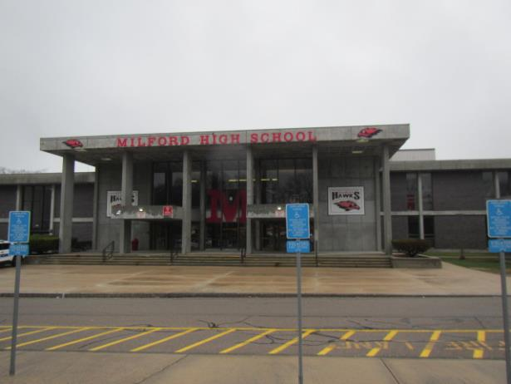

Prepared by:

Massachusetts Department of Public Health

Bureau of Climate and Environmental Health

Division of Environmental Health Regulations and Standards

April 2025

|  |  |
| --- | --- |
| Building: | Milford High School |
| Address: | 31 West Fountain Street, Milford, MA |
| Assessment Requested by: | Amanda M. Wilson, Director, Milford Board of Health |
| Date of Assessment: | April 8, 2025 |
| **Reason for Request:** | Community concerns about possible mold growth due to roof leaks in the building |
| Massachusetts Department of Public Health/Bureau of Climate and Environmental Health/Division of Environmental Health Regulations and Standards (MDPH/BCEH/EHRS) Staff Conducting Assessment: | Cory Holmes, Senior Advisor for Indoor Air Quality Inspections, Audits, Outreach and Training, and Ruth Alfasso, Environmental Engineer, EHRS |
| Building Description: | The school is a two-story brick and concrete building built in the late 1960s/early 1970s. The roof is flat rubber membrane with rock ballast and is original to the building/past it’s service life. |

# Methods

EHRS staff also performed visual inspection for water damage and/or microbial growth, and examined the space for the presence of odors or other environmental concerns within the affected areas of the building.

# Discussion and Observations

At the time of assessment, it was determined that the major leaks that occurred at the end of February/beginning of March 2025 were due to ice and snow melt, this was evidenced by the lack of current leaks/water penetration into the building. The assessment occurred on a day after rain and after a week of on/off rain, which was heavy at times.

The leaks are reported to be isolated to three main areas:

1. Mezzanine Hallway Front (Pictures 1 through 3)
2. Mezzanine Hallway Rear (Pictures 4 through 6), and
3. Gymnasium Hallway (Picture 7)

It is important to note that in all three cases, all building components were made of non-porous materials (e.g., concrete, cement, tile, metal, and glass) that are not conducive to mold growth. In addition, all materials were found dry, with no visible mold or associated odors.

At the time of assessment, Milford Public Schools (MPS) Facilities Director, Carlos Pena Zuluaga, reported that maintenance staff have cleaned walls and a bid was out for a painting contractor to refinish areas of water staining/leaks. In addition, the district was working with a roofing contractor to determine best methods to make roof repairs in the three major sections of leaks. It is also important to note that MPS is also in the process of submitting plans to replace the high school to the Massachusetts School Building Authority (MSBA), which helps districts fund capital upgrades.

**Other Conditions**

Light was seen penetrating beneath one of the exterior doors (Picture 8). Good door-sweeps/weatherstripping can not only exclude pests but can keep unconditioned outside air and moisture from entering the building.

Water-damaged ceiling tiles were noted in the Mezzanine Hallway Rear and in the main hallway, which can indicate leaks from the roof or plumbing system (Pictures 9 and 10). Water-damaged ceiling tiles can indicate sources of water penetration and provide a source of mold growth. Ceiling tiles should be replaced after a water leak is discovered and repaired.

Finally, accumulated dust and debris were noted on the ceiling vent in the gymnasium hallway (Picture 11). This dust can be aerosolized under certain conditions and can also be a medium for mold growth during hot, humid weather.

# Recommendations

In view of the findings at the time of assessment, the following recommendations are made:

1. Continue with plans to make roof repairs. Consider long-term plans for full roof replacement if new school is not built according to plans.
2. Continue with plans to paint water-stained surfaces in affected areas of roof leaks.
3. Continue to use buckets and other receptacles to collect water as needed. Ensure containers are emptied and cleaned frequently to prevent mold and associated odors.
4. Install weather-stripping on exterior hallway door (Picture 8), and any other doors that need tightening.
5. Clean dust/debris from vents in gymnasium hallway.
6. Ensure leaks are repaired then remove/replace any water-damaged ceiling tiles.

**Picture 1**

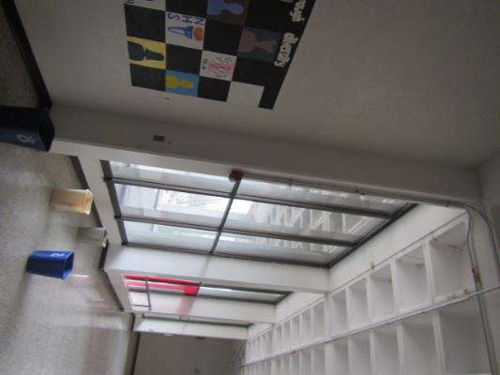

**Area of roof leaks Mezzanine Hallway Front**

**Picture 2**

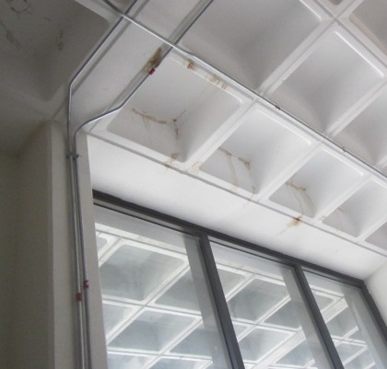

**Dark stains from roof leaks on concrete block ceiling Mezzanine Hallway Front**

**Picture 3**

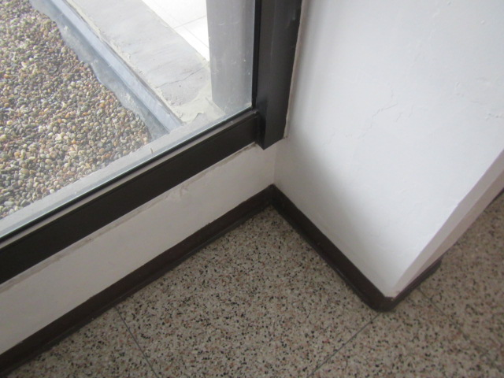

**Concrete walls and tile floor Mezzanine Hallway Front**

**Picture 4**

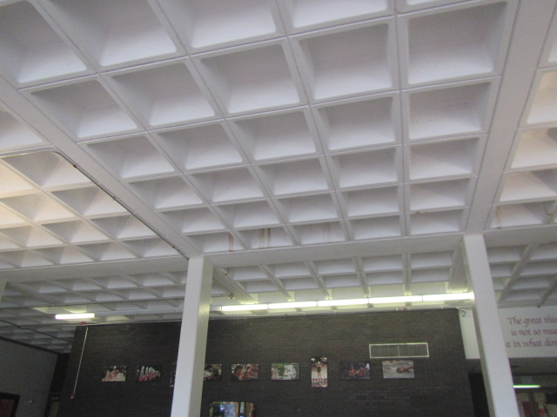

**Area of roof leaks Mezzanine Hallway Rear**

**Picture 5**

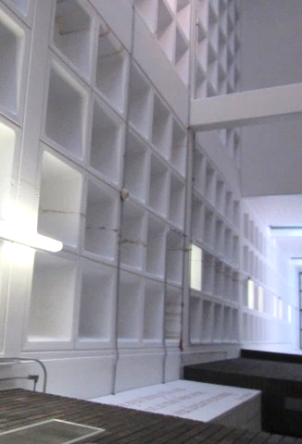

**Dark stains from roof leaks on concrete block ceiling Mezzanine Hallway Rear**

**Picture 6**

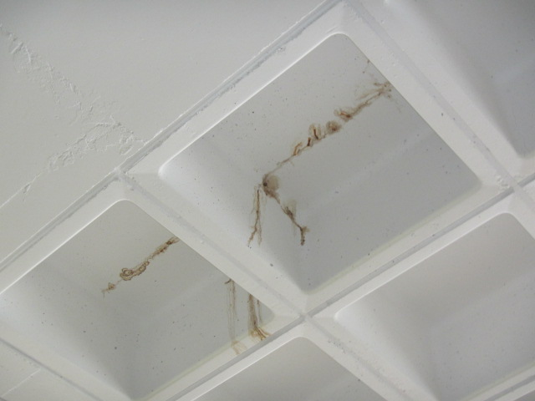

**Dark stains from roof leaks on concrete block ceiling Mezzanine Hallway Rear**

**Picture 7**

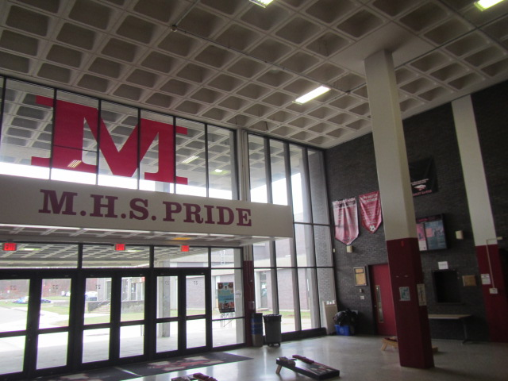

**Area of roof leaks Gymnasium Hallway**

**Picture 8**

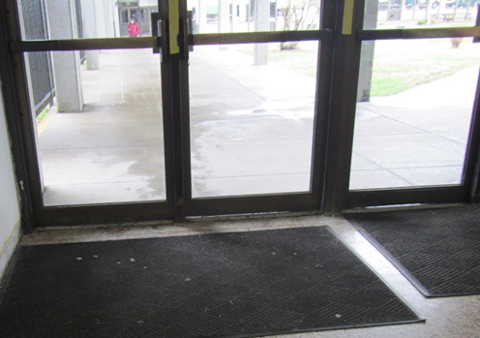

**Light penetrating through space under exterior door in hallway**

**Picture 9**

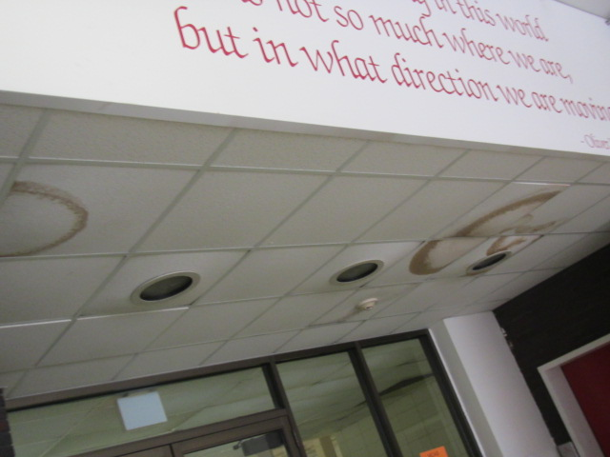

**Water-damaged ceiling tiles Mezzanine Hallway Rear**

**Picture 10**

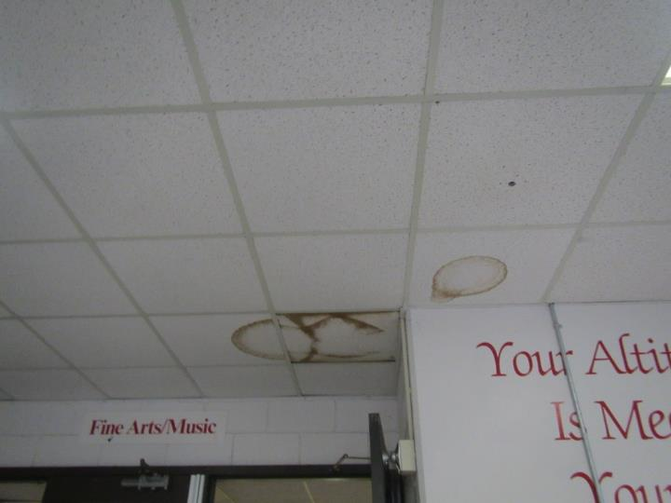

**Water-damaged ceiling tiles in hallway**

**Picture 11**

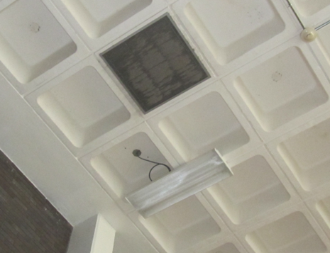

**Dust/debris accumulation on exhaust vent in Gymnasium Hallway**