**INDOOR AIR QUALITY ASSESSMENT**

**Massachusetts State 911 Department, Massachusetts State 911 Training Center, Municipal Police Training Committee and Massachusetts Department of Correction**

**31 Maple Street**

**Milford, MA**

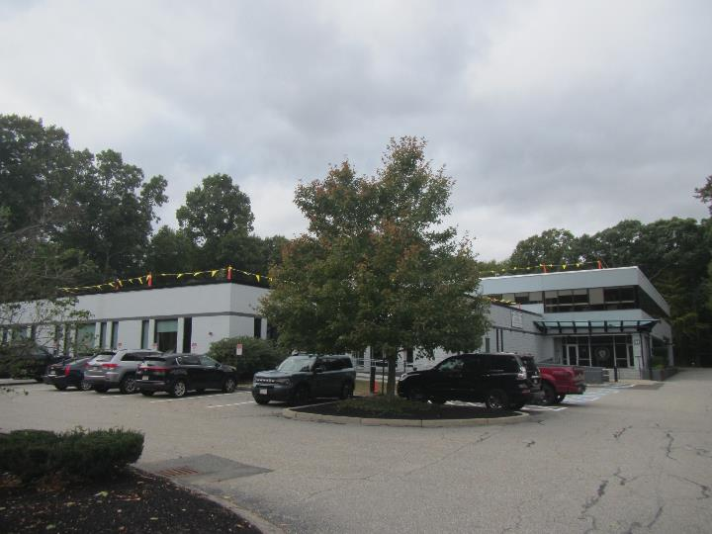

Prepared by:

Massachusetts Department of Public Health

Bureau of Climate and Environmental Health

Indoor Air Quality Program

October 2024

# BACKGROUND

|  |  |
| --- | --- |
| Building: | Massachusetts State 911 Department (MSD 911), Massachusetts State 911 Training Center (MSTC 911), Municipal Police Training Committee (MPTC), and Massachusetts Department of Correction (MDOC) |
| Address: | 31 Maple Street, Milford |
| Assessment Requested by: | Peter Woodford, Senior Project Manager, Division of Capital Asset Management & Maintenance (DCAMM) |
| Reason for Request: | DCAMM received a complaint from the Department of Labor Standards (DLS) regarding continuing sewage leaks and poor indoor air quality (IAQ). |
| Date of Assessment: | September 25, 2024 |
| Massachusetts Department of Public Health/Bureau of Climate and Environmental Health (MDPH/BCEH) Staff Conducting Assessment: | Thomas Murphy, Environmental Analyst, IAQ Program |
| Building Description: | The building at 31 Maple Street is a low-rise flat-roofed building originally built in the 1980s. The first floor is occupied by MSD 911 and MSTC 911, divided into three sections: MSD 911 rooms, a communications room, and MSTC 911 rooms. The MPTC and MDOC occupy offices/meeting rooms on the second floor which also includes a large gym. The roof is currently being replaced. |
| Building Population: | MSD 911 and MSTC 911 typically have 12-15 employees, MDOC has 6-8 employees, and MPTC has 1-2 employees. During training, the building could have 50-100 people inside. |
| Windows: | Windows are not openable. |
|  |  |

# EXECUTIVE SUMMARY

The MDPH/IAQ Program conducted a general IAQ assessment of the 31 Maple Street building after DCAMM received a complaint from DLS regarding continuing sewage leaks and poor indoor air quality in the MSD 911 section of the building. An inspection of the men’s and women’s first floor locker rooms/restrooms and other rooms in the MSD 911 section revealed no visible evidence of sewage leaks. According to DCAMM and MSD 911 staff, all areas affected by the sewage leaks, including the hallway carpets, room carpets, drywall, and insulation were discarded and replaced. DCAMM and MSD 911 staff reported the locker rooms/restrooms were still closed in this section due to maintenance performing final repairs and a final review of the sewage connections using a camera.

# METHODS

Please refer to the IAQ Manual for methods, sampling procedures, and interpretation of results (MDPH, 2015).

# RESULTS AND DISCUSSION

The following is a summary of indoor air testing results (Table 1).

* ***Carbon dioxide*** measurements were below the MDPH guideline of 800 parts per million (ppm) in nearly all areas tested indicating adequate air exchange at the time of assessment. However, the space was minimally occupied at the time of testing. Carbon dioxide levels would be expected to be higher with increased occupancy.
* ***Temperature*** was within or slightly below the recommended range of 70°F to 78°F in all areas.
* ***Relative humidity*** was above the recommended range of 40% to 60% in almost all areas examined. While this is reflective of outdoor conditions, it may also indicate that the HVAC system needs adjustment.
* ***Carbon monoxide*** levels were non-detectable (ND) in all indoor areas tested.
* ***Fine particulate matter (PM2.5)*** concentrations were below the National Ambient Air Quality Standard (NAAQS) level of 35 μg/m3 in all areas tested.

## Ventilation

A heating, ventilating, and air conditioning (HVAC) system has several functions. First, it provides heating and, if equipped, cooling. Second, it is a source of fresh air. Finally, an HVAC system will dilute and remove normally occurring indoor environmental pollutants by not only introducing fresh air, but also filtering the airstream and ejecting stale air to the outdoors via exhaust ventilation. Even if an HVAC system is operating as designed, point sources of respiratory irritation may exist and affect symptoms in sensitive individuals.

The HVAC system consists of air handling units (AHUs) which draw in outside air and heat/cool it. Conditioned air is ducted to supply vents and returned via ducted return vents (Pictures 1 and 2).

The AHUs for this building were not assessed during this visit due to renovations related to roof replacement. The MDPH IAQ program recommends that AHU filters be changed 2-4 times a year (or in accordance with the manufactures recommendations) and be at least minimum efficiency reporting value (MERV) 8, or higher if the equipment can handle them without a degradation in airflow, as these are adequate to filter out pollen, mold, and similar particulates (ASHRAE, 2012).

It is recommended that HVAC systems be re-balanced every five years and whenever significant changes are made to the layout of the building to ensure adequate air systems function (SMACNA, 1994). According to DCAMM staff, the HVAC system was balanced within the past five years prior to occupancy.

## Microbial/Moisture Concerns

### Sources of moisture

An inspection of the men’s and women’s first floor locker rooms/restrooms and offices/rooms in the MSD 911 section, revealed no visible evidence of sewage leaks. One of the restrooms was still under renovation. According to DCAMM and MSD 911 staff, all carpeting, drywall, and insulation that suffered sewage damage were discarded and replaced.

Water-damaged ceiling tiles were noted in several areas (Picture 3; Table 1). All the water-damaged ceiling tiles were found away from windows, indicating the cause could be from roof leaks, plumbing or HVAC leaks or condensation on components. Water-damaged ceiling tiles should be replaced when they are found. During replacement, the area above the ceiling tiles should be examined for additional water-damaged materials and sources of water, such as plumbing leaks, uninsulated pipes or ducts, or other issues. It is important to note the flat roof was currently being replaced.

Plants were noted in some rooms (Picture 4; Table 1). Plants, soil, and drip pans can serve as sources of mold/bacterial growth. Plants should be properly maintained, over-watering of plants should be avoided, and drip pans should be inspected periodically for mold growth.

Plants and bushes were observed in contact with and near the exterior foundation (Picture 5). Plants near the building can cause water damage to brickwork and mortar. In addition, plants and small trees shading exterior walls can slow drying. Water can eventually penetrate the brick, subsequently freezing and thawing during the winter. This freezing/thawing action can weaken and damage bricks and mortar.

The server room is equipped with ductless air conditioning units on the wall (Picture 6). These units have a condensation drain and pump to remove the collected condensation and transport it to an appropriate drain or outside. Over time, the pumps may malfunction, or the hoses become clogged, which can lead to leaks. This equipment should be checked periodically to ensure good condition and repaired/cleaned when necessary. Porous items such as boxes should not be stored underneath.

Water dispensers, including both wall-mounted water bubblers and freestanding water coolers, were found in carpeted areas (Pictures 7 and 8). Water dispensers can spill or leak and moisten carpeting. Use of a waterproof mat underneath these appliances, or moving them to a non-carpeted area, can help prevent water damage.

The US Environmental Protection Agency (US EPA) and the American Conference of Governmental Industrial Hygienists (ACGIH) recommend that porous materials (e.g., ceiling tiles, carpet) be dried with fans and heating within 24 to 48 hours of becoming wet (US EPA, 2008; ACGIH, 1989). If not dried within this time frame, mold growth may occur. Once mold has colonized porous materials such as cardboard, books or ceiling tiles, they are difficult to clean and should be discarded. Frequently solid/non-porous items can be cleaned to remove water stains and microbial growth.

### High relative humidity during hot, humid weather

Hot humid summers are becoming more frequent due to climate change. Massachusetts has experienced hot, humid, and rainy summers in 2018, 2021, and 2023. July of 2021 was the wettest ever recorded in Massachusetts, and the three-month period from June through August, known as the meteorological summer, was the fourth wettest on record, according to the National Oceanic and Atmospheric Administration’s (NOAA) Centers for Environmental Information (NOAA, 2021). The summer of 2023 was also hot, and wet, being measured as the second rainiest on record (WBUR, 2023). The summer of 2024 has also had significant stretches of hot, humid weather.

Relative humidity was above the recommended range of 40% to 60% in almost all areas examined in the building. When relative humidity is elevated, the air can feel uncomfortably damp, clammy, or sticky. Excess humidity for a significant amount of time can also lead to water damage in porous materials, particularly in areas with a lower temperature, such as ventilation equipment, or exterior windows or walls, due to condensation. In addition, high relative humidity will cause paper to absorb moisture, which in turn cause paper jams in photocopiers and computer printers (Fisher, N., 2024)

If signs of high humidity continue during the heating season, or return the following summer, adjustments may be needed to HVAC settings. Helpful adjustments to reduce humidity include temporarily reducing the amount of fresh air into the system during very humid weather, or increasing the setpoint temperature a few degrees, which will reduce relative humidity. If adjusting the HVAC settings doesn’t work, some other ventilation-engineering solution may be required.

## Other IAQ Evaluations

Most of the 31 Maple Street building has wall to wall carpeting. Carpets should be cleaned annually (or semi-annually in soiled/high traffic areas) in accordance with Institute of Inspection, Cleaning and Restoration Certification (IICRC) recommendations, (IICRC, 2012). Regular cleaning with a high efficiency particulate air (HEPA) filtered vacuum in combination with an annual cleaning will help to reduce accumulation and potential aerosolization of materials from carpeting.

Missing ceiling tiles and holes in the ceiling were observed in some areas (Picture 9). Damaged ceiling tiles and holes in the ceiling can allow dust and debris to fall into occupied areas. All openings and damaged areas should be repaired and replaced.

Air purifiers were observed in at least one room (Picture 10) and a hallway. These should be maintained, including filter changes, in accordance with manufacturer’s instructions. Air purifiers that may produce ozone should not be used in any occupied areas (EPA, 2003).

# CONCLUSIONS/RECOMMENDATIONS

In view of the findings at the time of the visit, the following recommendations are made:

## Short-term Recommendations

### Ventilation recommendations

1. Consider monitoring humidity periodically, particularly during very humid outdoor weather to ensure the HVAC system can reduce humidity for comfort and to prevent water damage and adjust as needed.
2. Ensure the air handling unit and other HVAC system filters are at least a MERV rating of 8 and are changed at least twice a year.
3. Operate the HVAC system (supply/exhaust) to provide for *continuous* fresh air ventilation during occupied hours.
4. Continue balancing the mechanical ventilation system every five years, as recommended by ventilation industry standards (SMACNA, 1994)

### Water damage recommendations

1. Permanently fix the sewage line to prevent further leaks/overflows.
2. Complete final repairs of restrooms affected by the sewage leaks.
3. Follow the guidance in <https://www.mass.gov/info-details/construction-and-renovation-generated-pollutants-in-occupied-buildings> to reduce the impact of any ongoing restroom renovations.
4. Replace water-damaged ceiling tiles. Investigate stained tiles for additional water damage and for sources of water including roof leaks, plumbing leaks, HVAC leaks, or piping/ducts in need of insulation, and repair as needed.
5. Keep plants in good condition, avoid overwatering, and keep them away from the airstream of ventilation equipment.
6. Trim plants, bushes, and small trees at least 5 feet away from the building.
7. Ensure that condensation from ductless air conditioner equipment is draining properly. Check collector pans, piping and any associated pumps for clogs and leaks and clean periodically to prevent stagnant water build-up and remove debris that may provide a medium for microbial growth.
8. Consider placing a waterproof mat underneath water dispensers to protect carpet from leaks.

### Other recommendations

1. Clean carpeting in accordance with IICRC recommendations (IICRC, 2012) annually (or semi-annually in soiled/high traffic areas).
2. After replacing and repairing holes in ceiling tiles, conduct a thorough cleaning of furniture and other items, including wet wiping of all surfaces.
3. Maintain air purifiers in accordance with manufacturer's instructions. Avoid using any air purifiers that may produce ozone (e.g., ionizers). Consider locating air purifiers so the outlet of the units is in the breathing zone of occupants.
4. Refer to resource manual and other related IAQ documents located on the MDPH’s website for further building-wide evaluations and advice on maintaining public buildings. These documents are available at: <http://mass.gov/dph/iaq>.

# REFERENCES

ACGIH.1989. Guidelines for the Assessment of Bioaerosols in the Indoor Environment. American Conference of Governmental Industrial Hygienists, Cincinnati, OH.

ASHRAE. 2012. American Society of Heating, Refrigeration and Air Conditioning Engineers (ASHRAE) Standard 52.2-2012 -- Method of Testing General Ventilation Air-Cleaning Devices for Removal Efficiency by Particle Size (ANSI Approved).

IICRC. 2012. Institute of Inspection, Cleaning and Restoration Certification. Carpet Cleaning: FAQ.

Fisher, N. 2024. How Humidity Affects Your Copier and Paper Quality. Cobb Technologies, Richmond, VA. <https://www.cobbtechnologies.com/blog/how-humidity-affects-your-copier-and-paper-quality>.

MDPH. 2015. Massachusetts Department of Public Health. Indoor Air Quality Manual: Chapters I-III. Available at: <https://www.mass.gov/lists/indoor-air-quality-manual-and-appendices>.

NOAA. 2021. Summer 2021 neck and neck with Dust Bowl summer for hottest on record. National Oceanic and Atmospheric Administration, 1401 Constitution Avenue NW, Room 5128, Washington, DC 20230 <https://www.noaa.gov/news/summer-2021-neck-and-neck-with-dust-bowl-summer-for-hottest-on-record>

SMACNA. 1994. HVAC Systems Commissioning Manual. 1st ed. Sheet Metal and Air Conditioning Contractors’ National Association, Inc., Chantilly, VA.

US EPA. 2003. “Ozone Generators that are Sold as Air Cleaners: An Assessment of Effectiveness and Health Consequences”. United States Environmental Protection Agency, Office of Air and Radiation, Indoor Environments Division, Washington, DC. Last updated September, 2018. <https://www.epa.gov/indoor-air-quality-iaq/ozone-generators-are-sold-air-cleaners>.

US EPA. 2008. “Mold Remediation in Schools and Commercial Buildings”. Office of Air and Radiation, Indoor Environments Division, Washington, DC. EPA 402-K-01-001. September 2008. Available at: <http://www.epa.gov/mold/mold-remediation-schools-and-commercial-buildings-guide>.

WBUR. 2023. “It's been a summer of rain and flooding misery in Mass.” WBUR local news. September 12, 2023. <https://www.wbur.org/news/2023/09/12/summer-flooding-rain-massachusetts>.

**Picture 1**

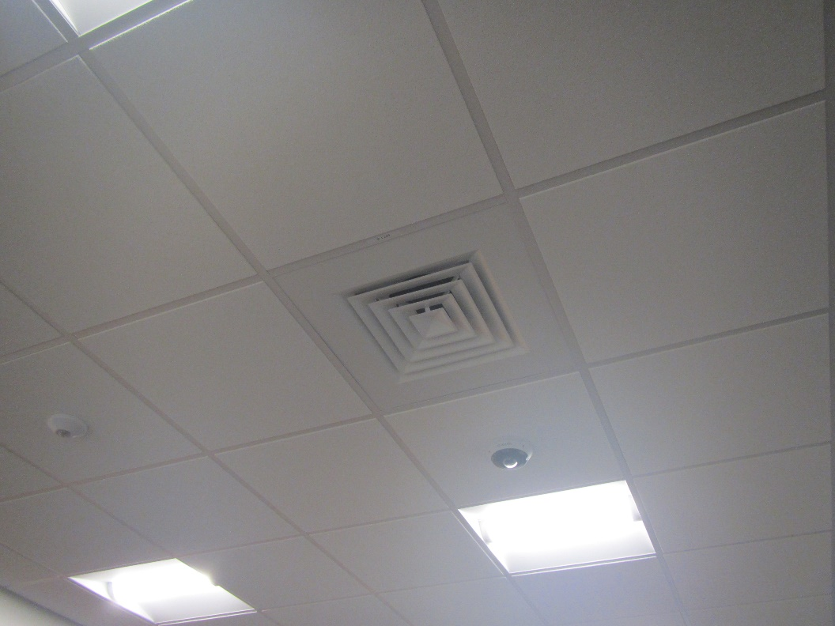

**Ceiling-mounted supply vent**

**Picture 2**

**Ceiling-mounted return vent
**

**Ceiling-mounted return vent**

**Picture 3**

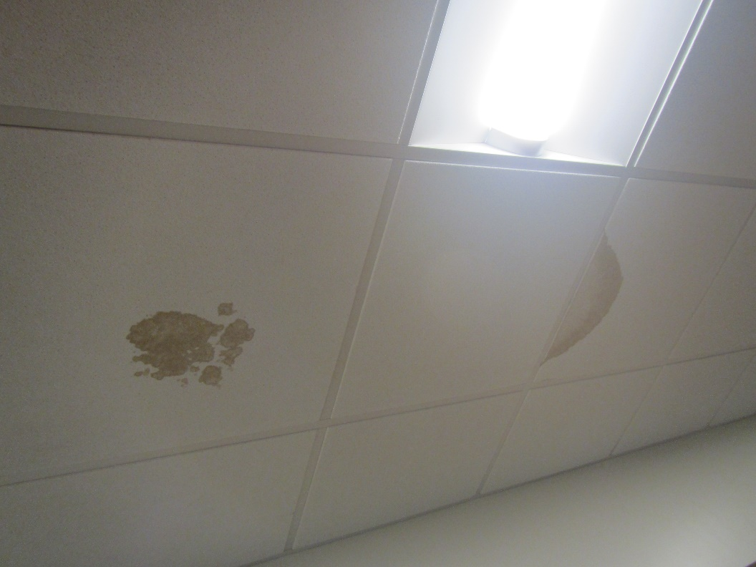

**Water-damaged ceiling tiles**

**Picture 4**

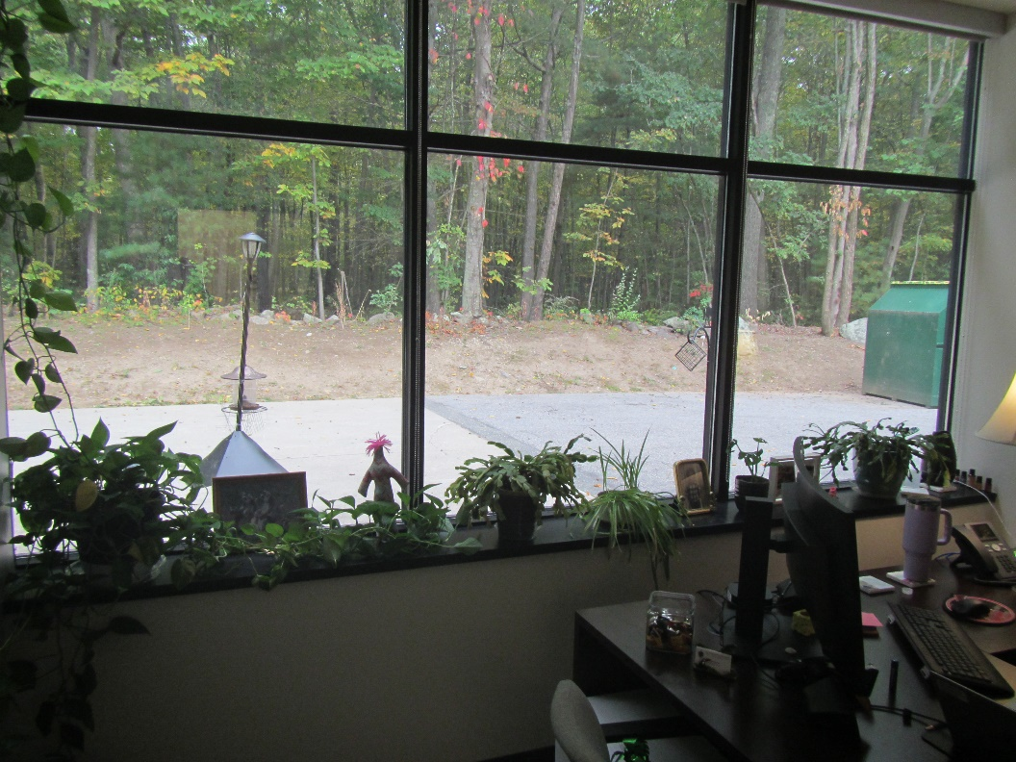

**Plants in an office**

**Picture 5**

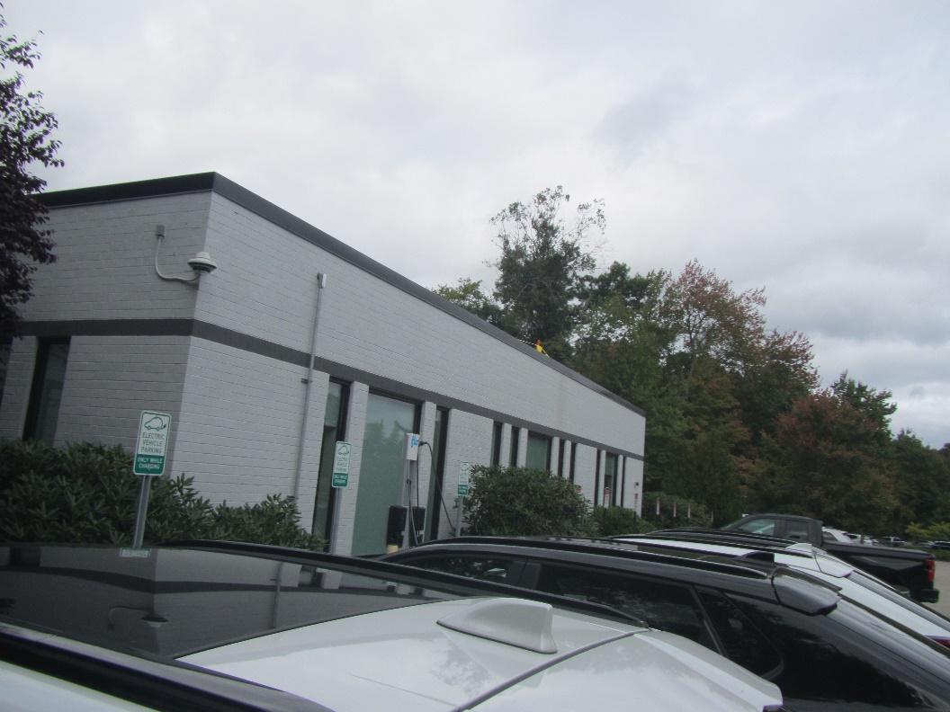

**Plants and bushes in contact with the side of the building**

**Picture 6**

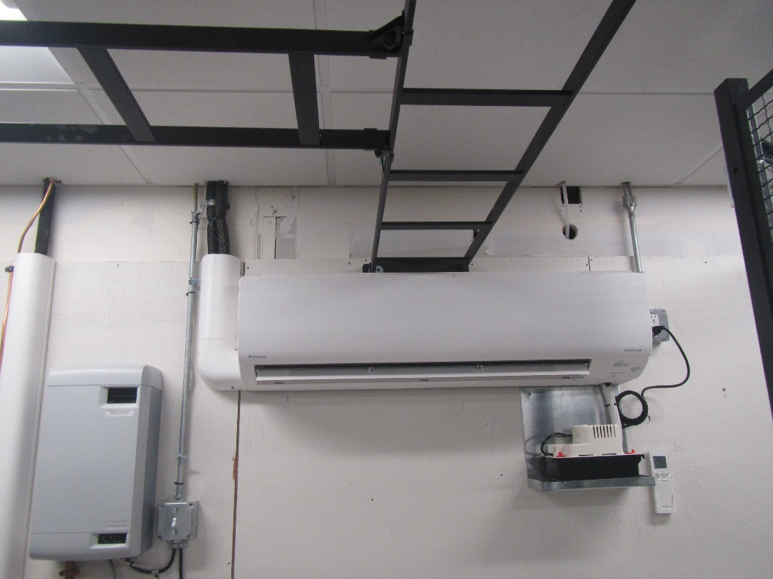

**Ductless air conditioner in the server room**

**Picture 7**

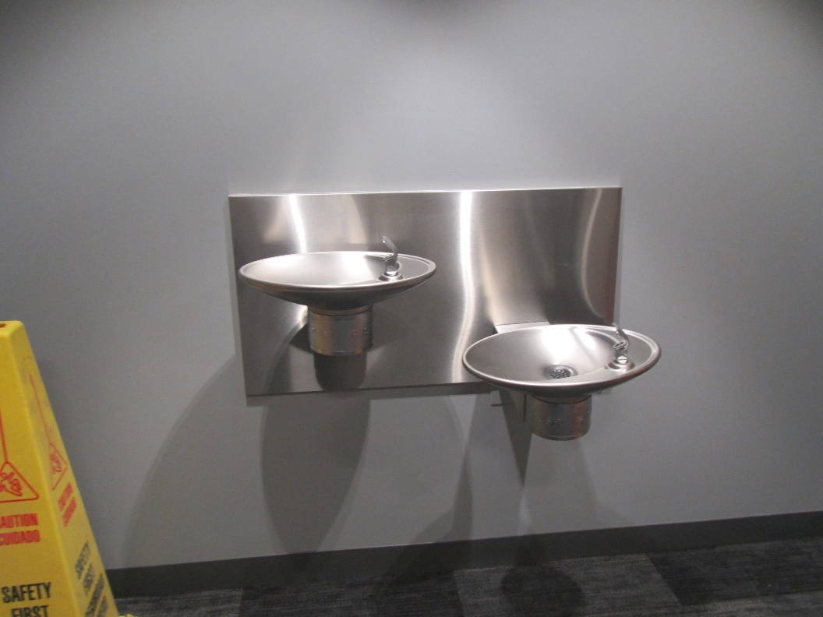

**Water bubblers over carpet**

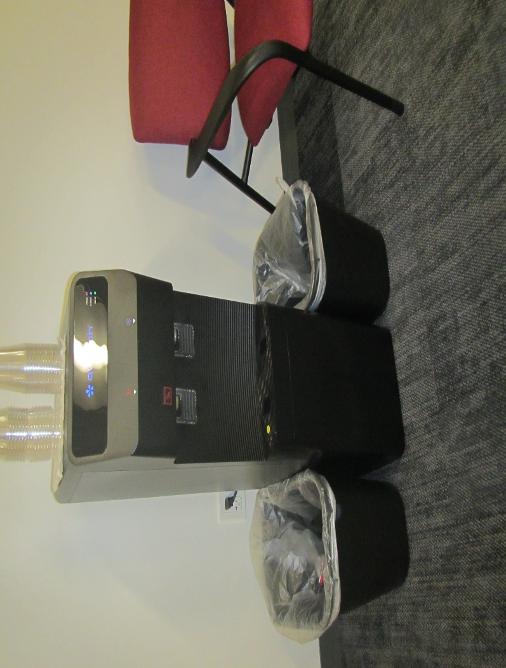**Picture 8**

**Water cooler on carpet**

**Picture 9**

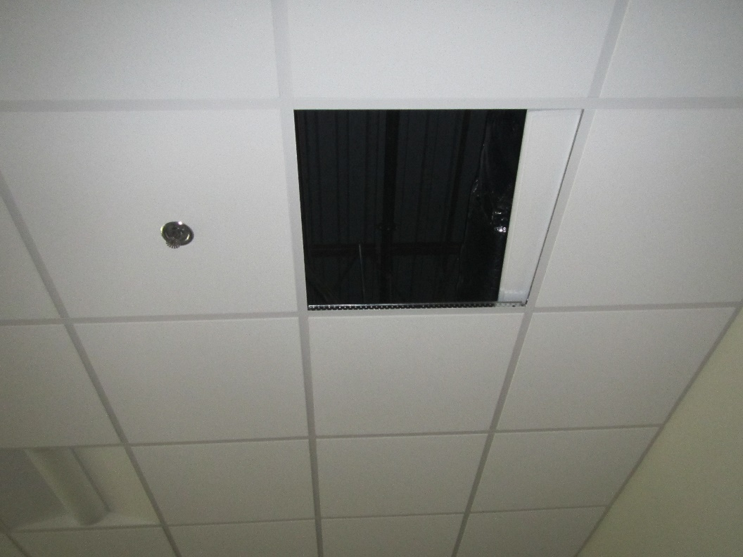

**Missing ceiling tile**

**Picture 10**

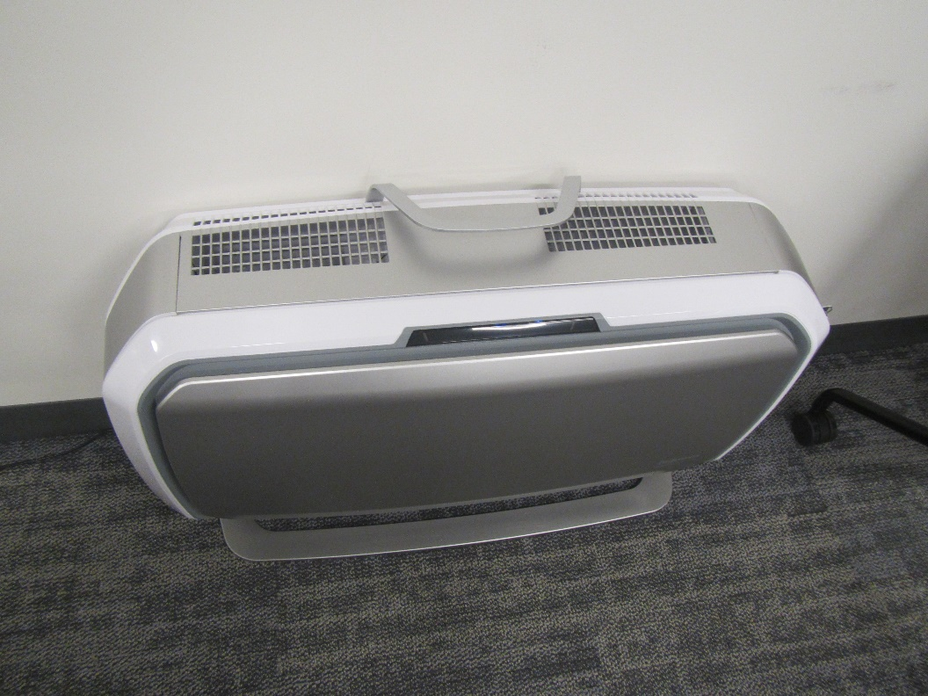

**Air purifier in a room**

| **Location** | **Carbon**  **Dioxide**  **(ppm)** | **Carbon Monoxide**  **(ppm)** | **Temp**  **(°F)** | **Relative**  **Humidity**  **(%)** | **PM2.5**  **(µg/m3)** | **Occupants**  **in Room** | **Windows**  **Openable** | **Ventilation** | | **Remarks** |
| --- | --- | --- | --- | --- | --- | --- | --- | --- | --- | --- |
| **Supply** | **Exhaust** |
| Background (outside) | 420 | ND | 65 | 63 | ND |  |  |  |  | Overcast |
| MSD 911 Section | | | | | | | | | | |
| Lobby | 562 | ND | 68 | 62 | 1 | 2 | N | Y | Y |  |
| Main hallway outside restrooms | 575 | ND | 69 | 62 | ND | 0 | N | N | Y | Carpet, drywall, and insulation replaced, air purifier, water bubblers over carpet, * |
| Men’s locker room (closed) | 543 | ND | 71 | 61 | ND | 0 | N | N | Y | No visible evidence of sewage leak, * |
| Men’s restroom (closed) | 580 | ND | 70 | 61 | ND | 0 | N | N | Y | No visible evidence of sewage leak, * |
| Women’s locker room (closed) | 713 | ND | 71 | 61 | ND | 0 | N | N | Y | No visible evidence of sewage leak, * |
| Women’s restroom (closed) |  |  |  |  |  |  | N |  |  | Under renovation, * |
| 127 | 552 | ND | 68 | 64 | 1 | 0 | N | Y | Y | Carpet, drywall, and insulation discarded and replaced, * |
| 128 | 545 | ND | 68 | 65 | ND | 0 | N | Y | Y | NC, water cooler |
| 129 | 540 | ND | 68 | 64 | ND | 0 | N | Y | Y | Carpet, drywall, and insulation discarded and replaced, * |
| 132 | 543 | ND | 69 | 63 | ND | 0 | N | Y | Y |  |
| 133 | 564 | ND | 69 | 63 | ND | 1 | N | Y | Y |  |
| 134 | 640 | ND | 69 | 63 | ND | 0 | N | Y | Y |  |
| 135 | 540 | ND | 71 | 60 | 1 | 0 | N | Y | Y | Plants |
| 136 | 929 | ND | 70 | 64 | ND | 1 | N | Y | Y | Plants |
| 137 | 540 | ND | 71 | 60 | ND | 0 | N | Y | Y |  |
| 138 | 541 | ND | 71 | 60 | ND | 0 | N | Y | Y |  |
| 139 | 611 | ND | 71 | 63 | ND | 0 | N | Y | Y | NC |
| 140 | 557 | ND | 69 | 63 | ND | 1 | N | Y | Y |  |
| 142 | 562 | ND | 70 | 62 | ND | 0 | N | Y | Y |  |
| 143 | 589 | ND | 69 | 64 | ND | 0 | N | Y | Y | NC |
| 144 | 592 | ND | 69 | 63 | 1 | 0 | N | Y | Y | Carpet, drywall, and insulation discarded and replaced, * |
| 151 | 546 | ND | 67 | 64 | ND | 0 | N | N | N | Server room, Ductless air conditioners |
| Mail/Copy room | 565 | ND | 69 | 67 | ND | 0 | N | Y | Y | Microwave, printer, refrigerator, NC |
| MSD 911 Communications Room Section | | | | | | | | | | |
| 155 (Left) | 664 | ND | 70 | 62 | ND | 2 | N | Y | Y |  |
| 155 (Middle) | 640 | ND | 71 | 60 | ND | 1 | N | Y | Y |  |
| 155 (Right) | 632 | ND | 71 | 58 | ND | 0 | N | Y | Y |  |
| Copy Room | 623 | ND | 71 | 60 | ND | 0 | N | Y | Y | Hole in ceiling, water cooler on carpet |
| MSTC 911 Section | | | | | | | | | | |
| 156 | 621 | ND | 69 | 62 | ND | 0 | N | Y | Y |  |
| 159 | 721 | ND | 69 | 62 | ND | 0 | N | Y | Y | Air purifier |
| 160 | 686 | ND | 69 | 64 | ND | 0 | N | Y | Y | NC, skylight window |
| 164 | 855 | ND | 68 | 65 | ND | 12 | N | Y | Y |  |
| 165 | 763 | ND | 70 | 62 | ND | 2 | N | Y | Y |  |
| 166 | 706 | ND | 69 | 64 | ND | 0 | N | Y | Y |  |
| 167 | 771 | ND | 68 | 64 | ND | 0 | N | Y | Y |  |
| 170 | 830 | ND | 70 | 62 | ND | 8 | N | Y | Y | Water-damaged ceiling tile |
| 172 | 715 | ND | 68 | 65 | ND | 0 | N | Y | Y |  |
| 174 | 658 | ND | 68 | 64 | 1 | 0 | N | Y | Y | Missing ceiling tile |
| 178 | 996 | ND | 70 | 64 | 1 | 1 | N | Y | Y | Training class just left room |
| Common area | 687 | ND | 68 | 65 | ND | 0 | N | Y | Y | Water-damaged ceiling tiles |
| Cubicle area | 734 | ND | 68 | 65 | 1 | 0 | N | Y | Y |  |
| 2nd floor – MPTC and MDOC Section | | | | | | | | | | |
| 213 | 629 | ND | 70 | 60 | ND | 0 | N | Y | Y |  |
| 214 | 630 | ND | 70 | 60 | ND | 0 | N | Y | Y |  |
| 215 | 638 | ND | 70 | 60 | ND | 0 | N | Y | Y |  |
| 216 | 645 | ND | 70 | 61 | ND | 0 | N | Y | Y |  |
| 217 | 648 | ND | 70 | 61 | ND | 0 | N | Y | Y |  |
| 219 | 682 | ND | 70 | 61 | ND | 0 | N | Y | Y |  |
| 221 | 680 | ND | 70 | 62 | ND | 0 | N | Y | Y |  |
| 222 | 668 | ND | 69 | 62 | ND | 0 | N | Y | Y |  |
| 223 | 678 | ND | 69 | 62 | ND | 0 | N | Y | Y |  |
| 224 | 672 | ND | 69 | 62 | ND | 0 | N | Y | Y | NC |
| 225 | 703 | ND | 69 | 61 | ND | 0 | N | Y | Y | Half carpeted, refrigerator, microwave |
| 226 | 685 | ND | 70 | 60 | ND | 1 | N | Y | Y |  |
| 227 | 654 | ND | 69 | 59 | ND | 0 | N | Y | Y |  |
| 228 | 722 | ND | 71 | 58 | ND | 0 | N | Y | Y | Plants |
| 229 | 748 | ND | 70 | 58 | ND | 0 | N | Y | Y | Plants |
| 230 | 689 | ND | 70 | 58 | ND | 1 | N | Y | Y | Plants |
| 231 | 715 | ND | 69 | 60 | ND | 1 | N | Y | Y | Plants |
| 233 | 730 | ND | 70 | 58 | ND | 1 | N | Y | Y |  |
| 235 | 723 | ND | 69 | 62 | ND | 0 | N | Y | Y |  |
| 236 | 705 | ND | 70 | 61 | ND | 2 | N | Y | Y | NC, kitchen |
| 240 | 701 | ND | 69 | 61 | ND | 0 | N | Y | Y |  |
| 241 | 739 | ND | 70 | 61 | ND | 2 | N | Y | Y | Water-damaged ceiling tile |
| 242 | 621 | ND | 70 | 61 | ND | 0 | N | Y | Y | NC, gym |