INDOOR AIR QUALITY ASSESSMENT

Milford Town Library
80 Spruce Street
Milford, Massachusetts

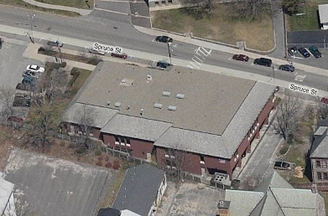

Prepared by:
Massachusetts Department of Public Health
Bureau of Environmental Health
Indoor Air Quality Program
June 2012

Background/Introduction
At the request of Paul Mazzuchelli, Health Agent, Milford Board of Health, the Massachusetts Department of Public Health (MDPH), Bureau of Environmental Health (BEH) provided assistance and consultation at the Milford Town Library (MTL), 80 Spruce Street, Milford, Massachusetts. On April 12, 2012, Cory Holmes, Environmental Analyst/Inspector in BEH’s Indoor Air Quality (IAQ) Program visited the MTL to conduct an assessment. The assessment was prompted by employee concerns of possible respiratory/irritant effects believed to be associated with exposure to airborne particulates potentially generated during a disc (CD/DVD) repair process.
The MTL is a two-story brick building constructed in 1986. Renovations were conducted throughout the facility in 2007. The lower level contains administrative offices, meeting rooms, the young adult area, employee break room and the book/disc repair room, where the disc repair process takes place. The main floor contains the circulation desk, open stack areas, restrooms and computer stations.

Methods
Air tests for airborne particle matter with a diameter less than 2.5 micrometers (μm) were taken with the TSI, DUSTTRAK™ Aerosol Monitor Model 8520 in response to concerns regarding the potential presence of airborne particulates. In addition, since the disc repair process involves the use of a liquid solution applied to discs, air testing for total volatile organic compounds (TVOCs) was conducted using a Thermo Environmental Instruments Inc., Model 580 Series Photo Ionization Detector (PID).

Results
The library has 23 employees and can have up to 500 visitors on a daily basis. Tests were taken during normal operations, with the exception of the disc repair process, which was enhanced to represent a worst-case scenario. Results appear in Table 1.

Discussion

IAQ Evaluations

As mentioned previously, the assessment was prompted by concerns of potential exposure to airborne pollutants thought to be generated by a disc repair process. The manufacture’s website states that “Unlike other repair solutions that rely on added wax filling and abrasive sanding, Venmill’s patented OptoClear™ Technology professionally protects your collection by using heat and force to smooth the disc’s plastic surface” (VenMill Industries, 2011). To determine if any pollutants were generated by the disc repair process, BEH staff took measurements for airborne particulates and TVOCs (Pictures 1 through 3).
The American Society of Heating Refrigeration and Air-Conditioning Engineers (ASHRAE) has adopted the National Ambient Air Quality Standards (NAAQS) as one set of criteria for assessing indoor air quality and monitoring of fresh air introduced by HVAC systems (ASHRAE, 1989). The NAAQS are standards established by the US EPA to protect the public health from six criteria pollutants, including carbon monoxide and particulate matter (US EPA, 2006). As recommended by ASHRAE, pollutant levels of fresh air introduced to a building should not exceed the NAAQS levels (ASHRAE, 1989). The NAAQS were adopted by reference in the Building Officials & Code Administrators (BOCA) National Mechanical Code of 1993 (BOCA, 1993), which is now an HVAC standard included in the Massachusetts State Building Code (SBBRS, 1997).

Particulate Matter
The US EPA has established NAAQS limits for exposure to particulate matter. Particulate matter is airborne solids that can be irritating to the eyes, nose and throat. The NAAQS originally established exposure limits to particulate matter with a diameter of 10 μm or less (PM10). According to the NAAQS, PM10 levels should not exceed 150 micrograms per cubic meter (μg/m³) in a 24-hour average (US EPA, 2006). These standards were adopted by both ASHRAE and BOCA. Since the issuance of the ASHRAE standard and BOCA Code, US EPA established a more protective standard for fine airborne particles. This more stringent PM2.5 standard requires outdoor air particle levels be maintained below 35 μg/m³ over a 24-hour average (US EPA, 2006). Although both the ASHRAE standard and BOCA Code adopted the PM10 standard for evaluating air quality, MDPH uses the more protective PM2.5 standard for evaluating airborne particulate matter concentrations in the indoor environment.
Outdoor PM2.5 concentrations the day of the assessment were measured in a range of 7-17 μg/m³ (Table 1). For comparison, BEH staff took PM2.5 measurements in unaffected areas on the main floor, in unaffected areas on the lower level away from the disc cleaning room, and finally directly in the disc cleaning room (on the lower level) during the disc repair process. It was reported by MTL personnel that a typical disc repair/cleaning session consists of cleaning 5-10 discs at about 30-60 seconds per disc. As mentioned previously, to create a worst-case scenario, BEH staff had MTL personnel clean up to 26 discs in succession. PM2.5 concentrations on the main floor were measured at 4 μg/m³ (Table 1). PM2.5 concentrations on the lower level in unaffected areas were measured in a range of 3-7 μg/m³ (Table 1). PM2.5 concentrations in the disc repair room during the repair process were measured in a range of 4-6 μg/m³, which were similar to those in unaffected areas.
Frequently, indoor air levels of particulates (including PM2.5) can be at higher levels than those measured outdoors. A number of activities that occur indoors and/or mechanical devices can generate particulate during normal operations. Sources of indoor airborne particulates may include but are not limited to particles generated during the operation of fan belts in the HVAC system, use of stoves and/or microwave ovens in kitchen areas; use of photocopiers, fax machines and computer printing devices; operation of an ordinary vacuum cleaner and heavy foot traffic indoors.

Volatile Organic Compounds (VOCs)
Indoor air concentrations can be greatly impacted by the use of products containing volatile organic compounds (VOCs) within the building. VOCs are carbon-containing substances that have the ability to evaporate at room temperature. Frequently, exposure to low levels of total volatile organic compounds (TVOCs) may produce eye, nose, throat and/or respiratory irritation in some sensitive individuals. For example, chemicals evaporating from a paint can stored at room temperature would most likely contain VOCs.
In an effort to determine whether measureable levels of VOCs were present during the disc repair process, air monitoring for TVOCs was conducted in a similar fashion as PM2.5 throughout the building. Outdoor air samples were taken for comparison. On the day of the assessment, outdoor TVOC concentrations were non-detect (ND) (Table 1). No measureable levels of TVOCs were detected in unaffected areas of the building or in the area of concern during the disc repair process (Table 1).

Other Conditions
Although no measureable levels of TVOCs were measured in the immediate area of the disc repair process, a potential hazard of exposure to VOCs existed in the form of stored materials. Of note was a half-gallon container of ammonia and an unlabeled spray bottle observed on the floor in the Tech Services work area (Pictures 4 and 5). Cleaning materials such as ammonium compounds or sodium hypochlorite (chlorine bleach) are alkaline materials. The use of these cleaners/disinfectants in a work setting can expose an individual to vapors which can lead to irritation of the eyes, nose or respiratory tract. Additionally, a Material Safety Data Sheet (MSDS) should be available at a central location for chemicals/cleaners used in the building in the event of an emergency such as an adverse chemical interaction between residues from cleaners used by the facilities staff and those from cleaners brought in by others.

Conclusions/Recommendations
The air testing conducted by MDPH/BEH staff would indicate that no acute or long-term health effects would be associated with the use of this disc cleaning device and/or its process. In view of the findings at the time of the visit, the following recommendations are made:
- Store cleaners/chemicals in custodial closet or designated storage area.
- Ensure spray bottles are properly labeled.
- All cleaning products used at the facility should be approved and accompanied with MSDS available at a central location in accordance with the Massachusetts’ Right-to-know Law, M.G.L. c. 111F (MGL, 1983).
- Reduce the use of cleaning materials that contain respiratory irritants (ammonia and/or bleach-containing compounds). Do not use these materials to disinfect equipment that comes into close contact with the respiratory system (e.g., telephones); substitute plain soap and hot water. Only use ammonia or bleach-containing cleaning products where necessary. If ammonia or bleach-containing cleaning products are used, rinse the area of application with water afterwards to remove residue. Never mix cleaners containing bleach with those containing ammonia as toxic gases may be formed.
- Refer to resource manuals and other related indoor air quality documents for further building-wide evaluations and advice on maintaining public buildings. These materials are located on the MDPH’s website: http://mass.gov/dph/iaq.
References
ASHRAE. 1989. Ventilation for Acceptable Indoor Air Quality. American Society of Heating, Refrigeration and Air Conditioning Engineers. ANSI/ASHRAE 62-1989.
BOCA. 1993. The BOCA National Mechanical Code/1993. 8th ed. Building Officials & Code Administrators International, Inc., Country Club Hills, IL.
MGL. 1983. Hazardous Substances Disclosure by Employers. Massachusetts General Laws. M.G.L. c. 111F.

SBBRS. 1997. Mechanical Ventilation. State Board of Building Regulations and Standards. Code of Massachusetts Regulations. 780 CMR 1209.0
US EPA. 2006. National Ambient Air Quality Standards (NAAQS). US Environmental Protection Agency, Office of Air Quality Planning and Standards, Washington, DC. http://www.epa.gov/air/criteria.html
VenMill Industries. 2011. Vhttp://www.venmill.com/OptoClear-Technology_ep_83.html
Picture 1

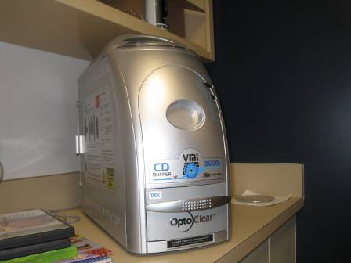

VenMill Industries, VMI 3500 Buffer

Picture 2

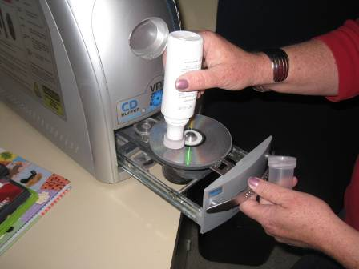

Disc Cleaning/Repair Process, Application of “AC Liquid” Antistatic Liquid Conditioner

Picture 3

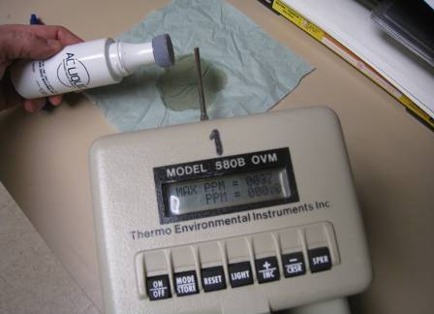

TVOC Measurement of AC Liquid with Photo Ionization Detector, Note Display Reads PPM = 000.0 (Lower Display), Indicating no Measureable Levels of TVOCs

Picture 4

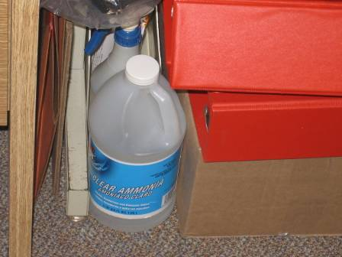

Container of Ammonia and Unlabeled Spray Bottle on Floor of Tech Services Area

Picture 5

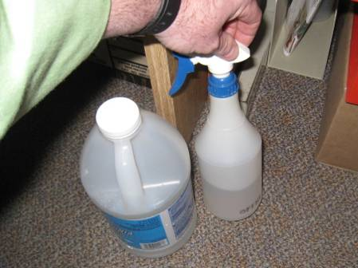

Container of Ammonia and Unlabeled Spray Bottle on Floor of Tech Services Area

Location/Room | PM2.5  (µg/m³) | TVOCs  (ppm) | Comments
Background | 7-17 | ND | Mostly cloudy, few showers, moderate traffic, cars idling in parking lot
Main Floor

Children’s Program Room | 4 | ND
Circulation Desk | 4 | ND
Reference Desk | 4 | ND
Lower Level

Lobby | 3 | ND
Staff Lounge | 4 | ND
Director’s Office | 7 | ND
Community Room | 4 | ND
Young Adult Room | 4 | ND
Tech Services Work Room | 4 | ND
Book/Disc Repair Room

 | 4-5 | ND | During buffing/repairing 1-5 discs, door shut
 | 5 | ND | During buffing/repairing 6-10 discs, door shut
 | 5-6 | ND | During buffing/repairing 10-26 discs, door shut

