INDOOR AIR QUALITY ASSESSMENT

Millville Elementary School
45 Independence Street
Millville, Massachusetts

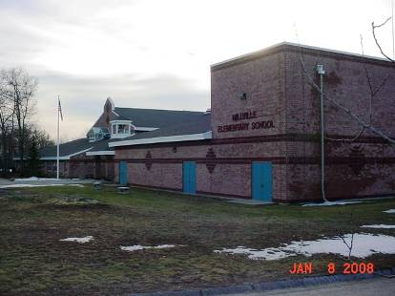

Prepared by:
Massachusetts Department of Public Health
Bureau of Environmental Health
Indoor Air Quality Program
April 2008

Background/Introduction
At the request of Herbert Levine, Superintendent, Blackstone-Millville School Department (BMSD), the Massachusetts Department of Public Health (MDPH), Bureau of Environmental Health (BEH) provided assistance and consultation regarding indoor air quality concerns at Millville Elementary School (MES), 122 Berthelette Way, Millville, Massachusetts. The request was prompted by an evacuation of the building (Milford Daily News, 2008), attributed to combustion blow-back from a water heater in the mechanical room.
On January 8, 2008, Michael Feeney, Director of the BEH’s Indoor Air Quality (IAQ) Program, visited the MES to conduct an IAQ assessment. Mr. Feeney was accompanied by Robert Therrien BMSD Facilities Manager. The school was constructed in 1992 in a combination single- and two-story building complex. Windows are openable in the building. Mr. Therrien reported that the odor problem appeared to originate from a water heater in the boiler room. Repairs had been made to this equipment prior to the BEH assessment.

Methods
Air tests for carbon monoxide, carbon dioxide, temperature and relative humidity were conducted with the TSI, Q-Trak, IAQ Monitor, Model 8551. Air tests for airborne particle matter with a diameter lesss than 2.5 micrometers were taken with the TSI, DUSTTRAK™ Aerosol Monitor Model 8520. Screening for total volatile organic compounds (TVOCs) was conducted using a Thermo Environmental Instruments Inc., Model 580 Series Photo Ionization Detector (PID). BEH staff also performed visual inspection of building materials for water damage and/or microbial growth. Water content of porous building materials was measured with a Delmhorst, BD-2000 Model, Moisture Detector with a Delmhorst Standard Probe.
Results
The school houses a student population of approximately 400 and a staff of approximately 80. The tests were taken during normal operations at the school and results appear in Table 1.

Discussion
Ventilation
It can be seen from Table 1 that carbon dioxide levels were below 800 parts per million (ppm) in all but two areas surveyed, indicating adequate air exchange in the majority of areas surveyed at the time of the assessment.
Fresh air in classrooms is supplied by unit ventilator (univent) systems (Picture 1). A univent draws air from outdoors through a fresh air intake located on the exterior wall of the building (Picture 2) and returns air through an air intake located at the base of the unit (Figure 1). Fresh and return air are mixed, filtered, heated and provided to classrooms through an air diffuser located in the top of the unit. In a number of classrooms, items placed on and/or in front of univents and exhaust vents obstructed normal airflow (Picture 1). Exhaust ventilation for classrooms is provided by ceiling vents ducted to rooftop motors (Picture 3).
To maximize air exchange, the MDPH recommends that both supply and exhaust ventilation operate continuously during periods of school occupancy. In order to have proper ventilation with a mechanical supply and exhaust system, the systems must be balanced to provide an adequate amount of fresh air to the interior of a room while removing stale air from the room. It is recommended that HVAC systems be re-balanced every five years to ensure adequate air systems function (SMACNA, 1994). The mechanical ventilation systems at MES were last balanced in 2001.
The Massachusetts Building Code requires a minimum ventilation rate of 15 cubic feet per minute (cfm) per occupant of fresh outside air or have openable windows in each room (SBBRS, 1997; BOCA, 1993). The ventilation must be on at all times that the room is occupied. Providing adequate fresh air ventilation with open windows and maintaining the temperature in the comfort range during the cold weather season is impractical. Mechanical ventilation is usually required to provide adequate fresh air ventilation.
Carbon dioxide is not a problem in and of itself. It is used as an indicator of the adequacy of the fresh air ventilation. As carbon dioxide levels rise, it indicates that the ventilating system is malfunctioning or the design occupancy of the room is being exceeded. When this happens, a buildup of common indoor air pollutants can occur, leading to discomfort or health complaints. The Occupational Safety and Health Administration (OSHA) standard for carbon dioxide is 5,000 parts per million parts of air (ppm). Workers may be exposed to this level for 40 hours/week, based on a time-weighted average (OSHA, 1997).
The MDPH uses a guideline of 800 ppm for publicly occupied buildings. A guideline of 600 ppm or less is preferred in schools due to the fact that the majority of occupants are young and considered to be a more sensitive population in the evaluation of environmental health status. Inadequate ventilation and/or elevated temperatures are major causes of complaints such as respiratory, eye, nose and throat irritation, lethargy and headaches. For more information concerning carbon dioxide, consult Appendix A.
Temperature measurements ranged from 69º F to 79º F (Table 1), which were within the MDPH recommended comfort range in the majority of areas surveyed. The MDPH recommends that indoor air temperatures be maintained in a range of 70º F to 78º F in order to provide for the comfort of building occupants. In many cases concerning indoor air quality, fluctuations of temperature in occupied spaces are typically experienced, even in a building with an adequate fresh air supply.
The relative humidity measured in the building ranged from 33 to 43 percent (Table 1) on the day of assessment, which was below or on the low end of the MDPH recommended comfort range. The MDPH recommends a comfort range of 40 to 60 percent for indoor air relative humidity. Relative humidity levels in the building would be expected to drop during the winter months due to heating. The sensation of dryness and irritation is common in a low relative humidity environment. Low relative humidity is a very common problem during the heating season in the northeast part of the United States.

Microbial/Moisture Concerns
Two areas had water damaged ceiling tiles. The US Environmental Protection Agency (US EPA) and the American Conference of Governmental Industrial Hygienists (ACGIH) recommend that porous materials be dried with fans and heating within 24 to 48 hours of becoming wet (US EPA, 2001; ACGIH, 1989). If not dried within this time frame, mold growth may occur. Once mold has colonized porous materials, they are difficult to clean and should be removed/discarded.
Gutters in certain sections of the building appeared to leak or were missing gutters/downspouts, wetting the exterior wall of the MES (Pictures 4 and 5). Repeated moistening can lead to exterior wall materials degradation and possible water penetration into the building interior.

Other IAQ Evaluations
Upon entering the MES, a slight furnace odor was detectable by BEH staff. This odor is attributable to the location of the mechanical room immediately adjacent to the music room. BEH staff examined the shared wall between the music room and boiler room and noted numerous breaches in this wall (Pictures 6 and 7). During the initial investigation by Mr. Therrien, he noted that light from the boiler room could be seen through breaches in the wall above the music room’s suspended ceiling. These breaches would serve as pathways for boiler room odors to enter into the occupied areas of the MES.
BEH staff conducted air testing to determine if any lingering effects of the water heater combustion product blow back remained after repairs. Indoor air quality can be negatively influenced by the presence of respiratory irritants, such as products of combustion. The process of combustion produces a number of pollutants. Common combustion emissions include carbon monoxide, carbon dioxide, water vapor and smoke (fine airborne particle material). Of these materials, exposure to carbon monoxide and particulate matter with a diameter of 2.5 micrometers (μm) or less (PM2.5) can produce immediate and acute health effects upon exposure. To determine whether combustion products were present in the school environment, BEH staff obtained measurements for carbon monoxide and PM2.5.
Carbon monoxide is a by-product of incomplete combustion of organic matter (e.g., gasoline, wood and tobacco). Exposure to carbon monoxide can produce immediate and acute health affects. Several air quality standards have been established to address carbon monoxide and prevent symptoms from exposure to these substances. The MDPH established a corrective action level concerning carbon monoxide in ice skating rinks that use fossil-fueled ice resurfacing equipment. If an operator of an indoor ice rink measures a carbon monoxide level over 30 ppm, taken 20 minutes after resurfacing within a rink, that operator must take actions to reduce carbon monoxide levels (MDPH, 1997).
The American Society of Heating Refrigeration and Air-Conditioning Engineers (ASHRAE) has adopted the National Ambient Air Quality Standards (NAAQS) as one set of criteria for assessing indoor air quality and monitoring of fresh air introduced by HVAC systems (ASHRAE, 1989). The NAAQS are standards established by the US EPA to protect the public health from six criteria pollutants, including carbon monoxide and particulate matter (US EPA, 2006). As recommended by ASHRAE, pollutant levels of fresh air introduced to a building should not exceed the NAAQS levels (ASHRAE, 1989). The NAAQS were adopted by reference in the Building Officials & Code Administrators (BOCA) National Mechanical Code of 1993 (BOCA, 1993), which is now an HVAC standard included in the Massachusetts State Building Code (SBBRS, 1997). According to the NAAQS, carbon monoxide levels in outdoor air should not exceed 9 ppm in an eight-hour average (US EPA, 2006).
Carbon monoxide should not be present in a typical, indoor environment. If it is present, indoor carbon monoxide levels should be less than or equal to outdoor levels. Outdoor carbon monoxide concentrations were non-detect (ND) (Table 1). Carbon monoxide levels measured in the school were ND.
The US EPA has established NAAQS limits for exposure to particulate matter. Particulate matter is airborne solids that can be irritating to the eyes, nose and throat. The NAAQS originally established exposure limits to particulate matter with a diameter of 10 μm or less (PM10). According to the NAAQS, PM10 levels should not exceed 150 microgram per cubic meter (μg/m³) in a 24-hour average (US EPA, 2006). These standards were adopted by both ASHRAE and BOCA. Since the issuance of the ASHRAE standard and BOCA Code, US EPA established a more protective standard for fine airborne particles. This more stringent PM2.5 standard requires outdoor air particle levels be maintained below 35 μg/m³ over a 24-hour average (US EPA, 2006). Although both the ASHRAE standard and BOCA Code adopted the PM10 standard for evaluating air quality, MDPH uses the more protective PM2.5 standard for evaluating airborne particulate matter concentrations in the indoor environment.
Outdoor PM2.5 concentrations were measured at 30 μg/m³ and indoor PM2.5 levels were measured between 26 to 44 μg/m³ (Table 1), which were below the NAAQS PM2.5 level of 35 μg/m³ in the majority of areas surveyed. These results can indicate that a source of pollutants is penetrating into occupied areas of the building, which would confirm the detection of furnace room odor in the front lobby of the building. Frequently, indoor air levels of particulates (including PM2.5) can be at higher levels than those measured outdoors. A number of mechanical devices and/or activities that occur in schools can generate particulates during normal operations. Sources of indoor airborne particulates may include but are not limited to particles generated during the operation of fan belts in the HVAC system, cooking in the cafeteria stoves and microwave ovens; use of photocopiers, fax machines and computer printing devices; operation of an ordinary vacuum cleaner and heavy foot traffic indoors. Although no measurable levels of carbon monoxide or elevated PM2.5 were detected, the potential for combustion products to migrate into the hallway from the boiler room was observed via a space under the boiler room door.
Indoor air quality can also be negatively influenced by the presence of materials containing volatile organic compounds (VOCs). VOCs are carbon-containing substances that have the ability to evaporate at room temperature. Frequently, exposure to low levels of total VOCs (TVOCs) may produce eye, nose, throat and/or respiratory irritation in some sensitive individuals. For example, chemicals evaporating from a paint can stored at room temperature would most likely contain VOCs. In an effort to determine whether VOCs were present in the building, air monitoring for TVOCs was conducted. An outdoor air sample was taken for comparison. Outdoor TVOC concentrations were ND (Table 1). Indoor TVOC concentrations were also ND (Tables 1).

Conclusions/Recommendations
Tests taken, which would indicate cause for health concerns, were for the most part found to be at or below healthy base guidelines. In view of the findings at the time of the visit, the following recommendations are made:
- Seal all breaches in the furnace room, including the space between the wall and roof decking (Picture 5) with an appropriate fire-rated sealant.
- Install weather stripping underneath boiler room/hallway door to prevent the migration of odors and particulates.
- Remove all blockages from univents.
- Replace water damaged ceiling tiles.
- Repair gutter above building exterior wall wet spots.

- Consider adopting a balancing schedule of every 5 years for all mechanical ventilation systems, as recommended by ventilation industrial standards (SMACNA, 1994).
- For buildings in New England, periods of low relative humidity during the winter are often unavoidable. Therefore, scrupulous cleaning practices should be adopted to minimize common indoor air contaminants whose irritant effects can be enhanced when the relative humidity is low. To control for dusts, a high efficiency particulate arrestance (HEPA) filter equipped vacuum cleaner in conjunction with wet wiping of all surfaces is recommended. Avoid the use of feather dusters. Drinking water during the day can help ease some symptoms associated with a dry environment (throat and sinus irritations).
- Consider adopting the US EPA (2000) document, “Tools for Schools”, as an instrument for maintaining a good indoor air quality environment in the building. This document is available at: http://www.epa.gov/iaq/schools/index.html.
- Refer to resource manual and other related indoor air quality documents located on the MDPH’s website for further building-wide evaluations and advice on maintaining public buildings. These documents are available at: http://www.state.ma.us/dph/MDPH/iaq/iaqhome.htm.

References
ASHRAE. 1989. Ventilation for Acceptable Indoor Air Quality. American Society of Heating, Refrigeration and Air Conditioning Engineers. ANSI/ASHRAE 62-1989
BOCA. 1993. The BOCA National Mechanical Code/1993. 8th ed. Building Officials & Code Administrators International, Inc., Country Club Hills, IL.
MDPH. 1997. Requirements to Maintain Air Quality in Indoor Skating Rinks (State Sanitary Code, Chapter XI). 105 CMR 675.000. Massachusetts Department of Public Health, Boston, MA.
Milford Daily News. 2008. “Noxious Smell Closes Millville Elementary School.” The Milford Daily News, Milford MA. January 7, 2008.
OSHA. 1997. Limits for Air Contaminants. Occupational Safety and Health Administration. Code of Federal Regulations. 29 C.F.R 1910.1000 Table Z-1-A.
SBBRS. 1997. Mechanical Ventilation. State Board of Building Regulations and Standards. Code of Massachusetts Regulations. 780 CMR 1209.0
SMACNA. 1994. HVAC Systems Commissioning Manual. 1st ed. Sheet Metal and Air Conditioning Contractors’ National Association, Inc., Chantilly, VA.
US EPA. 2000. Tools for Schools. Office of Air and Radiation, Office of Radiation and Indoor Air, Indoor Environments Division (6609J). EPA 402-K-95-001, Second Edition. http://www.epa.gov/iaq/schools/tools4s2.html
US EPA. 2001. “Mold Remediation in Schools and Commercial Buildings”. Office of Air and Radiation, Indoor Environments Division, Washington, DC. EPA 402-K-01-001. March 2001. Available at: http://www.epa.gov/iaq/molds/mold_remediation.html
US EPA. 2006. National Ambient Air Quality Standards (NAAQS). US Environmental Protection Agency, Office of Air Quality Planning and Standards, Washington, DC. http://www.epa.gov/air/criteria.html.
Picture 1

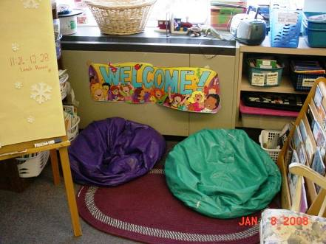

Classroom Univent, Note Items Obstructing Airflow

Picture 2

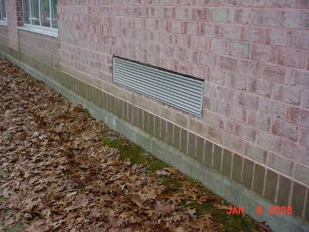

Univent fresh air intake

Picture 3

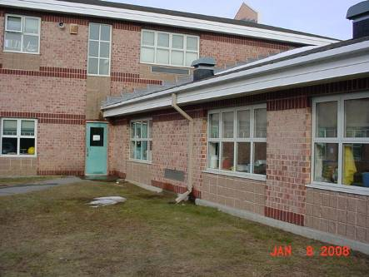

Rooftop Exhaust Vents

Picture 4

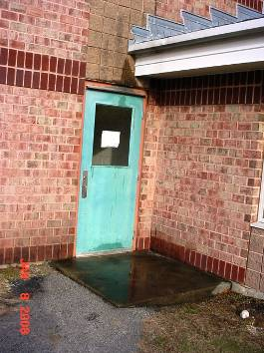

Wetted Exterior Wall

Picture 5



Wetted Exterior Wall, Note Lack of Gutter/Downspout

Picture 6

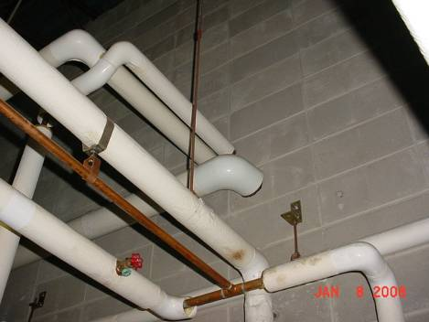

Possible Breaches in the Furnace Room Wall

Picture 7

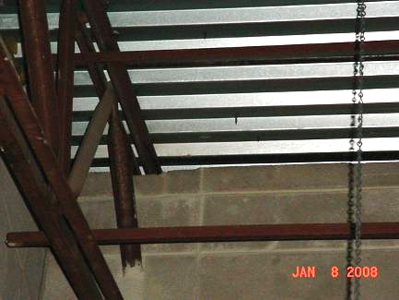

Open seam between Furnace Room Wall and Roof Decking

Location/ Room | Occupants  in Room | Temp  (°F) | Relative  Humidity  (%) | Carbon  Dioxide  (ppm) | Carbon Monoxide  (ppm) | TVOCs  (ppm) | PM2.5  (µg/m3) | Windows  Openable | Ventilation |  | Remarks
 |  |  |  |  |  |  |  |  | Supply | Exhaust | Remarks
background |  | 67 | 55 | 355 | 0 | 0 | 30
206 | 19 | 72 | 39 | 846 | 0 | 0 | 42 | Y | Y | Y
201 | 0 | 72 | 38 | 611 | 0 | 0 | 30 | Y | Y | Y
204 | 22 | 72 | 38 | 756 | 0 | 0 | 36 | Y | Y | Y
202 | 7 | 72 | 37 | 601 | 0 | 0 | 30 | Y | Y | Y
101 | 8 | 73 | 37 | 532 | 0 | 0 | 29 | Y | Y | Y
301 | 0 | 73 | 37 | 405 | 0 | 0 | 28 | Y | Y | Y
S-1 | 0 | 72 | 38 | 559 | 0 | 0 | 33 | Y | Y | Y | Photocopier
113 | 2 | 73 | 36 | 513 | 0 | 0 | 30 | Y | Y | Y
Library | 0 | 71 | 37 | 392 | 0 | 0 | 27 | Y | Y | Y
304 | 1 | 72 | 38 | 480 | 0 | 0 | 30 | Y | Y | Y
302 | 1 | 73 | 36 | 573 | 0 | 0 | 33 | Y | Y | Y
303 | 0 | 72 | 36 | 435 | 0 | 0 | 27 | Y | Y | Y
306 | 21 | 72 | 39 | 830 | 0 | 0 | 41 | Y | Y | Y
307 | 10 | 72 | 38 | 641 | 0 | 0 | 29 | Y | Y | Y
308 | 17 | 71 | 38 | 723 | 0 | 0 | 34 | Y | Y | Y
310 | 5 | 71 | 38 | 627 | 0 | 0 | 32 | Y | Y | Y
312 | 2 | 71 | 38 | 599 | 0 | 0 | 29 | Y | Y | Y
314 | 23 | 72 | 40 | 762 | 0 | 0 | 34 | Y | Y | Y
309 | 21 | 73 | 39 | 743 | 0 | 0 | 30 | Y | Y | Y
311 | 23 | 72 | 39 | 911 | 0 | 0 | 44 | Y | Y | Y
205 | 2 | 71 | 38 | 591 | 0 | 0 | 32 | Y | Y | Y
203 | 13 | 73 | 40 | 683 | 0 | 0 | 40 | Y | Y | Y
319 | 0 | 69 | 43 | 519 | 0 | 0 | 26 | Y | Y | Y
208 | 14 | 71 | 39 | 702 | 0 | 0 | 37 | Y | Y | Y
205 | 2 | 71 | 38 | 591 | 0 | 0 | 32 | Y | Y | Y
203 | 13 | 73 | 40 | 683 | 0 | 0 | 40 | Y | Y | Y
336 | 0 | 76 | 40 | 553 | 0 | 0 | 30 | Y | Y | Y
338 | 28 | 70 | 36 | 651 | 0 | 0 | 33 | Y | Y | Y
334 | 1 | 78 | 34 | 633 | 0 | 0 | 26 | Y | Y | Y
332 | 0 | 77 | 34 | 626 | 0 | 0 | 32 | Y | Y | Y
328 | 0 | 79 | 33 | 443 | 0 | 0 | 27 | Y | Y | Y
325 | 25 | 78 | 35 | 899 | 0 | 0 | 32 | Y | Y | Y
326 | 20 | 78 | 33 | 445 | 0 | 0 | 31 | Y | Y | Y
331 | 0 | 78 | 33 | 525 | 0 | 0 | 26 | Y | Y | Y
329 | 0 | 76 | 36 | 495 | 0 | 0 | 27 | Y | Y | Y
324 | 2 | 78 | 33 | 451 | 0 | 0 | 33 | Y | Y | Y
323 | 1 | 74 | 38 | 570 | 0 | 0 | 30 | Y | Y | Y
327 | 0 | 75 | 38 | 488 | 0 | 0 | 31 | Y | Y | Y
321 | 17 | 72 | 42 | 584 | 0 | 0 | 35 | Y | Y | Y
322 | 18 | 73 | 40 | 733 | 0 | 0 | 33 | Y | Y | Y
Gymnasium | 0 | 70 | 35 | 470 | 0 | 0 | 30 | Y | Y | Y
Cafeteria | 0 | 70 | 39 | 521 | 0 | 0 | 31 | Y | Y | Y

