**INDOOR AIR QUALITY ASSESSMENT**

**Longfellow Municipal Center**

**8 Central Street**

**Millville, Massachusetts**

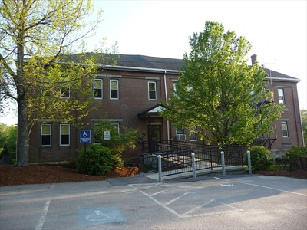

Prepared by:

Massachusetts Department of Public Health

Bureau of Environmental Health

Indoor Air Quality Program

October 2016

**Background**

|  |  |
| --- | --- |
| **Building:** | Longfellow Municipal Center (LMC) |
| **Address:** | 8 Central Street, Millville, MA |
| **Assessment Contacts:** | Jennifer M. Callahan, Millville Town Administrator |
| **Reason for Request:** | Mold odors in building |
| **Date of Assessment:** | August 12, 2016  October 7, 2016 |
| **Massachusetts Department of Public Health/Bureau of Environmental Health (MDPH/BEH) Staff Conducting Assessment:** | Mike Feeney, Director, Indoor Air Quality (IAQ) Program |
| **Date of Building Construction:** | 1850 with subsequent renovations |
| **Windows:** | Openable |

## Building Description

The LMC was constructed in 1850 as a two-story school with dirt cellar (Picture 1). The first addition, built along the east wall, includes portions of the front entrance (Picture 1). As evidenced by the tin ceiling, this section was likely added in the late 1800s. This addition appears to have been constructed over the east exterior wall of the original 1850’s structure, since a brick gable wall exists in the attic crawlspace (Simpson, Gumpertz & Heger, 2016). A second addition was made to the southwest corner of the 1850 building and houses the boiler room (boiler room addition). In the 1990's, an addition was made at the rear of the building complex to house an elevator shaft and hallways that connect to the 1850 building. The elevator addition was added to the south wall of the building complex, which enclosed a portion of the foundation and exterior wall.

Both the 1850 building and first addition were constructed on a granite/field stone foundation that encloses a dirt and living rock floor, to form a cellar that is used for storage (Picture 2). The entrance to the cellar is a wooden door in the foundation (Picture 3), which appears to have been originally outdoors and now enclosed inside a hallway of the elevator addition. The cellar door consists of wood planks with large spaces for air from the cellar to enter the basement elevator hallway.

**Methods**

Please refer to the IAQ Manual and appendices for methods, sampling procedures, and interpretation of results (MDPH, 2015).

# Results and Discussion

## Microbial/Moisture Concerns

During the assessment, a distinct mold odor was detected in the elevator shaft and foyers around the elevator door, on all floors of the building. This same mold odor was detected in the hallway near the rear stairwell and stairwell door. The source of this odor was traced to the cellar, which had a distinct musty odor from moistened soil. The cellar contains a multitude of stored materials that if moistened, can support mold growth (e.g., gypsum wallboard, paper, and wood). As noted previously, the cellar door is not airtight. Odors from the cellar readily pass into the basement elevator hallway.

In order to explain how mold odors from the cellar may be impacting the upper floors, the following concepts concerning heated air and creation of air movement must be understood.

* Heated air will create upward air movement (called the stack effect).
* Cold air moves to hot air, which creates drafts.
* As heated air rises, negative pressure is created, which draws cold air to the air shafts (e.g., stairwell and elevator shaft).
* Drafts or airflow created by the stack effect can draw particulates into the air stream.

Each of these factors will contribute to air being drawn from the cellar into the elevator hallway, then into the stairwell and elevator shaft and distributed into the upper floors.

Odors were also reported in the emergency operations center (EOC) located in the basement on the northwest corner of the building. According to Millville town officials, running water periodically passes beneath the floor of the EOC. The likely source is groundwater runoff from the parking lot (Picture 4) and the lawn around the northeast section of the LMC grounds (Picture 5), which is directed to a pipe installed under the building's front walkway. Water then travels downhill toward the EOC side of the building where it likely enters the basement through the fieldstone foundation (Picture 6). An aerial photo of the building depicts silt deposits on the driveway downhill from the building that shows the general direction of water flow (Picture 1). Adding to the water load on the lawn are gutters and downspouts that appear to empty at the base of exterior walls (Picture 7). Downspouts should empty at least five feet from the foundation to prevent water from entering the building. Over time, these conditions can undermine the integrity of the building envelope and provide a means of water entry into the building via capillary action through concrete and masonry (Lstiburek & Brennan, 2001).

Water draining through fieldstone foundations can be found in old constructed buildings like the LMC. Typically this type of basement space would be used for storage and be built from materials that would be resistant to water damage (heavy wood plank floors) that would be suspended over the flowing water. Unfortunately, the floor of the EOC was constructed using a tongue-in-groove laminate flooring (Picture 8), which is not designed for use in a high moisture environment. According to one manufacturer, their “flooring should not be installed over any ﬂoor with a sump pump or in a room with a ﬂoor drain” (Pergo, unknown).

Laminate flooring is usually manufactured using particle board plank with a laminate applied to the surface to give the appearance of natural wood. Due to its design, water vapor cannot readily pass through the material to escape from the space below the floor. This results in the floor beams, under-flooring and laminate to be chronically exposed to moisture. This in turn, may cause the flooring to be damaged/colonized with mold.

At the time of assessment, the basement appeared dry. In order for building materials to support mold growth, a source of water exposure is necessary. Identification of the location of materials with increased moisture levels can indicate an existing or potential location of mold colonization. Building materials with increased moisture content over normal concentrations may also indicate the possible presence of mold growth.

BEH/IAQ staff conducted moisture sampling of the laminate floor on August 12, 2016 and October 8, 2016. On both dates, the laminate floor was found to be moistened. Moisture content of materials may increase or decrease depending on building and weather conditions. It is important to note that the floor was found moistened six days (~144 hours) after the last measureable rainstorm prior to the August 12, 2016 measurements. The October 8, 2016 measurements were taken 72 hours after the last measurable rain (Picture 9).

Also of note is the condition of gypsum wallboard (GW) in the EOC, which has warped (Picture 10). GW is a rigid material and is not prone to warping unless exposed to moisture for a significant amount of time.

The United States Environmental Protection Agency (US EPA) and the American Conference of Governmental Industrial Hygienists (ACGIH) recommend that porous materials be dried with fans and heating within 24 to 48 hours of becoming wet (US EPA, 2008; ACGIH, 1989). If porous materials are not dried within this time frame, mold growth may occur. Once mold has colonized porous materials, they are difficult to clean and should be removed and discarded.

## Other Conditions Contributing to Water Penetration

During the course of this assessment, BEH/IAQ staff noted other conditions that indicate the building has had various sections settle, as evidenced by breaches in the exterior that can allow water to enter the building. These conditions are evident in the 1850 building, boiler room addition, and the 1990s elevator addition. The following conditions were noted:

* The first floor hallway floor connecting the 1850 building to the elevator door is sloped. This slope is noteworthy is it appears that that floor was installed during the 1990s elevator addition.
* The first floor hallway floor that leads from the stairwell of the boiler room addition to the elevator door is sloped. This slope in noteworthy due to its steepness. This hallway was also installed during the 1990s elevator addition.
* The first floor hallway floor that leads from the stairwell in the boiler room addition to the kitchen is sloped.
* The first floor kitchen floor in the boiler room addition is sloped from its hallway door towards its exterior wall.
* The second floor hallway is sloped from the boiler room addition to the stairwell.
* Both stairwells in the rear of the building have significant slopes (Picture 11).
* A large angled space was noted beneath a door leading to an 1800’s addition room with damaged ceiling (Picture 12).
* The roofline of the elevator shaft has a dip (Picture 13).
* Exterior wall brick in the rear of the 1850 building is crumbling (Picture 14), which may indicate a shift of load on this section of the building. This section of brick roughly coincides with the sloping stairwells in the rear of the building.
* Steel support beams in the boiler room were shimmed, which indicates movement of the floor (Pictures 15 and 16).
* Cracks and open seams were observed in the foundation.

As described previously, the foundation of the 1850 building is likely built on soil and living rock that appears to be stable. Based on these observations, it appears that the various additions are settling in different directions from the 1850 building (Picture 17). This type of movement can place stress on exterior walls, causing open spaces in roof/wall joints and damage brick and mortar of the 1850 building.

As reported by Millville officials, the LMC has had damage to the roof of the late 1800’s addition. It appears that the ceiling beam came loose from its mortise & tenon joints (Pictures 18 through 20). In order to support the now unsupported beams, a series of bundled 2 x 8 planks (shoring posts) were installed on the first and second floors (Picture 21). The joints between the installed support beams and the supported horizontal space do not appear to be flush in three of the four support planks on the second floor beneath the ceiling beam (Pictures 19, 22, and 23). Without a flush contact, the load of the supported beam is not evenly distributed to the support planks. The lack of a flush joint may indicate movement of the exterior wall and roof edge junction, which may open spaces that will cause cracks in the exterior wall and further damage the roof.

The exterior wall relies on the brick and stone to support the weight of interior floors and roof. To maintain support within the brick wall, granite lintels were installed above windows to transfer load to adjoining brick (Picture 24). At some point, parts of the brick wall were removed to allow for installation of air intakes for unit ventilators (Picture 25). For some unknown reason, univent openings are installed through a column in the easterly wall in two places (Pictures 26 and 27). The lack of bricks in this location may affect the ability of this wall to carry load.

# Conclusions/Recommendations

The conditions observed at the LMC are complicated. Water readily enters the building’s basement, resulting in chronic moistening of materials in the cellar and flooring of the EOC, which is the likely source of reported odors in the building. Due to various conditions involving the building envelope, it is also likely that long-term issues involving the roof, exterior walls, and foundation have resulted in cracks and other breaches that allow moisture to penetrate into the building. BEH/IAQ staff have also reviewed and concur with the observations and conclusions made by the engineering consultant Simpson, Gumpertz & Heger with regard to the condition of the damaged roof above the 1800s addition subject to their report on September 22, 2016.

**Short-term** and **long-term** recommendations are provide to address the conditions described in this assessment and to improve IAQ. The short-term recommendations can be implemented as soon as practicable. Long-term measures are more complex and will require planning and resources to adequately address overall IAQ concerns within the building.

## Short-term Recommendations

1. Remove all porous material from the cellar in a manner consistent with recommendations made in “Mold Remediation in Schools and Commercial Buildings” published by the US EPA (2008). This document can be downloaded from the US EPA website at: <https://www.epa.gov/mold/mold-remediation-schools-and-commercial-buildings-guide>.
2. Extend downspouts to a distance of five feet away from the foundation.
3. Replace the cellar door with an airtight door frame and door.
4. Consider installing a mechanical exhaust vent and necessary ductwork to vent both the cellar and space beneath the EOC to draw odors and eject water vapor from the building.
5. If use of the EOC is to continue, replace the existing flooring with one that is moisture resistant.
6. Replace the warped GW in the EOC. Consider replacing all GW in the EOC with cement board.
7. Have the joints between the bundled planks supporting the free ceiling beam assessed to ascertain if the beam has moved. Consideration should be given to installing cross beams between the bundled planks to arrest further movement.
8. Refer to resource manual and other related indoor air quality documents located on the MDPH’s website for further building-wide evaluations and advice on maintaining public buildings. These documents are available at <http://mass.gov/dph/iaq>.

## Long-term Recommendations

1. Consider installing a drain system that redirects parking lot runoff.
2. Consult a building engineer as to the best method for preventing or minimizing water penetration through the foundation.
3. Consult with a building engineer regarding the settling noted in the boiler room and elevator additions.
4. Consult with a building engineer on best practices to shore the rear stairwell.
5. Consult with a building engineer regarding the brickwork in Picture 14 to assess the structure of the wall above this section and best practice to repair the damage.
6. Consult with a building engineer regarding the sloping floors denoted in this report and make recommendations regarding arresting possible movement in the boiler room and elevator additions.

**References**

American Conference of Governmental Industrial Hygienists (ACGIH). 1989. Guidelines for the Assessment of Bioaerosols in the Indoor Environment. American Conference of Governmental Industrial Hygienists, Cincinnati, OH.

Lstiburek, J. & Brennan, T. 2001. Read This Before You Design, Build or Renovate. Building Science Corporation, Westford, MA. U.S. Department of Housing and Urban Development, Region I, Boston, MA.

Massachusetts Department of Public Health (MDPH). 2015. Massachusetts Department of Public Health. Indoor Air Quality Manual: Chapters I-III. Available at: <http://www.mass.gov/eohhs/gov/departments/dph/programs/environmental-health/exposure-topics/iaq/iaq-manual/>.

Pergo. Unknown. Pergo Installation Essentials Guide for Laminate Flooring. <http://sweets.construction.com/swts_content_files/151611/375951.pdf>.

Simpson, Gumpertz & Heger. 2016. Letter to Jennifer M. Callahan, Town of Millville, MA from Leonard J Morse-Fortier, Staff Consultant, Simpson Gumpertz & Heger, Inc. regarding Project 161177-Investigate Damage to Town Hall Roof Structure, Millville, MA. Simpson Gumpertz & Heger, Walltham, MA.

United States Environmental Protection Agency (US EPA). 2008. Mold Remediation in Schools and Commercial Buildings. US Environmental Protection Agency, Office of Air and Radiation, Indoor Environments Division, Washington, D.C. EPA 402-K-01-001. <http://www.epa.gov/mold/mold-remediation-schools-and-commercial-buildings-guide>.

**Picture 1**

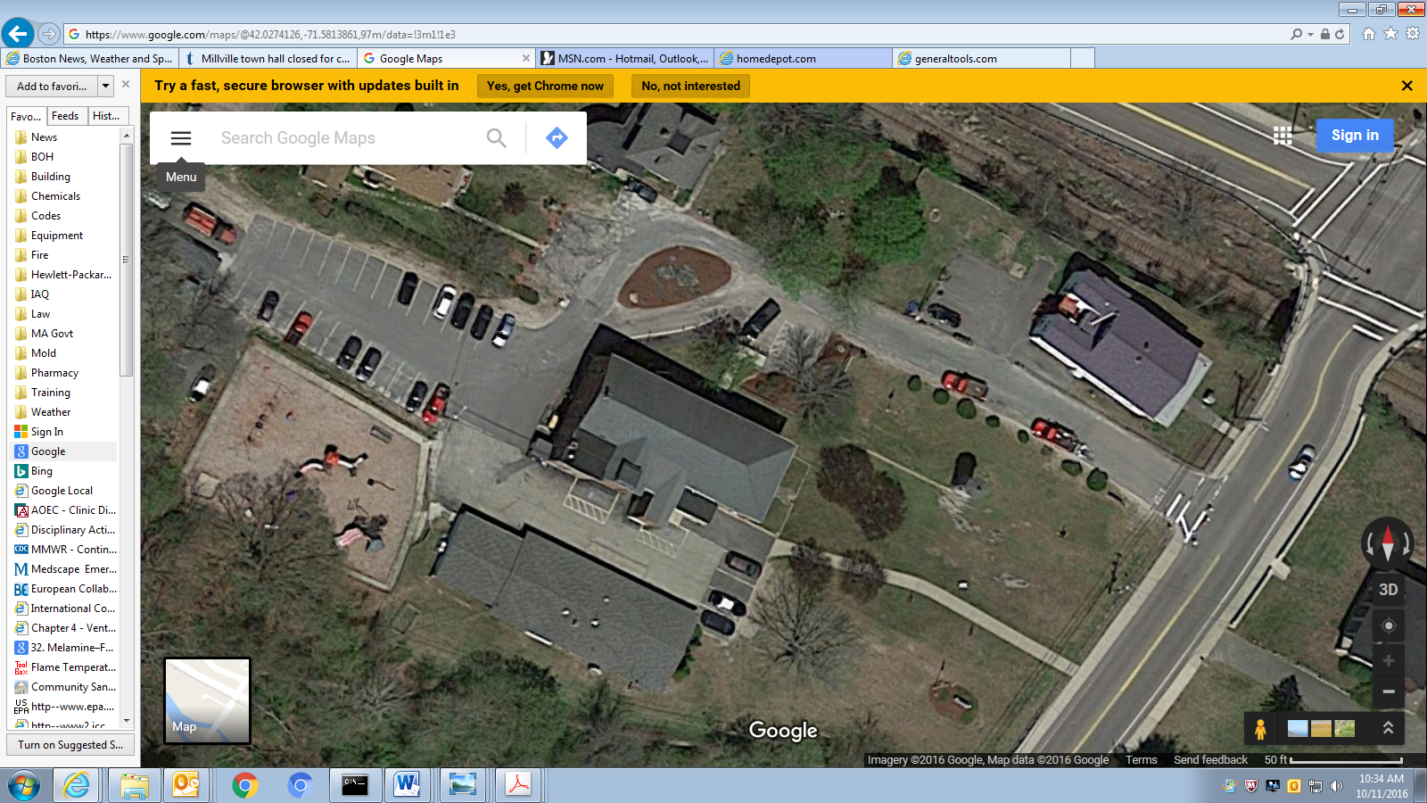

**1850 building**

**First addition**

**Boiler room addition**

**Elevator addition**

**General description of original building and additions (image source: Google Maps)**

**Picture 2**

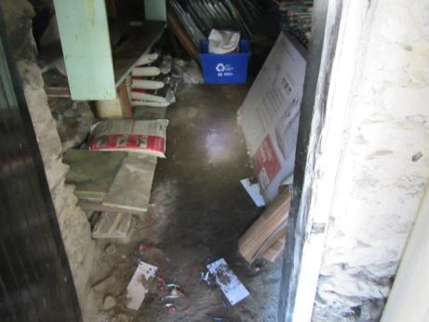

**The cellar**

**Picture 3**

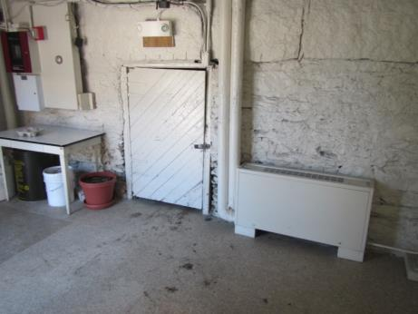

**Cellar door in elevator lobby, basement level**

**Picture 4**

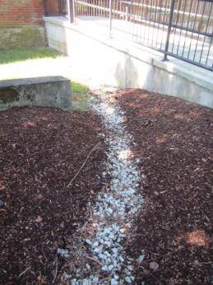

**Drainage from parking lot directed towards drain pipe beneath walkway**

**Picture 5**

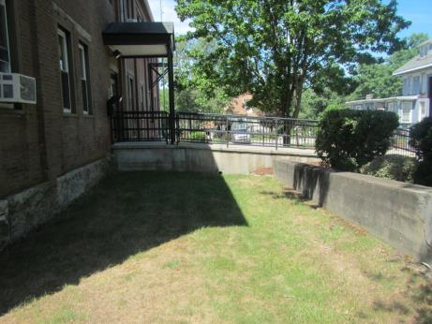

**Lawn on northeast side of building, note cement walkway with drainpipe**

**Picture 6**

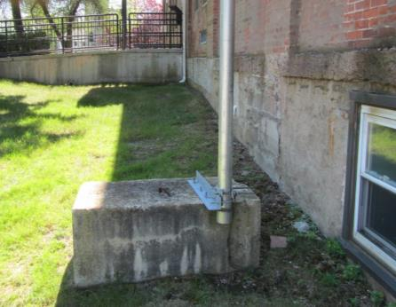

**Northwest corner of the building**

**Picture 7**

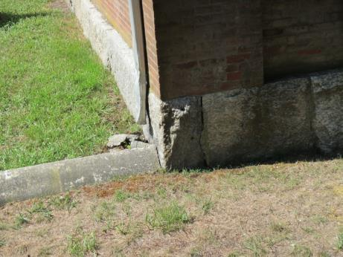

**Downspout emptying at the base of the exterior wall**

**Picture 8**

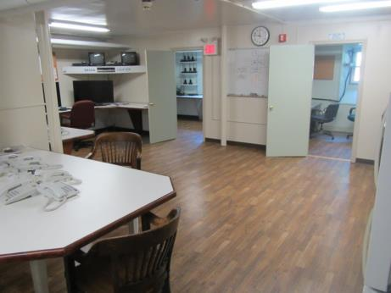

**Laminate floor in EOC**

**Picture 9**

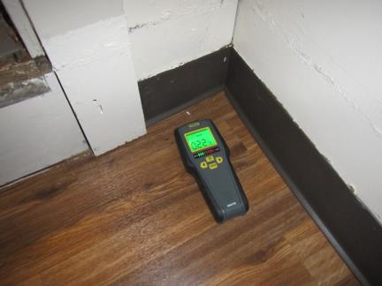

**Moisture meter detecting moistened laminate floor**

**Picture 10**

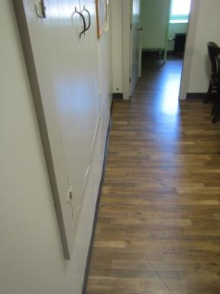

**Warped GW in EOC (Line added for emphasis)**

**Picture 11**

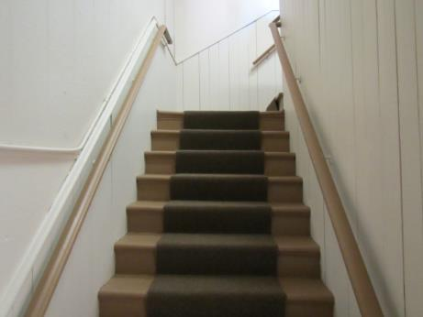

**Rear stairwell from first to second floor with uneven steps (line added for emphasis)**

**Picture 12**

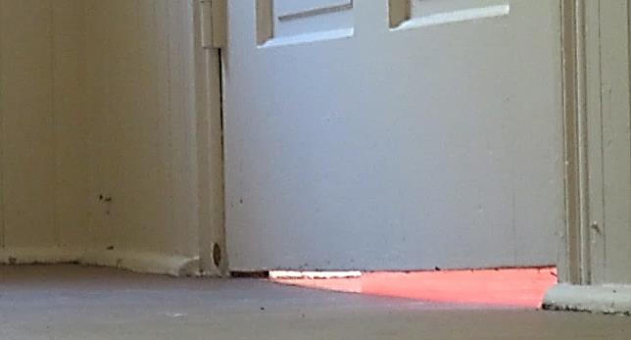

**Door to second floor room ceiling damage, note angle of the gap**

**Picture 13**

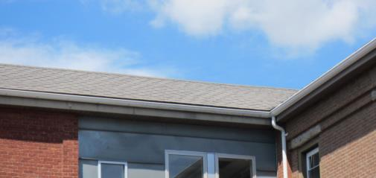

**Dip in the roof line of the elevator addition (line added for emphasis)**

**Picture 14**

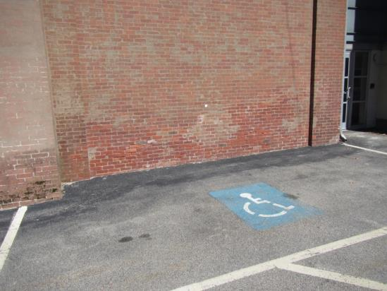

**Crumbling brick at rear of the building**

**Picture 15**

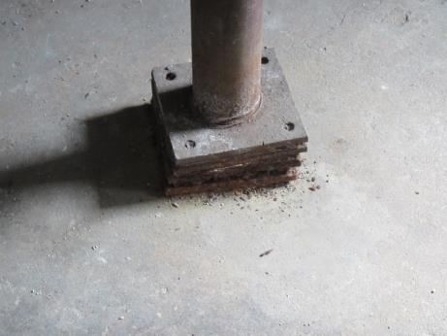

**Boiler room support column shimmed at its bottom**

**Picture 16**

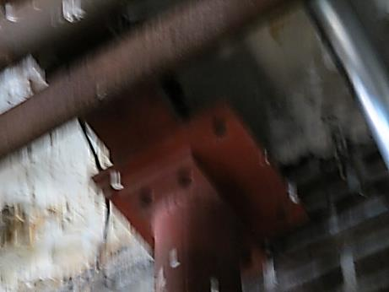

**Boiler room support column shimmed at its top**

**Picture 17**

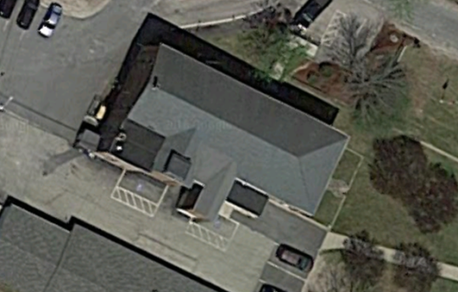

**Likely directions additions are moving away from the original building**

**Picture 18**

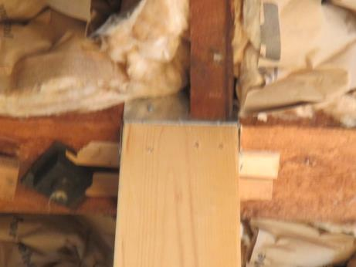

**Ceiling beam appears to have rods (arrow) that connect to the roof structure**

**Picture 19**

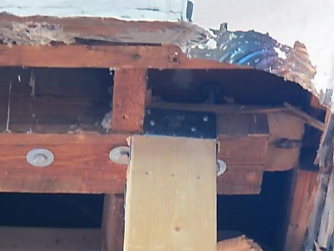

**Ceiling beam tenon (arrow) out of its mortise joint (Joint between the installed support beam and the supported ceiling beam does not appear to be flush)**

**Picture 20**

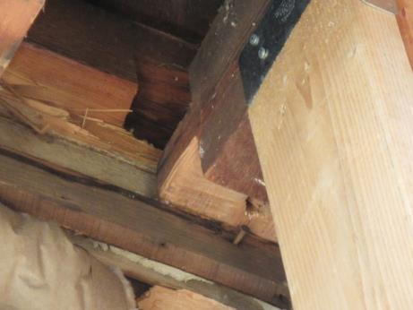

**Ceiling beam tenon (arrow) out of its mortise joint**

**Picture 21**

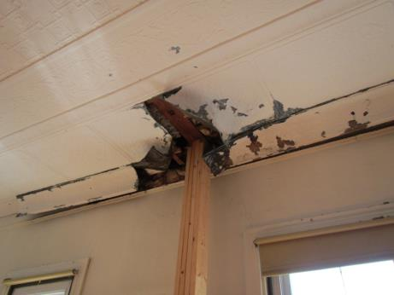

**Bundled 2 x 8 planks used to support free ceiling beam**

**Picture 22**

**Joint between the installed support beam and the supported ceiling beam does
 not appear to be flush (Note the joint is shimmed)
**

**Joint between the installed support beam and the supported ceiling beam does**

**not appear to be flush (Note the joint is shimmed)**

**Picture 23**

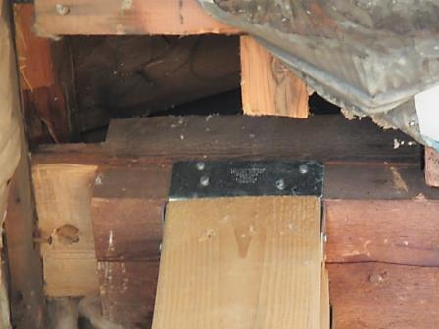

**Joint between the installed support beam and the supported ceiling beam does not appear to be flush**

**Picture 24**

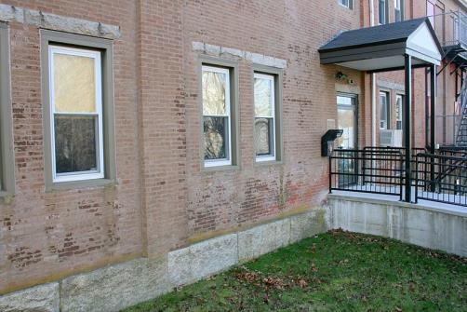

**Granite lintels above windows**

**Picture 25**

**Holes cut in side of building to install univent fresh air intakes

**

**Holes cut in side of building to install univent fresh air intakes**

**Picture 26**

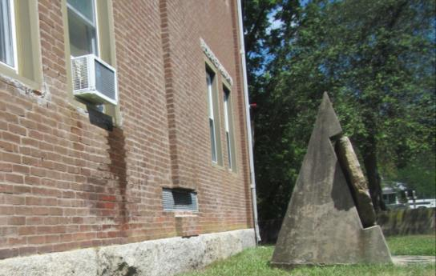

**Univent opening installed through a column in the easterly wall**

**Picture 27**

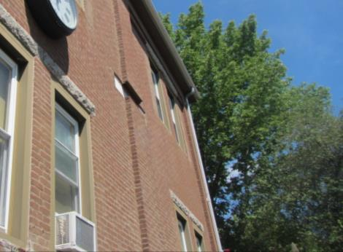

**Univent opening installed through a column in the easterly wall**